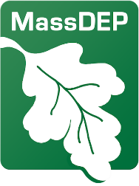
Commonwealth of Massachusetts
Executive Office of Energy and Environmental Affairs
Department of Environmental Protection
Address: 100 Cambridge Street, Suite 900, Boston MA 02114 | Phone: 617-292-5500
Maura T. Healey Governor
Kim Driscoll Lieutenant Governor
Rebecca Tepper Secretary
Bonnie Heiple Commissioner

Notice of Intent

Long Island Sound Partnership Nitrogen Reduction Infrastructure Grant

Request for Responses Coming June 17, 2026 (Estimated)

Summary
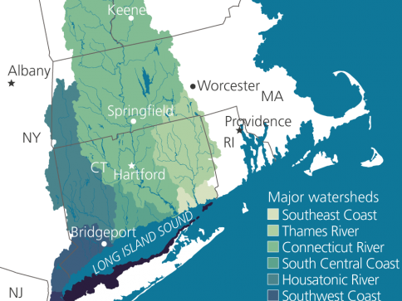
MassDEP intends to make approximately $7.2 million in funding available for Long Island Sound Partnership Nitrogen Reduction Grants and will be issuing a Request for Responses in June 2026. These grants, provided by the United States Environmental Protection Agency (USEPA through the Infrastructure Investment and Jobs Act (IIJA) and Long Island Sound Partnership, will fund project development and construction, including personnel, planning, design, equipment purchases, and construction activities related to nitrogen reduction solutions for Massachusetts wastewater treatment plants in the Connecticut, Housatonic, and Thames River Watersheds to address nitrogen discharging into the Long Island Sound Watershed. Preference for funds will be given to projects that are “shovel-ready” or in the final stages of design and permitting. MassDEP funded work must be completed by September 30, 2031.
Map of Long Island Sound Watershed
(Source: NEIWPCC)

Background
The Long Island Sound Partnership is a cooperative effort to improve water quality in, and restore the health of, the Long Island Sound (LIS). Established in 1985 by USEPA, New York and Connecticut, the Partnership is a bi-state partnership made up of federal and state agencies, user groups, concerned organizations and individuals focused on protecting and restoring the Sound.
In 1994, the Partnership developed a Comprehensive Conservation and Management Plan (CCMP) which was most recently updated in 2025. The first goal of the 2025 CCMP is to promote “Clean Waters and Healthy Watersheds” by restoring and maintaining water quality in the Connecticut River and LIS watersheds. Addressing nitrogen pollution is critical because excess nitrogen causes rapid growth of algae which blocks sunlight and may produce toxins that can be harmful to humans and animals. Algal blooms may also kill aquatic plants, consume oxygen needed by aquatic plants and animals which may endanger marine life and humans. Although water quality in the LIS has improved over time due to cumulative decline in nitrogen pollution, there is a continued need to address the effects of contamination through integrated approaches, including “enhanced support to address smaller, more diffuse pollutant sources, disturbances” such as wastewater infrastructure. The CCMP aims to accomplish this, in part, by reducing nutrients such as nitrogen and pathogens in the watershed through improvements to onsite wastewater treatment systems located in or along the LIS watershed.
To implement this work, the United States Environmental Protection Agency (EPA) awarded MassDEP $10.5 million in 2022 through the IIJA to fund nitrogen reduction projects within the Long Island Sound (LIS) watershed. On March 20, 2025, the EPA awarded MassDEP an additional $10.6 million from IIJA funds for Federal Fiscal Years (FY) 2025 and 2026. Through this program, MassDEP is currently funding three nitrogen reduction projects (to be completed by 2029-2031), and will be offering $7.2m in FY’26 to Publicly Owned Treatment Works (POTWs) in the LIS Watershed.

Eligible Entities
POTWs located within the LIS Watershed. The LIS includes the Thames River, Connecticut River, and Housatonic River Watersheds in Massachusetts.
POTWs in LIS Watershed:
Amherst WWTP, Athol WWTF, Barre WWTF, Belchertown WRF, Charlemont WWTF, Charlton WWTF, Chicopee WPC, Easthampton WWTP, Erving WWTP #1-3, Gardner WWTF, Great Barrington WWTF, Greenfield WPCF, Hadley WWTP, Hardwick-Gilbertville and Wheelwright WPCFs, Hatfield WWTF, Holyoke WPCF, Huntington WWTP, Lee WWTF, Leicester Water Supply WWTF, Lenox Center WWTF, Monroe WWTF, Montague WWTF, North Brookfield WWTP, Northampton WWTP, Northfield WWTF, Old Deerfield WWTP, Orange WWTP, Oxford Rochdale WWTP, Palmer WPCF, Pittsfield WWTF, Royalston WWTP, Shelburne WWTF, South Deerfield WWTP, South Hadley WWTF, Southbridge WWTF, Spencer WWTP, Springfield Regional WTP, Stockbridge WWTP, Sturbridge WPCF, Sunderland WWTF, Templeton WWTF, Ware WWTP, Warren WWTP, Webster WWTF, West Stocking WWTF, Westfield WWTP, and Winchendon WPCF.

Eligible Projects
These grants will provide funds for project development and construction, including personnel, planning, design, equipment purchases, and construction activities related to nitrogen reduction solutions to address nitrogen discharge into the Long Island Sound Watershed. Funds will be awarded based the following criteria: funding need; ability to reduce nitrogen from effluent; project readiness; project management capability; compliance with the requirements of 33 U.S.C § 1269; and whether the proposed project will be completed by September 30, 2031.

Funding Availability
MassDEP anticipates making approximately $7.2m available for grants in June 2026. All funds must be expended no later than September 30, 2031. Please note that these funds are federally sourced and subject Build American, Buy American and Davis Bacon Act provisions.

Application Process
A Request for Responses (RFR) will be posted to COMMBUYS and MassDEP's website. Instructions and a copy of the application will be provided in the RFR.

Outreach
MassDEP will be conducting one information session on April 6, 2026, at 1:00 P.M. E.S.T. on Zoom. Register here to attend.
In addition, MassDEP will be available to meet with individual facilities to discuss potential projects and address questions and/or concerns related to this funding opportunity. If interested, please contact Jennifer Wood (contact below) as soon as possible.
MassDEP
Jennifer Wood, Environmental Engineer
jennifer.wood@mass.gov
617-835-9886

Additional Information
MassDEP’s website
LIS Partnership’s website
LIS Comprehensive Conservation and Management Plan (2025)

