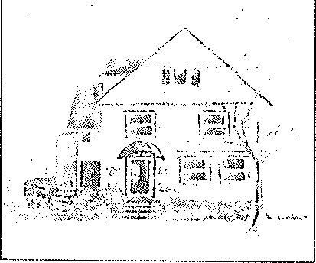Phillips Manor Nursing Home

28 Linwood Road Lynn, MA 01905-1638

Tel: (781) 592-8000

Fax: (781) 598-1556

E-Mail: [Raugeri@phillipsmanor.com](mailto:Raugeri@phillipsmanor.com) [www.phillipsmanor.com](http://www.phillipsmanor.com/)

October 18, 2024 Stephen Davis, Director

Department of Public Health

Division of Health Care Facility Licensure & Certification 67 Forest Street

Marlborough, MA *01752*

Re: Phillips Manor Nursing Home (License #0332)

Notice oflntent to Close Pursuant to 105 CMR 153.023

Dear Mr. Davis:

This letter is to provide notice to the Department of Public Health (DPH), the Phillips Manor Residents and Families, Staff and other Interested Parties1 pursuant to 105 CMR

153.023 of the intent to voluntarily discontinue operations and close Phillips Manor Nursing Home, effective February 20, 2025.

The family owned and operated Phillips Manor Nursing Home, a 29-bed facility that was reduced to a 22-bed facility located at 28 Linwood Road, Lynn, Massachusetts 01905 has served the Lynn and surrounding communities since 1952. The facility has maintained a reputation in Lynn and surrounding communities for excellent nursing care, offered in a

.home-like setting" However, the time has come. to make the difficult.decision Jo clq e,; ., Phillips Manor Nursing Home due to the financial feasibility due to the reduction of beds and the increase in costs.

The following provides DPH with additional information about the Facility's operations and closure plan:

1. The Proposed Date of Closure. Phillips Manor Nursing Home proposes to cease operations and close the Facility at its current location as of February 20, 2025, or sooner as the residents want to be stable for the holidays.
2. Reasons Leading to Closure. The reduction in beds has created hardship and the facility must close due to financial feasibility.
3. The Facility Representative. Residents, family members, staff or other Interested Parties may contact Richard Augeri, Administrator, with questions or concerns they may have regarding the proposed closure.
4. Draft Closure Plan. Phillips Manor Nursing Home is submitting the enclosed draft

closure plan (the Closure Plan) to DPH on October 21, 2024, along with this letter. In coordination with this letter, Phillips Manor is announcing the closure to the residents, families and staff and reviewing the closure process with them at separate meetings. To get the message out to everyone in a timely manner, Phillips Manor will also be providing a letter and the Closure Plan to the residents and families, staff and other Interested Parties via email, USPS or hand delivery. The Closure Plan will also be posted at the Facility and available from the Facility's Administrator upon request.

1. Public Hearing. We will work with DPH to schedule a public hearing on the proposed closure at least ninety (90) days prior to the proposed closure date. The Facility and DPH will provide notice of the date, time, and place of the hearing as soon as it is available. A copy of the public hearing notice also will be posted at the Facility and will be made available by the Facility's Administrator upon request.
2. Public Comments. Comments on the proposed closure and the draft Closure Plan may be filed with the Facility and/or DPH up until the date of the public hearing.

Please contact Richard Augeri, Administrator, at 781-592-8000, if you have any questions or should you require additional information.

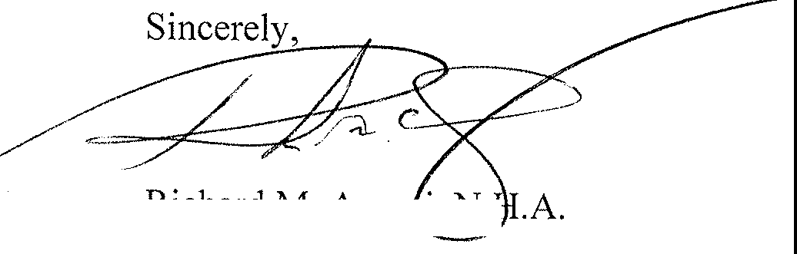

Richard M. Auge i, N. Owner/Operator

**cc:**

EOEA

State Long Term Care Ombudsman