Attachment 7

Notice of Intent

BA I THURSDAY JULY 1 2021 ! THE DAILY NEWS

Legal Notices Legal Notices

Councilors want Belknap Pool plan before deciding on purchase

FRAMil'-IGHAM - Tho city'& pur<.,huse oln former North1,1de pool und tenm& club wdl huvc- to wait
Councilon, onTum,day tabled avoteto appropn­ ato $362,150 from free c..n1,h to buy theformer Belk­ nap Pool and renms Club The Finance Committee earher thts month unammously signed olf on the purchase, but members stressed they want to see a dc>tnilcd plnn for the> fut11rc> U'i(' oft1w property be­ fore thPt1\lr<'ha'ie Wa'i official
"Isrethls:rem11tnlnga'ian ab11ndo11ed parcel lnto thr-futurr- bt>calll;e tt's nevr-r going togot the- lmdgot prlonly 1t necdi. without n plnn,'' 1,aid Distm.t 8
\C1une1lor John Stefamm
The Park'innd Rct.rCtLhonDcpfll'lmcnt cxpc(.1.S to hold a fontm th11, summer to1,ohc1t ft!cdlmck from rnsldont1, on a potential use- Opttom, have mcluded haV1ng the '3<.hool Department use the cxi1,tmg t<.n­ nls und volleyball <.ourts engaging mu pubhc·pn· vate partncn,h1p for1ecrentton activities, suhd1v1d­ mg the lot and maintaining it a'i open space
'I he putccl wtll not be Us<?d as a public pool "The conc;cm,un was thnt the pool lti;elf le; tra.lly
going to be too expr-r1s1w to rf''l\llrr-ct as ti puhhc pool ,met It's not n partJM.11.irJ} flttm1; •ntt•," n1dd !Ju,­ tnrt '3 Councilor Adam Sl:f>ln<'I "H owevrr1 there me
::.omo poshllnhti<", cmlthem, inc l\1dmg paiuuw tt!o('h
hke ..i. Rcrentwn pmk or u v.nlking aroa"

Marlborough
Continued from Page 1A

mayor smd "I hey have iwme 1mslnfommtlon '1 hf' Fire l)r-pa.rtmr-nt and I have had a prr-tty good xeln­ tlcm'ihi1>"
V1geunt smd Uwrn have been no promb,e1, to t,diw the tnlmtnum st,1ffmg h•vp) Ill' i.wd wlwn t.pet1kmg to lou1l ttmon leaders, that when a now fire- station lh built, he would look.it rmnlmmn slalf-
1 mg levels and to sci;' whut the budget would !.Up·
port
As far as the fJre prevenbon/mspect10n pos1bon, Vigeunt said the Job was posted mtemnll>• und has been offered toseveraJ peoplP who did notaccPpt it One per'ion did accept, but then backed out
"It's not hYc we havrn't tned to hue anvone, thf' ma.yor M)ld "No one h,1s br-en lntrreE.tc•d.,
The hrad oftlw Mddbom\1gh rhaJitf'r of the firr-­ ftghtf't'i 11111011, William 1uylor, w,is out oftown on Monda.y nnd uiuld 110t bet< nc hod for wmm nt <irt Tuesday
Nonnm, Miller C<ln b(• reacJmf at 'i08 6:?6 3823
1 or nm1ller@w1ckedlowl com For up to-datE cnme m.ws, follow Nonnan Mi/for on Tlvitter @Nor ma11_M1tlerMW or on Fw:.ebook at facebook com/
NurmanM1//erCrlm£•

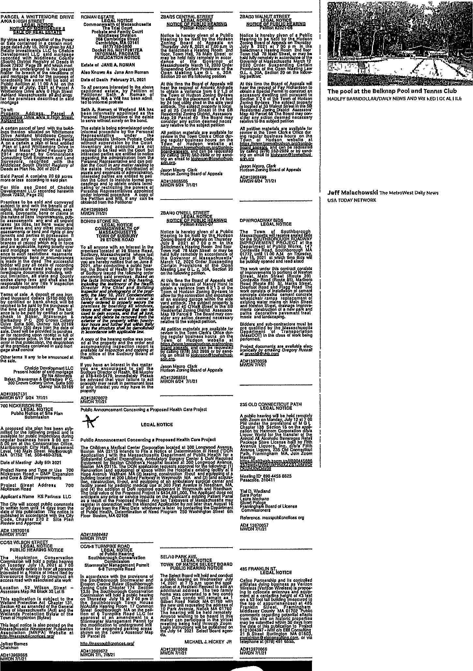

Pick up a little solll.ething or your chest pain.

Plck It up and dial 9-1-1 at the first warning sign The faster you get help, the better your chances of recovery To learn more, visit www.amerlcanheart erg ,-,
Amencan Heart _...
orcall 1-800-AH -USA1 Association.
Learn and Live.
!his space provided •• a public service C 19S9, American He"lr1 Association

Dogs
\ontmuetl from Pnge 1A

found thedogs about 9 45a m abandoned near the school In crates that l)ol1ce descnbed as 'filthy Thry 1mmed1utC'ly c.alled police and ammnl control, It1leysmd
EvE'n dunng thnt mommg hour, loc-.a! tC'mper-
1 &hares were- hk"l)• clo'>C' to 90 drg1<'PS
))oth dog'i-onr thnt nppl'nrn to bt>n Pomr-nuuau mlxnnd theotlwr n Shlb,1Jnunux.-app<•urtobeOK
..i.ud J.re berng <.ared for dt theAr1hn,ll Control Offlc.e Rllc.y Mud ubandonmg nn anlnrnl Is cruel - und
dleguI
MThcrc uro u-.onues to buJely give tip dog1,," ho 1,u1d "People, believe 1t or not, nrc lookmg for dogs" Polic.'e recommend contuchng orgamzut1om, such as the Ammnl Rescue l eague of Bo,;ton or the Mussuchusetts Society for the P1cvcnt10n ot Cruel­
ty to Ammals rather than abandcmmg a pet
Poltce nslc thnt anyone with information about thr- clogt. a.ncl/c,r thr-ir owners to <.nll n.nlmal c-o11trol nt S0H-512-5870 Rllr-y t.nld rnllers rnn rrmnin a.nonymo1lR
It I:, not known wh<.n the dogs will be avudablc for .idoption Mk.kPm h,dd they dog!) mmt rcmum v.1th tinun,tl wntrol for nt lea1,t 1,c,ven days After thut,1t 1s not known1f thcv will bc.. udoptC!d through ummal control, or transferred to another fac1hty or orgamzntlon
Norman Miller can be reached at 508·626·3823 or mmller@wickedlocal com For up to date public
<,afety news, follow Norman Miller on l'wltter
@Normari Mllle,MW or on Facebool.. at face book.ro1n./Nom1a11MU11>rCnme

or claims in
MWDN7/1/21
ZBA/40 O'NEILL STREET
FRAMINGHAM-The city's pur1

,ements, pub- LEGAL NOTICE

1d all unpaid Is, water and 1er municipal I rights of anY, IossessIon, if ting encum- 1 are In force g pnonty over or not refer­
*, easements, ncumbrances 1e successful of recording nd any other 1clud1ng, with·
, and county shall also be V mspectIon

t of one hun-
BOH/29 STONE RD
LEGAL NOTICE COMMONWEALTH OF MASSACHUSETTS TOWN OF SUDBURY 29 STONE ROAD
To all anY,one with an interest In the J)remIses located at 29 Stone Road Sudbury, Massachusetts, whose las! known owner was Carol R. Childs, you are hereby not1f1ed that on June 8, 2021hafter conducting a public hear­ Ing t e Board of Health for the Town of Sudbury issued the following order concerning said premises Based on the facts lntroduced at this hearmJJ, mc/udlng the testimony of the Hea/lfl D,rector, Ftre Chief and Building
lnspe1?,tor and P.hot rafhs of the prop·
0
NOTICE OF PUBL!R HEARING
Peti11on #20 -07
Notice Is hereby given of a Public Hearing to be nela by the Hudson Zoning Board of Appeals on Thursday, July 8, 2021 at 7 OD p.m in the Selectman's Hearing Room, 2nd floor, Town Hall, 78 Mam Street, or may be held fully remotely In accordance of the Governor of Massachusetts' March 12.,_ 2020 Order Suspending Certain r-rovlsions of the Open Meeting Law G L c 30A, Section 20 on the following petItlon·
At this time the Board of Appeals will
gg nt e.::rrn t f 6:ini. - \ Town of Hudson Zoning By-laws to
allow for the renovation and expansion
DPW/ROADWAY BIDS
LEGAL NOTICE

lJa saci :feis v?i1! rec fv t ua'/ s for the SOUTHBOROUGH ROADWAY IMPROVEMENT PROJECT at the
Department of Public Works, 147
Cordavllle Roadb Southborough, MA 01772 until 11 AM, on Thursday July 15( 2021, at which lime Bids will be publ cly opened and read aloud
o
The work under this contract consists of improvements to portions of Newton Street, Mam Street !Route 30), Cordav1lle Road (Route 85)₁_ Marlboro Road (Route 85), St MarKs Street, Deerfoot Road and Flagg Road The work consists of mstallaflon of cement
concrete sidewalks, cement concrete
Northside pool and tennis club wil Councilors on Tuesday tabled a ate $362,150 from free cash to buy nap Pool and Tennis Club. The Fin earlier this month unanimously s purchase, but members stressed tJ detailed plan for the future use of
fore the purchase was official.
"I see this remaining as an abarn
the future because it's never going priority it needs without a plan,

$100,000 00)
brifde h<;/!/1,Yi/i!/eia / if: ctg: :
fs of an existing _garage within the side
wheelchair ramps, replacement of

heck will be
reur'fh a,: rtIfIed or bank averman &
rown Colony
y, MA 02169
m the date of id to purchas­
;eIpt In full of e event of an 1e description i in said mart•
announced at elopment LLC
,ala mortgage his Attorneys, 1rbadoro, P C Ive, Suite 500
cy, MA 02169

hereby ordered to secure the
=1 7,"/u!o;/ J": w '/-e etoaN:J1 Jfn efie remo!':J &!!J:'l]i extenor of the P.fOPBrlY. Wdhm twen!y­ four hours and further that wntun th1itr. days the structure shall be demo//shea
,i accordance With applicable law.
A copy of the hearing notice was post­ ed al the property and the order and accompanying inspection report Is available for InspectIon and copym9 at
\eai? ;lce of tlie Sudbury Boar of

If you have an Interest m this matter, you are encoura_ged to call the Sudbury Director of Realth, Bill Murphy at 978-;j40-5479, 1mmed1ately. Please be advised that your failure to act promptly may result In permanent loss of any interest you may have ,n the property
AD#13970072 MWDN7/1/21

yard setback The sublect property Is located at 40 O'Neill S'tree! in the SB Residential Zoning District, Assessors' Map 19 Parcel 9. The Board may con­ sider any action deemed necessary relative to the subject petItIon
All petItIon materials are available for review in the Town Clerk's Office dur-
lf1Jv)';9u6f b J nsea5,;3 h gs1? tha1
gttps //www.townoft7udsog,orq/zornr,a-
bya6 fifffJT )8sns1- n89 [t u n Ing an email to kJOhnson@townofhud­ son org
Jason Mauro, Clerk
Hudson Zoning Board of Appeals
AD#13968501 MWDN 6/24, 7/1/21

existing water mains on Mam Street and Newton Street, drainage ImP,rove­ ments, construction of a new park and paths, decorative pavement treat­ ments, and landscaping
Bidders and sub-contractors must be pre-qualified by the Massachusetts Department of Transportation (MassDOTI in the class of work being performed
Project documents are available elec­ tronically b:,' emailing Gregory Russell at grussen@vhb com
AD#13970058 MWDN7/1/21

235 OLD CONNECTICUT PATH
Councilor John Stefanini.
The Parks and Recreation Depar hold a forum this summei to solic residents on a potential use. Optio having the School Department use nis and volleyball courts, engagin1 vate partnership for recreation acti ing the lot and maintaining it as o: The parcel will not be used as a "The consensus was that the p< going to be too expensive to rcsu pool and it's not a particularly fittn trict 3 Councilor Adam Steiner. "He some possibilities out there, incluc like a recreation park or a walking

::E
Ite Plan
1

,s been sub­ JroJect and Is
ct oii di:-1 n rai 0 t s ! Marlborough,
0-3768
h 2021
or Use· 700 P Expansion ements
ess 700
artners, LLC
lie comments lays from the TtiIs notice Is with the City Site Plan

Public Announcement Concerning a Proposed Health Care Project

LEGAL NOTICE

Publrc Announcement Concerning a Proposed Health Care Project
The Children's Medical Center Corporation located at 300 Longwood Avenui,1 Boston, MA 02115 intends to File a Notice of Determination of Need ("DOi. Application"\ with the Massachusetts Department of Public Health for a Substantial CaQ1tal ExP.end1ture, Ambulatory SurgerY. Center & DoN Required Equipment by Boston Children's Hospital focatea at 300 Longwood Avenue Boston, MA 02115. The DON application requests approval for Ifie following. ({l
I
Renovation [and equipping] of s_pace within the Hospital's existing facility at 9
Hope Avenue, Waltham, MA (2\ leasing, construction, fit-out, and egu1ppIng of a building located at 200 Libbey Parkway m Weymouth, MA , and (3) land acquisi­ tion( construction, fIt-out₁ ano equIppfng of an ambulatory surgical center and fac1Ity zoned for pediatric medical use at 380 First Avenue in Needham MA, and {4\ the addition of DoN required equipment in Wevrnouth and Neeaharn. The tofal value of the Proposed Pro1ect Is $ 34 691,000, The Applicant does not antIc1pate an'( price or service impacts on the Applicant's existing Patient Panel as a result o the Proposed ProJect Any ten Taxpayers of Massachusetts may register in connection with the intended AP.phcat1on by not later than August 16 or"3D days from the FIiing Date, whichever is later, by contacting the Department of Public Health, DetermInatIon of Need Program, 250 Washington Street, 6th Floor, Boston, MA 02108.
I

AD#13969482 MWDN7/1/21

LEGAL NOTICE
A public heanng will be held remotely with Zoom on Monday, July 12 at 7 00 PM under the provisions of M G.L Chapter 138, Section 15 on the apph• cation by_ Hannam Corporation d/b/a Liquor World for the transfer of the Annual All Alcoholic Beverages Retail Package Store License hela by Fifth Avenue Liquors, Inc. d/b/a Fifth Avenue Liquors, 235 Old Connecticut
! 1I Frammgliam, MA Join Zoom
us
Meeting ID 890 4456 8625
Passcoae 310411

Tie/ D. Wad/and Sara Porter Laura Medrano Stuart Pologe
;:;1 !, ard of License
Reference masspubhcnot1ces org AD# 13970057
MWDN7/1/21

Marlborough
Continued from Page 1A

mayor said. "They have some misi Fire Department and I have had a tionship."
Vigeant said there have been raise the minimum staffing level speaking to local union leaders, t fire station is bmlt, he would look a ing levels and to see what the bu port.
As far as the fire prevention/ins

E
NOTICE
CC/6-8 TURNPIKE ROAD
LEGAL NOTICE
Vigeant said the job was posted ir

onservatIon iubhc hearing 1021 at 7 DO
ar all persons Intent flied by construct an ted site work
1 Street - 35 Lot B
8,ect to the if th Jl1
/Act) and the
trlaw of the

Josted on the
,er Publishers Website at
ll9l
of Pubhc Hearing Southb o6 g 1 er vat10n
Stormwater Management Permit
6·8 Turnp1 e Road
In accordance with the provIsIons of the Southborour:ih Stormwater and Erosion Control Bylaw (Southborough Zoning Code Chapter 174, Section 13 5), 1he Southborough Conservation Commisswn will hold a public heanng on Thursday, July 15 at 7.00_ pm In the Southoorough Town House McAuhffe Hearing Room, 17 Common Street, Southborough, MA on the pell· tIon of 6 Turnp1Re Road LLC for approval of an amendment to a Slormwater Management Permit for the mod1flcatIon to underground mfll­ tratIon for expanded parking areas, shown on the Town's Assessor Map 39, Parcel 26
SEU1O PARK AVE,
LEGAL NOTICE
TOWN OF NATICK SELECT BOARD PUBLIC HEARING NOTICE
The Select Board will hold and conduct a/.ubhc hearln,9; on Wednesday, July
a
al,i 1 %! 1deRt e 8 t \gea g
g °01:l : d
\o eat fca unit. One condo will remain as 1 Gilbert Road, Natick, MA 01760, with
the new urnt requesting the address of 1 o Park Avenue Natlck MA 01760 The hearing wlli be held remotely,
Anyone wIsllmg to be heard in this malter can par!icIpate m the virtual meeting being held through Zoom Login instructions will be r,ufJhshed on the July 14, 2021, Select Board agen­ da.

485 FRANKLIN ST.
LEGAL NOTICE
Calleo Partnership and its controlled affiliates doing business as Verizon Wireless !Venzon Wireless) Is propos­ ing to conocate antennas and equip­ ment at a centerline height of 43 feet on a 52-foot tall building {measured to the top of appurtenances) at 485 Franklin Street, Fram1ng_ham, Middlesex County, MA 01702 -Public comments regarding potenlial effects from this site on historic properties may be submitted wIthIn 30 daY.s from the date of this hcatIon to ProJect 6121004397 c/o EBI Consulting, 21 B Street, ngton, MA 01803,
mraiginton e IC °!¥IO !;com, or
been offered to several people who One person did accept, but then b.
"It's not like we haven't tried to mayor said. "No one has been inte
The head of the Marlboroughd fighters umon, William Taylor, wa Monday and could not be reached Tuesday.
Norman Miller can be reached or nmiller@wickedlocal.com. For 1 news, follow Norman Miller on man_MillerMW or on Faceboolc a

http //masspubhcnot1ces org/ AD#13969672
MWDN 7/1, 7/8/21
MICHAEL J HICKEY, JR
AD#13970068 MWDN 7/1/21
e ephone a (678 •65,
AD#13970066 MWDN7/1/21
Via
NormanMillerCrime.

Dogs
Continued from Page 1A
,_ -

BA I WEDNCSDAY JUNE 30, 2021 I THE DAILY NEWS

Framingham man identified as victim of last week's crash

Norman MIiier
Thi! Mvtr11W1m (J ol:; tl11w, U",A TClll/\'/ NFTWORK

I IIAMINC,HAM - .\uthoritlC'R hnve ldE'llbli1•d tht< tn,ITI who wus k1llrd la'>t Wcdncbd,lv after he WUb hit by u t.ur whd(! cro1i'Jlng Ntmnnndy Rond
Huimm Pmg, 91, died Wcdnei.duy uf­ ttJr the 6 59 p m cnu,h, pohc.c 1,pokcb­ woman Sgt Ra<.hcl Mickens brud Mon­ day
rhe caune ot the crnshremnins under mvcstlgatlon 'J he driver, n 62-yeur-olrl Holliston man, has not been cited or rhargt•d
Authonh!"! say Ping Wll$ rrossing Nom1nndy Road 11r1tr Rosr I(ennf'dy Lnne, whrrc he lived, whrn he ,.,.ns sln1tk by n Hontlu Civic thut wa1, dnv­ mg \\1•i.t0011rul cm Nommndy Roud Au­ thorltlc1, 1,a.1d lt did not.ipp<-' 1r Ping ,...us m n croi,swalk when he wus btruck
The dn\.cr of the Honda rcmumud at thu bctmc and nuthontws smd he wu1, toopcrntmg with the mvcst1gntlon
Rei.cue workers ,mttally cnlled tor a medical rei.cue helicopter, but due to Pmg's cond1t10n, he was taken to Met-

STATE enrnFS
Massachusetts man pleads guilty to assaultlf'lg postal worker

BOSTON - A Mnssac.huscttsmun has plc.adcd guilty to dttuc.klng a postal worker and tr}•mg to steal a package that m1thontlcs later df'termnwd con­ tained n shipment of cocaine, federal pl'OSC'CUtOTS "ltUd
Rnymoud Ac<>vC1do, 29, ofWmchC's­ t<>r, plended guilty on Monday in ferl<>ml court m Roi.ton to robbrry, nrrnnult nod drng pObhCbhion d1.irgc•i., tuJ< oxdu1g to tt slutcrnont from tho U s uttornc)''"' or­ fi«
The attack occurred m October 2019 when tho postnl workertncd to dc.bvcr a package to an nddrm,s m Boston'b Dor­ che1,tor StLbon, authoutics 1,u1d
'rhe postal worker was unable to lo­ cate the mte11ded recipient <io wa,; re­ tummg to h1"l vehtclewhen Acevedo ap­ pmnd1<'<l nnd d<>numd<>cl th<> pmkagc>, prosecutors smd Wh<>n the postal worker would not hnnd it over, Aa>vc>do 1mtmted a. fight a.ncl took the pMka11e, nutborlhcs &dld
Wlwn the pru1k,1go was opt•ued, nu­ thorltle& fmtnd .i.lmot.t 3 1 pound1, or to• u1lne
Scntendng wu.s bchcdulcd for
OLt 26

MM pleads not guilty to destroying $12K worth of lobsters
BAU'VS fABLB - A man n facing

MWRTA
Continued from Page 1A

nuthontws farn·frce, but a dcL1s1on has not been mo.de
Advisory Board members nrf' tasked w1th hm11g the ndmlnrntrator, o.pprov­ mg the budget, advocatmg for thel? communltlf's and Rettmg fm:ei,
In rE'c>ent months, the MWR l'A hnfi E'>-.po.ndC1d i.ervire, nwluchng n new
<'A1'CH Conm,ot on-dcmund -wrv1cc1 o.1-
lowuig pat.scngcrb to bt-bmlulo tt nde to

Incumbents
C..ontmued from Page 1A
f'>-.-pm• at yf'm s <>nd
F'm thosf' mterc>,;tecl In rurnung ror muyor, City Counr1l or Srhool C'ommit­ t(•(', the last duy to pull pnpc•n.11, Ii pm on Fmfoy, Aug 13 Pnpors mu,;t be re• turned by S p m on th( followmg T\1c1,-
):°<,.< ! 0•t ,'l.h
,'•',Print Online

Framingham police officers Investigate the scene following a fatal pedestrian accident on Normandy Road In Fratnlngham on June 23
JOHN WALKFR/DA!LY l e·ws ANO WJCl<:ED LOCAL

roWef.t Med1cul C entf'r i11 I rnmmgha.m
wherr he died
Nmrnanrly ftcuul wM ,Jo<,('d totrnffic botWC!CII rlngg Dnve anti Ars1•nnl Road while 1-'rammJ?;lmm ,md St1d<-1 Pohc.c c.ond\totod their mvcht1gutton
Nonnan Miller c.an be rwe,hed at 508-626 3823 or nmdler@wlckedlo cal com For up"to date cnme newN, fol" low Norman Miller on Twitter @1'/or• mnn MlllerMW oron Facebook at face" book com/NormanM1llerCr11ne

t.h,ngC!S ('Onnt'(..tcd to debtroymg thou­ Hnnd1, of dollnrs worth of hvc lobsters ut a Mas1,nchusetb, st.afood murkct
Jo1,cph A Vnudo pleudcd not gudtv to cburgos of vnndullzmg property and us• mg another's comme1cml dump,;ter nt Supenor I obster &Seafood m &andwmh on Mondnv, the Cupe Cod flmcR report­ ed
Vaudo's bntl wa,; net ut $1,000 and n judgC' inshu<:tf'cl him to kerp away from i;tnff nnd th<> hw;m<>st
Pohu• rcwrds 1,howcd tluu V11udo Wll!. tho pr1wmu1, owner of Superior Lohst<1r & Amlfood wb(.n tt v,,u,; Mr Vntt do's F11,h Market
ALLording tothe pohLe report, Vuudo allegedly dc1,troycd between 8,000 to tl2,000 worth oflob1,ters
Video footage obtnmed by pohce ahowcd Vnudo arnvmg at the property on Thursday evening Police de11cnbed Vaudo retnevmg garbngc baga from his tnH h. ancl chhJJOslng th('m m thf' dump­ Gtf'r at the market, and tlwn turnmg off the pvv,, rr boxes
Tiu. !.tore munug('r told polite that wlwn he 1mwcl to the miukct Fndny momlng, ho notlt.cd tho power boxes th<•t k11 pt tlw live• ,;cmfood tank t m'l1l.it mgwcre turned olf The tnttnager turned the power buck on but tht lobsters wore "sttcs!:ood beyond normal" bccnuse of tholack ofoxygen and water circulation, the newspaper reported
As</ociated Pro<;<;

provlde fle>.,lnht:y ,rnd corivNdE-nt.i., flw m.lthonty ul1,o added11 tumpor,uv grot. ­ ry shuttle dunng tho pundcm1c, along
¥.'1th mcrcascd cvcmng and weekend SCr\'lCe
The MW"RT<\ services Ashland, Do­ ver, 1-ramlnghum, Hollrnton, Hopedale, Hopkmton, Hud"lon, Marlborough, Mll· fo1d, Natick, '-iherhom, Southborough, Surllmr)', Wayluncl, ½ellC''llc>)' nnd WC'b-
101\
Teff Mnlnrhou tk1 cw1 ht• r<'nchad at 50FJ.-,.J90·7466 or1m11.lochow kl(alwlc 1,.. edlocr1.l c.om Po/low lum mt Twitter @JmnfaLhawskiMW

day,Aug 17
Fo1 voters, the flnaJ day to rcg1ster to vote m the prehmmarv electwn 1s Sept JS, forthc mumc1pal clccuon, it's Oct Ll Ah,;entee hnllotb nre nvallnhlE• tbwugh theCity( lrrl,.'i; Offit e(lrthroughthec1ty w<'h:nte
L1lllan Eden can b<• rt'aLhc.>d at 617- 4'i9"6409 or ll'd1•n@gcmrwtt < om l-tJ/· low her 011 Ttvitt< r (@LJl/ian Hi'Ede11

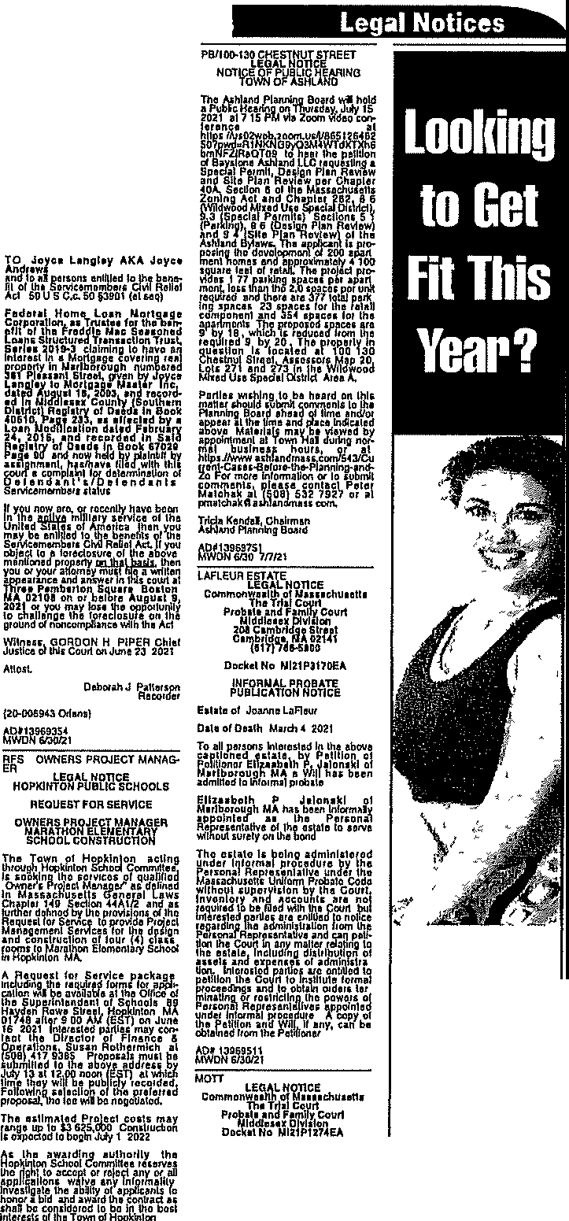
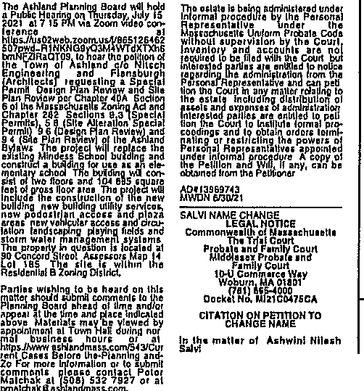
rt!J,fiia:tfth§ft
3111 PLEASANT STTIEET
COMMONWEALTH OF MASSACHUSETTS
;;:,_
LEGAL NOTICE
DEPARTNENTOFTHE TRIAL COURT
0<1ehl21SMOOOSU
.QBDJ:
lANOCOURT
Find a personal trainer.
HopklnlonSchoclCammlllu
b'3M?i9&,t 4b. 61Jo w, 7113121
p ;}J\\\ft! R1NG
tt fh"'A J' R8 1:1
Eltll1of Edw11dRlth11dN01I Alsoknown,11 EdwudR Motl o.1,01Du1h N,y17,10l9
J:Pt:JJ0 !1!'1l • l1 : • above
lllone1JohnR Matt al A1h!1nd
t:1llvG!¥J1tYti 1 :•t :
to,oNowUhovl&Uratyonlhe"t:.;:11.
Check out the Service Directory 1n Community Class1f1eds today, From therapists and trainers to landscapers and painters, the service directory 1s the best service to find local
professionals,
{r ui:iw, :: i :J : he;a
1ft
........
x :tt 1:n'¼ s
AW6 9Mh4h121
HOCJ•iiaii»a11ru
"': ,i lltJ:G
T\JESOff,i sL J3, 2021
ui:1ln':i1/n"ef 'l Jin,cA:fi g l i
IMPORTAITTNOTlCE
at
"'
IU
1 1 1
ri'a • r ti:J! "- 1rAi lMf.f
Oa!e:June21 2021
T11al; OoC1lslolaia RJg,s!arolProbota
bll ,Wl!li:tJi/'"
a112i5U9◄7UI
, ion◄D
Pu, code M73 3
-
;:::
■-
la
i
mHllng
- -cs
m -
1J
-
ra
:::::>
C:
E
M IJ;Colllns
b 6 M3.M,
E
8
rCa rBa "'S.
{=.
Publfc Arlnouncement ConGernln11 • PropoHd Health Care Project
The Chidren'11 Medlcal CMtor Co!pora!1on located at 300 Longwood Av&r1ue B on, MA 02115 ln\andslo Fila a No!lca ol DetemilnaUon of Need ("DON Applk:atlonj with1he Massachusetts Dapartm811I ol Public Heaflh for a SUbs1anllal Cap11af E endltwe, Ambulalory SurgaiyCenler& Doti Raquli&d Equipment by Bo!ifon Clllldren'i Hospltlll localed al 300 Longwood Avenue, Boston, MA 02115.The OON appUi;atloo request, app10val fo,
Iha followmg (l)AmovaUon fand equipping] of spaccwilhln the Hospl!als existing fac:llityat 9 Hope Avenue, Wallham, MA ('l)l11aslng, coos\ruci100, fit-oul and cqulpplng of a bulhf11g loeated al 200 Libbey Parkwayln Weymouth MA and (J) land acqulsllloo conMJcUon. Ill out and equipping of an ambula1Qf)' surgh;a! centa, and lacUityzoned fotpedla1rlc med/cal use at 3B0 Rist Avenue In Needham MA, and (4) tho add,tloo of DoN mqu&ed equipment !n Wll)'lllcU1h and Needham The total value ol the Proposed Project Is $434 691,000 The Applicanldounotantlo1paleanypriceorssvlcclmpactsoolheApplicanl'sexl,UngPatlenlPan!lasarasult of the Ploposed Project MytooTa aysrs ofMasnchu!etts may ragls1erln connection with the Intended Applica\!on by not later lhan Augusl16 or 30 days from Iha Filing Date, wh!chovar !slater, by contac!lng the OepartmMI of Publlc Health, Oe!emilnation of Need P1ogtam, 250Washington St1ee1, 6th Aoor, Boslon MA02106

4A I THURSDAY, JULY 1, 2021 I WALTHAM NEWS TRIBUNE
Legal Notices Legal Notices
TREEH t,:IirmmcE Publlc Announcement Concerning a P1oposed H11alth Care Project
NOTICE OF A PUBUC HEARING LEGAL NOTICE

re!ff.■!' f! 71 : ig: H Monka., D1!e Jum2i 202!
iaraE DoCn51o!a,o

3SCopeland St.12 Notwaymapla, S0Y,dc1dlourovorr.,blododilic
21 B1lgham Rd 25 Kwantan dw1y i;o cra dacay In tn,nk and btanchci;, twolHgebraJ\Chnbtoholflhlsyur
Cand.eo Ava I Barb.tra Rd Int 18 Noiway mepla In decnna Atmnla!la 100\rol,lai'{l tal'IUu.
.·t·d: · J:b kN01W•Y

IT'S ONLY A SILENT KILLER TO THOSE WHO REFUSE

You don't have to let high blood pressure take you by surprise Ask your doctor

The view from the new Mass General Waltham outpatient surgery Center at 52 Set:ond Ave twrci<eo LOCAL STAFF PHOTO/KERRV FELTNER)

Surgery center
Continued from Page 1A

\)rocedurcs The expans10n enables more patient<:: to avord travelfng Jnto Boston for surgeries and It alJows them to receive more mdlv1duallzed care in the small­ er, more conlamed setting ofthe center
"rt'sa great opportumty forµal1ents to getqmck ac cei,s tocommunity care and1l creates space in the Bos­ ton campus operating rooms for higher 1u.ulty pa­ tients," said Claire O'Brien, executive director ofnurs­ ing at the Mass General Waltham Outpatle11t Surgery Center
The expansion provides Waltham residents with more oJ:)tions for vital orthoJ:)edlc care as other com­ mon procedures like endoscopy, where surgeons can look inside the body for issues mvolvmg the digestive system
':4 lot of previous J)atients who've come to the or­
thopedic surgery center have asked 1f the Waltham campus proVldes endoscopy servrnes-somethmg a lot of people in the commumty need-and now, we're able to provide that," O'Brien said
While more services mean more access for patients m the region, 1t is important for Waltham res1dents and nearby cities and towns throughout the reg10n to know the Mass General Waltham Outpatient Surgery Center 1s not an emergency hospital
After construction for the project paused for two weeks due to the lmtlal state lockdown last year, 1t started up again, in full cotnpllat1on with COVID-19 protocols at the worksite
Today, all patients must have a negative COVID-19
test m order to be able to receive care
lnvestfng fn the community

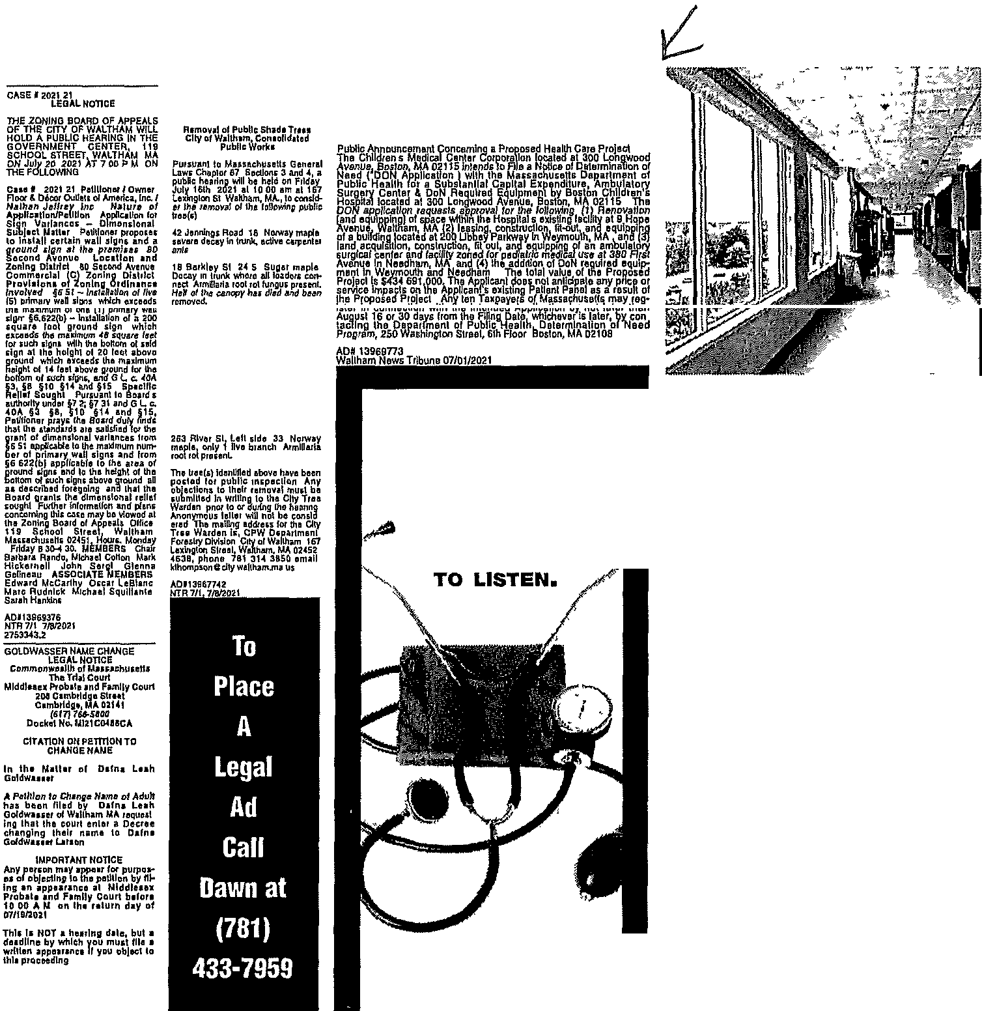
AOll396946D
NTR7 1/2021
RedsterorProba!e
Kidneys
Donot-e your Boat-,
Car, Truck, RV, Plane., or Real Esi'a'te. To heJp people needing
organ Transplan"ts on
Ma'tchingDonors com
to check 11 and help you keep It In check to reduce your nsk of heart attack and stroke Learn more at www amerlcanheart,org or call 1-B0D-AHA-USA1
American Heart afa
V'
Association.
Learn and Live,.
This space provided as a publlc service
© 1999, American Hearl Assoolatlon
The Mass General campus has existed for the past 16years Back in 2015, the Mass General Phys1ciansAs­ sociat1on purchased the two buildings at 52 Second Ave In Waltham across from Costco
The expansion 1s a statement of commitment to the community, Boyce said
"Mass General's strateg1c v1s1on for Waltham-the reason to invest so heavily mto an expansion of this magnitude dunng themiddle of a pandemic-firstand foremost ,s to expand commumty access and se1V1ce to the greater Waltham commumty," he said "But it's also to help lower the cost of healthcare delivery and to be prepared for the potentiaf shift of the market to ac­ countable care-which shows foresight m Mass Gen­ eral's thinking"
Another Mass General sites1m1lar to theone m Wal­ tham in that1t has mult1specialty operating capab1l­ lt1es-the North Shore Center for Outpatient Care­ was established In 2008 m Danvers
The Waltham site ls the nght place to be to cater to patient and staff needs, O'Bnen sa1d
"We couldn't be more perfectly geograph1cally lo­ cated simply because of ourproximity to Route128 and the Mass Pike and many of' the surgeons live In the communities that surround this s1te/' O'Brien said
Nmety medical personnel were hired at the center
as part of the expansion The volume of procedures has kept the new team busy with the gradual llftmg of restncbons in the state
u•sastoundmg to me the team that we have here­ it's amazmg what they've been through In this last year," O'Bnen c;:a1d "They've been front-racmg with COV10, they came back to the highest level of volume they've ever faced, and they'vescreened and hued and then trmned nn entire staff one and a half times their size"
The pandemic taught the world one important Jei;;­ son healthcare fs a cmcrnJ need m every commumty In Waltham, the Mass General Waltham Outpatient Surgery Center is addressing that need
'We are fully focused on l)abent as a customer and i,urgeon or protcdurahst as a customer," Boyte sauJ 'J hose arc our value1; and we live them"

Surgery Center (WICKED LOCALSTAFFPltOTO/KERRYFELTNERJ

WALTHAM WICKEDLOCAL COM I THURSDAY, JULY 1, 2021 I 3A

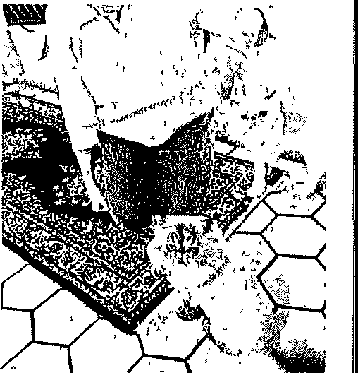
KITTY CORNER:
Help this fluffy duo find a retirement home
The Cat Connection

Hello, Kitty Corner readerslWeare Lallque, a grey, puffy female kitty, and Schubert, a white fluft'y male kitty, and we are searching for our for­

WALTHAM COMMUNITY CALENDAR
Community Content Upcoming
Cochran-Wrenn Duo
Live at Gore Place 7 30 pm July 15 Tickets
$21 To purchase http //gorep/ace org
Gore Place, the historic site In Waltham and Watertown, will offer a concert by Cochran Wrenn Duo The duo, Bonnie Cochran, flute, and Bryan Wrenn, guitar,

menslons Learning In­ stitute Program covers general behaviors, emo­ tions and challenges that may be expected throughout stages of dementia
Ongoing
My farm at Waltham tour 11 am Saturdays, Gore Place, 62 Gore St , Wal­ tham Cost $15, $10 for members For lnforma tlon http//
bit ly/2NlmckD Gore

ever home Lahque 1s 8 1/2 years old, while Schu­ bert1s131/2 years old We have been together as long as anyone can re­ member, and we make the perfect team Schu­ bert plays the role of big brother very welll
We lived with om par­ ents until they became unable to care for us due to their own age We were sad to leave om home, but we have adfuc;ted wetl to life Wlth our foster tnom She says she has never met a fricndllcr pau of cats We both ab­ solutely love attention, and we are not shy al all

Hello, Kitty Corner readers! We are lahque, a grey, puffy female kitty, and Schubert, a white fluffy male kitty, and we are searching for our forever home COlmr1:sVf>HO'fO
wlll perform a program of classlcal music for flute and guitar as well as their orlglnal compo sltlons
Call for Walkers Regis­ ter for the 33rd annual Boston Marathon Jimmy Fund Walk Your Way presented by Hyundai Participants are encour­ aged to "Walk Your Way' on Oct 3, to support patient care and re­ search at Dana-Farber Cancer Institute Details for Sunday, Oct 3, are still being fmalfzed, and participants can antici­ pate virtual programing throughout the day and
coping techniques and make connections with others on a sfmllar grief Journey Space Is l!mlted Register by July B grlef@CareDlmen­ slons org or 855-774- 5100
Camp Stepping Stones•
July 17 -22, mostly virtual Chlldren and their families who have experienced the death of someone Impor­ tant can join together over Zoom to connect, honor and remember lnformatmn http //Care­ Dlmenslons org
Dementia Through the Stages• noon to 1 p m Aug 10 To register
Place Is Inviting residents to Join a guided walking tour of Its historic grounds Participants can hear the story of Gore Plate as a country seat and working farm of the early 1800s Tours last 45 minutes and are l!mlted to 10people
Charles River Museum, Boiler House Jan, 730-
8 30 p m Fridays Dona­ tions suggested For in­
formation https //
bit ly/3304oua The Boiler House Jazz series returns onlfne via YouTube from the Main Gallery of the Charles River Museum
The show wJII be

about asking for ll when we need It New friends, old friends, anyone real­ ly, we are happy lo seek out attention and plop down on a lap for a mce, relaxing evening
We can often be found doubling up on the lap snuggles on top of our foster mom As two very fluffy cats, we are expert groomers and help each other out w\th those hard-to-reach spots We both love agood brushing session with extra pets from our foster mom We are not usually far from one another or our foster mom We even sleep on either side of her in the bed at night
We also enjoy runmng and Jumping around the house playing with all different types of toys It keeps us young at heartl Schubert hdd some den-
ta\ work done when he arnved al The Cat Con­ nection, but he docs not let a lack of teeth keep him down We cotitmue to live ourbest life, purr­ Ing often and seeking at­ tention whenever and wherever we can find It While we never expected to find ourselves ma fos­ ter home, we are sure that the perfet.t forever home is out there for us If you are looking fortwo professional cuddlers to jom your family, head on over to our website to fill out an appl1cat1on today As a reminder, we ask for adoption fees of SIOO for each cat over10, $160 for cats 5 to101 $200 for cats 1 to 4, and $225 for each kitten under l year old These fees fund neu­ termg1 vaccmatlons and combo testmg (felme leukemm and FIV) for
your adopted tat, rest.Ue efforh,, shelter and vet­ erinary care The Cdt Connect1on only adopts kittens m pairs, as the adoptions have a much higher success rate when kittens have compamons to help burn off their youthful energy
You can learn more about adopting, foster­ ing, volunteering and upcoming fundralsmg events by visiting The Cat Connection onlme at https //thecatconnec­ tlon org or contactmg The Cat Connection by phone at 781-899-4610 or via email atinfo@thecat­ connection org
If you can, please con­ sider donating to our snow removal fund for the feral cat colonies we care for m and around Waltham https // bit ly/2PFWof
In the days, weeks and months leiJdlng up to Jimmy Fund Walk Your Way To register or to support a walker
htpp //J!mmyFund­ Walk org or call B66-531- 9255 This year's event wlll have a lower fund­ raising requirement,
$100 for adults and $25 for those under 1B, with a $5 registration fee All reglstered walkers will receive a bib and medal and the first 5,000 to register wUI receive a commemorative Jimmy Fund Walk T-shirt General Grief & Loss
6 30 p m Thursdays,
July 15 to Aug 12 via Zoom This five-week support group Is open to anyone grieving the death of someone close to them Participants will find a safe space to process their grief, learn
http, //bit ly/3ytF9dS
Community weblnar host­ ed vlrtuo1lly by Mary Crowe, of the Care Oi-
stre;3med on the mu-

Waltham fiber artist to be featured in national online exhibition
Maloney"
PROPLI< l"ll::>
Affordable Homeownership Opportunity Fieldstone Way Condominiums - Phase 2 Wellesley, MA 02482 www,FleldstgneWaylottery,com
2 Avallable Income Restricted Condominiums
Available Units Unit Size Sales Price
2 3 Bedroom $339,500
Maximum Income per Household S12e
Households may request an appltcatlon be sent by email or mall from May 15, 2021 -July 14, 2021 through the following methods
Visit WWW,FleldstoneWaylottery,com
To have a hard copy of the apphcatlon sent to your mailing address, please call 781-992-5318 MARelay711
Informational Meeting•
Due to an abundance of caution, we have decided to cancel the information meeting To replace the Informational meet1n gs1 we have created a presentation that Includes Information
about the property, the application process, preferences, the lottery, and what happens after tha lolteJY For a copy of the presentation, please
visit www,F1e\dstoneWaylo\teJY,com
p =t
o I; ) ':JJ'cl: rJ:2
0
':f21
Maloney Properties, Inc Attention Fieldstone Way Lottery 27 Mica Lane, Wellesley MA 02481
Applicants may also email completed apphcat1ons to
F1eldstoneWay@malonewm.pe1hes com
election by lottery $75,000 Asset limit Use & resale
restrictions apply
For more mfo or reasonable accommodation .
Call Malone}'Properlles, Inc 781-992-5318 - US Relay
711 or
Email f1eldstoneWny@MalqneyPropert1es com
Equal Housing Opportunity
Household  Size | 80% AMI Low Income
1 | $70,750
2 | $80,850
3 | $90,950
4 | $101,050
5 | $109,150
6 | $117,250

COURTESY OF THE SOCIETY OF ARTS + CRAFTS

A new virtual exh1b1- tlon and retall show spot­ lights almost 50 fiber art­ ists from Massachusetts and across the country, mcludmg Waltham artist Mutfy Young, showcas­ ing their work and em­ phas1img the compelhng stories behmd the art­ form
"Fiber Stories," created by Boston's Society of Arts + Craftc;, opem on­ line ,July 16 and mn through Aug 291 shoppa­ ble at https //c;oc1ctyof­ craftc; org/fiber-stoncc;­ coming-soon and fully live on opening day The show highhghtc; the full spectrum or fiber crafts, spanning trud1t1onal and avant garde matcridls and techmqucs related to the fiber art& and Includ­ ing knitting, weaving,
basketry, felting and quilting
Young Is known for her handwoven, hand­ dyed scatves and shawls, which she's been creating since 1978 Her designs are complex, utilizing looms with 24 and 32 harnessesmstead of the typical 4 or 8
More mformatlon about the show is avail­ able at https //
bit ly/3gVCWkD Piece by Muffy Young coURTEsVPHmo
Publfo Ann1mncemenl Concemtng a Propoud Health Caril ProJ11ct
The Chffdren's Medical Genier CorporaUon localed at 300 Longwood Avenue, Boslon, MA 02115 Intends to FIie a Notice ol De\ermlna\fon of Need ('DON pl!caUt1n \ with the Mwaeh Oepartmffltol Pu'tl!lcHealthfar a Substantial Cap al Expendllure Ambulatory S1,1rgery Ct!nter & OoN Required Equ1pmant by Bo,!011 Ch!ldren's Hosp11al localed al 300 Longwood Avenue, Bos1on, MA 02115 The DON appllca11oo requests approval for
the following (1) Ranova11on Jand equlppingJ or space within the Hospi!als existing faca!ty at 9 Hope Avenlle Waltham, MA !2) leaslng comruuc11on fit-out and equipping of a building located al 200 Libbey Parkway In Weymou!h MA, and (3) land acquisition, coostroc\lon, m out, and equipping of an ambulalofY s11rglcal center
and raenlty zoned forpedlatnc medical use al 380First Aven1,1s In Needham MA, and (,1) the addiUon ofOoN
required equlpmenl In Weymouth and Needham. The Iota! value ol lhe Proposed Pfqeel Is $◄3 4,6!11,000.The
Appl/Gant does nol anUclpa!e any pnce or seirvlce Impacts on the AppUcant's eilstlng Pat!anl Panel as a rMult of the Proposed P,ojecl Ally ten TaKpayets of Ma.ssaehuselts may reglsterln connection with \belnlended Application by not !ater than A1,1gusl 16 or30 days from the FlJJng Date, Whlch11ver !s la1e,, by contacting \he Oepat1menl of Public Heallh Oelermlnatlon of Need Pmg,am 250 Washington St1eet, 61h fl()Of Boston, MA.02108

1l

NEWS

TRIBUNE
LlncMurphy,Mult!medlaSalesManager Keny Fdtner, S!!nlDI' MulUmedlY Joumalfst
promoUooal ol'fers frcm GiMl!tl New England and lls new,paperpleasecall86B 697-2737durlngthe r,milVlng any sud1offefl at artJ lime by contacting us

150 B•ker Ave Ellt,Suite 201, Con ord, MA 017,42.
Walthamw!tl"d}oc:al com
Send all $Ubm!u!orrs lo wa!tham@wlckedlocal eom
Peter Mayer, Presldcmt 3- G1oup Publisher Gann11ttNewEngh111d
Lin st, ..ttan, Vk!! Ptl!Sldl!nt of
News Gannett New En11bnrl K•thle.n Cl>l'd•lro, Reglor,al O!rectot ofNt1ws&Operatlons
1murph)l@lwkkedlocal com
781 398 8002, kft1[tner@wkked!ocal com Phl!Sai1bul"J,PrlnlPfodud!on
781433-8322 psallsburyetwlckedlocalcom
Btnfnglnq11frln11888MVPAPER(1 BBB-697-2737)
ReprlntOrders 11161r-N&-8f\03cr pho(otl!pr(nts@lwkkedlocal.com
Clrcul.th,n 1 888 MVPAPER(I see 697 2737) Le51a1Saleslll00-624•71551!xt7qs7 Clurlf!,dS•fe,i, 1800624•7365
Sub1crlplfon11$73 00" fot up to 52 wee1Csin town
$11000''outcllCWfl
related compal'Uef You mayunsubsc1lbe from
at1888697·2737 lfyousfgnupforourEzpay prog1am, Y(l'Jf subsc!lptlon wmWJ\omatka\\y be chargedtoyourC(edltcardOto14dayspriortoyour
currentexplraUondate,fortheduratlonofyour sulncriptlonotuntdyournotJlyusolherwlse.For mote lnfonnaUon ot to cancel y011r subsctlpl!on pleuecalll 888697•2737
CUSTOMER SERVICE! Contact 1 888 MVPAPl:R
(BBB liD7 2737) to start/step home dcllvciy, to reportdellveiyproblemsorforVilcaUonstopsor startsVoucanalsovlslthttps//eKplore.
hoursllstedabave Redellvtl)'notavaffableinall
Faw 617-7B673BIE mill dellVCl)'@lffl'Jpilpertodaycom.
POLICIESAdvertls!!rsshouJddleckthelradseach week This newspaper iUUmu naflnandal te:;.porulbl1Jtyfortypogrnptucalmortln advertlsements,butW1UteprJntwllhOlJtcha1gethat partofanyadvertlsementlnWhlehanerroroccurred
!fthet1rrorwasthiltofthenewspapl!fandthe newspaper Is notlned lfmledlately This newspaper assumetnoflnanclalresponslbn!tyforphotographs ri:producedlntheni:wspapnr althou!lhevcrycffort

JohnWillker,OJretlnrofV!sualMo::dJa
Nkal• S!mmoni, Oepuly Reg!orial Edlt<Jr
JHH Floyd, Director of Multlmed!a
Melfuill Rusu!!, 0LpULy D1rL-ctot ofMulUmedl
••l"!tntd \vety il.'131\ablt!\'l nl.ht!r.t!Wspap d!slrlbutlanareaonly8ysubirittln51youradd1ess i1nd/ctL oll1ml1 ycuru t1d crsla ttdthat yaur 11'1Yrcn lva
niypapc1tod,iyc01n Uou1s Mondayfrlday,6arn.to5 wl!I bl!m;ide lotl!tum original prints In good
pm.,Saturday Sunday and holidays ea m. to noon i:ondltf0t111ponreqvest
MISS YOUR PAPER? If you do not re,;clve you1 ID <>annctt New Enaland Nl tights reserved

NEEDHAM WICKEDLOCAL,COM I THURSDAY, JULY 1, 2021 I 9A

A"i: TM!!' urrntt1<11r
The Needham Free Public Library is located atn39 Highland Ave For more tnformrltion, call 781-455-7559
As of the l1brarysJune
1 reopening, people are able toenter the build in& browse the librar.Y s col­ lections, check matenals out at the circulahon desk, use the library s computers and read tlie library'.! newspapers and magazines All depart­ ments are oµe11, however, there are some restnc­ tion.r The children's room, the play area, the storytime room and the STEAM and craft room are closed Tn the adult area, there WJS one less rtudy room available Out of an abundance of caution and in consider­
ationofothen, people are requested to wear a ma:;k while m tha building, l!\­ pecrally while m thechU­ drens room, ar clnldnm

Jungle Jim Manning wlll prt1:se:nt a virtual balloon tw1stmg shtlw called "Tales from the Balloon" for families with children ages 4 and older cou1m.sv
PHOTO

sored by the Friends of the Needham Pubhc Li­ brary and 1s part of the Tails and Tales" Summer Reading Program for chil­ dren sponsored by the Needham Free Pubhc Li­ brary, the Massachusetts L1btary System, the Bos­ ton Bruins, the Massa­ chusetts Board of Library Commissioners and the Institute of Museum and Library SerVJces with support from the Nation­ al Women's Hockey League team Boston Pnde The library has an Early Literacy Supper Program for chlldren ages
o to 3 and a Summer
,
Reading Program for chil­ dren ages 4 to 11 To regis­ ter fot summer ReatJmg, visit the children's Room or needhamma bean­ stack org For more infor­ mation, call 781-451i- 7559, ext 20d

Sutnrner reading

they are the hero With every two hours of read­ ing they log, they will re­ ceive more of an ongmng story m which they are traveling through a 1ungle on a mission to save an orphaned baby rhmo They will encounter d1fM ferent ammals along the 1oumey Iftheyreadfor16 hours, they Wlll rescue the rhino
A stuffed animal rhmo will be v1S1ting the library and different locations around town Families are mv1ted to Jook for photos of h1m having summer fun on the li­ brary's Facebook page (https //fncebook com/ NeedhamFreePubhc Library) and Jnsta,gram People of all ages are also mVIted to share photos of their pets on the hbrary'o:; Facebook page and Insta­ gram
Children will be able to embark on an animal sa­

plete the program by readmg or bemg read to for16 hours over the sum­ mer will be entered m a grand pnze drawing for a Kindle Fire donated by Dedham Savmgs Bank, small custards from Ab­ bots Frozen custard, a large stuffed animal from Leaming Express Toy Store, a pass to Urban Afr trampolme park and more
For more lnformat1on, email neechtld@mfn..
lib net, call 781-455-7559, ext 204 or vls1t the li­ brary web page

Educatlohal and entertalnlhg children resources

On the Children's Ac.. tlvities at Home web­ page, reo:;1dents will flnd e-books, c-.comics and videos on COVID-19 cre­ ated ror children, on1inc
storytimeo:;, mcludmg a

younger than12 year,; old have not been vaccmal­ ed
The tradition adopted dimng the pandemic of not charging {I.nm, for overdue materials will continue 111e1Joardo(Li­ brury Trustees voted to Join the grow111g number of libraries that have ceased charging fines for overdue materials Rath­ er than be a deterrent to keeping items overdue, studies have shown that charging overdue fines actually adds to the rea­ sons that people keep li­ brary matenal beyond the duedate The increas­ ing day by day finecauses people to be embarrassed to bnng the materials to the library Another change that borrowers may notice is that the Friends Rental Collection has been abolished Be­ fore the pandemic start­ ed, use of this collection was shrlnkmg This col­ lectton was self-support­ mg, and the funds collect­ ed for checked out rentals were d1mm1shmg lo the point where they no long­ er supported the collec­
hon

Upcoming events
Children's Depart- ment Events
Register to JOtn all of these events through the calendar at
https I/bitly/3v8DE2Q Registration begins two weeks before events Events are subJect to change For more mfor­ mat1on, email the chil­ dren's librarian at nee­ chfld@mmlilJ net or call 781-455-7559, ext 204
Books and Beasts story times 10 a m July 8, 15 and 22 The Need­ ham Free Pubhc Library w>JI provide three virtual Books and Beasts story times for chlldren ages 2 to61iveon Zoom from the Rodger Wilhamo:; Park
al Womeu's Hockey League team Bosto11 Pnde The library has ah Early Literacy summer Reading Program for chil­ dren through age 3 in whlcl1 the adults read aloud to the children and a Summer Reading Pro­ gram for children 4 and up To register for these Summer neading Pro­ grams, visit the Chil­ dren's Room or https // needhamma
beanstack org/reader365 For more information
call 781-455-7559, ext
204
Tales from the Bal­
loon 4 30 pm July 13 Jungle Jim Manning will present a virtual balloon twisting show called "Tales from the Balloon" for families with children ages 4 and older This 45- minute extravaganza will feature mteract1ve story­ tellmg, magic, humor and Manning climbing ms1de of a giant 6-foot balloon The "Tails and Tales" pro­ gram encourages and motivates chlldren to cre­ ate their own stories through readmg and in­ terdctlve experiences at their local libraryand fea­ tures team building actIV- 1tles Manning's "Tails and Tales" show has re­ ceived local fundmg from the Needham Cultural council This program 1s supported m part by a grant from the Needham Cultural Council, a local agency which fs support­ ed by the Massachusetts Cultural Council, a state agency This event fs part of the summer Reading Program sponsored by the Needham Free Publfc Library, the Massachu­ setts Library System, the Boston Brutns, the Mas­ sachusetts Board of Li­ brary Commissioners and the Institute of Mu­ seum and Library Ser-
vices wllh support from the National Women's Hockey League team Boston Pride I love per­ forming in Needham," said Manning "The chil­ dren are great and lhe parents are involved,
which makes fora run ex
perience as a performer"
Children Wlll be en couraged to check out books to help them devel­ op their own storytelling skills
Admission to vntual Tails and Tales" ls free, but regfstratron fs re­ quired Register at https //needhamtna as­ sabetlnteractive com/ calendar/2021 july For more information, call
the Needham Free Public
Library at 781..455-7559, ext 204 Details about the program are available at dovemylibrary com
Ohver's Animals The
Needham Free Pubhc Li­ brary will provide four Vldeo VJrtual programs called ' Ohver s Animals" produced by Alex Thom­ as and Fnends Puppe­ teenng A boy and a pup­ pet will explore an en­ counter with a different
live ammal each week Videos are short, about15 minutes each, and can be viewed any time durJng the week Durmg the
week of June 28, children can get acquainted w1th a kmkajou The week of July 5, a python w1JI be the star of the show Be­ gmnfng on July 12, the vtdeo will show a gumea pig For the week of July 19, the program will pre­ sent a tort01se ReglstraM non 1s requited for these free videos eglster at https / /needhamma as­ sabetinteractfve com/ calendar/2021..1une/ or https / /needhamma as­ sabetlnteractive com/ calendar/2021-july/
Th1s series is span-
program

Chtldren whoare4 toll years old are invited to register for the Needham Free Public Library's Summer Reading Pro­ gram, 'Tails and Tales" Registration goes through July30
To register, visit
htt))s //needhamma beanstack org/reader365 or v1s1t the Children's Room Events begm June 21and run through Aug 9 Children who sign up will
receive a free pass to the
USS Constitution Mu­ seum, a free Ice cream cohe from McDonald's and a discount from Em­ pow Studios
Children read, are read aloud to or listen to audio books They record the time they spend reacling onllne or on paper Chil­ dren who complete the program by reading for16 hours over the summer will be eligible to wm grand pnzes Both m-per­ son and virtual events will be offered In-person events will take place outside at the Memonal Park Gazebo Register for events at needham­ ma assabet
mteracbve com/calendar All events are sponsored by the Friends of the Needham Public Ltbrnry
As children read and log their hours, they will progress through a 1ungle adventure story In which
fari with their ramthcs Saran sheets can be prfnled out from the J,­ brary wcbpdge or be picked up In the Chil· dren's Room Famfltes look In i.tore windows around town to spot dlf# ferenl animal photos from the library They mark off the ones they find and return the com­
pleted sheets to the li­
brary to claim a pnze The Children's Depart­
ment Wlll offer outdoor, in-person live amrnal
events mc1udlng Ammal Craze, Wing Masters Birds of Prey and Amrnal Adventures There will also be an m-person pup­ pet show with Cactus Head Puppets An In-per­ son V1s1t with a Vet will provide families w1th ln­ fotmatmn on adoptmg
and carmg for a pet Chil­
dren of all ages may drop otfa stuffed animal at the library for a Stuffle Slee­ pover
Virtual programs m­ clude Oliver's Ammals, Books and Beasts Story­ t:J.me with the Roger W1l­ hams Park Zoo and So­ fia's Safan Zookeeper Talks from Buttonwood Park Zoo There also will be two vntual author sto­ ry times oneaboutamu­ Slc Jovmg cat and one about a backyard chick­ en Children may read aloud to Tuckerthe thera­ py dog
Children who com-
storytelling of the Scot­ ttsh Tale, "Ass1pattle and the Muckle Mester Stoor Worm" and a storytelling of The Three Billy Goats GrulT" as told by librarian Paula, pre-school craft Ideas by librarian Elise, and music videos for tod­ dlers by popular perform­ er Sarah Watch for a live At-Home Lego Club with Lrbranan Veromca com­ ing soon
Children reading re­ sources
Readmg and bemg read to notonlystrength­ ens children's vocabulary and concentratlon ab1ll­
t1es, readmg books also develops social skills and background knowledge Several publishers have made then e-content available to libranes and patrons dunng thts time Authors are also domg readings of their own works Check the Need­ ham Free Pubhc Library website a.t
https / /bit ly/3cX4Hoa for more details In addi­ tion to the e-content on the Children's Activities at Home webpage, e­ books for all ages are available to download through the library's overdnve app and the Hoopla app If you get
stuck with these or have any questlons, call the li­
brary at 781-455-7559 ext 204 or emml nee­ chdd@mmhb net and leave a message

Zoo A 7ookeeper Wlll read a story feahmng an animal After the o:;tory, the 1ookeeper will pre­ sent the hve animal Sto­ ries may mclnde 'Verdi" by Janell Cannon, ''A Col­ or or His Own" by Leo L1- onm and Don't lel the Pi­ geon Drive the Bus" by
Publ/oA,mQl/ll,;omiml ConcomlnR a Propoffd Hoalth C<110 Project
Tho Childsans Medical Canter Corponi\1011 localed al 300 longWO!ld Avenue, Boslon, MA 02115 lntends to Fne a Nolko of De\61l'Tllnallo11of Need iOON Appl!ea.Uon1 with !he Massachusetts Dopartment of Publlc Health f01 a Sub;1iir\tlal Capital Eitpencfrture Ambulatory S111gory Cet1ler & [)QN Required Eqvlpment by Boston Clu1drens HosplbUoca!ed al 300 Longwood Avenue., BaSloo MA 02'115 The DON applica\lon requests approval far thefoHow!ng (1)RenovaUan[andequlpplngJofspac:oWl!hlnlheHosprtal&tJXlstinglac;i11tyal9HopeAYenue WBllham, MA /2) /easkig conslrucilon, ti! ou!, and eqVlpplng DI a bi!ldlngfflllld al 200Libbey Parkway Jn WS)'ITIDU\h MA, and (3)!and acqu1sltlon, canslruct1on, fit Oil!, and equipping of an ambulatory surgical center illtd faciity20ned forpedlatnc: medlulUs(t at 350 First Avenu,1n Needham MA, and(4) the addlllon of OoN required eQUlpment In Weymouth and N!!edham. The Iota! YalLJe al the Proposed Project ls t434 691,000 The. App!lc:antdoesnolanlltlpate any price.or ser.lCftlmpacts on theAppUcanl's existing Patient Panel asa,esLJlt of the Propoud Proj My l n Taxpay11111 of Massachuse11s may register In c:onnei;tlon Wllh Iha lnlended Awfk;6t,an by not later linur August 16 arJO days from th, Filing ll!lt11, Ml!ch11vN ls111/N; byC(J/lf11c/Jng /hlf Department ol PLJtilc Health, Deteim!natlon o!Need Program, 250 Washington streilt, 6th Floor Boston MA02108
Mo Willems lleg1stration
IS required for these free programs Register al hltps //needhamma as­ sabetintera<.live LOm/ calendar/2021-july Thfs series Is spom,ored by the Friends of the Needham Public Library and Is part of the 'Tails and Tales" Summer Readmg Pro­ gram for children spon­ sored by the Needham Free Public Library, the Massachusetts Library
System, the Boston Bruins, the Massachu­ setts Board of Library Comm1ss1oners and the Institute of Museum and Library Servtces with support from the Nation-
Prof.essionaC

Available for instruction during the summer for Grades K-5
16 years teaching exp
Call 617-756-9332

EOCUATION ACHIEVERS

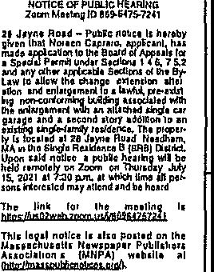
Falrfleld University
T• ",, ,.,,,,,. ,,J.;O ,, , J,r , o
i.-=•m 11•n.,..,..t •, .,..,n
Hk•nY_•Y_".."."..'_-.",."i.•,V,,o,d,U
...i,;;:;:: ';';! ';':.· : ;}: ·
•W..Z••"l'-'1'1
..--. h•hg"'•.o•ul•'•"-lhu,
i.•uo•t.1,v•r ="-A'"'"•'"' •"
NEEDHAM WICKEDLOCAL COM I THURSDAY, JULY 1, 2021 I SA
h's ONLY A SILENT KILLER TO THOSE WHO REFUSE
"
/
ttudlo,111Tlm117/lk!
20Ml2CSO\ITHSTIIEET
LEGALttOTICE.
20NIN1":8Xf. • "J,EA(.fl
NOllCEOFPUBUoHl>AAINO
Zoom Mu'1Ql0U 7 72O
ADl139U121
You don't have to let high blood pressure take you by surprise Ask your doctor to check It and help you keep 11 In check to reduce your risk of heart attack and stroke Learn more at www amencanheart org or
call 1•B00-AHA-USA1
Amencan Heart
aa,
Find a personal trainer.
Association.V
Learn and Live..
This space provided as a publlo service
@ 1999, American Heart Association

JontlSU"UklOIO>W
AOtll'IUW:,7 N11,1!1,1,,,T,m047/l 7/a/21
:ZBA/.UJAYNEIIOAD
TownolNocdlo..,, 20NING80AADOFAf'PEAL6
LEGALNOTllll<
Check out the Service Directory in Community
Class1f1eds today,
From therapists and trainers to landscapers and painters, the service directory 1s the best service to find local
professionals
UI
::I
:w :wtV.!t¾ J u : N.
Al lJ)
jll<1l_,,.1,11l1ri1l11,,_)'t,1,.-,1.., d by
11
JonD 6d11uidl>' Chall
I;:
■-
i
LI.I
ii
'P
-
·c
:::s
E
8
E
1§
"1:S
ftS
C
ftS
B
-fatS
{ff!.
-
Matthew Guagliano, Laura Melm and Amanda Wong, of Needham Heights, were named to the dean's 11st for the spnng semester at Fair­ field Umvers1ty in Con­ necticut To qualify, stu­ dents must have com­ pleted a mlmmum or 12 cred1t hours m a semes­ ter, ha.,e no outstanding
or incomplete grades for
that semester and have attained a semester GPA of 3 5 or h1gher
Henry Brown, Juha Cavallo, Margaret Char­ ter, Marcella Hunt, Megh­
an Stevens and Anne To­ moc;.1V1tch1 of Needham 1 were named to the dean'<i list for the spnng semes­ ter at Fmrfield Umversity m Connectlct1t To q11ah­ fy1 <:.turlents muc;t ha'le completed a mmimum of 12 credit hours m a 1,e­ mcster, have no out­ standing or incomplete grades ror that semester and have dtt,uncd a se­ mester GPA of3 5 orlngh­
er
Endicott College
Logan DeMarla, of Needham, graduated in May from Etid1cott Col­ lege m Beverly DeMaria, son of Donna DeMana and Gary DeMana, earned a Bachelor of Arts degree m hberaf studies and education
Sophie Findlay Wal­
ters and Barrett Pratt, of

AROUNOTOWN
Note In response to concerns about the coro­ navzrus, area events may besub1ect tocancellatwn, postponement or atten­ dance limits Please con­ tactorgamzers to confirm event details
UPCOMING

Needham Carnival July 22 to 25 Needham High School, 609 Webster St The Needham carm­ val will return for the summer m July The Ro­ tary Club of Needham, along with Cushmg Amusements, will have rides and games includ­ mg kiddie rides, thnll rides and grown-up ndes The midway will have games and carnival treats For more mforma­ t10n, visit
https //bit ly/3cusYlls

ONGOING

Needham Farmers Market. Started June13 Needham Town Com­ mon, Gamty's Way The Needham Farmers Mar­ ket returns for its 10th an­
mversary season on the
Needham Town Common with fresh local produce, baked goods, fish, meat and eggs Themarketw1II featmc two v11i1tmg art­ ists each week who o;cll jewelry, paintings, pot­ tery antJ n variety of hand-crafted goods Shoppe1s are mvitcd lo shop and enJoylivcmusic every Sunday from noon to 4 pm For a hst ofvet1- dors, lhc1rpre-orderlmks and the weekly market map, vts1t http //need­ hamfannersinarket org or follow @needhamfar­ mersmarkel on socml med1a

Needham Art in Bloom For more mfor­ matmn/to view needhamartmbloom com Beth Shalom Garden Club presents the 13th Need­ ham's Art m Bloom virtu­ ally m 2021 Beth Shalom Garden Club and partici­ pants from Needham Garden Club and Kaimfa Garden Club win inter­ pret artwork by Needham
Needham, were named to the dean's list for the spnng semester at Endi­ cott College m Needham Walters, daughter of SU­ san Findlay, 1s studying studio art Pratt1 son of Carol Owens and James Pratt, 1s studying sport management

Providence College

Isabella Fagg1an o1 or Needham, was named to the dean's list for the spring semester at ProV1- dence College m Rhode Island Fagg1ano is the child of John and Kelly Fagglano To qualify, full­ time undergraduate stu­ dents must earn a GPA of 3'>1> or higher on a 40 scale, with nograde lower than C and no incomplete grade,;;

University of Wisconsin-Madison

Samuel Epstein, of Needham, gradm1ted m May from tl1c University ofW1sconsm-Mad1son m Wisconsin Epiitam earned a Bachelor's de­
gree in politlcal science and cl certffkate fn public policy from the La Follette School of Public Affairs With nearly 70 gradu­ ates, this Is the secotid cohort of students com­ pleting the certificate program, which allows students to applyapublic l)olicy-perspectlve to community and world events

High School students with nower arrange­ ments Residents can vis- 1t the Needham Art m Bloom website to view the artworl<

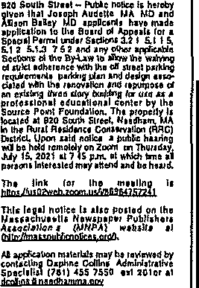
Virtual NAMl sup­ port group 7 p m on the second Tuesday of each month For Information http //namimass org To register email lnfo@na­ minw org The Nat10nal Alltance on Mental Ill­ ness1shostinga group for caregivers of persons with mental Illness on Zoom Thosewhow,sh to Join will need to send thelf email and phone number to register
Your News
In Print
d line
All about you
WICKED
lDCAr

Council Thrift Shop
10 am -4 pm Tuesdays
and Thursdays, 10 a m -2
pm Fridays, Needham Communlty Council, 570 Hills1deAve Forlnforma­ t1on 781-444-2415,
https / /bit ly/3d8DCF The Needham Commum­ ty Council 1'hnft Shop has reopened outdoors under a tent Maslcs are reqmred, with social d1s­ tancmg and contact-free transactions bemg ut1\- 11ed No out ide bag,; are permitted and the num­ berof people In the tentat a time will be hmlterl

School summer mt"ah; 11 nm-1 pm Mondays and Thursdnys, High Rock School, 77 rerndule Ave free For infom1dl10n 781-455-
0400, ext 11216,
ruth_gnffm@nccd-
hJm ltl2 Tnd us Need ham PubUc St.hools are contfrmmg to dlstnbute bredkfast and lunches lo­ go for clnldren and teens throughout the summer Any thi\d or teen between the ages ofland 20are el- 1g1ble to receive free meals Meals will be giv­ en ma drive-through for­
mat, with bags bemg gw..
en with brealcfast and lunch meals for every day until the next service day, including weekend days

Needham Retired Men's: Glee Club 10-ll 30

See EVENTS, Page 6A

4B I WEDNESDAY, JUNE 30, 2021 \ WEYMOUTH NEWS

al Notices

WEYMOUTH ZBA HEARINGS 7/14/21
LEGAL NOTICE TOWN OF WEYMOUTH

BOARD OF ZONING APPEAL
Noltcc 1s hereby given of a
public hcarmg oflhc Board
HAMPlON ESfAfE LEGAL NOTICE
Commonwealth of l\lassachusetts The Trial Court
Probate and Fanulv Court
Norfolk Probate and Family Court
3S Shawmut Road Canton, MA 02021
DocklmJ 2iH:192EA
CITATION ON PETI• TION FOR
ARCANGELI ESTATE LEGAL NOTICE
Commonwealth of
t
35 Shawmut Road
Canton, MA 02021
(781) 830-1200
Docket No N021P1057EA
INFORMAL PROBATE PUBl,TCATION NOTICE
OEPINA CONSERVA­ t?o HIP (TERMINA-
LkGAL NOTICE
Commonwealth of Massachusetts The Trial Court
Norfolk Probate and FamffyCourt
35 Sha\\mUt Road
Canton, MA 02021 Docket No N018P1941PM
LOVETT ESTATE LEGAL NOTICE
Commonwealth or Massachusetts The Trial Court
Norfolk Probate and Famllv Court
35Shawmut Road
Canton, MA 02021
(781) 830-1200
DocketNo NO21P1167EA

INFORMAL PROBATE PUBLICATION NOTICE

To

Place

;i 1
rVc: \t°ii,
FORMALADJUDICA- TJON
E'itatc of Barry P
Estate of Ronald E

MGL Ch 40A, Sec 14, of
the General Laws and Code
Estate or Wanza Lee
An:imgeh
In the lntcrcsls or B11an
Lovell A

of lhc Town of Weymoulh,
Hampton
Also known as Barry Paul Ivan Depina Da.teofDeath 01/31/2021

ir t Pd rllc\cs 24& 7 00PM
WEDNESDAY, JULY
14,2021
MCCULLOCH

Date ofDeath: 0\/03/2020
To all mterested persons A Petition for Formal Appointment Personal Representative has been
or
Arcangel!
foi'9 of Death Apnl 26,
To all persons mterested 1n
the above--capt10ned estate,

Of Wc,mouth, MA
RCSPONDENT
lnenpnc1tnted Person/Protected Perso11
To the named Respondent

To all persons mtercsted m
the abovc-eapttoned estale,
_by Petition of Pel/I/oner Michael B Lovett of Brockton MA a will hds been admitted to mforma\
Ad
South Weymouth MA

Legal

BUILDING MARY MC Y
afirled by Verlnlta Edwards ki f : h 1 J°j1rJ[{l! n!} and all other mterested per- probate

MEETING 182GREEN T
WEYMO MASSAC
On the followtng cases
rcqucslmg that lhe Court
enter a formal Decree and Order and for such other 1cllcf as requested m the Petition
We,mouth MA,
Michael J, McMann of Weymouth MA has been
P : l'll f,fe0 1
'i : u et f
m d /it! f:s i .:re f
Windsor CT ln the above eapuoned matter rcquesl• mg thal the court
Terminate the
Michael B Lovett of
Brockton MA has been
f
?r: !J 1 f \1: t 11
ft
;1;e
the estate to serve w1thom
surely on (he bond

Case #3454- The,Wllllon-
Ji ;:: w;'t:d ai ;s } 1hc estate lo serve without
Conservatorsh1p
The pet,t10n asks the court

The estate 1s bemg admln­
Call

iftset[ , r&Tt : : t 1zc1m:sutie n 1 The estate 1s hemg admm
surety on the bond
lo make a detenmnallon
t'itercd under mfonnal pro-

i ft{t \ l l o!' l

Rcprescnrat1ve(s) of 5a1d estate lo serve Without
ts1ered under mfonmi/ pro-­ !hat the Guardian and/or R t ;:e:fat !!JneJ! fh eedurc by the Personal Conservator should be Massachuseus Umform
Dawn

Weymouth Town Atlas Surety on the bond 1n
Represenlat1vc under the ! 1 0
Probate Code without

sheet 19, block 17
locdtcd m the PIP
unsupervised adminlstra• tion
lMPORTAN r NOTICE
Massachusetts Umform Probate Code without supervJs1on by the Court
i tilad b! re d f
fi oa di! ; ;por t\ d
Conscrvatorslup 1s no
supcrv1S1on by the Court lnvcntory and accounts are not required to be filed

c foft' :! \ 1e nJ
Inventory and accounts are
You have the right to
longer necessary and there­
with the Court, but mter­ at

the rcqu1reme1tt'i of the
obtain a cop) of the
not required lo be filed
fore should be 1ermmated
ested parllcs are entitled lo

r?i' ? Zonmg

Petition from the
with the Court, but mtcr­ The ongmal peution 1s on
d 1 1st df m t

Special Permit - I 20-40
Petitioner or at the
Court You have a right
csted parties arc entnled to
d1 1 1st: ft df gm H
filew1tn the court

!1 Jsg;; 1 fo et,;;tt i

extension or chdLlge by ! oh.f cl ot, if c; !;
:s !: 1 fo e h: 1 tri
You have the right to 1n any matter relatm_g to
(781)

spee1alpcrm1t
expenses of admm1strat1on
'i
atfotney must me a wnt
ten appearance and

tn any matter relatm_g to
the estate mcludmg d1stn­
exrcenses of admmtstrnlion
fN t s cfct i ;. nlfr
your attorney must flle a
the estate, 1ncludmg d1stn­ but1011 of assets and

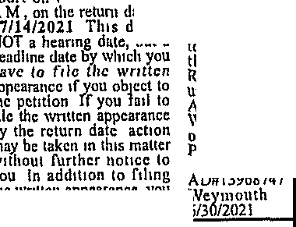
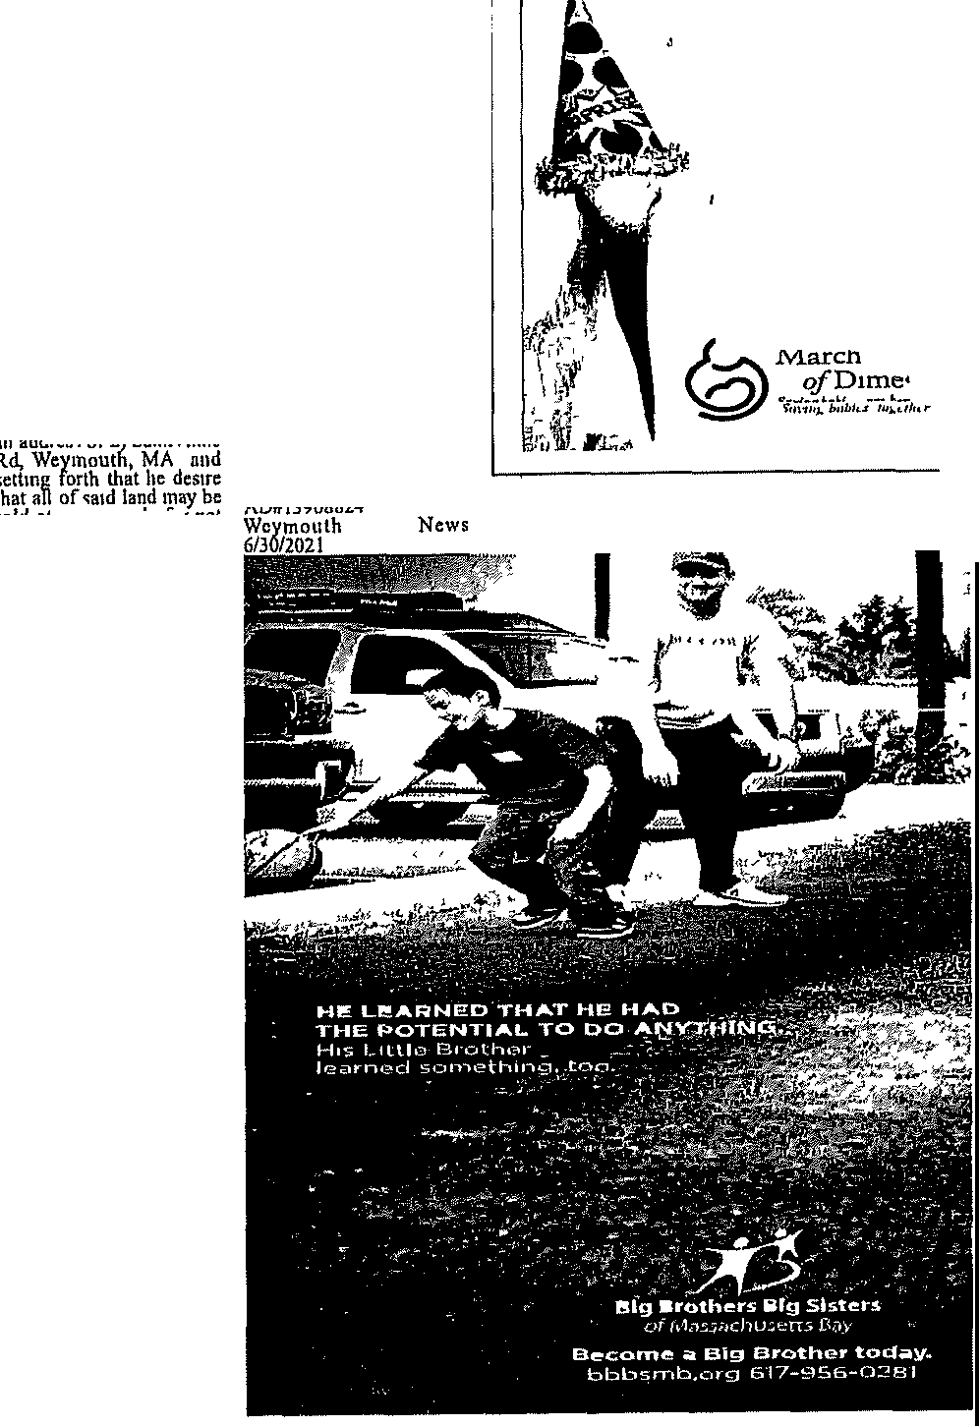
r;9.g54J>{? a r z
433.7959
bmldmgs on the 'ille One
: n"f{:
h lo '! ;J!1
butwn of asscH and
written appearance 1toli
l 1
1 1,ci d1 u

1
0
t ' t a; t ii al , e1
smokestack upon \\h1ch 1s localed wireless communi­ cations serv1ce'i fnc1hty antennas Petitioner seck'i
rctum day of07/J4/201I
This ls NOT .t he11rlng date, but a deadline b, which vou musl file a written affearanee and
{r cr, et Pi ltt1a5 c uW: 1 inslllute formal proec:ed­ mgs and to obtam 01 ders
h n 1: o;{p5: :1 i
c
8
ate of
day IS
msuture formal proceed­ ings and lo obtam orders
0
irt is
6/ 1f: c n a
c): 'i1 i r :1spar c ed

to tempornnly install a
120 aOove ground level
f i: c;
11
oce ear: gobtie .
!:s s1 nf :1sp£ :; cd
A copy of the Peut1on and
1 ln;a anr(o dn
h\

temporary and removable
fail to file a llmcly writ­ A copy of the Petition and l

monopole ,;tylc ballasted
ten appearance and :X\1!rnd! anlron an tr,
Pcritloncr

tower Wilh 6 panel anten­ nas mounted 10 be located
t el
o! hl:c: i?' J!;, );1
Wfa n }1 e l o Peuttoner

w1lh111 a Cell on Wheels
,;helter w1tl11n a temporary
AD#l3967892
ey l: f;a s enri wnttcn affidavit stating the
News

fenced wmpound area
li !;:c Kt ir
? :fhc ce: ;; thout :raffQ2j'h News SJ!CCJfic facts and grounds
of your obJectton wtthm 30

alf of pregnancies are unexpected

r ,c
:J e§l°lP91 t lt Hill Dr also shown on Weymouth Town Alias
PETITION TO PARTI­ TION
LEGAL COMM OF MASS
days flfter the rerurn date
TMl'ORTANT NOTICE
The outcome of this pro--
) 1 1;n;:\ m ;c i';
(But that's not the real surprise )
Tt:, tJwt 11 01111!11 u.111 ht!lp
red11u.1 the 11\/.. ofcertain se1io11s bi1 th dcfc,l<t Simply

'iheet 3, block 4, lots 30 &
31, located 1n the R-1
A ersonal
PROM
Norfolk Division
above-named person has
the right to make deci•
tal,,1 a n-w/th 11,1111111 ll
11h

D1stnct The ficllUoncr 1s : ht:'JJbj1'< 1 t!!
Docket No
fol,c acid e1 er,• dav w, part

}6 n ffi h;e!! 11 1: n fl6
the Weymouth Zonmg
Ordmancc

un upervised administra­ tion 1s not rcqun cd to file
dll mventon or annual
21E0019PP
To 'Rachel S Webb of
! a'i:s o brt:atncYai '&:i:: or bolh The above­
named person has the
0/11 Ju..rJ/Jlwt/1eJ
11 h1.,,{l,c,1 m 110/ Vott
plan a VHlt ji'Om

act.11\1111 with the Court
Weymouth MA 111 the 1 0
the vtor/.. Fm mme

pedal Jl'crmit • l 20 40
Pt.nons lntcrc11ted In the
County ofNorfolk and to
e fofn! !'"t\'1
lf!{ormaflon contact the

1 estate are entitled to al! other person'i mterested,
request on tclrnlf of the
Alm ch of D11nes '11

: x ! ; i1 r 1; 3.f- \ jch1 notice regardrn,: the
above-named person, If

ifimcns1onal rc9utrcments
- nunimum lot size
adrnimstrahot1 d1recth
from the Personal
A pelll1on has been pre­
sented lo said Court by
the above-named pcr on
! 1::: y" c:t
t p /:;:a
1 888-MODIMES
01 n wn modinev mg

::rfri e ;tE':u rfni: :
Ii! ufJacci. 1fc l 'ia j
Hmgham, Ma rcprcscnlmg matter relating to the they hold as lcndnt tn com
James K Costello of Stale expense

fa1

1dndC.: i1\' lg
::;11
estate, including the dis
tributlon of assets and
mon undivided pan or WITNESS, Hon John D
Casq ₁ First Jushce or this

:
211 22 sf parcef with an existing srn,g.le family
dwellmg Pettltoner sccl.:s
cxpcn cs of admini tra­
hon
WITNESS, Hou Patricia
artv ;;g a \ d ![! County Norfolk, and bncfly duenbLd as hnvmg
Court
Dare June IO, 2021

i : ?ct R rtb1 i! ;1 &orman, First Tustwc of
Pamck W McDermott

Pro'ipeet Hill Dr
Digital copies of lhc docu­
this Court
Dale June 09, 2021

so at pnvatc sa c for nol
Register of Probate

ments for the above hear­
less than M40,000 00 dol-
Colleen M Brierley l :

ings can be accessed for review on the Board of 1
1: 1 t
i :frcc
ts
Rcg1 ter of Probale ADH/3969140
t!t ; 1aWTh1
land aPorcsiud lo law, and
;
to 1ha1 end Jhat a comm1s­

section on the To\\n of Weymouth wcb'i\lC \\CV• month mans
Board of Zomng Appeals
Xfj\f1%2t1h
s1oncr be appomted to make such partition and be ordered to make sale and vif! de1! J •11 c\1 t\t

AD# 13969615
}J?Jiiouth News 6/30,
Court finds cannot be
advantageously d1v1ded either dl pnvate sale or pubhc dUcl1011, and be ordered to d1stnhute the net
3

l'ubllc AMOW1ccmcn1 Concetmng 3 Proposed H hh ( re!'roJed
l.tG4LN'OTTCE
Public Announcement Concerning 11. Pwpo.i.:d Hc11.l\h Ulre J"roJcd
The Ch1ldm,', Mcd1c11.! Ccnicr Corpor.tmn looted al 300 Longwood A,cnuc Boston MA 02-115 h1\cnds lo File 11. No1!ce ofDclcnnmat1on of Need ( DON
.-'\ppllcamm' 1 llllh !he Mu,JdlllJcllJ Dtpulmcnl o( Pubh Jfullh (or a Sub,,;titt11tal Cnpltal Exrcndmue Ambulatol} Surgery Center & tlt'N Re11111rcd l:qu1pmc1,t by Bo$11m Ouldrc11, Hoqihal located al 300 L011i;wood A\t:uuc B0$!011 MA 0:!-1 IS The DON arp!kitlPn rcquciu 11.prmval (or the rollow1n1
- Rer,D\'allP11 (dn<l cqu1pp1u11] o( "!' CC w1thm the Hn<r•t I cx1<lmg (Mohty
al 9 tlop{ "ivcny \\ allhlm M Ji 121lcu1ng eoMtNcllon fit out •nd cqlllf"'
proceeds thereof
If you desire to obJcct thereto you or your attor• ncy 'ihould file a written fi, ,;:' ;f ;: c m the forenoon on the 14th
fe rn°Ja> / 'h1t la lo he

rin& o(R h11tld1ni; located at 200 Llbhc) i'arl."Y>ay m Weymout11 \fA and {31 W1lnc'iS, Palr1cla A

h.nd uqu1J1Uon connrucuon fit out. und t11U1ppmg o(an ambu1 tory t\llllltal center and r dHt) innccl for pcdbtnc mcdtc l U!c at JRO Tir.1\ Avenue In Needham, 1\1", and (41 the1ddltlon o(OoN r qu1ud cqu,pmcnt m Weynmuh and Nccdh,\ffl The lot ! \aluc o(!hc i'ropornl Project u S434 lo'II 000 The "ipp!kanl docs not ao1k1p3t<: an) pr"c or JCl'VICC /mpacU 011 !he r\pplr""n/ i culillng Pa!lenl Panel 11.1 a rcsull nflhc Prnrcucd ProJcct Any ten Taxpaycn or!,la.uachll.lctli may rc11l tcr !n connecunn wnh rhc lnlcndcd App!lnuon by nlllbtcrth:uiAu£11.1116or3Uday,fromthcF1hngDatc wl11chcvcr1ila1cr by conlaclln& the Dcr,;.1\mcnt ofl'ubhe ltuhh Dclcrm1n11!011 orNe1:d l'roi:ram 15V W.uhm&ICll S!rtd (,th P!oor BnJ;ton MA ulJVg
AD-13969711
WcymouthNc11s 06f30120;!.1
Gorman, Esf!Utrc, First Judge of aid Court tlm rnth clay of May, 2021
Colleen M Brierley
Register
AD#l3963244
Xf2j,1/Ji ofiews 6/16,

2A I WEDNESDAY, JUNE 30, 2021 I WEYMOUTH NEWS
....---

MOST LIKELY TO SUCCEED
Phil Dormitzer and Brenda Birmann
Phil Dormltler was voted most llkely to succeed by the Class cf 1981 at Cohasset High COURTESY PHOTO

On the origin of a vaccine developer: Philip Dormitzer

Robin Chan WlckedLoi:al USATOOAYNETWORK
I

neer and his mother Is an author and copy editor wl11ch helped him with his writing that proved

most business hke In his approach which he thought would serve h1m we11 in the sciences

works m the real world settmg
"It's easy to get in very esotenc research realms

ion And Phil was very good at that"
Bemg a detective helps m vaccme development

n nature, both geno­ type and phenotype influence the final product The geno­ type refers to an orga­ nism's raw genetics while the phenotype refers to external mfluences that may have shaped an or­ ganism Being part of the natural world, that1s also the case with our own de­
velopment
This1s true for Dr Phd- 1p Dormitzer, whose ex­ periences with his family1 m the Cohasset public
schools and at South Shore Hospital led htm to Pfizer-where he was one of the leaders of the team that developed the CO­ VID-19 vaccine that1s the answer to the ongoing COVJD-19 pandemic
Domutzer grew up m Cohasset with his family on South Main Street m the 1960s and 70s They moved from their home in

-)
Publlc Announcomonl Concorning a Propond Hoallh Care Project
Tho CMdren s Medical Center Ccrpora\Jon located at 300 Longwood Avenua, Boston, MA 02115 lntoods to Alo a Notice of De1ermlna\1on ol Need rooN ,App1Jcatlon1 w1H1 tho Mamehusott& Department o( Public Health lot a Substantial Capital E pendltu1e, Arnbulatoq Surgeey Cenler & DoN Required Equipment by Boslon Ch dren11 Hosp!!&! localed al 300 Longwood Avenue, Boston MA 02115 The DON appUcaU011 r&ques1s approval for
the foMowm11 (1) Renovation land equipping] ol spacewlthln the Hosplal s e)(istlngfaclhty al 9 Hope Avenue Waltham, MA (2) !easing, cons!rucllon, Iii oul, and oqulpplng ol a buUdmg localed at 200 Libbey Parkway In Weymouth MA, and (3) land acqu!slhon consbucUon, Iii out, and equipping of an ambulalorj su,glcal center and facility zoned for pedlalnc medical use at 380Flr5t Avenue in Needham, MA, and( ) the addiUon of DoN t8qulred equ!pmcinl In Weymouth and Needham The lolal value of the Propond Profed Is $434,691,000 The Appneant docs not anticipate any price!letVlco Impacts on lhe Applicant's oxlshng Pallenl Panel as a result of the Proposed Project Ally ten Taxpayers of Massachusetts mayro11lsler inconnection Wilh theIntended App1Jr.:al!an by not la!er then Augusl 16 or 30 days flDm the Filing Date, whlcheve,r lslatu, by contacting the Departml!n! ol Public Health Oelermlnal!on of Need Program, 250 Washington Street 61h FJ()(lr, Boston MA02108

Dr Philip Dormltzer Is Vice President and the Chief Scientific
Officer Viral Vaccines at Pfizer PETER ROSS

Brookline nght next door to his grandfather, Henry Dormltzer, an inventor and businessman and someone who influenced Philip m his fonnat1ve years he credits his grandfather for mstllhng a sense of cunos1ty, an important mgred1ent in the sciences
His father was an eng1-
useful when wntmg manuscnpts and making regulatory fllmgs for Pfiz­ er
Other mfluences m­
cluded Jim Mullen, who helped him with his sixth grade science project that looked at the hydrology of Pegram Brook which was frequently floodmg his neighbor's house This use of applied science early on shined a hght on how science can impact ourhves
Dormitzer credits two Cohasset teachers, Mr G1lrnartm, who taught science m the Middle School, and Mr Franey, who taughtbmlogy at the high school, for instillmg a Jove of sCJence
"You can Just tell from the way they taught that they themselves were fascinated by what they were teaching," remem­ bered Dormltzer "It was kind ofinfecbous"
Their enthusrnsm for then ,;ubiect rubbed off onDorm1t:1er
''Mr Gilmartin, he de­ scnbes th11t the miracle of life could he undentood on the basis or chemistry and science," recounted Dorm1tzer 'That this mysterious thing of thmgs bemg alive, that there's a science behind that"
Jim l•rancy who was a science teacher at the high bchool from 1961 to 1999, remembers Dor­ tnlt.c1er as a really studi­ ous btudenl who was al-
He saw Dorm1t2er's
potential but wasn't sure how far tt wi.ll take h,m once he left Cohasset High He was glad to hear that he put hts assets to good use
Jim believes Dorm1tzer and his other Bmlogy honors students were able to reach their fullest potential because of the support he had at Cohas­ set's public schools
"The Cohasset school system always encour­ aged high achievement so the teachers were provid­ ed with everythmg they needed/' said Franey "In turn the students got ev­ erythmg they needed It was a wonderful school system to work m "
Donn1tzer spent his youth outside exploring the woods of Cohasset discovenng remnants of walls from New Eng­ land's past and also the abandoned bana.cks at Wompatuck State Park when he was old enot1gh to nde hie: bike there
Music was very much part ofh1s hfe He played In the high school band at Cohasset Hlgh and was in the church choir at St Anthony's He played taps while talnng part In Cohassct's Memorial Day parade ai. a Boy Scout The class of1981Valedic­ torian was also nominat­ ed Most Likely lo succeed by his peers In his high school yearbook
After college, one of his stops included his time as a hospltallst at South Shore Hospital where hetrained as an m­ temal medicine physi­ cian and sub speciahzed in infectious disease dur­ ing the early 2000s
Working directly with l}attents and seemg the real world impact or m­ fectlous disease m hispa­ tients helped ground him to what he calls the "prac­ tical pracbce of medi­ cine" and what really
where there's mterestmg sC1ent1fic questions, dnd forget that thmgs that only effect a few people may be mterestlng/ ob­ served Dormftzer, 'But whatw11l havetheb1ggest impact on the commumty are thmgs that effect lots of people"
Dr John Stevenson was a colleague of Dor­ mitzer's at South Shore Hospital He was the for­ mer Chief Medical Officer for South Shore Health Systems from 2009-2017 and has met a number of smart and talented peo­ ple over the years, but Dorm1tzer has always stood out to John
"There are a lot of peo­ ple who are good at one of three thmgs, they're good at either takmg care of patients one on one, or they're good at develop­ mg research mterests, or they're good at popula ban health type of con­
,;iderattons," according to Stevenson "But It's pret­ ty unique to actually be good at all three of them" But beyond hts exccp­ bonal intellectual talents, John appreciated Dor­ m1t2cr's hard work and hts cheerful attitude with both patients and staff Ir he was on a shlfi at the hospital, John knew that he hdd someone who would roll up his leeves to provide help where 1t Wds needed and someone who could share a funny slory or joke to 11ft the
mood
Dorm1tzer's expen ence working with pa­ tients helped him Wlth his current work develop­ ing vaccines for Pfizer
"The field ofmfectious disease is almost a cer­ tam amount of detective
\'lork,' aceordlng to Ste­
venson "Chnictans have to figure out the sourc.e or infection, what pathogen ft Is, and what the nght treatments are, in a very sort of methodical fash-
as scientists need to fig­ ure out the best method of attack wh\le mm1m17r mg averse symptoms In this case, scientists fo­ cused on COVIDM19's re­ ceptors that bmd to our cells causing the virus to merge Wlth our own and mfectourcells
Dormltzer, along with other researchers at Pfiz­ er, was working 7 days a week and long hours each day on this problem Jt was not uncommon where he would only get 3M4 hours of a sleep while working 12 plus hours a day mterpretmg data, wntmg manuscripts and submitting regulatory ftl­ mgs
Part of a larger team, Dorm1t2er1s very humble about what he has ac­ comphshed knowmghow many people had a hand in a drug, from manufac­ turing to development, with work spannmg an ocean
"For a very incred1bly
talented gl.lYi not a lot of ego there," said Steven­ son
However, Dormltzcr, as vice prco;ldent and chief vaccme officer at Pfizer, he had a slgmfi­ cant role and was the right pcn,on m the nght moment
To some degree, I've
been prepanng Uns for
decades," he said
What started tn the Cohasset school i.ystems led to being trained m vi­ rology and i.tructural bi­ ology In college, followed by work at South Shore Hos):11tal During the 2009 HlNl pandemic, he was one of the Inventors of the vaccine used fnthe US so he has experience fighting a pandemic
A11 of those e"Xperlenc­ es led him to his role at Pfizer where he met the moment

ZOA / THURSDAY JULY 1, 2021 / THE PATRIOT LEDGER
To Place an Advertisement Call 617-786-7100 • Mon-Fri 9am-5pm
•-11111'1 .l!II-• -mrmt

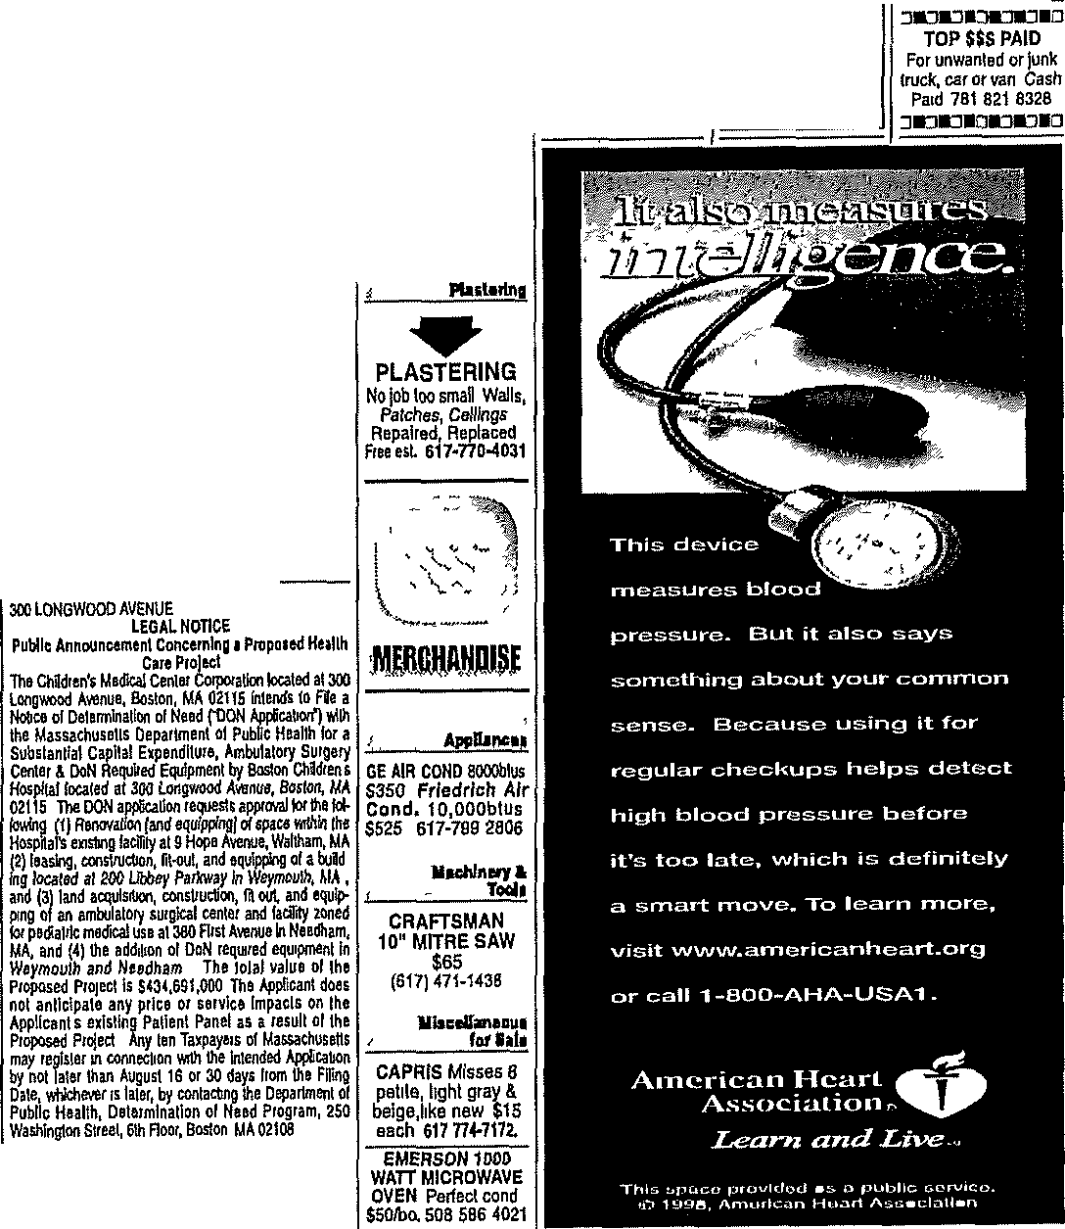
ba•i. r 1.qall =;====L,.=.11c. ;====L.=.!2·=

pookapoag ba/'IIXltp NOTICE
Ustolalpersons ecled
!oofficeol
eel tower
ro\& ZiTE
Earn Extra Cash

Flo ng
HJIJJJJfti
PONKAPOAG BANCORP, MHC
HeldonWednesday,June9,2021
atlhe2021Alvlua1Meetrig
p,,.,antlo M.Glc 3-0B,§ 16, •• TOllTI 01 Sciblale Is
: nr ;ad : dl ! ; a11n!O:
ru: ! l: ,:;:
e'l
0
0
0 1
Palriotledger Adult Delivery Routes available,
Make $1200-$2000 a Month

- KHAM'S FLOOR ♦ Sandlng,Stalnlng& Rep !rs Oe&lgneri'E"xpert
tnstal!atlon 5Year
Warranly 617-472 3240
Llaaf•
Wanltdlolbly
whohavalakenoalholoffi lo 'o111feh!lteywereelecieda11dafst oltheMemberso!lheCorpo!'ation TRUSTEES
Chosen!OfThreeVeali
TermExpl1es2024
.kihn ffJ:rfCZif P.A.
ChosenlotThr88Yearg
02
Jam 1k1 1!:
malnlalnlng one wr1eless communlcabona lt>War !ad\ity
and1elafed equIpmenl for a !erm o/ lo twenty
t:r
; r s::b : a al1: :sThe
ctmentleaseaxplresJune00,2023

b:fsfoa e eu:: l :; e' tt o Admlmslrator's o!llce localed at 600 Chief Jusllce
Cuslung Hv.y, Scituate, MA 02066 H0111s lll'e Monday
:U:t 1: f t :n
, Gel extra cash roc those past
due bills or that new car
t : :1::e
•
•Beyourol'mbos.s
You must be able lo wort< mornings/
afternoon Monday through fmfay and early
morning on Saturday Warehouse opens
at 7 am Monday w Friday Saturday opens

llttleRlohle's Antiques Records,muslcal lnstr,cameras,toys, sTiver,gold,palntlngs
FITZPATRICK MATTEF!
LEGAL NOTICE
Commonwealth o! Nasmhuse\ls ThtTrlalCourt
Jr &, P A.
Mdia :er :r,t'tC.FP MarlaliK Pendergast StevenV Ro!ela, C.PA.

^{p}AM s^{s}T^{a1} u
s m
1!! ::::a':
st., b!rulledbyAu 1i 2021 ,1100
su gus ' a

at 2 00 am You must havea rsllable vahlcieandthedeslretoprovide top notch service to our customers

loals,fum, jewelry,
ca!nsi; / 1.ii.f ds
so Hancock SL Braintree
781--380 8165
llH/er)chltunllque.s.com
IJlddlmrProbtl&and
F1m!IJ'Cow1
10-l!Commeie,Way w-,w.01801 (781)865-4000
Docke\No M121A030CW
TetmlnallonolParental
Chosen!orThreeYearg
Termfaplres2022 JamesM Downey CP.A.,C.F.A.
sr =t

DonaldPt,kN!!lce,Jr LlslotlheCorporalorsol
TermEJ:plres2022
JAMES BOUDREAU
TOWN ADM!N!STRATOR
TOWN OF SCITUATE MASSACHUSETTS
13969080 Patrior Ledge,6/!H 711 02
'
"''\:':I:
Routes are avallable in the foHowmg areas
- Nmvell
- Braintree
You could be Call Today, tomorrow!
making money

617-786-7241

Nol\ceo!Pelltlonlor
R!ghtsGLc.210§3
lnlhemal\erol BabyGlrl
Fftzpatriek
To any unknown or unnamedfalher,parellts(s) ollheabovenamedcillld
  - A pulaUve falhlr w111 nolhavestandlngua
a:
:;: I
h
PonkapoagBaneorp.MttC
PelerS Donadio EugeneFMannlng StevenVRo!ela,CPA. ChrisfopharC.Sm/tlt LlndaM Wiria TermExptres2023 EarlJ d'Enl1emoot,Jr KnshnOrapet
M!dlae!A.Galer,C.P.A C.FP SeanW GaMn EdwartlJ Marshal
DlaMCSilvla
111
TWIN FRAME
COMPLETE: Only used 5 days $70 Qulnc)t 617-412--0582
i. ;:;,,;,,_.,...-,-:::::::::::::

JliUllt§ APJOM!IJJIIJ

0 1 1
: t' !n2:
WonltdlolluY

:1J 1!:1 f: 'j: i1!:ifyn
flllOrtllftll'flenl AutomOhUes.
2004 NISSAN XTERRA
Runs great 99,240 mlles, no denls, lnle rlor In great shape

Ape\11lon has been pre sentedtosaldcourtby Adopllon Ruoutou, Wallhim , MA 024511 le}):' men tha\lheraren!{s)
GregotyLPando,A.lA.
Te f:,e!:s
Cacciatore Brolhers
Slncel91H AsphaltPaW!g
&Landsca.p!ngBackhoe Service,slumpgnnding& 1emoval Freee&LUc &
Insured. 617-479-3706

CASH FOR RECORD ALBUMS
33LP's & 45's wanted
GaUGeOfge617-633-2682

HulVNanlasketBeh

. u a d(isne: 11
:
re:aed:iness 7o aGsume

LauiancaJ.Grolpen

p:1arlr a:
LeslieLodcarci
Flaarlnq
CASH FORTOOLS $5500foo Call Fred
Hand/Pwt,Carpenters, @ 781 626 8086 or
l Je, } •: o,
- KHAM'S FLOOR ♦ Machlnlsts,Mechanlcs, s =1a1 l i email fJblOOcomcasLnet

r : !to J!1!b l !r
ers plan lo, lhec lldwm
1
Gervelhechlld'sbes11n!er
GleooDSll!Warl
Tos ,ce:n J7
Sanding, Staining & Repairs Designer/Expert lnslaltatlon 5Year
Plumbers, Ro1laways 2015 MINI COOPER
1 800-745-6665 Rel:l/vm1te,3lkm1,
LlttleRlchle'a WHITMAN Clean safe greatcondAulo,sumf,
$11,200 508-2026960

e&ts,and,requesbnglhal
th1sHonOfableCaurt11nter
Rober\Gallery
llanaMPMcNe/ci,,
War,anly 617-472 3240
Antique,
Records, musical
lncls ums,lridge,m!cro, tum,011silemanagerF10m

adecteeunderlheprov!
WilliamFMcNelce
Ro.aflngl
lnslr,came1as,toys, SISON,k. 781-4474784 AulOIJ!Dllvl

slonsollheGene1allaws
J.WesleyRawding
-Gutlctl sllvar,gotd,palnllngs,
Aft>m,all<ol

olMassachusells,Chapler 210, Secbon3,thalshall havelheelledtnle1nlmal
BeajamlnShel!InglDI\ TermEJ:pires2028
JamasP Ande1s.en,J1, c.PA.

WEATHERTITE ROOFING
Many roof repairs
under$200 30year
tools,lurn, Jewelry, To Advertise m
coins, mllltary, swords the Classifieds
CASH PAID

lnglhe1lghlso!lhaper
i:C!f:J:':! : o
1
SlephenPCos!eDo
JamasM Downey, CPA., C.FA.
Pal»G Cou!ure

NewRools
60Hanc-ockSI
/'JrauCal/

;1a etihJ ! O:, t,
:;ir :
Inspection, no direct ll"!erlchlesantlques.eom

0
guardranshlpadopttonot otherdlsposlllonollhe duldnamedhereln
IF YOU DESIRI:: TO
g J\CJuWEfrf:!gAm
MUSI FILE A WRITTEN
APPEARANCE IN SAID
COURT AT Woburn ON OR BEFORE TEN O'CLOCK IN THE MORN ING (10 00 AM) ON 08/10/2021
YOU ARE ENTITLED ro THE APPOINTMENT OF AN ATTORNEY IF YOU ARE AN INDIGENT PER
: :rfilf E is
The definition Includes bul

RoberlPMon!z,Tr
MollyPSmith
r , :

JamesO.Egan,C.PA.
Jr:::
Robe1IMacDonakf

JohnM SweaneyC.PA. SusanOWalsh Anlhonyllffl
k a NlcholasJ Maralhas,Jt Laona1dPepe,CP.A.
TermExpiles203l Kate eri,C.PA RanjanlNa,ayanan RobertM Russe!t,Esq.
DerakSandlez Todd A.Sandler
KennelhS!arr
Free rooflguUer
contact needed Porches All rolled wood replaced lns'd Reg:Hls 168929
Braintree 617-716-7100
508942-4200
wealher6teroolingma.com
781·38 8165 iil1r PPtt1ot lrllorr

Call
1-800,mypaper
888·697-2737
to subscribe
i'i:hr l)otriot irrbger
\ ! 6e i :1 ;t it Di 13970S01Palnolledger7/l/2021
b! rWt 1f ! v:l::;:,
1elugeereselllamentbane Ills, medicald, and SSI TheCoul1W1lldetermlne1f youa,ermfigent Contact anAss!slantJudlcla!Case Manager/AdopllonsC!e1k of the Courtonorbelo,e lhedalellstedaboveto ob1a1ntheneces.saryforms.
W!TNES5iffon Maureen HMonka,AntJusUceol th!•Coutl.
Date .kine9 2021
TaraEDeCm.loJaro
Regrotero!P1obale
A0,1396875-4
PL 07/01, 07/08 &
07/1512021

2020 hyunda1accent Tobe Auctioned off 711&'2021
VlN
3KPC24A66LE12.5727
Pursuan!toMGLC255
S39A
t

Local
al Erp1esslowln9
761843-6909

AOl13969921 Pl711/2021

e_v_e_ry_da_y_l , Jf7 ?,:mT;;e

Travel
Contmued from Page 1A

ln Massurhusettfl, more tbon I J mil­ hon people nrc expected to be plnnrung tnph for thf' holiday, up f-wm 964,000 m. OJ.O
Oftho1 i 1mllrnutrnvf'lf'fs, c.lowtol 2 nullh>n nrE' expcrtud to d11vo t1> tlwlr d11 '>tlnutfon<. AA-\ und INRLX predlC't thttt dnvccs 1,\llt uxptitlem.e the wm 1. traffic congestion hi>adlng mto the Jmll­ day weekend and on the Monday after
Tm1,ul by bub ttnd truin ure L'xpec.tcd to rlhe 72 percent t..ompurcd to h1bt yeur "\t\c uro really ttlmost buc.lc to pre­ pandenuc level'! ot travt>I," Mary Ma­ guire, a spoJ...e'lpenmn for AAA N01ih­ t'llSt, 1mld "In term'! of the number ot people, ,-.e pro}1•ct to be dnvmg for .July
,1, Wf' reactuu11y gt)mg tos1w the hi1thent volume f'Vf'r''
Mnnuirf' smd mod'! may i.cr i.tng­ tw etl lrnw1 v,lwni- dilfl•n•11l µ110µ\1• leove 0111 hursduy, rild •Y and Suturd.t)' mommg Whtie many w1ll ho roturmng on Moll(foy, M11g\1ne hnid '>Cini< may r< turn on Tuesday to bent the Monday

Holiday traffic ls expected to be heavy this year rtG Fill:. l'H010

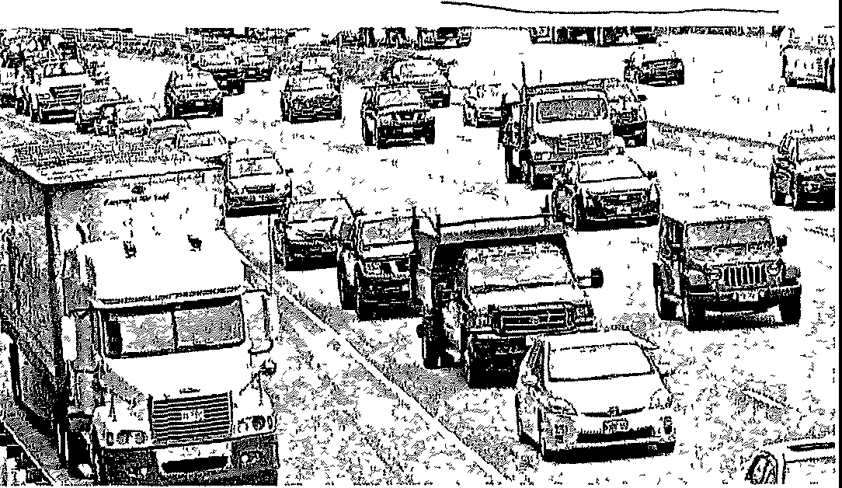
PATRIOTL.EDGER COM J THURSDAY, JULY 1, 2021 I SA

rush
She ;.md the staggered trm-cl may help Lat.c lralflc eongcstmn over lhc holiday v.erkend
The. heaviest traffic 1s exprcted from 11mrsday afternoon to l'hursday eve­ ning1md Fndny11fl:crnoon toI r1duv CVf'­ nlng
Mnguilf' 11;>rommt•ndrd that drlVf'n llbf' tri1wl 3ppt. tc111J.uge1hc•tr.iffwaitua­ tlon wh<'ll phmnl11g thctr route, partic- 1llnrly on th1• M11%UC !msNlt- Turnpike, the lnt0:n,ect1on of lntc1:,.to.re 495 lttad­ mgnorth to New Humpshlrn, and southM bound to cape Cod und the Cupe bndge!r.
Mt1gum? stud drivers cun also Jou\.c early m th(' morning to ('Scape trafrlc ond have more tlmr to deal with nn)' dif­ ficulties on the road
Mw nald prh.'.(>n for tmmportotlon nr,;, tip lnc\udlngg11<:, rar rentnls ondhott•h, Rrntnl pnc.< R an• \IP 86 porrent <'Om­ prm d with lllRt July 4, hotf'h, mtes hnvc
m(.rMsud bctwc<•n 3'> md 'Vi pee< Ntt and gus pm.\!-4 llt(l 93 L. l\h, h1ghor tlum lnht ye ur in M,U,hll( huhctt.,, v.Ith aii nv­ emgc price of '!12 '>5 for 1mlcnded
Gnb pm:<?s ure the hlgho1,t they hnvc
been m !r.cvcn ycnr1,
To pm,!r.1blv su\e money on gm,, Mu­ gitlre rec.ommended (llllng up the lank near home to uvold more c,pcnslve
highway or tourist dw,tm11t1on gus stu­ tmns or when uosslng stutc hneb mto u state with higher gus pnccs surh as Connecticut
"It simply mak<"s c;en.se to fill 7our tnnh. before you leave, especmlly 1fyou IM• hl'I(' In Mf.tR'l:OChU'lfllts COlltlf'Cti<'Ut hnc; murh hlghf'r ga'lohnu prkl'&, for e:ic­ umplc-, bNO\l'l:<' theyhnvc a h.lgh rgnf.o lmu tux:' M,1gulre smd "hi! vom t:.111k c.10&1.' to home Buy regular Mo l <.<m,
<..an h,rndlu ,eg,1lar Just 11,w Tlwy don't
w;i(l<l1mdg[\),dc or prnnuum"
llowevcr, Maguire smd ;.he docb 11ot thmkh1gh pnc.es will reduce demand for tmvul after a yc.ur when mnny Amcn­ c.t1ns restm.tcd tht.ir movcment1,
"I don't thmk thut's gomg to dutcr people from tniv,;,Jmg given all the pent­ up demand," sh<? srud "People arc j11st rf'a.lly rondy to gf't aw.ay"
lf firlvrrs ,,..lsh to mmtmm• stopn due to concc,rn over COVI0-19, Mnguhe t.ald they should p11rk evf'T)'thmg they nerd, m(.(udlng musk'), food und w1uor Phmch and public \to.tu,pmtut\on \.t\\1 rcqu1rn
l'J'UU,kb
oneot the ro.isons why we're sec-mg close to 93 pcrc.cnt of all fourth of Jitly travelcr1, gmng bv cnr 1s thut it's much ca1,ler to control your environment und your i.nfety and rour snmtntlon whf'n vou're m !,our own vehicle/ i.hc sn1d
Bub} holiday weekends often bLO an
mc.n.n1.e m erushe!r., Mugmrc srud She encouraged dnvcrs to remember to wear seat belts, not to dnve under thf' mflucnc-e, nol to dnve while distracted and to not dnve whtle drowsy
'Bf'! aui.e of r('rent 1wws of Anwnr..nn Airllnes 1wedmg to eancE1I ah<mt 1,000 fl1ght,i: due to a s}iortagt> of staff, Mn­ gmre i.nld pcCJplc who uw rrnwhng wlth Amcru.nn Alrllno>i !r.hould gut lc\t um flrm.i.hon ubout fhght lnfun11<1tlcin t<1 s.H1y \tpduted t1nd quit.k\y ru c.b(!dU\I!
,my <.Urtcde<l lllghl
In a summer in wh1c.h mt1ny tmdi t1onul act1v1tws nrc cxpucted to rctttrn
and hobpltahty 1s hopmgto recoup pun dcm1c loS!:,Cb, Mugmrc s,.ud the July 4 numbers ure cncourngmg tor the travel lnduntry
'1 think it',; great news for the trawl
induntry We'rr secmg m addltlon to the rc.rord nmnbrr ofpC>oplf' who arr dnv­ mg for lulylouxth tlll'l)'ra.r, w,;,1m•f.e<•­ lng three-and-a-half tlmM the mr trm­ eler>i W0'v< cc.nt1ht1•ndylucmu,cioulr tmvcl Jn rec.u11t wcelu,," bhc suid "It'
\'£1ry oncourngmg lo hOll the pcnt ttp dt•­
m,md out thero, lo el!pcoplu' w1Umg­ nesb to truvcl and enthu!r.iru.m for trav­ el"

'RENEWAL
Publ!o Announcl»t'lent Conc11rnlng a Ptopond Hci!llh Caret Project
The Children• Med!cal Contnr Corporation l!Y'atod al 100 Longwood AvMuo l:11rntnn MA 02115 Intend, toFife aNo!lce cl Dnlmmina!lon of N11ed ( DON Appltcatlon") with the MMsechusetts plll'lment cif PubHr Health (Of a bobstanHal t.apltal F.xpendltvre, Ambulatoiy blJl{ler'Y CM!ar t. OoN Aeqo!,ed Equipment by Bo,;.IOI\ c..h,ldi(!n'$ Hosp(la\ lota\Bd at auo Iongwood IWenoe, Bos\nn MA. tl'l1tS- ThB 00N app\lca\\tm rnque ts approval !or the following (1) R ove\loll (and oqolpp!ngJ of spaco \',\thin the l-lospltal's ,ixlsllng faclht;t at 9 Hope Avenue, Waltham, MA (2) leasing, con.stnicllon, f -oot, and ,iqulpplng ol a bu8dlng localed at 200 Ubbey Parkway In Weymouth MA and (3) lend acqolslllon, const/Uctlon lit out, and equipping of an ambJlaloty su1g1tal eent&t Bild facnity zoned !or ped!atnc m&dlcal 0110 at 38D First AvenJe ln Needham, MA and (4) tho addllk 1 of DoN reo,o,red equ1pinenl In Weymouth and Needham The ,olal vatua ol Ut1:1 Propowd Pru/eel Is $134,691,000 Tiie Appr1:ant doll!o not anllclpate any pike or seMee Impacts: on the Appl!c1111\'s l!)(1sUng Pallant Panel usa11.>sutt ol ltn.• Propos:ed Proleot My tan Toxpayers of Massachusetts may n,glster fn coMell11on with the lnlencled AppUoaUon by not leler than August 16 or 30 clay.$ fltlm the FJUng Date whichever ls /aler by tor1tacllng the Oopai1mMI of Publ!c lieaflh Detemunalion of Need Program, 250 Washmgton Slreet, oth Floer Boston MA 02108
: byANDERSEN
RIU.SU'dtflt1XD{11HOOOUE1UCflilOO

}

We're celebrating our 26 anniversary-we couldn't have done 1t without you, and we wanted to give you our BIGGEST new customer DISCOUNT EVER.

RENEWAL
byANDERSEN
IW!lrf;l l l111Ullldl
•

M1ihri ymu horn1 mr>r.t.
'i'!lni1 r 80<1k n Vu b.1,11 01
h, f f<m'u1' Appomtmnnt
1-800-226-8233

Attachment 8

Articles of Organization

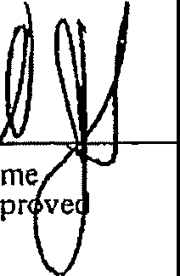
IDl1r Oinmmntttutaltlr of fltt1l1ntrl1unetta
J efJ
aminer
·C -
p
-
M
R.A. D
□
. .
//
MICHAEL JOSEPH CONNOLLY
Secretary of State
ONE ASHBURTON PLACE, BOSTON, MASS. 02108

ARTICLES OF ORGANIZATION
(Under G.L. Ch. 180)
Incorporators
NAME RESIDENCE
Include given name in full in case of natural persons: in case of a corporation, give state of incorporation.

Davids. Weiner 28 Norwich Road

Wellesley, MA 02181

The above-named incorporator(s) do hereby associate (themselves) with the intention of forming a corporation under the provisions of General Laws, Chapter 180 and hereby statc(s):

- The name by which the corporation shall be known is:

The Children's Hospital Corporation

- The purposes for which the corporation is formed is as follows:
To provide medical and surgical care and treatment to infants, children, adolescents and young adults.
To instruct, supervise and train physicians, nurses, technicians and others in the care, treatment and prevention of disease of infants, children, adolescents and young adults.
To operate and conduct a hospital or hospitals, together with affiliated institutions, research laboratories and other services where all the resources of medical and related sciences will be combined to provide quality care for infants, children, adolescents and young adults, and to determine new and improved methods for the treatment and prevention of diseases, and to disseminate information about suchl,matters.
To participate to the extent desirable or practical, in any activity designed and carried on to promote the general health of the comr.:1unity.
To do all things necessary or advisable to carry out any or all of the foregoing purposes.

Note: Ifthc space provided under any article or item on this form is insufficient, additions shall be sel forth on separate 8 1/2 x 11 sheets of paper leaving a left hand margin of at least I inch for binding. Additions to more than one article may be continued on a single sheet so long as each article requiring each such addition is clearly indicated.

- If the corporation has more than one class of members, the designation of such classes, the manner of election or appointment, the duration of membership and the qualification.and ri,ghts, including voting rights, of the members of each class, are as follows. -

Not Applicable

*4, Other lawful provisions, if any, for the conduct and regulation of the business and affairs of the corporation, for its voluntary dissolution, or for limiting, defining, or regulating the powers of the corporation, or of its directors or members, or of any class of members, are as follows:-

See pages 4A through 4D attached hereto
and made a part hereof.

*If there ar!! no provisions state ''None''.

- The corporation shall have the following powers in furtherance of its corporate purposes:

- The corporation shall have perpetual succession in its corporate name.

- The corporation may sue and be sued.

- The corporation may have a corporate seal which it may alter at pleasure.

- The corporation may elect or appoint directors, officers, employees and other agents, fix their compensation and define their duties and obligations.

- The corporation may purchase, receive or take by grant, gift, devise, bequest or otherwise, lease, or otherwise acquire, own, hold, improve, employ, use and otherwise deal in and with, real or personal property, or any interest therein, wherever situated, in an unlimited amount.

- The corporation may solicit and receive contributions from any and all sources and may receive and hold, in trust or otherwise, funds received by gift or bequest.

- The corporation may sell, convey, lease, exchange, transfer or otherwise dispose of, or mortgage, pledge, encumber or create a security interest in, all or any of its property, or any interest therein, wherever situated.

- The corporation may purchase, take, receive, subscribe for, or otherwise acquire, own, hold, vote, employ, sell, lend, lease, exchange, transfer, or otherwise dispose of, mortgage, pledge, use and otherwise deal in and with, bonds and other obligations, shares, or other securities or interests issued by others, whether engaged in similar or different business, governmental, or other activities.
- The corporation may make contracts, give guarantees and
.incur liabilities, borrow money at such rates of interest as the corporation may determine, issue its notes, bonds and other obligations, and secure any of its obligations by mortgage, pledge or encumbrance of, or security interest in, all or any of its property or any interest therein, wherever situated.
♦
- The corporation may lend money, invest and reinvest its funds, and take and hold real and personal property as security for the payment of funds so loaned or invested.

4A

{k) The corporation may do business, carry on its operations, and have offices and exercise the powers granted by Massachusetts General Laws, Chapter 180, in any jurisdiction within or without the United States, although the corporation shall not be operated £or the primary purpose of carrying on for profit a trade or business unrelated to its tax exempt purposes.

  - The corporation may pay pensions, establish and carry out pension, savings, thrift and other retirement and benefit plans, trusts and provisions for any or all of its directors, officers and employees.
•

  - The corporation may make donations in such amounts as the members or directors shall determine, irrespective of corporate benefit, for the public welfare or for community fund, hospital, charitable, religious, educational, scientific, civic or similar purposes, and in time of war or other national emergency in aid thereof; provided that, as long as the corporation is entitled to exemption from federal income tax under Section 50l(c)(3) of the Internal Revenue Code, it shall make no contribution for other than religious, charitable, scientific, testing for public safety, literary, or educational purposes or for the prevention of cruelty to children or animals.

  - The corporation may be an incorporator of other corporations of any type or kind.

  - The corporation may be a partner in any business enterprise which it would have power to conduct by itself.

  - The directors may make, amend or repeal the by-laws in whole or in part, except with respect to any provision thereof which by law or the by-laws requires action by the members.

{g) Meetings of the members may be held anywhere in the United States.

- No part of the assets of the corporation and no part of any net earnings of the corporation shall be divided among or inure to the benefit of any officer or director of the corporation or any private individual or be appropriated for any purposes other than the purposes of the corporation as herein set forth; and no substantial part of the activities of the corporation shall be the carrying on of propaganda, or otherwise attempting, to influence legislation except to the extent that the corporation makes expenditures for purposes of influencing legislation in conformity with the requirements of Section SOl(h) of the Internal Revenue Code; and the corporation shall not

4B

participate in, or intervene in (including the publishing or distributing of statements), any political campaign on behalf of any candidate for public office. It is intended that the corporation shall be entitled to exemption from federal income tax under Section 50l(c)(3) of the Internal Revenue Code and shall not be a private foundation under Section 509(a) of the Internal Revenue Code.

- Upon the liquidation or dissolution of the corporation, after payment of all of the liabilities of the corporation or due provision therefor, all of the assets of the corporation shall be disposed of to The Children's Medical Center Corporation, a Massachusetts corporation, so long as it is then exemp from federal income tax under Section SOl(c)(3) of the Internal Revenue Code or if it is not then so exempt, to one or more organizations exempt from federal income tax under Section 501(c)(3) of the Internal Revenue Code.
- In the event that the corporation is a private foundation as that term is defined in Section 509 of the Internal Revenue Code, then notwithstijnding any other provisions of the articles of organization or the by-laws of the corporation, the following provisions shall apply:

The directors shall distribute the income for each taxable year at such time and in such manner as not to become subject to the tax on undistributed income imposed by Section 4942 of the Internal Revenue Code.

The directors shall not engage in any act of self dealing as defined in Section 494l(d) of the Internal Revenue Code; nor retain any excess business holdings as defined in Section 4943(c) of the Internal Revenue Code; nor make any investments in such manner as to incur tax liability under Section 4944 of the Internal Revenue Code; nor make any taxable expenditures as defined in Section 4945(d) of the Internal Revenue Code.

- The corporation shall have and may exercise all powers necessary or convenient to effect any or all of the purposes for which the corporation is formed; provided, however, that no such power shall be exercised in a manner inconsistent with Massachusetts General Laws, Chapter 180 or any other chapter of the General Laws of The Commonwealth of Massachusetts; and provided, further, that the corporation shall not engage in any activity or exercise any power which would deprive it of any exemption from federal income tax which the corporation may receive under Section 50l(c)(3) of the Internal Revenue Code.

4C

- All references herein: (i) to the Internal Revenue Code shall be deemed to refer to the Internal Revenue Code of 1954, as now in force or hereafter amended; (ii) to the General Laws of The Commonwealth of Massachusetts, or any chapter thereof, shall be deemed to refer to said General Laws or chapter as now in force or hereafter arnendedi and (iii) to particular sections of the Internal Revenue Code or the General Laws of The Commonwealth of Massachusetts shall be deemed to refer to similar or successor provisions hereafter adopted.
•

4D

THE CHILDREN'S HOSPITAL CORPORATION

BOARD OF TRUSTEES

Name
Residence
Post Office Address

Aldo Castaneda,

Nancy Kaplan
M.D. 121 Monodnock Rd. 300 Longwood Avenue Chestnut Hill, MA 02167Boston, MA 02115
96 Country Club Lane
Belmont, MA 02178

George Kidder

John Kirkpatrick, David Kosowsky,

Sc.D.

Laware, John P.

David A. Mittell

E. James Morton

George W. Phillips

Hon. Joseph L. Tauro
110 Spencer Brook Rd. Concord, MA 01742

M.D. 34 Lowell Rd. Wellesley, MA 02181
100 Dudley Rd.
Newton ctre, MA 02159

100 Codman Rd. Brookline, MA 02145

22 Chestnut Pl.
Brookline, MA 02146

- Rockridge Road Wellesley, MA 02181

- Tophet Rd. Lynnfield, MA 01940

47 Nanepashemet St.
Marblehead, MA 01945
Hemenway & Barnes
60 State Street
Boston, MA 02109
300 Longwood Avenue
Boston, MA 02115
Damon, Inc.
115 4th Avenue
Needham, MA 02194
Shawmut Bank of Boston One Federal Street Boston, MA 02211
Davenport & Peters Co.
177 Milk Street Boston, MA 02109

John Hancock Mutual Life Ins. Co.
P. O. Box 111 Boston, MA 02117

The Boston Company One Boston Place Boston, MA 02106
U.S. District Court
P.O. Court House
Building
Room 1615
Boston, MA 02109

7A

David S. Weiner

William W. Wolbach
28 Norwich Rd,
Wellesley, MA 02181
I
377 Summer Street
300 Longwood Avenue
Boston, MA 02115
One Boston Place

Manchester, MA 01944
Suite 923
Boston, MA 02108

♦

7B

David S. Weiner
Pre$/dent
The Children's Hospital Medical Center
300 Longwood Avenue, Boston, Massachusetts 02115, Telephone: (617) 735-6433

August 11, 1982

Secretary of State Corporations Division One Ashburton Place Boston, MA 02202
Gentlemen:
The Children's Hospital Medical Center Corporation,
a corporation organized· under the laws of Massachusetts
in 1869, hereby consents to the use of the name The Children's Hospital Corporation by a corporation soon to be organized under Chapter 180 of the General Laws. The Children's Hospital Medical Center Corporation further states its intention to change its name before The Children's Hospital Corporation begins active operations.

THE CHILDREN'S HOSPITAL MEDICAL CENTER CORPORATION
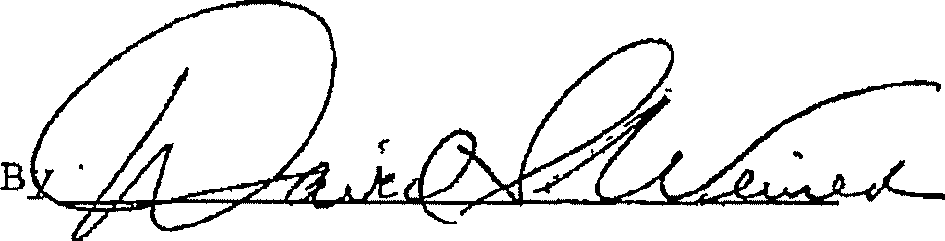
DSW:mok

- By-laws of the corporation have been duly adopted and the initial directors, president, treasurer and clerk or other presiding. financial or recording officers whose names arc set out below, have been duly elected.

- The effective date oforganizationofthe corporation shall be the date of 11!ing with the Secretary of the Commonwealth or if later date is desired, specify date, (rtot more than JO days after date of filing),

- The following information shall not for any purpose be treated as a permanent part of the Articles of Organization of the corporation.

  - The post omce address of the initial principal office of the corporation in Massachusetts is:

300 Longwood Avenue, Boston, Massachusetts 02115

  - The name, residence. and post office address of each of the initial directors and following officers of the corporation are as follows:
NAME RESIDENCE POST OFFICE ADDRESS

President: David S. Weiner 28 Norwich Road

Wellesley, MA 02181
Treas1.1rer: George W. Phillips 12 Tophet Road
Lynnfield, MA 01940

Secretary:
300 Longwood Ave.
Boston, MA 02115
The Boston Company One Boston Place Boston, MA 02106

®N- Jane L. O'Neill
1802 Massachusetts Ave 300 Longwood Ave.
Cambridge, MA 02140 Boston, MA 02115

Directors: (or officers having the powers of directors)

See pages 7A through 7B attached hereto and made a part hereof.

c, The date initially adopted on which the corporation's fiscal year ends is.

September 30 of each year.
- The date initially fixed in the by-laws for the annual meeting of members of the corporation is:
Fou th Tuesday in October.
- The name and business address of the resident agent, if any. of the corporation is:

None
IN WITNESS WHEREOF. and under the penalties of perjury the INCORPORATOR(S) sign(s) these Articles of Organization this \ \ i'"\.\ day of A,\J<s,u , .19 82
l/We the below signed INCORPORATORS do hereby certify under the pains and penalties of perjury that I/We have not been convicted of any crimes relating to alcohol or gaming within the past ten years: I/We do hereby further certify that Lo the best of my/our knowledge the above named principal officers have not been similarly convicted. ff so convicted, explain.

- 0 I • I O t O ♦ I I O O ' I O O • 0 I •• I O I t • I I f t I O O I I O O 1 I I • 0 I O ._ 0 I • 0 I O O O O O O O O I O I O < I O O I I O O O I O O I O O O O • 0 0 • ; O O O ,o • I O O O O O O o O I o I I
The signature of each incorporator which 1s not a natural person must be by an individual who shall show the capacity in wh1eh he acts and by signing shall represent under the penalties of perjury that he is duly authorized on its behalf to sign these Articles of Organization.

SEG-8.ElARY· OF ,
T-Ht C-GMMOHWEt.l..TI

198 AUG 1·2· P,H· 3: 3
,. • I

GORP RATfllffElt7:i0!l(lMONWEALTH OF MASSACHUSETTS

ARTICLES OF ORGANIZATION
GENERAL LAWS, CHAPTER 180

l hereby certify that, upon an examination of the within-written articles of organization, duly submitted to me, it appears that the provisions of the General Laws relative to the organization of corporations have been complied with, and I hereby approve said articles: and the filing fee in the amount of$30.00 having been paid, said articles,,a jeemed to have been !led with
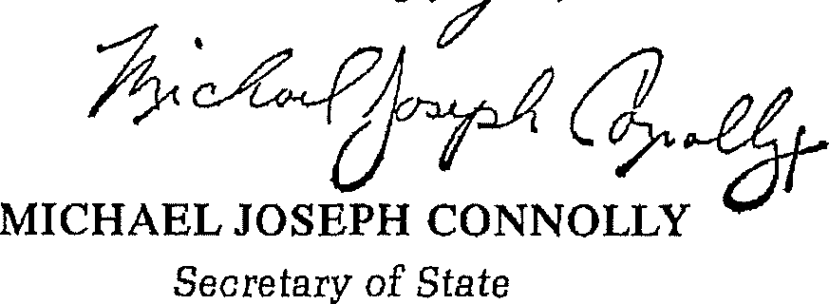
me this /3.,;;yrp.ay of U 19&.,.Z
Effective date

TO BE FILLED IN BY CORPORATION ,
PHOTO COPY OF ARTICLES OF ORGANIZATION TO BE SENT

TO:

Ronald B. Schram

......- :p._e . - . - '!-X...................................
.... ...?. -.r . P:l'.::.l.t.r:i..f?.t.•. r .. 9. '!=:<?n, .. W:\ 9.? ;I)._q
Telephone .....(.6..1.7..)...4..2.3..-.6..1.0..0...........................
Filing Fee $30.00 Copy Mailed OCT 7 1982

Attachment 9

Affidavit of Truthfulness and Compliance

49
93484883_22

Attachment 9

Affidavit of Truthfulness and Compliance

1,,1<0F

"le,

Massachusetts Department of Public Health

J; i\
8
fJl

i
"?v

Determination of Need Affidavit of Truthfulness and Compliance
Version: 7-6-17

lvroFpl.lEI'-'
with law and Disclosure Form 1oo.40S(B)

Instructions: Complete Information below. When complete check the box "This document is ready to print:". This will date stamp and lock the form. Print Form. Each person must sign and date the form. When all signatures have been collected, scan the document and e-mail to: dph.don@state.ma.us Include all attachments as requested,
Application Number: I (3cJ.b-A DI 1 / L/1 / - lff Original Application Date:I 7 _ J1-c,'l c'.) J.-.j I
Applicant Name: he Children's Medical Center Corporation Application Type: Hospital/ClinicSubstantial CapItal Expenditure
Applicant's Business Type: r.Corporation r Limited Partnership r Partnership (' Trust (' LLC (' Other
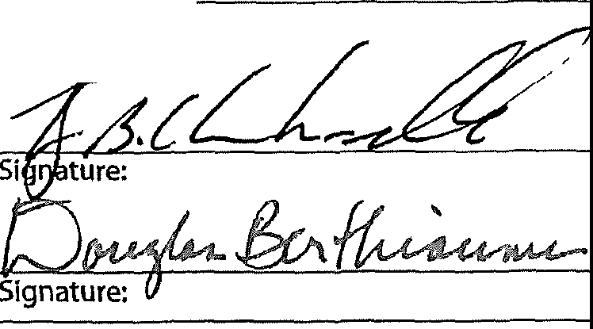
Is the Applicant the sole member or sole shareholder of the Health Facility(ies) that are the subject of this Application? c; Yes I No The undersigned certifies under the pains and penalties of perjury:
1, The Applicant Is the sole corporate member or sole shareholder of the Health Facility[ies] that are the subject of this Application;
- I have been Informed of the contents of 1OS CMR 100.000, the Massachusetts Determination of Need Regulation;
- I understand and agree to the expected and appropriate conduct of the Applicant pursuant to 1OS CMR 100.800;
- I have been informed of the contents of this application for Determination of Need including all exhibits and attachments, and have been informed that all of the information contained herein is accurate and true;
- I have submitted the correct Filing Fee and understand it is nonrefundable pursuant to 1OS CMR 100.40S(B);
- I have submitted the required copies of this application to the Determination of Need Program, and, as applicable, to all Parties of Record and other parties as required pursuant to 105 CMR 100.405{B);
- I have caused, as required, notices of intent to be published and duplicate copies to be submitted to all Parties of Record, and all carriers or third-party administrators, public and commercial, for the payment of health care services with which the Applicant contracts, and with Medicare and Medicaid, as required by 1OS CMR 100.405(0, et seq.;
- I have been informed of proper notification and submissions to the Secretary of Environmental Affairs pursuant to 1OS CMR 100.405(E) and 301 CMR 11.00;
9, If subject to M.G.L. c. 6D, § 13 and 958 CMR 7.00, I have submitted such Notice of Material Change to the HPC - in accordance with 105 CMR 100.405(G);
- Pursuant to 105 CMR 100.21 0(A)(3), I certify that both the Applicant and the Proposed Project are in material and
substantial compliance and good standing with relevant federal, state, and local laws and regulations, as well as with all Notices of Determination of Need issued in compliance with 105 CMR 100.00, effective January 27, 2017 and amended Dec 28, 2018;
- I have been informed of the contents of and understand the limitations on sollcitation of funding from the general public prior to receiving a Notice of Determination of Need as established In 105 CMR 100.415;
- I understand that, if Approved, the Applicant, as Holder of the DoN, shall become obligated to all Standard Conditions pursuant to 105 CMR 100.310, as well as any applicable Other Conditions as outlined within 105 CMR 100.000 or that otherwise become a part of the Final Action pursuant to 105 CMR 100.360;
- Pursuant to 105 CMR 100,705(A), I certify that the Applicant has Sufficient Interest in the Site or facility; and
- Pursuant to 105 CMR 100.705(A), I certify that the Proposed Project is authorized under applicable zoning by-laws or ordinances, whether or not a special permit is required; or,
  - If the Proposed Project is not authorized under applicable zoning by-laws or ordinances, a variance has been received to permit such Proposed Project; or,
  - The Proposed Project Is exempt from zoning by-laws or ordinances.

Corporation:
Attach a copy of Articles of Orgamzation/lncorporatio d
Kevin B. Churchwell
CEO for Corporation Name:
Douglas A. Berthiaume
Board Chair for Corporation Name:

Date

Affidavit of Truthfulness The Children's Medical Center Corporation Page 1 of2

Attachment 10

Filing Fee

1---­
- --I
- 82020

Boston Children's Hospital
f.@J
Until every child 1s well"

VENDOR NAME: COMMONWEALTH OF MASSACHUSETTS DATE: 06/24/2021 CHECK NO. 0001393260
INVOICE | NO. | I | DATE | I | P.O.NO. | I | GROSS | AMOUNT | I | DISCOUNT | I | NET AMOUNT
NONUMBER | 06/23/2021 |  |  | 04857413 |  | 869,382 00 |  |  | 0 00 |  | 869,382 00

.----------REMOVE DOCUMENT ALONG THIS PERFORATION ,
Check No. 0001393260 s-1a1110
Date: June 24, 2021
PAY El
****"*869,382.00
PAY COMMONWEALTH OF MASSACHUSETTS TO THE 67 FOREST ST
ORDER OF MARLBOROUGH MA 01752

E $25,000 :HORIZED SIGNATURE

1

1- - - ....., 1- - - , ,-- - --, 1- - - --,

i- - - ....., ,- - - 7

'----' '----1
'- - - _I '- -- - _I
----' L ,

Attachment 11

HPC ACO Certification Approval Letter

5/27/2021 The HPC Accountable Care Organization (ACO) Certification Program I Mass gov

IL J l

j;

Atrius Health, Inc.

Baycare Health Partners, Inc., inclusive of Pioneer Valley Accountable Care, LLC; and Baystate Health Care Alliance, LLC

Beth Israel Lahey Performance Network, inclusive of Beth Israel Deaconess Physician Organization, LLC (Beth Israel Deaconess Care Organization); Lahey Clinical Performance Network, LLC; and Lahey Clinical Performance Accountable Care Organ1zat1on, LLC

BMC Health System, Inc., inclusive of Boston Accountable Care Organization, Inc.; and BMC Integrated Care Services, Inc.

Cambridge Public Health Commission D/B/A Cambridge Health Alliance

Children's Medical Center Corporation, inclusive of Children's Hospital Corporation; and Boston Children's Health Accountable Care Organization (Boston Children's Accountable Care Organization)

Community Care Cooperative, Inc.

httos.//www.mass aov/serv1ce-deta1ls/the-hpc-accountable-care-organ1zat1on-aco-cert1ficat10n-program 4/6

Attachment 12

Affiliated Parties

pplicant Information

Massachusetts Department of Public Health Determination of Need
Affiliated Parties
Apphcat1onNumber I '6c.,1-I- - CJ/]/L//1- 1+r:.
Version DRAFT
3-15-17
DRAFT

Applicant Name The Children's Medical Center Corporation

Contact Person jD_o_n_n_a_C_a_s_e_y
 | ffiliated Parties
1.9 Affiliated Parties:
List all officers, members of the board of directors, trustees, stockholders, partners, and other Persons who have an equity or otherwise controlling interest m the apphcat1on
Add/ Del Rows |  | Name (Last) | Name (First) |  | Ma1hng Address | City | State | Aff11iat1on | Pos1t1on with affiliated entity  (or with Applicant) | Stock, shares, or partnership | Percent  Eqwty  (numbers only) | Conv1ct1ons or v1olat1ons | List other health care fac1ht1es affiliated with | Business relat1onsh1p with Applicant
[±][:] |  | Berthiaume | Douglas |  | 1B Buttonwood Dnve | Andover | MA | The Children's Hospital  Corporation | Director/Officer |  | 0% | No |  | No
[±l[:] |  | Bufferd | Allan |  | 8 Whitney Road | Newtonv1lle | MA | The Children's Hospital  Corporat1on | D,rector/Officer |  | 0% | No |  | No
[±][:] |  | Churchwell | Kevin |  | 14Baldpate Hill Road | Newton Center | MA | The Children's Hospital  Corporation | Officer |  | 0% | No |  | No
EElG |  | Fishman | Steve |  | 11 Bradford Road | Weston | MA | The Children's Hospital  Corporation | Director |  | 0% | No |  | No
[±][:] |  | Fleisher | Gary |  | 101 Waban Park | Newton | MA | The Children's Hospital  Corporat1on | Director |  | 0% | No |  | No
±][I |  | Henderson | Winston |  | 70 Northampton Street, Apt 101 | Roxbury | MA | The Children's Hospital  Corporation | D,rector |  | 0% | No |  | No
[±][:] |  | Horn | Ivor |  | 581 Manon Ave | Palo Alto | CA | The Children's Hospital  Corporation | Director |  | 0% | No |  | No
i[±][:] |  | Karp | Stephen |  | 3 Possum Road | Weston | MA | The Children's Hospital Corporation | Director |  | 0% | No |  | No
[±][:] |  | Knchmar | Steven |  | 5 Preston Circle | Andover | MA | The Children's Hospital  Corporatron | Director |  | 0% | No |  | No
I[±][:] |  | Langer | Robert |  | 98Montvale Road | Newton | MA | The Children's Hospital  Corporation | Director |  | 0% | No |  | No
ll:BG |  | Laussen | Peter |  | 419 Commonwealth Avenue, Unit 3 | Boston | MA | The Children's Hospital Corporation | Director |  | 0% | No |  | No

j Title Vice President, Business Planning, Analysis, and Budget

Phone 16_1_73_5_5_2_68_3
,, Ext '----' E-mail ldonna casey@chJldrens.harvard.edu

[

Affiliated Parties The Children's Medical Center Corporation 06/30/2021 7 31 am Page 1 of2

Addi Del Rows | Name  (Last) | Name (First) | Mailing Address | City | State | Afflhation | Pos1t1on with affiliated  entity  (or with Applicant) | Stock, shares, or partnership | Percent Equity (numbers only) | Convictions or v1olat1ons | List other health care fac11it1es affiliated with | Business rela1:1onsh1p with  Applicant
BB | Lee | V1v1an | 240 Mercer Street #301 | New York | NY | The Children's Hospital  Corporation | Director |  | 0% | No |  | No
[±][] | Lodish | Havey | 120 Seaver Street, Unit C202 | Brookline | MA | The Children's Hospital  Corporation | Director |  | 0% | No |  | No
BG | Loverman | Gary | 5 Sabrina Farm Road | Wellesley | MA | The Children's Hospital  Corporation | Director |  | 0% | No |  | No
[±J[l | Martin | Ralph | 202B Allandale Road | Chestnut Hill | MA | The Children's Hospital Corporation | Director |  | 0% | No |  | No
BG | Melendez | Thomas | 88 Exeter Street | West Newton | MA | The Children's Hospital  Corporation | Director |  | 0% | No |  | No
l±J[l | Pappend1ck | Wilham | 164 Brattle Street | Cambndge | MA | The Children's Hospital  Corporation | Director |  | 0% | No |  | No
[±JG | Proctor | Mark | 470 Commonwealth Avenue | Newton | MA | The Children's Hospital Corporation | Director |  | 0% | No |  | No
BG | Regan | Kathleen | 72 Willow Street | Brooklyn | NY | The Children's Hospital  Corporation | Director |  | 0% | No |  | No
[£][] | Taunton-  Rigby | Alison | 8 Farrar Road | Lincoln | MA | The Children's Hospital  Corporat,on | Director |  | 0% | No |  | No
BEl | smith | Robert | 35 Cansbrooke Road | Wellesley | MA | The Children's Hospital  Corporation | D1rector/Off1cer |  | 0% | No |  | No
BG | Wielan | Lisa | 16 Elm Street | Wellesley | MA | The Children's Hospital  Corporation | Director |  | 0% | No |  | No
BG | Wolpow | Marc | 17 Clark Road | Wellesley | MA | The Children's Hospital Corporation | Director |  | 0% | No |  | No
BG | Wood | Laura | 59 South Cottage Road | Belmont | MA | The Children's Hospital  Corporation | Director |  | 0% | No |  | No
BG | Young | Gregory | 4 Sundance Way | Natick | MA | The Children's Hospital  Corporation | Director |  | 0% | No |  | No
BG |  |  |  |  | MA
ffi[l |  |  |  |  | MA
BG |  |  |  |  | MA
Document Ready for Filing
When document 1s complete chck on "document 1s ready to file" This will lock m the responses and date and time stamp the form To make changes to the document un-check the "document 1s ready to file" box Edit document then lock file and submit Keep a copy for your records. Chck on the "Save" button at the bottom of the page
To submit the apphcat1on electronically, click on the"E-mail subm1ss1on to Determination of Need" button

This document is ready to file: IZ]
pate/tlipe sr,iittp.jt:i6J)Ol2 '.?,l :31a
--- -----=':::';- '--' " -
' ' --7
E-mail submission to
Determination of Need

Affiliated Parties The Children's Medical Center Corporation 06/30/2021 7·31 am Page 2 of2

Attachment 13

Change in Service

Application Number 'B_C_H_-2_1_0_7_14_1_1_-H_E
Applicant Information

Massachusetts Department of Public Health Determination of Need
Change in Service

Original Application Date io-7/15/-202-1---------

VerSIOIJ_ DRAFT 6-14-17
DRAFT

Applicant Name The Children's Medical Center Corporation

Contact Person JD_o_n_n_a_M_C_as_e_y
I Title Vice President, Strategic Business Planning & Budget

Phone
ldonna casey@ch!ldrensharvard.edu

2.2 Complete the chart below with existing and planned service changes Add add1t1onal services with in each grouping 1f applicable
dd/Del |  | Licensed Beds  Existing | Operating Beds  Existing |  | Change in Number of Beds ( +/-)  Licensed Operating |  | Number of Beds After Project Completion (calculated)  Licensed Operating |  | Patient Days  (Current/ Actual) |  | Patient Days  Projected | Occupancy rate for Operating Beds  Current Beds Projected |  | Average Length of Stay  (Days) | Number of Discharges  Actual | Number of Discharges  Projected
Rows
 | Acute
 | Med1cal/Surg1cal |  |  |  |  |  |  |  |  |  |  |  | 0% 0%  0% 0%
 | Obstetrics (Maternity)
 | Ped1atncs | 272 | 283 |  |  |  | 272  24  108  11  415 | 283  24  97  11  415 | 81,488  7,817  27,932  775  118,012 |  | 81,488  7,817  27,932  775  118,012 | 79% 79% 44 18,267 18,267  89% 89% 229 341 341  79% 79% 214 1,301 1,301  19% 19% 1 02 757 757  78% 78% 4972 20,666 20,666  0% 0%
 | Neonatal Intensive Care | 24 |  | 24  97  11
 | ICU/CCU/SICU | 108
[±][J | Waltham Ped1atncs | 11
 | Total Acute | 415 | 415
 | Acute Rehabilitation
+ - |  |  |  |  |  |  |  |  |  |  |  |  | 0% 0%  0% 0%
 | Total Rehab1htation
 | Acute Psychiatric

Change in Service The Children's Medical Center Corporation BCH-21071411-HE 07/14/20211207 pm Page 1 of4

\dd/Del Rows |  | Licensed Beds  Existing | Operating Beds  Existing | Change in Number of Beds  (+/-)  Licensed Operating |  | Number of Beds After ProJect Completion (calculated)  Licensed Operating |  | Patient Days  (Current/ Actual) | Patient Days  Projected | Occupancy rate for Operating Beds  Current Beds ProJected |  | Average Length of Stay (Days) | Number of Discharges  Actual | Number of Discharges  Projected
 | Adult |  |  |  |  |  |  |  |  | 0% | 0%
 | Adolescent |  |  |  |  |  |  |  |  | 0% | 0%
 | Ped1atnc |  |  |  |  |  |  |  |  | 0% | 0%
 | Genatnc |  |  |  |  |  |  |  |  | 0% | 0%
+lr-l |  |  |  |  |  |  |  |  |  | 0% | 0%
 | Total Acute Psychiatric |  |  |  |  |  |  |  |  | 0% | 0%
 | Chronic Disease |  |  |  |  |  |  |  |  | 0% | 0%
+lr-l |  |  |  |  |  |  |  |  |  | 0% | 0%
 | Total Chronic Disease |  |  |  |  |  |  |  |  | 0% | 0%
 | Substance Abuse
 | detox1ficat1on |  |  |  |  |  |  |  |  | 0% | 0%
 | short-term intensrve |  |  |  |  |  |  |  |  | 0% | 0%
+11-i |  |  |  |  |  |  |  |  |  | 0% | 0%
 | Total Substance Abuse |  |  |  |  |  |  |  |  | 0% | 0%
 | Skilled Nursing Facility
 | Level II |  |  |  |  |  |  |  |  | 0% | 0%
 | Level Ill |  |  |  |  |  |  |  |  | 0% | 0%
 | Level IV |  |  |  |  |  |  |  |  | 0% | 0%
+II-I |  |  |  |  |  |  |  |  |  | 0% | 0%
 | Total Skilled Nursing |  |  |  |  |  |  |  |  | 0% | 0%

Change 1n Servrce The Children's Medical Center Corporation BCH-21071411-HE 07/14/20211207pm Page 2 of 4

2 3 Complete the chart below If there are changes other than those listed in table above
Add/Del Rows | List other services 1f Changing e.g OR, MRI, etc | Existing Number of Units | Change in Number+/- | Proposed Number of Units | Existing Volume | Proposed Volume
BG | Waltham OR | 6 | 0 | 6 | 471,559 | 499,474
[±][l | Lexington OR | 4 | -4 | 0 | 186,242 | 0
tEl G | Needham OR | 0 | 8 | 8 | 0 | 584,571
[±] [:] | Longwood OR | 24 | 0 | 24 | 2,766,251 | 3,300,702
tEl G
[±] [:] | Longwood MRI | 8 | 0 | 8 | 169,511 | 193,369
[±1 [:] | Peabody MRI | 1 | 0 | 1 | 10,259 | 11,857
[±] [:] | Waltham MRI | 1 | 0 | 1 | 41,139 | 20,570
[±1 [:] | Needham MRI | 0 | 1 | 1 | 0 | 14,500
[±] [:] | Weymouth MRI | 0 | 1 | 1 | 0 | 14,500

Change in Service The Children's Medical Center Corporation BCH-21071411-HE 07/14/20211207pm Page 3 of 4

Document Ready for Filing
When document 1s complete click on "document 1s ready to file". This w1ll lock in the responses and date and time stamp the form To make changes to the document un-check the "document 1s ready to file" box.
Edit document then lock file and submit Keep a copy for your records Chck on the "Save" button at the bottom of the page
To subm1tthe application electronically, chck on the"E-ma1l subm1ss1on to Determination of Need" button
This document is ready to file: lZl Date/t1meStamp Jo7/14/20211207pm j

E-mail subm1ss1on to Determination of Need

Change 1n Service The Children's Medical Center Corporation BCH-21071411-HE 07/14/202112 07 pm Page4of4

