Charles D. Baker  Governor  Karyn E. Polito  Lieutenant Governor  Thomas A. Turco, III  Secretary of Public Safety and Security |  |  | Terrence Reidy  Undersecretary  Chief Robert J. Ferullo, Jr. ret.  Interim Executive Director

 | Commonwealth of Massachusetts  Municipal Police Training Committee  “Training for Today, Planning for the Future” | 6 Adams Street  Randolph, MA 02368  Phone: (781) 437-0300  Fax: (781) 963-0235 | 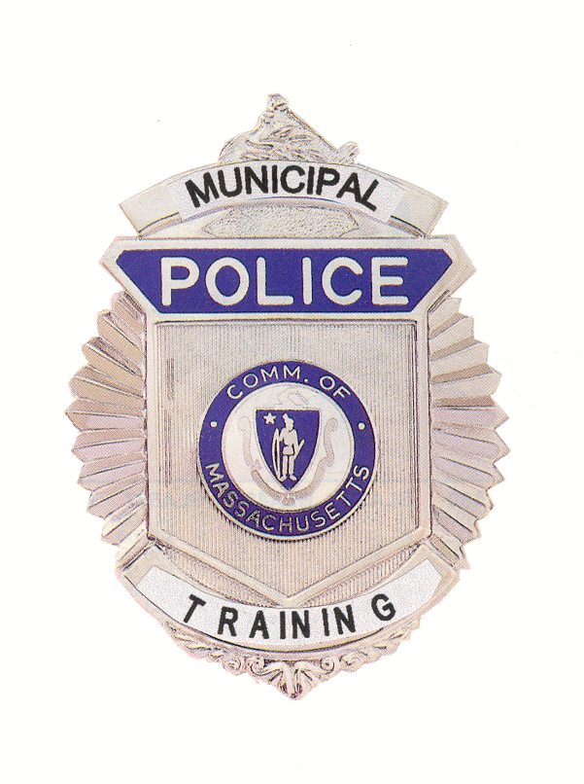

MEMORANDUM

TO: Secretary of State
(delivered via email to regs@sec.state.ma.us )
Department of Administration and Finance
(delivered via email to Melissa.andrade@state.ma.us )

FROM: Chief Robert J. Ferullo, Jr., (ret.)

Interim Executive Director

DATE: April 22, 2020

RE: Notice of Special Open Meeting
_____________________________________________________________________________________________

NOTICE OF SPECIAL OPEN MEETING

Under the provisions of M.G.L. c. 30A, The Municipal Police Training (Committee) will hold a Special Meeting via Zoom virtually on Friday April 24, 2020 at 11 am.

To join this Zoom Meeting on computer, laptop, tablet or smartphone with speakers and microphone, use this link: https://zoom.us/j/98970454781?pwd=QjNERXFYSVYzTGpuN24vaWs4N3dZQT09

Meeting ID: 989 7045 4781 Password: 214594 Dial in - 1-929-436-2866

AGENDA

1. Curriculum issues with ongoing academies.
2. In-service topics 20-21
3. In-service scheduling issues 19-20
4. Other COVID-19 related issues that may legally come before the committee

