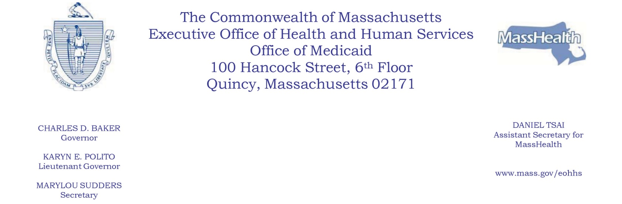
NOTICE OF PROPOSED AGENCY ACTION

SUBJECT: MassHealth Payment Policies for Disaster-Struck Nursing Facilities

AGENCY: Massachusetts Executive Office of Health and Human Services (EOHHS)

EOHHS is amending its Medicaid State Plan to clarify policies related to MassHealth payments to disaster-struck nursing facilities for MassHealth members who must be temporarily evacuated to another facility for up to 30 days after the disaster event. Payment will be the same as if the member were residing in the disaster-struck nursing facility, and no other payment will be made to either facility for evacuated members.

A disaster-struck nursing facility must meet the following conditions in order to receive payment for evacuated MassHealth members.

- The disaster-struck facility must have a contract with the facility accepting the evacuated member. The contract must include: (i) terms of reimbursement and mechanisms to resolve any contract disputes; (ii) protocols for sharing care and treatment information between the two facilities; and (iii) requirements that both facilities meet all conditions of Medicaid participation, as determined by MassHealth.

- The disaster-struck facility must notify MassHealth of the disaster event; maintain records of all evacuated individuals that include each member’s name, date of evacuation, and accepting facility; and update MassHealth on the status of any necessary repairs.

- The disaster-struck facility must determine within 15 days of the disaster event whether evacuated members will be able to return to the facility within 30 days of the disaster event. If the disaster-struck facility determines that it is not able to reopen within 30 days, it must discharge all evacuated members and work with them to choose admission to other facilities or alternative placements. Nothing shall preclude an evacuated member from requesting to be discharged and admitted to another facility or alternative placement. Payment to the disaster-struck facility shall cease when a member is discharged from the facility.

EOHHS is making these changes to ensure continuity of care for MassHealth members residing in nursing facilities during disaster events. The changes are projected to have no impact on annual aggregate MassHealth expenditures.

Individuals may submit written comments by emailing ehs-regulations@state.ma.us. Please submit electronic comments as an attached Word document or as text within the body of the email with “Reimbursement for Disaster-Struck Nursing Facilities” in the subject line. All submissions must include the sender’s full name and address. Individuals who are unable to submit comments by email should mail written comments to EOHHS, c/o D. Briggs, 100 Hancock Street, 6th Floor, Quincy, MA 02171. Copies of the proposed changes are available at EOHHS or may be viewed at EOHHS’s website at https://www.mass.gov/service-details/executive-office-of-health-and-human-services-public-notices.

Posted: July 26, 2019

