Gary J. Lambert
Assistant Secretary for Operational Services
The Commonwealth of Massachusetts
Executive Oﬃce for Administration and Finance
Operational Services Division
Maura Healey, Governor
Kim Driscoll, Lieutenant Governor
Matthew Gorzkowicz, Secretary

NOTICE OF POLICY CHANGES TO
Fiscal Year 2023 UFR Audit and Preparation Manual

- The Commonwealth of Massachusetts has established a new reimbursable annual rate for the salaries of officers and managers in accordance with 808 CMR 1.02 (24) Salaries of Officers and Managers. The fiscal year 2023 reimbursable amount for the salaries of officers and managers is $___ 199,537.88____.

- Workforce Investing Funding Under 101 CMR 452 and 101 CMR 453

Certain rates received additional funding for Workforce Investment during fiscal year 2023 (July 1, 2022 – June 30, 2023). At least 90% of these funds must be used for direct care workforce development, which could include hiring and retention bonuses and other categories of worker compensation. The Executive Office for Health and Human Services (EOHHS) has previously provided the following examples of how the funds may be used.
- Recruitment” defined as offering of incentives and/or onboarding/training.
- “Bonuses” defined as added compensation that is over and above an hourly rate of pay and are not part of an employee’s standard wages. An employee may receive a retention or recruitment bonus.
- “Overtime” defined as compensation for additional hours worked beyond the employer’s standard work week.
- “Shift differential” defined as additional pay beyond the employee’s standard hourly wage for working a specific shift (e.g., nights, weekends, holidays, etc.) or working for special populations (dementia, autism spectrum disorder, etc.).
- “Hourly wage increase” defined as an increase to the wage the provider agrees to pay an employee per hour worked.
- "Wraparound benefits” defined as employer provided benefits to help the workforce remain employed. Examples include public transportation or shared ride reimbursements, meal vouchers, or grants for childcare or elder care assistance or regular car maintenance. Other examples include paying for testing or certification materials, continuing education credits (CEUs), or exam fees to encourage retention of staff moving up in the career ladder.

EOHHS has concluded that providers are considered beneficiaries and not subrecipients with respect to any Federal funds included in this funding. As a result, any such Federal funds provided under 101 CMR 452 and/or 101 CMR 453 are not subject to the Federal Single Audit Requirements.

Providers have until September 30, 2023, to expend the funds.
Providers receiving this funding will be required to submit an attestation by December 31, 2023, assuring EOHHS that they have used at least 90% of the funds for direct care workforce development as noted above.
Providers receiving this funding must also submit a spending report to EOHHS by December 31, 2023, that accounts for how the enhanced funds were used.
For additional information please see:
https://www.mass.gov/regulations/101-CMR-45200-supplemental-rates-for-workforce-investment-for-certain-health-and-human-services-programs-0
https://www.mass.gov/regulations/101-CMR-45300-enhanced-rates-for-certain-home-and-community-based-services-related-to-section-9817-of-the-american-rescue-plan-act-0

Questions regarding this funding should be submitted to:

EOHHSProviderCOVIDCost@mass.gov

Other Workforce Related Funding

During fiscal year 2023 (July 1, 2022 – June 30, 2023) , EOHHS announced its intent to enter into payment agreements with human services providers whose rates are subject to review and implementation under Chapter 257 of the Acts of 2008 and as set forth in a directive from the General Court of the Commonwealth to EOHHS in Chapter 268 of the Acts of 2022 (the “Economic Development Law”) at Section 2, line item 1599-6066.

As a result, EOHHS has determined that providers receiving funding under certain rates would receive a one-time payment equal to 3% of its EOHHS agency’s total payments to the provider for the provision of the respective social service program in fiscal year 2022.

This funding must be used to increase payments to direct care, front-line and medical and clinical staff, which may include, but shall not be limited to, hourly rate increases, wraparound benefits, shift differentials, overtime, hiring and retention bonuses or recruitment, as defined by EOHHS.

It appears these funds must be expended by December 31, 2023, but providers should consult with their specific EOHHS agencies for the specific dates by which these funds must be expended.

Providers who receive this funding will be required to submit a written attestation regarding the use of the funds in the form and format as required by EOHHS. Information about the written attestation submission process, including the deadline for the submission, will be provided in a future communication.
EOHHS’ Notice of Intent regarding this funding including the specific Chapter 257 rates affected can be found at:

https://www.commbuys.com/bso/external/bidDetail.sdo?docId=BD-23-1039-EHS01-EHS02-83566

Providers should submit questions regarding this funding to their specific EOHHS agency providing the funding or EOHHS.

EOHHS may be contacted at:

EOHHSProviderCOVIDCost@mass.gov

Questions and answers

- Question
How should any federal or state COVID-19 or Workforce (as described or similar to the Workforce funding noted above) related funding and related expenses be reported as revenue and expenses on the UFR? Are these funds reported with programs to which they are related, or do they need to be reported separately?

Answer
Any federal or state COVID-19 or Workforce (as described or similar to the Workforce funding noted above) related funding and related expenses should be reported as revenue and expenses in the applicable programs and line items to which the funding and expenses are related. Any such COVID-19 or Workforce related funding and related expenses are not to be reported separately from an organization’s applicable existing programs and the applicable line items on the UFR to which the COVID-19 or Workforce related funding and related expenses are related. This means any federal or state COVID-19 or Workforce related funding and the related expenses should not be reported as separate programs on the UFR but rather should be reported with the program(s) to which they are related on the UFR.

- Question
How should any federal or state COVID-19 related funding that is recognized as revenue in the current reporting year for which the related expenses were incurred and reported in a prior year UFR be reported in the current reporting year UFR?

Answer
Any federal or state COVID-19 related funding that is recognized as revenue in the current reporting year UFR for which the related expenses were incurred and reported in a prior year UFR should be reported on Line 23 – Other Increases (Decreases) on the Statement of Activities (SOA) in the current reporting year UFR Template. For-profit organizations should similarly report any COVID-19 related federal or state funding that is recognized as revenue in the current reporting year for which the related expenses were incurred and reported in a prior year UFR as other increases in their current reporting year non-UFR format financial statements (i.e., on the Income Statement or similar financial statement). This means any federal or state COVID-19 related funding that is recognized as revenue in the current reporting year for which the related expenses were incurred and reported in a prior year UFR is not reported in any of the Supplemental Schedules of the current year reporting UFR for both nonprofit and for-profit organizations and should be reported as noted above. As needed, a reconciliation of the reporting of any such Commonwealth of Massachusetts COVID-19 related funding to any such funding included in the POS Expenditure and Federal Funds Listing – Fiscal Year 2023 should be attached to the UFR.

Approved Federal Indirect Cost Rate (FICR)
Contractors receiving federal assistance which have an approved federal indirect cost rate may utilize the federal approved method of cost allocation utilized to establish the approved federal indirect cost rate. Please include a copy of the approval letter with the submission of the UFR.

UFR Extension Requests/MAB Allocation Plan/Regulation Waiver Requests

Effective June 30, 2022, OSD no longer accept Extension Requests, Waiver Requests and MAB Allocation plan Requests through the UFR eFiling system. All requests must be submitted using our online form, which is located on the OSD’s UFR homepage under Request Forms. These requests can be found at:

https://maosd.formstack.com/forms/ufr_extension_allocation_waiver_forms

Please review this page and follow the instructions for inputting your data when you are requesting either an Extension Request, a Waiver Request, or a MAB Allocation Plan Request.

Any questions or concerns should be submitted to ufrefilehelp@mass.gov.

UFR License Agreement

The Operational Services Division (OSD) administers the Uniform Financial Reporting (UFR) System pursuant to a license agreement with the UFR software vendor. OSD has acquired a single license for use by your organization.

Please fill in, sign, and upload the UFR license agreement form. After signing the form, name the file Vendor_UFRLicense (for Vendors), CPA_UFRLicense (for CPAs), and Agency_UFRLicense (for State Agencies). The UFR License Agreement letter is located on the OSD’s UFR homepage under Manuals and Regulations. The Agreement letter can be found at:

www.mass.gov/files/documents/2023/08/11/UFR%20License%20Agreement%20Letter.pdf

Follow the instructions below to upload the form. If you have additional questions, please email ufrefilehelp@mass.gov.

- Who must upload the UFR license?
All new contractors, certified public accountants (CPAs), state agencies with a profile, username and password.

- When is this UFR license must be uploaded?
Once, the contractor receives the confirmation email from the UFR efiling system.

- Where is the UFR license must be uploaded?
The UFR license must be uploaded in the contractor’s current year home page.

- What if a Certified Public Accountants firm has multiple clients
Firms with multiple clients must upload their UFR_license in each of their client’s home page.

- What will happen if the UFR license is not uploaded?
Contractors and/or CPAs that failed to upload their UFR license will not be able to access the home page.

- How to upload the UFR license for contractor

To upload document
In the Create or Review UFRs box in the left margin, click the File for Extension choice.
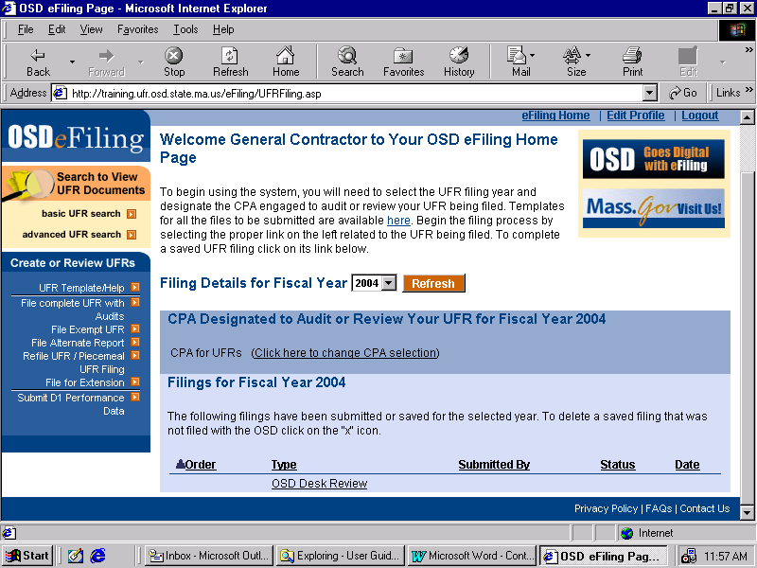

Select a Fiscal Year from the dropdown box and click Upload Documents >>.
The Information Upload page will appear for the File for Extension.
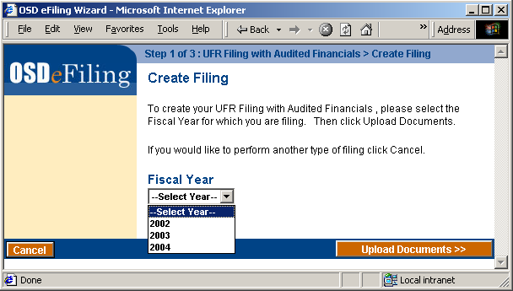

For this filing, please check the “Other” box in the Required Documents Check List window and
Contractors must type, Contractors_UFR License
Certified Public Accountants must type : CPAs_UFR License
State Agencies must type : Agencies_UFR License

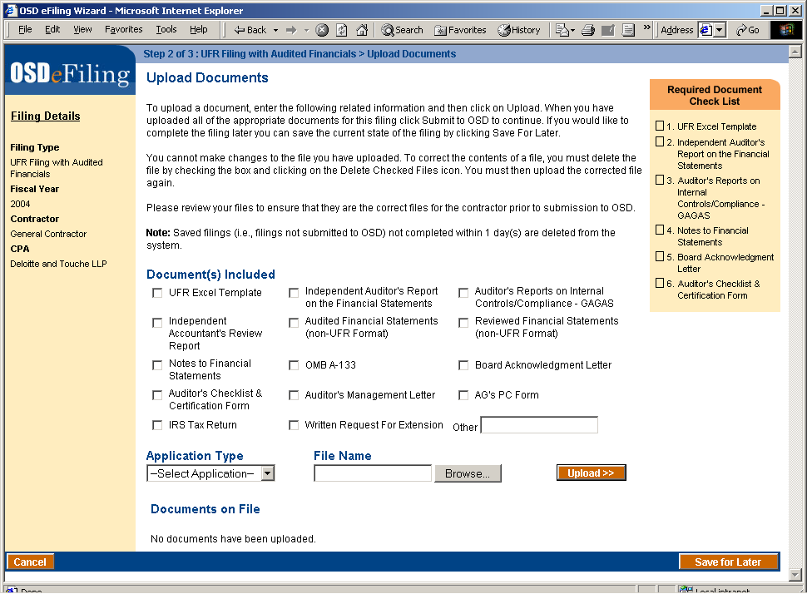

Then select the type of file being uploaded from the Application Type dropdown list.

To select the file to upload, click the Browse button.

The Choose File file browser will appear.

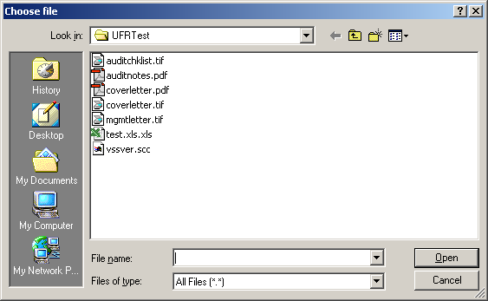

Select the file by clicking to the appropriate directory and double-clicking the desired file.

Click the Upload button. The please wait screen will appear.

Upon successful completion of the upload, the Upload Files screen will reappear. The document just uploaded will appear in the list of Documents on File.
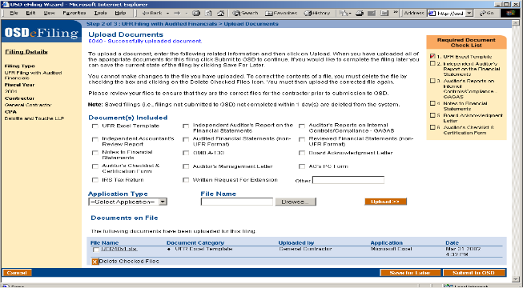

Clicking on the file name will bring up the OSD eFiling Document Viewer.

NOTE: It is possible to save the filing for later by clicking the Save for Later button. However, any unsubmitted documents and filings left for more that 24 hours will be deleted.

Once you have uploaded all of the required documents and any other documents you wish to include in the filing, click the Submit to OSD button. The Please Wait screen will appear.

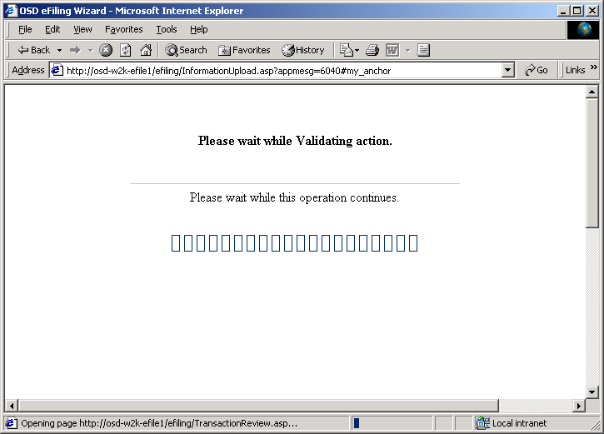

Upon successful validation of the filing, the Review filing screen will appear. The information that is displayed is:

- Fiscal Year
- Contractor contact information
- CPA Contact information
- Documents on File

NOTE: At this point, the uploaded documents are still being staged in the eFiling system. Carefully review this information prior to final submission to OSD to ensure that this is the correct information to be submitted for the UFR Filing.

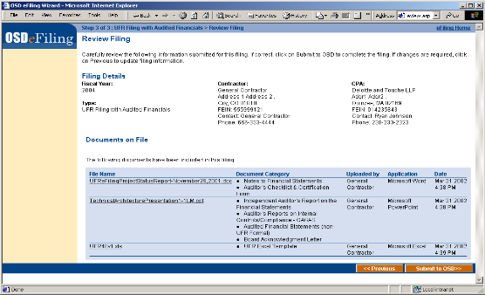

If all the required documents are present, click Submit to OSD. The Please Wait Screen will appear.

When the Submittal is finished, the Filing Receipt and Confirmation screen appears. The following information is displayed in the window:
  - Who submitted the filing to OSD,
  - When the filing was submitted.
  - Receipt Number
  - Fiscal Year
  - Contractor contact information
  - CPA Contact information
  - Documents on File

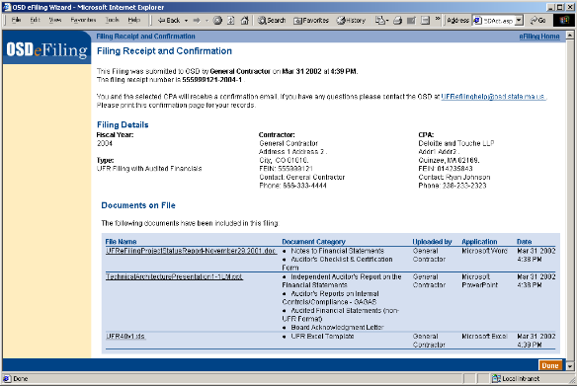

A confirmation e-mail will be sent to your email address as well as your CPA, as given in your profile. This e-mail will contain a summary of the information that was presented to you in the Filing Receipt.

