Massachusetts Department of Environmental Protection
Bureau of Water Resources – Water Management Act Program
Notification of Golf Course Water Use Restriction
Important: When filling out forms on the computer, use only the tab key to move your cursor - do not use the return key.  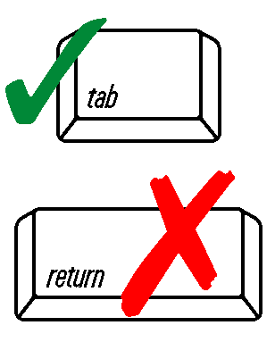 | MassDEP regulations (310 CMR 36.07(2) and 36.28(3)) allows for the inclusion of water conservation measures in WMA registrations and permits that are appropriate to the use. WMA registrations and permits may require MassDEP notification within 14 days when specific water conservation measures are implemented. Proper completion and submission of this form may serve as that notification. MassDEP requests that any golf course implementing an irrigation restriction, amending, or ending a restriction, complete and submit this form. Please return this form to: MassDEP WMA Program, 100 Cambridge Street 9th floor, Boston, MA 02114, or email to: linjun.yao@mass.gov.
 | A. Responsible Party Information
 | Golf Course Name |  | Registration/Permit #
 | Contact Person/Title |  | Today’s Date
 | Telephone Number |  | Email
 | Golf Course Address
 | B. Restriction Details
 | 1. Effective date: |  | Effective Date of Restriction
 | 2. WMA Registration/Permit Action Level Based on (check one):
 | MA Drought Management Task Force Declaration
 | 1. Mild Drought 2. Significant Drought 3. Critical Drought 4. Emergency
 | OR USGS Stream Flow Gage: | Gage ID # |  | Gage Trigger Value (cfs)
 | OR Non-WMA Permit Reason: | Please provide details
 | 3. Irrigation Reduction
 | Reduction determined by: Reduction in Irrigation Minutes Reduction in Irrigated Acres
 |  |  | From (Minutes or Acres) |  | To (Minutes or Acres)
 | Irrigated Tees and Greens
 | Irrigated Fairways
 | Irrigated Roughs
 | Irrigated Landscapes & Ornamentals

