Massachusetts Department of Environmental Protection
Bureau of Water Resources – Water Management Act Program
Notification of Water Use Restriction (PWS)
Important: When filling out forms on the computer, use only the tab key to move your cursor - do not use the return key.  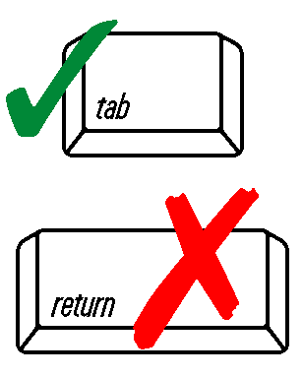 | MassDEP regulations (310 CMR 22.15(8)) require that all public water systems establishing mandatory restrictions on water use notify the Department in writing within 14 days of the effective date of these restrictions. This notice must include a description of the appropriate regulations, bylaws or ordinances imposing the restriction. Proper completion and submission of this form may serve as that notification. MassDEP also requests that systems implementing a voluntary water use restriction, amending, or ending a restriction, complete and submit this form. Please return this form to: MassDEP WMA Program, 100 Cambridge St. Suite 900, Boston MA 02114 or email to: Brittany.Segill@mass.gov
 | A. Responsible Party Information
 | PWS Name |  |  |  | PWS ID #
 | Contact Person/Title |  |  |  | Today’s Date
 | Telephone Number |  |  |  | Email
 | B. Water Use Restriction Details
 | 1. This restriction is: mandatory voluntary
 | 2. Effective date: |  |  |  | Effective Date of Restriction
3. Specify the action being taken: Implementing a restriction Raising level of restriction
Easing a restriction Ending a restriction
 | 4. Reason for implementing restriction. For restrictions imposed by a WMA permit, specify one of the first 3 boxes:
 | Calendar trigger (May 1 – Sept. 30)
 | USGS streamflow trigger: | USGS Gage ID # |  |  |  | Streamflow Trigger Value (cu ft/sec.)
 | Other WMA permit or registration condition:
 | Non-WMA reason:
 | 5. Restriction details (check all that apply). Please attach a copy of your notice.
 | Number of days per week allowed (specify # of days per customer):
 | Hours of day allowed (specify):
 | Certain uses restricted (specify):
 | Ban on all non-essential outdoor water use
 | C. Notification of Enforcement
 | 1. How will your customers be notified of this action (newspapers, signs, reverse 911, etc.)?
 | 2. How will this restriction be enforced (water department staff, police, citations, etc.)?
 | 3. Cite local bylaw, regulation, or ordinance that authorizes mandatory restrictions.

