The Commonwealth of Massachusetts
Executive Office of Health and Human Services
Department of Public Health
250 Washington Street, Boston, MA 02108-4619
617-624-6000 | mass.gov/dph


Maura T. Healey
Governor
Kimberley Driscoll
MA State Public Health Laboratory
CLIA # 22D0650270
Lieutenant Governor
Kiame Mahaniah, MD, MBA
Secretary
Robert Goldstein, MD, PhD
Commissioner
www.mass.gov/state-public-health-laboratory-services

TO: Clinical Laboratory Directors and Submitters

FROM: Nicolas Epie PhD, HCLD, TS (ABB); MLS(ASCP)
Laboratory Director, MA State Public Health Laboratory

RE: Notification Regarding Massachusetts SPHL Manual of Laboratory Tests and Services

DATE: November 10, 2025

As a valuable partner of the MA State Public Health Laboratory, we are sending this message to keep you informed about the recent changes in our testing guidelines and procedures. This notification is intended to provide you with important information needed for patient care.

We sent a memo in August 8, 2025 regarding the updated Manual of Laboratory Tests and Services (MLTS) regarding our specimen collection, shipping and storage requirements.
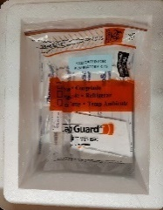
Please note the following transport recommendation updates that are critical to assuring specimen integrity and require strict adherence to the regulatory compliance for specimen acceptability:
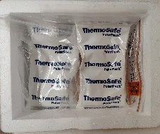
Refrigerated (2-8°C) Specimens:
- Utilize pre-frozen cold packs
- Sandwich specimen bags with pre-frozen cold packs
- Send to MA SPHL same day delivery via Courier
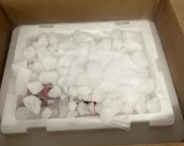
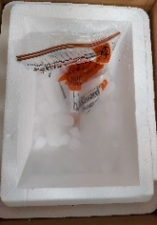
Frozen (≤-20°C) Specimens:
- Pack dry ice in polystyrene foam cooler
- Place dry ice at the bottom
- Place specimens in cooler
- Cover the specimens with dry ice (submerge specimen)
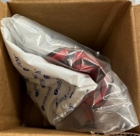
- Send to MA SPHL next day delivery

Room Temperature Specimens:
- Utilize unfrozen room temp gel packs
- Wrap/sandwich specimens transport bags.

For any questions and/or regarding this update, please contact MA SPHL-Quality at MASPHL-Quality@mass.gov

