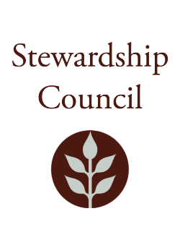

Stewardship Council Meeting
Thursday, November 13, 2025| 9:00AM to 11:00AM
Conducted via Videoconference

Agenda

TOPIC | SEGMENT
Welcome and Chair’s Update – Dicken Crane, Chair | 9:00 – 9:10 AM
DCR Report – Kendra Amaral, Deputy Commissioner | 9:10 – 9:30 AM
Regular Business I  - Erving Complex Resource Management Plans Presentation – Paul Cavanagh, Resource Management Planner  - Approve Minutes: October 9, 2025  - Public Comment | 9:30 – 10:45 AM
Regular Business II  - Vote on Approval of Otter River Complex RMPs  - Approval of 2026 Meeting Dates  - Committee Updates  - Councilor Comments | 10:45 – 11:00 AM
Adjourn | 11:00 AM

Zoom Meeting Information

Meeting of the DCR Stewardship Council
You are invited to register for a Zoom webinar!

When: Nov 13, 2025 09:00 AM Eastern Time (US and Canada)
Topic: November 13, 2025 DCR Stewardship Council Meeting

Register in advance for this webinar.

After registering, you will receive a confirmation email containing information about joining the webinar.

Please contact Matt Perry at matthew.s.perry1@mass.gov for accessibility information.
11/6/2025 11:23 AM

