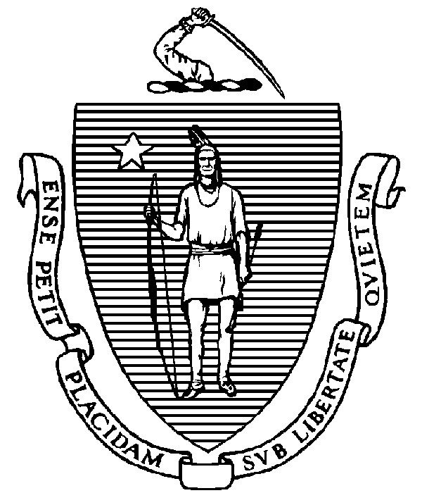
THE COMMONWEALTH OF MASSACHUSETTS
EXECUTIVE OFFICE FOR ADMINISTRATION AND FINANCE
STATE HOUSE ▪ ROOM 373
BOSTON, MA 02133
TEL: (617) 727-2040
FAX: (617) 727-2779
www.mass.gov/eoaf

NOTICE OF PUBLIC MEETING

Capital Debt Affordability Committee

Friday, November 18, 2022 1:00 p.m.
In accordance with Section 20 of Chapter 20 of the Acts of 2021, as extended by Chapter 107 of the Acts of 2022, this meeting will be conducted, and open to the public, via Zoom and Teleconference.
Zoom URL: https://mass-gov-anf.zoom.us/j/83548928062?pwd=WXUydlJ2ZHNtc2dUc2hUR21EWTE0dz09 Zoom Password: DAC111822
Teleconference line: 713-353-7024; Conference code: 319738

AGENDA

- Administrative Matters
  - DAC membership update
  - Adoption of meeting minutes from October 28, 2022 (Vote)

- DAC Bond Cap Recommendation Modeling

- DAC New Reporting Requirement Cont. Discussion
  - Reducing debt service and increasing bond ratings

- Adjournment

