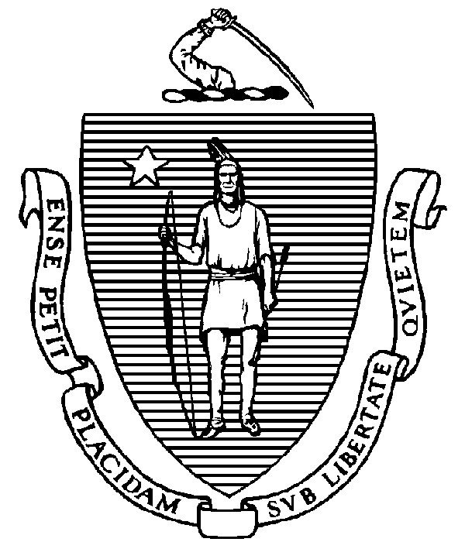
THE COMMONWEALTH OF MASSACHUSETTS

EXECUTIVE OFFICE FOR ADMINISTRATION AND FINANCE STATE HOUSE ▪ ROOM 373 BOSTON, MA 02133 TEL: (617) 727-2040

FAX: (617) 727-2779 www.mass.gov/eoaf

NOTICE OF PUBLIC MEETING

Capital Debt Affordability Committee

Friday, November 19, 2021 1:00 p.m. In accordance with the Governor’s Executive Order Suspending Certain Provisions of the
Open Meeting Law, G.L. c. 30A, § 20, signed and dated March 12, 2020, this meeting will be conducted, and open to the public, via Zoom video and teleconference.
Zoom: URL: https://mass-gov-anf.zoom.us/j/86554815985?pwd=ODEzcDR5a04xdmg0ZTNXWU5wUXBxQT09; Password: DAC111921
Teleconference line: 713-353-7024; Conference code: 319738

AGENDA

- Administrative Matters
• Adoption of meeting minutes and presentation from October 22, 2021 (Vote)

- Debt Affordability Modeling Review

3. Adjournment

