Massachusetts Attorney General’s Office Public Charities Online Filing Portal Instructions

Table of Contents

Links to Access 2

How to Sign Up for The Portal 2

When to Submit an Initial Charity Registration 3

Submitting an Initial Charity Registration 3

Submitting an Annual Form PC Filing 3

Completing the Annual Form PC Filing in Multiple Sittings 9

How to Share a Draft of Form PC 11

How to Electronically Sign the Annual Form PC Filing/Schedule A2 12

How to Recall a Filing for Editing 13

How to Submit a Payment for a Charity’s Registration/Annual Form PC Filing/Schedule A2 14

How to Submit Miscellaneous Charity-Related Documents 15

# Links to Access

* [Charity Initial Registration eForm](https://masscharities.my.site.com/CharityRegistration/s/)
* [Charity Portal](https://masscharities.my.site.com/CharityPortal/s/) (Annual Form PC Filing, Schedule A2, and Payment Access)

# 

# How to Sign Up for The Portal

1. From the Portal website, click on the “Create a new user account” text.

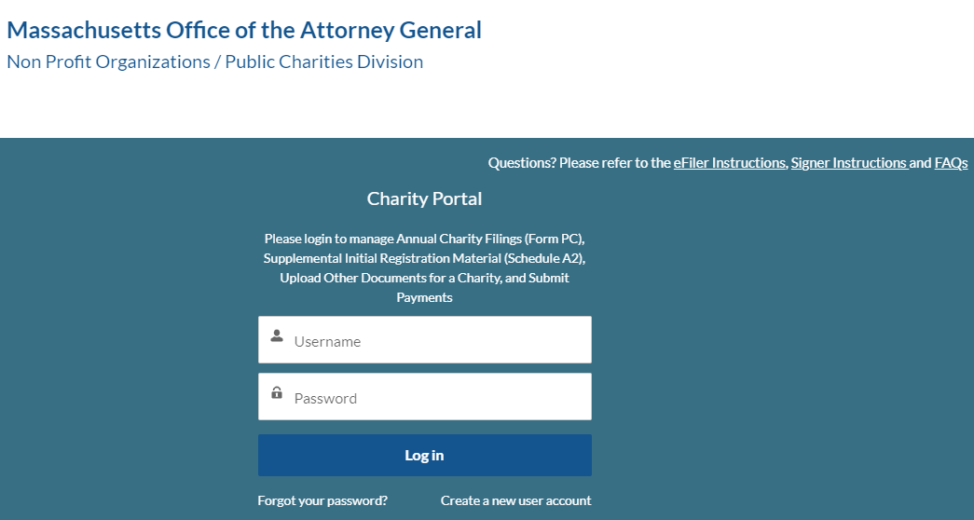

1. Enter the requested fields: first name, last name, and email.

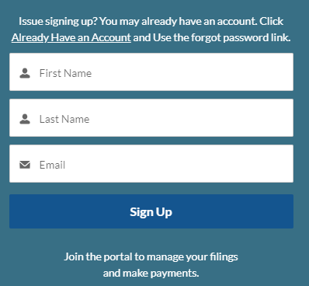

**Note:** If you are signing up via a link through email (i.e. if you have been assigned as a reviewer for a filing), you **must** use the same email address you received the link through to sign up.

Failure to do so will result in not having access to review that filing.

1. Go to your email inbox and look for the email from Salesforce.
2. Click on the link provided in the email.
3. Change your password.

# When to Submit an Initial Charity Registration

If the charity has never registered with the AGO (and does not have an Attorney General Account Number), gather the required information:

1. The Registration eForm requires basic information about the charity, such as address, contact information, type of organization (e.g., corporation, trust), and IRS tax exempt status.
2. In addition, you will also need electronic copies (pdf, doc, docx) of the following attachments:
   1. Organization’s charter, articles of organization, agreement of association, instrument of trust, or written statement of purpose, whichever is applicable.
   2. List of the current officers/directors and their addresses.
   3. Organization’s By-laws.
   4. IRS letter designating the organization’s 501(c) status if the organization has received one.

# Submitting an Initial Charity Registration

1. Use the link provided above to navigate to the Registration eForm. This initial Registration eForm is not accessible from the Portal.
   * Note: you will not have to sign into your Portal account to complete this step. Please provide accurate emails on the Registration, as these are the emails through which the AGO will contact the charity regarding the status of its registration.
2. Fill out the information in the Registration eForm. This is a short form and **must be done in one sitting**. Unlike the annual Form PC, you are not able to save & exit the Registration eForm.
3. Once submitted, wait! The AGO will review the registration and notify you regarding whether the registration has been accepted.
4. Once your organization has been registered, you will receive an email from the AGO notifying you of the next steps. You will be required to make the $100 registration payment (excluding those with VCO status) after the AGO accepts the charity’s registration and issues an Attorney General Account Number. You will also be informed of any filings that may be necessary (Form PC filing(s) or Schedule A-2) depending on when your organization formed/began operating in MA and whether your organization plans to solicit funds from the public.

# Submitting an Annual Form PC Filing

# 

**What Must be Filed?**

All public charities must include the following items for their filing to be complete. Your filing will be considered incomplete if any required attachments are missing.

**Form PC Data**

All required fields will be marked with a red asterisk. You cannot submit your filing without completing all required fields. If your organization solicits funds from the public and requires a Certificate for Solicitation, there must be TWO different signatories on your filing**.** See additional information on obtaining digital signatures on page 11.

**Filing Fee**

Payment will be made within the Portal, through our online payment processer nCourt. Fees are calculated automatically within the Portal, based on your Gross Support and Revenue (GSR). Please be sure to report your GSR correctly, based on the chart provided on page 7.

|  |  |
| --- | --- |
| **Gross Support and Revenue** | **Filing Fee** |
| Less than $100,000 | $35 |
| $100,001 to $250,000 | $70 |
| $250,001 to $500,000 | $125 |
| $500,001 to $1 million | $250 |
| $1,000,001 to $10 million | $500 |
| $10,000,001 to $100 million | $1,000 |
| $100 million+ | $2,000 |

**Federal Form and/or Probate Account**

If the charity has a Gross Support and Revenue of more than $25,000, one of the following forms **must** be submitted:

1. Federal Form 990, 990-EZ, or 990-PF (with all required IRS Schedules, **except Schedule B**)
2. Probate Account
3. Federal Form 1120 or Federal Form 1041

PLEASE NOTE:

* Federal Form 990-N (postcard) is not accepted at any time
* **Inclusion of Schedule B with any IRS 990 filing will delay the processing of your filing**
* Blank Federal Forms 990 may be obtained from the Internal Revenue Service at <https://www.irs.gov/>.

**Financial Statements**

You must submit the following additional type of financial statement based on your Gross Support and Revenue:

|  |  |
| --- | --- |
| **Gross Support and Revenue** | **Type of Financial Statement** |
| $0 to $500,000 | No additional financial statement is required |
| $500,001 to $1,000,000 | CPA’s Review Report |
| $1,000,001 or more | Audited Financial Statements, prepared by an independent CPA in accordance with generally accepted accounting principles (GAAP), and the accompanying independent auditor’s report |

All financial statements must be final, not draft versions. The Division does not accept compilations.

The following organizations are exempt from the audit requirement by regulation (940 CMR 2.02):

1. Private foundations that file a 990-PF with the IRS;
2. Trusts filing probate accounts; and
3. Trusts audited by certain state and federal agencies.
4. Navigate to the Portal website.
5. Sign in using your email and password. If you have not made an account yet, please refer to the ‘How to Sign Up’ section.
6. Click on the ‘Manage Form PC’ button.
7. Type in the Attorney General Account Number or Employer Identification Number into the search bar. Click the ‘Search Charity’ button to return the results.

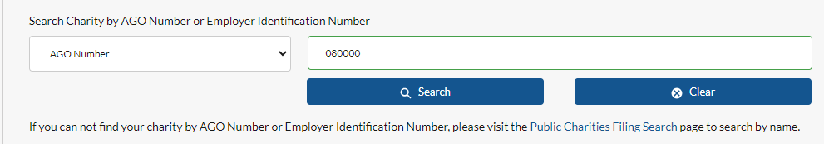

1. Using the dropdown, select the correct charity. Click on ‘Get Form-PC Filings’ button.

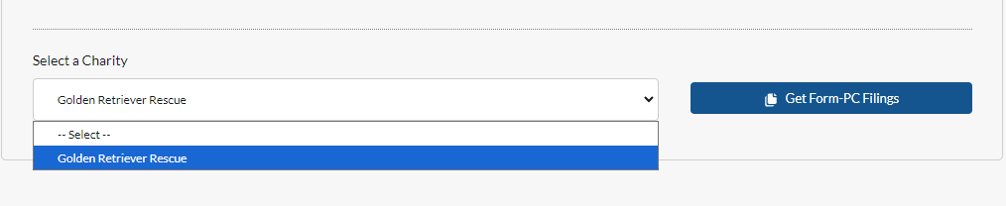

1. Scroll down to the ‘Create a new Form PC’ section. Use the dropdown to select the fiscal year for which you wish to file. Be sure to select the END of your fiscal period from the drop-down. For example, a filing for the fiscal period of 7/1/2023 – 6/30/2024 would be the **2024** filing, not the 2023. Note: only the last six years are available for filing. For an organization to be considered “in compliance” with our office, we must have complete filings on record for the **four (4)** most recent fiscal years. 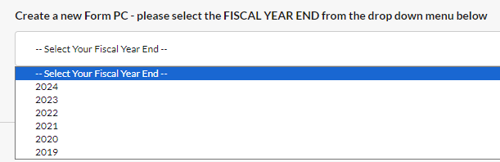

Once you have selected a year, click ‘Start.’

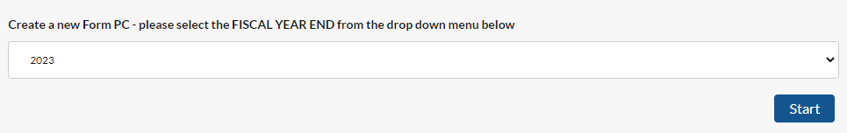

1. A new page will load, and you are able to fill out the Form PC.

The Form PC is broken down into different tabs to make navigating the filing easier. Required fields in each tab are marked with a red asterisk. See below for specific instructions for certain tabs. There are also instructions and additional information built into the Portal, to easily guide you as you complete your organization’s filing.

**Organization Information Tab:**

The “Final Report” check box on the **Organization Information tab** should be checked for PC filers that are permitted under law to stop filing after this report. Examples of PC filers for whom a “Final PC” may be appropriate without a judicial dissolution include: a trust with self-contained termination powers; a charity that has merged into another, separately reporting charity; unincorporated associations; or a non-charity or out-of-state charity that was, but is no longer, holding Massachusetts charitable funds. A charity incorporated in Massachusetts must obtain a judicial dissolution, not merely file a “final report.” The Division has prepared a guide to dissolutions that is available on our website.

**Solicitation Data Tab:**

If your organization solicited contributions during the fiscal year you’re reporting on and your org is not claiming the exemption from the solicitation certificate requirement* you must complete all questions related to the Schedule A-1.

If your organization will be soliciting contributions at any time during the fiscal year following the year reported on the Form PC and your org is not claiming the exemption from the solicitation certificate requitement* you must complete all questions related to the Schedule A-2. If your organization will be soliciting funds from the public, you must obtain a Certificate for Solicitation from our office.

*Exemptions are available for 1. Religious organizations or 2. an organization which: (a) does not raise more than $5,000 during a calendar year OR does not receive contributions from more than ten persons during a calendar year; AND (b) carries out all of its activities, including fundraising, through unpaid volunteers. [*The conditions at both (a) and (b) must be met for your organization to qualify for this exemption.*]

**Financial Data Tab:**

The Summary of Financial Data must be completed in its entirety whether or not a similar question has been answered on an attached federal IRS form. You should use your completed IRS form to answer Question 5. Below we have broken down how to complete Question 5 based on the type of tax return you have attached.

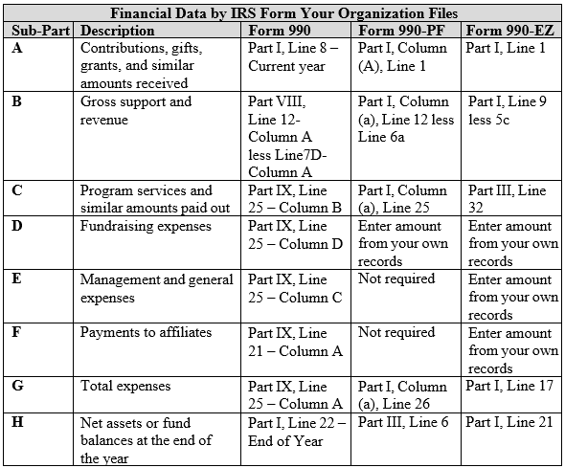

If your organization had paid employees, you must provide all additional information regardless of whether a question regarding compensation is answered on an attached IRS return.

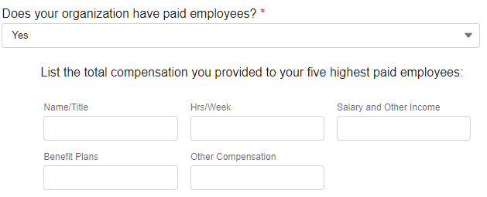

Under “Salary and Other Income,” report salary, fees, bonuses, severance payments and all other items included as personal income for federal income tax purposes.

Under “Benefit Plans,” report (to the extent not reported in other columns) all forms of deferred compensation (whether or not funded or subject to conditions, and whether or not the deferred compensation plan is a qualified plan under federal tax laws) and all payments by your organization to employee benefit plans and retirement plans.

Under “Other Compensation,” report (to the extent not reported in other columns) all other taxable and non-taxable benefits.

**Restricted Funds Tab:**

As a general rule, donor restrictions may only be removed by court order and donated funds may not be loaned in violation of donor restrictions on the use of principal.

**Related Parties Tab:**

See the definitions linked within the Portal for definitions of “Related Party” “Termination of Employment or Change of Control Compensatory Arrangement” and “Indebtedness”.

Report only if payments made or promised to any individual are in excess of four months’ salary at time of termination, or $100,000.00, whichever dollar amount is less.

**Schedule VCO Tab**:

Charitable organizations established to benefit veterans or the military, who intend to solicit in the Commonwealth, may apply to receive designation as a Veterans Charitable Organization (VCO). VCO status can be obtained by completing the Schedule VCO tab and will be valid for 3 years starting with the year of the Form PC being filed. VCO status exempts eligible organizations from the filing fee requirement of the Form PC, and the $100 initial registration fee if the organization is registering for the first time. Pursuant to M.G.L. c. 68, s. 19A, any organization receiving VCO status may not utilize paid fundraisers (commercial co-venturers, or professional solicitors); doing so will result in the loss of VCO status.

**Schedule RO Tab:**

If your organization has a Related Organization as defined within the Portal, you must answer “Yes” and complete Schedule RO. Once completed, Schedule RO should provide a roadmap to the system of organizations which are related to your organization.

For each Related Organization you must identify its name, primary purpose or business activity, and restrictions on its assets as of its most recent FYE, broken down as follows:

|  |  |  |
| --- | --- | --- |
|  | **Category of Assets** | **Additional Description** |
| **A** | Donor restricted funds (-) liabilities | n/a |
| **B** | 3rd party restricted funds (-) liabilities | Those funds which cannot be used other than for their intended purpose without incurring penalties or other adverse impact (for example, insurance reserves or funds restricted by covenants contained in financing instruments) and which were restricted by individuals or organizations unrelated to the reporting charity. |

|  |  |  |
| --- | --- | --- |
| **C** | Unrestricted funds (-) liabilities | Unrestricted Funds includes funded depreciation. |
| **D** | Total net assets (A+B+C) | n/a |

You must identify the amount of compensation paid to the chief executive (e.g., executive director) of your organization and the four other current or former directors, trustees, officers, or employees within your family of Related Organizations that receives the highest aggregate compensation within the system of Related Organizations identified in Schedule RO, Section 1. Include these persons even if their compensation is paid only by your organization and not by related organizations. Itemize each compensation source, regardless of number of sources. List only those individuals whose total annual compensation is $30,000 or higher.

Religious Related Organizations: If the filing organization is related to a religious organization, the filer need not disclose the assets that the religious organization holds or the compensation that the religious organization pays, so long as the filer (1) states the name and primary purpose of the religious organization in the Schedule RO tab, Question 1 and (2) answers “yes” to Schedule RO, Question 3.

Non-Charitable Related Organizations: If the filing organization is a foundation created by a non-charitable Related Organization and the non-charitable Related Organization (a) is not required by law to register and file with the Division, (b) is not created, owned or controlled by any charitable organization, and (c) is not established to benefit or further the purposes of any charitable organization, the filer need not disclose the assets that the non-charitable Related Organization holds or the compensation that the non-charitable Related Organization pays so long as the filer (1) states the name and primary purpose or business activity of the non- charitable Related Organization in Schedule RO, Question 1 and (2) answers “yes” to Schedule RO, Question 3.

Charities with a gross support and revenue of $5,000 or less are not required to file a federal form with the Form PC. If your organization’s revenue is under that threshold, the Division will ask that you nevertheless complete Question 5 using figures from your own records.

# Completing the Annual Form PC Filing in Multiple Sittings

1. Complete the steps to create a Form PC.
2. Once some information has been filled out and you wish to close the Form, use the ‘Save and Close’ button located at the bottom of each page. The page will reload and you will be brought to the Portal home page.

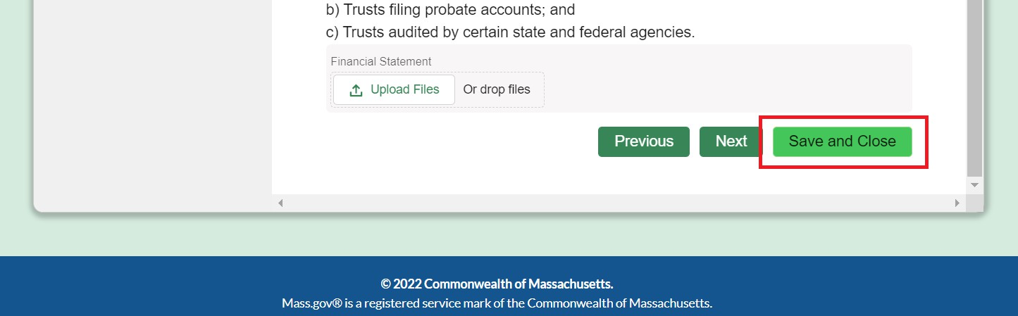

1. When you are ready to complete more of the Form PC, return to the Portal page.
2. Click on ‘Manage Form PC’ button.
3. Type in either the Attorney General Account Number or Employer Identification Number of the charity you have started the Form PC for. Click ‘Search Charity.’
4. Scroll down the page to the ‘Your Active Filings’ section. Your draft Form PC filings should be displayed with the Filing Year and a Filing Status of **‘In-Progress.**’

Note: only the user who is signed in & started this filing will be able to see this.

1. Click on the pencil icon labeled as “click to edit” - this will open up the Form PC. (To simply view the information you have input so far, select “click to view”. From this page you can print to PDF if you wish to share a draft with others. See page 11 for more).

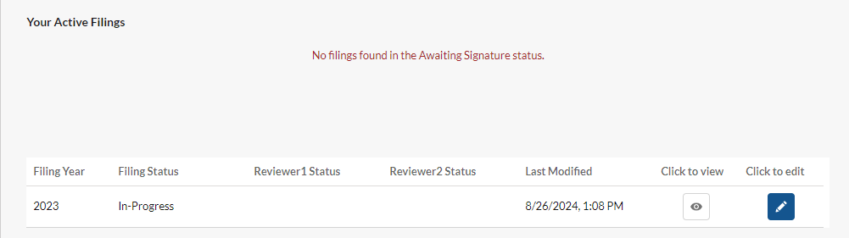

1. When you are ready to Submit the Form PC, you will be asked to provide Reviewer/Signatory information in the Reviewer’s Data tab. You will be asked if you, the preparer/eFiler, are an Authorized Signatory. If you are, you’ll be asked to input your name as confirmation of signature.

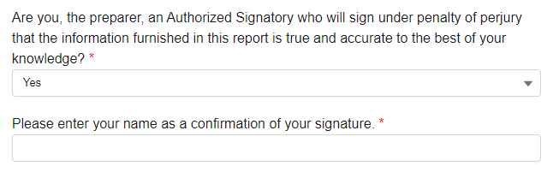

If you are not an Authorized Signatory, or in the event that you need a second Signatory, you will be asked to provide the name and email address of an Authorized Signatory. You cannot list yourself as an additional Signatory. If your organization solicits funds from the public, you must have a total of two Authorized Signatories listed on the filing. This means that if you, the eFiler, are not an Authorized Signatory, you will need to provide two other names/email addresses.

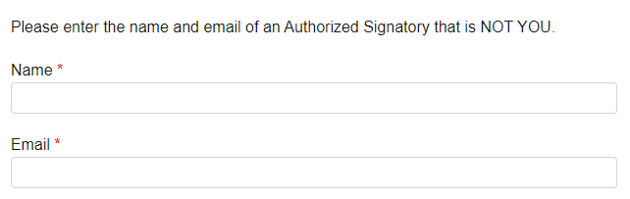

1. Go to the Form Submission tab, check the Box and enter your name as the Preparer of the Form PC then click ‘Submit’.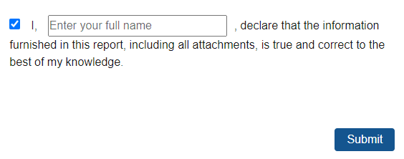

# How to Share a Draft of Form PC

Note: Only the individual who created the Form PC record will be able to perform this task.

1. Log into the portal. Click on ‘Manage Form PC’ and enter the AG Number of the form that you wish to share the draft of.
2. Scroll to ‘Your Active Filings’ where you will see the in-progress filing.
3. Select on the “Click to view” option. This will open a new tab with a printable view of the Form PC.



1. In upper right corner of the PC data page, use the ‘Print This Page’ button to either save as a PDF and share electronically or to print the Form PC draft and share physically.



# How to Electronically Sign the Annual Form PC Filing/Schedule A2

1. If the Annual Form PC Filing/Schedule A2 preparer is an Authorized Signatory for the charity, then the preparer can input their signature on the final tab “Form Submission.”
2. If additional signatures are required, the preparer will enter names and email addresses in the Reviewer’s Data tab.
3. If you are a Reviewer/Authorized Signatory (and non-preparer), you should navigate to your email inbox and search for the email titled ‘Annual Filing/Schedule A2 Filing for [Charity Name] Is Waiting for Your Review.’
4. Click on the link provided to you in the email. This will bring you to the Portal.
5. If you do not have a Portal account, create one now. Refer to ‘How to Sign Up’ instructions. If you do have a Portal account, log in.
6. Click ‘Manage Form PC’ or ‘Manage Schedule A2’ button.

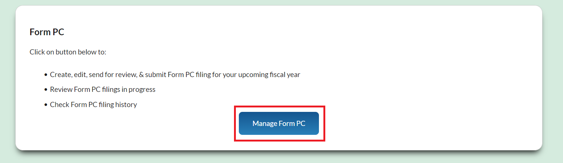

1. Type in either the Attorney General Account Number or Employer Identification Number of the charity for which you must review the filing. Click ‘Search Charity.’
2. Scroll down to the ‘Submitted Filings for Your Review and Signature’ section.
3. Select the “Click to Review” button all the way to the right of the record

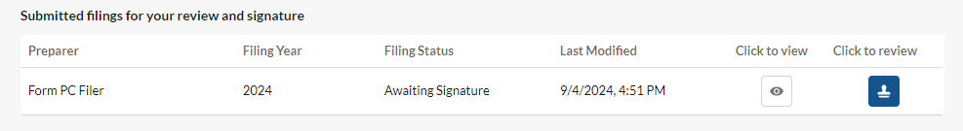

1. A new page will open where you can view the Form PC draft as well as the attachments included in the Form PC.

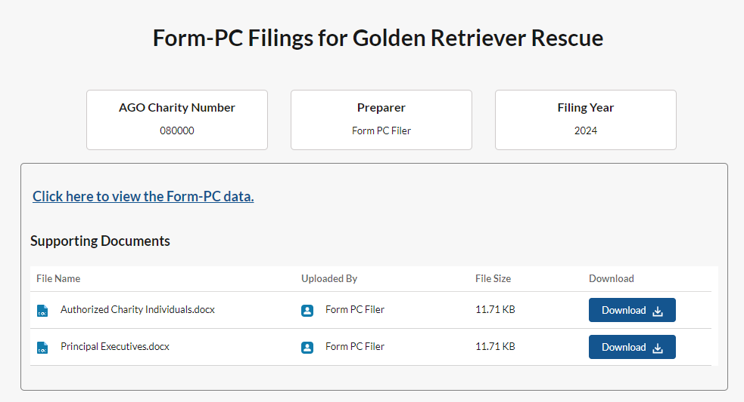

1. Review the data & documents and record your review decision of either ‘Accepted’ or ‘Need Corrections.’

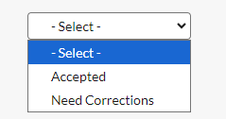

If the filing needs corrections, you must communicate with the eFiler offline what needs to be corrected, as they will not be automatically notified. If you select “Accepted” you will attest that the information is correct, and then hit the Submit button.

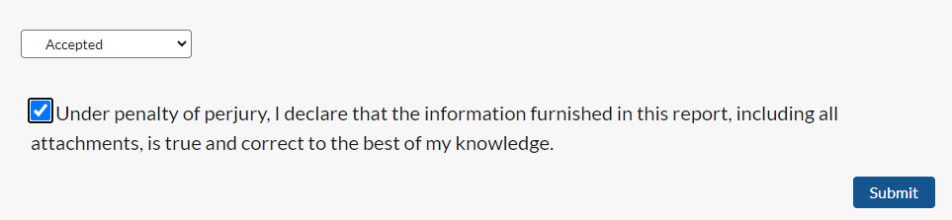

# How to Recall a Filing for Editing

After submitting a filing for signature, an eFiler may find it necessary to edit some information on a filing. One common scenario may be that a Reviewer/Authorized Signatory’s email address was entered incorrectly, or an organization wishes to name a different person as a Reviewer/Authorized Signatory. In the instance that an eFiler may need to edit a filing after it has already been submitted for signature, please follow these steps:

1. Log into the charity portal and click on the “Manage Annual Filing” section, then search for the organization by AG account number.
2. Scroll down to the filings in the Awaiting Signature section and locate the FY filing that you want to recall.
3. Select the “Click to recall” button all the way to the right of the record

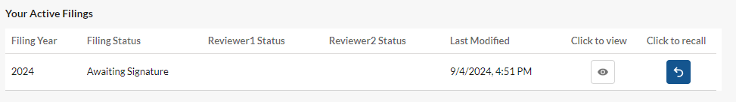

1. Select "Need Corrections" and then hit "Recall" in the dropdown at the bottom of the new screen



1. Notify the reviewers that you (eFiler/preparer) are making edits, so they do not attempt to access the form until it is resubmitted to signers for review.

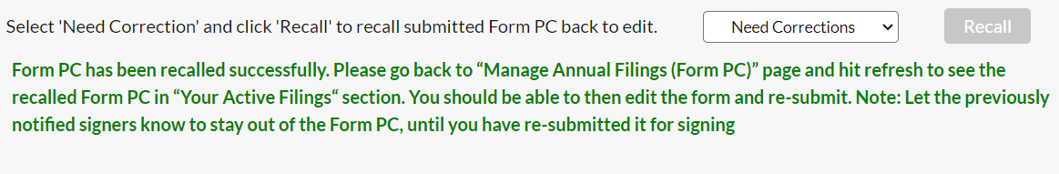

1. You’ll be redirected to the “Manage Annual Filing” section of the Portal, where you can search by AG number and find this filing now listed as “In-Progress”. You will be able to edit to update any information necessary before the filing is once again submitted for signature. Please note: if the filing has been accepted by all listed Signatories, the filing will no longer for available for recall.

# How to Submit a Payment for a Charity’s Registration/Annual Form PC Filing/Schedule A2

**Note:** when completing a Form PC or Schedule A2, you must make a payment before the filing is officially submitted to the AGO for review and processing. You will receive an email notifying you that the filing has been approved by all signatories and is pending payment before official submission. For the registration, you are not required to make a payment until after the AGO’s review.

1. Navigate to the Portal and sign in.
2. Scroll down to the ‘Payments’ section and click on ‘Make Payments.’
3. Type in the AG Account Number for the charity for which you would like to make a payment.
4. If any payments are owed, they will be shown under ‘List of Pending Payments.’ This will include Form PC, Schedule A2, and Registration fees. 
5. Select the “Click to pay” button, and you will be redirected to the payment processing site, nCourt.
6. We accept credit/debit card payments, as well as electronic check/ACH payment. You will pay a small convenience fee if you elect to pay by credit card. ACH transfer does not involve a fee. Fill out the Billing Information and Payment Information sections. Double check to ensure accuracy and submit payment.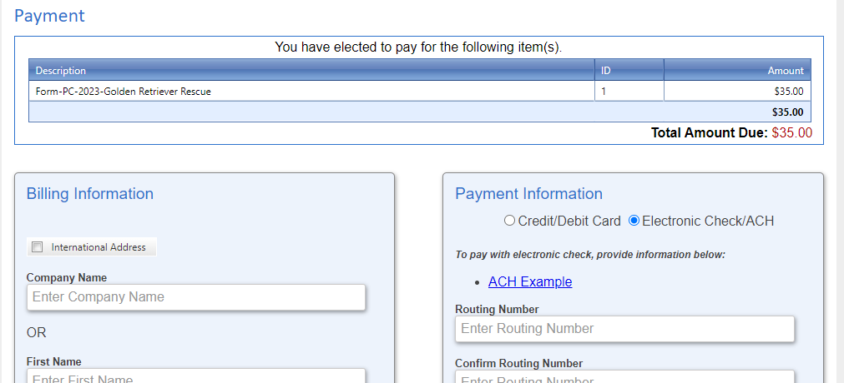
7. You will receive an electronic receipt from payment processor nCourt to confirm that the payment was submitted. If this is a Form PC/Schedule A2 payment, you will also be notified via email by the AGO that the charity’s filing was submitted successfully.

# How to Submit Miscellaneous Charity-Related Documents

Note: The Initial Charity Registration Form and Annual PC Filing will require you to attach some documents within the forms. This additional Upload Documents feature applies to the instances where you need to submit a charity document to the AGO, but you are not submitting an Annual Filing at that time (e.g., updated by-laws, instrument of trust, articles of organization). **You cannot use this feature to upload attachments for a specific Annual Filing**.

1. Navigate to the Portal and sign in. Scroll down to the Upload Documents section and click on ‘Upload Documents.’



1. Enter the Attorney General Account Number you wish to upload documents for.
2. Select the document type from the dropdown. If none apply to the document, please select ‘Other Optional Attachment.’

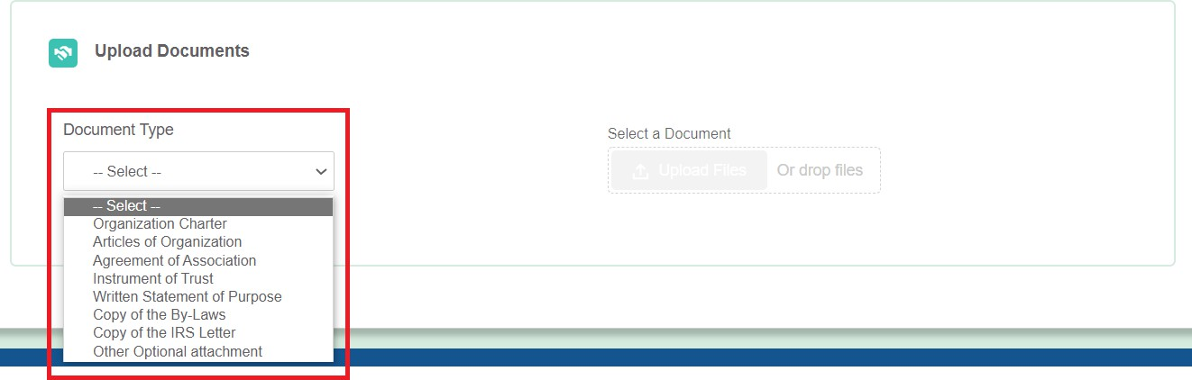

1. Use the ‘Upload Files’ button to select the document from your files that you are looking to upload.

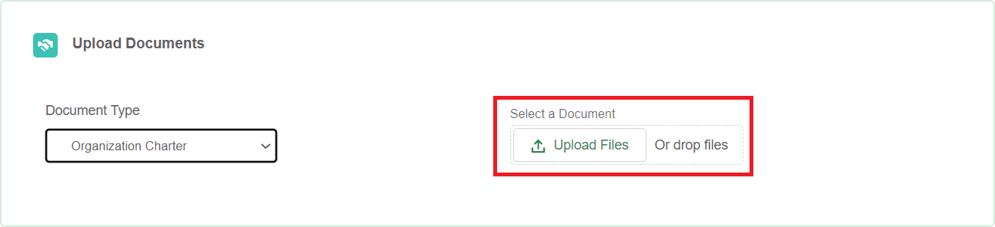

1. Once your file has uploaded, you will see this popup. Press ‘Done’ and your file will be successfully submitted, as noted by a message onscreen.

