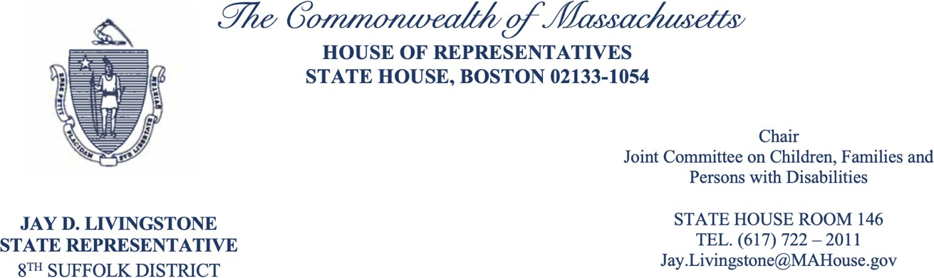
November 25, 2025 Secretary Kiame Mahaniah
Executive Office of Health and Human Services 1 Ashburton Pl, Boston, MA 02108

Dear Secretary Mahaniah,

Thank you for your attention to the important matter of selecting a new Child Advocate. As the House Chair of the Joint Committee on Children, Families and Persons with Disabilities, I recognize that the nomination process for the Child Advocate is both well defined in statute and critical to maintaining stability within the Commonwealth’s child-serving systems. While I appreciate the recent public meeting and effort to engage broader communal input, I trust that the final decision will be made in accordance with the law.

I have had the privilege of working closely with Maria Mossaides on a number of issues, and I believe she has performed, and continues to perform, exceptionally well in her role as the Child Advocate. For that reason, I do not recommend appointing an interim Child Advocate. Instead, I hope the selection of a permanent Child Advocate can be completed as quickly as possible. I think we are lucky as a state every day that Maria remains in her post.

Regardless of whether the new Child Advocate comes from within the office, another state agency, or outside state government altogether, I hope they will approach the role with the same dedication, integrity, and child-centered focus that Maria always has. She has been an excellent advocate for the children and families of Massachusetts, and I trust her successor will uphold that high standard and, I hope, take a similar approach.

If you have any questions, please feel free to reach out to myself or my Staff Director Cassidy.Trabilcy@mahouse.gov

Best regards,

Jay Livingstone
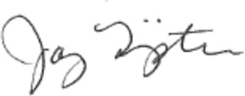

State Representative
House Chair, Joint Committee on Children, Families and Persons with Disabilities

