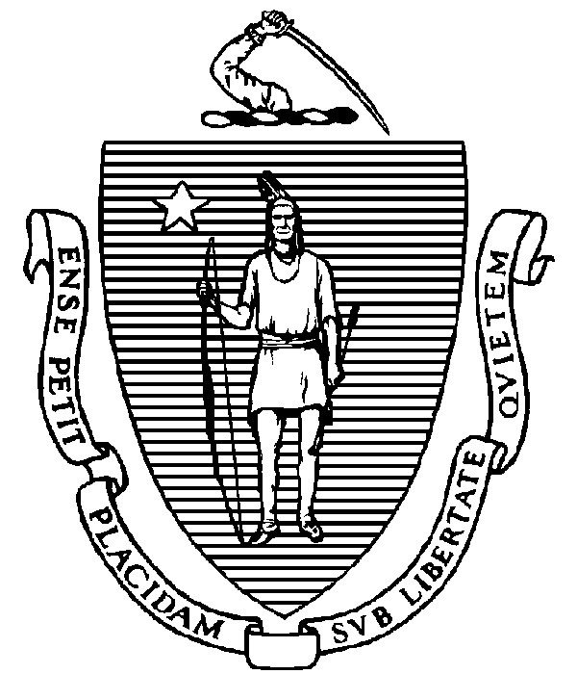
THE COMMONWEALTH OF MASSACHUSETTS
EXECUTIVE OFFICE FOR ADMINISTRATION AND FINANCE
STATE HOUSE ▪ ROOM 373
BOSTON, MA 02133
TEL: (617) 727-2040
FAX: (617) 727-2779
www.mass.gov/eoaf

NOTICE OF PUBLIC MEETING

Capital Debt Affordability Committee

Friday, November 08, 2024 1:00 p.m.
In accordance with Section 20 of Chapter 20 of the Acts of 2021, as extended by Chapter 107 of the Acts of 2022, this meeting will be conducted, and open to the public, via Zoom and Teleconference.
Zoom URL: https://us02web.zoom.us/j/83935411857?pwd=o0ViLM1tc6nFZpMbxuM9gNySafQYhm.1 Meeting ID: 839 3541 1857; Passcode: 040354
Teleconference line: 1-646-558-8656; Passcode: 040354#

AGENDA

- Administrative Matters
• Adoption of meeting minutes from October 25, 2023 (Vote)

- DAC Model Input Review

• CAGR growth rates • Interest Rates

- Other DAC Business
- Adjournment

