Table of Contents

Annual Report to the Massachusetts Board of Registration 2

Instructional Text 2

Important Instruction 3

Parent Institution Information/Parent Institution Accreditation Status 4

Instructional Text 4

Nursing Education Program Information 5

Instructional Text 5

Nursing Program Accreditation Status 6

Instructional Text 6

Nursing Program Options & Student Data/Total Nursing Program Student Data (all program options/cohorts/locations combined) 7

Instructional Text 7

Mission & Governance/Total Number of Faculty/Faculty Retention Rates 8

Instructional Text 8

Full time Faculty 9

Instructional Text 9

Part time Faculty 10

Instructional Text 10

Students 11

Instructional Text 11

Curriculum 12

Instructional Text 12

Leadership and Professional Development Experiences 13

Instructional Text 13

Resources 14

Instructional Text 14

Preceptor Profiles 15

Instructional Text 15

Cooperating Agencies 16

Instructional Text 16

Outcomes/First-time Performance on Licensure/Certification Examination Aggregated for Entire Program 17

Instructional Text 17

Performance on Program Completion – Aggregated for Entire Program 18

Instructional Text 18

Admission Rates Reported on Annual Reports – Aggregated for Entire Program 19

Instructional Text 19

Required Documentation 20

Instructional Text 20

E-Signature 21

Instructional Text 21

## Annual Report to the Massachusetts Board of Registration

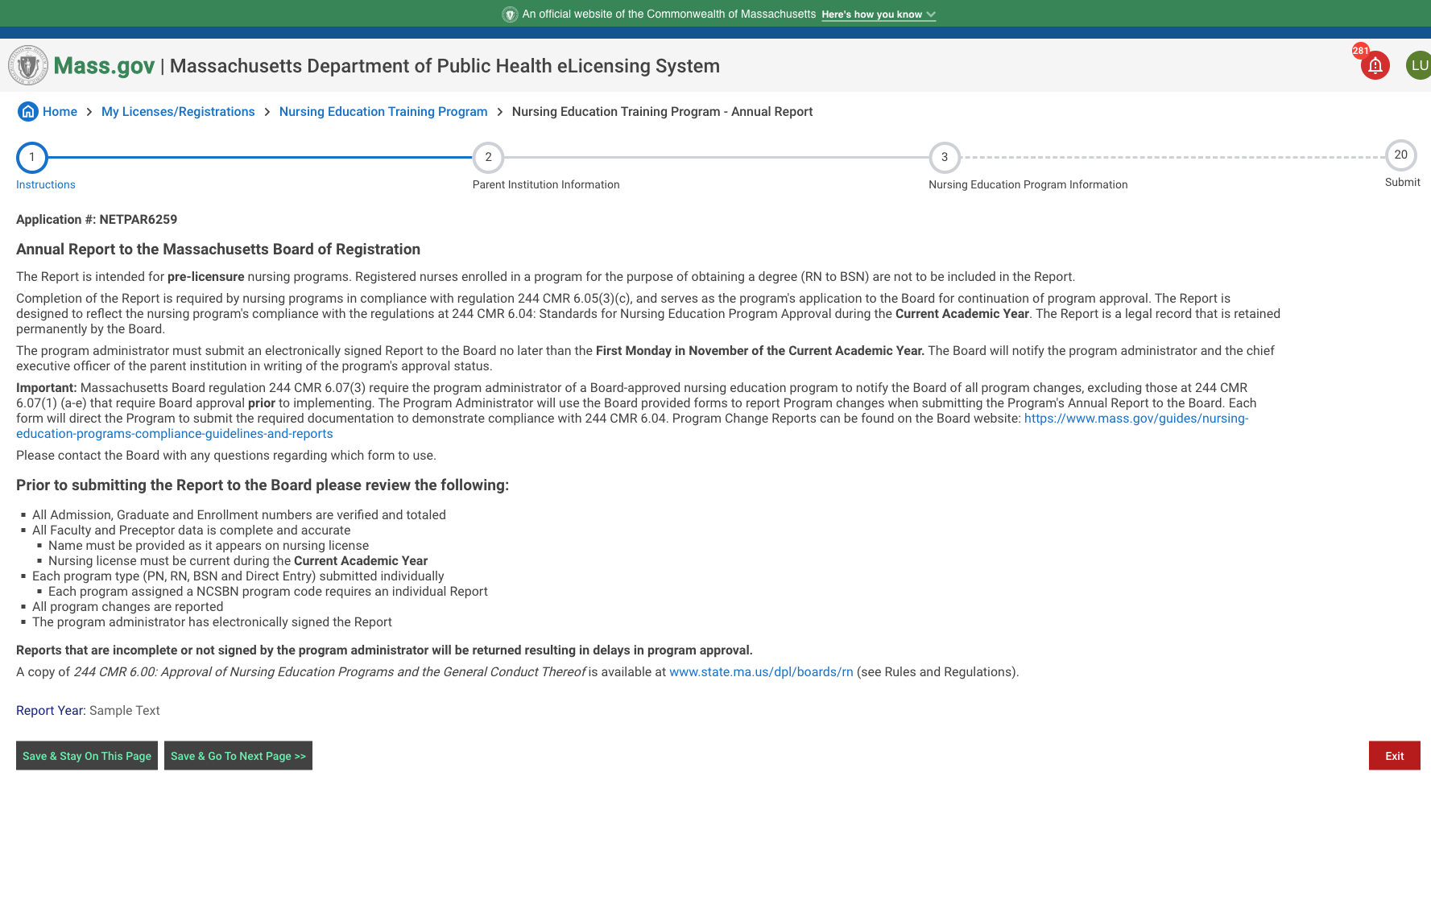

### Instructional Text

The Report is intended for pre-licensure nursing programs. Registered nurses enrolled in a program for the purpose of obtaining a degree (RN to BSN) are not to be included in the Report.

Completion of the Report is required by nursing programs in compliance with regulation 244 CMR 6.05(3)(c), and serves as the program's application to the Board for continuation of program approval. The Report is designed to reflect the nursing program's compliance with the regulations at 244 CMR 6.04: Standards for Nursing Education Program Approval during the Current Academic Year. The Report is a legal record that is retained permanently by the Board.

The program administrator must submit an electronically signed Report to the Board no later than the First Monday in November of the Current Academic Year. The Board will notify the program administrator and the chief executive officer of the parent institution in writing of the program's approval status.

Important: Massachusetts Board regulation 244 CMR 6.07(3) require the program administrator of a Board-approved nursing education program to notify the Board of all program changes, excluding those at 244 CMR 6.07(1) (a-e) that require Board approval prior to implementing. The Program Administrator will use the Board provided forms to report Program changes when submitting the Program's Annual Report to the Board. Each form will direct the Program to submit the required documentation to demonstrate compliance with 244 CMR 6.04. Program Change Reports can be found on the Board website: <https://www.mass.gov/guides/nursing-education-programs-compliance-guidelines-and-reports>  
Please contact the Board with any questions regarding which form to use.  
Prior to submitting the Report to the Board please review the following:

* All Admission, Graduate and Enrollment numbers are verified and totaled
* All Faculty and Preceptor data is complete and accurate
* Name must be provided as it appears on nursing license
* Nursing license must be current during the reported on2024-2025 Current Academic Year
  + Name must be provided as it appears on nursing license
  + Nursing license must be current during the Current Academic Year
* Each program assigned a NCSBN program code requires an individual Report
* All program changes are reported
* The program administrator has electronically signed the Report

A copy of 244 CMR 6.00: Approval of Nursing Education Programs and the General Conduct Thereof is available at [www.state.ma.us/dpl/boards/rn](http://www.state.ma.us/dpl/boards/rn) (see Rules and Regulations).

As you progress through the Annual Report, you will be allowed to save as you go.

### Important Instruction

Please ONLY send your *username* to Ethan Ketchum, [Ethan.Ketchum2@mass.gov](mailto:Ethan.Ketchum2@mass.gov), and NOT your *password*.

## Parent Institution Information/Parent Institution Accreditation Status

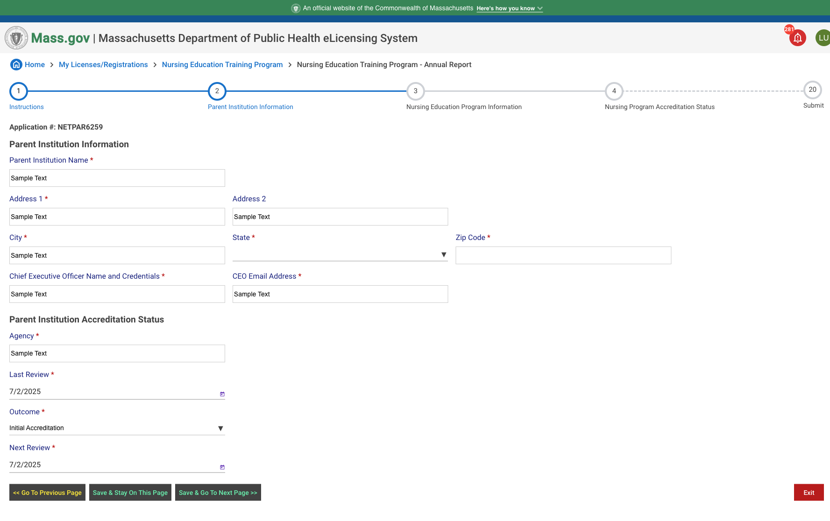

### Instructional Text

Please include all demographic information for the parent institution. All fields are required to progress.

## Nursing Education Program Information

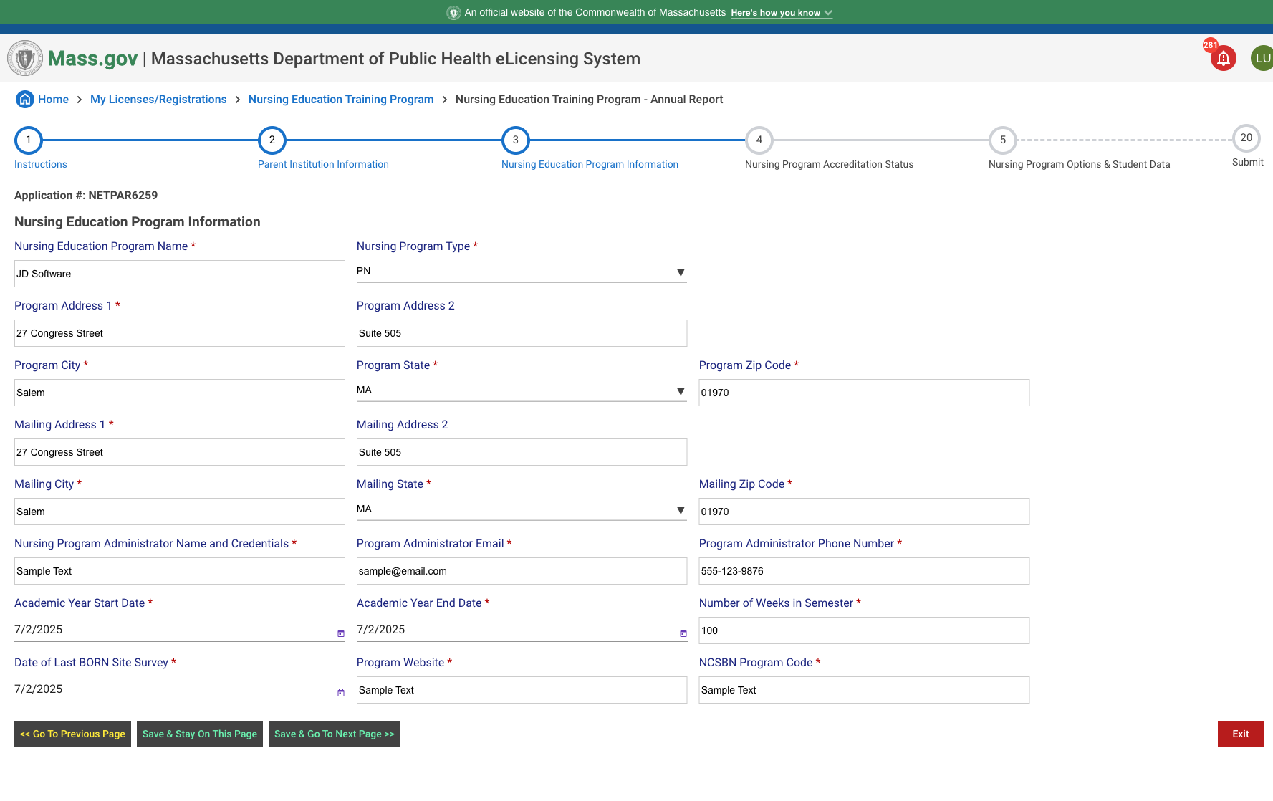

### Instructional Text

Please include all information for the nursing education program. All fields are required to progress.

## Nursing Program Accreditation Status

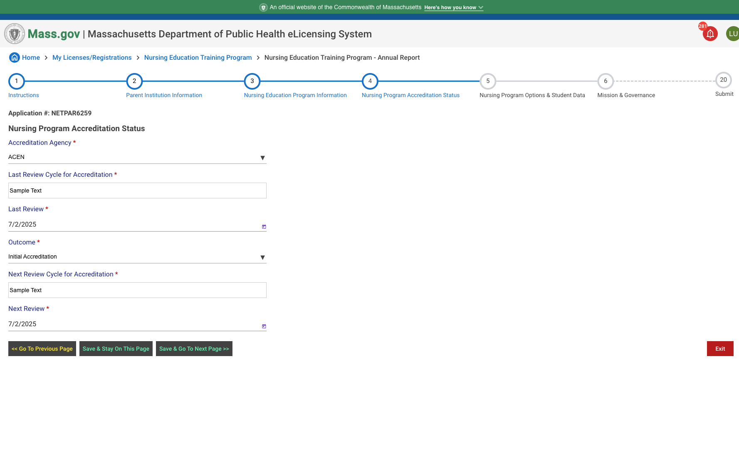

### Instructional Text

## Nursing Program Options & Student Data/Total Nursing Program Student Data (all program options/cohorts/locations combined)

### Instructional Text

Admissions: Report the number of new students matriculated for the first time and identified as nursing majors admissions for the Program during the Current Academic Year.  
Graduates: Report the number of students who graduated from the nursing education program during the Current Academic Year.  
Enrollment: Report the total number of students enrolled during the Current Academic Year.  
Enrolled student numbers should be inclusive of all admissions, graduates and the number of students continuing their program of study during the academic year for each option.  
Full-time faculty are those individuals who are dedicated full time to this Program Option.  
Part-time faculty are those individuals who are not dedicated full time to this Program.

## Mission & Governance/Total Number of Faculty/Faculty Retention Rates

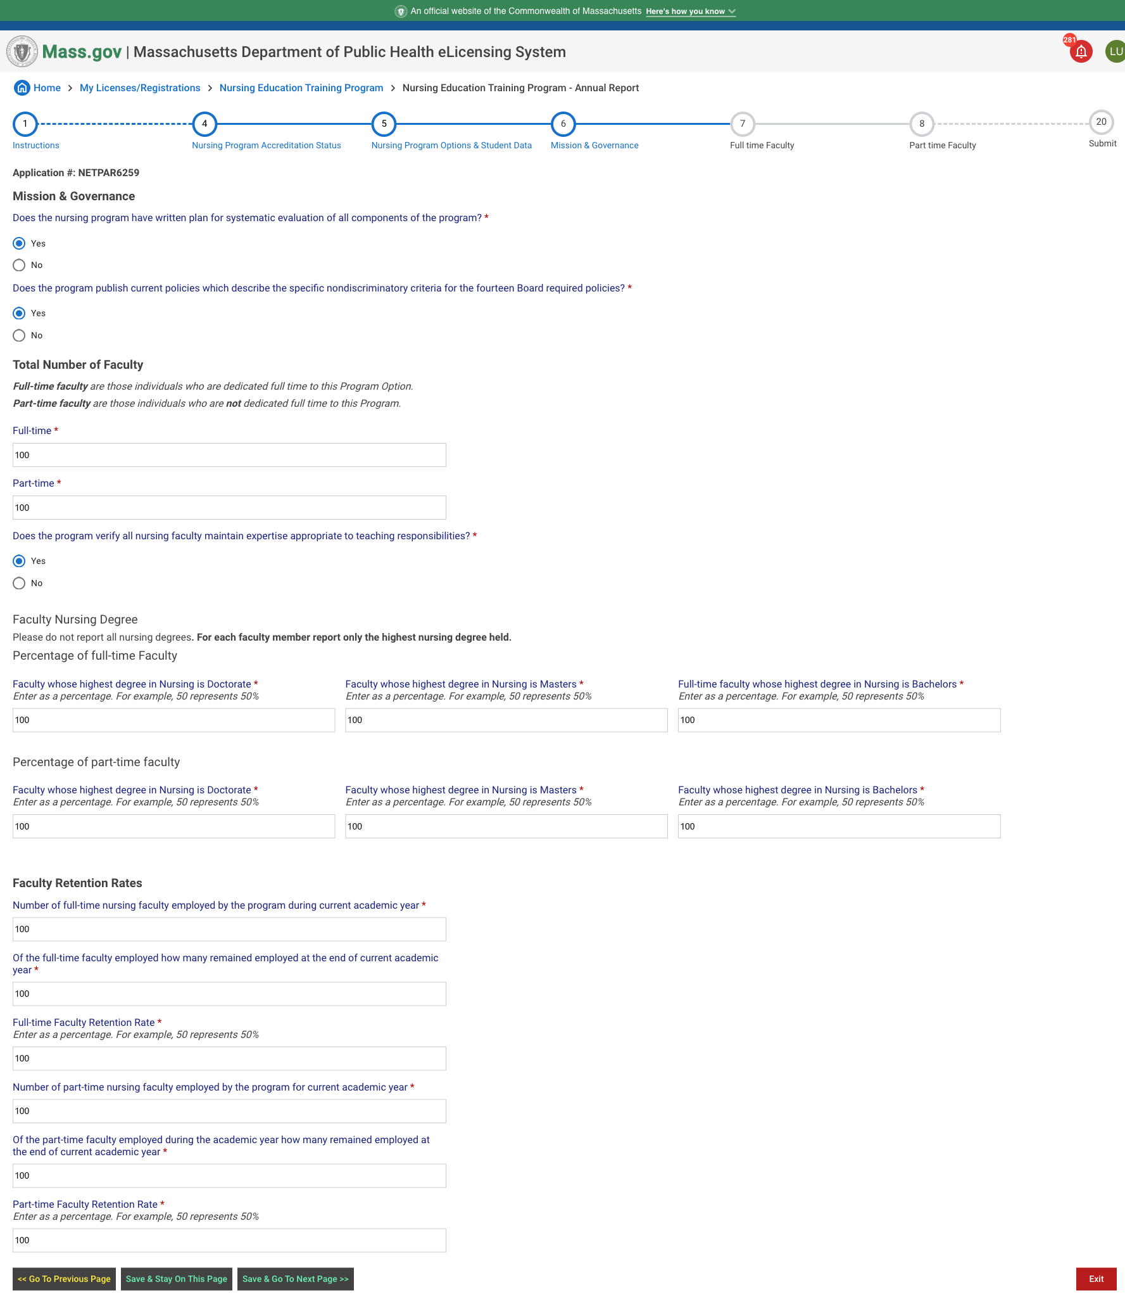

### Instructional Text

Full-time faculty are those individuals who are dedicated full time to this Program Option.  
Part-time faculty are those individuals who are not dedicated full time to this Program Option.  
  
Faculty Nursing Degree  
Please do not report all nursing degrees. For each faculty member report only the highest nursing degree held.  
Percentage of full-time Faculty

## Full time Faculty

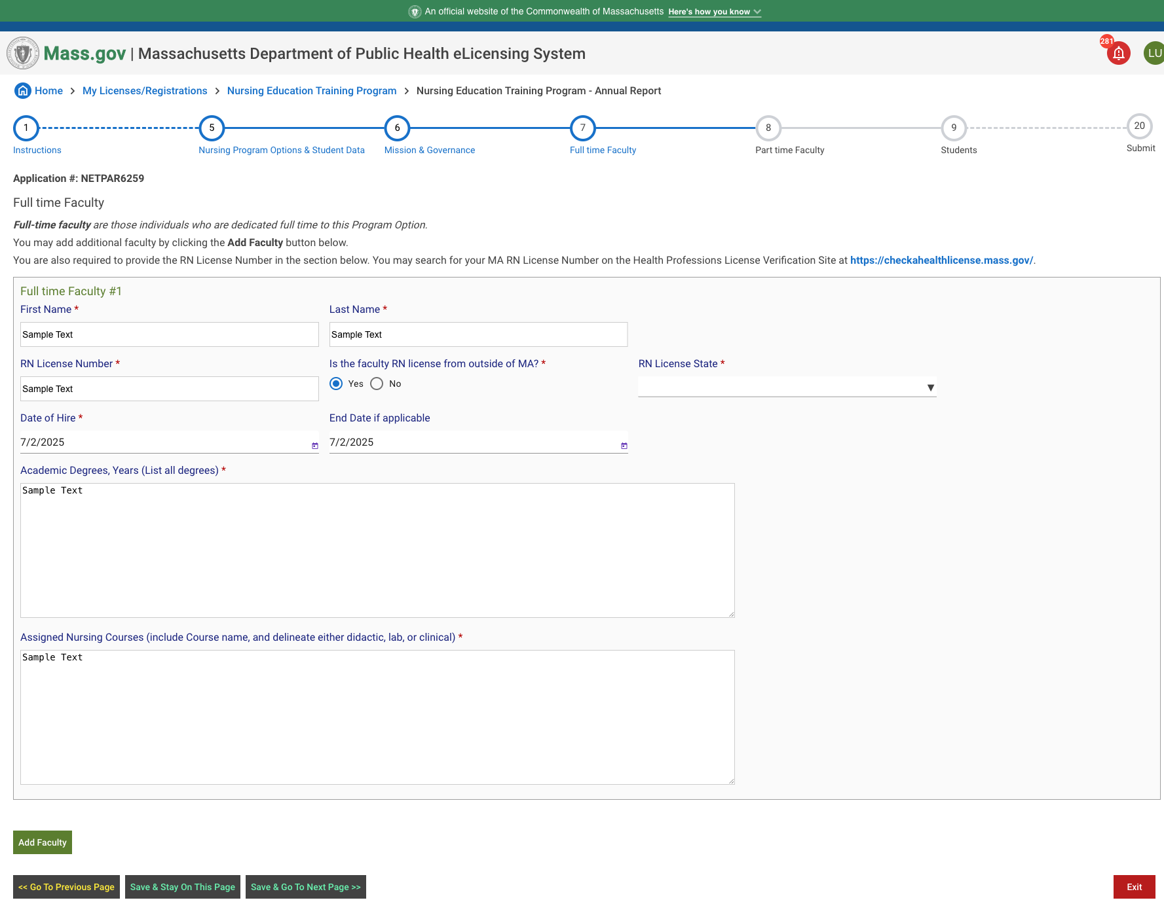

### Instructional Text

Full-time faculty are those individuals who are dedicated full time to this Program Option.  
You may add additional faculty by clicking the **Add Faculty** button below.  
You are also required to provide the RN License Number in the section below. You may search for your MA RN License Number on the Health Professions License Verification Site at <https://checkahealthlicense.mass.gov/>.

## Part time Faculty

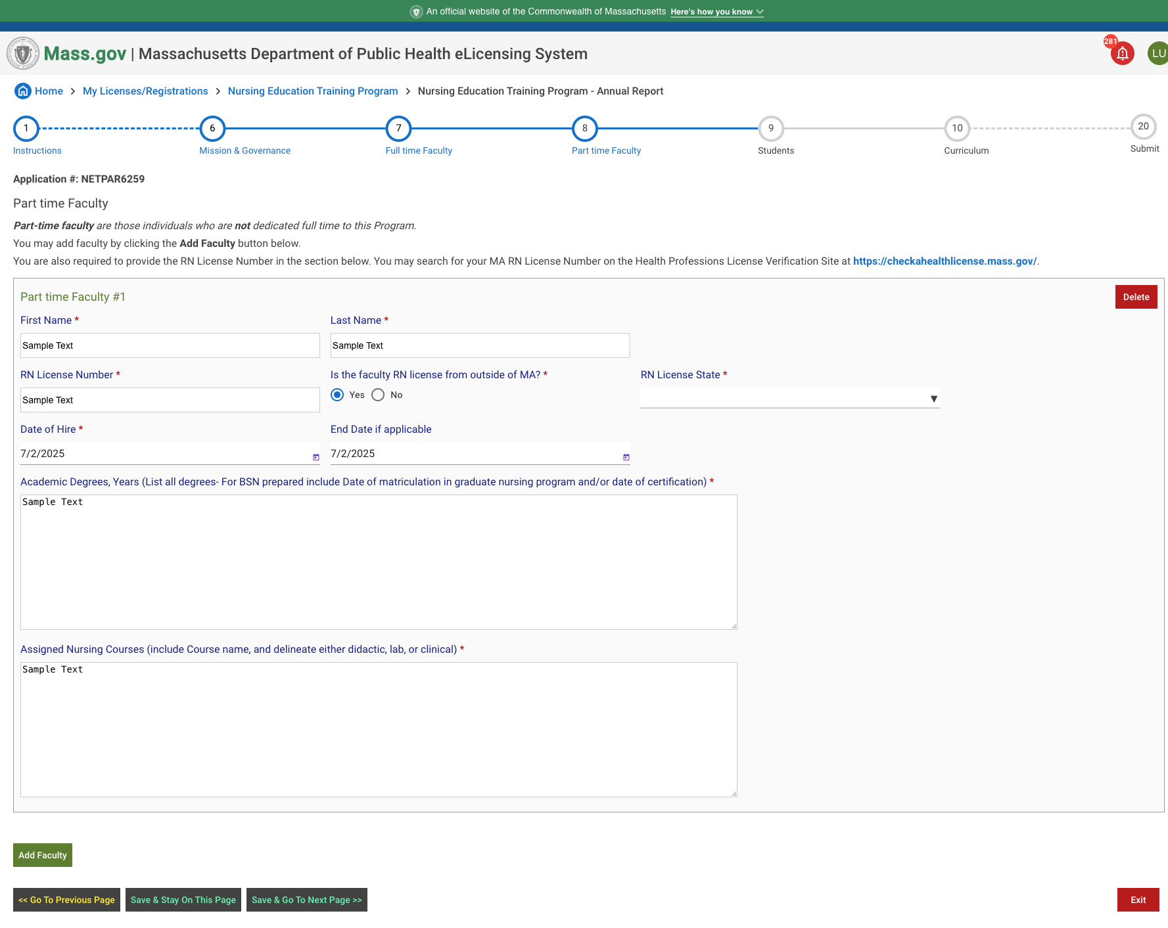

### Instructional Text

Part-time faculty are those individuals who are not dedicated full time to this Program.  
You may add faculty by clicking the **Add Faculty** button below.  
You are also required to provide the RN License Number in the section below. You may search for your MA RN License Number on the Health Professions License Verification Site at <https://checkahealthlicense.mass.gov/>.

## Students

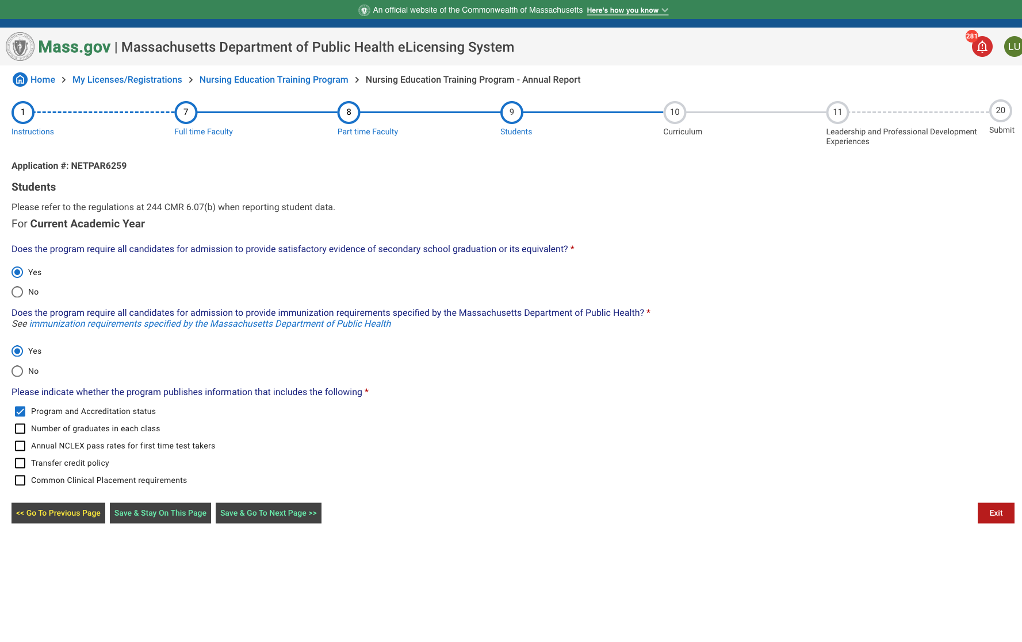

### Instructional Text

Please refer to the regulations at 244 CMR 6.07(b) when reporting student data for the 2024-2025 Academic Year.

## Curriculum

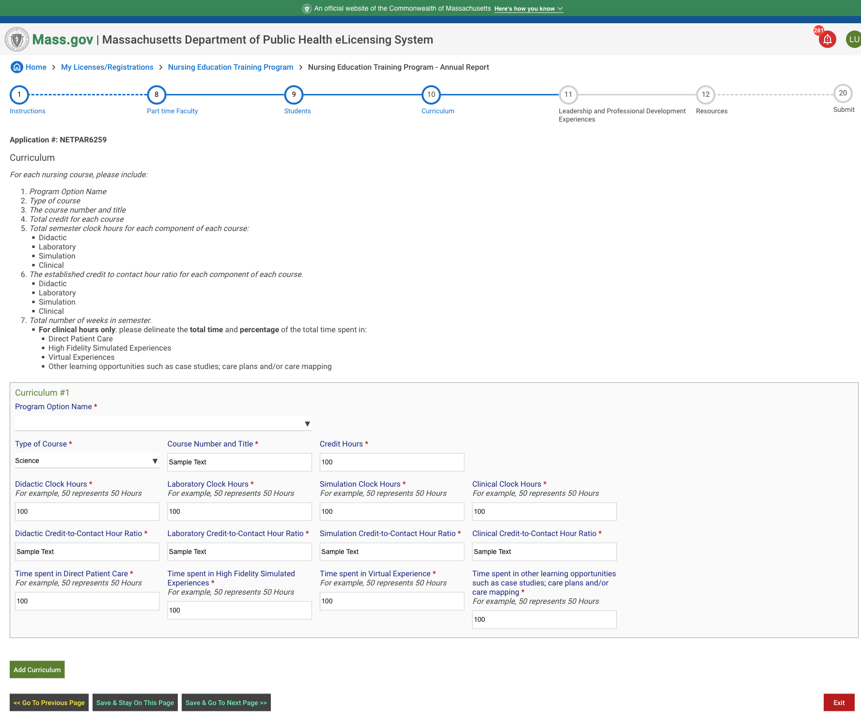

### Instructional Text

For each nursing course, please include:

* Program Option Name
* Type of course
* The course number and title
* Total credit for each course
* Total semester clock hours for each component of each course:
  + Didactic
  + Laboratory
  + Simulation
  + Clinical
* The established credit to contact hour ratio for each component of each course.
  + Didactic
  + Laboratory
  + Simulation
  + Clinical
* Total number of weeks in semester.
  + For clinical hours only: please delineate the total time and percentage of the total time spent in:
    - Direct Patient Care
    - High Fidelity Simulated Experiences
    - Virtual Experiences
    - Other learning opportunities such as case studies; care plans and/or care mapping

## Leadership and Professional Development Experiences

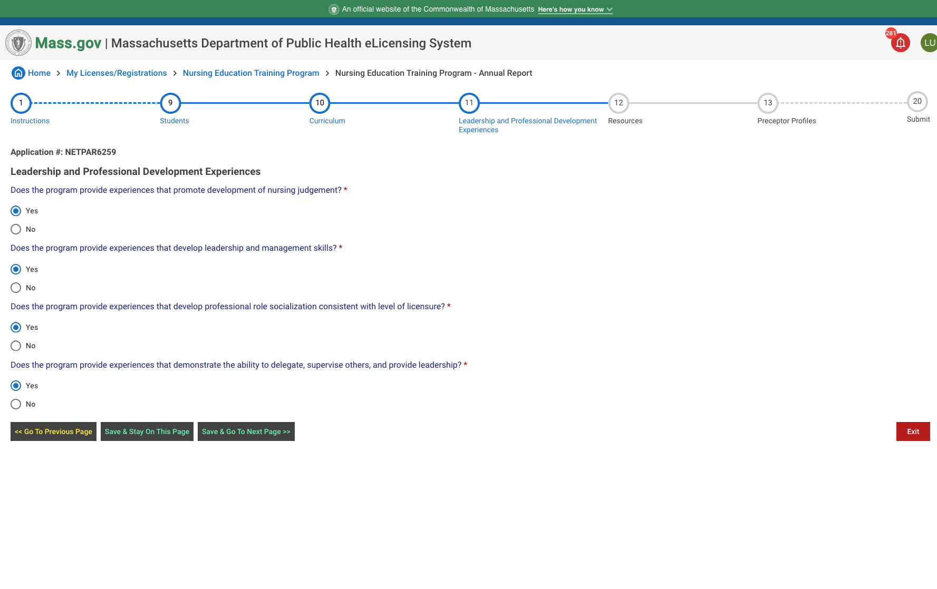

### Instructional Text

Please respond and complete the leadership and professional development experiences questions in this section.

## Resources

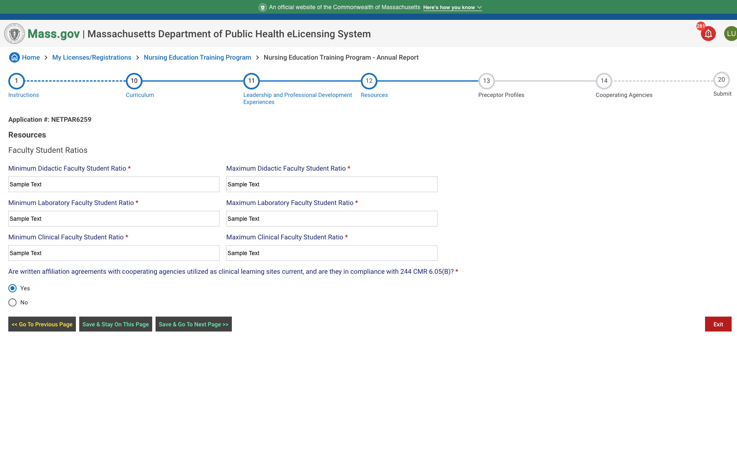

### Instructional Text

Please respond by completing the Faculty-Student Ratios in this section.

## Preceptor Profiles

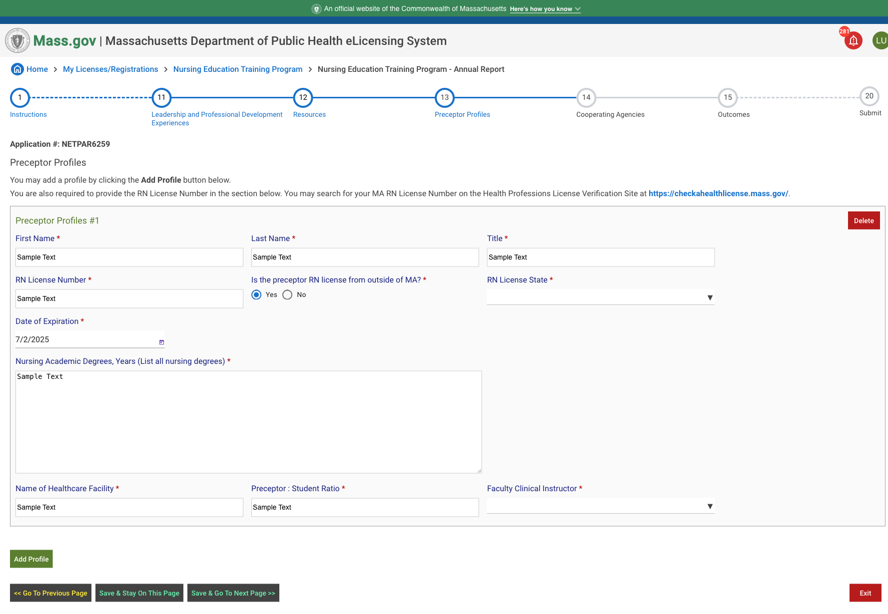

### Instructional Text

You may add a profile by clicking the **Add Profile** button below.  
You are also required to provide the RN License Number in the section below. You may search for your MA RN License Number on the Health Professions License Verification Site at <https://checkahealthlicense.mass.gov/>.

## Cooperating Agencies

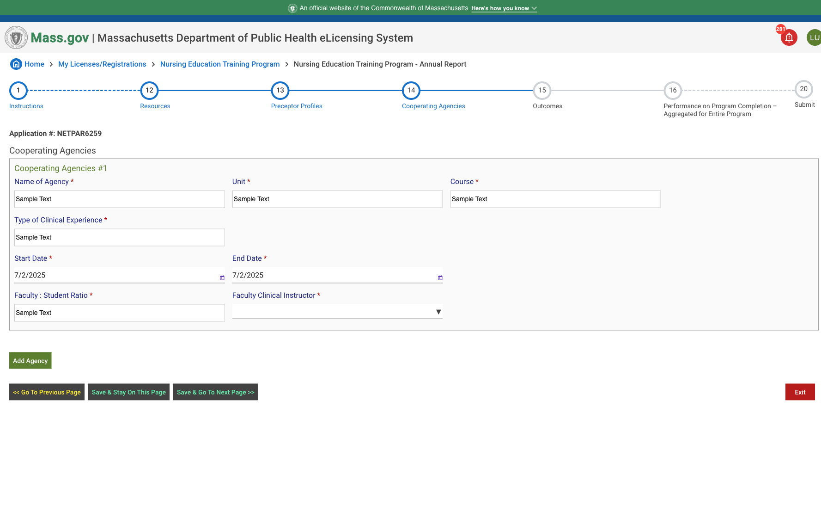

### Instructional Text

Please complete the cooperating agencies section. You may add an additional agency profile by clicking the **Add Agency** button below.

## Outcomes/First-time Performance on Licensure/Certification Examination Aggregated for Entire Program

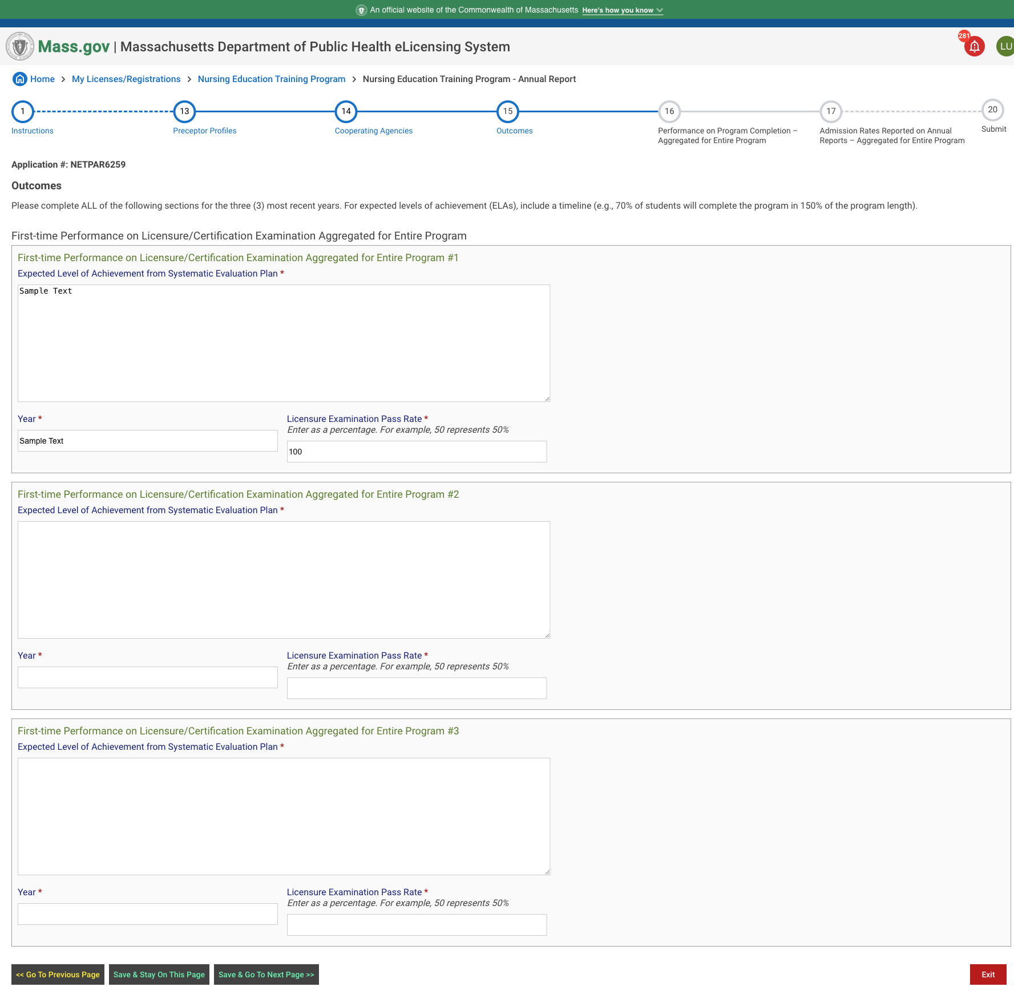

### Instructional Text

Please complete ALL of the following sections for the three (3) most recent years. For expected levels of achievement (ELAs), include NCLEX first-time pass rates (e.g., 90% of students will pass on first attempt on the NCLEX.)

## Performance on Program Completion – Aggregated for Entire Program

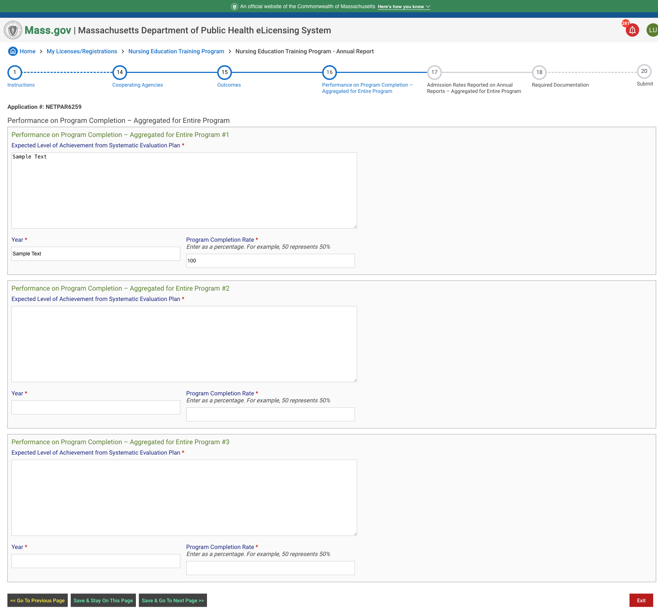

### Instructional Text

Please complete ALL of the following sections for the three (3) most recent years. For expected levels of achievement (ELAs), include a timeline (e.g., 70% of students will complete the program in 150% of the program length).

## Admission Rates Reported on Annual Reports – Aggregated for Entire Program

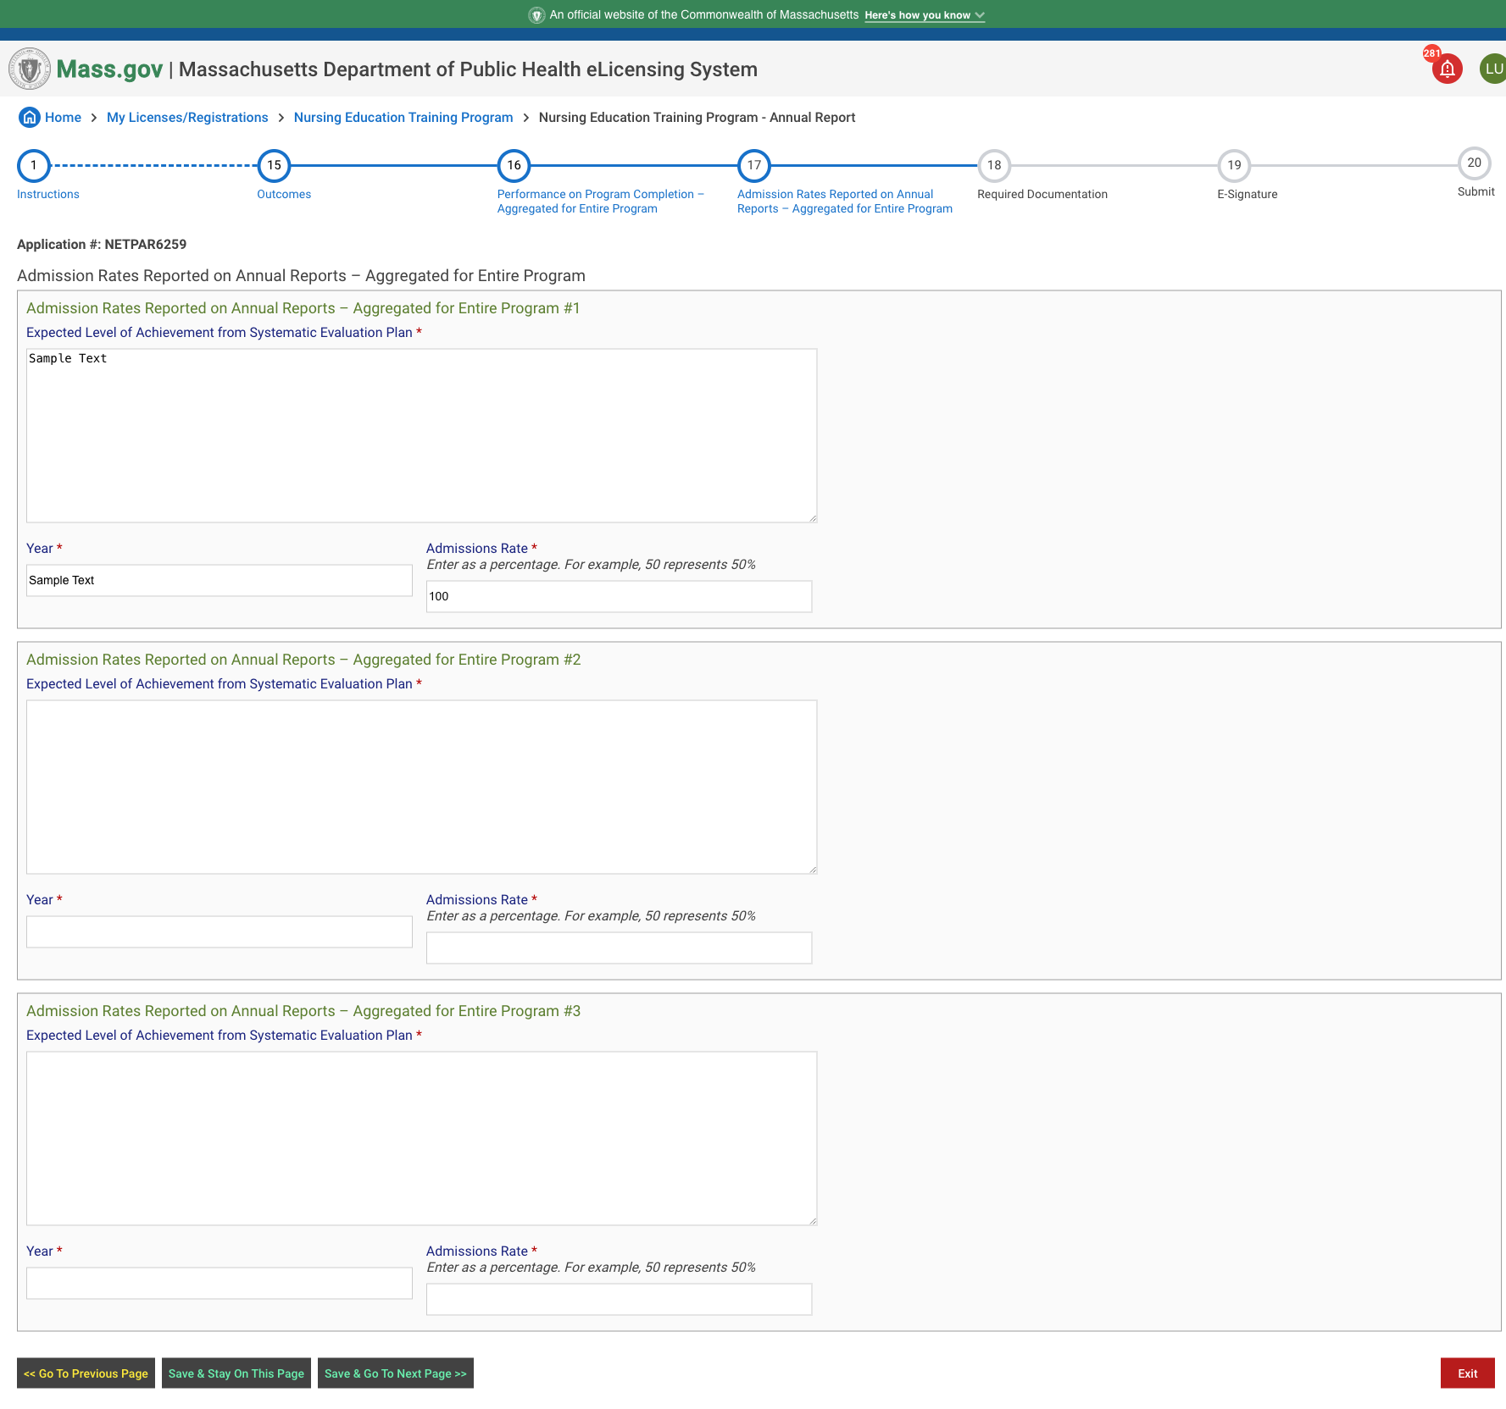

### Instructional Text

Please complete ALL of the following sections for the three (3) most recent years. For expected levels of achievement (ELAs), include a timeline for the admissions rates.

## Required Documentation

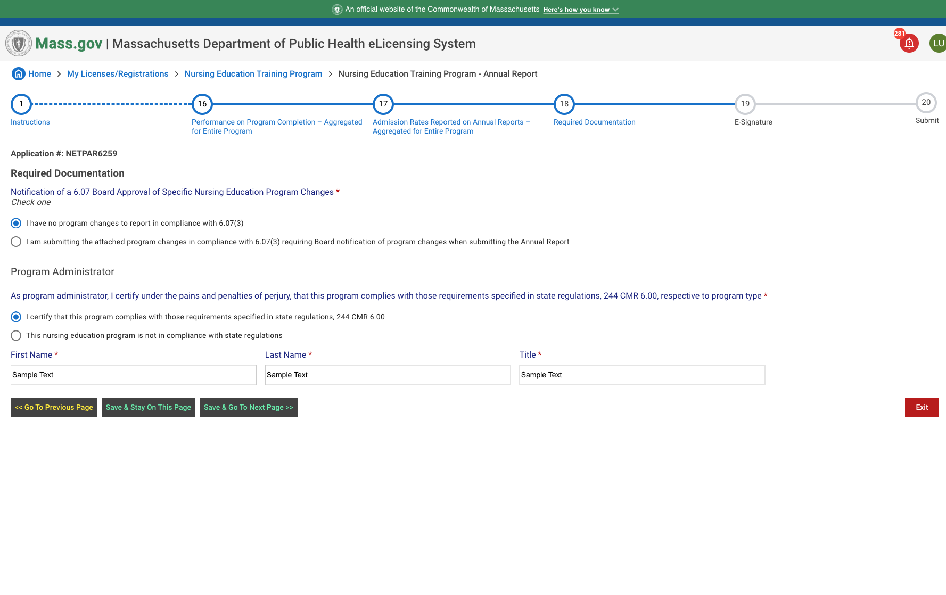

### Instructional Text

This form should be submitted by the Program Administrator.

## E-Signature

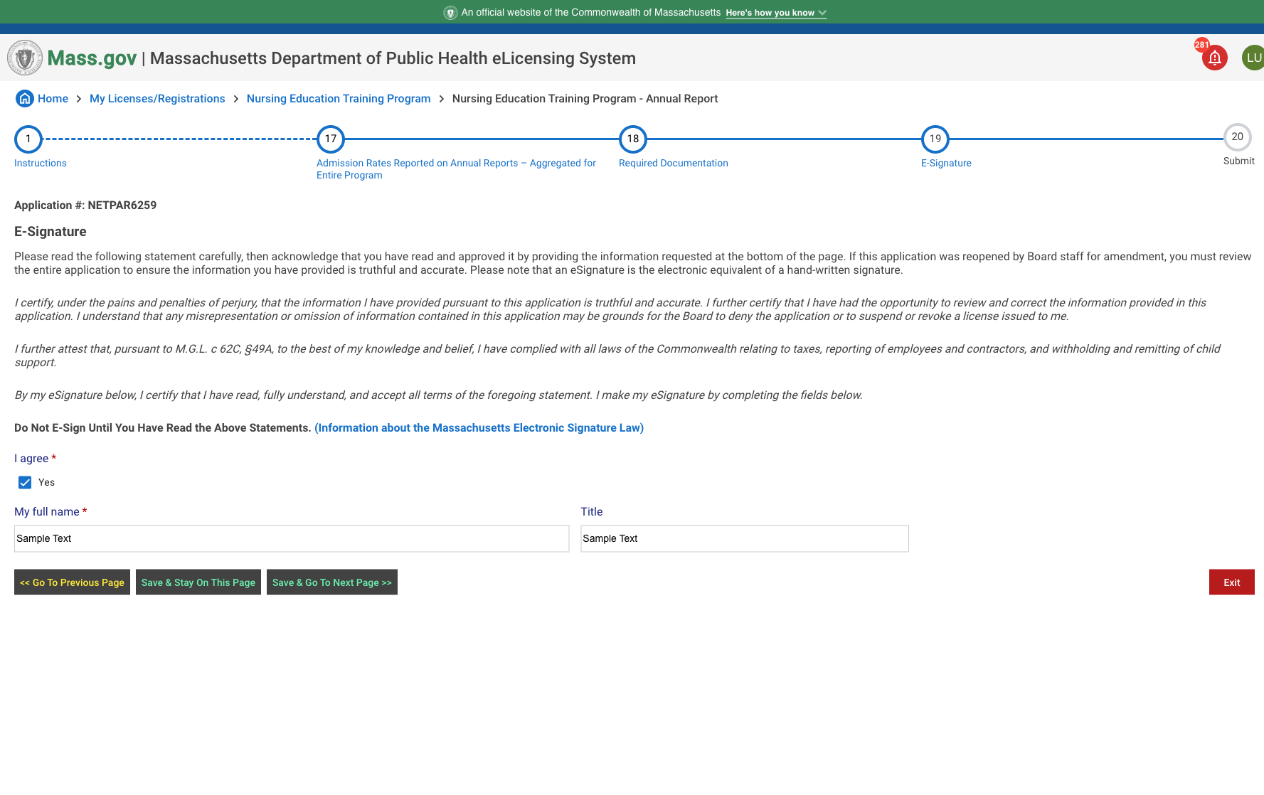

### Instructional Text

Please read the following statement carefully, then acknowledge that you have read and approved it by providing the information requested at the bottom of the page. If this application was reopened by Board staff for amendment, you must review the entire application to ensure the information you have provided is truthful and accurate. Please note that an eSignature is the electronic equivalent of a hand-written signature.  
  
*I certify, under the pains and penalties of perjury, that the information I have provided pursuant to this application is truthful and accurate. I further certify that I have had the opportunity to review and correct the information provided in this application. I understand that any misrepresentation or omission of information contained in this application may be grounds for the Board to deny the application or to suspend or revoke a license issued to me.*  
  
*I further attest that, pursuant to M.G.L. c 62C, §49A, to the best of my knowledge and belief, I have complied with all laws of the Commonwealth relating to taxes, reporting of employees and contractors, and withholding and remitting of child support.*   
  
*By my eSignature below, I certify that I have read, fully understand, and accept all terms of the foregoing statement. I make my eSignature by completing the fields below.*  
  
Do Not E-Sign Until You Have Read the Above Statements. [(Information about the Massachusetts Electronic Signature Law)](https://www.mass.gov/doc/frequently-asked-questions-16/download#:~:text=(a)%20A%20record%20or%20signature,was%20used%20in%20its%20formation)