Commonwealth of Massachusetts
Executive Office of Health and Human Services

Office of Medicaid
www.mass.gov/masshealth

MassHealth
Nursing Facility Bulletin-138
December 2014

TO: Nursing Facilities Participating in MassHealth

FROM: Kristin L. Thorn, Medicaid Director 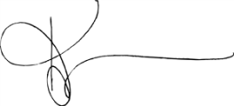

RE: Increase in Medical Leave-of-Absence (MLOA) Days

Background

The final state budget for fiscal year 2015 authorized MassHealth to increase coverage of medical leave-of-absence (MLOA) days.

Summary of Change

Effective for dates of service on or after September 1, 2014, and notwithstanding the language in 130 CMR 456.000 allowing payment to nursing facilities for up to 10 MLOA days, MassHealth will pay nursing facilities for up to 20 MLOA days per inpatient hospital stay in an acute, chronic disease, psychiatric, or rehabilitation hospital. The payment rate for MLOA days remains at $80.10 per day.

Questions

If you have any questions about the information in this bulletin, please contact the MassHealth Customer Service Center at 1-800-841-2900, e-mail your inquiry to providersupport@mahealth.net, or fax your inquiry to 617-988-8974.

