Commonwealth of Massachusetts
Executive Office of Health and Human Services

Office of Medicaid
www.mass.gov/masshealth

MassHealth
Nursing Facility Bulletin 139
December 2015

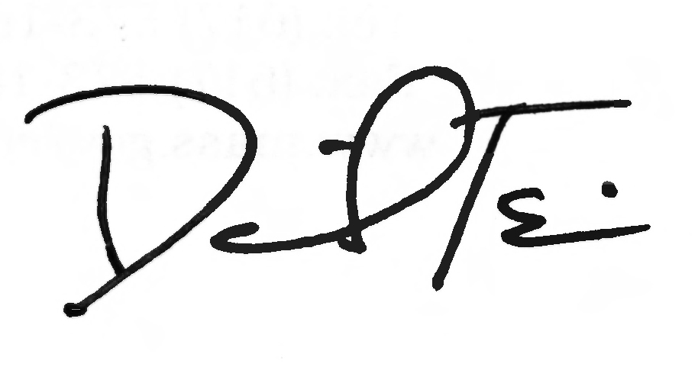
TO: Nursing Facilities Participating in MassHealth

FROM: Daniel Tsai, Assistant Secretary for MassHealth

RE: Inclusion of Observation Stays in Medical Leave of Absence
(MLOA) Days

Background

Recent state legislation requires MassHealth to include observation stays in excess of 24 hours in coverage for medical leave of absence (MLOA) days.

Summary of Change

Effective for dates of service on or after July 1, 2015, medical leave of absence days, also known as bed-hold days, include observation stays in excess of 24 hours in acute inpatient and psychiatric hospitals.

MassHealth will continue to pay nursing facilities for up to 20 MLOA days per hospital stay in accordance with MassHealth Nursing Facility Bulletin 138. MassHealth will also continue to pay nursing facilities for up to 10 nonmedical leave of absence days per 12-month period, starting with the first day of the nonmedical leave.

The payment rate for MLOA days remains at $80.10 per day.

Questions

If you have any questions about the information in this bulletin, please contact the MassHealth Customer Service Center at 1-800-841-2900, e-mail your inquiry to providersupport@mahealth.net, or fax your inquiry to 617-988-8974.

Follow us on Twitter @MassHealth.

