Institutional Nursing Facility Map – User Guide

Navigating the Nursing Facility Map
- Each nursing facility is displayed on the map with a location pin to represent the facility’s precise location.
- Hovering your cursor over any location pin will display the following information associated with that nursing facility:
  - Facility Name
  - Address (street, city/town, state, zip code)
  - Telephone
  - Languages
  - Units
  - Diagnoses and Patient Groups
  - Additional Services
  - Additional Features
Zooming in/out of the Nursing Facility Map
- Some nursing facilities are close in proximity, causing their location pins to partially overlap. By zooming into the map, you can see each facilities location more distinctly.
- There are two options for zooming into the map.
- Hovering your cursor over the map, you can use the + and - symbols to zoom in and out respectively.
- Hover your cursor over the map, scroll up and down to zoom in and out respectively.
- To revert the map back to its original view, select the pin button in the map toolbar (see below)
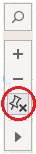
Filtering the map to locate specific nursing facilities
- To the right of the map are four filter categories: Language, Unit, Diagnosis/Patient Group, and Additional Feature.
- Selecting a filter will update the map to display only nursing facilities that contain the specific attribute that has been filtered on.
- To select a filter, use your cursor to click on the square directly to the right of it.
  - Once selected, a black border will appear around the square.
- Multiple filters can be selected.
  - Note: Depending on the filter selected, other filters may no longer be available. This indicates that the remaining nursing facilities do not contain that specific attribute.
- To remove a filter, click on the square to deselect it.

Search for nursing facilities by county, city/town, and zip code
- By hovering your cursor over the map, the map search icon will appear in the top left corner of the view. When you click the search icon, a search box will appear.
- When you begin to type in the search box, map search suggests possible locations that are in the map view.
  - Note: You can search by county, city/town, and zip code
- Select a location from the list of suggestions to pan and zoom to that location on the map.
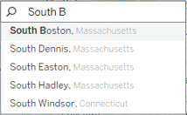

Search for nursing facilities within a specific distance/radius
- The radial tool allows you to identify nursing facilities within a desired distance.
  - Note: You must zoom in to the map several times before you can measure distance with the radial tool. The measured distance will not appear if you are zoomed too far out of the map
- After you have zoomed in to a particular area or location in your view, select the radial tool on the view toolbar (see image below).
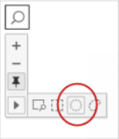
- With the radial tool selected, click and drag across the view. The measured distance (in miles) appears to the right of the circle when you drag across the view.
- As you drag, the Radial tool selects nursing facilities that are located within the radius of the circle. After dragging to the desired distance, the map filters will remove any attributes not available at the nursing facilities selected.
- To remove the radial selection, click anywhere on the map.

Download PDF of Nursing Facility Map
- Click the Download PDF button.
- In the pop-up window, select the following:
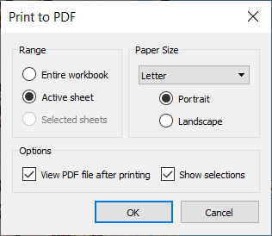
Note: View PDF file after printing is optional
- Click OK

Download Image of Nursing Facility Map
- Click the Download Image button.
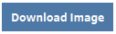
- In the pop-up window, update the File Name and save the image to your desired location.

Institutional Nursing Facility Table – User Guide

Navigating the Nursing Facility Table
- The second tab contains the below information associated with each Nursing Facility, in a searchable table:
  - Facility Name
  - Address (street, city/town, state, zip code)
  - Telephone
  - Languages
  - Units
  - Diagnoses and Patient Groups
  - Additional Services
  - Additional Features
- To search the table, type a key word into the search bar
Note: Only one key word can be searched at a time
- Entering a key word into the search bar will update the table, displaying all nursing facilities containing the key word in at least one of the fields listed above.
- To refresh the table, remove the key word from the search bar and hit enter.
Download Excel/CSV of Nursing Facility Table
- Click the Download as Excel/CSV File button
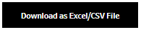
- In the pop-up window, select the “Download Excel/CSV” sheet
- Select the desired format
- Click the download button

