# Nursing Facility Rate Add-ons Billing Guidance Effective 10/1/2023

There is ***no change*** to Nursing Facility Rate add-on billing due to the MassHealth transition to MDS 3.0 effective October 1, 2023. Nursing facilities should continue to follow the instructions as outlined in this guidance.

* Effective February 2, 2024, there is a ***new*** Nursing Facility Bariatric Rate add-on. Please review page 4 of this guidance for more information.
* Effective October 1, 2023, there is a ***new*** Nursing Facility rate add-on for SUD Induction periods. Please review page 4 of this guidance for more information.
* Nursing facility rate add-ons are directly billable to MassHealth for MassHealth members covered by the plans below:
* \MassHealth Standard (FFS)
* MassHealth CommonHealth
* MassHealth Family Assistance
* MassHealth CarePlus
* Questions about add-ons for MassHealth members enrolled in managed care plans (e.g., ACO Model “A”, MCO, SCO, PACE, or OneCare plans) should be forwarded directly to the managed care plans.
* Nursing facility rate add-ons are not billable for any medical or non-medical leave days.
* Nursing facility rate add-ons are not billable for MassHealth members covered by hospice.

# **Rate Add-ons:**

* **101 CMR 206.10(7) Medicaid Transitional Add-on**: Effective January 15, 2022, nursing facilities may bill an additional $200.00 per member per day for the first 60 days of a nursing facility admission if the MassHealth member is transferring from an acute or non-acute inpatient hospital setting, is not returning from a medical leave of absence, and MassHealth is the primary payer at the time of the admission.
  + *HCPCS code S0317*
  + May be billed in conjunction with the following add-ons:
    - Only one of the following: SUD add-on ***or*** SUD Induction add-on ***or*** behavioral add-on
    - Bariatric Add-on
    - Tracheostomy add-on
    - Dialysis den add-ons
  + May not be billed with the following add-ons:
    - Temporary resident add-on
    - Homelessness add-on
* **206.10(13) Homelessness Rate Add-on**: Effective January 15, 2022, nursing facilities may bill an additional $200.00 per member per day for the first 6 months (180 days) of admission if a MassHealth member is admitted from any setting, the members homelessness status has been verified and approved by EOHHS, and MassHealth is the primary payer at the time of admission.
  + *HCPCS code S0311*
  + May be billed in conjunction with the following add-ons:
    - Dialysis den add-on
    - Trach add-on
  + May not be billed with the following add-ons:
    - Behavioral add-on
    - SUD add-on
    - SUD induction add-on
    - Bariatric Add-on
    - Temporary resident add-on
    - Transitional add-on
* **206.10(1)(b)** **Temporary Resident Add-on**: Effective October 1, 2022, nursing facilities may bill an additional $130.00 per member per day for the first 30 days of admission if a MassHealth member is admitted directly from their home and subsequently discharges to their home within a 30-calendar day window.
  + *HCPCS code S0316*
  + May be billed in conjunction with the following add-ons:
    - Bariatric Add-on
    - Dialysis den add-on
    - Only one of the following: SUD add-on ***or*** SUD Induction add-on ***or*** behavioral add-on
    - Trach add-on
  + May not be billed with the following add-ons:
    - Homelessness add-on
    - Transitional add-on
    - Enhanced temporary resident add-on (b)
* **206.10(1)(b) Enhanced Temporary Resident Add-on**: Effective October 1, 2022, nursing facilities may bill an additional $250.00 per member per day for the first 30 days of admission if a MassHealth member is admitted directly from their home and subsequently discharges to their home within a 30-calendar day window, and the *MassHealth member is younger than 22 years of age.*
  + *HCPCS code S0315*
  + May be billed in conjunction with the following add-ons:
    - Bariatric Add-on
    - Den dialysis add-on
    - Only one of the following: SUD add-on ***or*** SUD Induction add-on ***or*** behavioral add-on
    - Trach add-on
  + May not be billed with the following add-ons:
    - Temporary resident add-on (a)
    - Homelessness add-on
    - Transitional add-on
* **206.10(15)(b) and (c) Den Dialysis Add-ons**:
  1. 206.10(15)(b) Add-on Rate of $85.00 Per Member Per Dialysis Treatment: Nursing facilities with an approved on-site home dialysis services program in accordance with 101 CMR 206.10(15)(b) may receive a rate add-on of $85.00 per MassHealth member residing and receiving home dialysis services in the nursing facility, for each instance of home dialysis services received for which the following two conditions are concurrently met: a) MassHealth is not the primary payer for the members home dialysis services received in the nursing facility, and b) MassHealth is the primary payer for the members nursing facilities services at the time the home dialysis services are received in the nursing facility.
     + *HCPCS code S0353*
  2. 206.10(15)(c) Add-on Rate of $379.00 per Member per Dialysis Treatment: Nursing facilities with an approved on-site home dialysis services program in accordance with 101 CMR 206.10(15)(a) may receive a rate add-on of $379.00 per MassHealth member residing and receiving home dialysis services in the nursing facility for each instance of home dialysis received for which the following two conditions are concurrently met: a) MassHealth would be the primary payer for the dialysis services if they were received outside of the nursing facility, and b) MassHealth is the primary payer for the members nursing facilities services at the time the home dialysis services are received in the nursing facility.
* *HCPCS code S0354*
  + Either of the above den dialysis add-ons may be billed in conjunction with the following:
    - Bariatric Add-on
    - Transitional add-on ***or*** temporary resident add-on
    - Only one of the following: SUD add-on ***or*** SUD Induction add-on ***or*** behavioral add-on
    - Trach add-on
  + **Or** may be billed in conjunction with the following add-on:
    - Homelessness add-on
* **206.10(6) Tracheostomy Add-on**: Effective October 1, 2022, nursing facilities that provide tracheostomy services to tracheostomy dependent MassHealth members for whom MassHealth is the primary payer may bill a $220.00 per member per day add-on while the member requires and receives tracheostomy services.
  + *HCPCS code S0342*
  + May bill in conjunction with the following add-ons:
    - Bariatric Add-on
    - Dialysis den add-on
    - Transitional add-on ***or*** Temporary Resident add-on
    - Only one of the following: SUD add-on ***or*** SUD Induction add-on ***or*** behavioral add-on
  + Or may be billed in conjunction with the following add-ons:
    - Dialysis den add-on
    - Homelessness add-on
  + **May not be billed with the following add-ons:** 
    - Ventilator add-on as described in 101 CMR 206.10(2), communication-limited ventilator add-on described in 101 CMR 206(3), or any special contract rate executed with the Executive Office of Health and Human Services related to ventilator or tracheostomy services.
* **206.10(16) Behavioral Indicator Add-on**: Effective October 1, 2022, nursing facilities may bill for an additional $50.00 per member per day for MassHealth members residing in a nursing facility and whose most recent MDS was coded as 2 or 3 on one or more of the following Minimum data set 3.0 (MDS 3.0) indicators: Behavioral Health (E0200A, E0200B, or E0200C), Rejection of Care (E0800), or Wandering (E0900).
  + *HCPCS code S0340*
  + May be billed in conjunction with the following add-ons:
    - Bariatric Add-on
    - Dialysis den add-on
    - Transitional add-on ***or*** Temporary Resident add-on
    - Trach add-on
  + May not be billed with the following add-ons:
    - SUD add-on or SUD induction add-on
    - Homelessness add-on
  + Note: If a MassHealth member receiving the behavioral indicator add-on has a subsequent MDS assessment completed that does not meet the add-on criteria:
  + The nursing facility may no longer bill for the add-on **as of the first day of the month following the most recent MDS assessment reference date (ARD)**
  + If a MassHealth member not currently receiving the add-on has a subsequent MDS assessment completed that **does** meet the add-on criteria:
  + The nursing facility may begin to bill for the add on **as of the first day of the month following the most recent MDS assessment reference date (ARD)**
  + For new admissions to a nursing facility member’s that qualify for the add-on: the behavioral add-on may be billed beginning on the day the member is admitted to the facility.
* **206.10(14)(a)1 SUD Add-on**: Effective October 1, 2022, nursing facilities may bill an additional $50.00 per member per day for MassHealth members residing in the nursing facility and whose active diagnosis falls within the following eligible ICD-10 groupings: F10 through F16 (mental and behavioral disorders due to psychoactive substance), F19 (other psychoactive substance related disorders), or T40 (poisoning by, adverse effect of and underdosing of narcotics and psychodysleptics (hallucinogens).
  + - *HCPCS code S0341*
  + May be billed in conjunction with the following add-ons:
    - Bariatric Add-on
    - Dialysis den add-on
    - Transitional add-on ***or*** Temporary Resident add-on
    - Trach add-on
  + May not be billed with the following add-ons:
    - SUD Induction add-on
    - Homelessness add-on
    - Behavioral Indicator add-on
* **206.10(14)(a)2 SUD Induction Add-on**: Effective October 1, 2023, nursing facilities may bill an additional $200.00 per member per day for MassHealth members residing in the nursing facility and who has a documented SUD diagnosis listed in 206.10(14)(a)1 above, and who require transportation with direct care staff to an Opioid Treatment Program clinic for the member’s Induction Period
  + - *HCPCS code S0320* Bariatric Add-on
  + May be billed in conjunction with the following add-ons:
    - Bariatric Add-on
    - Dialysis den add-on
    - Transitional add-on ***or*** Temporary Resident add-on
    - Trach add-on
  + May not be billed with the following add-ons:
    - SUD add-on
    - Homelessness add-on
    - Behavioral Indicator add-on
* **206.10(21) Bariatric Add-on:** Effective February 2, 2024, nursing facilities may bill an additional $300.00 per member per day for MassHealth members residing in a facility for whom MassHealth is the primary payer, and all the following conditions are met:

**1.** prior to the member’s admission, the facility must receive approval from MassHealth

to bill the add-on based on the clinical profile of the member;

**2**. the member has a Body Mass Index (BMI) greater than 40 that can be supported by an

ICD-10 code after admission.

**3.** the member is dependent, as defined by MDS, for at least one activity of daily living

that requires a service listed in 130 CMR 456.409(B); and

**4.** the member requires a minimum of two staff members to assist with transfers,

personal care and/or bed mobility.

* + *HCPCS code S0310*
  + May be billed in conjunction with the following add-ons:
    - Dialysis den add-on
    - Transitional add-on ***or*** Temporary Resident add-on
    - Only one of the following: SUD add-on ***or*** SUD Induction add-on ***or*** behavioral add-on
    - Tracheostomy add-on
    - Dialysis den add-ons
  + May not be billed with the following add-ons:
    - Homelessness add-on
* 206.15 Add-on for Members with Complicated High-cost Care Needs: Nursing facilities may receive a member-based rate add-on, in addition to the facility’s standard *per diem* rate established under 101 CMR 206.00, for any member (for example, a bariatric resident), for whom reasonable and allowable direct care costs associated with providing for such member’s clinical care needs are significantly greater than the standard nursing facility rate (for example, because the member’s care needs necessitates the purchase or rental of specialized equipment or hiring of additional staff). The facility may receive an add-on for such member, as calculated according to 101 CMR 206.15(2), provided that all of the following conditions are met:

(a) the facility certified that the direct care costs associated or, if prior to admission, expected to be associated with providing services to such member are necessary to provide the services recommended by the member’s physician and care team, and documented in the member’s care plan;

(b) the facility submitted a summary of expected direct care costs associated with providing services to such member demonstrating that the requirements of 101 CMR 206.15 have been met;

(c) the facility provides the MassHealth agency with any additional or clarifying documentation in support of the actual or expected direct care costs associated with the resident’s care needs; and

(d) the facility receives approval from the MassHealth agency for the add-on.

For general questions regarding the complicated high-cost care needs add-on or any of the nursing facility rate -add-ons, please email: [LTSSPLACEMENTSUPPORT@Mass.gov](mailto:LTSSPLACEMENTSUPPORT@Mass.gov)

# **BILL NURSING FACILITY ADD ON RATE USING AN INSTITUTIONAL 837I OUTPATIENT CLAIM**

**These are the values that are different than what a Nursing Facility normally bills for.**

On the 837I transaction enter a Type of Bill TOB: **231**

**From and through dates of claim**: **Should include the entire month for which you are billing, excluding any units for medical or non-medical leaves of absence a member may have had in the month for which an outpatient claim is being submitted.**

**Use Revenue Code**: 0220 Special Charges General Classification

**Use the appropriate HCPCS Code below for each add-on that you are seeking reimbursement for**

|  |  |  |  |  |
| --- | --- | --- | --- | --- |
| **HCPC** | **LONG DESCRIPTION** | **Which Providers may bill?** | **Add-on per Day** | **Effective Date** |
| S0310 | Bariatric Add-on | Requires Prior Approval -Facility Specific | $300 | 2/2/2024 |
| S0311 | Homeless Add-on - Facility specific | Requires Prior Approval -Facility Specific | $200 | 10/1/2022 |
| S0315 | Enhanced Temporary Resident Add-on | All Nursing facilities may bill | $250 | 10/1/2022 |
| S0316 | Temporary Resident Add-on | All Nursing facilities may bill | $130 | 10/1/2022 |
| S0317 | Transitional Add-on | All Nursing facilities may bill | $200 | 10/1/2022 |
| S0320 | SUD Induction Add-on | All Nursing facilities may bill as of 10/1/23 | $200 | 10/1/2023 |
| S0340 | Behavioral Add-on | All Nursing facilities may bill | $50 | 10/1/2022 |
| S0341 | SUD Add-on | All Nursing facilities may bill as of 10/1/23 | $50 | 10/1/2022 |
| S0342 | Tracheostomy add-on | All Nursing facilities may bill | $200 | 10/1/2022 |
| S0353 | Den Dialysis Service fee add-on | Only Nursing Facilities with a Den Dialysis may bill | $85 | 10/1/2022 |
| S0354 | Den Dialysis - MH FFS Treatment Add-on | Only Nursing Facilities with a Den Dialysis may bill | $379 | 10/1/2022 |

**EXAMPLE IF BILLING ELECTRONICALLY ON THE INSTITUTIONAL 837I**

## Image from page 145 of the 837I Guide, annotated to instruct billers to use Type of Bill Code 231

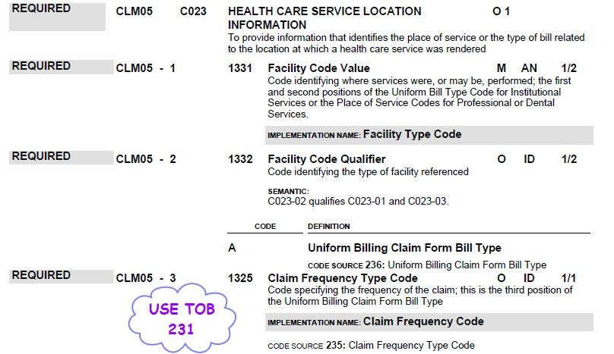

## Image from page 284 of the 837I Guide to instruct billers on the use of Value Code 24

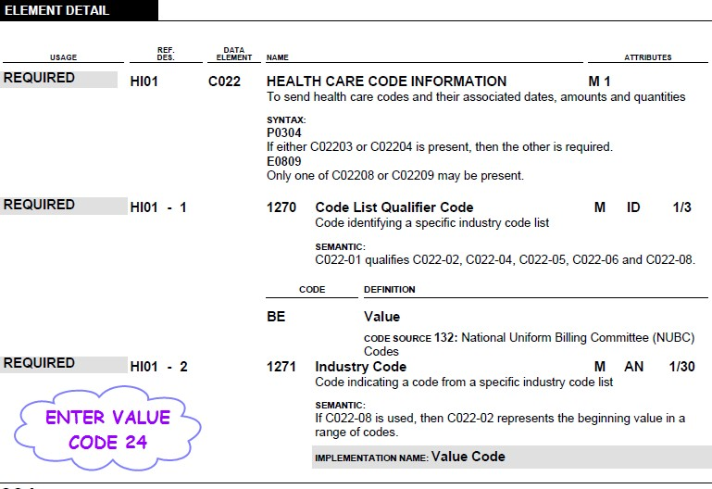

## Imagefrompages 424, 425, and 426 of the 837I Guide, annotated to instruct billers on the use of Revenue Code 220 and corresponding HCPCS code

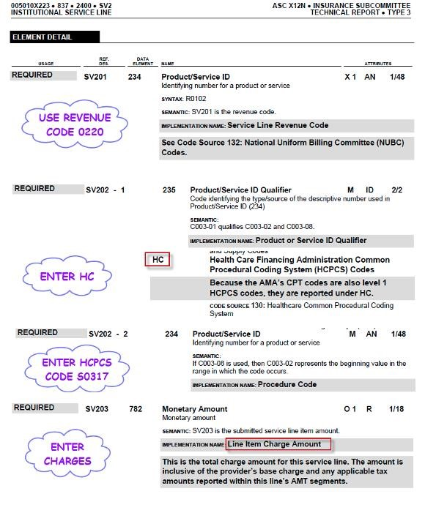

Image from page 428 of the 837I Guide, annotated to instruct Billers on inputting of required Days

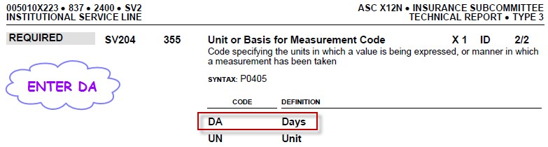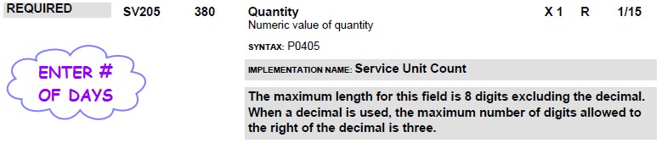

## Image from pages 319-321 of the 837I Guide on the NPI requirements for Billers

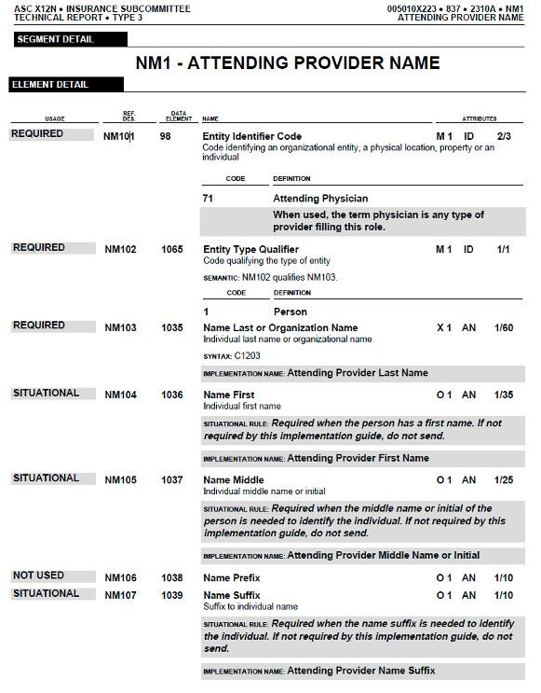

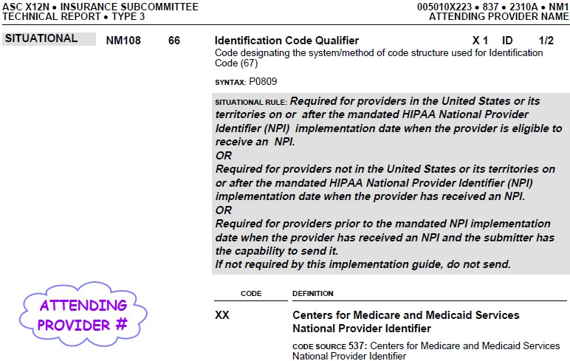

# EXAMPLE POSC SCREEN SHOTS IF MANUALLY BILLING VIA DIRECT DATA ENTRY (DDE)

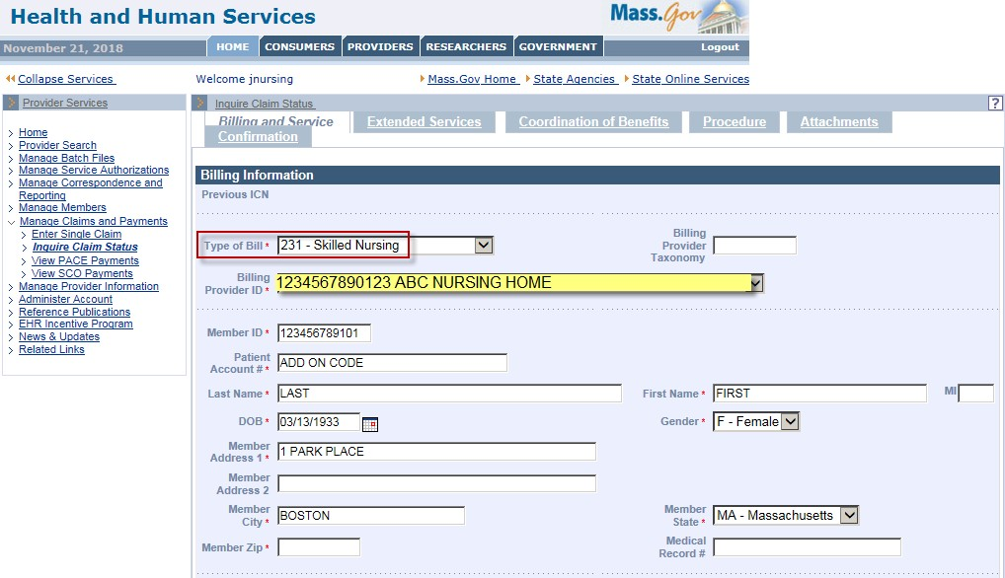

*Must indicate Attending Provider ID

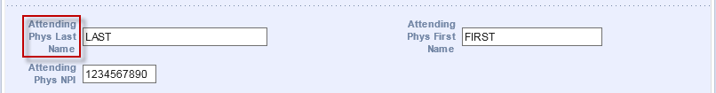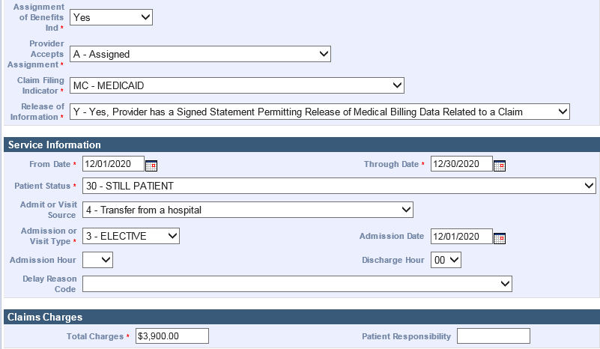

*Patient Account Number field: type in the Patient Account Number

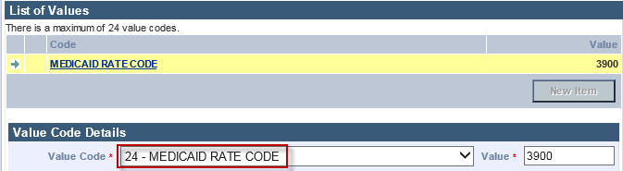

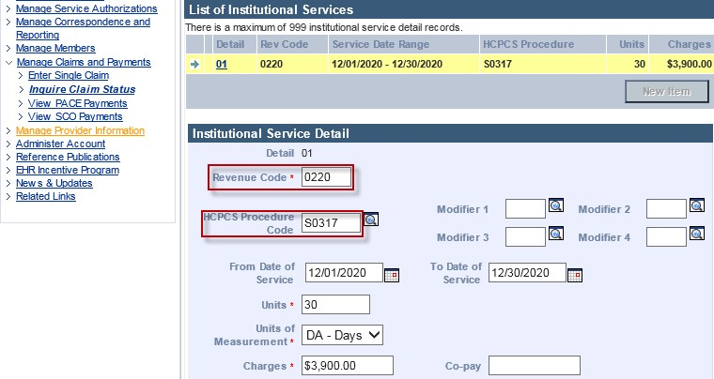

**Which Add-ons can be combined?**

