LEAD POISONING
Call for free: 1-800-532-9571
Assistance available in other languages.

Nutrition and Children

Lead poisoning is caused by too much lead in the body. Lead is a metal that hurts the brain, kidneys, and nervous system of children.

Lead dust and lead paint in older homes can poison children. Lead dust can come from peeling or chipping paint. Lead dust falls on the floor and toys. Lead dust gets into a child’s body when he puts his hands and toys in his mouth.

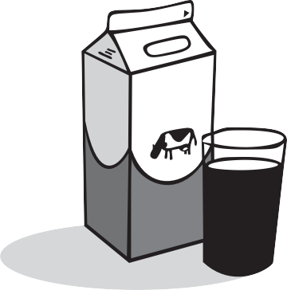Foods for Your Children
Give your children foods that are high in calcium, iron and vitamin C.

Calcium • Milk, yogurt, tofu, cheese
- Food made with milk (pudding, pizza, macaroni & cheese)
- Green leafy vegetables (collards, spinach, broccoli)

Iron • Lean meats (beef, chicken, pork, goat)
- 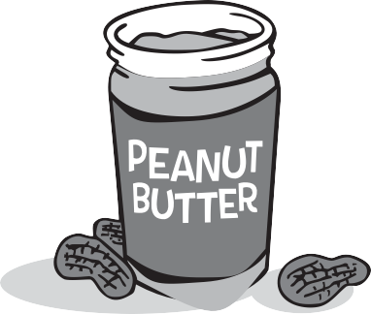Fish
- Cereals (infant cereal with iron, cream of wheat)
- Beans (black, kidney, pinto)
- Peanut butter and nuts
- Dried fruits (raisins, cranberries, prunes)

Vitamin C • Oranges, grapefruit, mangos
- Green and red peppers
- Tomatoes
- 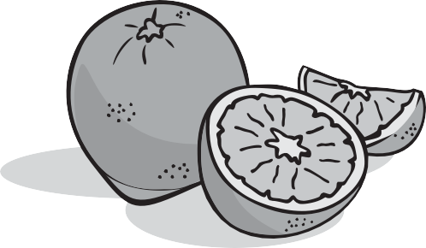Juices (orange, grapefruit, tomato)

Nutrition Tips

www.mass.gov/dph/clppp

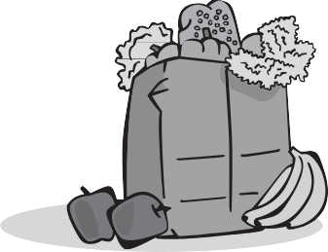Make meal time safer:
Keep children from walking around with food. Children can put food down in areas with lead dust.
- Wash your children’s hands before every snack or meal.
- Don’t eat food that has fallen on the floor.
- Eat meals and snacks at the table.

Give your children healthy snacks like:
- Fresh fruits and vegetables
- Whole grain crackers
- Cheese slices
- Yogurt

Feed your children 4 to 6 small meals during the day.
Children absorb less lead on a full stomach.

Contact your local WIC office for more nutrition information.
Call toll-free 1-800-942-1007.

Remember: The best way to prevent lead poisoning is to have your home inspected and made lead safe!

The Massachusetts Lead Law protects children under 6 who live in a home built before 1978. If there is lead paint in your home,
the landlord must fix it. Ask your landlord to test your home for lead.

Childhood Lead Poisoning
Prevention Program (CLPPP)
Call: 1-800-532-9571 or 1-617-624-5757
TTY: 1-617-624-5286
Email: clppp@state.ma.us
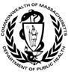On the web: www.mass.gov/dph/clppp

Massachusetts Department of Public Health
Bureau of Environmental Health 2015

