Microsoft Office 365 FAQ
The purpose of this job aid is to share with you general frequently asked questions (FAQ) about migrating to Exchange Online (Office365 E-Mail).

What is being migrated?
Only your Outlook mailbox. We are migrating from an on premise-based Exchange environment to Microsoft's hosted Office 365 offering.

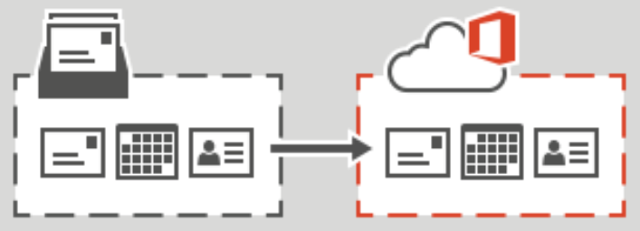

Will I be notified when my email will be migrated?
Yes, you will be notified in an email about a week before your mailbox will be migrated to Office 365. You will also receive notification 2 days prior to the migration and the day of the migration. See sample notification below:

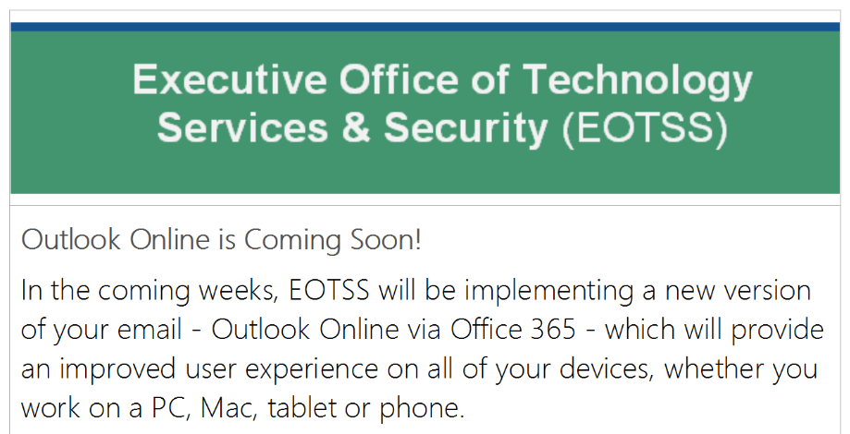

What will be the impact to me?
When the migration is complete, you will receive a message to restart Outlook.

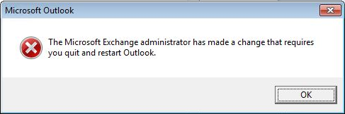

You will be prompted to enter your credentials the first time you open Outlook. Your user ID will be your @mass.gov email address and current network password.

Mobile Devices:
You will need to reconfigure your mobile device to connect to Office 365.

Mobile Airwatch users will need to re-enter your password on your mobile device.

IPhone: Android:
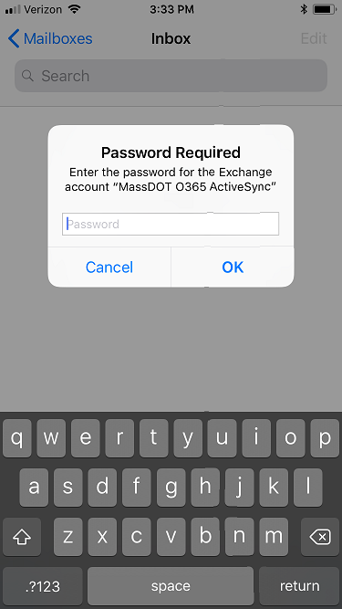 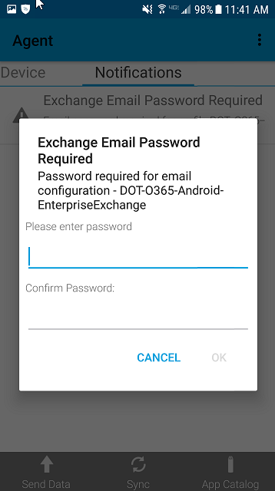
Note: Due to new security requirements, you will be required to set a 6-digit passcode screen lock for your device.

If I am not in the office during the scheduled migration time, will my Outlook Mailbox still be migrated?
Yes.

Will My Email Address Be Changing?
Yes. All Executive Branch email addresses are changing to @mass.gov. You will still receive mail directed to your @state.ma.us address or your @massmail.state.ma.us address.

What happens to my old email and calendar entries?
Your email folders, contacts and calendar entries will migrate along with your mail.

Helpful Links:
Learn to Manage Your Calendar In Office 365

Will mailbox and calendar sharing permissions (delegates) be migrated or will they have to be set up again?
Delegate permissions will migrate, but will require that users with delegation be migrated together.

Helpful Links:
How to Assign a Delegate to Your Inbox in Office 365
How to Assign a Delegate to Your Calendar in Office 365
How to Open a Shared Mailboxes in Office 365

Do I still have my email signature inserted to new emails?
Yes, if the outlook profile is not rebuilt

Helpful Links:
How to Create a Signature in Office 365

How much space do I have for my Outlook email account in Exchange Online (Office365 E-mail)?
Each Office 365 mailbox has a quota of 100 GB. The Archive mailbox size is unlimited.

What the maximum allowed attachment size for my message?
The maximum allow attachment size is 25 MB.

Will I still be able to manage my Distribution Lists in Outlook?
During the migration of users in your agency, you will not be able to manage your distribution lists in Outlook after moving to the cloud. Once all users in the agency are migrated, the Distribution List will be re-created in Office 365 and Outlook can once again be used for management.

Why didn’t I receive email sent to the distribution list?
All users in the agency/secretariat must be synchronized to Office 365. If not, when an Office 365 person sends an email to the distribution list users will not get the email. Contact your helpdesk to make sure you are included in the distribution list and you are synchronized to Office 365.

Where are my old emails?
Any email older than 2 years have been moved to the Online Archive and have retained the mailbox folder structure. When the email is moved to the Online Archive, the folders are not deleted in the mailbox. If they folder is empty, validate the email is in the Online Archive. The old folders in your mailbox can be deleted once all email in the folder is moved.

My mailbox still shows my massmail email address
Updating the users email address to @mass.gov will NOT update the display in Outlook. Because the Outlook profile does not update you may notice your email is still @massmail.state.ma.us. The 2 methods to update Outlook is to re-create the profile or removal of Outlook and install of new version.

Where are my shared mailboxes?
With the upgrade to Exchange Online, any shared mailboxes that are currently configured as a ‘user’ mailbox type will be converted to the ‘shared’ mailbox type. This step is critical, as shared mailboxes do not consume a user license in Exchange Online.

Today, you may log in to the shared mailboxes you have access to using a separate username and password. After the upgrade, you will need to re-map this shared mailbox in Outlook by following these steps (this will allow to access shared mailboxes without logging in to them):
- Open Microsoft Outlook 2010
- Click File tab in the Toolbar
- Click Account Settings button, select Account Settings
- Select the E-Mail tab
- Highlight your mailbox, click the Change button
- Click the More Settings button
- Select the Advance tab
- Click the Add button
- Type the Shared E-Mail Address
- Click the Apply and Ok buttons

How do I send a message from the shared mailbox?
- Open a new Mail Message
- Click the From button
- Select Other E-Mail Address
- Type in the Shared E-Mail Address in the From field
- Send message

How to I add a share mailbox in Outlook Online?
- Sign in to your Outlook Online account
- Right-click your primary mailbox in the left navigation pane
- Choose add shared folder
- In the add shared folder dialog box, type the name or email address of the shared mailbox
- Click add

