**INDOOR AIR QUALITY**

**ASSESSMENT**

**Oak Bluffs Fire Department**

**6 Firehouse Lane**

**Oak Bluffs, MA**

Exterior view of Oak Bluffs Fire Department
6 Firehouse Lane
Oak Bluffs, MA


Prepared by:

Massachusetts Department of Public Health

Bureau of Climate Change and Environmental Health

Indoor Air Quality Program

March 2024

# EXECUTIVE SUMMARY

The Oak Bluffs Fire Department needs a heating, ventilation, and air conditioning (HVAC) system preventative maintenance program and an overall system evaluation. The HVAC equipment is original to construction of the building (< 10 years old) but is showing significant signs of corrosion. There is also a lack of knowledge/control over the HVAC system. These conditions can make it difficult to control outside airflow, temperature, and relative humidity, particularly during hot, humid, summer conditions that can lead to widespread condensation and water damage issues, including mold growth. As climate change and global warming intensifies, the urgent need for modern, energy-efficient solutions becomes clear. Without a preventative maintenance program and a comprehensive understanding of the operation and control of HVAC equipment and components, building conditions and indoor air quality will continue to degrade.

# BACKGROUND

|  |  |
| --- | --- |
| Building: | Oak Bluffs Fire Department (OBFD) |
| Address: | 6 Firehouse Lane, Oak Bluffs, MA |
| Assessment Requested by: | OBFD staff and coordinated through Deputy Fire Chief, Stephen Foster |
| Reason for Request: | General indoor air quality (IAQ) assessment |
| Date of Assessment: | January 5, 2024 |
| Massachusetts Department of Public Health/Bureau of Climate and Environmental Health (MDPH/BCEH) Staff Conducting Assessment: | Cory Holmes, Assistant Director, IAQ Program |
| Building Description: | The OBFD is a two-story building with an attic and basement, constructed in 2014-2015. The main building has several peaked metal roofs with gables; the engine bays have a flat rubber membrane roof. The interior space consists of suspended ceiling tiles, laminate flooring, and gypsum wallboard. The attic contains the air handling units (AHUs) for the HVAC system. The basement contains a gym, network/server room, and storage areas. |
| Windows: | Openable |

# METHODS

Please refer to the IAQ Manual for methods, sampling procedures, and interpretation of results (MDPH, 2015).

**RESULTS and DISCUSSION**

The following is a summary of indoor air testing results (Table 1).

* ***Carbon dioxide*** levels were above the MDPH guideline of 800 parts per million (ppm) in 3 of 17 areas surveyed, indicating a need for increased air exchange in these areas.
* ***Temperature*** was slightly below the MDPH recommended range of 70°F to 78°F in a number of areas tested.
* ***Relative humidity*** was below the MDPH recommended range of 40 to 60%, in all areas tested, which is typical for New England during the heating season.
* ***Carbon monoxide*** levels were non-detectable (ND) in all areas tested.
* ***Fine particulate matter (PM2.5)*** concentrations measured were below the National Ambient Air Quality Standard (NAAQS) limit of 35 μg/m3 in all areas tested.
* ***Total volatile organic compounds (TVOCs)*** levels were ND in all areas tested.

## Ventilation

A heating, ventilating, and air conditioning (HVAC) system has several functions. First it provides heating and, if equipped, cooling. Second, it is a source of fresh air. Finally, an HVAC system will dilute and remove normally occurring indoor environmental pollutants by not only introducing fresh air, but by filtering the airstream and ejecting stale air to the outdoors via exhaust ventilation. Even if an HVAC system is operating as designed, point sources of respiratory irritation may exist and cause symptoms in sensitive individuals.

Fresh air is supplied by two AHUs located in the attic (Picture 1), which is accessible by hatches in the ceiling of the 2nd floor and several ladders. The building uses ceiling-mounted “cassette” units in occupied areas for heating, cooling, and air distribution (Picture 2). Air is directed back to the AHUs via ceiling-mounted return vents (Picture 3). It appeared that the AHUs were programmable and controlled by a digital screen on the units in the attic themselves (Picture 4), which are difficult to access. As stated in the Executive Summary, the HVAC system needs a preventative maintenance program. Due to lack of maintenance, one of the units appeared to have collected water that caused a significant amount of corrosion in its interior (Picture 5), as opposed to the second unit (Picture 6). This damage should be evaluated by an HVAC professional as to whether it can be cleaned/treated to prevent further degradation. According to the American Society of Heating, Refrigeration, and Air-Conditioning Engineers (ASHRAE), the service life[1] of this type of unit is 15-20 years, assuming routine maintenance of the equipment (ASHRAE, 1991), interior corrosion causes accelerated aging of the equipment.

It is important to note that the HVAC system at OBFD is of an unusual configuration. In a typical HVAC system found in public buildings, AHUs are equipped with filters to remove particles that are found indoors. The MDPH recommends pleated filters with a Minimum Efficiency Reporting Value (MERV) of 8 or higher, which are adequate in filtering out pollen and mold spores (ASHRAE, 2012). Since fire department operations involve operating equipment that uses diesel fuel in engine bays, an exhaust ventilation system that attaches to the tailpipe of fire emergency vehicles is used to directly vent engine exhaust outdoors. The engine bay is equipped with a tailpipe exhaust collection system (called a Plymovent, Pictures 10 and 11). In order for this system to properly operate, regular preventative maintenance of Plymovent equipment is necessary to properly vent vehicle exhaust from engine bays. In addition, the HVAC system that services occupied areas outside the engine bays should pressurize the occupied space to prevent the draw of pollutants into offices, the bunkhouse, and other locations.

OBFD has an HVAC system that uses AHUs equipped with filters that have a MERV 16 rating (Picture 7). In the experience of IAQ staff, MERV 16 filters are usually used in facilities that either must control airborne particles in order not to interfere with manufacturing processes, such as computer chip manufacturing; or prevent releases to the outdoor environment of particles, such as indoor firearms ranges. In health care facilities, certain types of operations are recommended to have MERV 14 filters (ASHE, 2014). Based on IAQ staff observations, the OBFD has no operation that would require the use of MERV 16 filters if the Plymovent system is operating.

Another consideration is that an HVAC system equipped with MERV 16 filters requires increased maintenance and complexity to operate when compared to a typical HVAC system. Filters must be installed correctly, cleaned, and replaced in a manner consistent with the manufacturer’s recommendations. Such systems require training of facilities staff to control and maintain in order for it to operate as designed. For example, cleaning of the HVAC system is recommended once a year, unless otherwise indicated by a message on the HVAC system display that reads “Filter” or “Cleaning” message on the unit (Picture 8).

To maximize air exchange, the IAQ program recommends that both supply and exhaust ventilation operate *continuously* during periods of occupancy. In order to have proper ventilation with a mechanical ventilation system, the systems must be balanced after installation to provide an adequate amount of fresh air to the interior of a room while removing stale air from the room. It is recommended that HVAC systems be re-balanced every five years to ensure adequate air systems function (SMACNA, 1994). The last date of balancing of the systems was not known at the time of assessment.

Local exhaust ventilation exists in the kitchen, laundry room, turn-out gear rooms, restrooms, and showers. It is important to ensure proper function and that they vent directly outdoors and do not mix with the general HVAC systems. OBFD staff reported that the kitchen exhaust hood does not vent directly outdoors (Picture 9).

There was a thermostat mounted on the wall of the Telcomms room on the second floor, similar to others located throughout the building near cassette units. It was not clear if this thermostat was functional or connected to any of the HVAC units.

## Microbial/Moisture Concerns

Shower vents in locker rooms were also not vented to the outdoors (Picture 12). In this condition, water vapor can be capture by the HVAC system and distributed to other locations. This condition can cause moisture issues inside a building (listed below), particularly during extended periods of hot, humid weather.

* Steam and water vapor released above the ceiling can cause damage to the suspended ceiling tiles and building components inside the plenum.
* Stored materials that are moistened can become mold-colonized, such as paper, cardboard, upholstered furniture, carpeting, or other items.
* If captured by the HVAC system, increased water vapor may overwhelm the drip pan’s ability to drain condensation.
* Condensation can accumulate inside the HVAC system to wet accumulated materials (e.g., dust/debris) or cause corrosion to duct system components.
* Increased humidity may also wet HVAC system filter media and frames, which in turn may result in mold growth.

All of these conditions may be present due to shower-generated water vapor. This condition likely worsens during hot, humid weather when the HVAC system is operating in cooling mode.

Roof leaks were reported in the ambulance side of the engine bay. Roof leaks should be repaired to prevent corrosion of metal structural materials or water damage and potential mold growth in porous items.

Also, of note along the exterior were trees/branches growing close to the building (Picture 11). Plants near the building envelope can cause water damage. In addition, trees shading exterior walls can slow drying and lead to damage to exterior building materials, corrosion, and water infiltration into the building.

In the basement, cardboard boxes and paper items were stored directly on the floor (Picture 13). These items should be elevated or stored on shelves to prevent getting wet (from condensation) and growing mold.

## Other Concerns

Of particular importance is vehicle exhaust, which involves the process of combustion. Although the engine bays are equipped with a specialized system to remove exhaust during idling, pathways for vehicle exhaust and other pollutants to migrate into adjacent/occupied areas were identified. Doors separating the engine bays from occupied space are not tightly sealed, as noted by space observed beneath them (Picture 14). These spaces should be sealed with weather-stripping to prevent the migration of products of combustion.

The kitchen stove has a subfloor grease trap (Picture 15). It was reported that previous to the MDPH site visit, the grease trap had overflowed and leaked on flooring materials in the basement. The grease trap should be monitored and maintained (e.g., cleaned out at regular intervals) for proper operation.

Some supply, exhaust and return vents had accumulations of dust and debris. This dust/debris can be reaerosolized under certain conditions, and should be cleaned periodically (e.g., during regular filter changes).

A few areas had dislodged/missing ceiling tiles and open utility holes in drywall (Table 1, Pictures 16 and 17). Ceiling tiles should be replaced, and breaches in walls should be repaired to prevent dust, drafts, and odors from migrating between the ceiling plenum/wall cavities into occupied areas. An open hole was noted in the ductwork in the attic (Picture 18). This hole should be plugged to prevent heating/cooling loss.

Finally, portable air purifiers were noted in a few areas (Table 1). Air purifiers should be cleaned and maintained in accordance with manufacturers’ instructions.

# CONCLUSIONS AND RECOMMENDATIONS

The HVAC system in the OBFD is complex when compared to other fire stations. The installation of a system capable of using MERV 16 filters requires understanding of the proper operation and maintenance, as well increased cost for filter replacement, compared to a typical fire station HVAC system. Given the complexity of the HVAC system, a number of possible recommendations may be made. Since the system is complicated, consulting with a ventilation engineer that has worked with fire stations is recommended. Such an individual should consider whether installation of a MERV 16 filter equipped HVAC system is appropriate for fire operations. One consideration would be to discern if the HVAC system can be adjusted and adapted to accommodate a filtration system that would be more appropriate for the operations of a fire station in a high humidity environment.

In view of the findings at the time of assessment, the following recommendations are made:

### **Ventilation recommendations**

1. Establish preventative maintenance plans for general HVAC and Plymovent systems.
2. The HVAC system controls and components should be fully evaluated by an HVAC engineering firm to determine optimal efficiency and operation of existing equipment and the feasibility of upgrading to a modern electronic management system that can be monitored and operated via laptop or computer.
3. Change filters and clean cores for HVAC equipment as per the manufacturer’s recommendations or more frequently if needed.
4. Ensure shower and restroom vents are ducted to the outdoors and not tied into the general HVAC system.
5. Consider ducting stove/range hood to the outdoors.
6. Work with HVAC engineer to determine if fresh, outside air is provided to ceiling mounted *cassette* units in occupied areas.
7. Clean the interior of AHUs and univents during regular filter changes using a HEPA-filtered vacuum cleaner with brush attachment or compressed air.
8. Periodically check local exhaust vents for turn out rooms, dryer, kitchen hood, and restrooms for proper operation and make adjustments/repairs as needed.
9. Clean dryer vent at regular intervals.
10. Seal holes in ductwork in attic to prevent heating/cooling loss.
11. Determine function of thermostat in Telcomms room.
12. Have the HVAC system balanced every 5 years in accordance with SMACNA recommendations (SMACNA, 1994).

### **Water Damage recommendations**

1. Ensure all leaks are repaired and clean/replace water-damaged building materials.
2. Trim plants away from the building a minimum of five feet.
3. Keep cardboard and paper items off floor in basement storage areas to prevent mold growth.

### **Other recommendations**

1. Seal spaces beneath apparatus bay doors with weather-stripping to prevent the migration of products of combustion into occupied areas.
2. Clean supply, return, and exhaust vents regularly to remove accumulated dust/debris.
3. Replace missing/dislodged ceiling tiles.
4. Repair/fill holes in walls.
5. Clean supply, return, and exhaust vents regularly to remove accumulated dust/debris.
6. For buildings in New England, periods of low relative humidity during the winter are often unavoidable. Therefore, scrupulous cleaning practices should be adopted to minimize common indoor air contaminants whose irritant effects can be enhanced when the relative humidity is low. To control for dusts, a high efficiency particulate arrestance (HEPA) filter equipped vacuum cleaner in conjunction with wet wiping of all surfaces is recommended. Avoid the use of feather dusters. Drinking water during the day can help ease some symptoms associated with a dry environment (throat and sinus irritations).
7. Maintain portable air purifiers in accordance with manufacturer's instructions.
8. Establish a preventative maintenance plan for the grease trap.
9. Refer to resource manual and other related IAQ documents located on the MDPH’s website for further building-wide evaluations and advice on maintaining public buildings. These documents are available at: <http://mass.gov/dph/iaq>.

**REFERENCES**

ASHE. 2014. Air Filtration in Hospitals. American Society for Health Care Engineers. https://www.ashe.org/compliance/ec_02_05_01/01/airfiltration

ASHRAE. 1991. ASHRAE Applications Handbook, Chapter 33 “Owning and Operating Costs”. American Society of Heating, Refrigeration and Air Conditioning Engineers, Atlanta, GA.

ASHRAE. 2012. American Society of Heating, Refrigeration and Air Conditioning Engineers (ASHRAE) Standard 52.2-2012 -- Method of Testing General Ventilation Air-Cleaning Devices for Removal Efficiency by Particle Size (ANSI Approved).

MDPH. 2015. Massachusetts Department of Public Health. “Indoor Air Quality Manual: Chapters I-III”. Available at: [Indoor air quality - manual and appendices | Mass.gov](https://www.mass.gov/lists/indoor-air-quality-manual-and-appendices)

SMACNA. 1994. HVAC Systems Commissioning Manual. 1st ed. Sheet Metal and Air Conditioning Contractors’ National Association, Inc., Chantilly, VA.

US EPA. 2023. What is a MERV rating? US Environmental Protection Agency, Washington, DC. https://www.epa.gov/indoor-air-quality-iaq/what-merv-rating

**Picture 1**

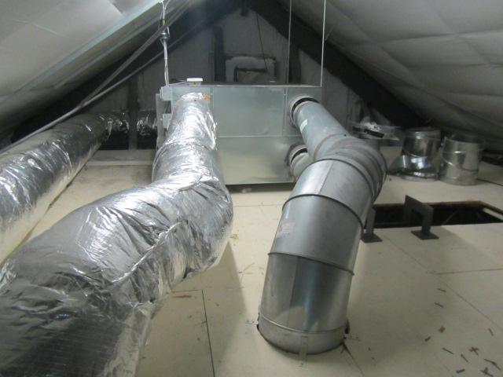

**One of two AHUs in attic**

**Picture 2**

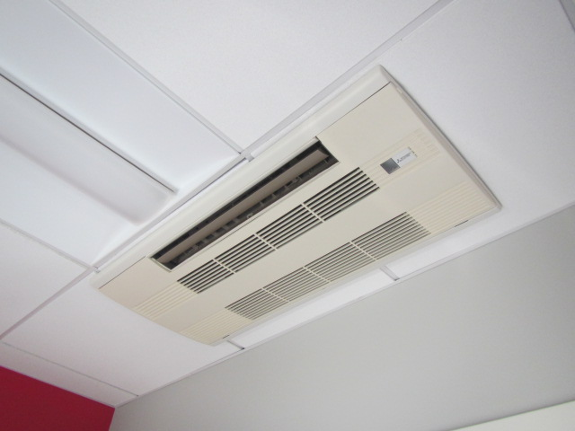

**Ceiling-mounted *cassette* AHU**

**Picture 3**

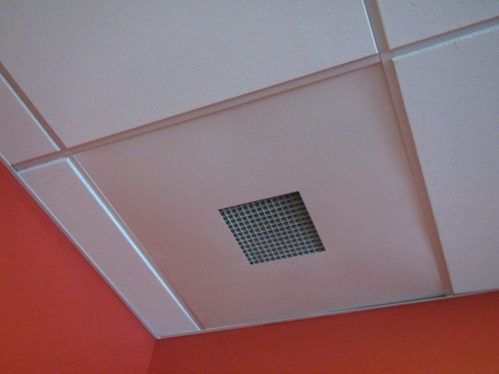

**Ceiling-mounted return vent**

**Picture 4**

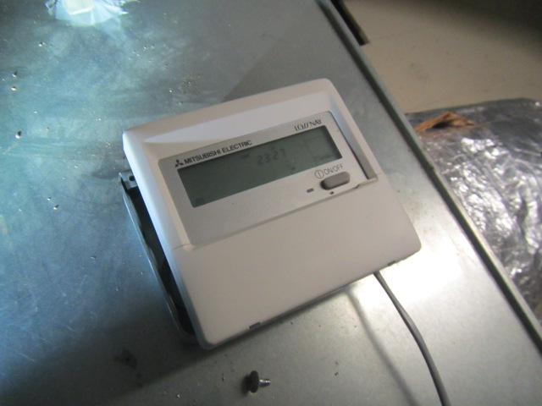

**Digital program pad on AHU in attic**

**Picture 5**

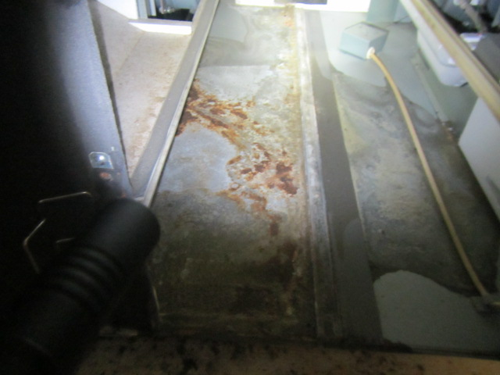

**Interior of AHU in attic, note corrosion on floor of unit**

**Picture 6**

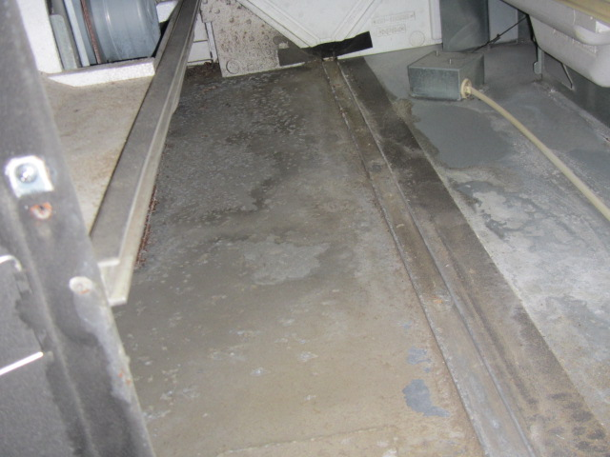

**Floor of 2nd AHU in attic, note lack of corrosion**

**Picture 7**

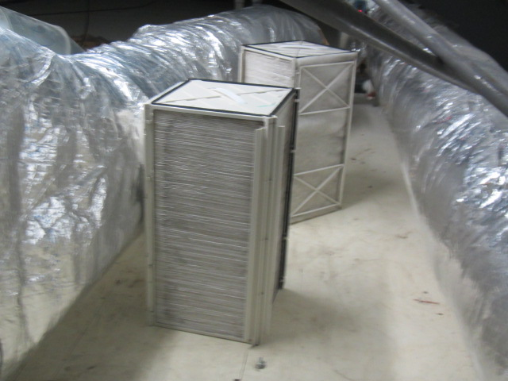

**Core and filters for AHUs**

**Picture 8**

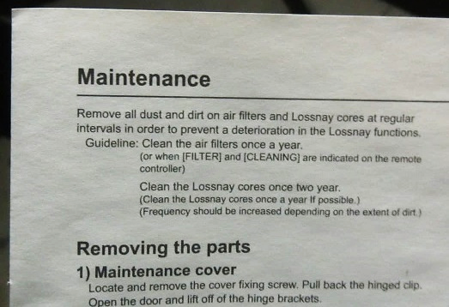

**Maintenance instructions for cores and filters**

**Picture 9**

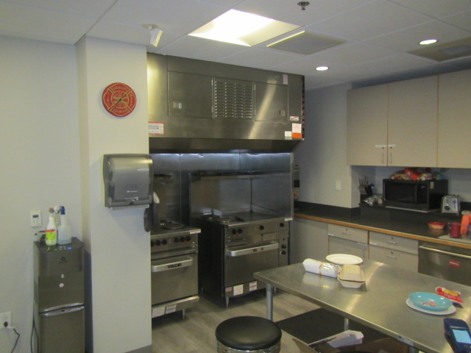

**Kitchen range hood**

**Picture 10**

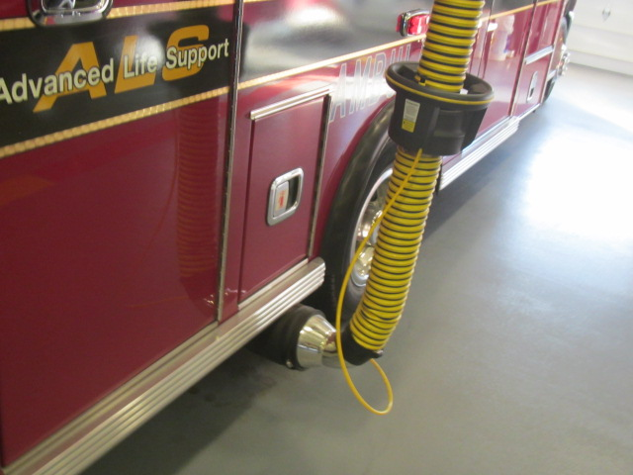

**Plymovent hooked up to exhaust pipe**

**Picture 11**

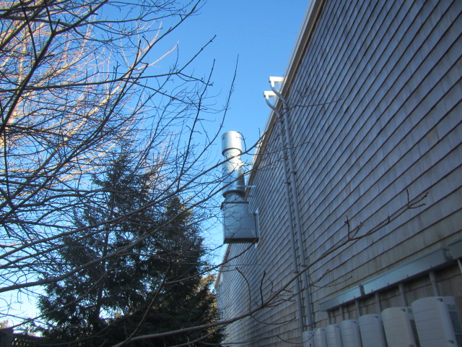

**Exhaust terminus for Plymovent system, note trees/branches in close proximity to exterior walls**

**Picture 12**

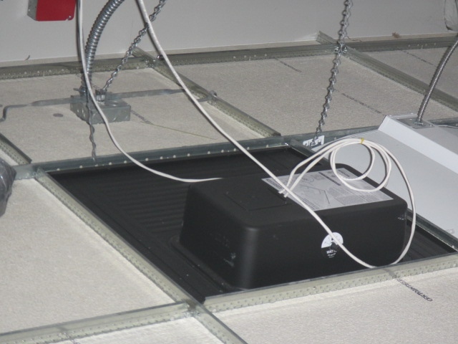

**Exhaust fan above locker room not connected to anything**

**Picture 13**

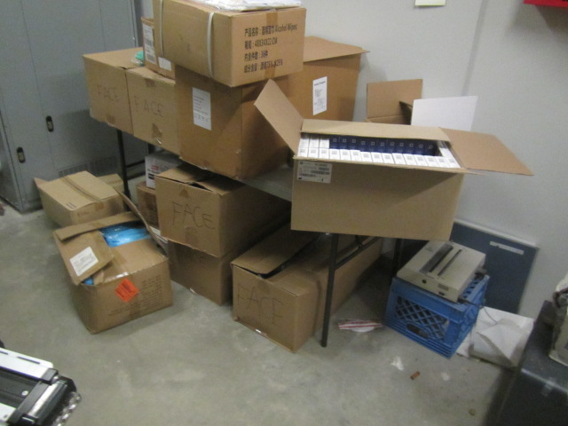

**Cardboard boxes stored directly on floor in basement**

**Picture 14**

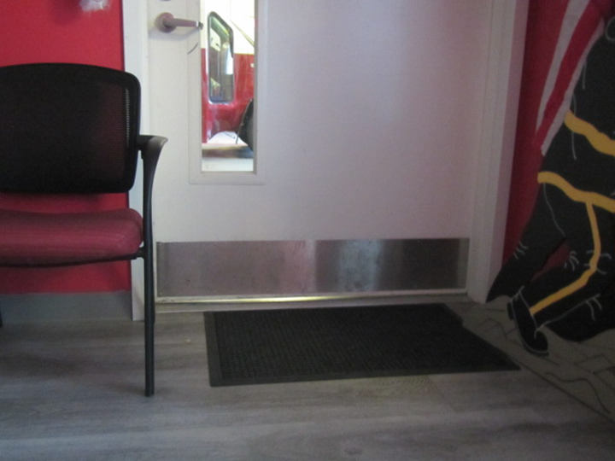

**Space beneath door to apparatus bay**

**Picture 15**

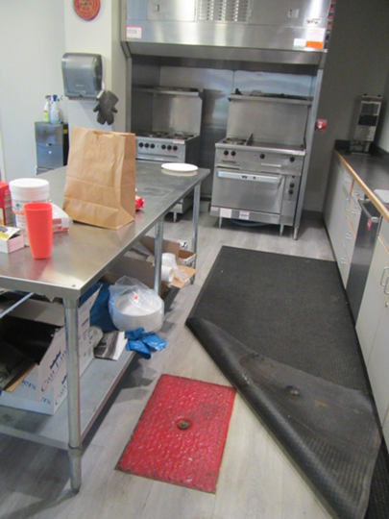

**Grease trap access panel in kitchen area**

**Picture 16**

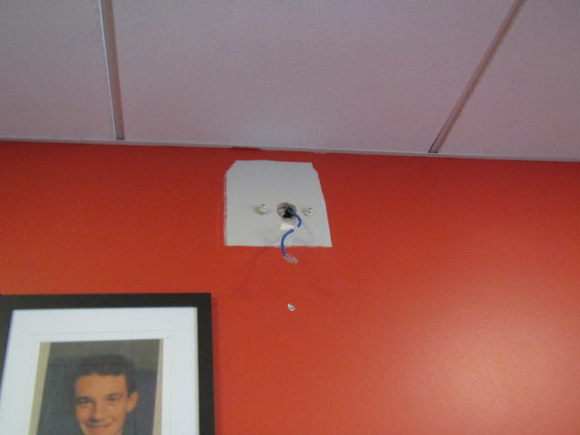

**Open utility hole in wall**

**Picture 17**

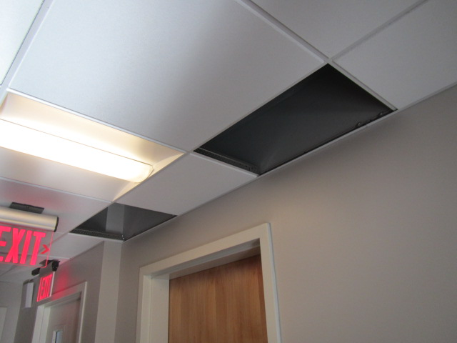

**Missing ceiling tiles**

**Picture 18**

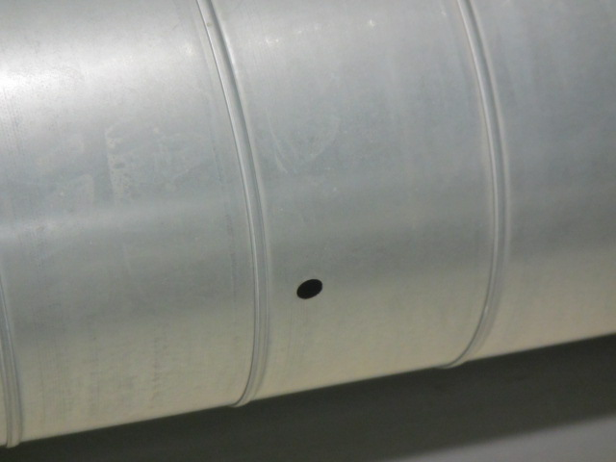

**Open hole in ductwork in attic**

| Location | **Carbon**  **Dioxide**  **(ppm)** | **Carbon Monoxide**  **(ppm)** | **Temp**  **(°F)** | **TVOCs**  **(ppm)** | **Relative**  **Humidity**  **(%)** | **PM2.5**  **(µg/m3)** | **Occupants**  **in Room** | **Windows**  **Openable** | **Ventilation** | | **Remarks** |
| --- | --- | --- | --- | --- | --- | --- | --- | --- | --- | --- | --- |
| Background | 411 | ND | 35 | ND | 34 | 1 |  |  |  |  | Cold, clear, dry |
| Chief Office | 1338 | ND | 72 | ND | 34 | 1 | 0 | Y | Y | Y |  |
| Admin Office | 1319 | ND | 70 | ND | 36 | 1 | 2 | Y | Y | Y |  |
| 2nd Floor Hallway |  |  |  |  |  |  |  |  |  |  | Missing CTs |
| Conference Room | 592 | ND | 69 | ND | 31 | 1 | 0 | Y | Y | Y | Holes in wall |
| Deputy Chief | 711 | ND | 69 | ND | 32 | 1 | 0 | Y | Y | N |  |
| Tel Comms |  | ND |  | ND |  |  |  |  |  |  | Thermostat-functional? |
| Training Room | 622 | ND | 70 | ND | 28 | 1 | 0 | Y | Y | Y |  |
| Male/Female Locker Rooms |  |  |  |  |  |  | 0 | N | Y | Y | Shower exhausts not ducted to outside |
| Bunk Room 1 | 640 | ND | 68 | ND | 28 | 1 | 0 | Y | Y | N |  |
| Bunk Room 2 | 664 | ND | 68 | ND | 28 | 1 | 0 | Y | Y | N |  |
| Bunk Room 3 | 600 | ND | 67 | ND | 29 | 1 | 0 | Y | Y | N |  |
| EMS Day Room | 614 | ND | 66 | ND | 29 | 1 | 0 | Y | Y | N |  |
| EMS Bunk Room 1 | 730 | ND | 69 | ND | 32 | 1 | 0 | Y | Y | N |  |
| EMS Bunk Room 2 | 613 | ND | 69 | ND | 27 | 1 | 0 | Y | Y | N | Portable air purifier |
| EMS Bunk Room 3 | 644 | ND | 69 | ND | 26 | 1 | 0 | Y | Y | N |  |
| EMS Decon/Supply | 629 | ND | 69 | ND | 26 | 1 | 0 | N | Y | N |  |
| Kitchen | 621 | ND | 68 | ND | 25 | 1 | 0 | Y | Y | Y | Dust/debris on vents, range hood not vented to the outside |
| EMS Office | 904 | ND | 69 | ND | 29 | 1 | 0 | N | Y | N | PF |
| Basement Gym | 793 | ND | 72 | ND | 26 | 1 | 0 | N | N | N |  |
| Engine Bay | 748 | ND | 70 | ND | 21 | 1 | 0 | N | Y | Y | Plymo vent system |

1. The service life is the median time during which a particular system or component of … [an HVAC]… system remains in its original service application and then is replaced. Replacement may occur for any reason, including, but not limited to, failure, general obsolescence, reduced reliability, excessive maintenance cost, and changed system requirements due to such influences as building characteristics or energy prices (ASHRAE, 1991).