INDOOR AIR QUALITY ASSESSMENT

Oak Bluffs Town Hall
56 School Street
Oak Bluffs, Massachusetts

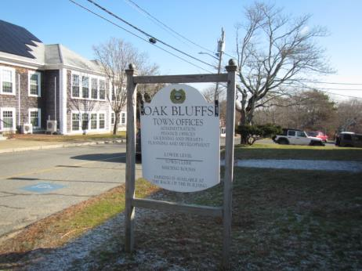

Prepared by:
Massachusetts Department of Public Health
Bureau of Environmental Health
Indoor Air Quality Program
December 2018

BACKGROUND
Building: | Oak Bluffs Town Hall (OBTH)
Address: | 56 School Street, Oak Bluffs, MA
Assessment coordinated via: | Oak Bluffs Board of Health
Reason for Request: | Water damage and general indoor air quality (IAQ)
Date of Assessment: | December 12, 2018
Massachusetts Department of Public Health/Bureau of Environmental Health (MDPH/BEH) Staff Conducting Assessment: | Cory Holmes, Environmental Analyst/Inspector, IAQ Program
Date of Building Construction: | 1920s, originally built as an elementary school, the building has served as town offices for approximately 20 years.
Building/Site Description: | The OBTH is a two-level (built into hill) building that has wooden shingle siding and asphalt shingle roof. A number of areas contain wall to wall carpeting and suspended ceiling tile systems.
Building Population: | The building is staffed with 18-20 employees and serves the public daily.
Windows: | Openable, although some in disrepair.

METHODS
Please refer to the IAQ Manual for methods, sampling procedures, and interpretation of results (MDPH, 2015).

RESULTS and DISCUSSION
The following is a summary of indoor air testing results (Table 1).
- Carbon dioxide levels were below the MDPH guideline of 800 parts per million (ppm) in all areas.
- Temperature was below the MDPH recommended range of 70°F to 78°F in a number of areas, particulary on the first floor.
- Relative humidity was below the MDPH recommended range of 40 to 60% in all occupied areas, which is common during the heating season.
- Carbon monoxide levels were non-detect (ND) throughout the building.
- Particulate matter (PM2.5) concentrations measured were below the National Ambient Air Quality (NAAQS) level of 35 μg/m³ in all areas tested.

Ventilation
The heating, ventilation and air conditioning (HVAC) system consist of air handling units (AHUs) located in a mechanical room on the main level (Picture 1). Conditioned air is supplied via ceiling or wall-mounted diffusers (Picture 2) and ducted back to the AHUs via return vents (Picture 3). The AHUs appear to be several decades old. Efficient function of equipment of this age is difficult to maintain, since compatible replacement parts are often unavailable. According to the American Society of Heating, Refrigeration, and Air-Conditioning Engineering (ASHRAE), the service life of this type of unit is 15-20 years, assuming routine maintenance of the equipment (ASHRAE, 1991). It appears the optimal operational lifespan of this equipment has been exceeded.
It is also important to note that one of the AHUs was missing its filter panel (Picture 4), which can draw airborne dust/debris into the unit (called filter bypass) and distribute into occupied areas. This can serve as a source of respiratory irritation.
To maximize air exchange, the MDPH recommends that both supply and exhaust ventilation operate continuously during periods of occupancy. In order to have proper ventilation with a mechanical supply and exhaust system, the systems must be balanced to provide an adequate amount of fresh air to the interior of a room while removing stale air from the room. It is recommended that HVAC systems be re-balanced every five years to ensure adequate air systems function (SMACNA, 1994).

Microbial/Moisture Concerns
The building has chronic issues with water penetration, as demonstrated by stained/damaged materials seen throughout the space, as well as from photographs provided by OBTH staff (Pictures 5 through 14). The US Environmental Protection Agency (US EPA) and the American Conference of Governmental Industrial Hygienists (ACGIH) recommends that porous materials (e.g., wallboard, carpeting) be dried with fans and heating within 24 to 48 hours of becoming wet (US EPA, 2008; ACGIH, 1989). If porous materials are not dried within this time frame, mold growth may occur.
Visible mold growth was observed on drywall in the Building Department (Picture 2), which should be removed. Mold growth was also noted on wall-mounted AC units in both the upstairs and downstairs IT rooms (Pictures 15 and 16). However, these units are plastic, which can be cleaned.
An unconditioned space in the lower level is used for records storage. The dampness in this space makes it a poor choice for storing porous materials such as paper and cardboard (Pictures 6 through 8). Elevated humidity and condensation may lead to the moistening/mold contamination of these materials, which would need to be discarded. The severe corrosion of the metal roof in this area demonstrates chronic dampness in this area (Pictures 17 and 18).
A perimeter inspection of the building was conducted to identify any breaches/potential pathways for water intrusion:
- Wooden fascia board was missing/damaged near the roof (Picture 19);
- Missing/damaged wooden shingles (Picture 20);
- Missing/damaged window caulking (Picture 21);
- Clinging plants on exterior walls (Pictures 22 and 23);
- Exterior doors that do not shut (Picture 23); and
- Missing/damaged gutters and downspouts (Pictures 24 and 25).
Over time, these conditions can undermine the integrity of the building envelope and provide a means of water entry into the building via capillary action through foundation concrete and masonry (Lstiburek & Brennan, 2001). The freezing and thawing action of water during the winter months can create cracks and fissures in the foundation. These breaches may provide a means for moisture and pests to enter the building.

Other IAQ Evaluations
Several areas were carpeted. Carpets should be cleaned annually (or semi-annually in soiled/high traffic areas) in accordance with Institute of Inspection, Cleaning and Restoration Certification (IICRC) recommendations, (IICRC, 2012). The service life of carpeting is approximately 10-11 years (IICRC, 2002). In some areas, carpeting was observed to be worn and stained (Picture 26). Carpeting of this age and condition becomes increasingly difficult to clean and maintain and may be a source of particulate matter to the indoor environment. Regular cleaning with a high efficiency particulate air (HEPA) filtered vacuum in combination with an annual cleaning will help to reduce accumulation and potential aerosolization of materials from carpeting.
Missing/damaged ceiling tiles were observed in a number of areas (Table 1, Pictures 12 and 27), which can provide a pathway for dust/debris above ceiling tiles into occupied areas. Exposed fiberglass was observed in the Conservation Commission, which can provide a source of skin, eye and respiratory irritation.
An oil spill occurred in the boiler room prior to the BEH/IAQ assessment during refueling (Picture 28). Fuel oil odors were detected in the adjacent areas of the lower level, most likely due to the pressurization of the boiler room due to the exterior door that does not shut properly (Picture 23), which may allow uncontrolled introduction of outside air into the building. Pressurization would force odors (and any other airborne dust/debris) through open utility holes that might exist in the common wall/ceiling of the boiler room.
Finally, damaged pipe insulation (Pictures 29 and 30) was noted in the boiler room and lower level hallway and damaged floor tiles were observed in the early voting room (Picture 31). Due to the age of the building these tiles may be asbestos containing materials (ACM). Intact ACM does not pose a health hazard. If damaged, ACM can be rendered friable and become aerosolized. Friable asbestos is a chronic (long-term) health hazard, but will not produce acute (short-term) health effects (e.g., headaches) typically associated with buildings believed to have IAQ problems. Where asbestos-containing materials are found damaged, these materials should be removed or remediated in a manner consistent with Massachusetts asbestos remediation laws (MDLI, 1993). It was reported by Health Agent, Meegan Lancaster, that the Massachusetts Division of Labor and Industries (MDLI), Asbestos Program was contacted for assistance on this matter.

CONCLUSION AND RECOMMENDATIONS
In view of the findings at the time of the visit, the following recommendations are made:
- Continue with plans to have damaged insulation and floor tiles addressed by MDLI/remediated in accordance with state and federal regulations for asbestos-containing materials.
- Have the spilled fuel oil/absorbent material in the boiler room removed/properly cleaned.
- Replace filter panel for AHUs.
- Ensure filters for AHUs are of a pleated variety, Minimum Efficiency Reporting Value (MERV) dust-spot efficiency 8 or higher, which are adequate in filtering out pollen and mold spores (ASHRAE, 2012). Filters should be changed 2-4 times a year or in accordance with the manufacture’s recommendations.
- Due to the age/condition of HVAC system/components, develop a plan for replacement or overhaul of the HVAC systems including the controls.
- Consider adopting a balancing schedule of every 5 years for all mechanical ventilation systems, as recommended by ventilation industrial standards (SMACNA, 1994).
- Ensure that local exhaust vents are operating correctly (e.g., bathrooms) and that exhaust is ejected outside of the building.
- Use windows to provide supplemental fresh air during temperate weather. Close windows tightly during wet and hot, humid weather to prevent moisture accumulation.
- Make repairs to inoperable windows or replace.
- Make repairs to the building envelope (roof, windows, fascia, etc.) to prevent further leaks and damage including:
  - Replace missing/damaged window caulking.
  - Replace missing/damaged gutters/downspouts.
  - Remove clinging plants from exterior walls.
  - Repair/replace door to boiler room, ensure it closes properly.
- Consider installing an HVAC system for climate controlled environment in lower level records storerooms. If chronic water penetration persists, consider removing all stored porous materials from areas affected and store in a lower humidity environment.
- Remove/replace/refinish any water-damaged ceiling tiles and building materials including scraping loose paint and sealing water-damaged ceiling and wall plaster.
- Clean the mold from the air conditioners in the IT rooms. Ensure condensation from these units can drain from the building.
- Replace missing/damaged ceiling tiles.
- Wrap/cover exposed fiberglass in Conservation Commission.
- Periodically clean dust and debris from floors, flat surfaces, fans, vents and AC units.
- Seal abandoned exhaust vents in restrooms that are backdrafting (Picture 32).
- Seal open utility holes/breaches in ceilings, floors and walls with a fire-rated sealant, particularly in the boiler room.
- For buildings in New England, periods of low relative humidity during the winter are often unavoidable. Therefore, scrupulous cleaning practices should be adopted to minimize common indoor air contaminants whose irritant effects can be enhanced when the relative humidity is low. To control for dusts, a high efficiency particulate arrestance (HEPA) filter equipped vacuum cleaner in conjunction with wet wiping of all surfaces is recommended. Avoid the use of feather dusters. Drinking water during the day can help ease some symptoms associated with a dry environment (throat and sinus irritation).
- Store porous items (i.e., cardboard and paper) off the floor in sealed boxes, bags or totes to prevent water damage. Discard water-damaged and/or moldy materials.
- Regularly HEPA vacuum remaining carpeting/area rugs and clean carpeting at least once per year according to IICRC recommendations (IICRC 2012). Consider replacing any carpeting that is beyond its service life. In below-grade areas, consider using non-porous flooring instead of carpeting when flooring is replaced.
- Refer to resource manual and other related indoor air quality documents located on the MDPH’s website for further building-wide evaluations and advice on maintaining public buildings. These documents are available at http://mass.gov/dph/iaq.

REFERENCES
ACGIH. 1989. Guidelines for the Assessment of Bioaerosols in the Indoor Environment. American Conference of Governmental Industrial Hygienists, Cincinnati, OH.
ASHRAE. 1991. American Society of Heating, Refrigerating, and Air-Conditioning Engineers (ASHRAE). ASHRAE Applications Handbook, Chapter 33 “Owning and Operating Costs”. American Society of Heating, Refrigeration and Air Conditioning Engineers, Atlanta, GA.
ASHRAE. 2012. American Society of Heating, Refrigeration and Air Conditioning Engineers (ASHRAE) Standard 52.2-2012 -- Method of Testing General Ventilation Air-Cleaning Devices for Removal Efficiency by Particle Size (ANSI Approved). 2012.
IICRC. 2002. Institute of Inspection, Cleaning and Restoration Certification. A Life-Cycle Cost Analysis for Floor Coverings in School Facilities.
IICRC. 2012. Institute of Inspection, Cleaning and Restoration Certification. Carpet Cleaning: FAQ.
Lstiburek, J. & Brennan, T. 2001. Read This Before You Design, Build or Renovate. Building Science Corporation, Westford, MA. U.S. Department of Housing and Urban Development, Region I, Boston, MA.
MDLI. 1993. Regulation of the Removal, Containment or Encapsulation of Asbestos, Appendix 2. 453 CMR 6,92(I)(i).
MDPH. 2015. Massachusetts Department of Public Health. Indoor Air Quality Manual: Chapters I-III. Available at: http://www.mass.gov/eohhs/gov/departments/dph/programs/environmental-health/exposure-topics/iaq/iaq-manual/.
SMACNA. 1994. HVAC Systems Commissioning Manual. 1st ed. Sheet Metal and Air Conditioning Contractors’ National Association, Inc., Chantilly, VA.
US EPA. 2008. Mold Remediation in Schools and Commercial Buildings. US Environmental Protection Agency, Office of Air and Radiation, Indoor Environments Division, Washington, D.C. EPA 402-K-01-001. http://www.epa.gov/mold/mold_remediation.html
Picture 1
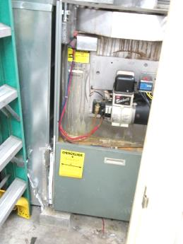
Air handling unit (AHU) in mechanical closet
Picture 2
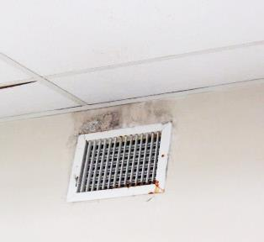
Supply vent, note stained gypsum wallboard above vent, which is likely mold growth from water damage
Picture 3
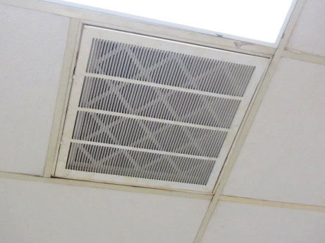
Ceiling-mounted return vent, note filter
Picture 4
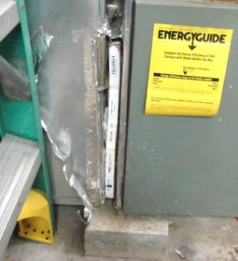
AHU in mechanical room missing filter panel (arrow)
Picture 5
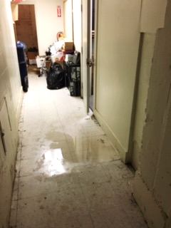
Water infiltration in lower level
Picture 6
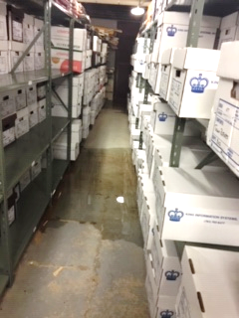
Water infiltration in lower level
Picture 7
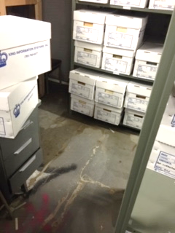
Water infiltration in lower level
Picture 8
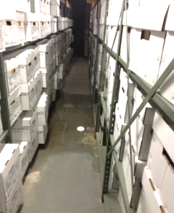
Water infiltration in lower level
Picture 9
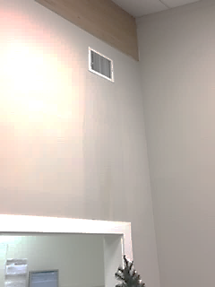
Moisture coming from vent in Building Department
Picture 10
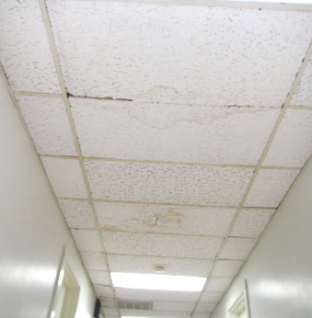
Water-damaged ceiling tiles
Picture 11
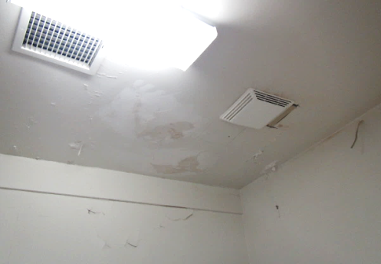
Peeling paint and water-damaged ceiling and walls in men’s restroom
Picture 12
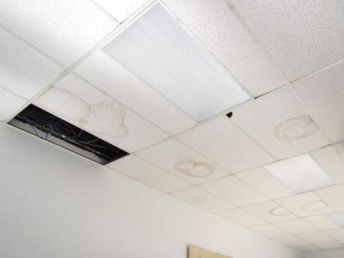
Missing/water-damaged ceiling tiles in lower level meeting room
Picture 13
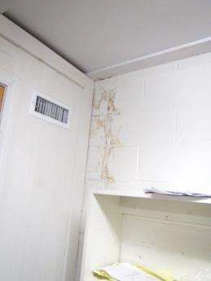
Water-damaged wall lower level
Picture 14
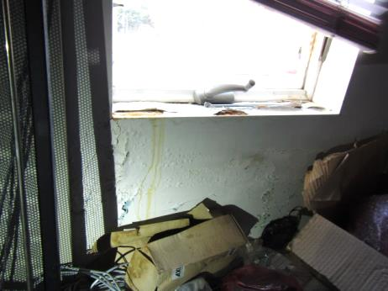
Severe water damage in IT room
Picture 15
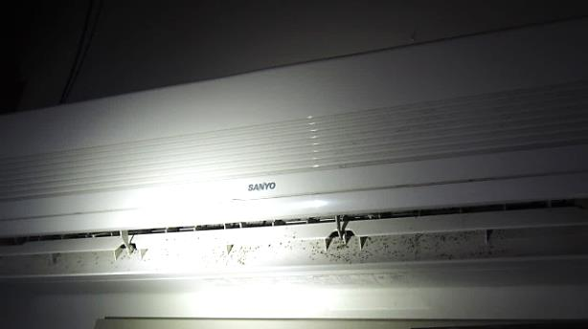
Visible mold growth (dark spots) on AC unit in upstairs IT room
Picture 16
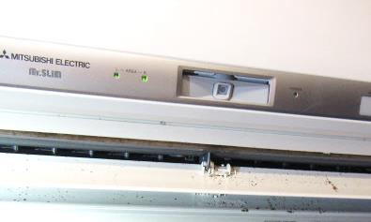
Visible mold growth (dark spots) on AC unit in downstairs IT room
Picture 17
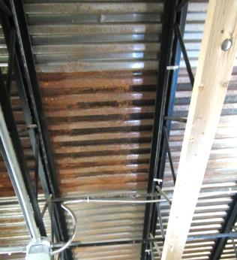
Corrosion of metal roof, lower level
Picture 18
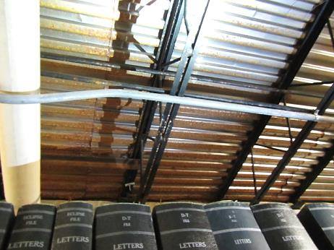
Corrosion of metal roof, lower level
Picture 19
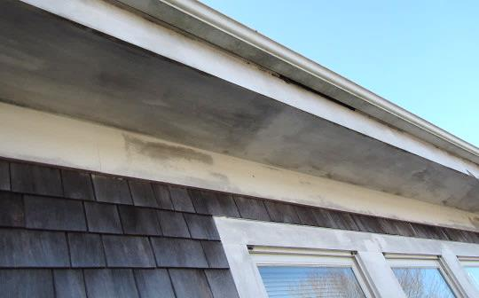
Missing/damaged fascia board near roof
Picture 20
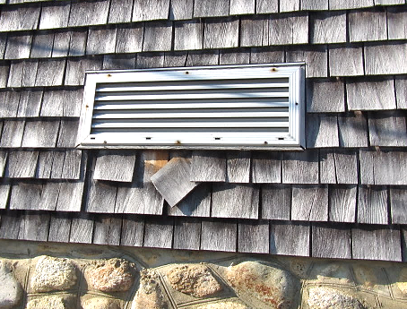
Missing/damaged wooden shingles
Picture 21
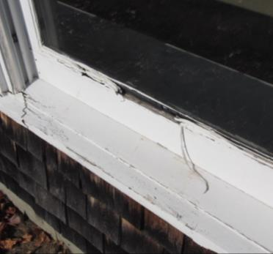
Missing/damaged window caulking
Picture 22
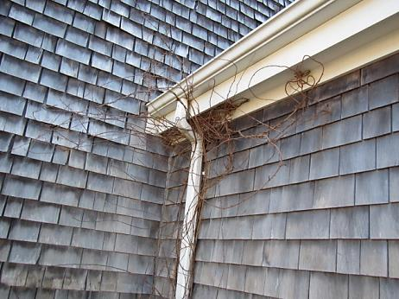
Clinging plants
Picture 23
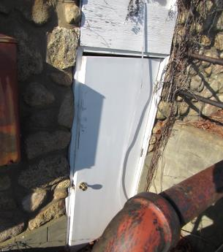
Door to boiler room that does not shut, also note clinging plants
Picture 24
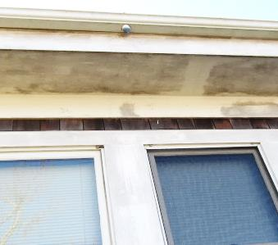
Missing downspout (arrow)
Picture 25
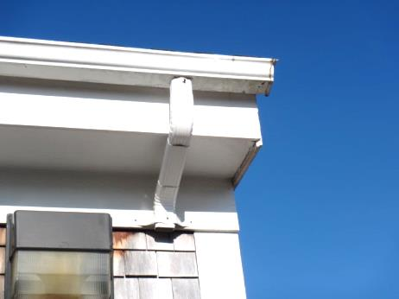
Missing downspout
Picture 26
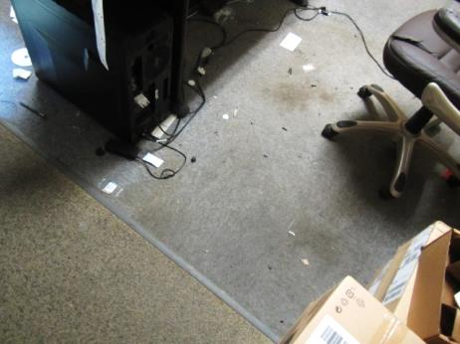
Stained/worn carpeting
Picture 27
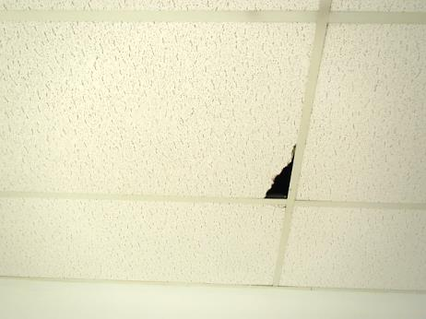
Damaged ceiling tile
Picture 28
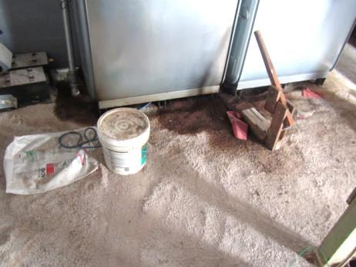
Fuel oil spill and absorbent material in boiler room
Picture 29
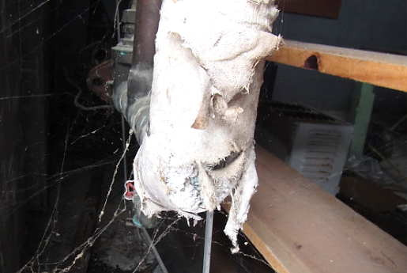
Damaged pipe insulation in boiler room
Picture 30
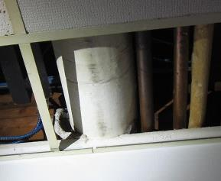
Loose/damaged pipe insulation (arrow) in lower level hallway above ceiling
Picture 31
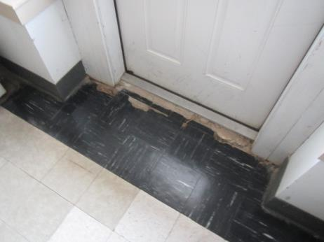
Damaged floor tiles in Early Voting room
Picture 32
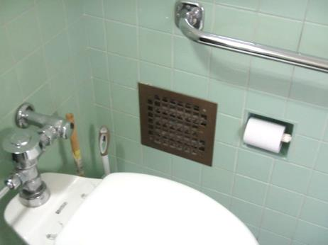
Abandoned exhaust vent in restroom that was backdrafting cold air
Location | Carbon  Dioxide  (ppm) | Carbon Monoxide  (ppm) | Temp  (°F) | Relative  Humidity  (%) | PM2.5  (µg/m³) | Occupants  in Room | Windows  Openable | Ventilation |  |  | Remarks
 |  |  |  |  |  |  |  | Intake | Exhaust
Background (outside) | 361 | ND | 40 | 33 | 12
Boiler Room |  |  |  |  |  |  |  |  |  |  | Oil spill, exposed insulation material
Board of Health | 611 | ND | 66 | 30 | 10 | 1 | N | Y |  | Y | PF, area carpet, leak in storage room vent pipe
Building Department | 665 | ND | 69 | 27 | 10 | 3 | Y | Y |  | Y | AC, windows in disrepair
Building Commissioner/ Planning Board Office | 608 | ND | 68 | 26 | 9 | 0 | Y | Y |  | Y | Water stained GW under vent, open homes in wall, carpet, paper/cardboard on concrete floor in storage area
Main Hallway |  |  |  |  |  |  |  |  |  |  | WD CTs
Conservation Commission | 638 | ND | 66 | 32 | 13 | 1 | Y | Y |  | Y | Exposed fiberglass, visible mold/WD on GW over vent
IT Room |  |  |  |  |  |  |  |  |  |  | Window open-water penetration/water damaged cardboard/paper and building materials
Assistant Town Manager | 532 | ND | 69 | 34 | 12 | 0 | Y | Y |  | Y | WD CTs, dust/debris on vents
Assistant Town Manager Restroom |  |  |  |  |  |  |  |  |  | Y | WD CT, no draw from exhaust vent
Treasurer | 720 | ND | 70 | 28 | 28 | 3 | Y | Y |  | Y | Humidifier
Storage |  |  |  |  |  |  |  |  |  |  | Cardboard boxes on floor
Town Admin/Board of Selectmen | 603 | ND | 72 | 22 | 12 | 2 | Y | Y |  | Y
Town Administrator Office | 566 | ND | 75 | 22 | 12 | 0 | Y | Y |  | Y
Accounting | 643 | ND | 74 | 20 | 15 | 1 | Y | Y |  | Y | Light penetration around exterior door
Assessors/Collector | 593 | ND | 72 | 21 | 11 | 3 | Y | Y |  | Y | Plants, PF, area carpet
Women’s Restroom |  |  |  |  |  |  | N | Y |  | Y | Old vents-backdrafting cold air
Men’s Restroom |  |  |  |  |  |  | N | Y |  | Y | Exhaust vents not operating, old vents-backdrafting, WD ceiling
Early Voting Room | 534 | ND | 58 | 31 | 15 | 0 | Y | N |  | N | Damaged floor tiles
Planning Board File Room | 587 | ND | 61 | 29 | 15 | 1 | Y | N |  | N | WD CTs, window condensation
Basement IT | 522 | ND | 65 | 27 | 16 | 0 | N | Y |  | Y | Soiled carpet, visible mold on AC unit, accumulated items
Archive Storage |  |  |  |  |  |  | N | N |  | N | Unconditioned space, paper/cardboard records, etc., corrosion of metal ceiling
Vault |  |  |  |  |  |  | N | Y |  | Y | Desiccant/dehumidifier
Downstairs Meeting Room | 454 | ND | 66 | 31 | 19 | 0 | Y | N |  | Y | Exhaust vent dusty, oil fumes, missing tiles, WD CTs, fiberboard panel-drafts from boiler room
Downstairs Restroom |  |  |  |  |  |  |  |  |  |  | Abandoned toilet/covered in plastic
Town Clerk | 574 | ND | 69 | 27 | 17 | 1 | Y | N |  | Y | Holes in CTs, WD CT

The service life is the median time during which a particular system or component of …[an HVAC]… system remains in its original service application and then is replaced. Replacement may occur for any reason, including, but not limited to, failure, general obsolescence, reduced reliability, excessive maintenance cost, and changed system requirements due to such influences as building characteristics or energy prices (ASHRAE, 1991).

