INDOOR AIR QUALITY
WATER DAMAGE ASSESSMENT

Oak Ridge Elementary School
Modular Building
260 Quaker Meeting House Road
East Sandwich, MA

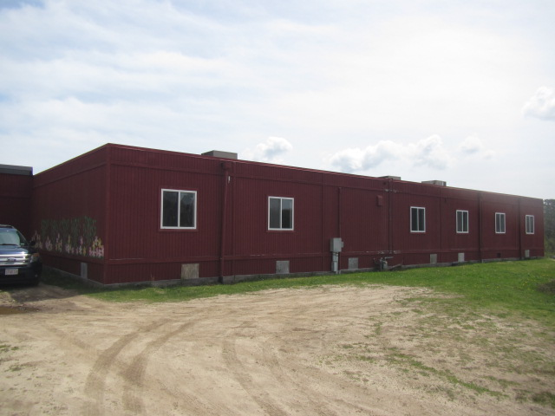

Prepared by:
Massachusetts Department of Public Health
Bureau of Environmental Health
Indoor Air Quality Program
May 2023

BACKGROUND
Building: | Oak Ridge Elementary School (ORES), Modular Building (MB)
Address: | 260 Quaker Meeting House Road, East Sandwich, MA
Assessment Requested by: | Chris George, Facilities Director, Sandwich Public Schools (SPS)
Reason for Request: | Collaborative effort to perform general indoor air quality (IAQ) assessments throughout the SPS District.
Date of Assessment: | April 28, 2023
Massachusetts Department of Public Health/Bureau of Environmental Health (MDPH/BEH) Staff Conducting Assessment: | Cory Holmes, Assistant Director, IAQ Program
Building Description: | The MB at ORES was added in the 2000s and contains 6 classrooms. It is a stand-alone, wood-sided, flat-roofed structure, that is connected to the building by a foyer. It is important to note that the Modular Building has reportedly been unoccupied for 4-5 years due to water damage/mold concerns.
Windows: | Openable

METHODS

BEH staff conducted a visual inspection for standing water, water-damaged building materials, and microbial growth.

RESULTS AND DISCUSSION

Microbial/Moisture Concerns
In March 2002, the Modular Building Institute (Stewart, 2002) released guidance concerning mold growth prevention in modular classrooms. According to this guidance, the following improvements can be made to avoid microbial growth within these structures:
- Ensure structures are constructed with a properly installed gutter and downspout system to drain rainwater.
- Site modular structures on well-drained surfaces.
- Direct surface water run-off away from the structure.
- Ventilate the crawlspace under the structure.
- Examine all caulking and/or flashing around windows and service posts, especially after moving a structure.
- Maintain ventilation according to American Society for Heating, Refrigerating and Air-conditioning Engineers (Stewart, 2002).

As previously mentioned, the MB classrooms have been unoccupied for several years. Musty odors were noted throughout the structure due to lack of air exchange. A number of areas had signs of water damage and mold growth was visible on surfaces of porous building materials such as ceiling tiles and insulation (Pictures 1 through 6).
A prominent source of odors is the wall-to-wall carpeting (Picture 7). Carpeting that is chronically moistened through either water leaks or exposure to high humidity may become colonized with mold and be a source of odors. Although no visible mold was observed on carpeting, conditions have occurred that may have led to mold colonization on or under the carpeting. If the modulars were to be reopened, carpeting should be lifted up in a number of areas for inspection. If mold colonization is discovered, the carpeting should be removed and discarded. If no mold colonization is found, the carpeting should be professionally cleaned.
BEH/IAQ staff examined the modular unit using the guidelines above as evaluation points. The following conditions were noted:
- Missing/damaged gutters and downspouts were observed along the edge of the roof (Pictures 8 through 10). Over time, rainwater may accumulate against exterior walls and pool beneath the modular structure.
- The soil around the modular structure is not graded to slope away from the building. Without grading the soil, rainwater cannot readily drain away from the structure.
- The crawlspace below the structure is designed with passive vents to create air exchange (Picture 11). In some cases, vents were sealed preventing ventilation (Picture 12) or left open (Picture 13) to allow for animals and pests to harbor beneath the structure.
- The exterior of the building has breaches in its skirting and wooden exterior (Pictures 12, 14 and 15). These breaches can allow for uncontrolled drafts and moisture, as well as provide an entryway for pests, including insects and rodents.

The American Conference of Governmental Industrial Hygienists (ACGIH) and the US Environmental Protection Agency (US EPA) recommend that porous materials be dried with fans and heating within 24 to 48 hours of becoming wet (ACGIH, 1989; US EPA, 2008). If carpets and other porous materials are not dried within this time frame, mold growth may occur. Water-damaged carpeting cannot be adequately cleaned to remove mold growth and should be replaced. The application of a mildewcide to moldy carpeting is not recommended.

CONCLUSIONS/RECOMMENDATIONS
Based on observations at the time of assessment, if the MB classrooms were to be reoccupied, the following is recommended:
- Consider hiring a professional mold remediation/flooding restoration firm for repairs/removal and full assessment of water-damaged/mold-colonization throughout MB classrooms.
- Ensure plumbing, roof, and any other exterior leaks are repaired.
- Remove and replace any mold contaminated/water-damaged building materials (gypsum wallboard, ceiling tiles, insulation, carpeting, etc.). This measure will remove actively growing mold colonies that may be present. Remove mold contaminated materials in a manner consistent with recommendations found in “Mold Remediation in Schools and Commercial Buildings” published by the US Environmental Protection Agency (US EPA, 2008). The document is available at the US EPA website: at: http://www.epa.gov/mold/mold-remediation-schools-and-commercial-buildings-guide.
- Repair/replace water-damaged windowsills.
- Make repairs to roof drains, gutters, and downspouts. Inspect periodically for proper drainage.
- Examine for means to regrade the soil around the building to drain water away from the building.
- Repair breaches in the building envelope including holes in walls, foundation, and missing/damaged siding materials.
- Restore crawlspace ventilation.
- Inspector for and remove any animals, pests, and related debris/waste from underneath the structure.
- Prior to occupancy, flush the HVAC system out for 24 hours. Operate supply and exhaust ventilation continuously in all areas during occupied periods. Ensure all HVAC equipment is cleaned/maintained in accordance with manufacturer’s instructions.
- After flushing the HVAC system for 24 hours, change filters prior to occupancy, and additionally 2-4 times a year using the highest Minimum Efficiency Reporting Value (MERV) rating the building’s ventilation system can accommodate to improve air filtration as much as possible without significantly reducing airflow.
- Clean the interior of AHUs during regular filter changes using a HEPA-filtered vacuum cleaner with brush attachment or compressed air.
- Balance the HVAC system every 5 years in accordance with Sheet Metal and Air Conditioning Contractors’ National Association (SMACNA) recommendations (SMACNA, 1994).
- Upon completion of remediation, perform a final, thorough, cleaning including wet wiping of all smooth surfaces and use of a HEPA vacuum of all carpeting prior to moving back into the space.

REFERENCES
ACGIH. 1989. Guidelines for the Assessment of Bioaerosols in the Indoor Environment. American Conference of Governmental Industrial Hygienists, Cincinnati, OH.
MDPH. 2015. Massachusetts Department of Public Health. Indoor Air Quality Manual: Chapters I-III. Available at: Indoor air quality - manual and appendices | Mass.gov
SMACNA. 1994. HVAC Systems Commissioning Manual. 1st ed. Sheet Metal and Air Conditioning Contractors’ National Association, Inc., Chantilly, VA.
Stewart, B. 2002. Preventing Mold Growth in Temporary School Structures. Modular Building Institute, Charlottesville, VA. March 2002.
US EPA. 2008. Mold Remediation in Schools and Commercial Buildings. US Environmental Protection Agency, Office of Air and Radiation, Indoor Environments Division, Washington, D.C. EPA 402-K-01-001. http://www.epa.gov/mold/mold-remediation-schools-and-commercial-buildings-guide

Picture 1
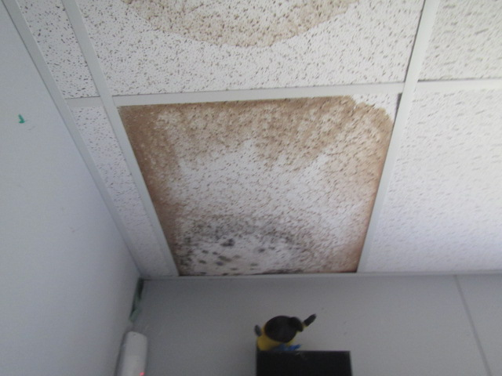
Water-damaged ceiling tiles, dark stains indicate mold growth
Picture 2
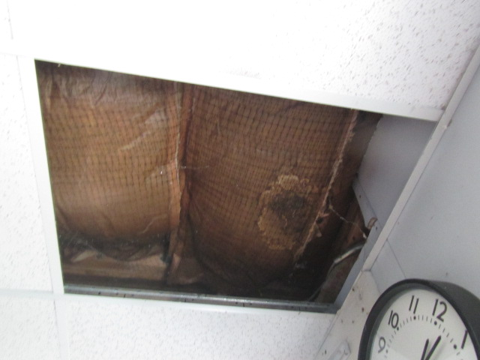
Water-damaged insulation, dark stains indicate mold growth
Picture 3
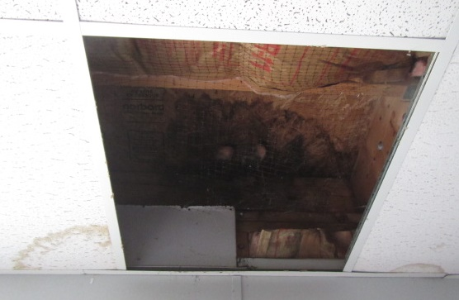
Water-damaged insulation
Picture 4
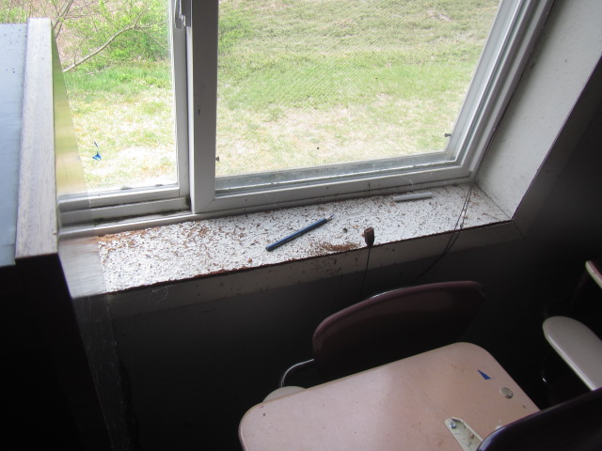
Water-damaged particle board windowsill
Picture 5
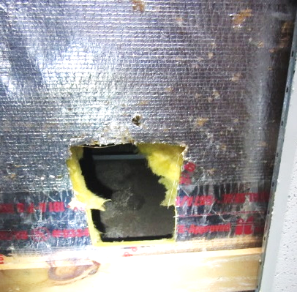
Water-damaged insulation, light stains (arrow) indicate mold growth
Picture 6
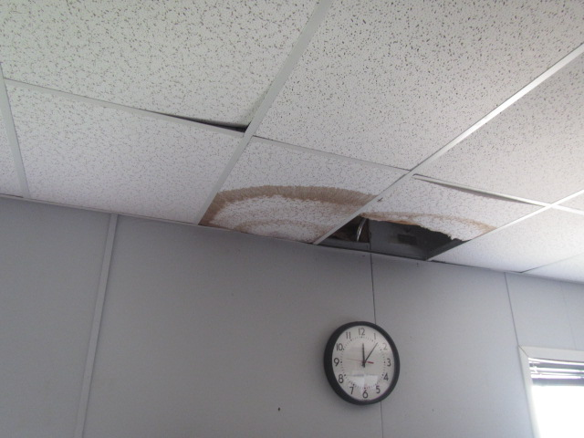
Water-damaged ceiling tiles
Picture 7
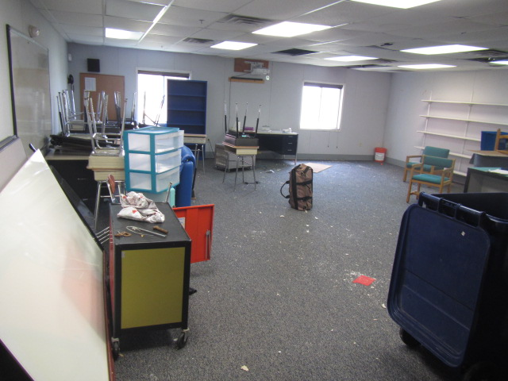
Wall-to-wall carpeting, note missing ceiling tiles and debris on floor
Picture 8
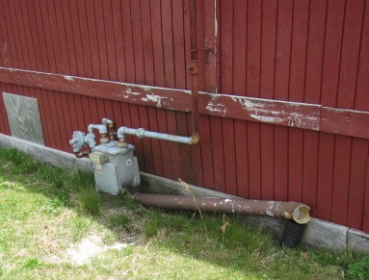
Dislodged downspout on ground
Picture 9
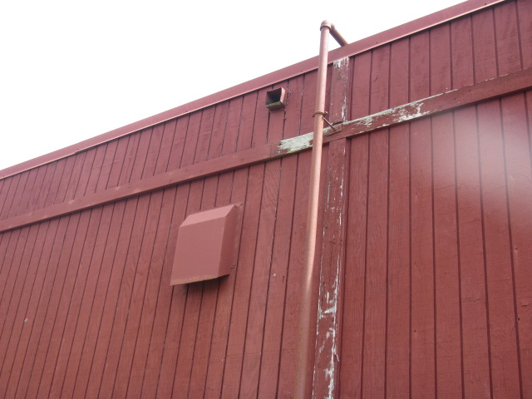
Roof drainage spout (arrow), Note absence of downspout
Picture 10
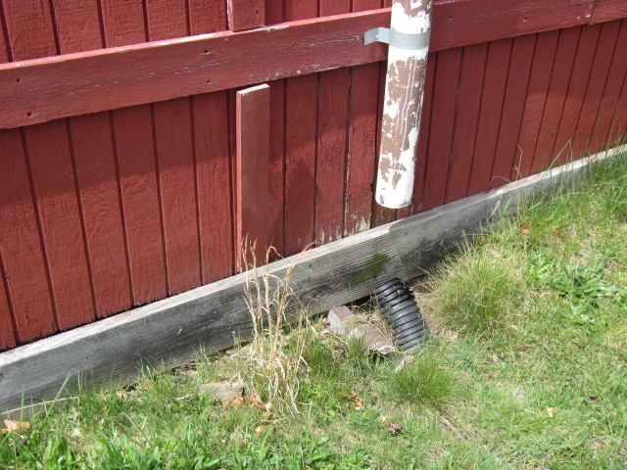
Downspout not connected to drainage tube
Picture 11
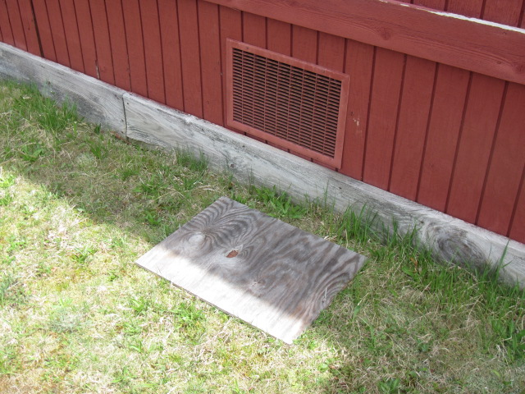
Crawlspace vent
Picture 12
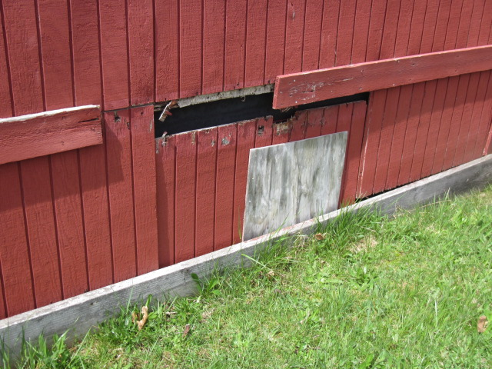
Crawlspace vent sealed with plywood, Note open breach in siding
Picture 13
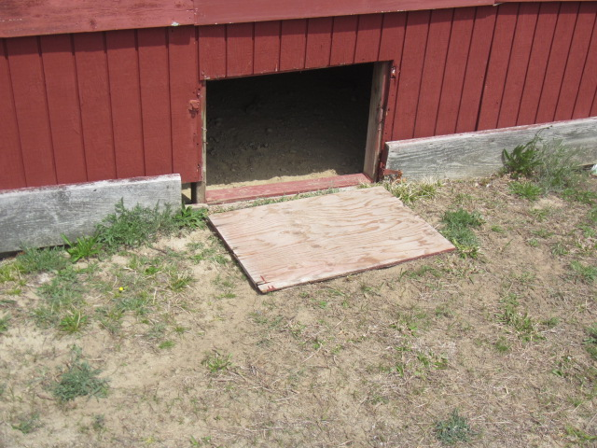
Crawlspace vent with missing grill
Picture 14
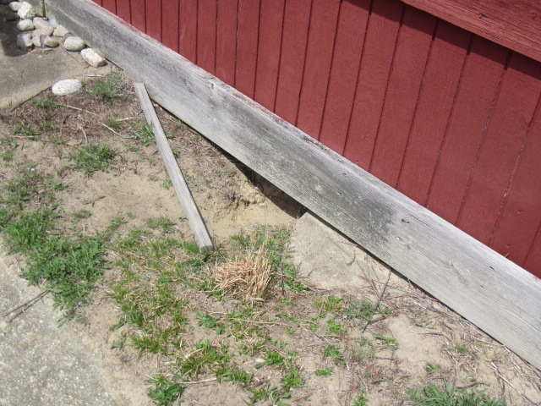
Breaches under Modular Building for animal/pest harborages
Picture 15
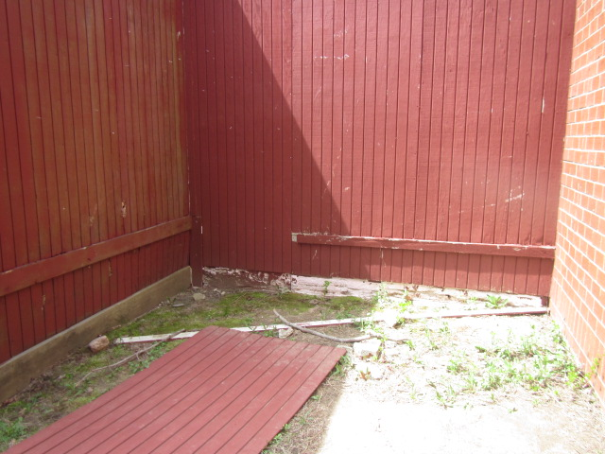
Missing/damaged siding, exposing insulation material along base of exterior wall

