BACKGROUND

INDOOR AIR QUALITY/WATER DAMAGE ASSESSMENT

Oak Ridge Elementary School
260 Quaker Meeting House Road
East Sandwich, MA

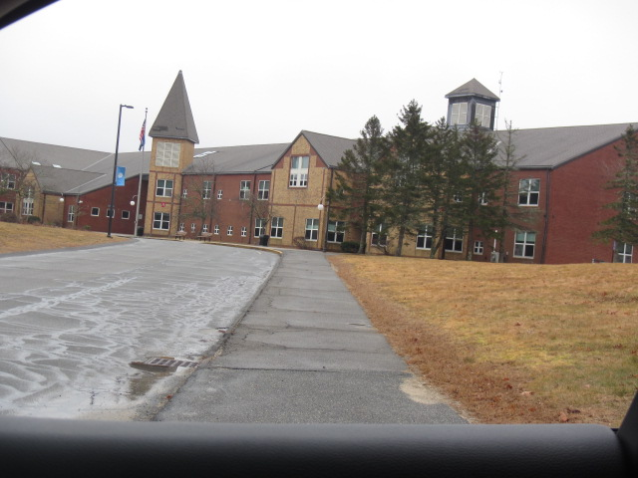

Prepared by:
Massachusetts Department of Public Health
Bureau of Environmental Health
Indoor Air Quality Program
March 2023
Building: | Oak Ridge Elementary School (ORES)
Address: | 260 Quaker Meeting House Road, East Sandwich, MA
Assessment Requested by: | Christopher George, Director of Facilities,  Sandwich Public Schools
Reason for Request: | Assessment of remediation of water-damaged building materials due to frozen pipe/plumbing leak in the media center.
Date of Assessment: | February 17, 2023
Massachusetts Department of Public Health/Bureau of Environmental Health (MDPH/BEH) Staff Conducting Assessment: | Cory Holmes, Assistant Director, Indoor Air  Quality (IAQ) Program
Building Description: | The ORES is two-story brick building constructed in the late 1980s housing grades 3-6. The media center consists of carpeting, with gypsum wallboard (GW) walls and ceiling.
Windows: | Openable

It was reported that on Saturday February 4, 2023, a pipe burst on a sprinkler head above the ceiling of the Media Center (Pictures 1 and 2) due to extreme cold that occurred in New England over that weekend. Significant water damage was reported but isolated to this area of the building. An initial alarm was sounded at the Sandwich Fire Department who contacted school administration. Sandwich Public Schools Facilities staff arrived on scene to begin wet carpet extraction and drying operations. That evening Service Master, a commercial restoration company, was contacted and arrived on site Sunday February 5, to remove wet materials and initiate remediation with drying machines, fans, dehumidifiers and high, efficiency particulate arrestance (HEPA) filtration units on the effected floors. On Monday February 6, moisture measurements were conducted, and water-damaged GW was identified and removed (Pictures 1 through 4). Although the building was open, the damaged section of the Media Center was isolated with temporary plastic barriers (Pictures 5 and 6) to allow for the drying/cleaning mitigation to be completed. MDPH IAQ staff arrived on-site February 17 (the Friday prior to February vacation) to conduct an IAQ Assessment of the affected area.

METHODS
Please refer to the IAQ Manual for methods, sampling procedures, and interpretation of results (MDPH, 2015).

RESULTS AND DISCUSSION
Media sampled |  | MDPH Guideline/  Comparison Value |  | Measured Range |  |  | Comments
 |  |  |  | Outdoors/  Background | Indoors
Water-Damaged Building Materials |  | Normal = Dry |  |  |  |  | All water-damaged materials were either removed (i.e., ceiling tiles, GW), or dried in place (e.g., carpet, ceilings/GW). Carpeting was scheduled to be professionally cleaned over February vacation.
Carbon Dioxide (CO₂) |  | < 800 parts per million (ppm) is preferred |  | 421 | 479-526 |  | HVAC operating providing adequate airflow
Total Volatile Organic Compounds (TVOCs) |  | Equal to or below background level measured |  | ND | ND
Carbon Monoxide (CO) |  | Non-detectable (ND) or equal to or below background level measured |  | ND | ND
Particulate Matter 2.5 (PM2.5) |  | US EPA National Ambient Air Quality Standards (NAAQS) 35 μg/m³ or less |  | 10 | 5-6 |  | Below NAAQS
Temperature |  | 70 to 78ºF |  | 55 | 70-72 |  | Within MDPH comfort guidelines
Relative Humidity (RH) |  | 40% to 60% |  | 100 (intermittent rain) | 54-56 |  | Within MDPH comfort guidelines and below outdoor/background conditions, indicating successful drying operations
ppm = parts per million | µg/m³ = microgram per cubic meter |  | ND = non-detectable |  |  | TVOCs = Total Volatile Organic Compounds

Ventilation
A heating, ventilating, and air conditioning (HVAC) system has several functions. First it provides heating and, if equipped, cooling. Second, it is a source of fresh air. Finally, an HVAC system will dilute and remove normally occurring indoor environmental pollutants by not only introducing fresh air, but by filtering the airstream and ejecting stale air to the outdoors via exhaust ventilation. Even if an HVAC system is operating as designed, point sources of respiratory irritation may exist and cause symptoms in sensitive individuals.
The building’s mechanical ventilation system is provided via air handling units (AHUs), which feed into occupied areas via wall or ceiling-mounted air diffusers. Return air is drawn into wall or ceiling-mounted exhaust vents back to AHUs. Fresh air is supplemented by openable windows.

Microbial/Moisture Concerns
The United States Environmental Protection Agency (US EPA) and the American Conference of Governmental Industrial Hygienists (ACGIH) recommend that porous materials be dried with fans and heating within 24 to 48 hours of becoming wet (US EPA, 2008; ACGIH, 1989). If porous materials are not dried within this time frame, they should be removed and discarded.
At the time of assessment, all water-damaged materials had been removed or remediated. A number of blowers/fans, and dehumidifiers were observed in the space (Pictures 6 and 7). Moisture measurements of carpeting and GW were taken by MDPH IAQ staff in areas impacted by the flooding event (Table 1). All moisture measurements were normal (i.e., dry). At the time of assessment. It was reported that rebuilding and final cleanup operations were scheduled over February vacation.

Other Issues
As a general rule, carpets should be cleaned annually (or semi-annually in soiled/high traffic areas) in accordance with Institute of Inspection, Cleaning and Restoration Certification (IICRC) recommendations, (IICRC, 2012). The service life of carpeting is approximately 10-11 years (IICRC, 2002). Carpeting of this age and condition becomes increasingly difficult to clean and maintain and may be a source of particulate matter to the indoor environment. Regular cleaning with a high efficiency particulate air (HEPA) filtered vacuum in combination with an annual cleaning will help to reduce accumulation and potential aerosolization of materials from carpeting.

RECOMMENDATIONS
In view of the findings at the time of the visit, the following recommendations are made:

Water Damage Recommendations
- Finalize drying and cleaning operations.
- Replace water-damaged building materials.
- Continue with plans to investigate insulation conditions in similar parts of the building to prevent further leaks/incidents.
- Store porous items (i.e., cardboard and paper) off the floor in sealed boxes, bags, or totes to prevent water damage. Discard water-damaged and/or moldy materials.

Ventilation Recommendations
- Change HVAC filters using the best quality/highest MERV rated filters that can be used with current equipment. During filter changes, vacuum debris from AHU cabinets.
- Use windows to provide supplemental fresh air during temperate weather. Close windows tightly during wet and hot, humid weather to prevent moisture accumulation or during extreme cold to prevent frozen pipes.

Other Recommendations
- Clean carpeting annually or semi-annually in soiled high traffic areas as per the recommendations of the Institute of Inspection, Cleaning and Restoration Certification (IICRC 2012).
- Consider replacing carpeting past its useful life (> 10-11 years).
- Refer to the resource manual and other related indoor air quality documents located on the MDPH’s website for further building-wide evaluations and advice on maintaining public buildings. These documents are available at http://mass.gov/dph/iaq.

REFERENCES
ACGIH. 1989. Guidelines for the Assessment of Bioaerosols in the Indoor Environment. American Conference of Governmental Industrial Hygienists, Cincinnati, OH.
IICRC. 2002. Institute of Inspection, Cleaning and Restoration Certification. A Life-Cycle Cost Analysis for Floor Coverings in School Facilities.
IICRC. 2012. Institute of Inspection, Cleaning and Restoration Certification. Carpet Cleaning: FAQ.
MDPH. 2015. Massachusetts Department of Public Health. “Indoor Air Quality Manual: Chapters I-III”. Available at: Indoor air quality - manual and appendices | Mass.gov
US EPA. 2008. “Mold Remediation in Schools and Commercial Buildings”. Office of Air and Radiation, Indoor Environments Division, Washington, DC. EPA 402-K-01-001. September 2008. Available at: http://www.epa.gov/mold/mold-remediation-schools-and-commercial-buildings-guide.
Picture 1
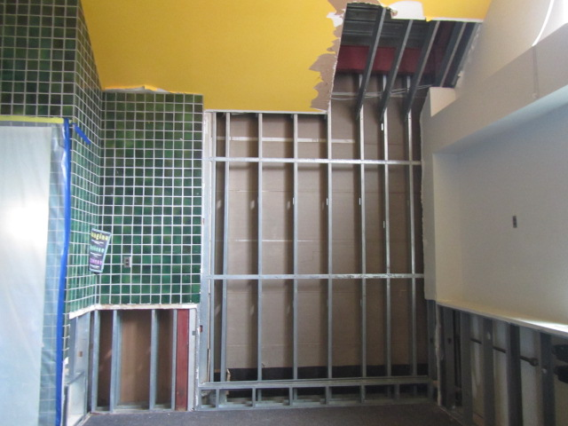
Area of frozen sprinkler head (arrow) above ceiling of Media Center
Picture 2
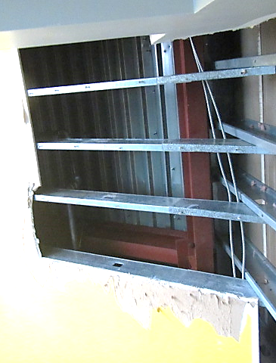
Area of frozen sprinkler head (arrow) above ceiling of Media Center
Picture 3
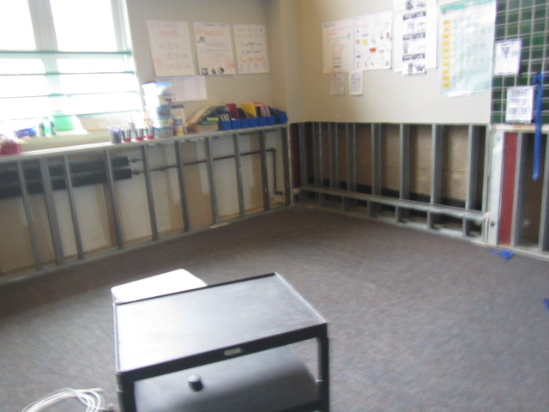
Removed water-damaged gypsum wallboard in Media Center
Picture 4
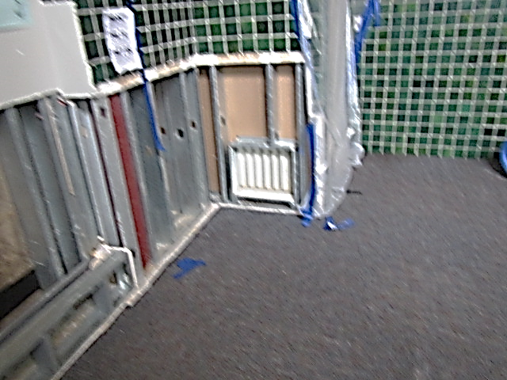
Removed water-damaged gypsum wallboard in Media Center
Picture 5
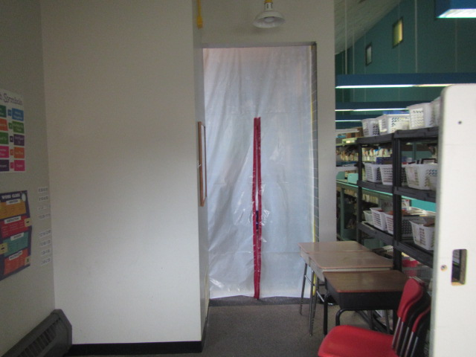
Isolated area of flooding event in Media Center
Picture 6
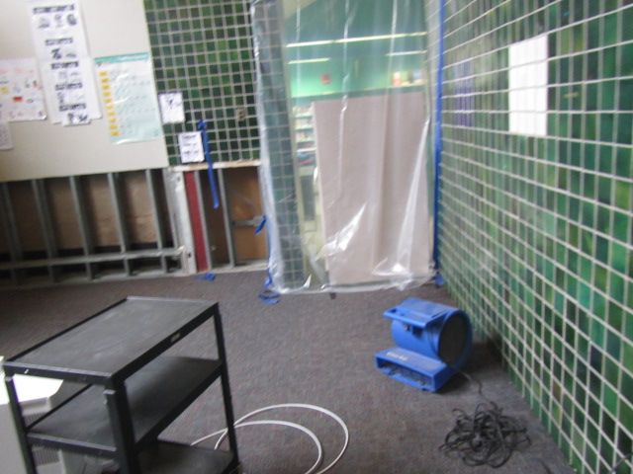
Isolated area of flooding event in Media Center, also note drying fan on carpet
Picture 7
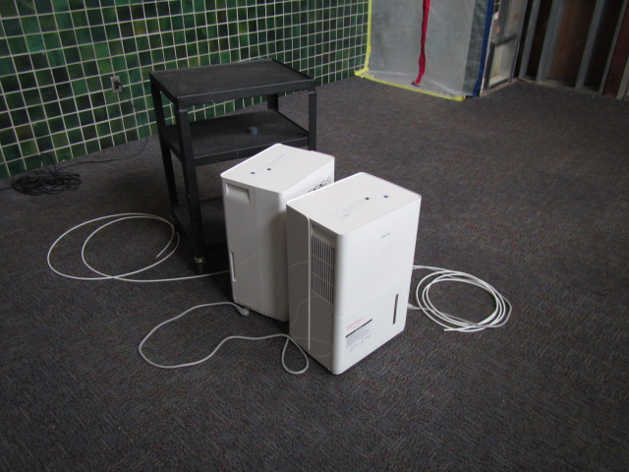
Dehumidifiers in Media Center

