INDOOR AIR QUALITY ASSESSMENT

Oak Ridge Elementary School
260 Quaker Meeting House Road
East Sandwich, Massachusetts

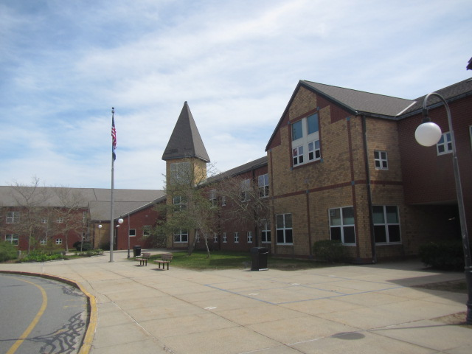

Prepared by:
Massachusetts Department of Public Health
Bureau of Environmental Health
Indoor Air Quality Program
May 2023

BACKGROUND
Building: | Oak Ridge Elementary School (ORES)
Address: | 260 Quaker Meeting House Road  East Sandwich, Massachusetts
Assessment Requested by: | Chris George, Facilities Director, Sandwich Public Schools (SPS)
Reason for Request: | Collaborative effort to perform general indoor air quality (IAQ) assessments throughout the SPS District
Date of Assessment: | April 28, 2023
Massachusetts Department of Public Health/Bureau of Environmental Health (MDPH/BEH) Staff Conducting Assessment: | Cory Holmes, Assistant Director, IAQ Program
Date of Building Construction: | Originally constructed in late 1980s, opened in 1990, with a modular wing added in the early 2000s.
Building Description: | The ORES is two-story brick building housing grades 3-6. Building materials consist of carpeting (both wall-to-wall and carpet squares), with gypsum wallboard (GW) walls, and suspended ceiling tiles.
Windows: | Windows are openable throughout the building.

METHODS
Please refer to the IAQ Manual and appendices for methods, sampling procedures, and interpretation of results (MDPH, 2015).
Note that this building was visited by the BEH/IAQ program in February 2023 to inspect remediation efforts to water-damaged building materials in response to a frozen pipe burst. At the time of the visit all water-damaged materials had been removed or remediated. The report from this visit is available on the MDPH website at Indoor air quality reports - cities and towns: S | Mass.gov
It was reported that the Modular wing has been unoccupied for 4-5 years and is currently in disrepair. IAQ Program staff conducted a limited walkthrough of this area, which will be the subject of a separate report.

RESULTS and DISCUSSION
The following is a summary of indoor air testing results (Table 1).
- Carbon dioxide levels were above the MDPH recommended level of 800 parts per million (ppm) in about half of the areas surveyed, indicating some areas needed increased air exchange at the time of assessment.
- Temperature was within or close to the MDPH recommended range of 70°F to 78°F in occupied areas.
- Relative humidity was within the MDPH recommended range of 40 to 60% in all areas tested the day of assessment.
- Carbon monoxide levels were non-detectable (ND) in all areas tested.
- Particulate matter (PM2.5) concentrations measured were below the National Ambient Air Quality (NAAQS) level of 35 μg/m³ in all areas tested, with the exception of room 132, which was operating an oil diffuser with a measurement of 190 μg/m³.

Ventilation
A heating, ventilating and air conditioning (HVAC) system has several functions. First it provides heating and, if equipped, cooling. Second, it is a source of fresh air. Finally, an HVAC system will dilute and remove normally-occurring indoor environmental pollutants by not only introducing fresh air, but by filtering the airstream and ejecting stale air to the outdoors via exhaust ventilation. Even if an HVAC system is operating as designed, point sources of respiratory irritation may exist and cause symptoms in sensitive individuals.
It was reported that HVAC components are managed by a computerized control system. The control system should respond to changing conditions and feed back to a centralized computer for monitoring and adjustment. However, due to the program age, type of software and likely obsolescence of the underlying computer operating system, computerized control of HVAC systems can often go out of calibration, which in turn require update or assessment by an HVAC engineering firm.
Ventilation is provided by air handling units (AHUs) located in mechanical rooms (Picture 1). Fresh air is drawn in through air intakes on the exterior of the building and distributed to classrooms via ceiling or wall-mounted air diffusers (Picture 2). Wall or ceiling-mounted exhaust vents remove stale air from classrooms and provide air exchange (Picture 3). Some exhaust vents were not functioning or were weak (Table 1), and one was obstructed (Picture 4), preventing airflow during the assessment.
Also preventing proper air exchange is the location of both the supply and exhaust vents on the same interior wall of some classrooms (Picture 5). This condition is known as short circuiting (Figure 1), “Short circuiting of ventilation air occurs when ventilation air enters and leaves a space or duct before it has a chance to mix well enough with room air to do the job it was intended to do—that is, to adequately dilute pollutants…Lack of ventilation air distribution always occurs when short circuiting occurs.” (Building Science Corporation, 2013).
The location of some exhaust vents (i.e., above the hallway door) can also limit exhaust efficiency (Picture 6). If doors are left open, the vents will tend to draw air from the hallway into the classroom instead of stale air and airborne pollutants out of the classroom, as designed.
To maximize air exchange, the IAQ program recommends that both supply and exhaust ventilation operate continuously during periods of occupancy. In order to have proper ventilation with a mechanical ventilation system, the systems must be balanced after installation to provide an adequate amount of fresh air to the interior of a room while removing stale air from the room. It is recommended that HVAC systems be re-balanced every five years to ensure adequate air systems function (SMACNA, 1994).
It is also important to note that the majority of HVAC system components are original to the building’s construction, which are over 33 years old at the date of this report. According to the American Society of Heating, Refrigeration, and Air-Conditioning Engineering (ASHRAE), the service life of this type of unit is 15-20 years, assuming routine maintenance of the equipment (ASHRAE, 1991).
Room 119 was not equipped with any mechanical ventilation (i.e., supply or exhaust), nor did it have any windows/means for natural ventilation. The International Mechanical Code, which is included in the Massachusetts Building Code by reference, requires that classrooms have a minimum ventilation rate of 10 cubic feet per minute (cfm) per occupant of fresh outside air or some method of natural ventilation (openable windows) (BBRS, 2017; IMC, 2021; ASHRAE, 2022). The ventilation must be on at all times that the room is occupied. Providing adequate fresh air ventilation with open windows and maintaining the temperature in the comfort range during the cold weather season is impractical. Mechanical ventilation is usually required to provide adequate fresh air ventilation.

Microbial/Moisture Concerns
Water-damaged ceiling tiles were observed in some areas of the building (Table 1), which indicate historic leaks from the building envelope or plumbing system. Ceiling tiles are considered a porous material which, if exposed to chronic moisture, may become a source for mold growth. These tiles should be discarded and replaced. However, some ceiling tiles are of a type that are adhered directly to the ceiling substrate (Picture 7). These tiles are difficult to replace and necessitate the destruction of the tile, furthermore, replacement tiles are often obsolete and difficult to obtain.
Water-damaged gypsum wallboard and peeling paint were observed in the corner of the Media Center (Picture 8), which appeared to be evidence of a former leak. No visible mold was observed, and all moisture measurements were normal (i.e., dry) at the time of assessment.
Several rooms contained portable or wall-mounted ductless air conditioners (ACs, Table 1). Condensate drains and pumps from ductless AC units should be monitored periodically for leaks and clogs to prevent water damage.
Plants were present in some classrooms and other areas (Table 1). Plants should be well maintained, not overwatered, and not placed on porous materials or in the airstream of ventilation equipment. A few aquariums and terrariums were observed in classrooms (Table 1). These items should also be kept in good condition to prevent mold, scale, and associated odors.

Other Conditions
Other conditions that can affect IAQ were observed during the assessment. The MDPH recommends pleated filters with a Minimum Efficiency Reporting Value (MERV) of 8, which are adequate in filtering out pollen and mold spores (ASHRAE, 2012). Filters should also be changed two to four times a year, or per the manufacturer’s recommendations.
In some areas, supply diffusers (and surrounding ceiling tiles), exhaust vents and personal fans had accumulated dust/debris (Table 1, Pictures 2, 9, and 10). This dust can be reaerosolized under certain conditions and can also be a medium for mold growth.
Most areas had carpeting (Table 1). Carpeting should be vacuumed regularly with a high efficiency particulate arrestance (HEPA) filter equipped vacuum cleaner to avoid particulates from causing further irritation or serving as a reservoir for microbial colonization. Also, carpeting and rugs should be cleaned at least once per year according to IICRC recommendations (IICRC 2012). However, it should be noted that the usable life of carpeting in schools is approximately 10-11 years (IICRC, 2002). Aging carpet can produce fibers that can be irritating to the respiratory system. Area carpets too worn to be effectively cleaned should be replaced. Area rugs should be rolled up and stored in a clean, dry place when rooms are not occupied during the summer months to prevent moistening due to condensation.
In many classrooms, large numbers of items were on floors, windowsills, tabletops, counters, bookcases and desks, which provide a source for dusts to accumulate. These items (e.g., papers, folders, boxes) make it difficult for custodial staff to clean. Items should be relocated and/or be cleaned periodically to avoid excessive dust build up. In addition, dust and debris can accumulate on flat surfaces (e.g., desktops, shelving and carpets) in occupied areas and subsequently be re-aerosolized causing further irritation.
Exposure to low levels of total volatile organic compounds (TVOCs) may produce eye, nose, throat, and/or respiratory irritation in some sensitive individuals. BEH/IAQ staff examined rooms for products containing VOCs. BEH/IAQ staff noted hand sanitizers, plug-in air fresheners (Picture 11), and dry erase materials in use within the building. All of these products have the potential to be irritants to the eyes, nose, throat, and respiratory system of sensitive individuals.
Of particular note was a plug-in natural oil diffuser, which as mentioned previously was producing airborne particulates several times over (190 μg/m³) the NAAQS of 35 μg/m³. Also of note was the laminator in the media center (Picture 12), and a 3-D printer in room 231 (Picture 13). Laminators and 3-D printers can give off VOCs/unpleasant odors, and excess heat while operating, and should be used in a well-ventilated area with local exhaust ventilation and away from occupants (e.g., copy room).
Missing, broken or ajar ceiling tiles were observed in some areas (Table 1, Picture 14). These breaches can provide a pathway for dust, debris, and particulates from the ceiling plenum into occupied areas, which can be a source of eye, skin, or respiratory irritation.
A few classrooms contained high efficiency particulate arrestance (HEPA)-filtered air purifiers (Picture 15). It is important to note that filters should be cleaned/changed, and these units be maintained in accordance with the manufacturers’ recommendations (Picture 16). As mentioned previously, several rooms contained portable or wall-mounted ductless ACs (Table 1). These units also contain filters that should be cleaned or changed in accordance with the manufacturer's instructions.
Note that the Environmental Protection Agency (EPA) conducted a National School Radon Survey in which it discovered nearly one in five schools had “…at least one frequently occupied ground contact room with short-term radon levels above 4 [picocuries per liter] pCi/L” (US EPA, 1993). The BEH/IAQ Program therefore recommends that every school be tested for radon, and that this testing be conducted during the heating season while school is in session in a manner consistent with USEPA radon testing guidelines. Radon measurement specialists and other information can be found at www.nrsb.org and http://aarst-nrpp.com/wp, with additional information at: http://www.mass.gov/eohhs/gov/departments/dph/programs/environmental-health/exposure-topics/iaq/radon.

CONCLUSIONS/RECOMMENDATIONS
In view of the findings at the time of the visit, the following recommendations are made:

Ventilation Recommendations
- Make necessary adjustments to HVAC controls/air intakes to allow an increase in fresh air to rooms with elevated carbon dioxide levels (Table 1).
- As previously discussed, the age (> 33 years old), software limitations, and availability of parts for mechanical ventilation system components and controls should be fully evaluated by an HVAC engineering firm to determine the operational lifespan of existing equipment and the feasibility of repair vs. replacement.
- Work with HVAC engineering firm to evaluate design of interior wall vents (short circuiting) and make recommendations to facilitate proper distribution/mixing of air in classrooms.
- Have HVAC engineering firm examine the feasibility of providing mechanical ventilation to room 119, and/or any other areas that do not have proper mechanical ventilation (supply and exhaust) or openable windows.
- Operate all supply and exhaust ventilation equipment continuously during occupied hours.
- Ensure all supply and exhaust/return vents are free of obstructions to facilitate airflow.
- Periodically check exhaust vents in classrooms and restrooms for draw and repair any non-operating motors/vents.
- Close hallway doors during occupancy to allow for more effective air exchange within classrooms.
- Temperature/comfort complaints should be made through proper channels and followed up by facilities staff using an electronic reporting system.
- Use openable windows to supplement fresh air during temperate weather. Ensure all windows are tightly closed at the end of the day or during periods of elevated relative humidity to avoid condensation/mold issues, or extreme cold and freezing of pipes.
- Continue to change filters for HVAC equipment 2-4 times a year using MERV 8 or the highest MERV rating the ventilation system can accommodate to improve air filtration as much as possible without significantly reducing airflow.
- Clean the interior of AHUs during regular filter changes using a HEPA-filtered vacuum cleaner with brush attachment or compressed air.

Water Damage Recommendations
- Continue to ensure any roof and plumbing leaks are repaired promptly and replace any remaining water-damaged suspended ceiling tiles or other porous building materials.
- Consider long-term plans to replace interlocking ceiling tile systems.
- Repair water-damaged wallboard and peeling paint in corner of Media Center. Examine exterior of the building in this area to determine if breaches are present and repair/seal to prevent further water infiltration.
- Periodically monitor drains from ductless AC units for clogs and leaks, and repair promptly.
- Clean and maintain aquariums and terrariums to prevent mold/algal growth and associated odors.
- Roll up area rugs and store in a clean, dry place when rooms are unoccupied during summer months to prevent moistening due to condensation.
- Consider using the methods described in the document “Preventing Mold Growth in Massachusetts Schools During Hot, Humid Weather” to help reduce impact of conditions during hot, humid weather. This guideline can be found online at: https://www.mass.gov/service-details/preventing-mold-growth-in-massachusetts-schools-during-hot-humid-weather

Other Recommendations
- Ensure copy rooms are equipped with local exhaust ventilation, make repairs/adjustments as necessary.
- Consider relocating 3-D printer and laminator to copy rooms or areas equipped with local exhaust.
- Reduce use of products and equipment that create irritating volatile organic compounds (VOCs) and only use in well-ventilated areas. Minimize the use of air fresheners (e.g., plug-ins), deodorizers and scented products.
- Change filters and maintain portable air purifiers/HEPA units in accordance with manufacturers’ recommendations.
- Regularly clean supply/return/exhaust vents and fans to avoid aerosolizing accumulated particulate matter. To clean ceiling vents/grills, remove and wash, refinish/replace if necessary.
- If ceiling tiles around dusty vents cannot be cleaned, replace.
- Clean AC filters prior to the start of the cooling season and on a regular basis while in use.
- Replace missing and/or broken suspended ceiling tiles.
- Consider reducing the number of items stored in rooms to make cleaning easier. Periodically move items to clean flat surfaces. Store porous items on shelving and away from walls.
- For buildings in New England, periods of low relative humidity during the winter are often unavoidable. Therefore, scrupulous cleaning practices should be adopted to minimize common indoor air contaminants whose irritant effects can be enhanced when the relative humidity is low. To control dusts, a high efficiency particulate arrestance (HEPA) filter equipped vacuum cleaner in conjunction with wet wiping of all surfaces is recommended. Avoid the use of feather dusters. Drinking water during the day can help ease some symptoms associated with a dry environment (throat and sinus irritations).
- Clean carpeting annually or semi-annually in soiled high traffic areas as per the recommendations of the Institute of Inspection, Cleaning and Restoration Certification (IICRC, 2012).
- Consider replacing any carpeting that is beyond its service life (i.e., > 11 yrs.).
- The school should be tested for radon by a certified radon measurement specialist during the heating season when school is in session. Radon measurement specialists and other information can be found at: www.nrsb.org, and http://aarst-nrpp.com/wp.
- To learn more about radon, review the MDPH’s Radon in Schools and Child Care Programs factsheet, with additional information at: http://www.mass.gov/eohhs/gov/departments/dph/programs/environmental-health/exposure-topics/iaq/radon.
- Consider forming an IAQ committee in each school building district wide. Committees should have an IAQ liaison/teacher representative, a member of maintenance/facilities and administration that conduct regular walk-throughs to identify on-going and/or potential environmental issues.
- Utilize the US EPA’s (2000), “Tools for Schools”, as an instrument for maintaining a good IAQ environment in the building available at: https://www.epa.gov/iaq-schools.
- For guidance on maintaining an asthma-friendly healthy school environment, please consult the MDPH Asthma Prevention and Control Program’s Clearing the Air: An Asthma Toolkit for Healthy Schools.
- Refer to resource manual and other related IAQ documents located on the MDPH’s website for further building-wide evaluations and advice on maintaining public buildings. These documents are available at: http://mass.gov/dph/iaq.

REFERENCES
ASHRAE. 1991. ASHRAE Applications Handbook, Chapter 33 “Owning and Operating Costs”. American Society of Heating, Refrigeration and Air Conditioning Engineers, Atlanta, GA.
ASHRAE. 2012. American Society of Heating, Refrigeration and Air Conditioning Engineers (ASHRAE) Standard 52.2-2012 -- Method of Testing General Ventilation Air-Cleaning Devices for Removal Efficiency by Particle Size (ANSI Approved).
ASHRAE, 2022. American Society of Heating, Refrigeration and Air Conditioning Engineers (ASHRAE) Ventilation for Acceptable Indoor Air Quality. ANSI/ASHRAE Standard 62.1-2022. Atlanta, GA.
BBRS. 2017. Ninth Edition of the MA State Building Code. CMR 780. Board of Building Regulations and Standards, Office of Public Safety and Inspections https://www.mass.gov/massachusetts-state-building-code-780-cmr
Building Science Corporation. 2013. BSD-016: Top Ten Issues in Residential Ventilation Design. Armin Rudd. January 15, 2013. BSD-016: Top Ten Issues in Residential Ventilation Design | buildingscience.com
IICRC. 2002. Institute of Inspection, Cleaning and Restoration Certification. A Life-Cycle Cost Analysis for Floor Coverings in School Facilities.
IICRC. 2012. Institute of Inspection Cleaning and Restoration Certification. Institute of Inspection, Cleaning and Restoration Certification. Carpet Cleaning: FAQ.
IMC. 2020. 2021 International Mechanical Code. International Code Council Inc. Washington, DC. https://codes.iccsafe.org/codes
MDPH. 2015. Massachusetts Department of Public Health. Indoor Air Quality Manual: Chapters I-III. Available at: Indoor air quality – manual and appendices | Mass.gov
SMACNA. 1994. HVAC Systems Commissioning Manual. 1st ed. Sheet Metal and Air Conditioning Contractors’ National Association, Inc., Chantilly, VA.
US EPA. 1993. Radon Measurement in Schools, Revised Edition. Office of Air and Radiation, Office of Radiation and Indoor Air, Indoor Environments Division (6609J). EPA 402-R-92-014.
US EPA. 2000. Tools for Schools. Office of Air and Radiation, Office of Radiation and Indoor Air, Indoor Environments Division (6609J). EPA 402-K-95-001, Second Edition. https://www.epa.gov/iaq-schools.
Figure 1
HVAC “Short-Circuiting”
Both Supply and Exhaust Vents on Same Interior Wall, Limiting Air Circulation across Classroom

Exhaust Supply
E

Picture 1
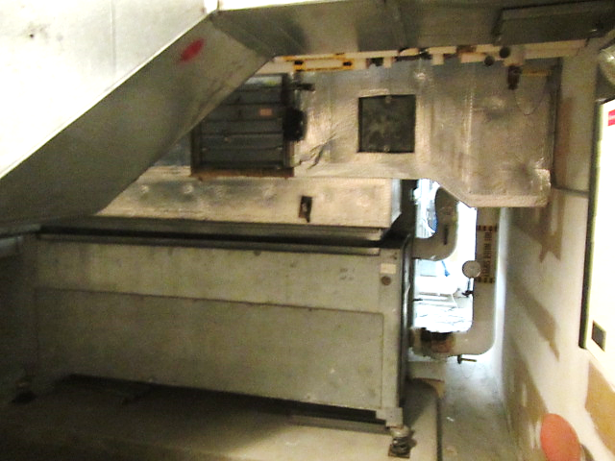
Air handling unit in mechanical room

Picture 2
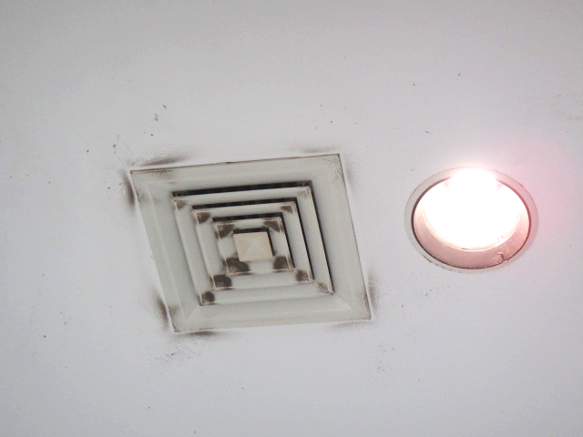
Supply diffuser, note accumulated dust/debris
Picture 3
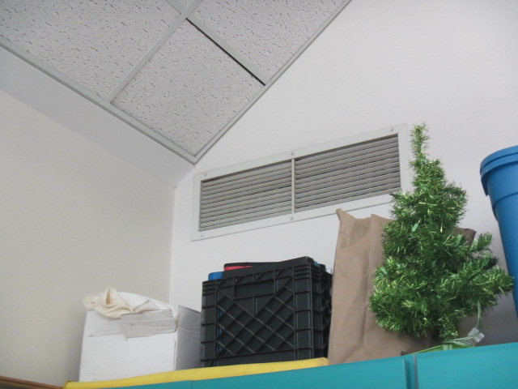
Wall-mounted exhaust/return vent in classroom

Picture 4
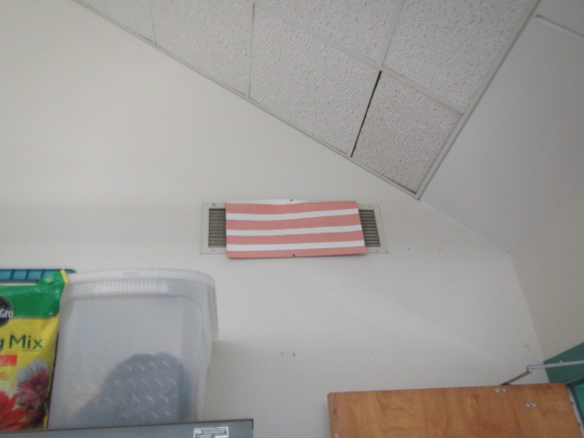
Obstructed exhaust/return vent in classroom
Picture 5
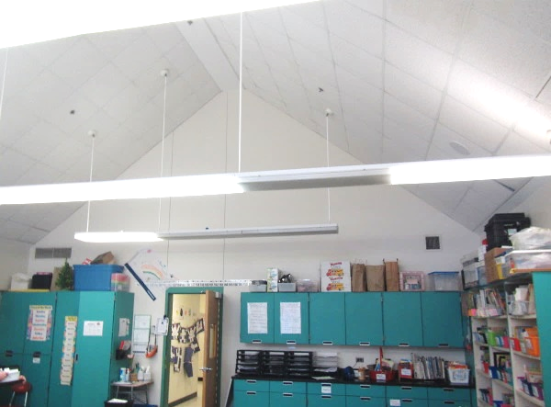
Location of supply and exhaust vents (arrows) on same interior wall, (short-circuiting) preventing proper distribution of classroom air (see Figure 1)
Picture 6
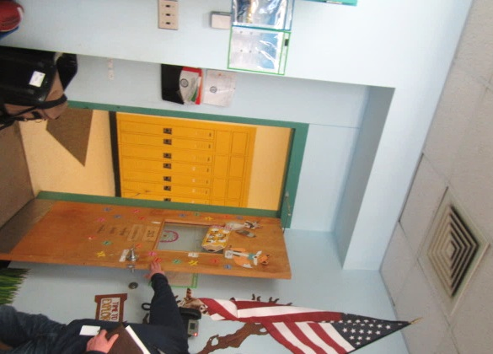
Location of exhaust vent (arrows) near open classroom door
Picture 7
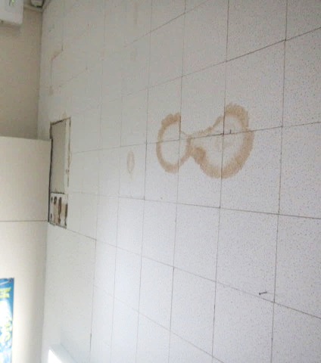
Water-damaged and missing ceiling tiles; note tiles are adhered directly to ceiling
Picture 8
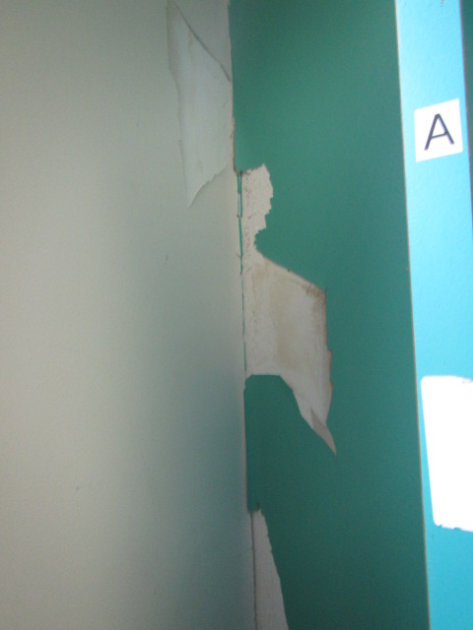
Water-damaged gypsum wallboard and peeling paint in Media Center
Picture 9
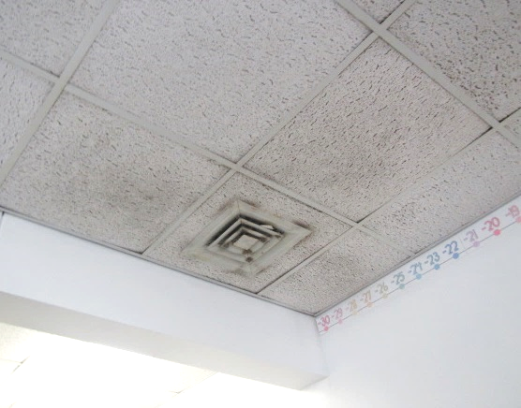
Accumulated dust/debris on vents and surrounding ceiling tiles
Picture 10
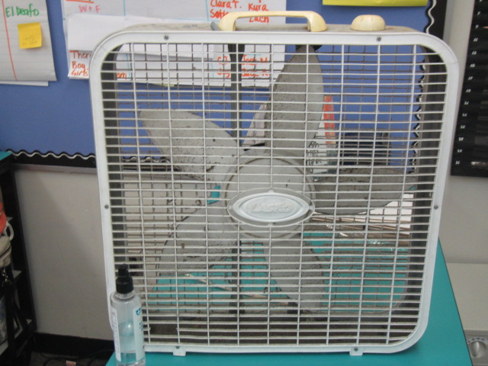
Classroom fan with accumulated dust/debris
Picture 11
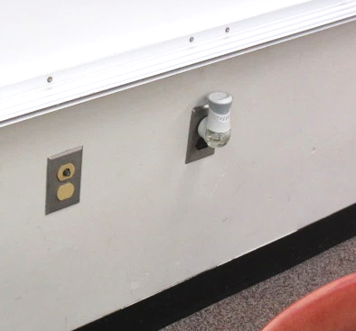
Plug-in air freshener in classroom

Picture 12
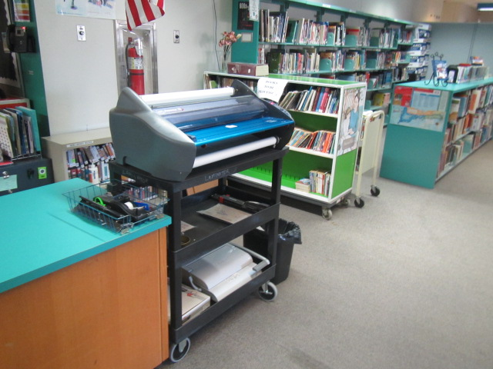
Active laminator in Media Center
Picture 13
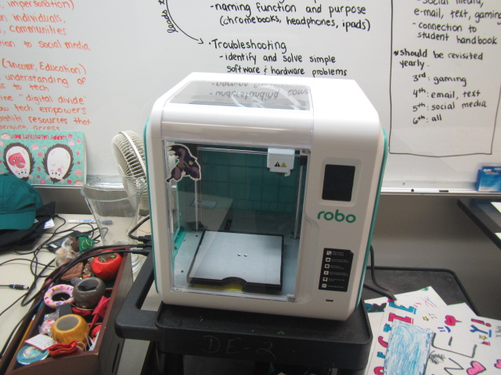
3-D printer in classroom 231

Picture 14
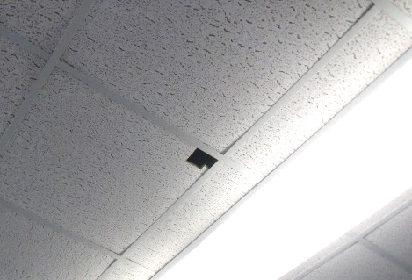
Hole in classroom ceiling tile
Picture 15
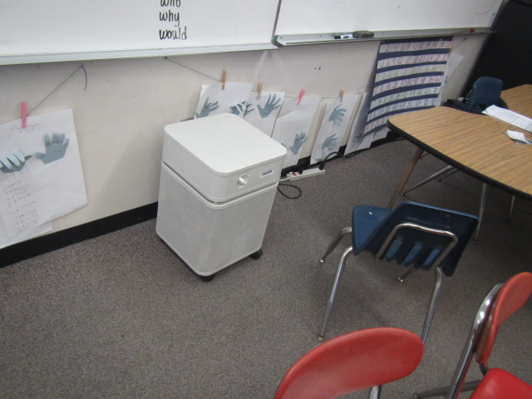
Air purifier in classroom

Picture 16
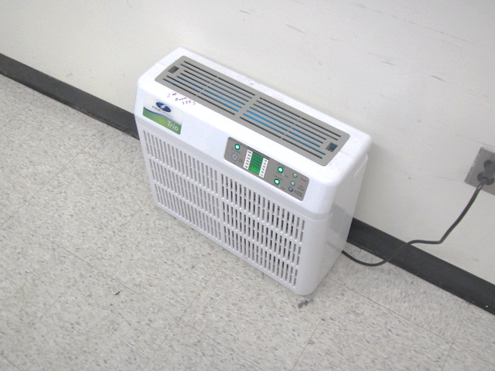
Air purifier, note indicator lights indicating maintenance required
Location | Carbon  Dioxide  (ppm) | Carbon Monoxide  (ppm) | Temp  (°F) | Relative  Humidity  (%) | PM2.5  (µg/m³) | Occupants  in Room | Windows  Openable | Ventilation |  | Remarks
 |  |  |  |  |  |  |  | Intake | Exhaust
Background | 436 | ND | 56 | 62 | 13 |  |  |  |  | Sunny, cool, breezy
Auditorium | 547 | ND | 71 | 44 | 2 | 0 | Y | Y | Y
Cafeteria | 790 | ND | 72 | 46 | 4 | ~180 | Y  Open | Y | Y
105 | 697 | ND | 71 | 44 | 7 | 4 | Y | Y | Y | HEPA unit
107 | 734 | ND | 72 | 45 | 6 | 20 | Y | Y | Y | AP, DO, wall-to-wall carpeting, hole in CT
109 Copy Room | 760 | ND | 71 | 44 | 4 | 0 | N | Y*  Off | N | Copier, confirm vent supply or exhaust*, possible location for laminator?
111 | 935 | ND | 72 | 47 | 4 | 20 | Y | Y | Y | Accumulated dust/debris on vents, AP
112 | 651 | ND | 69 | 47 | 4 | 0 | N | Y | Y
115 | 668 | ND | 70 | 46 | 5 | 0 | Y | Y | Y | AP, wall-to-wall carpeting, ductless air conditioners (2)
119 | 1441 | ND | 70 | 51 | 7 | 2 | N | N | N | No mechanical ventilation or windows
119b | 724 | ND | 71 | 46 | 13 | 0 | N | N | N | AP
Media Center | 725 | ND | 71 | 44 | 3 | 20 | Y | N | N | Strong laminator odors, WD CTs, AP, accumulated dust/debris on vents, wall-to-wall carpeting
130 A | 722 | ND | 70 | 43 | 4 | 0 | N | Y | Y
132 | 858 | ND | 72 | 45 | 190* | 2 | Y | N | N | AP, wall-to-wall carpeting, area carpets, oil diffuser*
Gym | 541 | ND | 68 | 48 | 3 | 0 | Y | Y | Y | Accumulated dust/debris on vents
135 Music | 686 | ND | 71 | 45 | 3 | 19 | N | Y | Y | Accumulated dust/debris on vents/ceiling tiles, area carpets, WD CTs
138 S | 648 | ND | 71 | 46 | 3 | 0 | N | Y | Y | Accumulated dust/debris on vents, AP
143 Music | 532 | ND | 70 | 44 | 3 | 2 | N | Y | Y | Accumulated dust/debris on vents/ducts, wall-to-wall carpeting, PF
145 | 579 | ND | 69 | 48 | 5 | 10 | Y | Y | Y | AP, WD CT
147 | 590 | ND | 71 | 46 | 5 | 5 | Y  Open | Y | Y | Wall-to-wall carpeting, AP, area carpets, DO
148 | 796 | ND | 70 | 47 | 10 | 15 | Y | Y | Y | PF, AP, wall-to-wall carpeting, plants
149 | 878 | ND | 71 | 46 | 5 | 5 | Y | Y | Y | AP, wall-to-wall carpeting
150 | 837 | ND | 71 | 46 | 3 | 15 | Y | Y | Y | Wall-to-wall carpeting, AP, area carpets, plug-in AD
151 | 921 | ND | 71 | 47 | 3 | 16 | Y | Y | Y | DO, wall-to-wall carpeting, AP
152 | 775 | ND | 70 | 47 | 5 | 14 | Y | Y | Y | Wall-to-wall carpeting, AP, area carpets
153 | 801 | ND | 69 | 49 | 3 | 2 | Y | Y | Y | PF, AP, wall-to-wall carpeting
155 | 810 | ND | 68 | 50 | 5 | 0 | Y | Y | Y | Occupants just left for lunch, PF, carpet squares, area carpets
158 | 924 | ND | 69 | 49 | 6 | 22 | Y | Y | Y | DO, AP, wall-to-wall carpeting
160 | 1098 | ND | 69 | 49 | 4 | 21 | Y | Y | Y | DO, AP, PF, carpet squares
165 | 578 | ND | 66 | 51 | 4 | 3 | Y | Y | Y | PF, carpet squares
166 | 1222 | ND | 71 | 49 | 4 | 18 | Y | Y | Y | PF, wall-to-wall carpeting, area carpets
167 | 739 | ND | 69 | 47 | 3 | 2 | Y | Y | Y | PF, wall-to-wall carpeting, WD CT, terrarium, AP
201 | 856 | ND | 73 | 43 | 2 | 10 | Y | Y | Y | Accumulated dust/debris on vents, AP, wall-to-wall carpeting, WD CTs, area carpets
203 | 946 | ND | 72 | 45 | 2 | 16 | Y | Y | Y | Accumulated dust/debris on vents, AP, wall-to-wall carpeting, WD CTs, area carpets, DO, PF
205 | 863 | ND | 72 | 44 | 4 | 21 | Y  Open | Y | Y | Accumulated dust/debris on vents, AP, wall-to-wall carpeting, area carpets, DO, plug in air freshener
207 | 914 | ND | 72 | 45 | 2 | 16 | Y | Y | Y | Accumulated dust/debris on vents, AP, wall-to-wall carpeting, DO, PF
208 | 833 | ND | 72 | 44 | 2 | 16 | Y  Open | Y | Y | Accumulated dust/debris on vents, AP, wall-to-wall carpeting, area carpets, PF
209 | 1084 | ND | 72 | 46 | 8 | 17 | Y | Y | Y | Accumulated dust/debris on vents, AP, wall-to-wall carpeting, WD CT
210 | 783 | ND | 72 | 44 | 3 | 12 | Y | Y | Y | Accumulated dust/debris on vents, WD CTs, DO, PF, plants
219 | 749 | ND | 69 | 46 | 4 | 24 | Y  Open | Y | Y | Accumulated dust/debris on vents, WD CTs, area carpets
220 | 720 | ND | 70 | 46 | 4 | 12 | Y  Open | Y | Y | Accumulated dust/debris on vents, AP, area carpets, DO, PF
222 | 706 | ND | 71 | 45 | 3 | 10 | Y | Y | Y | Accumulated dust/debris on vents, wall-to-wall carpeting, WD CTs, area carpets, DO
223 | 745 | ND | 71 | 45 | 2 | 16 | Y | Y | Y | Accumulated dust/debris on vents, wall-to-wall carpeting, WD CTs, DO, PF
224 | 666 | ND | 72 | 42 | 2 | 1 | N | Y | N | Room divided in half from 226
226 | 760 | ND | 73 | 43 | 2 | 2 | N | Y | Y | AP, wall-to-wall carpeting
228 Office Suite | 649 | ND | 72 | 42 | 2 | 2 | N | Y | Y | Accumulated dust/debris on vents, AP, wall-to-wall carpeting, DO
231 | 612 | ND | 72 | 43 | 2 | 0 | N | Y | Y | Wall-to-wall carpeting, 3D printer, PF
233 | 727 | ND | 72 | 42 | 2 | 2 | Y | Y | Y | AP, wall-to-wall carpeting
PT/OT | 605 | ND | 73 | 42 | 1 | 1 | N | Y | Y | Accumulated dust/debris on vents, AP, wall-to-wall carpeting, WD CTs, area carpets
235 | 838 | ND | 74 | 43 | 1 | 18 | Y | Y | Y | Accumulated dust/debris on vents, AP, kiln in room, aquarium
236 | 675 | ND | 70 | 45 | 2 | 6 | Y | Y | Y | Accumulated dust/debris on vents, AP, wall-to-wall carpeting, holes in CTs (2)
237 | 868 | ND | 71 | 46 | 4 | 23 | Y | Y | Y | Accumulated dust/debris on vents, area carpets, AP, wall-to-wall carpeting, WD CT, plants
238 | 1034 | ND | 71 | 46 | 2 | 21 | Y  Open | Y | Y | Accumulated dust/debris on vents, area carpets, AP, wall-to-wall carpeting & area carpets
239 | 867 | ND | 71 | 46 | 4 | 21 | Y  Open | Y | Y | Accumulated dust/debris on vents, aquarium/turtle, wall-to-wall carpeting & area carpets
240 | 1071 | ND | 71 | 46 | 3 | 24 | Y | Y | Y | Accumulated dust/debris on vents, AP, wall-to-wall carpet, WD CT
241 | 707 | ND | 71 | 44 | 5 | 25 | Y | Y | Y | Accumulated dust/debris on vents, AP, wall-to-wall carpet, AT
242 | 891 | ND | 71 | 45 | 3 | 16 | Y | Y | Y | Accumulated dust/debris on vents, WD CTs, area carpets, AP, PF
243 | 785 | ND | 71 | 44 | 3 | 19 | Y  Open | Y | Y | Accumulated dust/debris on vents, AP, wall-to-wall carpet
247 | 790 | ND | 72 | 46 | 5 | 19 | Y  Open | Y | Y  Weak | MT, WD CTs
248 | 1095 | ND | 72 | 46 | 3 | 19 | Y | Y | Y | Accumulated dust/debris on vents and surrounding CTs, WD CTs, area carpets
250 | 895 | ND | 73 | 43 | 3 | 1 | Y | N | N | AP
254 | 1068 | ND | 72 | 45 | 3 | 8 | Y | Y | Y  blocked | WD CTs, area carpets, DO, AT, PF, exhaust covered with paper
257 | 1020 | ND | 72 | 44 | 3 | 0 | Y | Y | Y  Off | Supply and exhaust on same interior wall-short circuiting, DO
258 S | 997 | ND | 71 | 47 | 4 | 0 | N | N | N | PC, DO
260 | 1180 | ND | 70 | 47 | 4 | 16 | Y | Y | Y  Off | Accumulated dust/debris on vents, WD CTs, area carpets
261 | 1016 | ND | 71 | 46 | 4 | 17 | Y | Y | Y | Accumulated dust/debris on vents, WD CTs, area carpets

The service life is the median time during which a particular system or component of …[an HVAC]… system remains in its original service application and then is replaced. Replacement may occur for any reason, including, but not limited to, failure, general obsolescence, reduced reliability, excessive maintenance cost, and changed system requirements due to such influences as building characteristics or energy prices (ASHRAE, 1991).

