ISSUE 1 | VOLUME 2 | June 2017
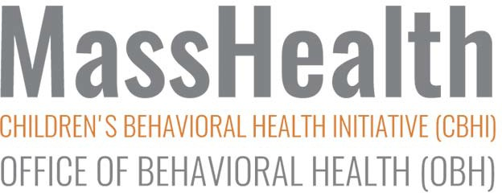

News from MassHealth's Office of Behavioral Health and the Children's Behavioral Health Initiative

IN THIS ISSUE:| Implementing the IHT Practice Profile | Yale Supervision Project | NEW: Licensure Reimbursement Program |
ARC and GROW | Congratulations, Laura Conrad-Laberinto |
Implementing the IHT Practice Profile
Nine program sites are currently piloting the implementation of the IHT Practice Profile, using a structured approach outlined by the National Implementation Research Network (NIRN). Frontline IHT providers, TT&S, and supervisors are helping to pilot tools focused on:

- self-assessment;
- behavioral rehearsal, and
- field observations.

The Practice Profile (http://www.cbhknowledge.center/ihtpp/) was released earlier in the year with the intent of improving the quality of In-Home therapy services for children and youth enrolled in CBHI services through MassHealth. IHT is one of our most heavily used services, with over 17,000 clients currently enrolled. The Practice Profile itself has been very well received, and

implementation to ensure fidelity to its principles is being rigorously managed and evaluated through this implementation work. For more information on the pilot, please visit the CBH Knowledge Center website.

IHT Practice Profile

Yale Supervision Project
Four CBHI providers—LUK, High Point, The Bridge of Central Massachusetts, and Family Services of Greater Boston—are taking part in the Yale Supervision Project in 2016-17. Yale created a model for strengthening supervisor competencies and shaping supervision practice in health and human service organizations. The university then contracted with the CBH Knowledge Center and MassHealth to offer this six-month consulting/training curriculum to child- and youth- serving agencies and organizations in Massachusetts.

Over 200 frontline supervisors and midlevel managers have taken part in the project. Initial response from participants has been overwhelmingly positive. According to Jack Simons, PhD., Director of CBHI, “from a workforce-development perspective, strengthening supervision is one of the most effective and efficient interventions in any organization, and we are hopeful that this will help us to strengthen and improve services to the kids and families we serve.”

Because the response to the program this year has been so positive, talks are underway to offer the training next year. Details will be announced in fall 2017.
Informational Webinar - Strengthening Supervision Initiative

New: Licensure Reimbursement Program
As a part of ongoing efforts to support our provider workforce, MassHealth’s Office of Behavioral Health has just announced a new program to financially support IHT and ICC staff seeking licensure. Up to $1500 in reimbursement will be available to support staff, including LICSW, LMHC, LMFT, and psychologists, achieving independent licensure. You can find information about the program, including criteria, exclusions, and an application, in the attached file. For more information, contact Amy Horton at TAC by email at ahorton@tacinc.org or by phone at 617-266-5657, x 122.
CBHI Licensure Reimbursement Program Description and Application

ARC and GROW
As part of the overall effort to support providers and improve the quality of CBHI services, almost 200 providers participated in a series of three-day trainings. “GROW: Adaptation of the ARC Framework as a Caregiver Skill Building Intervention” attracted trainees from 30 different sites, and included providers such as Therapeutic Mentors, In-Home therapists, ICCs, and Family Partners.

The “Attachment, Self-Regulation, and Competency (ARC)” framework is a treatment model with a focus on trauma. GROW is designed as a home- based caregiver skill-building intervention for families who are impacted by chronic adversity or stress. Combining the two concepts by training providers in the ARC intervention model, while introducing family members to the GROW curriculum, allowed for a richer understanding of the role of caregivers and families. Attendees at the training participated in role playing, group discussions, and video demonstrations, and

commented favorably about the quality of the trainers and the content of the training. Some attendees even requested that the training be expanded to a five-day course One participant commented that “the structure of the GROW curriculum is needed in IHT as a good tool to access when working with parents and children. I was glad to see clinicians and TT&S staff excited about implementing this with families.”

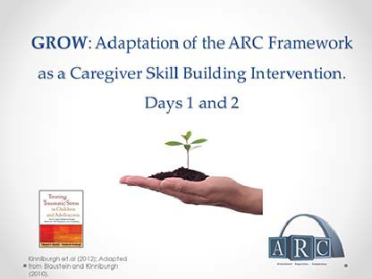
For more information about ARC, visit the Attachment, Regulation and Competency (ARC) web page. A day-long follow-up GROW “booster training” for attendees who completed the training is tentatively scheduled for March 2018.

For More Info on ARC

Congratulations, Laura Conrad-Laberinto
The Autism Insurance Resource Center at the UMass Medical School recently named three champions for autistic children in Massachusetts. Laura Conrad-Laberinto was recognized for her work in establishing Applied Behavioral Analysis (ABA) as a MassHealth-covered service. Her knowledge of the ins-and-outs of MassHealth was instrumental in expanding that service, which is currently providing therapy for thousands of MassHealth members. Congratulations, and thank you, Laura

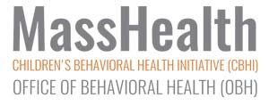 Congratulations to Laura Conrad-Laberinto
Receive this OBH/CBHI newsletter as a

MASSHEALTH
OFFICE OF BEHAVIORAL HEALTH (OBH)

CHILDREN'S BEHAVIORAL HEALTH INITIATIVE (CBHI)
forward? Sign up to receive our future emails. Follow this link if you would like to unsubscribe from receiving future OBH/CBHI newsletters.
Visit the CBHI website (www.mass.gov/masshealth/CBHI).
Follow us on Twitter @MassHealth | Follow us on YouTube.

MassHealth CBHI CANS

