This document contains detailed instructions for completing the Occupancy Rate Application (ORA) version FY25 (effective July 1, 2024). There are three sections:
- Page 1 – Introduction. This brief introduction has general information to keep in mind when completing the ORA,
- Pages 2 to 3 – Eligibility & Timeline. Overview of sites that are eligible for the ORA process. This includes timeline information going back to when the new site was just an idea between the provider and the DDS area office, and
- Pages 4 to 20 – Instructions. Step-by-step instructions for completing each application section. Each section is defined and identifies minimum documentation requirements, if any, that are triggered when specific entries are made.
General Information for completing the ORA:
- Make entries only in gray boxes.
- Yellow boxes will be automatically computed using data that’s been input to gray boxes.
- Expenses are site-specific, not engagement-wide.
- Expenses paid through a Commonwealth-funded start-up or capital budget are not allowed on the application.
- Salaried staff position expenses are not allowed on the application.
- Vehicle-related expenses are not allowed on the application.
- Related Parties to a provider, include but are not limited to, another organization that includes a member(s) of the provider’s executive staff or board, or the spouse of an executive staff or board member. Full definition: 808 CMR 1.05(8). Also, see GAAP Rules pertaining to related parties.
If ownership of a rental site is not clear (realty trusts or other legal entities where individual ownership is unclear), the lease may be treated as a related party transaction and subject to related party rules.
Questions? Please check with your area contacts, regional contacts, or the DDS Central Office contracts team:
- General Inquiries - DDS-POS-Occupancy@mass.gov
- Thomas Higgins, Residential Housing Expense Analyst – Thomas.Higgins6@mass.gov
- Cesar Barreto-Gonzalez, Business Analyst - Cesar.A.Barreto-Gonzalez@mass.gov

Eligibility & Timelines
Several scenarios require a DDS ALTR (Adult Long Term Residential) site to go through the ORA process. The situations outlined below will prompt a new ORA:
- Brand New. Any ALTR site that is new to DDS requires an ORA.
- Change in Acquisition Status. Any ALTR site with a change in acquisition status requires an ORA. For example, this would apply to a site that was originally leased to the provider before the provider purchased/otherwise obtained ownership of the property; or a site that was originally purchased and is now leased.
- Former ALTR Sites. Any former ALTR site that has not been in use as a DDS ALTR site for at least one (1) year requires an ORA.
- Razed ALTR Sites. Any new ALTR site that is replacing an ALTR site that was effectively razed to make way for the new site requires an ORA.
- Provisional Rates. A Provisional Rate is a temporary rate assigned to a site. When an ALTR site is issued a Provisional Rate, a Final Rate will need to be established within one (1) year of the first move in. The process of repricing from a Provisional Rate to a Final Rate requires a finalized ORA. Additional documentation will be required.
- Select Changes in Capacity. Any existing ALTR site that increases in capacity from 1-3 to 4+ or decreases in capacity from 4+ to 1-3 requires an ORA. These capacity changes will impact a site’s expense caps in Section [7] – Summary of Projected Annual Occupancy Expenses of the ORA.
- Significant Building Improvements. Any existing ALTR site with improvements may require an ORA.
Scenarios may vary. The ORA process and final determination are at the discretion of DDS Central Office.
DDS Central Office contracts staff have sixty (60) calendar days from receipt of a complete ORA package to review and establish an occupancy rate for the site. A “complete ORA package” includes all supporting documentation deemed necessary by DDS.
The provider should submit a completed application, with supporting documentation, to DDS Central Office contracts no sooner than two weeks prior to move in and no later than two months after the first person has moved into the site. Application packages submitted to DDS more than two months after the first person move-in date risk limiting reimbursement. If there are any concerns about these timelines, please contact DDS Central Office Contracts.
The provider must include the Area Director or the ABI Coordinator in all communication related to the ORA. This is to ensure the area has worked with the provider to establish the new site; is aware of the site costs; and has funds to cover the occupancy rate established by DDS Central Office. Area offices may refuse to fund a site if they are not fully informed.

Eligibility & Timelines (Continued)
The provider submits the completed ORA and associated documentation to DDS Central Office for review. All documentation must be submitted directly to DDS-POS-Occupancy@mass.gov with the appropriate area and regional office contacts copied on the email correspondence. Thomas Higgins, Residential Housing Expense Analyst at DDS Central Office, will review the documentation. If the application and/or documentation are incomplete or incorrect, DDS Central Office will contact the provider for corrective action.
In the event of missing or insufficient supporting documentation, a Provisional Rate may be assigned based on the documentation on file. A Provisional Rate may also be assigned when an explanatory request for additional time is not made. Missing documentation usually adversely impacts the occupancy rate. In these situations, DDS Central Office will notify the provider.
Upon receipt of a complete ORA package, DDS Central Office will establish a per person rate and the provider will be notified. An updated occupancy worksheet will be created reflecting the assigned rate. The ORA and new occupancy worksheet will be sent to the provider contact(s) with instructions regarding next steps of the process.
A provider can appeal an assigned rate within 30 calendar days of rate finalization. An appeal must be in writing, include justification for the appeal, and contain supporting documentation. The appeal should be sent electronically to Victor Hernandez (Victor.Hernandez@mass.gov) and Thomas Higgins (DDS-POS-Occupancy@mass.gov) and the regional and area contacts need to be copied on the email correspondence.

The following are section-by-section definitions and trigger requirements of expense documentation:
OCCUPANCY RATE APPLICATION (ORA) INSTRUCTIONS - SECTION 1
APPLICATION FIELD | DEFINED | TRIGGERS REQUIREMENT FOR
“Agency Area Contact Name” | The DDS Area Director for ID sites or ABI Coordinator for ABI sites | None
“Title” | The title of named Area Director or ABI Coordinator Contact | None
“DDS Area Office/State Agency” | From the drop-down menu, select the name of the applicable area office of the Agency Area Contact, or ABI equivalent | None
“Name of Provider Agency” | The legal name of the provider agency that will be operating the new site | None
“20-Character Doc ID” | The 20-character Occupancy Doc ID number. If the Occupancy Doc ID is unknown, please contact the Regional office. | None

OCCUPANCY RATE APPLICATION (ORA) INSTRUCTIONS - SECTION 1 CONTINUED
Operational Contract Type (Contains DDS ID 3153, DDS ABI 3751, DDS Emerg. 3182, DDS Respite 3759, DDS Other, MCB, and MRC next to boxes to check) | The lead, or majority financing, Commonwealth agency of the site.  Only select one | None

OCCUPANCY RATE APPLICATION (ORA) INSTRUCTIONS - SECTION 2
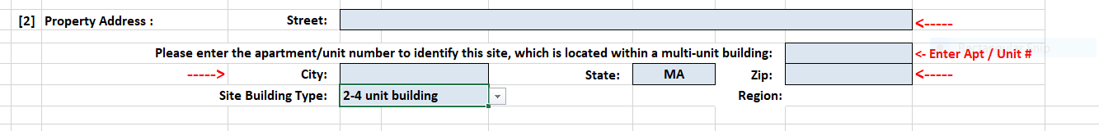
APPLICATION FIELD | DEFINED | TRIGGERS REQUIREMENT FOR
“Street” and “Apartment/Unit Number” | Full street address of new site, including any apartment, unit, or building number. | None
“City” | Name of the city the new site is in. MA cities must match one of the 351 official MA cities and towns. | None
“State” | Name of the state where the site is located
“Zip” | 5- or 9-digit zip code of the site | None
“Site Building Type” | Drop down menu with three choices: “single unit building” is a free-standing single-family building; “2 to 4 unit building” houses 2 to 4 apartments; “5 or more unit building” is a building or complex with five or more apartments.  Note that “unit” refers to a whole unit of housing, not a bedroom. | None
- Region: This field will auto-populate based on “City”.

OCCUPANCY RATE APPLICATION (ORA) INSTRUCTIONS - SECTION 3
APPLICATION FIELD | DEFINED | TRIGGERS REQUIREMENT FOR
“Total Capacity of Site” | Total number of individuals (regardless of funding source), not staff, who can live at the site | Explanation in writing why any extra bedroom(s) are not part of “Total Capacity of Site”.
“Capacity Purchased Under This Contract” | Total number of individuals, not staff, to live at the site and to be funded by the 20-Character Doc ID # in Section 1. This number cannot exceed “Total Capacity of Site”, but it may be equal to or less than “Total Capacity of Site”. | None

OCCUPANCY RATE APPLICATION (ORA) INSTRUCTIONS - SECTION 4
APPLICATION FIELD | DEFINED | TRIGGERS REQUIREMENT FOR
“Acquisition Type” (Financing) Select 1:  - Purchase  - Lease  - Capital Lease | - Purchase – Provider obtains ownership of the site. Provider must be the owner of record.  - Lease – Provider rents the site.  - Capital Lease – Provider enters into a lease arrangement where the ownership will be transferred to the lessee at the end of the lease term. | Please refer to Section 5 for documentation requirements.
“Acquisition Type”, second row, only for “Acquisition Type” above of “Purchase”  Select One:  - Existing Structure  - New Construction | (Only for “Purchase” acquisition type)  - Existing Structure – the site existed before provider acquired the property.  - New Construction– the site was newly constructed at the time provider acquired the property. | Please refer to Section 5 for documentation requirements.
“Is lessor a related party (for leased sites)?”  - Yes  - No | - Yes – the lessor is a related party  - No – the lessor is not a related party | Answer of “Yes” triggers the same documentary requirements outlined in Section 5 for “Purchase” of “Existing House”, pages 9-10, or “New Construction”, pages 11-12

OCCUPANCY RATE APPLICATION (ORA) INSTRUCTIONS - SECTION 4 (CONTINUED)
Note: Related Party rules apply to lease transactions where the provider rents a site that is owned by a related entity or individual. DDS checks property ownership during the review process for all ORAs.
As noted on page 1, a related party to a provider, includes but is not limited to, another organization that includes a member(s) of the provider’s executive staff or board, or the spouse of an executive staff or board member. Full “Related Party” definition can be found at 808 CMR 1.05(8). Also see GAAP Rules pertaining to related parties.
If ownership of a site leased to a provider is unclear (realty trusts, or other legal entities where individual ownership cannot be determined) the lease may be treated as a related party transaction and subject to all related party rules.

OCCUPANCY RATE APPLICATION (ORA) INSTRUCTIONS - SECTION 5 – EXISTING HOUSE INFORMATION
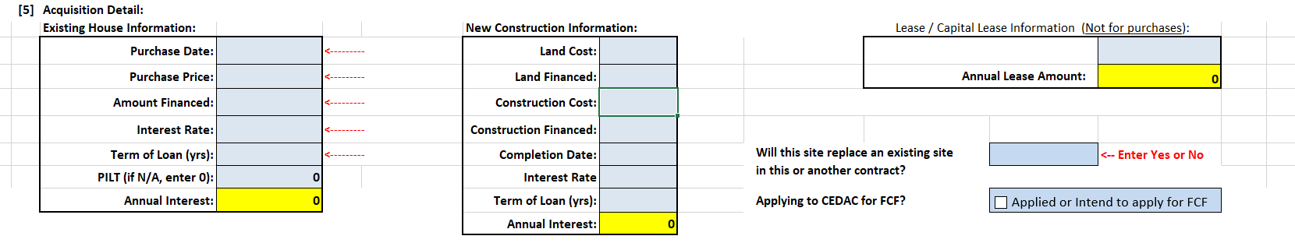
[5] Acquisition Detail: “Existing House Information” - Completed when provider purchases an existing site
APPLICATION FIELD | DEFINED | TRIGGERS REQUIREMENT FOR
“Purchase Date” | Date provider legally purchased site | HUD 1 Settlement Statement, Deed, Land Card, or other document stating provider Purchase Date of site
“Purchase Price” | Original purchase price of the site. Only purchase price - no renovation costs, taxes, closing costs, or any other expenses associated with the site | Same as “Purchase Date”
“Amount Financed” | Amount financed by the provider to acquire the site | Financing Documents – mortgage, loan documents, bond documents, or other finance documents associated with provider acquisition of the site. Documentation must include the site address referenced as collateral. Additionally, if the financing is for multiple properties, supporting documentation is required referencing the specific amount or percentage of the total financing attributed to the site address.  Also, submit proof of other items that were financed.
OCCUPANCY RATE APPLICATION (ORA) INSTRUCTIONS - SECTION 5 – EXISTING HOUSE INFORMATION (CONTINUED)
APPLICATION FIELD | DEFINED | TRIGGERS REQUIREMENT FOR
“Amount Financed” (Continued) | Amount financed by the provider to acquire the site | In cases where the property was refinanced or improved, additional documentation may be required at the discretion of DDS.
“Interest Rate” | Interest rate of financing the provider uses to acquire the site | Please refer to “Amount Financed”
“Term of Loan (yrs)” | Number of years the loan or bond amortization is based upon | Please refer to “Amount Financed”
“PILT” (if N/A, enter 0) | If applicable, enter the annual amount of payment in lieu of taxes. | PILT Agreement (if applicable)
- Total Interest: Total interest paid over the life of the loan.
- Annual Interest: The total interest of the loan divided by 27.5 years. This is computed using the straight-line method.

The “Annual Interest” field will auto-populate in accordance with the data entered into the application fields outlined above.

OCCUPANCY RATE APPLICATION (ORA) INSTRUCTIONS - SECTION 5 (CONTINUED) – NEW CONSTRUCTION INFORMATION
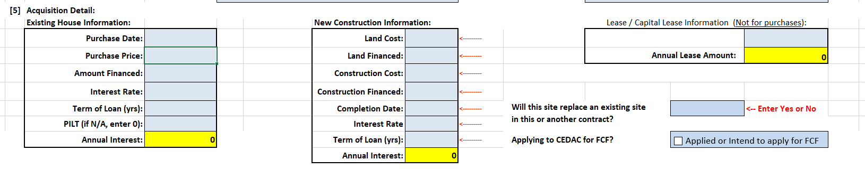
[5] Acquisition Detail: “New Construction Information” - Completed when provider constructs a new site.
APPLICATION FIELD | DEFINED | TRIGGERS REQUIREMENT FOR
“Land Cost” | Cost of land new site is constructed on | Deed, Land Card, or other document stating provider cost of land purchase to build new site
“Land Financed” | Amount of land cost that is financed by provider | Financing Documents – mortgage, loan documents, bond documents, or other finance documents associated with provider acquisition of land
“Construction Cost” | Cost of construction of the new site. | Contractor, AIA (American Institute of Architects), or other documents detailing the construction and costs, including number of bedrooms, baths, etc., associated with building the site, and proof of provider payment of those costs, or pending payment
“Construction Financed” | Amount of construction cost that is financed by provider | Same as “Land Financed”
“Completion Date” | Date construction of new site was completed | None
OCCUPANCY RATE APPLICATION (ORA) INSTRUCTIONS - SECTION 5 – NEW CONSTRUCTION INFORMATION (CONTINUED)
APPLICATION FIELD | DEFINED | TRIGGERS REQUIREMENT FOR
“Interest Rate” | Interest rate of financing the provider uses to build the site | Same as “Land Financed”
“Term of Loan (yrs)” | Number of years the loan or bond amortization is based upon | Same as “Land Financed”
- Total Interest: Total interest paid over the life of the loan.
- Annual Interest: The total interest of the loan divided by 27.5 years. This is computed using the straight-line method.

The “Annual Interest” field will auto-populate in accordance with the data entered into the application fields outlined above.

OCCUPANCY RATE APPLICATION (ORA) INSTRUCTIONS - SECTION 5 (CONTINUED) – LEASE/CAPITAL LEASE INFORMATION
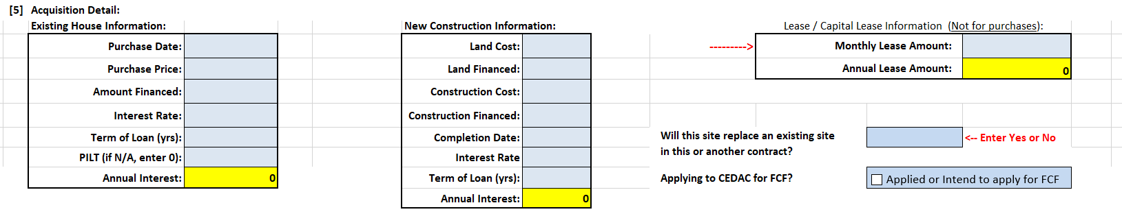
[5] Acquisition Detail: “Lease/Capital Lease Information” - Completed when provider leases a site or enters into a capital lease arrangement.
APPLICATION FIELD | DEFINED | TRIGGERS REQUIREMENT FOR
“Monthly Lease Amount” | Amount of monthly lease or capital lease payment | Lease Agreement or Capital Lease Agreement, Capital Lease Budget, and  Proof of payment by capital lease holder of costs listed on Budget
The “Annual Lease Amount” field will auto-populate in accordance with the data entered into the application field above.

Note: * Related Party leases also require the same documentation as “Existing House Information” or “New Construction Information” (see page 5 for more detail).

OCCUPANCY RATE APPLICATION (ORA) INSTRUCTIONS – SECTION 5
[5] Acquisition Detail “Will this site replace an existing ALTR site in this or another contract?” and “Applying for CEDAC for FCF?” (funding)
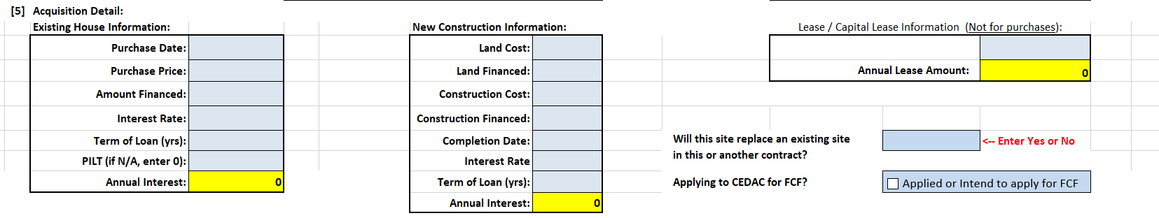
APPLICATION FIELD | DEFINED | TRIGGERS REQUIREMENT FOR
“Will this site replace an existing site in this or another contract?” | Select “Yes” or “No” from the drop-down menu. | Provide the address of the existing site that will be replaced to DDS Central Office.
“Applying to CEDAC for FCF?” | Question whether CEDAC or FCF funding will, or has been, applied for as part of site funding. Only check box if answer is affirmative. | If answered funding question in the affirmative, complete the “Date of CEDAC application” with a date or TBD if no firm date is available at the time of the ORA submission.

OCCUPANCY RATE APPLICATION (ORA) INSTRUCTIONS - SECTION 6
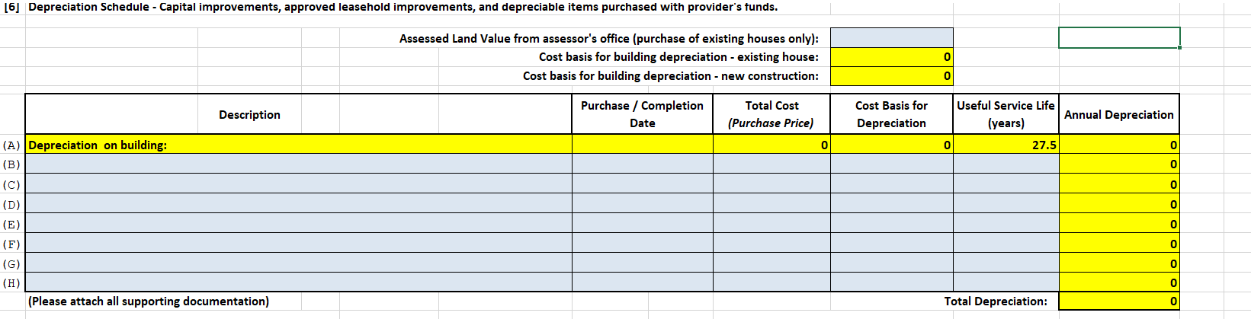
APPLICATION FIELD | DEFINED | TRIGGERS REQUIREMENT FOR
“Assessed Land Value from assessor’s office (purchase of existing houses only)” | Assessed value of land as listed on the city/town assessor’s office land card (sometimes called property card). | Land Card or comparable document
“Description – Lines B through H” | Describes renovations and life safety improvements made to existing site.  - Does not include start-up costs.  - Like renovations grouped together; “Useful Service Life” (Service Life of Assets tab) is sometimes a good indicator of like renovations  - Complete “Purchase/ Completion Date” (of the improvement), “Total Cost”, “Cost Basis for Depreciation” (usually the same amount), and “Useful Service Life” (from Service Life of Assets tab) | For renovations or life safety improvements: American Institute of Architects (AIA) documents or detailed contractor proposals or invoices, and proof of payment to contractor or explanation of pending payment
Making the land value entry will compute and auto-populate the following:
- Cost Basis for “Depreciation on building”, Line A of Depreciation Schedule for an Existing House (Purchase Price from [5] less Assessed Land Value, 1st red arrow)
- Cost Basis for Depreciation on the Depreciation Schedule (Purchase Price less Assessed Land Value, 2nd red arrow)

OCCUPANCY RATE APPLICATION (ORA) INSTRUCTIONS - SECTION 7
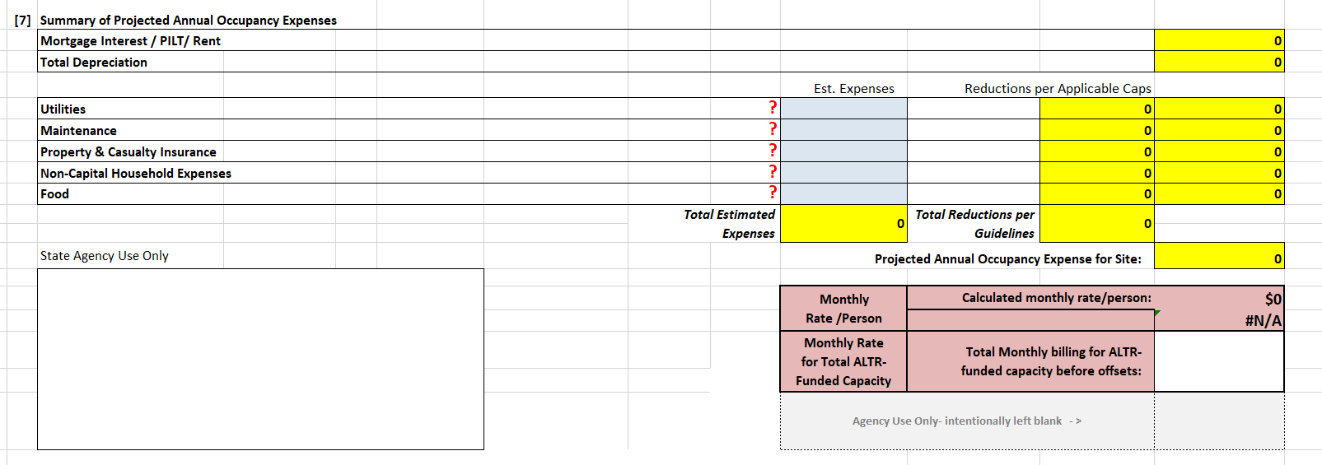
These are estimated, or projected, annual expenses for the new site only. Formulas embedded in the application will cap these expenses based on previously entered data (capacity, type of site, and type of acquisition). Provider can enter any reasonable cost estimate but any amounts higher than the caps will be adjusted downward on the application. All items are stated as annual expenses for each occupancy expense category.

APPLICATION FIELD | DEFINED | TRIGGERS REQUIREMENT FOR
“Utilities” | Electricity, natural gas, heating oil, water/sewer  No vehicle or staff expenses | None
“Maintenance” | General upkeep of site, snow removal, trash removal, lawn care  No vehicle or staff expenses | None
“Property & Casualty Insurance” | Property & Casualty insurance on the building and contents (furniture, clothing) only; rental insurance on contents only for leased sites  No vehicle insurance or any other insurance | None
OCCUPANCY RATE APPLICATION (ORA) INSTRUCTIONS - SECTION 7 (CONTINUED)
APPLICATION FIELD | DEFINED | TRIGGERS REQUIREMENT FOR
“Non-Capital Household Expenses” | Paper goods, cleaning supplies, small expenditures | None
“Food” | For individuals, not staff, living at the site | None *

Note: *“Food” is computed per 101 CMR 420.00.
- Total Estimated Expenses – This field will auto-populate based on the sum of the entries from “Utilities” through “Food”.
- Total Reductions Per Guidelines – This field will auto-populate to reflect the reductions per applicable caps for “Utilities” through “Food”.
- Projected Annual Occupancy for Site – This field will auto-populate to reflect the estimated grand total of annual occupancy expenses based on the information above.

OCCUPANCY RATE APPLICATION (ORA) INSTRUCTIONS - SECTION 8
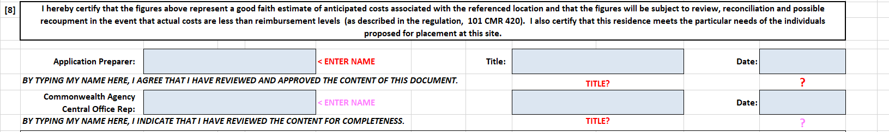
APPLICATION FIELD | DEFINED | TRIGGERS REQUIREMENT FOR
“Application Preparer” | Provider Application Preparer name | None
“Title” | Title of named Provider Application Preparer | None
“Date” | Date of final, complete, application submission | None

OCCUPANCY RATE APPLICATION (ORA) INSTRUCTIONS - SECTION 9
APPLICATION FIELD | DEFINED | TRIGGERS REQUIREMENT FOR
“Estimate of Annual Offsets” | Estimated total amount of annual (twelve months) offsets for all individuals comprising “ALTR Funded Capacity”. Offsets are usually charges for care (SSI, SSDI, etc.), SNAP, and housing benefits received by the individuals living at the site. DDS regional office will pro-rate for actual occupancy used in first FY | None
“Projected move in/start date” | The date the first DDS individual is projected to move, or has moved, into the site | None

