How to complete the Occupancy Rate Application
(formerly known as the New Site Occupancy application, or NSO)

This document contains detailed instructions for completing the Occupancy Rate Application (ORA) versions: v2021_05_01 (for FY22) and v2020_12_01 (for FY 21). There are three sections.
- Page 1 – Introduction. This brief introduction has general information to keep in mind when completing the ORA
- Page 2 – Eligibility & Timeline. Which sites are eligible for the ORA process along with timeline information going all the way back to when the site was just an idea between the provider and the DDS area office
- Pages 3 to 11 – Instructions. Step-by-step instructions for completing each application section. Each application entry is defined and explained, and the reader is notified whenever an entry triggers a documentary requirement

Introduction
General Information for completing ORA’s:
- Make entries only in gray boxes.
- Yellow boxes will be automatically computed using data that’s been input to gray boxes.
- Expenses are site-specific, not engagement-wide.
- Expenses paid through a Commonwealth-funded start-up or capital budget are not allowed on the application.
- Salaried staff position expenses are not allowed on the application.
- Vehicle-related expenses are not allowed on the application.
- A Related Party to a provider, includes but is not limited to, another organization that includes a member(s) of the provider’s executive staff or board, or the spouse of an executive staff or board member. Full definition 808 CMR 1.05(8). Also see GAAP Rules pertaining to related parties.
- If ownership of a rental site is not clear (realty trusts or other legal entities where individual ownership is unclear) the lease may be treated as a related party transaction and subject to related party rules.

Questions? Check with your area or region contacts or Anthony Piccolo, Anthony.piccolo@mass.gov
The latest version of this document can be found on the DDS POS website

Eligibility & Timelines

DDS ALTR (Adult Long Term Residential) sites that need to go through the Occupancy Rate Application (ORA) process. This includes ABI/MFP sites:
- Any ALTR site that is brand new to DDS
- Any ALTR site with a change in acquisition status. For example, a site leased to the provider that the provider purchases or otherwise obtains ownership of
- Any former ALTR site that has not been in use as a DDS ALTR site for at least one year
- Any new ALTR site that is replacing an ALTR site that was effectively razed to make way for the new site
- Any ALTR site that is transitioned from one provider to another (not provider name changes)
DDS central office contracts staff have 30 calendar days from receipt of a complete ORA package to review and establish an occupancy rate for the new site. A “complete ORA application package” includes all documentation deemed necessary by DDS.
The provider should submit a completed application, with back up documentation, to their area (or ABI coordinator) and regional offices as soon as possible and not later than two months (60 calendar days) after the first person has moved into the site or the site has transitioned from one provider to another. Application packages submitted to DDS more than two months after the first person move-in date, or date of transition between providers, risk limited reimbursement.
The provider includes the state officer name, title, and area in application section [1]. This is an acknowledgement that the area has worked with the provider to establish the site; is aware of the site costs; and has funds to cover the occupancy rate established by DDS central office. The area office would notify regional and central office if any of those items could not be acknowledged.
The regional office reviews the submitted ORA and associated documentation in conjunction with this checklist. If an application and documentation are complete, the regional office will forward the package to Anthony Piccolo at DDS central office and the area office. If the application and documentation are incomplete or incorrect the regional staff will contact the provider for corrective action.
The region will forward the application package, complete or not, within one week of receipt from the provider.
Upon receipt and review of a complete application package DDS central office will establish an occupancy rate and forward that rate and supporting documentation to regional, area, and provider contacts. A provider can appeal an assigned rate within 30 calendar days of rate establishment. An appeal must be in writing, include detailed justification for the appeal, and contain supporting documentation. The appeal should be sent electronically to Victor Hernandez. Anthony Piccolo and the regional and area (or ABI) contacts must be copied.

The following are section-by-section definitions and trigger requirements of expense documentation.
OCCUPANCY RATE APPLICATION INSTRUCTIONS SECTION 1
APPLICATION SECTION | DEFINED | TRIGGERS DOC REQUIREMENT FOR
“Agency Area Contact Name” | The DDS Area Contact. Usually the Area Director for ID/DDS sites, Community Systems Director for ABI/DDS sites | None
“Title” | The title of named Agency Contact | None
“DDS Area Office/State Agency” | Name of the area office of the State Agency, DDS Area Contact, or ABI equivalent (drop down menu) | None
“Name of Provider Agency” | The legal name of the provider agency that will be operating the new site | None
“20-Character DocID” | 20 character Document identifier number with “L” as the 9th digit and ending in “M”; also called “Contract #” | None
“DDS Area Office/State Agency” Box | Enter the appropriate DDS Area Office or ABI Region, or other state agency, from drop down menu | None
Table below “DDS Area Office/State Agency” Box  (not titled, but contains DDS 3153, DDS ABI, MCB, MRC, next to check off boxes) | Only select one from the four choices  The “Capacity Purchased Under This Contract”, from Section 3, is purchased by this agency | None

OCCUPANCY RATE APPLICATION INSTRUCTIONS SECTION 2
APPLICATION SECTION | DEFINED | TRIGGERS REQUIREMENT FOR
“Street” | Full street address of site | None
“Please enter any apartment/unit number, if one exists” | Any identifying apartment or unit #’s | Required for multi-unit buildings
“City” | Name of the site city. MA cities must exactly match one of the 351 official cities and towns as listed in the application “Cities & Regions” tab | None
“State” | Select the state abbreviation from drop down menu | None
“Zip” | 5 or 9 digit zip code of site address | None
“Site Building Type” | Select the site building type from the three choices on drop down menu.  Note that “unit” refers to a whole unit of housing (house, apartment, etc) not a bedroom | None

OCCUPANCY RATE APPLICATION INSTRUCTIONS SECTION 3
APPLICATION SECTION | DEFINED | TRIGGERS REQUIREMENT FOR
“Total Capacity” | Total number of individuals (regardless of funding source), not staff, who can live at the site | Explain in writing any extra bedroom(s) that are not part of “Total Capacity”
“Capacity Purchased Under This Contract” | Total number of individuals, not staff, to live at the site and are funded by the DocID # in Section 1. This number cannot exceed Total Capacity, but may be less than or equal to Total Capacity | None
OCCUPANCY RATE APPLICATION INSTRUCTIONS SECTION 4
APPLICATION SECTION | DEFINED | TRIGGERS REQUIREMENT FOR
“Acquisition Type (financing) (select 1)”:  - Purchase  - Lease  - Capital Lease | - Purchase – provider purchases site  - Lease – provider leases site (including related party transactions)  - Capital Lease – provider enters into a capital lease arrangement | None
“Owner of Record” | Name & address of site owner | None
“Acquisition Type (select 1)”, second row, only for “Purchase” “Acquisition Type”  Select One  - Existing  - New | (Only for “Purchase” acquisition type)  - Existing – site existed before provider acquired it  - New – site was newly constructed at the time provider acquired it | None
“Is lessor a related party (for Lease sites)?”  - Yes  - No | - Yes – the lessor is a related party  - No – the lessor is not a related party | “Yes” triggers the same documentary requirements from Section 5 for “Purchase” of “Existing House”, page 6, or “New Construction”, page 7
“Ready to move in?” Select One:  - Pending  - Completed | - Pending – provider acquisition of the site is not complete either legally and/or physically  - Completed – provider acquisition of the site is complete legally and physically | None
Notes: Related Party rules apply to lease transactions where the provider rents a site that is owned by a related entity or individual. A related party to a provider includes, but is not limited to, another organization that includes a member(s) of the provider’s executive staff or board, or the spouse of an executive staff or board member. Full “Related Party” definition can be found at 808 CMR 1.05(8); also see GAAP Rules pertaining to related parties.
If the ownership of a site leased to a provider is unclear (realty trusts, or other legal entities where individual ownership cannot be determined) the lease may be treated as a related party transaction and subject to all related party rules.

OCCUPANCY RATE APPLICATION INSTRUCTIONS SECTION 5
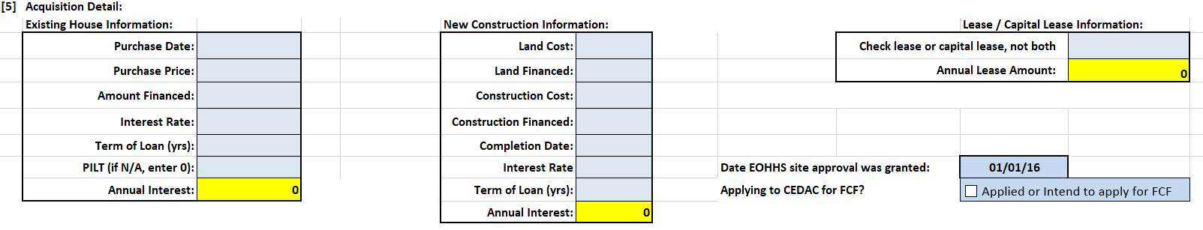

[5] Acquisition Detail: “Existing House Information” - Completed when provider purchases an existing site
APPLICATION SECTION | DEFINED | TRIGGERS REQUIREMENT FOR
“Purchase Date” | Date provider legally purchased site | HUD 1 Settlement Statement, Deed, Land Card, or other document stating provider Purchase Date of site
“Purchase Price” | Purchase price of the site. Only purchase price - no renovation costs, closing costs, taxes, or any other expense | Same as “Purchase Date”
“Amount Financed” | Amount financed by the provider to acquire the site. | Financing Documents – mortgage, loan documents, bond documents, or other finance documents associated with provider acquisition of the site  Also, proof of other financed items, associated with the site acquisition, in addition to purchase price, or part of purchase price (examples: closing costs, life safety improvements)
“Interest Rate” | Interest rate of financing the provider uses to acquire the site | Same as first paragraph of “Amount Financed”
“Term of Loan (yrs)” | Number of years the loan or bond amortization is based upon | Same as first paragraph of “Amount Financed”
“Annual Interest” | Computed for you on application based on prior information | Same as first paragraph of “Amount Financed”

OCCUPANCY RATE APPLICATION INSTRUCTIONS SECTION 5
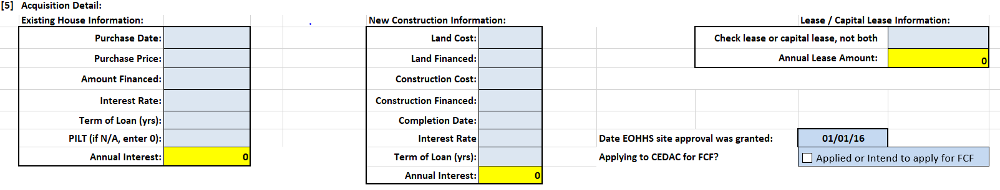
[5] Acquisition Detail: “New Construction Information” - Completed when provider constructs a new site
APPLICATION SECTION | DEFINED | TRIGGERS REQUIREMENT FOR
“Land Cost” | Cost of land new site is constructed on | Deed, Land Card, or other document stating provider cost of land purchase to build new site
“Land Financed” | Amount of land cost that is financed by provider | Financing Documents – mortgage, loan documents, bond documents, or other finance documents associated with provider acquisition of land
“Construction Cost” | Cost of constructing the site | Contractor, AIA (American Institute of Architects), or other documents detailing the construction and costs, including number of bedrooms, baths, etc., associated with building the site, and proof of provider payment of those costs, or pending payment
“Construction Financed” | Amount of construction cost financed by provider | Same as “Land Financed”
“Completion Date” | Date construction of site is completed | None
“Interest Rate” | Interest rate of financing that the provider used to build the site | Same as “Land Financed”
“Term of Loan (yrs)” | Number of years the loan or bond amortization is based upon | Same as “Land Financed”
“Annual Interest” | Computed for you on application based on prior information | Same as “Land Financed”
OCCUPANCY RATE APPLICATION INSTRUCTIONS SECTION 5
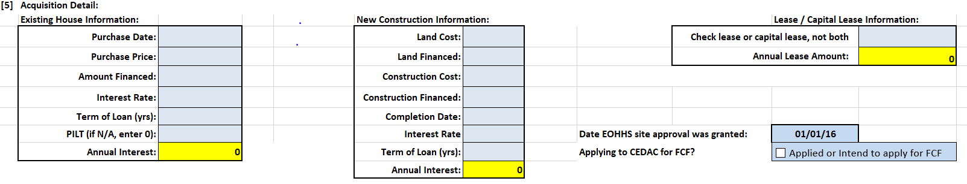
[5] Acquisition Detail: “Lease/Capital Lease Information” - Completed when provider leases a site, or enters into a capital lease arrangement
APPLICATION SECTION | DEFINED | TRIGGERS REQUIREMENT FOR
“Check lease or capital lease (from Section 4) not both” | Amount of monthly lease or capital lease payment | Lease *or Capital Lease Agreement, Capital Lease Budget, and  Proof of payment by capital lease holder of costs listed on Budget
“Annual Lease Amount” | Computed for you on application based on information you entered | None

Notes: * Related Party leases also require the same documentation as “Existing House Information” or “New Construction Information” (see page 5 for more detail)
[5] Acquisition Detail: “site approval” and “CEDAC for FCF” funding
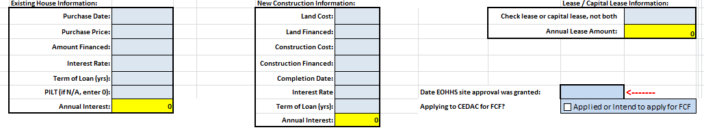
APPLICATION SECTION | DEFINED | TRIGGERS REQUIREMENT FOR
“Date EOHHS site approval was granted” | The date EOHHS approved this proposed site location | None for provider; DDS area office to provide
“Applying to CEDAC for FCF?” | Whether CEDAC or FCF funding will, or has been, applied for by site developer. Only check box if answer is affirmative | If answered in the affirmative, complete the “Date of CEDAC application” with a date or TBD if no firm date is available at application time
OCCUPANCY RATE APPLICATION INSTRUCTIONS SECTION 6
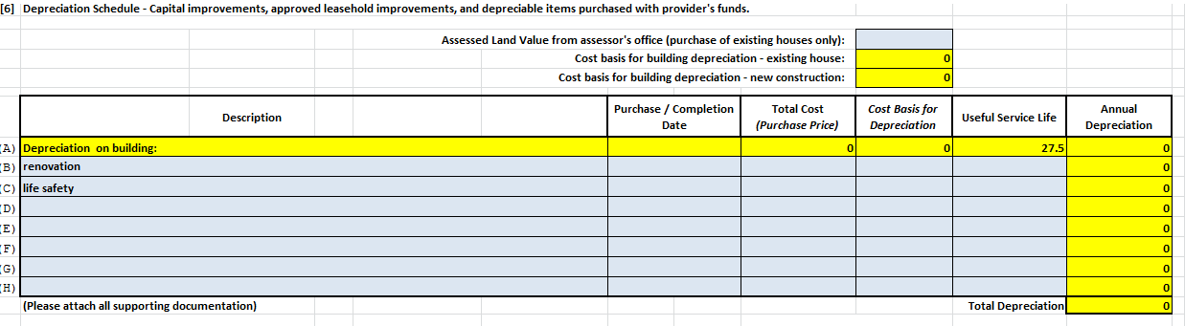
APPLICATION SECTION | DEFINED | TRIGGERS REQUIREMENT FOR
“Assessed Land Value from assessor’s office (purchase of existing houses only)” | Assessed value of land as listed on the city assessor’s office land card (sometimes called property card).  Making the land value entry will compute and auto-enter:  - Cost Basis for “Depreciation on building”, Line A of Depreciation Schedule for an Existing House (Purchase Price from [5] less Assessed Land Value, 1st red arrow)  - Cost Basis for Depreciation on the Depreciation Schedule (Purchase Price less Assessed Land Value, 2nd red arrow) | Land Card or comparable document
“Description – Lines B through H” | Describes renovations and life safety improvements made to existing house  - Does not include Start-up costs  - Like renovations grouped together. “Useful Service Life” (Service Life of Assets tab) is sometimes a good indicator of like renovations  Complete “Purchase/Completion Date”(of the improvement), “Total Cost” “Cost Basis for Depreciation” (usually the same amount), and “Useful Service Life” (from Service Life of Assets tab) | For renovations or life safety improvements: American Institute of Architects (AIA) documents or detailed contractor proposals or invoices, and proof of payment to contractor or explanation of pending payment
OCCUPANCY RATE APPLICATION INSTRUCTIONS SECTION 7
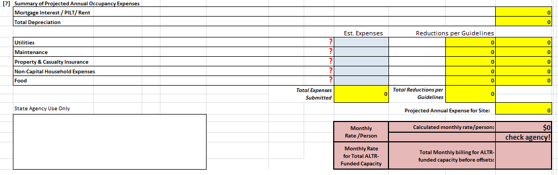
These are estimated, or projected, annual expenses for this site only. Formulas embedded in the application will cap these expenses based on data you already input (capacity, location, type of site, and type of acquisition). Provider can enter any reasonable cost estimate but any amounts higher than the caps will be adjusted downward on the application. All items are stated as annual expenses for each occupancy expense category.
APPLICATION SECTION | DEFINED | TRIGGERS REQUIREMENT FOR
“Utilities” | Electricity, natural gas, heating oil, water/sewer  No vehicle or staff expenses | None
“Maintenance” | General upkeep of site, minor repairs; No vehicle or staff expenses | None
“Homeowner/Rental Insurance” | Property & Casualty insurance on the building and contents (furniture, clothing) only; renter’s insurance on contents only for leased sites  No vehicle insurance or any other insurance | None
“Non-Capital Household Expenses” | Paper goods, cleaning supplies, small expenditures | None
“Food” | Cost of food for individuals, not staff, living at the site | None *

Notes: * “Food” is computed at $8.16 per person, per day

OCCUPANCY RATE APPLICATION INSTRUCTIONS SECTION 8
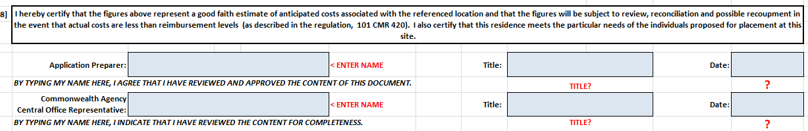
APPLICATION SECTION | DEFINED | TRIGGERS REQUIREMENT FOR
“Application Preparer” | Provider Application Preparer name | None
“Title” | Title of named Provider Application Preparer | None
“Date” | Date of final, complete, application submission | None
Notes: Provider should not complete any information for “Commonwealth Agency Central Office Representative”

OCCUPANCY RATE APPLICATION INSTRUCTIONS SECTION 9
APPLICATION SECTION | DEFINED | TRIGGERS REQUIREMENT FOR
“Estimate of Annual Offsets” | Estimated total amount of annual (twelve months) offsets for all of the individuals comprising “ALTR Funded Capacity”. Offsets are usually SSI, SNAP, and housing benefits received by the individuals living at the site. DDS regional office will pro-rate for actual occupancy used in first FY | None
“Projected move in/start date” | The date the first individual is projected to move, or has moved, into the site | None
“Projected # of months used in first year” | The number of months during the first fiscal year the site will be receiving a DDS Occupancy Rate. Based off the projected move in date | None

After the Occupancy Rate is Set

DDS Central Office Contracts will send the ORA “Approval Cover” (a tab on the ORA) to:

- Provider,
- Region, and
- Area or ABI contacts

The final “Application” is another tab on the ORA

The Provider has 30 calendar days from that contact date to appeal an Occupancy Rate. Appeals must be in writing and contain specific reasons and documentation that support the appeal.

Appeals should be sent electronically to Victor Hernandez, EOHHS. Anthony Piccolo, regional and area (or ABI) contacts should be copied.

The Provider should work with their Regional contacts to have a new site added to the Occupancy Worksheet.

Questions about completing the ORA should be directed to your Area, ABI, or Regional contact, or Anthony Piccolo (anthony.piccolo@mass.gov)

