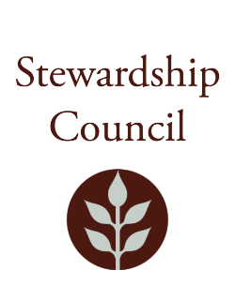

Stewardship Council Meeting
Friday, October 11, 2024 | 9:00 to 11:00 AM
Conducted via Videoconference

Agenda

TOPIC | SEGMENT
Welcome and Chair’s Update – Jack Buckley, Chair | 9:00 – 9:10 AM
DCR Report – Brian Arrigo, Commissioner | 9:10 – 9:25 AM
Regular Business I  - Update on Forests as Climate Solutions, Stephanie Cooper, Undersecretary, Massachusetts Executive Office of Energy & Environmental Affairs, Kurt Gaertner, Asst. Secretary for Environmental Policy, Massachusetts Executive Office of Energy & Environmental Affairs  - Approve Minutes: September 12, 2024  - Public Comment | 9:25-10:00 AM
Regular Business II  - Update from the Nominating Committee  - Committee Updates  - Councilor Comments | 10:00 – 11:00 AM
Adjourn | 11:00 AM

October Meeting of the DCR Stewardship Council

Join Zoom Meeting
https://zoom.us/j/92685304276?pwd=UmJScUxSVFhTemRwOWFwWTVzZS95UT09

Meeting ID: 926 8530 4276
Passcode: 191034

One tap mobile
+13092053325,,92685304276#,,,,*191034# US
+13126266799,,92685304276#,,,,*191034# US (Chicago)

Please contact Matt Perry at matthew.s.perry1@mass.gov for accessibility information.
10/4/2024 1:59 PM

