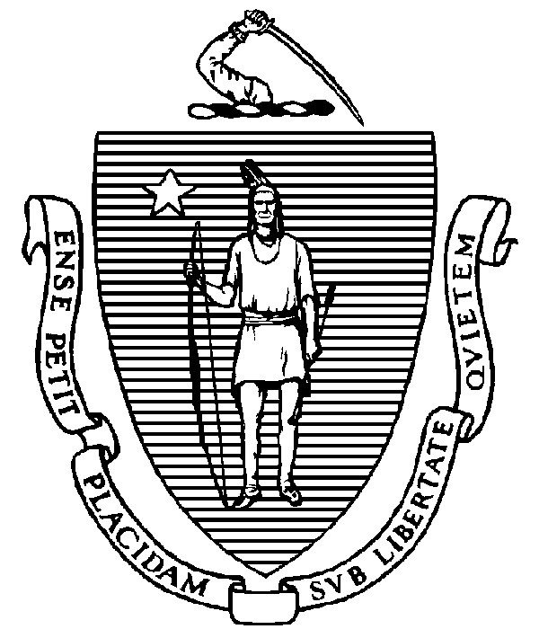
THE COMMONWEALTH OF MASSACHUSETTS
EXECUTIVE OFFICE FOR ADMINISTRATION AND FINANCE
STATE HOUSE ▪ ROOM 373
BOSTON, MA 02133
TEL: (617) 727-2040
FAX: (617) 727-2779
www.mass.gov/eoaf

NOTICE OF PUBLIC MEETING

Capital Debt Affordability Committee

Friday, October 14, 2022 1:00 p.m.
In accordance with Section 20 of Chapter 20 of the Acts of 2021, as extended by Chapter 107 of the Acts of 2022, this meeting will be conducted, and open to the public, via Zoom and Teleconference. Zoom URL: https://mass-gov-anf.zoom.us/j/89260050854?pwd=Tk9Mc3k2Zk01RDJmNlJHbGQ2ckVjUT09 Password: DAC101422
Teleconference line: 713-353-7024; Conference code: 319738

AGENDA

- Administrative Matters
• Adoption of meeting minutes from September 30, 2022 (Vote)

- Department of Revenue (DOR) Update

- Capital Plan Overview

- Commonwealth Credit Ratings

5. Adjournment

