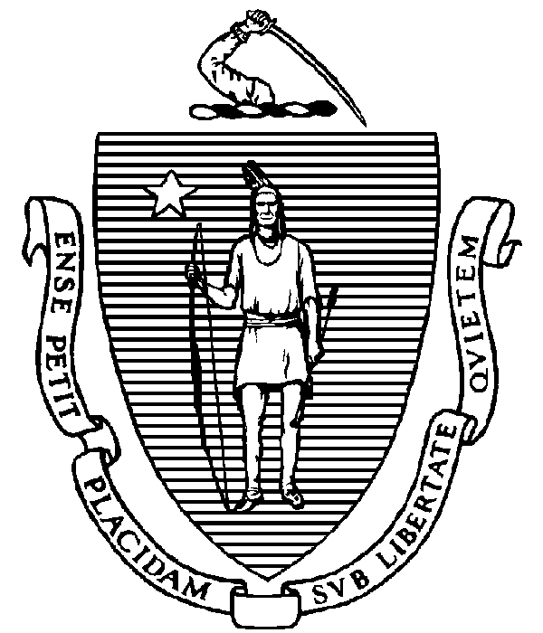

The Commonwealth of Massachusetts

Executive Office for

Administration and Finance

STATE HOUSE **▪** ROOM 373

BOSTON, MA 02133

TEL: (617) 727-2040

FAX: (617) 727-2779

www.mass.gov/eoaf

**Notice of Public Meeting**

**Capital Debt Affordability Committee**

**Friday, October 17, 2025**

**1:00 p.m.**

In accordance with Section 20 of Chapter 20 of the Acts of 2021, as most recently extended by Chapter 2 of the Acts of 2025, this meeting will be conducted, and open to the public, via Zoom and Teleconference.

Zoom Link:  <https://us02web.zoom.us/j/82089649271?pwd=B9faB5gWP4Tb6BEIu2fIabNjUQaMUw.1>

Meeting ID: 820 8964 9271

Passcode: 547583

Teleconference line: 1-305-224-1968; Phone Conference code: 547583#

**AGENDA**

1. **Administrative Matters**
   * Introductions
   * Adoption of meeting minutes from December 13, 2024 **(Vote)**
2. **Debt Affordability Committee (DAC) Introduction & Workplan**
3. **Commonwealth Debt Portfolio Overview**
4. **Adjournment**