TRCC – Crash Replacement System - Meeting Minutes
Meeting Date | October 27, 2016 | Meeting Time | 9:00 am – 11:00 am
Location | 10 Park Plaza – 6th floor  Boston | Meeting Chair | Jeff Larason / Carmen Pons
Attendees
Casey Woodley | EOPSS - MACCS PM | Jeff Larason | EOPSS – HSD | Ridgely Ficks | DPH - OEMS
Karen Perduyn | MassDOT - RMV | Bob Kearney | EOPSS – HSD | Mary-Jo Griffin | MassDOT - RMV
Mark Abbott | Boston MPO/CTPS | David Dinocco | MassDOT - GIS | George Snow | MRPC
Benjamin Krepp | Boston MPO/CTPS | Erin Deveney | RMV, Registrar | Derryl Dion | EOPSS - DFS
Erin Curran | Boston EMS | Matthew Poirier | US DOT - FMCSA | Ken Canaan | MassDOT - RMV
Raymond Guarino | Old Colony PC | Bertina Backus | DPH - OEMS | Carmen Pons | MassDOT - IT
Tom Bowes | Merit Rating Board | Rob Raymond | CMRPC | Robin Reissman | UMass - Safe
Tom Bonarrigo | Merit Rating Board | Jennifer Inzana | MassDOT - Highway | Carlos Cannon | BPD
Bob Meaney | Mass Chiefs of Police | Rick Conard | MassDOT - Highway | Jeanne Hathaway | DPH

Items Discussed:
- Jeff Larason asked if everyone had reviewed the minutes from the prior meeting (February 2016) and if the team approved. Minutes were approved by those in attendance.
Jeff also mentioned that the plan was to get back to a regular schedule in 2017.

- C. Pons mentioned that the purpose of the meeting was to kick off the replacement of RMV/Highway Division Crash Systems and to engage the different agencies and departments that leverage Crash Information. She went on to describe the meeting agenda:
  - Introduction by Registrar – E. Deveney
  - Project Information – C. Pons
    - Project Background
    - Business Opportunity and Outcomes
    - Activities and High Level Schedule
    - Scope: In and Out
  - Pain Points – Team Exercise
  - Principles for Critical Success Factor – Team Exercise
  - Next Steps

- Registrar Deveney kick off points
  - Secretary Pollack identified earlier this year that an important objective for both RMV and Highway was to find ways to improve Crash Reporting. The Secretary was particularly troubled by the high number of pedestrian fatalities that had been happening early this year as a result or in conjunction with motor vehicle crashes.
  - While the RMV had primary responsibility for crash data, this replacement system was for the benefit of all the different parties represented in the room as everyone is impacted by the need to get good crash data. Those in the TRCC are stakeholders and the RMV wants to reach out to as many parties involved as possible since the opportunity to do this type of projects is limited and the RMV does not want to do this in a vacuum.
  - RMV would like to use this project as an opportunity to
    - Increase the data that MassDOT gets and do this in an efficient and user friendly manner
    - Reduce paperwork as this is a very inefficient way of doing business
    - Increase electronic submission of crash data as that will improve the amount of information available and the quality of the data
    - Reduce the amount of significant effort performed by all parties to get the crash data. Receiving the data in a timely manner is critical as not reporting in a timely manner puts the DOT at risk of losing Federal dollars.
  - For this project, the RMV would like to:
    - Use a Commercial Off-the-Shelf Software (COTS) solution or make modifications to an existing solution versus developing an entirely custom system. Custom solutions generally take a significant amount of time and money and do not always yield the desired results
    - Have a single system for both RMV and Highway to avoid potential data inconsistency
    - Make information available to all
  - The Registrar mentioned this effort had the full support of the Highway Administrator and the Chief Engineer. Both RMV and Highway are working closely together to drive this project forward
  - The Registrar also thanked everybody for coming to this meeting and for their participation in this project. Her hope is that at the end of this project, we will have a system and processes that will benefit all parties (more data, better quality)
- C. Pons went over the “Crash Replacement System – Kick Off” slides listed below:
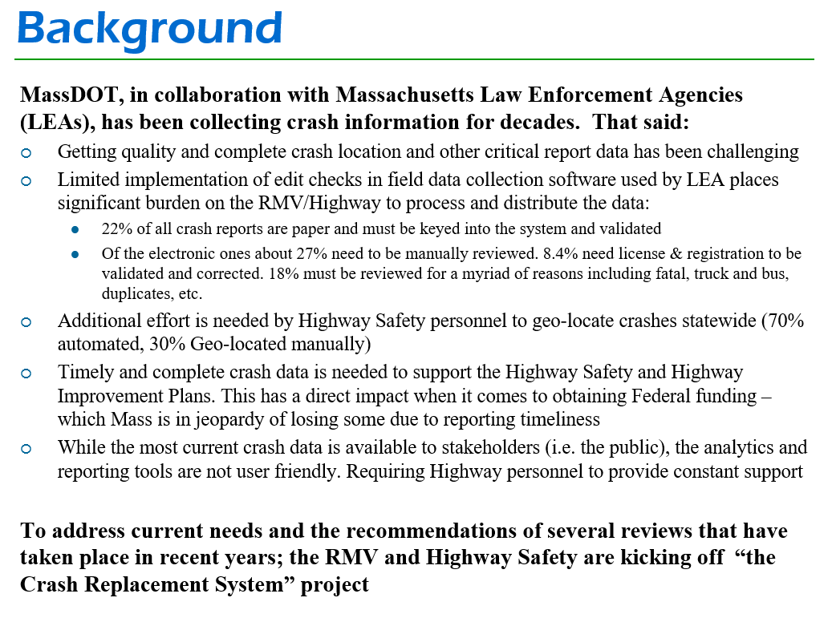

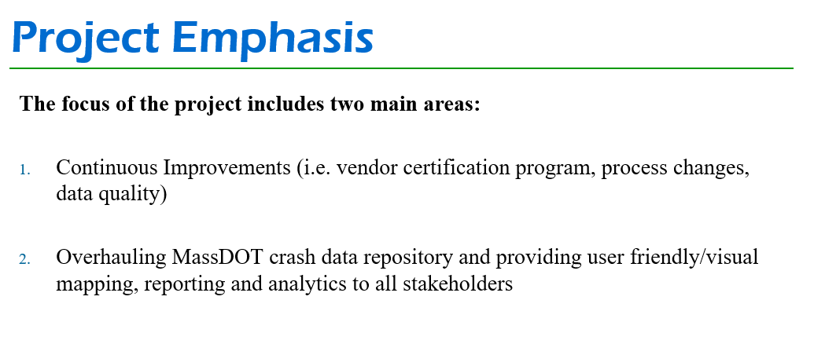
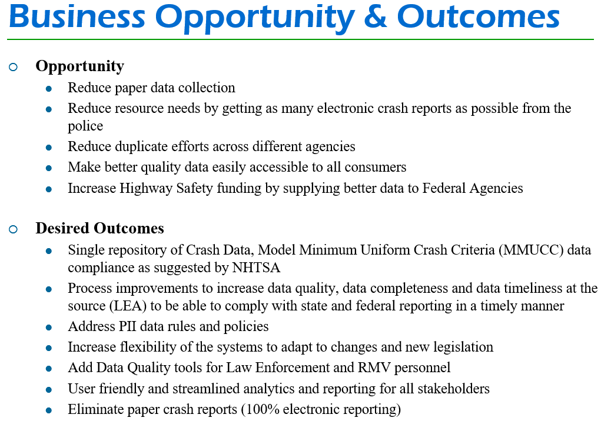
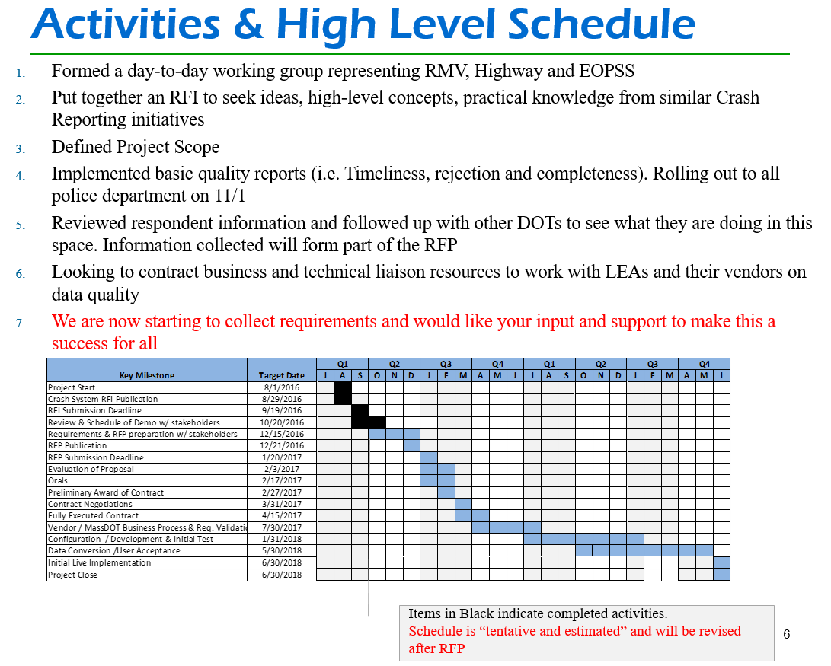

  - C. Pons stated that there were multiple vendors that provided responses to the RFI. The team decided to follow up with: Kologik, IBB and UConn / CTDOT. UConn / CTDOT have a partnership where UConn developed their solution and nowadays does their reporting and supports their repository.
There was a question asked if UMass could help MassDOT in a similar way. C. Pons mentioned that it is early to say as we are just beginning this project. There are always opportunities to help, given how much help is needed with data quality, etc.

  - There was a question whether the RFI was specifically looking for COTS solutions. The answer was “no”. MassDOT wanted to see what solutions were out there whether it was COTS, Custom or a hybrid.

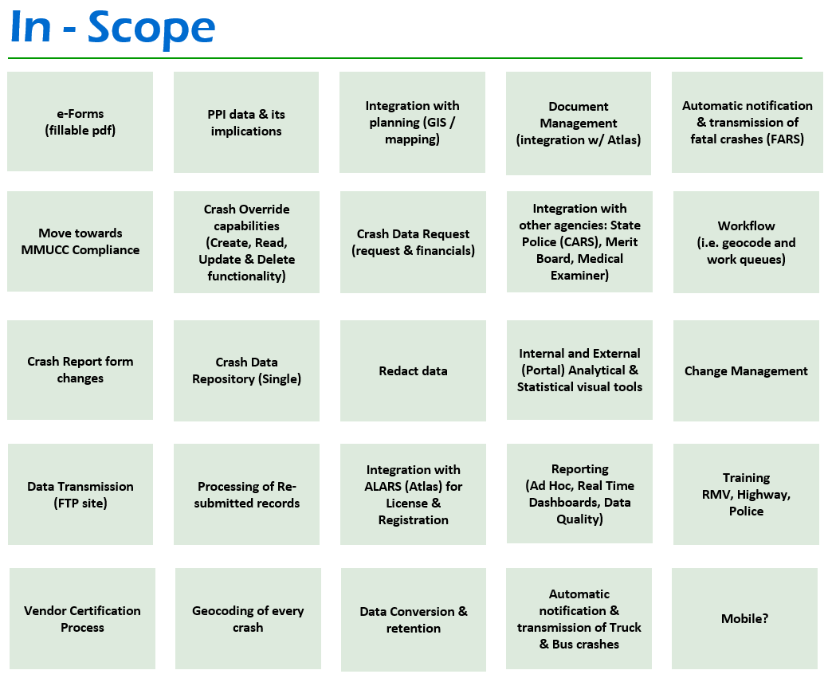

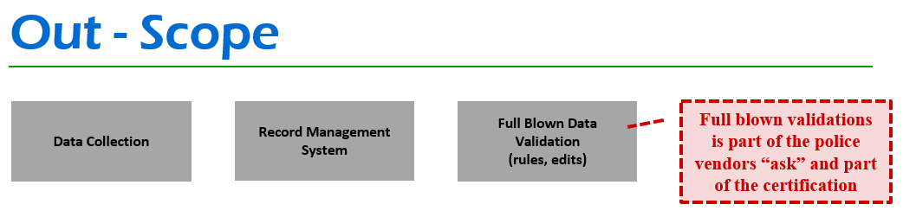

- Team Exercise – Crash Pain Points
Group to answer: What problems do we need to address to meet “your section needs when it comes to Crash”? For example: I need to have this _____ otherwise I would have to do X. X is painful because ______

Below are the ideas presented – Please note that these were not consolidated. They are listed as written and presented in the room.

  - Quick Clearance and ease of reporting
  - Increase Electronic Submission
  - Consistency – would not have to revise HSP or AR as much (Federal vs. State).
  - Timeliness of reporting especially fatalities to the RMV (i.e. do not hold for reconstruction details)
  - Data consistency
  - More timely access to data to perform analysis. Frequency of data availability needs to be weekly or monthly rather than quarterly
  - Improve data quality
  - Improve tools for collecting x/y coordinates – make them more effective
  - Improve data collection for law enforcement (consistency as to what is required for vendors)
  - Need accurate data because it will help us study causes of crashes on the road (i.e. accuracy of crash location data)
  - Need flexibility to extract crash data as needed by external agencies. Ideally data extraction should be open interface / format agnostic to allow approved agencies to manipulate data as needed. i.e. map / geospatial querying
  - Need ability to redact information promptly of needed fields prior to providing them to the public
  - Need to increase the amount and quality of data received by increasing submission and using easy forms to collect data via multiple formats. Streamline and aggregate fields
  - Need for real time data submission with validation fields. If forms can’t be fully completed, ability to submit partial for later completion and submission (after investigation and research).
  - Need for secure permission based system
  - Need to allow for modification to data and reports
  - Need to collect impression / causation – collecting any environmental factors, etc.
  - Need exact x/y coordinate otherwise we can’t identify problem, location and patterns
  - Need data that is current otherwise we cannot gauge the effectiveness of improvements
  - Need geocoding
  - Need customizable reports
  - Need standardized data collection
  - Need for a dashboard function to identify hot spots
  - Better truck & bus data. More timely and accurate (if data not available in a timely manner, there is the potential to lose federal funds for motor carrier enforcement)
Truck and bus team (State Police) must do significant manual intervention before the data is loaded into their system. Need more automated transfer of the data mapped to their system
  - Better understanding of the role of “operator” reports
  - Better data access for the public and enhanced public awareness of that existence of that data (i.e. libraries, etc.)
  - Need for a more efficient way to distribute bulk data (right now Highway does that with CDs, may be a FTP site)
  - Link crash and Trauma Data
  - Better crash location and overall data collection system
  - Location determination - training on how to capture location. This is something Law Enforcement needs to do better with the proper MassDOT / vendor support
  - Training for Police Officers including recruits in police academy (Each year officers get trained a certain number of hours. There is a Training Committee that determines what goes in the curriculum and this project team should engage with them so we can be added to the curriculum)
  - Private consumer / stakeholders – involve the likes of Carfax. Carfax gets the information and disseminates it for money especially to insurance companies. Involve insurance companies, reach out to them to aid in payment of training as this is critical to them. Without the Crash Reports, they would not be able to settle claims.
  - Timely submission of data (i.e. guidelines for submission need to be defined. Can’t be monthly or quarterly)
  - For more involved crashes, identify which Police departments have crash reconstruction units and talk to them about communication process, etc. Often, MassDOT finds out about fatal crashes through the media versus our own teams
  - From an end user point of view, the replacement system should be able to provide all information that it is currently found on a crash report instead of having to gather crash reports from a Police Department. This includes the Crash Diagram and Crash Narrative however long it may be

- Team Exercise – Principles for Success
Group to answer: What things should we “do” to ensure the success of the Crash Program? What things should we “NOT do” to ensure the success of the Crash Program?

Ideas presented – Please note that these were not consolidated. They are listed as written and presented in the room.

Things we should “ALWAYS DO”
  - Consider all users and their needs (think outside the box)
  - Extensive training (law enforcement and end user of the data)
  - Extensive testing before go-live by law enforcement. Hands on experience of the application with feedback (easy user interface)
  - Team work and collaboration
  - Include training or if made available identify agencies or whoever needs it (i.e. online training)
  - Have a well-defined acceptance criteria
  - Should always certify our crash vendors for vendor neutral data format and other pre-existing standards
  - Vet the crash vendors as healthy businesses
  - Aim for simplicity
  - Use plain language
  - Coordinate across agencies
  - Look to build off existing capabilities
  - Establish a work plan and a timeline
  - Find out what other states are doing
  - Build a nimble system where it is easy to add fields
  - Create a Data Dictionary for the new system
  - New Crash Manual to go with the new system
  - Gather history / issues from many sources
  - Dedicated funding so this program can keep going
  - Allow police to attach photos which may help with crash location
  - Continuous communication between all the groups
  - Work with the police and their vendors to facilitate data quality, data completeness and data timeliness
  - Need engagement and commitment of law enforcement and their vendors

Things we should “NEVER”
  - Implement large scale projects with broad statewide impact in a vacuum
  - Let the vendor run the specifications or set the standards as we need consistency across the board
  - Be exclusive, be inclusive
  - Lose all legacy crash data
  - Quit

- Chief Meaney mentioned that he was excited about this effort and would help to push it forward. A key piece is to involve other law enforcement personnel as this will be a way to ensure credibility and success.

- Robin mentioned that they are finishing their crash data audit and they have good feedback from the police that can be used as the beginning of requirements for the system. This feedback includes issues and recommendations. We also need other ways to reach out to law enforcement agencies and hear what they have to say.

- Jeff Larason and Chief Meaney thanked the Registrar for staying for the whole meeting and demonstrating the commitment MassDOT is making on this effort. The Registrar then suggested that we make Chief Meaney our spoke person with the police.

- Next Steps
- Summarize discussion
- Invitation to some requirements workshops
- Share materials as they are developed

