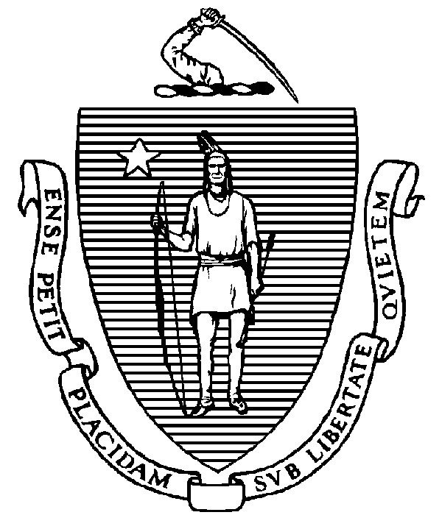
THE COMMONWEALTH OF MASSACHUSETTS
EXECUTIVE OFFICE FOR ADMINISTRATION AND FINANCE
STATE HOUSE ▪ ROOM 373
BOSTON, MA 02133
TEL: (617) 727-2040
FAX: (617) 727-2779
www.mass.gov/eoaf

NOTICE OF PUBLIC MEETING

Capital Debt Affordability Committee

Friday, October 27, 2023 1:00 p.m.
In accordance with Section 20 of Chapter 20 of the Acts of 2021, as extended by Chapter 107 of the Acts of 2022, this meeting will be conducted, and open to the public, via Zoom and Teleconference.
Zoom URL: https://zoom.us/j/94113662597?pwd=UGxLd1hTSUltWlh6YzZPdmlUdkNzQT09 Meeting ID: 941 1366 2597; Passcode: 959023
Teleconference line: 1-305-224-1968; Passcode: 959023

AGENDA

- Administrative Matters
  - Introductions
  - Adoption of meeting minutes from December 14, 2022 (Vote)

- Debt Affordability Committee (DAC) Intro
- DAC Draft Workplan
- Commonwealth Debt Portfolio Overview
- FY24 Capital Investment Plan (CIP) Overview
- Adjournment

