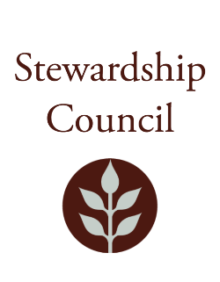

# Stewardship Council Meeting

**Thursday, October 9, 2025|** 9:00AM to 11:00AM

Conducted via Videoconference

## Agenda

|  |  |
| --- | --- |
| TOPIC | SEGMENT |
| **Welcome and Chair’s Update** – Dicken Crane, Chair | 9:00 – 9:10 AM |
| **DCR Report** – Nicole LaChapelle, Commissioner | 9:10 – 9:30 AM |
| **Regular Business I**   * Otter River Complex Resource Management Plans Presentation – Paul Cavanagh, Resource Management Planner * Approve Minutes: September 11, 2025 * Committee Discussion * Public Comment | 9:30 – 10:45 AM |
| **Regular Business II**   * Committee Updates * Councilor Comments | 10:45 – 11:00 AM |
| **Adjourn** | 11:00 AM |

## Zoom Meeting Information

**Meeting of the DCR Stewardship Council**

You are invited to register for a Zoom webinar!

When: Oct 9, 2025 09:00 AM Eastern Time (US and Canada)

Topic: October 9, 2025 DCR Stewardship Council Meeting

Register in advance for this webinar:

https://zoom.us/webinar/register/WN_18qI1SJiT8GshRD1GKnCNw

After registering, you will receive a confirmation email containing information about joining the webinar.

Please contact Matt Perry at [matthew.s.perry1@mass.gov](mailto:matthew.s.perry1@mass.gov%20) for accessibility information.

10/2/2025 12:09 PM