INDOOR AIR QUALITY ASSESSMENT

Robert G. O’Donnell Middle School
212 Cushing Street
Stoughton, Massachusetts 02072

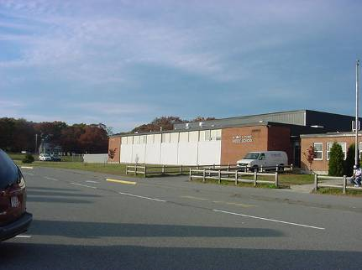

Prepared by:
Massachusetts Department of Public Health
Center for Environmental Health
Emergency Response/Indoor Air Quality Program
January 2007

Background/Introduction
At the request of Joel Harding, Facilities Director for the Stoughton School Department (SSD), the Massachusetts Department of Public Health (MDPH), Center for Environmental Health (CEH) provided assistance and consultation regarding indoor air quality at the Robert G. O’Donnell Middle School (OMS). On October 31, 2006, a visit to conduct an assessment of the OMS was made by Sharon Lee and Cory Holmes, Environmental Analysts in MDPH’s Emergency Response/Indoor Air Quality (ER/IAQ) Program.
The school was previously visited by MDPH in December of 1998 to assess whether polluted groundwater was impacting the IAQ of the OMS. A report was issued describing conditions in the building at that time and recommendations on how to correct problems (MDPH, 1997). This most recent visit by MDPH/CEH was prompted by occupant concerns of mold growth on building materials.
The school was visited in November 2002 by FLI Environmental, Inc (FLI) to conduct a baseline IAQ assessment. FLI recommended that ventilation systems throughout the OMS be checked for proper operation, particularly fresh air dampers; and that mechanical ventilation operate continuously and free of obstructions during occupied periods (FLI, 2002).

Methods
CEH staff performed a visual inspection of building materials for water damage and/or microbial growth. Moisture content of ceiling tiles and other porous building materials prone to moistening (e.g., ceiling tiles, wood) was measured with a Delmhorst, BD-2000 Model, Moisture Detector equipped with a Delmhorst Standard Probe. Air tests for carbon monoxide, carbon dioxide, temperature and relative humidity were taken with the TSI, Q-Trak, IAQ Monitor, Model 8551. Air tests for airborne particle matter with a diameter less than 2.5 micrometers were taken with the TSI, DUSTTRAK™ Aerosol Monitor Model 8520. Screening for total volatile organic compounds (TVOCs) was conducted using a Hnu, Model 102 Snap-on Photo Ionization Detector (PID).

Results
This school has a student population of approximately 1,000 and a staff of approximately 100. The tests were taken under normal operating conditions. Test results appear in Table1.

Discussion
Ventilation
It can be seen from the Table 1 that carbon dioxide levels were above 800 parts per million (ppm) in twenty-one of fifty-seven areas surveyed, indicating a lack of adequate air exchange in those areas. Fresh air in classrooms is supplied by unit ventilator (univent) systems (Figure 1). A univent draws air from the outdoors through a fresh air intake located on the exterior wall of the building and returns air through an air intake located at the base of the unit. Fresh and return air are mixed, filtered, heated and provided to classrooms through an air diffuser located in the top of the unit. Adjustable louvers control the ratio of outside to recirculated air. Univents were found deactivated in some rooms (Table 1). Obstructions to airflow, such as items stored on or in front of univents were seen in a number of areas (Picture 1). In order for univents to provide fresh air as designed, units must be activated while rooms are occupied and air diffusers should remain free of obstructions.
The mechanical exhaust ventilation system consists of unit exhaust ventilators and/or ceiling mounted vents ducted to rooftop motors, the majority of which were operating; some unit exhaust ventilators were operating weakly. As with the univents, unit exhaust ventilators were obstructed in a number of areas limiting airflow. Without sufficient supply and exhaust ventilation, environmental pollutants can build up and lead to indoor air quality/comfort complaints.
Ventilation for modular classrooms is provided by AHUs. Fresh air is distributed to classrooms via ductwork connected to ceiling-mounted air diffusers and drawn back to the AHUs through return grills. Thermostats control each heating, ventilating and air conditioning (HVAC) system and have fan settings of “on” and “automatic”. Thermostats were set to the “automatic” setting during the assessment (Picture 2). The automatic setting on the thermostat activates the HVAC system at a preset temperature. Once the preset temperature is reached, the HVAC system is deactivated. Therefore, no mechanical ventilation is provided until the thermostat re-activates the system.
To maximize air exchange, the MDPH recommends that both supply and exhaust ventilation operate continuously during periods of school occupancy. In order to have proper ventilation with a mechanical supply and exhaust system, the systems must be balanced to provide an adequate amount of fresh air to the interior of a room while removing stale air from the room. It is recommended that existing ventilation systems be re-balanced every five years to ensure adequate air systems function (SMACNA, 1994). Mr. Harding reported that balancing of mechanical ventilation at the OMS is on-going as funds become available.
The Massachusetts Building Code requires a minimum ventilation rate of 15 cubic feet per minute (cfm) per occupant of fresh outside air or have openable windows in each room (SBBRS, 1997; BOCA, 1993). The ventilation must be on at all times that the room is occupied. Providing adequate fresh air ventilation with open windows and maintaining the temperature in the comfort range during the cold weather season is impractical. Mechanical ventilation is usually required to provide adequate fresh air ventilation.
Carbon dioxide is not a problem in and of itself. It is used as an indicator of the adequacy of the fresh air ventilation. As carbon dioxide levels rise, it indicates that the ventilating system is malfunctioning or the design occupancy of the room is being exceeded. When this happens a buildup of common indoor air pollutants can occur, leading to discomfort or health complaints. The Occupational Safety and Health Administration (OSHA) standard for carbon dioxide is 5,000 parts per million parts of air (ppm). Workers may be exposed to this level for 40 hours/week based on a time weighted average (OSHA, 1997).
The MDPH uses a guideline of 800 ppm for publicly occupied buildings. A guideline of 600 ppm or less is preferred in schools due to the fact that the majority of occupants are young and considered to be a more sensitive population in the evaluation of environmental health status. Inadequate ventilation and/or elevated temperatures are major causes of complaints such as respiratory, eye, nose and throat irritation, lethargy and headaches. For more information concerning carbon dioxide, please see Appendix A.
Temperature measurements ranged from 70º F to 77º F, which were within the MDPH recommended comfort guidelines in all areas surveyed during the assessment. The MDPH recommends that indoor air temperatures be maintained in a range of 70 º F to 78 º F in order to provide for the comfort of building occupants. In many cases concerning indoor air quality, fluctuations of temperature in occupied spaces are typically experienced, even in a building with an adequate fresh air supply.
The relative humidity ranged from 35 to 45 percent, which were within or slightly below the MDPH recommended comfort range in all areas surveyed during the assessment. The MDPH recommends that indoor air relative humidity is comfortable in a range of 40 to 60 percent. During the heating season, relative humidity levels would be expected to drop below the recommended comfort range. The sensation of dryness and irritation is common in a low relative humidity environment. For buildings in New England, periods of low relative humidity during the winter are often unavoidable.

Microbial/Moisture Concerns
Mr. Harding reported that the building has had water infiltration issues through the roof and window systems over the years. To prevent further water penetration the roof was replaced and attempts were made to seal windows. Several areas had water-stained ceiling tiles, which are evidence of historic roof leaks. The assessment occurred after several days of driving rain with westerly winds from 20-30 MPH (The Weather Underground, 2006). No current roof leaks were identified by CEH staff. In addition, CEH staff conducted moisture testing of water stained ceiling tiles. In order for building materials to support mold growth, a source of water exposure is necessary. Identification and elimination of water moistening building materials is necessary to control mold growth. Materials with increased moisture content over normal concentrations may indicate the possible presence of mold growth. All water damaged ceiling tiles tested were found to have low (i.e., normal) moisture content (Table 1) at the time of the assessment, indicating they were the result of historic leaks.
Occupants did however report window leaks in rooms 205, 206 and 210. In rooms 206 and 210 occupants were storing porous items in the general areas of window leaks and they had become water damaged (Pictures 3 and 4). Water-damaged porous materials can serve as a medium for mold and should be discarded or relocated away from moisture sources.
Occupants in several classrooms had concerns about a mold growth around interior window panels. These panels were recently sealed by the SPS maintenance department using a gel-like caulking material. CEH staff examined these window panels and found that the sealant had a tacky texture, as a result airborne dirt and dust had become adhered to the surface of the sealant (Picture 5).
Concerns were also raised of possible mold contamination beneath carpet in the main guidance area and in office 1, where the carpet had been wet in the past. The carpeting in both areas was tested for moisture content and found to have low (i.e., normal) moisture content at the time of the assessment. In addition, CEH staff conducted a thorough visual examination beneath damaged carpeting (which required the removal of carpeting in the area) and behind vinyl coving along the base of the wall in Office 1. No elevated moisture measurements, visible mold growth or associated odors were observed/detected beneath the carpeting during the assessment.
Occupant in rooms 104 and 105 had concerns of stained floor tiles believed to be possible mold growth. CEH staff examined tiles in these rooms and observed a gum-like substance (Picture 6). The material appeared to be mastic/glue that had seeped around tiles.
Occupants also reported mold on a number of other non-porous surfaces including shower stalls, shower curtains, metal panels, window shades and blinds. Not all of these areas could be examined at the time of the assessment; however many of these surfaces are non-porous and should be cleaned with a mild detergent or antimicrobial agent if mold growth is suspected.
The US Environmental Protection Agency (US EPA) and the American Conference of Governmental Industrial Hygienists (ACGIH) recommend that porous materials be dried with fans and heating within 24 to 48 hours of becoming wet (US EPA, 2001; ACGIH, 1989). If porous materials are not dried within this time frame, mold growth may occur.

Other Concerns
Indoor air quality can be negatively influenced by the presence of respiratory irritants, such as products of combustion. The process of combustion produces a number of pollutants. Common combustion emissions include carbon monoxide, carbon dioxide, water vapor and smoke (fine airborne particle material). Of these materials, exposure to carbon monoxide and particulate matter with a diameter of 2.5 micrometers (μm) or less (PM2.5) can produce immediate, acute health effects upon exposure. To determine whether combustion products were present in the school environment, MDPH staff obtained measurements for carbon monoxide and PM2.5.
Carbon monoxide is a by-product of incomplete combustion of organic matter (e.g., gasoline, wood and tobacco). Exposure to carbon monoxide can produce immediate and acute health affects. Several air quality standards have been established to address carbon monoxide and prevent symptoms from exposure to these substances. The MDPH established a corrective action level concerning carbon monoxide in ice skating rinks that use fossil-fueled ice resurfacing equipment. If an operator of an indoor ice rink measures a carbon monoxide level over 30 ppm, taken 20 minutes after resurfacing within a rink, that operator must take actions to reduce carbon monoxide levels (MDPH, 1997).
The American Society of Heating Refrigeration and Air-Conditioning Engineers (ASHRAE) has adopted the National Ambient Air Quality Standards (NAAQS) as one set of criteria for assessing indoor air quality and monitoring of fresh air introduced by HVAC systems (ASHRAE, 1989). The NAAQS are standards established by the US EPA to protect the public health from six criteria pollutants, including carbon monoxide and particulate matter (US EPA, 2000a). As recommended by ASHRAE, pollutant levels of fresh air introduced to a building should not exceed the NAAQS levels (ASHRAE, 1989). The NAAQS were adopted by reference in the Building Officials & Code Administrators (BOCA) National Mechanical Code of 1993 (BOCA, 1993), which is now an HVAC standard included in the Massachusetts State Building Code (SBBRS, 1997). According to the NAAQS, carbon monoxide levels in outdoor air should not exceed 9 ppm in an eight-hour average (US EPA, 2000a).
Carbon monoxide should not be present in a typical, indoor environment. If it is present, indoor carbon monoxide levels should be less than or equal to outdoor levels. On the day of assessment, outdoor carbon monoxide concentrations were non-detect (ND). Carbon monoxide levels measured in the school were also ND (Table 1).
The US EPA has established NAAQS limits for exposure to particulate matter. Particulate matter is airborne solids that can be irritating to the eyes, nose and throat. The NAAQS originally established exposure limits to particulate matter with a diameter of 10 μm or less (PM10). According to the NAAQS, PM10 levels should not exceed 150 microgram per cubic meter (μg/m³) in a 24-hour average (US EPA, 2006). These standards were adopted by both ASHRAE and BOCA. Since the issuance of the ASHRAE standard and BOCA Code, US EPA proposed a more protective standard for fine airborne particles. This more stringent PM2.5 standard requires outdoor air particle levels be maintained below 35 μg/m³ over a 24-hour average (US EPA, 2006). Although both the ASHRAE standard and BOCA Code adopted the PM10 standard for evaluating air quality, MDPH uses the more protective proposed PM2.5 standard for evaluating airborne particulate matter concentrations in the indoor environment.
Particulate matter is airborne solids that can be irritating to the eyes, nose and throat. Outdoor PM2.5 concentrations were measured at 17 μg/m³. PM2.5 levels measured in the school were between 14 to 33 μg/m³, which were below the NAAQS of 35 μg/m³. Frequently, indoor air levels of particulates can be at higher levels than those measured outdoors. A number of mechanical devices and/or activities that occur in schools can generate particulates during normal operation. Sources of indoor airborne particulate may include but are not limited to particles generated during the operation of fan belts in the HVAC system, cooking in the cafeteria stoves and microwave ovens; use of photocopiers, fax machines and computer printing devices, operating an ordinary vacuum cleaner and heavy foot traffic indoors.
Indoor air quality can also be negatively influenced by the presence of materials containing volatile organic compounds (VOCs). VOCs are carbon-containing substances that have the ability to evaporate at room temperature. Frequently, exposure to low levels of total VOCs (TVOCs) may produce eye, nose, throat and/or respiratory irritation in some sensitive individuals. For example, chemicals evaporating from a paint can stored at room temperature would most likely contain VOCs. In an effort to determine whether VOCs were present in the building, air monitoring for TVOCs was conducted. An outdoor air sample was taken for comparison. Outdoor TVOC concentrations were ND. Indoor TVOC concentrations were also ND.
Please note, TVOC air measurements are only reflective of the indoor air concentrations present at the time of sampling. Indoor air concentrations can be greatly impacted by the use of TVOC containing products. In an effort to identify materials that can potentially increase indoor TVOC concentrations, MDPH staff examined classrooms for products containing these respiratory irritants. Several classrooms contained dry erase boards and dry erase board markers. Materials such as dry erase markers and dry erase board cleaners may contain VOCs, such as methyl isobutyl ketone, n-butyl acetate and butyl-cellusolve (Sanford, 1999), which can be irritating to the eyes, nose and throat. Cleaning products were also found on countertops in some classrooms. Like dry erase materials, cleaning products contain VOCs and other chemicals that can be irritating to the eyes, nose and throat of sensitive individuals.
Several classrooms had plug-in type air fresheners (Picture 7). Air fresheners contain chemicals that can be irritating to the eyes, nose and throat of sensitive individuals. Furthermore, air fresheners do not remove materials causing odors, but rather mask odors that may be present in the area.
Several other conditions that can affect indoor air quality were noted during the assessment. In some classrooms items were observed on windowsills, tabletops, counters, bookcases and desks. The large number of items stored in classrooms provides a source for dusts to accumulate. These items, (e.g., papers, folders, boxes) make it difficult for custodial staff to clean. Items should be relocated and/or be cleaned periodically to avoid excessive dust build up.
A number of exhaust/return vents and personal fans had accumulated dust (Picture 8). If exhaust vents are not functioning, backdrafting can occur, which can re-aerosolize dust particles. In addition, these materials can accumulate on flat surfaces (e.g., desktops, shelving and carpets) in occupied areas and subsequently be re-aerosolized causing further irritation.
Accumulated chalk dust and dry erase board particulate were noted in several classrooms. Chalk dust and dry erase board particulates can be easily aerosolized and serve as eye and respiratory irritants.
Finally periodic sewer gas odors were reported by occupants in room S17. The room formally served as a locker/restroom and contains a floor drain that was clogged with debris (Picture 9). Drains are usually designed with traps in order to prevent sewer odors/gases from penetrating into occupied spaces. When water enters a drain, the trap fills and forms a watertight seal. Without a periodic input of water (e.g., every other day), traps can dry, breaking the watertight seal. Without a watertight seal, odors or other material can travel up the drain and enter the occupied space.
Finally, a running lawnmower was observed unattended outside the building located in close proximity to univent air intakes/open windows during the school day (Picture 10). Gas-powered lawn equipment can give off carbon monoxide, particulates and other products of combustion that can be a source of respiratory irritation. Activities such as these in close proximity to the building should be conducted during unoccupied periods.

Conclusions/Recommendations
In view of the findings at the time of the assessment, the following recommendations are made:
- Continue to work with concerned individuals to identify and address IAQ/mold concerns. Should mold issues occur, remove mold-contaminated materials in a manner consistent with recommendations found in “Mold Remediation in Schools and Commercial Buildings” published by the US EPA (US EPA, 2001). Copies of this document can be downloaded from the US EPA website at: http://www.epa.gov/iaq/molds/mold_remediation.html.
- Operate all ventilation systems throughout the building (e.g., gym, auditorium, classrooms) continuously during periods of school occupancy independent of thermostat control to maximize air exchange. To increase airflow in classrooms, set univent controls to “high”.
- Consider setting thermostat controls in modular classrooms to the fan “on” position to provide constant supply and exhaust ventilation during periods of occupancy.
- Use openable windows in conjunction with classroom univents and exhaust vents to increase air exchange. Care should be taken to ensure windows are properly closed at night and weekends to avoid the freezing of pipes and potential flooding.
- Remove all blockages from univents and exhaust vents to ensure adequate airflow.
- Close classroom doors to improve air exchange.
- Continue to balance mechanical ventilation systems as funds become available. Consider adopting a balancing schedule of every 5 years for mechanical ventilation systems, as recommended by ventilation industrial standards (SMACNA, 1994).
- For buildings in New England, periods of low relative humidity during the winter are often unavoidable. Therefore, scrupulous cleaning practices should be adopted to minimize common indoor air contaminants whose irritant effects can be enhanced when the relative humidity is low. To control for dusts, a high efficiency particulate arrestance (HEPA) filter equipped vacuum cleaner in conjunction with wet wiping of all surfaces is recommended. Drinking water during the day can help ease some symptoms associated with a dry environment (e.g., throat and sinus irritations).
- Work with school staff to identify window leaks and make repairs to prevent further water infiltration.
- Do not store porous items (boxes, papers, books, etc.) in areas of suspected water leaks.
- Continue to remove/replace water damaged ceiling tiles. Make repairs to “bowed” ceiling tile systems in classrooms 104 and 105.
- Clean black debris on window sealant in classrooms 118 and 119.
- Clean gum-like/mastic substance around floor tiles in rooms 104 and 105 with a mild detergent. If continued accumulation/damage to floor tiles in the building recurs, consideration should be given to contacting a reputable flooring contractor to remove/replace old tiles and mastic. Slab should be completely cleaned, prepped and sealed using a proper sealant.
- Relocate or consider reducing the amount of materials stored in classrooms to allow for more thorough cleaning. Clean items regularly with a wet cloth or sponge to prevent excessive dust build-up.
- Store cleaning products properly and out of reach of students.
- Clean fans blades, exhaust and supply vents periodically to prevent excessive dust build-up.
- Clean chalkboards and dry erase board trays regularly to avoid the build-up of particulates.
- Refrain from using strongly scented materials (e.g., air fresheners) in classrooms.
- Seal the floor drain in room S17 or ensure water is poured into the drains every other day (or as needed) to maintain the integrity of the traps.
- Conduct lawn mowing activities that are in close proximity to the building during unoccupied periods to prevent the entrainment of odors, particulates and other products of combustion.
- Consider adopting the US EPA (2000) document, “Tools for Schools”, to maintain a good indoor air quality environment on the building. This document can be downloaded from the Internet at: http://www.epa.gov/iaq/schools/index.html.
- Refer to resource manuals and other related indoor air quality documents for further building-wide evaluations and advice on maintaining public buildings. These materials are located on the MDPH’s website: http://mass.gov/dph/indoor_air.
References
ACGIH. 1989. Guidelines for the Assessment of Bioaerosols in the Indoor Environment. American Conference of Governmental Industrial Hygienists, Cincinnati, OH.
ASHRAE. 1989. Ventilation for Acceptable Indoor Air Quality. American Society of Heating, Refrigeration and Air Conditioning Engineers. ANSI/ASHRAE 62-1989
BOCA. 1993. The BOCA National Mechanical Code-1993. 8th ed. Building Officials & Code Administrators International, Inc., Country Club Hills, IL.
FLI. 2002. FLI, Environmental, Inc. Baseline Indoor Air Quality, Stoughton Public Schools. January, 2002.
MDPH. 1997. Requirements to Maintain Air Quality in Indoor Skating Rinks (State Sanitary Code, Chapter XI). 105 CMR 675.000. Massachusetts Department of Public Health, Boston, MA.
OSHA. 1997. Limits for Air Contaminants. Occupational Safety and Health Administration. Code of Federal Regulations. 29 C.F.R 1910.1000 Table Z-1-A.
Sanford. 1999. Material Safety Data Sheet (MSDS No: 198-17). Expo® Dry Erase Markers Bullet, Chisel, and Ultra Fine Tip. Sanford Corporation. Bellwood, IL.
SBBRS. 1997. Mechanical Ventilation. State Board of Building Regulations and Standards. Code of Massachusetts Regulations. 780 CMR 1209.0
SMACNA. 1994. HVAC Systems Commissioning Manual. 1st ed. Sheet Metal and Air Conditioning Contractors’ National Association, Inc., Chantilly, VA.
US EPA. 2000. Tools for Schools. Office of Air and Radiation, Office of Radiation and Indoor Air, Indoor Environments Division (6609J). EPA 402-K-95-001, Second Edition. http://www.epa.gov/iaq/schools/tools4s2.html

US EPA. 2001. “Mold Remediation in Schools and Commercial Buildings”. Office of Air and Radiation, Indoor Environments Division, Washington, DC. EPA 402-K-01-001. March 2001. Available at: http://www.epa.gov/iaq/molds/mold_remediation.html
US EPA. 20006. National Ambient Air Quality Standards (NAAQS). . US Environmental Protection Agency, Office of Air Quality Planning and Standards, Washington, DC. http://www.epa.gov/air/criteria.html

Weather Underground, The. 2006. Weather History for Stoughton, Massachusetts, October 30, 2006. Available at: http://www.wunderground.
Picture 1

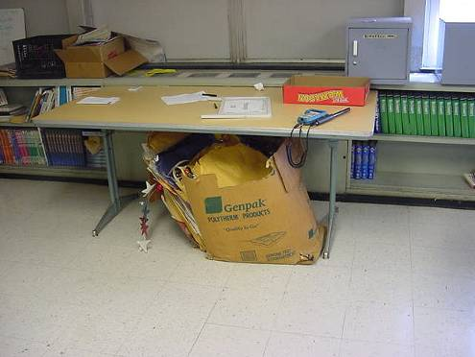

Classroom Items Obstructing Univent Return Vent (Bottom Front of Unit)

Picture 2

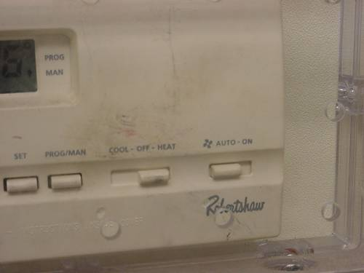

Thermostat for Modular Classroom, Note Fan Set to “Auto” Position

Picture 3

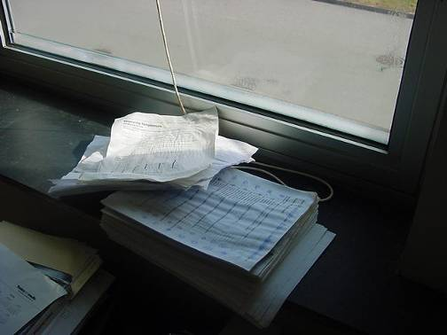

Water Damaged Papers on Windowsill Room 206

Picture 4

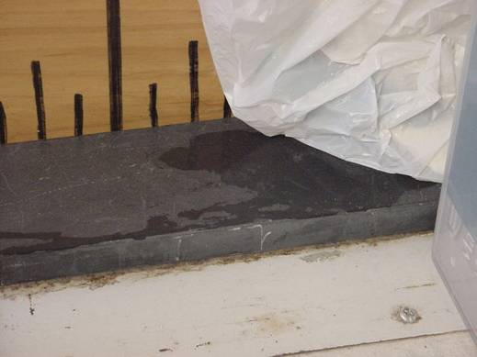

Standing Water on Windowsill Room 206
Picture 5

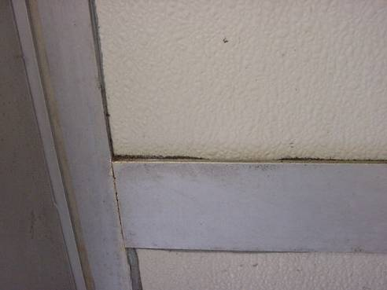

Black Dust/Debris Adhered to Sealant around Window Frames in Rooms 118 & 119

Picture 6

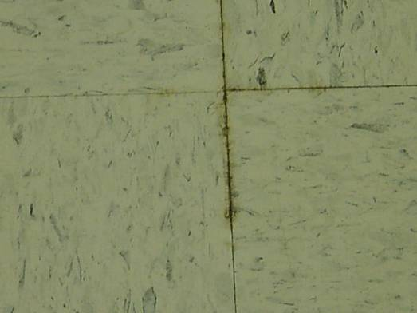

Gum-Like Material (Mastic) around Floor Tiles in Rooms 104 and 105 l
Picture 7

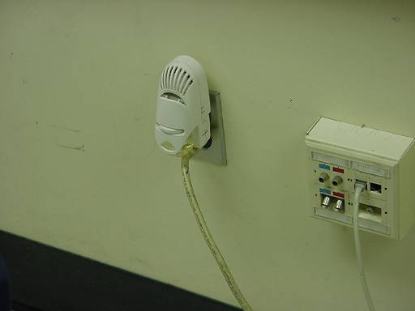

Plug-In Air Freshener in Classroom

Picture 8

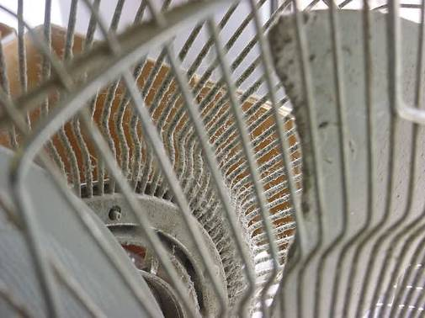

Dust/Debris Accumulation on Fan in Classroom
Picture 9

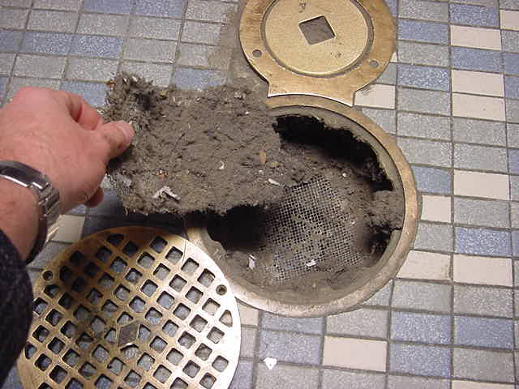

Accumulated Debris in Floor Drain of Room S17

Picture 10

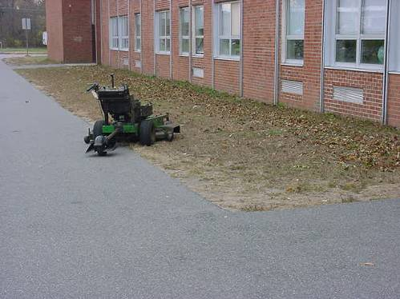

Unattended Lawnmower Operating in Close Proximity to Univent Air Intakes During School Hours
Location/ Room | Occupants  in Room | Temp  (°F) | Relative  Humidity  (%) | Carbon  Dioxide  (ppm) | Carbon Monoxide  (ppm) | TVOCs  (ppm) | PM2.5  (µg/m3) | Windows  Openable | Ventilation |  | Remarks
 |  |  |  |  |  |  |  |  | Supply | Exhaust | Remarks
background |  | 61 | 61 | 413 | ND | ND | 17 |  |  |  | Overcast, light breeze.
204 | 23 | 73 | 43 | 616 | ND | ND | 14 | Y | Y | Y | 1 window open, accumulated items, DEM
229 | 16 | 72 | 41 | 745 | ND | ND | 17 | Y | Y | Y | Furniture obstructing UV, DEM
227 | 27 | 72 | 42 | 748 | ND | ND | 17 | Y | Y | Y | 1 window open, DEM
225 | 17 | 72 | 41 | 967 | ND | ND | 17 | Y | Y | Y | Dust acuum. on exhaust vent, DEM, cleaners
223 | 16 | 75 | 40 | 686 | ND | ND | 14 | Y | Y | Y | UV partially blocked, dust acuum on ex vent, DEM
222 | 24 | 74 | 40 | 978 | ND | ND | 16 | Y | Y | Y | UV and exhaust obstructed, chalk dust, DEM, windows open
220 | 24 | 72 | 43 | 1283 | ND | ND | 19 | Y | Y | Y | Dust acuum on ex vent, damaged partition (dirt on bottom), PF, DEM, accumulated items
219 | 24 | 73 | 41 | 1077 | ND | ND | 16 | Y | Y | Y | Dust acuum on ex vent, DEM, PF, 2 CT, MTs, damaged partition (dirt along edge), window open
218 | 16 | 74 | 40 | 1017 | ND | ND | 14 | Y | Y | Y | UV obstructed by furniture, DEM, window open, PF, PS, 4 CT, 8 MTs
214 | 23 | 73 | 38 | 765 | ND | ND | 15 | Y | Y | Y | Dust accum on ex vent, plants on radiator, DEM, CT, 25 MTs, window open
212 | 19 | 74 | 42 | 1056 | ND | ND | 22 | Y | Y | Y | Dust acuum on ex vent, UV obstructed by furniture, CT-around pipe/above door, DEM, plants
Prep room |  |  |  |  |  |  |  |  |  | Y  ceiling | Wet toner copier
213 | 24 | 74 | 45 | 1631 | ND | ND | 15 | Y | Y | Y | DEM, PF
215 | 22 | 74 | 43 | 1353 | ND | ND | 14 | Y | Y | Y | DEM, CT
217 | 1 | 71 | 38 | 466 | ND | ND | 14 | Y | Y | Y | UV obstructed by furniture, CT/MTs, window open
224 | 23 | 73 | 41 | 709 | ND | ND | 16 | Y | Y | Y | Exhaust obstructed by items/furniture, CT/MT, bowed CTs, window open
129 | 9 | 74 | 38 | 953 | ND | ND | 19 | Y | Y | Y | UV off, exhaust weak-obstructed by furniture, orange scent, DEM
127 | 8 | 73 | 34 | 758 | ND | ND | 16 | Y | Y | Y | Dust acuum on exhaust vent, DEM, accumulated items, window open
125 home economics | 2 | 73 | 39 | 514 | ND | ND | 16 | Y | Y | Y | Exhaust obstructed by furniture
123 | 9 | 72 | 40 | 754 | ND | ND | 12 | Y | Y | Y | Acuum dust on UV-obstructed by items, DEM, MT, plants
116 | 34 | 74 | 45 | 1477 | ND | ND | 15 | Y | Y | Y | AP, aquarium, items hanging from CTs
114 | 7 | 74 | 39 | 617 | ND | ND | 16 | Y | Y | Y | Exhaust weak-dust, PF, dirt/debris along baseboard, MTs, 5 CTs
112 | 22 | 74 | 44 | 1215 | ND | ND | 18 | Y | Y | Y | Dust accum-UV & exhaust, MTs, water damaged WP/CT
109 | 3 | 72 | 41 | 636 | ND | ND | 14 | Y | Y | Y | Dust acuum-exhaust vent, DEM
108 | 21 | 73 | 42 | 793 | ND | ND | 20 | Y | Y | Y | Windows open, exhaust vent-dust, DEM, CT around pipe, MTs
107 | 22 | 72 | 41 | 637 | ND | ND | 19 | Y | Y | Y | UV obstructed by items/dust, exhaust vent obstructed by furniture, DEM
106 | 22 | 75 | 38 | 869 | ND | ND | 16 | Y | Y | Y | Acuum dust-exhaust vent, DEM, CT
128 | 20 | 73 | 41 | 833 | ND | ND | 19 | Y | Y | Y | Exhaust vent obstructed by furniture/dust, dirt/dust baseboards, DEM
130 | 0 | 73 | 45 | 480 | ND | ND | 16 | Y | Y | Y | Exhaust vent obstructed by items/furniture, CT, DEM
124 | 11 | 72 | 41 | 630 | ND | ND | 17 |  | Y | Y | Water damaged paper near sink, UV obs by furniture/items, DEM, aquarium
Prep room |  |  |  |  |  |  |  | Y |  |  | 5 CT
117 | 25 | 72 | 42 | 860 | ND | ND | 17 | Y | Y | Y | UV obstructed by boxes/items, exhaust vent-dust, windows open, DEM, accumulated items
115 | 13 | 72 | 43 | 1056 | ND | ND | 22 | Y | Y | Y | UV obs by clutter, exhaust vent-dust, DEM, PF, DO
121 | 23 | 71 | 41 | 651 | ND | ND | 18 | Y | Y | Y | Exhaust vent-dust, windows open, DEM, 3 CT, 3 MTs, bowed CTs
131 | 6 | 71 | 44 | 511 | ND | ND | 16 | Y | Y | Y | Windows open, UV obs by furniture/items, dust, CD, DEM, CT
132 | 4 | 72 | 44 | 916 | ND | ND | 33 | Y | Y | Y | CD, DEM, PS
Girl’s Locker Room |  |  |  |  |  |  |  |  | Y | Y | Dust accumulation
Office 2 | 1 | 70 | 43 | 574 | ND | ND | 17 | Y | N | N | Window open, MT
Main Office | 5 | 73 | 43 | 672 | ND | ND | 17 | Y | Y | Y
205 | 26 | 73 | 43 | 795 | ND | ND | 19 | Y | Y | Y | UV obstructed by items, dust/debris false window, holes in CT-sprinkler, DEM
206 | 30 | 74 | 42 | 893 | ND | ND | 21 | Y | Y | Y | Dusty PF, periodic water leaks reported-left window panel-storage of porous items-standing water on sill, DEM
207 | 1 | 74 | 38 | 976 | ND | ND | 15 | Y | Y | Y | 25 occupants gone 45 mins, CTs/MTs
208 | 21 | 73 | 36 | 758 | ND | ND | 21 | Y | Y | Y | MTs, DEM
209 | 25 | 76 | 35 | 1212 | ND | ND | 14 | Y | Y | Y | DEM, PF
210 | 22 | 77 | 35 | 960 | ND | ND | 19 | Y | Y | Y | Window leak reported-wet papers on window sill, wood/GW-low (normal) moisture, MT, carbon monoxide detector
228 | 0 | 75 | 35 | 478 | ND | ND | 17 | Y | Y | Y | WD CTs-low moisture  WD WP-low moisture, no visible mold/odors, DEM, DO
226 | 5 | 73 | 36 | 592 | ND | ND | 20 | Y | Y | Y | WD CTs-low moisture, hole in CT, DEM, PF
104 | 4 | 74 | 37 | 466 | ND | ND | 19 | Y | Y | Y | UV deact by occupant due to reports of blowing cold air, bowed CTs, WD papers, mastic seepage around floor tiles-no reports of water infiltration
105 | 23 | 76 | 37 | 757 | ND | ND | 23 | Y | Y | Y | WD CTs-low moisture, bowed CTs, DEM, 2 CTs, leaks reported around corners of windows-storage of boxes
S 17 | 4 | 72 | 42 | 972 | ND | ND | 20 | Y | Y | Y | Floor drain-occasional odors-trap wet, former bath room, exhaust not operating
111 | 23 | 72 | 43 | 861 | ND | ND | 21 | Y | Y | Y | Windows open, DEM, plug-in air freshener, CTs, DO
113 | 22 | 73 | 43 | 1066 | ND | ND | 16 | Y | Y | Y | Windows open, DEM, plug-in air freshener, CTs, DO
114 A | 0 | 73 | 41 | 850 | ND | ND | 19 |  | Y | Y | WD CTs-low moisture
118 | 2 | 73 | 39 | 545 | ND | ND | 18 | Y | Y | Y
119 | 21 | 73 | 42 | 1177 | ND | ND | 24 | Y | Y | Y | Visible mold on starfish, WD on window panel, UV deactivated by occupant-heat complaints, DEM, DO
120 Art | 31 | 74 | 44 | 1336 | ND | ND | 27 | Y | Y | Y | WD CTs-low moisture
Mod 136 | 19 | 74 | 42 | 797 | ND | ND | 20 | Y | Y | Y | DEM, thermostat-“auto”
Mod 137 | 16 | 73 | 42 | 880 | ND | ND | 21 | Y | Y | Y | DEM, thermostat-“auto”
Mod 138 | 22 | 74 | 44 | 990 | ND | ND | 23 | Y | Y | Y | DEM, thermostat-“auto”
Guidance Office | 4 | 72 | 40 | 687 | ND | ND | 15 | Y | Y | Y | Openable window in offices, periodic leaks reported from AC system, carpet dry, no visible mold under carpet in main area & Gilardi office, behind wall coving or in ceiling plenum of main area

