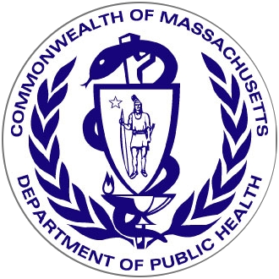

Massachusetts Department of Public Health

Overdose Education and Naloxone Distribution

Program Core Competencies

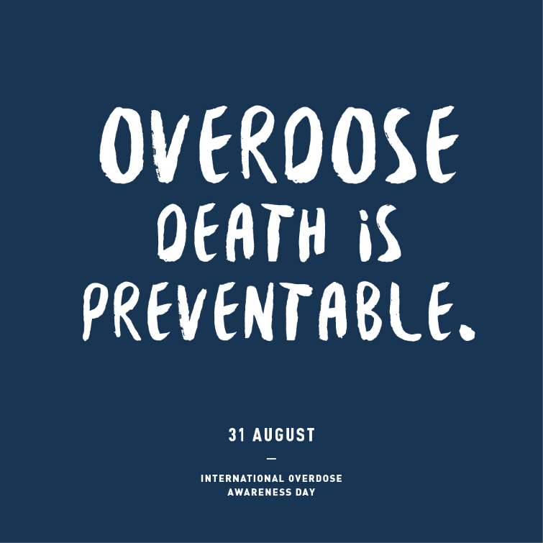



**Table of Contents**

Acknowledgements:

Thank you to all the Massachusetts Department of Public Health partners who are working to save lives as participants in this Overdose Education and Naloxone Distribution program.

This version was updated in 2019 and is available at: [www.mass.gov/naloxone](http://www.mass.gov/naloxone)

About this Document 3

Introduction: the Need and Response 4

What are Opioids? 5

What is an Opioid Overdose? 7

What is Naloxone? 7

Preventing Overdose: Knowing Risk Factors for Opioid Overdose 8

Recognizing and Responding to an Opioid Overdose 11

Making a Safety Plan 16

Stigma 17

Fatal Overdoses and Experiencing Loss 18

Summary and Contacts 19

Appendix I: Other Resources 20

Appendix II: Standing Order 21

**About this Document**

This document describes the knowledge and core competencies necessary for overdose responders trained as part of the Massachusetts Department of Public Health (MDPH) Overdose Education and Naloxone Distribution (OEND) program. Opioid overdose responders include people who use opioids; family and friends of people who use opioids; first responders such as police, fire, and emergency medical services personnel; and other workers that serve people who use opioids. This guide provides information on opioid overdose prevention, recognition, and response. It also provides important contextual information.

The MDPH OEND program is part of a broader effort to prevent and decrease risky opioid use. This effort focuses on prevention, intervention, treatment, and recovery support. A more detailed overview of these strategies can be found on the MDPH Bureau of Substance Addiction Services [website](https://www.mass.gov/orgs/bureau-of-substance-addiction-services).

**Introduction: the Need and Response**

**Opioid Related Deaths of MA Residents Report, posted June 2020**

revention training session.overdose may want to be prepared to show some overdose epidemiology and/or successes of the OEND prAs part of MDPH’s comprehensive approach to addressing opioid overdose, OEND programs are selected for their ability to reach populations and venues in the state with the highest rates of fatal and non-fatal overdoses. The State of Massachusetts (MA) has been particularly successful in expanding overdose prevention services to thousands of state residents. This has been due to support from MDPH, and committed efforts from community-based harm reduction and substance addiction treatment and prevention agencies.

Naloxone is an opioid antagonist drug, which means it displaces opioids from opioid receptors in the brain. When administered, it reverses the effects of opioids, including the the respiratory depression that occurs during an opioid overdose. It is is safe, effective, and has no potential for abuse. Naloxone has been used by emergency healthcare providers since the 1960s. Naloxone is a prescription medication, and is not a controlled substance.

MDPH publishes quarterly reports that track the progression of the overdose crisis in MA: <https://www.mass.gov/lists/current-opioid-statistics>

**Laws and regulations that support the MDPH OEND program:**

* **Naloxone dispensing via a public health program:** MDPH is operating the OEND program in accordance with M.G.L. c. 94C and MDPH/Drug Control Program regulations at 105 CMR 700.003(D). The dispensing of naloxone to approved trained individuals is authorized by MDPH, and by a standing order issued by the Medical Director of the OEND program.

1. **The Good Samaritan Law:**

In MA, according to Chapter 52 of the Acts of 2016 Section 12FF, “Any person who, in good faith, attempts to render emergency care by administering naloxone or any other opioid antagonist, as defined in section 19B of chapter 94C, to a person reasonably believed to be experiencing an opiate-related overdose, shall not be liable for acts or omissions resulting from the attempt to render this emergency care; provided, however, that this section shall not apply to acts of gross negligence or willful or wanton misconduct.”

**What are Opioids?**

Opioids are either derived from the opium poppy, or are synthetically manufactured. Whether synthetic or naturally occurring, opioids all act similarly in the body: In the peripheral tissues (such as skin, muscles, blood vessels, and organs other than the brain), opioids reduce pain by blocking pain receptors. In the brain, opioid receptors regulate pain perception, emotional memory, reward, and pleasure sensations. Generally, opioids are depressants, which slow down the central nervous system.

At high levels, opioids in the brain cause euphoria. This creates a feeling of warmth, drowsiness, and contentedness. In the brainstem, opioids reduce consciousness, and decrease breathing. Types of opioids differ in strength and length of action. The stronger an opioid is, the more likely it is to cause on overdose.

**Important factors to consider when judging the strength of an opioid are:**

1. Prescription opioids come in **short-acting and long-acting formulations**, which contribute to overdoses in different ways:

Slow-acting (extended release) opioids: An example of a slow-acting opioid is oral methadone. Its peak effects occur after 4-6 hours, and it can stay in the body for over 24 hours. Slow-acting opioids like methadone can contribute to overdose risk over a long period of time.

Fast-acting (short release) opioids: An example of a fast-acting opioid is injected fentanyl. It has a strong peak effect within seconds, and contributes to overdoses over a shorter period of time, compared to slow-acting opioids.

1. **Changing how an opioid is formulated** can turn a slow-acting, less potent opioid, into a fast-acting, more potent opioid. If a slow-acting (extended release) opioid is crushed, it may act as as a fast-acting (short release) opioid when snorted or injected.
2. **Changing how an opioid is administered** can change how long it takes for an opioid to be delivered to the brain. The faster it is delivered, the more intense the high, and the greater the risk of overdose. For example, injecting delivers opioids to the brain faster than snorting does.

**A note about fentanyl:**

Fentanyl is a strong synthetic opioid that is given intravenously in hospitals for anesthesia, rapid pain control, and sedation. It is also prescribed for the treatment of chronic pain, as a transdermal patch. In 2013, illicitly-made fentanyl started showing up regularly in the heroin supply in New England. Fentanyl is responsible for the surge in opioid-related deaths seen in MA since 2013, due to it being a potent and fast-acting drug. Fentanyl is typically sold as is or as heroin but may be present in other drugs such as [cocaine](https://www.mass.gov/clinical-advisory/clinical-advisory-on-opioid-deaths#increase-in-opioid-related-overdose-deaths-with-cocaine-present) and pressed pills without the user’s knowledge.

**Key Points: What are Opioids?**

* Opioids reduce pain by blocking pain receptors
* Opioids differ in strength, formulation, and length of action
* Route of administration of an opioid into one’s body can affect the timing of an overdose
* Fentanyl is dominant in the illicit opioid market in MA

**What is an Opioid Overdose?**

An opioid overdose is caused by a person taking too many opioids (this amount is different for everyone). High doses of opioids can cause respiratory depression, which can ultimately lead to death. Respiratory depression is when breathing becomes dangerously slow, or stops entirely.

**Progression of an opioid overdose:**

1. The length of time in-between using an opioid, and an overdose occuring, depends on the type of the opioid. Overdoses caused by:
   * Slower-acting/less potent) opioids can take minutes to hours to occur.
   * Faster-acting/more potent) opioids (like fentanyl) can take seconds to minutes to occur.
2. Opioid overdoses may begin with a person just appearing to be very high. However, an overdose will always progress into respiratory depression.
3. During respiratory depression, breathing will always slow before it stops.

**Symptoms of an opioid overdose:**

1. Unresponsiveness to verbal or physical stimulation
2. Respiratory depression (no or slow breathing)
3. Deep snoring or gurgling (sometimes referred to as “the death rattle”)
4. Purple/blue or grey lips and fingertips (this suggests a lack of oxygen)
5. Slow heartbeat or pulse
6. Pinpoint pupils

**Key Points of an Opioid Overdose**

* Definition:
  + - Reduced/stopped breathing and unresponsiveness caused by opioids
* Opioid overdose happens as a process – breathing slows down before it stops
  + - It takes minutes to hours after most opioids are used
    - Fentanyl overdoses take seconds to minutes
* 3 key signs to look for:
  + - Delayed or no breathing
    - No reaction to stimulation/unresponsiveness
    - Purple/blue or grey lips and fingertips

**What is Naloxone?**

Naloxone is an antidote to an opioid overdose. Naloxone blocks opioids from attaching to opioid receptors in the brain. Naloxone temporarily reverses the effects of an opioid overdose, and lasts for about 30-90 minutes. It typically works in about three minutes, but stronger opioids may require several doses before the person “comes to”. Once the naloxone has successfully reversed the effects of an overdose, the person should seek medical attention. Some individuals will fall back into an overdose after naloxone wears off, so it is important that they are observed at a medical facility.

Naloxone cannot cause an overdose. However, administering naloxone to anyone who has opioids in their system (whether they are overdosing or not) can cause withdrawal symptoms, such as:

* + Anxiety
  + Runny nose and eyes
  + Chills
  + Muscle discomfort
  + Disorientation
  + Combativeness
  + Nausea and/or vomiting
  + Diarrhea
  + Cravings for opioids

**Different forms of naloxone:**

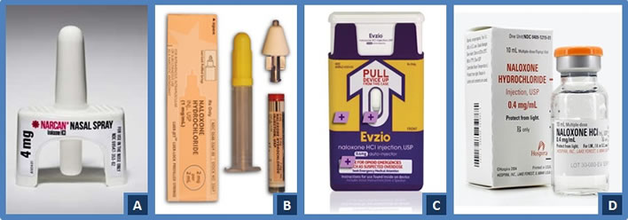

**A**. Narcan nasal spray (single-step)**B**. Generic nasal naloxone with atomizer (multi-step) **C**. Evzio instramuscular auto-injector **D**. Generic intramuscular injection

**Taking care of naloxone:**

* Protect naloxone from direct sunlight and extreme temperatures.
  + Store at room temperature: 59-86 degrees Fahrenheit
* Check the expiration date regularly, and replace expired doses.
  + Note: Naloxone should still work years after the expiration date, but it may be less effective. It is always better to give expired naloxone, than no naloxone.

**Preventing Overdose: Knowing Overdose Risk Factors**

*“The street drug supply has always been, and will always be, unpredictable and inconsistent. Assume an overdose risk no matter what drug you’re using, and practice as much harm reduction as possible, as consistently as possible.”*

*– The DOPE Project, San Francisco 2018*

The goals of the MDPH OEND program include preventing overdoses from occurring, and saving lives when they do. This section describes common risk factors for opioid overdoses. A person with a risk factor has an increased chance of opioid overdose. Educating people who use opioids about their risk factors can help keep them safe.

Treatment with medication for opioid use disorder, including methadone, buprenorphine, and/or naltrexone, is protective against overdose, if the person is taking the medication as prescribed. Stopping any of these medications leads to an increased risk of overdose for several weeks after stopping these treatments.

**Opioid Dose and Changes in Purity**

Fentanyl is a potent, fast-acting opioid that can be lethal in very small amounts. There is no regulation on the quality or strength of opioids bought on the street. A bag of heroin, for instance, can vary greatly in purity. Weak heroin may be made stronger by cutting it with fentanyl or other psychoactive substances. In MA, fentanyl can be sold as is, but can also be sold as other drugs, like heroin. There have been reports that fentanyl is being cut into drugs such as cocaine and pressed pills. The same harm reduction practices that decrease overdose risk when using heroin and other drugs will work with fentanyl and its analogues.

**Previous Near Fatal Overdose**

Previously experiencing an overdose increases the risk of dying from an overdose in the future. This is because people who have previously overdosed may have drug use patterns that continue to put them at risk for an overdose in the future. They may also have a genetic predisposition to overdose, which means that the genes they were born with may not protect them from overdose as well as other people’s genes. Additionally, experiencing a near fatal overdose may cause damage to the brain or lungs, even if the person survives. This damage may make future overdoses more likely to occur, and more likely to be fatal.

**Abstinence and Changes in Tolerance**

With daily use, the body develops tolerance. This means that a person must use an increasing amount of a drug to achieve the same effect. Because of this, someone who uses opioids daily has a greater tolerance than someone who does not use opioids daily. However, with just a few days of opioid abstinence, tolerance is reduced. Reduced tolerance increases the risk of overdose, especially when someone uses the same amount of a drug they used before the period of abstinence.

Risk of Overdose increases after a periods of abstinence, such as:

1. Incarceration
2. Hospitalization
3. Detoxification or other types of drug-free treatment
4. Section 35 Commitment

**Unsupervised drug consumption**

When a person uses opioids alone, there is no one around to: (a) recognize the signs and symptoms of an overdose, and (b) take the appropriate steps to intervene in that overdose. The prevalence of fentanyl in street drugs has decreased the window of time to intervene during an overdose, as most overdoses now occur within seconds to minutes after using. It is crucial that a person using opioids is with someone who is equipped with naloxone, and can call for help should an overdose occur. Ideally, this means that if both people use opioids, they stagger when they use, to avoid both individuals overdosing at the same time.

**Mixing Opioids with other substances/polypharmacy**

All sedative drugs carry overdose risks of their own. However, when drugs are combined, the risk is substantially increased. The sedating effects of the drugs work together, making the sedation greater when these drugs are used in combination, compared to when any of these drugs are used alone.

* Mixing with benzodiazepines (benzos): sedating drugs that include alprazolam (Xanax), chlordiazepoxide (Librium), lorazepam (Ativan), clonazepam (Klonopin), and diazepam (Valium).
  + These medications are typically prescribed to treat anxiety disorders, insomnia, tremors, and alcohol withdrawal.
  + In MA, benzodiazepines are the most common type of drug mixed with heroin and/or fentanyl, resulting in multi-drug overdoses.
  + Although Z-drugs, like zolpidem (ambien) and eszoplicone (lunesta), are commonly believed to be safer than benzodiazepines, they are not. Z-drugs work very similarly, and contribute to overdose risks similarly, to benzodiazepines.
  + Benzodiazepines are particularly dangerous because they impair memory, which means that people may use more than they intend to use.
  + While benzodiazepine use contributes to overdose risk, doctors may still prescribe them to patients using opioids when the benefits of treating an anxiety disorder or insomnia outweigh these risks.
* Mixing with alcohol and/or other sedating medications: including clonidine (Catapres), gabapentin (Neurontin), quetiapine (Seroquel), and promethazine (Phenergan).
  + While these medications have different clinical uses, they are all sedating, which means they slow down breathing and heart rate and can lower blood pressure.
  + When mixed with an opioid, sedative drugs increase the risk of overdose, compared to use of the opioid alone.
  + Combining alcohol with opioids increases the risk for overdose in the same manner as other sedating drugs or medications.
* Mixing with cocaine or other stimulants: examples of other stimulants include amphetamine and methamphetamine.
  + Stimulants combined with opioids can create a cycle of trying to treat the sedating effects of one medication with the stimulating effects of the other, and vice versa. In this setting, the side effects of each of these medications can accumulate to increase the risk of overdose. For example, to counteract the over-stimulation from stimulants, people using opioids may misjudge how much opioid they need to come down, overshoot their tolerance, and overdose.
  + MDPH data show an upward trend in overdose deaths where both cocaine and fentanyl are present. This likely includes cases of individuals who knowingly used cocaine and opioids prior to the overdose, as well as cases of individuals who used cocaine, and were unknowingly exposed to fentanyl that was present in cocaine.
  + It is important to educate individuals that any illicit drugs may contain fentanyl, and that they should be aware of the overdose prevention and response techniques described in this document. All individuals using any illicit drugs should have access to naloxone.

**Chronic medical conditions, including substance use disorder**

People with longer histories of drug use are at increased risk for fatal overdose, due to the cumulative effects of long-term substance use on their bodies. Injection drug use can result in conditions such as viral hepatitis, HIV, or infections like endocarditis or cellulitis. These conditions can all lower an individual’s immune system, leaving them more susceptible to a fatal overdose. In addition, liver and lung health are often negatively impacted by hepatitis and smoking. The liver and lungs play important roles in an overdose, because the liver filters substances from the body, and the lungs replenish the oxygen supply. Both of these functions are essential for a person to survive an overdose.

**How to Respond to an Overdose**

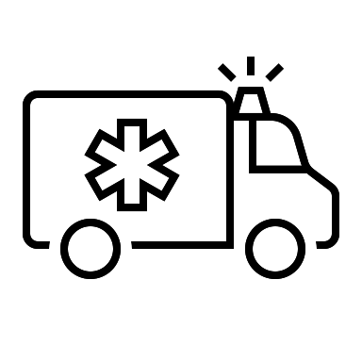



1. **Recognize Overdose**

**It is important to be able to distinguish an overdose from being high on opioids.**

|  |  |
| --- | --- |
| **Really High** | **Opioid Overdose** |
| * Responds to stimulation like yelling, sternal rub, pinching, etc. | * Doesn’t respond to verbal or physical stimulation |
| * Takes 8+ breaths per minute | * Takes less than 8 breaths per minute * Deep snoring or gurgling (death rattle) |
| * Speech is slow/slurred | * Unable to speak |
| * Normal skin tone | * Purple-blue/gray lips and fingertips * Pale, clammy skin |

Overdose rescue!

Stimulate and observe!

**Stimulation**

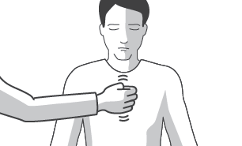If you suspect that a person is having an overdose, see if the person responds to stimulation. Try the following techniques, in this order:

1. Verbal: Call the person’s name
2. Physical: Try tapping on the person’s shoulders/chest, and continue to call their name
3. Phyiscal: Rub your knuckles up and down on their sternum (the breastbone in middle of chest) – this is called the “sternal rub”
   1. Rub hard! Try it on yourself – it should hurt
   2. As an alternative, rub your knuckles on their upper lip

If the person does not respond to any of these stimulation techniques, it is safe to assume they are having an overdose, and you should continue onto the following steps. If the person responds to verbal or physical stimulation, they are not overdosing. You should continue to monitor their breathing and responsiveness, to make sure they do not slip into an overdose.

1. **Call 9-1-1**

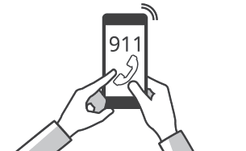If a person does not respond to stimulation, **call 9-1-1!** It is important that the person who overdosed seeks medical attention, even if they “come to” after being administered naloxone. Since naloxone only lasts for a 30-90 minutes, it is possible for the person to slip back into an overdose. If this happens, the safest place for them to be is at a medical facility.

**Good Samaritan Law**

The Massachusetts Good Samaritan Law protects overdose victims, and those who call 9-1-1, from charge, prosecution, and conviction for possession or use of controlled substances. The Law, Chapter 94C, Section 34A: “Immunity from prosecution under Secs. 34 or 35 for persons seeking medical assistance for self or other experiencing a drug-related overdose” can be found on the [Massachusetts Legislature General Laws website](https://malegislature.gov/Laws/GeneralLaws/PartI/TitleXV/Chapter94C/Section34A).

It is important to note that the law does not protect overdose victims and those who call 9-1-1 from: losing their public housing, being arrested on prior warrants (if the police decide to run names of those on-scene), and becoming involved with the Department of Children and Families if children are present.

1. **Administer Naloxone**

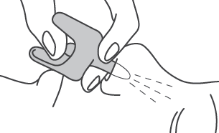As soon as naloxone is available, you should administer the first dose. The second dose should be administered 3 minutes after the first dose, if the person continues to be either unresponsive or have impaired breathing. While waiting for the naloxone to work, the responder should perform rescue breaths (Step 4). Typically, one or two doses of naloxone is sufficient to successfully reverse the effects of an opioid overdose. In some situations, more than two doses may be necessary.

**Single-step nasal naloxone (NARCAN®)**

All OEND Programs distribute single-step NARCAN®.

1. **PEEL** back the package to remove the device. Hold the device with your thumb on the bottom of the plunger and two fingers on the nozzle.
2. **PLACE** and hold the tip of the nozzle in either nostril until your fingers touch the bottom of the person’s nose.
3. 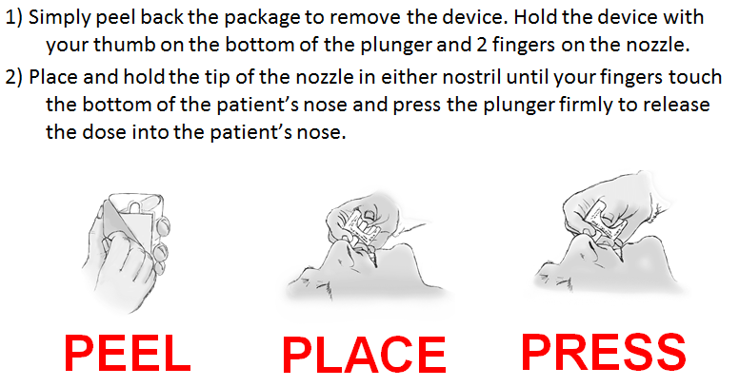**PRESS** the plunger firmly to release the dose into the person’s nose.

**Intramuscular (IM) naloxone**

A limited number of OEND program distribute IM naloxone.

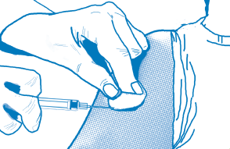

1. **REMOVE** the orange top from the vial
2. **DRAW UP** 1cc/1mL/100u of naloxone into the syringe
3. **INSERT** the needle straight (NOT at an angle) into the thigh, shoulder, or upper-outer quadrant of the butt
4. **PRESS DOWN** plunger slowly to administer naloxone
5. **PULL** syringe straight out to remove, and
6. **APPLY** pressure at the injection site with sterile gauze
7. **Perform Rescue Breathing**

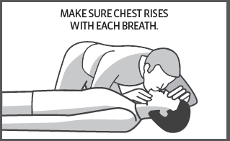

In between administering naloxone doses, provide rescue breaths to the person, following these steps:

1. Make sure there is nothing in the person’s mouth
2. Tilt head back, lift chin, pinch nose to give a breath
3. Give a breath every 5 seconds, watching for chest rise and fall
4. If you are trained in CPR, proceed to give chest compressions

Remember to time yourself, and stop rescue breathing every three minutes to give another dose of naloxone. If the person starts breathing on their own, for eight or more breaths per minute, stop giving naloxone and rescue breathing, and monitor the person’s breathing.

**Equipment to Assist Rescue Breathing**

CPR masks, mouth barriers, Ambu bags, and other one-time use equipment can protect the rescuer. These should be disposed of and replaced after use. If you have access to these devices, practice using them BEFORE an emergency occurs.

* CPR mask: place mask over the nose and mouth, and apply pressure to make a tight seal. Breathe into mask, and watch for chest rise and fall.
* Mouth barrier: place barrier over mouth, and apply pressure to make a tight seal. Pinch nose, breathe into barrier, and watch for chest rise and fall.
* Ambu bag attached to CPR mask: squeeze the bag to force air through the mask, and watch for chest rise and fall. If stomach expands (lower abdomen), readjust mask or barrier to create a tight seal, and attempt again.

1. **Stay Until Help Arrives**

It is important to stay with the person who is overdosing until help arrives, to monitor their condition. Tell emergency medical services (EMS) workers what happened, and what actions you took (i.e. how many doses of naloxone you gave, if you performed rescue breathing, what the person took, etc.)

It is important for a medical facility to to monitor the person who overdosed, because naloxone only lasts 30-90 minutes. However, the effects of opioids can last 4+ hours, especially with long-acting opioids like methadone. This means that when naloxone wears off, the person may slip back into an overdose. The likelihood of overdosing again depends on several things including: the dose of opioids taken, the type of opioids taken, the overall health of the person who overdosed, and if the person uses again after receiving naloxone. Even if the person “comes to” before EMS arrives, encourage the person to seek medical attention.

**Leaving the scene of an overdose**

The Recovery Position:

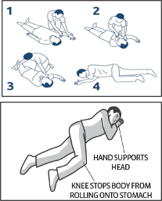

Many bystanders must leave the scene of an overdose to ensure their own personal safety. If you must leave:

* Administer the person naloxone before leaving, if time allows.
  + Leave any packaging or unopened doses around the person (anyone who finds the person will know what happened, and can provide them with any unused doses).
* Provide as many rescue breaths as time allows.
* Leave the person in the recovery position.

**When the person “comes to”**

The goal of using naloxone is to get people breathing again, not necessarily to wake them up, or completely take away their high. STOP administering naloxone and providing rescue breathing when either of the following occur:

* The person becomes alert (i.e. they are responsive to verbal or physical stimulation)
* The person starts breathing eight or more breaths per minute

After being administered naloxone, most people start breathing again in 3-5 minutes. However, some overdoses require more doses, especially those involving fentanyl. If the person begins breathing well again, put them into the recovery position.

Many people will feel confused, embarrassed, and/or anxious after being revived with naloxone. Most people will not think realize they were overdosing, and may be upset that their high is gone. It is important to explain to the person that they were overdosing and/or not breathing, and you used naloxone on them.

Because naloxone blocks the effects of opioids, it can cause rapid withdrawal symptoms. Withdrawal symptoms can very from person to person. Reassure the person who overdosed that withdrawal symptoms will diminish as the naloxone wears off. Due to the unpleasant nature of opioid withdrawal symptoms, the person may want to use again. Encourage the person to wait several hours before using again, as this increases the risk of falling back into an overdose, after the naloxone wears off. Additionally, naloxone will inhibit the person from feeling the effects of opioids, so using right after being given naloxone would simply be a waste of their supply.

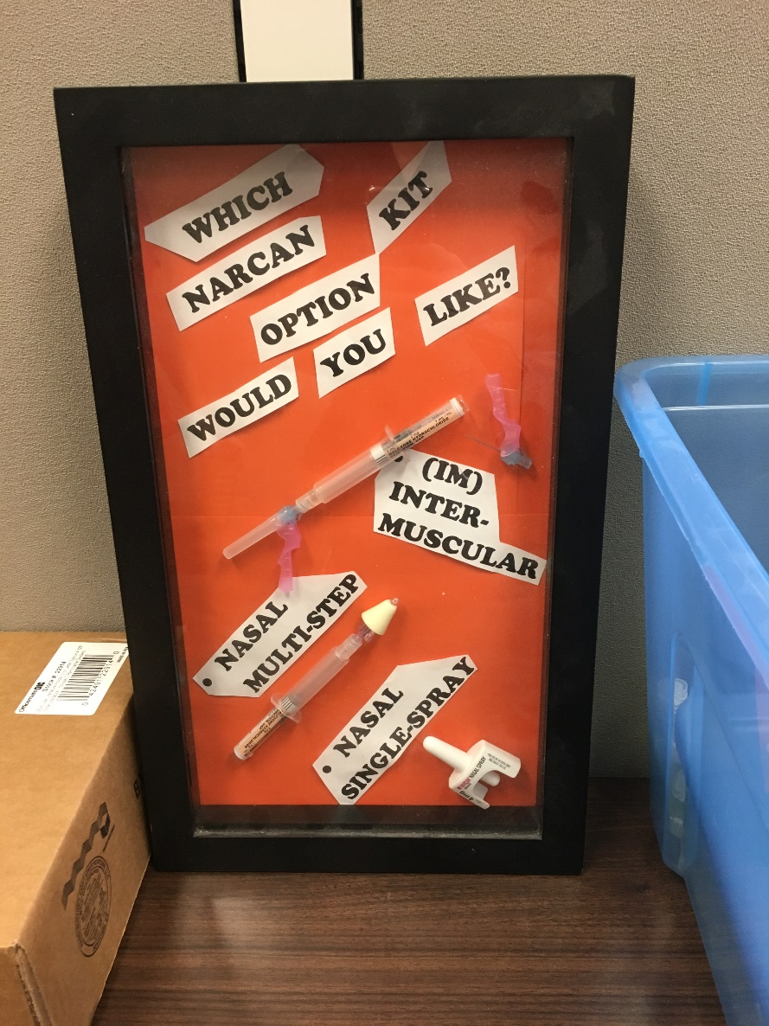

**Making a Safety Plan**

**Creating a safety plan with a participant**

While attempts at abstinence should be applauded, risk-reduction plans should be in place, in case the person relapses. See if participants feel comfortable training their network on how to recognize an overdose, call for help, provide rescue breathing, and administer naloxone**.** Make the person’s plan individualized, and recognize that what works for some may not work for others.

Ask participants:

* How do you protect yourself against overdose?
* If plan A is not using, what’s your plan B? How will you keep yourself safe if you do use?
* What is your plan if you witness an overdose in the future?
* Have you received training to prevent, recognize, and respond to an overdose?

Encourage participants to:

* Use only when directly observed by someone who has naloxone, and is able to call for help
* Keep a naloxone kit where they use
* Assume that all street drugs contain fentanyl or its analogues
* Avoid mixing substances, especially benzos and alcohol (sedatives) with opioids
* Take turns, using a buddy system, so that each person using is observed by someone ready to respond with naloxone
* Start low and go slow (do tester shots)
* Control their own fix/shot, and become familiar with how much their body can handle

**Conducting an overdose prevention training for staff**

Review and role-play the following scenarios, alternating who is the responder, and who is the person who is overdosing:

* 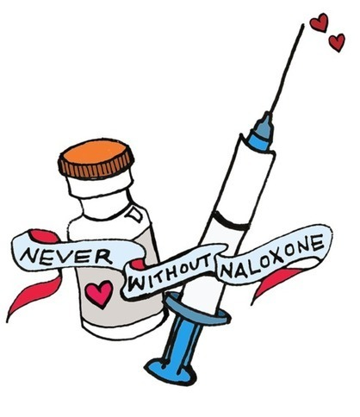Person overdoses in bathroom of your program
* Person overdosing has locked jaw, or other blockage around nose/mouth
* Survivor is rescued, and refuses transport to ED
* Person in treatment is discharged and relapses

**Stigma and People Who Use Drugs**

**Stigma and Drug Use**

People who are stigmatized for their substance use often experience social rejection, labeling, stereotyping, and discrimination. This manifests in a variety of ways, including denial of employment or housing, social isolation, estrangement from family and friends, and incarceration. People who use drugs are less likely to be offered help than people with a mental illness or physical disability. Healthcare professionals often hold negative, stereotyped views of people who use drugs. Stigma is a major factor that prevents individuals from seeking and completing addiction treatment, and utilizing harm reduction services, such as syringe access overdose prevention programs. In a vicious cycle, the social exclusion created by stigma can increase the need for a variety of services.

**What Can Be Done to Fight Stigma?**

* + - Know the facts:
      * Many people who use drugs do not experience negative consequences, develop physical dependence, or develop a substance use disorder.
      * A substance use disorder is a chronic health condition with risks and consequences.
      * Studies show that only one in 12 people with substance use disorders get treatment, and that stigma is a key barrier for many people who *don’t* seek treatment.
      * Studies also show that health care professionals, and the treatment decisions they make, are influenced by how we talk about addiction.
* Challenge your unconscious biases:
  + - * People with substance use disorders should be afforded the same dignity, respect and support as someone with any other chronic health condition.
      * The way we talk about drugs, and the people who use them, can create or uphold stigma.
      * 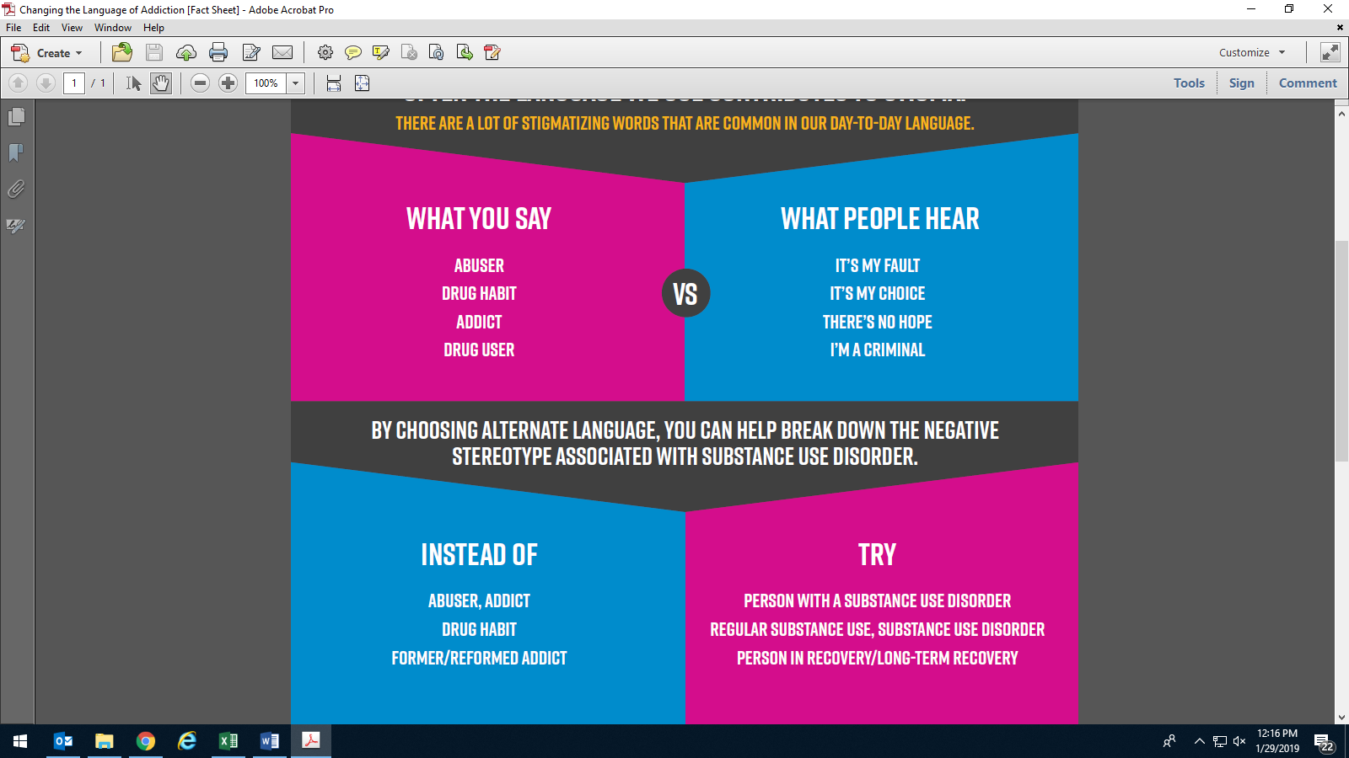Using the right language has a direct impact on decreasing stigma. and increasing treatment for people with substance use disorders.

*“Words Matter” from Canadian Centre on Substance Use and Addiction 2017*

**Fatal Overdoses and Experiencing Loss**

**Experiencing Loss from Overdose**

Every individual who is exposed to a fatality has their own personal history, and current experiences related to loss, trauma, and stress. Each person also has their own style of coping, level of resilience, and capacity for healing. All of this influences a person’s reaction to the death.

Responders to opioid overdoses may be exposed to overdose fatalities in many ways, including:

* A person dying during a rescue attempt
* A person being found dead upon arrival to the scene
* Being told of a person’s death by another agency, friend, or family member
* Learning of a person’s death when receiving an overdose report
* Learning of a death that is reported by the media

A rescue attempt is a life-or-death situation characterized by an intense, confusing, and/or chaotic scene. The situation can be extremely stressful for the people involved, and for witnesses or bystanders. The reactions of staff, responders, and bystanders are likely to be influenced by adrenaline, strong emotions, and/or traumatization. Reactions can come immediately or can be delayed

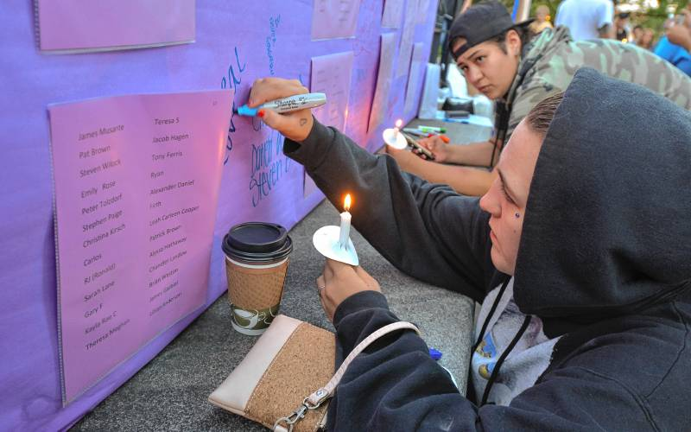When a death occurs, a person may be confronted with many issues simultaneously: their own emotional fallout, shock, and distress from witnessing a sudden death; the emotional reactions, shock, and distress of other people on the scene; the dismay and grief of people who have a close relationship to the deceased; the need to attend to the deceased’s body; the challenge of restoring order after the upheaval caused by the rescue attempt and death; and the pressure of job duties that require attention.

**Coping in the Aftermath of a Death**

The following five core actions can be helpful to people who have been exposed to a traumatic event that involves loss of life:

1. Promote safety
2. Promote calm
3. Promote connectedness
4. Promote hope
5. Promote self- and community-efficacy

Preparations for, and execution of, responses to a death can be organized around these core actions. Consider how each one may be applied to any issues that arise, to meet the needs of various people affected by a fatality.

When preparing for, engaging in, or debriefing the aftermath of a fatality, consider how these actions can be applied in the circumstances you face, and with the audiences you serve. [***Coping with Overdose Fatality: Tools for Public Health Workers***](https://www.mass.gov/files/documents/2019/02/04/coping-with-overdose-fatalities-tools-for-public-health-workers.pdf) is a good place to begin when considering building long-term resilience for your organization and community.

**Summary**

This guide is intended for active MDPH OEND Programs, as part of a comprehensive strategy that includes overdose prevention and response. This document is limited to the core competencies that are expected of these programs, and is not an exhaustive presentation of opioid overdose prevention. It is necessary that each group of potential opioid overdose witnesses be familiar with the strategies, resources, and tools needed to quickly and effectively respond to an overdose. Support for these prevention and response strategies are available through the links within this document.