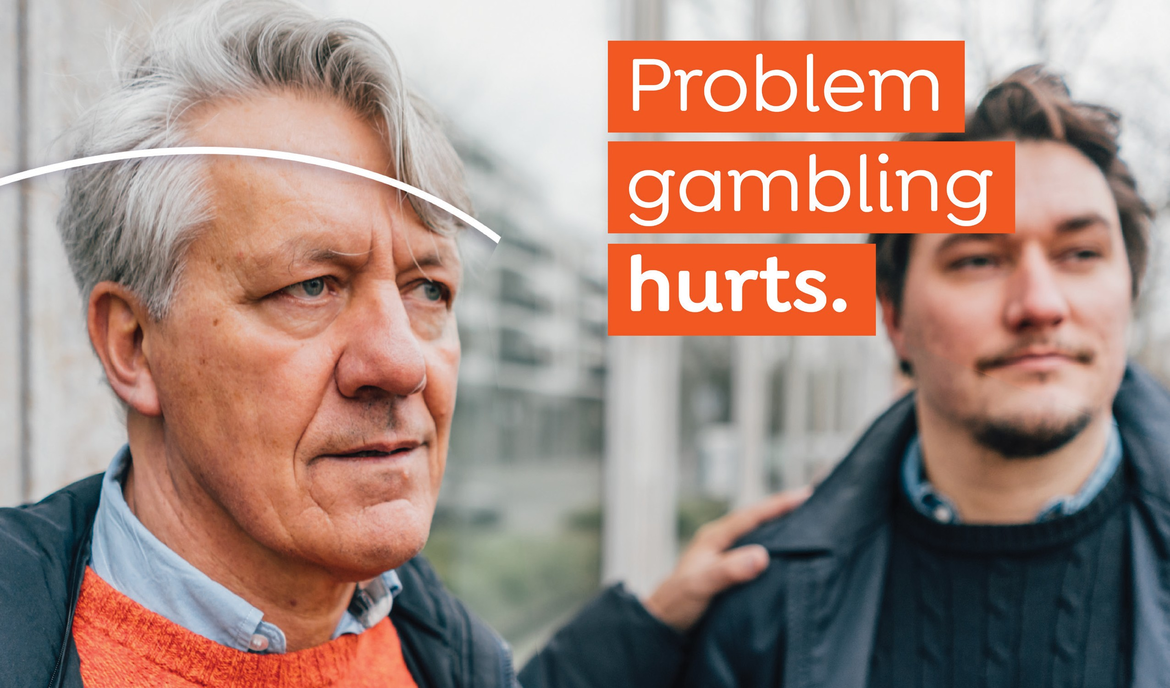

Annual Report

**Fiscal Year 2021**

Massachusetts Department of Public Health Office of Problem Gambling Services

#### Table Of Contents

Message From The Department of Public Health

**03**

**06**

Our Local Connection

**09**

Public Health Trust Fund

**17**

Looking Ahead to FY22

The Office of Problem Gambling Services

Strategic Vision

**04**

**07**

**10**

OPGS by the Numbers



2

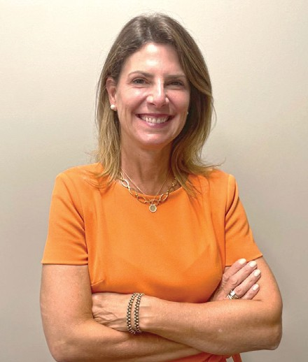Dear Colleagues,

#### Message from Margret Cooke, Commissioner, Massachusetts Department of Public Health

The Office of Problem Gambling Services is part of the Massachusetts Department of Public Health and is overseen by the Executive Office of Health and Human Services. I’m so proud of the ongoing work of this office and am pleased to share this FY2021 Annual Report, which outlines the year’s key achievements.

We are committed to wisely using the funds that come to us from the Public Health Trust Fund, this year totaling $9.6 million. These funds are generated by a percentage of the tax on gross gaming revenues in the Commonwealth. We put these resources back into the community in the form of research, prevention, intervention, treatment, and recovery support services for residents experiencing problem gambling and related issues.

The FY22 budget of $9.6 million represents a program budget increase of $4.6 million due to enhanced tax revenue from casinos in Massachusetts. These resources will allow us to continue and expand services, to invest in priority populations, and to start new initiatives, all informed and driven by data.

We thank our many partners for their assistance and support of our efforts to mitigate the harms associated with gambling here in our Commonwealth.

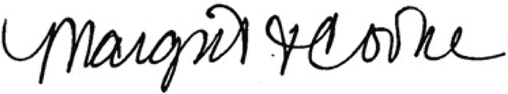

Margret Cooke, Commissioner

3

#### The Office of Problem Gambling Services

The Office of Problem Gambling Services (OPGS) exists within the Massachusetts Department of Public Health (DPH) and reports to the Department’s Associate Commissioner. DPH is an agency within the Executive Office of Health and Human Services, the largest secretariat in Massachusetts state government. Since its inception in 2016, the Office of Problem Gambling Services has worked every day to promote equity and empowerment and minimize the harms associated with gambling.

We are committed to the optimal health and well-being for all residents of the Commonwealth and to helping ensure that our communities are healthy and equitable places to live. We work with community partners across the state

to provide problem gambling prevention, intervention, and treatment services to those who most need them. Each and every resident has the right to good health and we must work together to remove barriers so that everyone has the same opportunity to improve their lives and their health. This belief is reflected in our initiatives, organized by the following categories:



**Programs and Services**

**Community**

**Engagement and Assessment**

**Public Awareness**

**Technical Assistance**

**and Evaluation**

**Workforce**

**Training and Supports**

44

#### What We Do

Our mission, vision, and principles are built on tenets that support a true public health response to problem gambling. The office is committed to transparency, community engagement, and equity. Our goals around these commitments are highlighted below:

### Engage Communities

**Enhance Transparency**

* Continue to conduct annual Stakeholder Listening Sessions, a forum for MA residents to share their cultural and community expertise to inform our work and future planning of problem gambling initiatives.
* Enhance the Stakeholder Listening Session process to include input from different sectors and stakeholders across the Commonwealth to ensure a broad and deep range of voices is included.
* Include on our website information about the Public Health Trust Fund to ensure the public has easy access to information about programs and services, including evaluation and quality assurance components. All of these can be found [here](https://www.mass.gov/info-details/public-health-trust-fund).
* Post our budget on our website to detail how public funds are being expended to serve the Commonwealth.

### Promote Accountability

**Plan Comprehensive and Responsive**

* Publish an annual report to regularly report out to the community.
* Develop public materials that highlight our budget, services, and outcomes.

### Development

* Conduct a strategic planning process to update plans to meet our goals.

55

#### Our Local Connection



We collaborate with a network of internal and external partners and stakeholders to achieve an optimal public health response to problem gambling, centered on equity. Through this work, the OPGS has created tailored services and programs for priority populations, adapted to the changing public health environment, and developed plans for the future. Office staff collaborate, inform, guide, and partner with our network of stakeholders.

6

6

#### Strategic Vision

The following graphic represents the framework of the Department of Public Health’s mission and vision and the principles that support the Department’s work. Everything that OPGS does is guided and informed by this framework with the goal of promoting wellness and health equity for all.

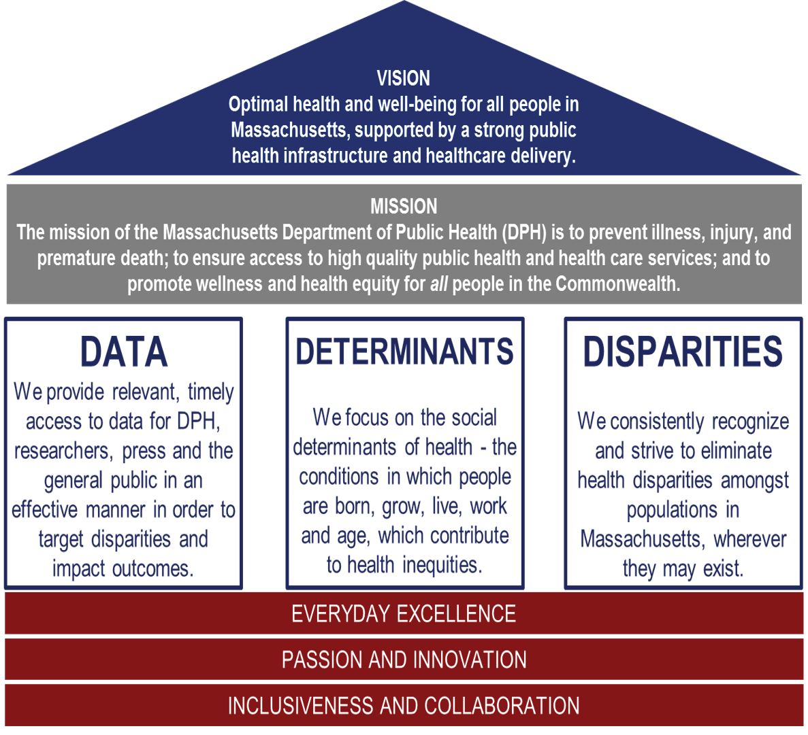

7

**OPGS’ purpose, mission, and vision support the DPH mission**

###### Purpose



Work to prevent and address problem gambling and related issues in Massachusetts.

###### Vision



To ensure a comprehensive and integrated public health response that includes using data to inform initiatives, engage communities, and ensure cultural intelligence and humility.

###### Mission



The Office works every day to mitigate the harmful effects of problem gambling and related health concerns through a variety of community-level strategies that ensure a strong public health response to problem gambling.

**Our guiding principles**



###### Community Engagement

OPGS serves the community, is inspired by the community, is guided by the needs and insights of the community,

and empowers the community, including individuals and groups passionate about addressing problem gambling and associated health concerns, at risk for problem gambling, or struggling with problem gambling and its ill effects.

###### Racial Equity

The OPGS adheres to the definition of racial equity put forth by the Center for Social Inclusion as “both an outcome and a process. As an outcome, we achieve racial equity when race no longer determines one’s

socioeconomic outcomes; when everyone has what they need to thrive, no matter where they live.”

###### Public Trust

As part of a publicly funded state agency, OPGS has a responsibility to the people of Massachusetts to ensure that all of its operations and programs are administered with integrity and strong internal controls.



###### Partnership

OPGS actively seeks to connect with others who share our vision and principles while bringing complementary knowledge, skills, and resources. The Office works with an array of public and private partners on a joint,

comprehensive, and integrated public health response to problem gambling and associated health concerns.

8

**“The purpose of the Public Health Trust Fund was to allocate resources to research, prevention, intervention, treatment, and recovery support services for problem gambling**

**and related issues.”**

9

##### Public Health Trust Fund

In 2011, The Expanded Gaming Act (G.L. c.23k) was passed, allowing for up to three destination resort casinos across the Commonwealth. The Gaming Act also created the Public Health Trust Fund from a percentage of the tax on gross gaming

revenues. The purpose of the Public Health Trust Fund was to allocate resources to research, prevention, intervention, treatment, and recovery support services for problem gambling and related issues.

In 2016, the Public Health Trust Fund Executive Committee (created to set the budget and protocols for expenditures) adopted a five-year Strategic Plan ([PDF](https://www.mass.gov/doc/strategic-plan-for-services-to-mitigate-the-harms-associated-with-gambling-in-massachusetts-0/download)) to mitigate the harmful effects of problem gambling and related issues. Over the last five years, in alignment with the Strategic Plan, OPGS established and enhanced its infrastructure and led 23 programs and services across the problem gambling

continuum of care. After five years, the Public Health Trust Fund Executive Committee has

been sunset. The work of OPGS and DPH is now directly overseen by the Executive Office

of Health and Human services. To learn more about this, [please visit our website](https://www.mass.gov/orgs/office-of-problem-gambling-services).



##### OPGS by the Numbers

Despite continuing challenges posed by the COVID-19 pandemic, we continued to serve Massachusetts residents most at risk for developing problem gambling behaviors and added new services to help support our mission. In FY21, our overall spending increased by 2 percent while our program and service count increased by 10 percent.

Please see the table below for our FY21 spending per program.

**Program / Service FY21**

1. Stakeholder Listening Sessions

10

1. Ambassador Project Region A/B
2. Ambassador Project Region C
3. Community Level Health Project - Springfield
4. Community Level Health Project - Everett
5. Evaluation for Prevention Services
6. MA Problem Gambling Helpline
7. Photovoice Region A/B
8. Photovoice Region C
9. Suicide Prevention and Problem Gambling Community-Based Activities
10. Suicide Prevention and Problem Gambling Trainings
11. MA Center of Excellence on Problem Gambling Prevention
12. MA Technical Assistance Center for Problem Gambling Treatment
13. Health Promotion Campaigns
14. Massachusetts Clearinghouse
15. Project Build Up
16. Veterans and Problem Gambling Education
17. Community Based Integration Initiatives
18. Springfield Community Health Worker Pilot
19. Staffing and Program Support

$35,000

$219,356

$68,340

$150,000

$110,204

$199,983

$274,342

$140,503

$98,011

$58,000

$57,885

$585,742

$637,414

$500,927

$16,606

$230,264

$47,342

$110,000

$160,000

$934,358

##### OPGS by the Numbers

In the pages that follow, we highlight several of our programs and services. Despite the COVID-19 pandemic, which spanned all of FY21, these programs and services thrived. All highlighted programs and services adjusted to the challenges presented by COVID-19.

**Stakeholder Listening Sessions**

One of OPGS’ longest-standing programs, and the root of the Office’s public health response to problem gambling, stakeholder listening sessions remain the cornerstone of information-gathering in at-risk communities.

**Vendors: JSI**

**FY21 KEY ACCOMPLISHMENTS:**

* Engaged communities to promote health and racial equity
* Gained input on the continued development of programs and services regarding problem gambling

# $35,000

**39**

11

“A lot of people are struggling with paying their rent on time, not having food on their tables, not being able to pay their bills, because they are addicted to going there

to gamble.” **- Stakeholder Listening Session participant**

11

**Community, government, and service organizations attended**

**85**

**Individuals attended**

**The Ambassador Project**

The Ambassador Project is a peer-based, community-centered, participatory, and culturally responsive approach to reaching a population at higher risk for problem gambling and to engaging them in prevention discussions

through individual, group, and community-level interactions. The Ambassador Project is founded upon the idea that the comorbidity between gambling, substance use, and mental health disorders indicates a need for holistic and comprehensive prevention strategies.

**Vendors: Gandara Center (3 sites), Mental Health Association FY21 KEY ACCOMPLISHMENTS:**

* + Re-procured contract and added new site in casino host community of Springfield
  + Shifted services virtually

# $260,000

**80 5**

**Conversations with high risk individuals Community events attended**

# 145

12

“We’ve really come together as a team, both within our agency and with the guys at the other sites. Despite everything going on, we were still able to be productive. We never stopped a beat.”**– Ambassador**

“One of my biggest successes as an Ambassador was when one of the guys I frequently engage with called me and said he was in need of detox. I went and picked him up and brought him to detox. It started as a gambling pitch and turned into helping further.” **– Ambassador**

12

**People who attended**

**355**

**Men of color reached**

13



“I see it is very strong for the community to be growing. […]

If we involve more, our community will be stronger. This

is an opportunity to not only participate in this activity but to act as leaders. I think this is the time. We need to take action [...]” **– Community Member**

13

**Community Level Health Project - Everett**

Community Level Health Project (CLHP) - Everett was comprised of a diverse group of stakeholders from the catchment area of the Everett casino, which included community-based agencies, community health centers, and a regional planning agency. Using the two frameworks of the social determinants of health and community engagement, the goal of the CLHP was to identify a health priority concern for the catchment area and make a data-driven and community-prioritized recommendation to MDPH for how to address gambling-related problems.

**Vendors: Boston Chinatown Neighborhood Center FY21 KEY ACCOMPLISHMENTS:**

* + Worked closely with four community-based organizations to plan, partner, engage community, and develop intervention
  + Completed CLHP planning report
  + Identified behavioral health, racial equity, and culturally appropriate services as the health priorities of this project
  + Recommended the program Project RISE (Resilient Immigrants Striving for Equity) as a continuation of this work in FY22

**Photovoice**

One of OPGS’ most impactful programs, as evidenced by the number of community members engaged, the Photovoice project uses a youth peer-to-peer approach to creating problem gambling awareness.

**Vendors: Old Colony YMCA, High Point Treatment Center, Cambridge Health Alliance, MLK Jr. Family Services, Gandara Mental Health Center**

**FY21 KEY ACCOMPLISHMENTS:**

* + Moved program virtually while engaging 60 youth and 91 caregivers
  + Widened dissemination strategies to include social media and other virtual platforms
  + Piloted enhanced call to action activities

14

“When school was all remote, this was a way for me to still

see my friends and talk to people outside of class…. even if it was still on the computer. We got our work done, but it was the social piece too.” **- Photovoice Youth**

“These opportunities are so great because we, as students, get

to learn about things that we usually don’t get to learn in school. I never knew the risks of problem gambling before this…. how much it pulls you in.” **- Photovoice Youth**

14



Photovoice participant Sylvie captured this photo. About the photo, she says, “Instead of putting yourself at risk by being exposed to gambling or other unhealthy risks, you can try a fun new trick on a skateboard or find a new hobby to try out.”

## $375,000 1713

**Community members reached**

## 91

**Caregivers engaged**

## 60

**Youth trained**

**Suicide Prevention & Problem Gambling Trainings**

Designed to provide professional development in a train-the-trainer model, suicide prevention and problem gambling trainings provide essential skills to MA Suicide Prevention Coalition members.

**Vendors: Adcare**

**FY21 KEY ACCOMPLISHMENTS:**

* + Conducted three day-long trainings
  + Conducted a five day train-the-trainer session

# $60,000 55

**Individuals who participated in trainings**

# 3

**Day-long trainings**

I thought this [training] was fun from the start, being interactive. The role play pushed me out of comfort zone, which enabled me to learn something about myself. Thanks for a great learning day.” **– Training Participant**

15

15

**Massachusetts Technical Assistance Center for Problem Gambling Treatment**

The Massachusetts Technical Assistance Center for Problem Gambling Treatment (M-TAC) provides capacity building and technical assistance (TA) services for treatment and recovery programs and providers across the Commonwealth.

**Vendors: Health Resources in Action**

**FY21 KEY ACCOMPLISHMENTS:**

* Administered the MA Problem Gambling Specialist certificate, with 13 renewals and 2 new certifications. Moved the application process online, where it is available in English and Spanish
* Completed comprehensive assessment on state-funded problem gambling treatment providers, leading to 25 TA plans and the foundation for future trainings
* Developed website, launched in FY22

# $700,000 13 25

**Renewals of the MA Problem Gambling Specialist certificate**

16

“The support your company offers makes this process less

stressful than if I had to navigate on my own.” **– Provider**

16

**Completed comprehensive assessments**



##### Looking Ahead to FY22

The Office of Problem Gambling Services and its partners celebrate all the accomplishments made together in FY21. In FY22, OPGS strives to continue its sound financial performance, embark on a strategic planning process, and further solidify itself as a national model for problem gambling prevention, intervention, and treatment.

**Office of Problem Gambling Services**

**250 Washington Street**

**Boston, MA 02108**

**mass.gov/opgs**

17

17