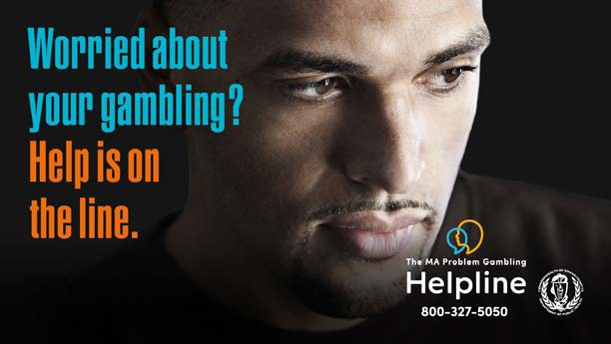

Annual Report
Fiscal Year 2022
Massachusetts Department of Public Health Office of Problem Gambling Services

Table Of Contents

Message From The Department of Public Health
03
05

OPGS Purpose, Vision, and Mission
07

OPGS by the Numbers

Who We Are and What We Do

Public Health Trust Fund
04
06
14

Looking Ahead to FY23

2

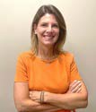
Dear Colleagues,

Message from Margret Cooke, Commissioner, Massachusetts Department of Public Health

I’m so proud of the ongoing work of The Office of Problem Gambling Services and am pleased to share this FY22 Annual Report, which outlines the year’s key achievements and demonstrates the positive impact of the Office’s work on the citizens of the Commonwealth.

We are committed to wisely using the funds that come to us from various sources, including the Public Health Trust Fund. In FY22, the Office’s budget totaled more than $10.6 million. These funds are generated by a percentage of the tax on gross gaming revenues in the Commonwealth. We put these resources back into the community in the form of research, prevention, intervention, treatment, and recovery support services for residents experiencing problem gambling and related issues.
In FY22, we used these funds to build capacity and enhance workforce development, maintain adult and youth programming, and create new linkages to better meet the needs of priority populations.

The FY22 budget represents an increase of $1 million due to enhanced tax revenue from casinos in Massachusetts. The expansion of sports gambling options expected in the months to come means that our work must expand as well. These resources will allow us to invest in new initiatives, expand existing partnerships, and continuously evaluate and improve our programs in FY23 and beyond.

We thank our many partners for their assistance and support of our efforts to mitigate the harms associated with gambling here in our Commonwealth.

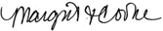
Margret Cooke, Commissioner

3

Who We Are
The Office of Problem Gambling Services (OPGS) is an Office within the Massachusetts Department of Public Health, a Department under the Commonwealth’s Executive Office of Health and Human Services (EOHHS),
the largest secretariat in Massachusetts state government. Since its inception in 2016, OPGS has engaged over 2,000 community stakeholders and 40 community partners to promote equity and empowerment and minimize the harms associated with gambling.

What We Do

OPGS is committed to the optimal health and well-being for all residents of the Commonwealth and to ensuring they are provided with healthy and equitable communities to work and live in. We work with community partners in specific areas across the state to provide problem gambling prevention, intervention, and treatment services to those who need them the most. Everyone should have the opportunity to be healthy. Everyone has the right to good health. To make this a reality, we must work together to remove barriers so that everyone has the same opportunity to improve their lives and their health. This is reflected in our programs and services, which are organized by the following categories:

Surveillance, Community Engagement,
and Evaluation

Public Awareness
Programs and Services

Technical Assistance
Workforce Training and
Supports

44

OPGS’ purpose, mission, and vision support the DPH mission

Purpose
Work to prevent and address problem gambling and related issues in Massachusetts.

Vision
To ensure a comprehensive and integrated public health response that will include utilization of data to inform initiatives, engage communities, and ensure cultural intelligence and humility.

Mission
The Office works every day to mitigate the harmful effects of problem gambling and related health concerns through a variety of community-level strategies that ensure a strong public health response to problem gambling.

Our guiding principles

Community Engagement
OPGS serves the community, is inspired by the community, is guided by the needs and insights of the community,
and empowers the community. This includes individuals and groups who are passionate about addressing problem gambling and associated health concerns, at risk for problem gambling, or struggling with problem gambling and its ill effects.

Racial Equity
OPGS adheres to the definition of racial equity put forth by the Center for Social Inclusion as “both an outcome and a process. As an outcome, we achieve racial equity when race no longer determines one’s socioeconomic outcomes; when everyone has what they need to thrive, no matter where they live.”
Public Trust
As part of a publicly funded state agency, OPGS has a responsibility to the people of Massachusetts to ensure that all of its operations and programs are administered with integrity and strong internal controls.

Partnership
OPGS actively seeks to connect with others who share the Office’s vision and principles while bringing complementary knowledge, skills, and resources.
The Office works with an array of public and private partners on a joint, comprehensive, and integrated public health response to problem gambling and associated health concerns.

5

“The purpose of the Public Health Trust Fund was to allocate resources to research, prevention, intervention, treatment, and recovery support services for problem gambling
and related issues.”
6

Public Health Trust Fund

In 2011, The Expanded Gaming Act (G.L. c.23k) was passed, allowing for up to three destination resort casinos across the Commonwealth.
The Gaming Act also created the Public Health Trust Fund (PHTF) from a percentage of the tax on gross gaming revenues. The purpose of the PHTF was to allocate resources to research, prevention, intervention, treatment, and recovery support services for problem gambling and related issues.

In 2016, the PHTF Executive Committee (created to set the overall budget and protocols for expenditures from the PHTF) adopted a
five-year Strategic Plan (PDF/DOC) to mitigate the harmful effects of problem gambling and related issues. Over the last five years, in alignment with the Strategic Plan, OPGS established and enhanced its infrastructure and led 23 programs and services across
the problem gambling continuum of care.
The Strategic Plan matured in 2021, five years since its creation, and, with that, the PHTF Executive Committee has been sunset.

In FY22, the OPGS launched a comprehensive strategic planning process that builds on the successes of the previous strategic plan to empower community voice in order to guide
its work and priorities. OPGS will work over the time period governed by this plan to continue maximizing positive impact by ensuring
reach and effectiveness of problem gambling prevention, treatment, and recovery services.

To learn more about the PHTF, please visit our website.

OPGS by the Numbers - Spending

In FY22, the Office of Problem Gambling Services continued to serve Massachusetts residents most at risk for developing problem gambling behaviors and added new services to help support our mission. Total annual spending across these programs was $ 8,035,405.

Please see the table below for our FY22 spending per program.

Program / Service FY22

- Photovoice Project
- Ambassador Project
- CHW and Gambling Pilot: Springfield
- AAPI Community Empowerment Initiative
- Community Level Health Project
- Suicide and Gambling Community-based Activities
- Suicide and Problem Gambling Training for Suicide Prevention Workforce
- Problem Gambling and Community Initiatives
- Public Awareness Campaigns
- Massachusetts Health Promotion Clearinghouse
- Technical Assistance (TA) of Prevention Services
- Stakeholder Listening Sessions
- Prevention Program Evaluation
- MA Problem Gambling Helpline Services
- Project Build Up
- MA Technical Assistance Center
- Veterans and Problem Gambling Education
- Strategic Planning
- Staffing and Program Support
$ 315,404
$ 387,072
$ 160,000
$ 100,000
$ 670,000

$ 59,247
$ 60,000
$ 110,000
$ 2,050,000
$ 19,953
$ 871,327
$ 135,230
$ 229,657
$ 367,792
$ 448,248
$ 739,862
$ 100,000
$ 25,000
$ 1,186,613

7

Community Level Health Project - Springfield

The Community Level Health Project (CLHP)-Springfield is a program that has identified a health priority concern for the catchment area of the Springfield Casino. As part of its pilot phase, the CLHP-Springfield made a data-driven and community-prioritized recommendation to DPH on how to address problem gambling-related issues which led to the launch of Beat the Odds. Beat the Odds is a youth-led group peer mentoring program that focuses on mental health topics prevalent within the group.

Vendor: Public Health Institute of Western MA FY22 KEY ACCOMPLISHMENTS:
- Updated the Beat the Odds (BTO) Peer Mentoring framework
- Branded BTO and developed resources to incentivize BTO projects and for youth to hand out at awareness events
- Completed a peer mentoring landscape analysis that provided data around training needs, mental health support for mentors and mentees, and opportunities for collaboration
- Fulfilled the Professional Development & Community Education training initiative
- Engaged Behavioral Health CEOs through quarterly meetings to gain direct knowledge of the treatment infrastructure in Greater Springfield and align the coalition’s prevention efforts
19

157

Clinicians, community health workers, residents, educators, and CBO leaders trained through Professional Development and Community Education initiative

Organizations involved in Design, Advisory, Communications, Youth Advisory communities, and quarterly Behavioral Health CEO meetings

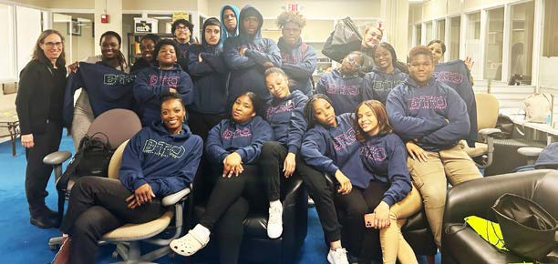

“. . . some end up going the pathway towards drugs and gangs, but if you can join a group like this, you can go on a better path.” – Youth Group Participant
8
8

Community Level Health Project - Everett
The Community Level Health Project (CLHP)-Everett is a program that has identified a health priority concern for the catchment area of the Everett casino. As part of its pilot phase, the CLHP-Everett made a data-driven and community- prioritized recommendation to DPH on how to address problem gambling-related issues, leading to the launch of the Asian American and Pacific Islanders (AAPI) Empower Project and Project RISE (Resilient Immigrants Strive for Equity). Both projects engage their community to raise awareness and discuss the impacts of problem gambling.

Vendor: Boston Chinatown Neighborhood Center (BCNC) FY22 KEY ACCOMPLISHMENTS:
AAPI Empowerment Project:
- Implemented recreational activities and raised awareness of problem gambling in the community
- Built trusting relationships with program participants, who have demonstrated an increased willingness to talk about problem gambling
- Encouraged participation in volunteer programs, provided up-to-date information and resources, destigmatized mental health and problem gambling by facilitating conversations with participants and offering more community events related to traditional cultural festivals
Project RISE:
- Hired family connectors at partner agencies
- Integrated Project RISE into the host agencies and built capacity to address problem gambling within the community
- Strengthened the relationship between BCNC and its partners — Everett Haitian Community Center and Eliot Family Resource Center.

3589

People impacted by
AAPI Empowerment Project
3 Project Rise Connectors hired

“The casino keeps sending an invitation letter to me every month. I went there several times because I didn’t know what activities I could attend in my community. I am retired and free every day. After participating in your events, I am pleased to meet new friends and play ping pong with them without any language barrier.” – Program Participant

9
9

Public Awareness Campaigns
Public Awareness Campaigns are a key component of OPGS’ prevention framework and are part of the Let’s Get Real About Gambling Platform, aimed at promoting frank conversations about gambling as an issue of health equity. These public awareness campaigns have used comprehensive strategies that include social media, websites, radio, streaming, billboards, and more to bring attention to problem gambling, particularly among priority populations.

Vendor: ThinkArgus

FY22 KEY ACCOMPLISHMENTS:

- Developed additional assets in Spanish for every public awareness campaign
- Launched the MA Problem Gambling Helpline campaign during Problem Gambling Awareness month with strategic media placements in high visibility areas around casinos
- Expanded the Holiday Lottery campaign with radio and out-of-home tactics
- Redesigned the First Step to Change Workbook and expanded languages to Spanish, Vietnamese, Traditional Chinese, and Simplified Chinese
- Successfully launched multiple public awareness campaigns simultaneously with excellent results

million
12
Impressions, General Campaign

million
Impressions, Helpline Campaign
43.66

million
Final impressions, all campaigns
97.35

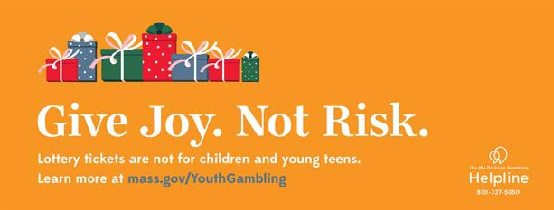

10
10

Project Build Up
Project Build Up (PBU) is a capacity-building and workforce development program that aims to strengthen the capacity of the workforce in outpatient substance use and gambling treatment agencies through grants and Learning Academies focused on priority populations. Through PBU, treatment agencies enhance their capacity to provide
or promote gambling treatment services, with an emphasis on addressing the impact of problem gambling on populations that are disproportionately affected.

Vendor: Health Resources in Action (HRiA) FY22 KEY ACCOMPLISHMENTS:
38
53
7

Staff receiving paid time through PBU to attend trainings
47
Mental health professionals receiving the Community Champion Scholarship
Participants from substance use and gambling treatment agencies and CBOs who attended 3 PBU Learning Academies
Outpatient substance use and gambling treatment agencies, and one CBO received PBU funding

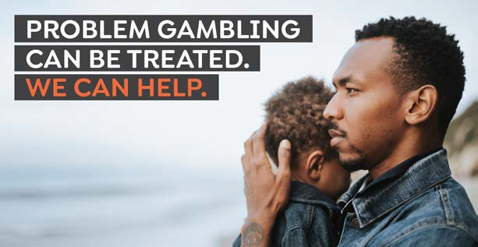

“Staff has gained valuable knowledge of available support for individuals with gambling-related issues, as well as technical assistance and consultation support for providers.”– Participant
11
11

MA Technical Assistance Center for Problem Gambling

The Massachusetts Technical Assistance Center for Problem Gambling Treatment (M-TAC) provides capacity building and technical assistance (TA) services for treatment and recovery programs and providers across the Commonwealth.

Vendor: Health Resources in Action (HRiA) FY22 KEY ACCOMPLISHMENTS:

- Launched M-TAC website to provide treatment agencies with the most up-to-date information on programs, services, and trainings
- Implemented Phase 1 of the Community Voices in Recovery program, including the development and launch of the Gambling Case Study Series online course with two modules
- Uploaded and launched online courses with 10 modules and a case study series with two modules

Bureau of Substance Addiction Services (BSAS) programs engaged with M-TAC
27
173

Total number of participants attending trainings

“Many people from my organization attended this training. I think this has opened a door for us to talk about racism and implicit bias among ourselves.”

Course Participant

“I will definitely utilize the screening tools with clients and will also use the techniques presented to create a safe place for the client to discuss his gambling behaviors.”

Course Participant
12
12

MA Center of Excellence on Problem Gambling Prevention

The Massachusetts Center of Excellence on Problem Gambling Prevention (MCOE PGP) provides a range of capacity building services to support local communities in understanding, addressing, and implementing projects focused
on problem gambling prevention. MCOE PGP provides technical assistance to OPGS’ Photovoice, Ambassadors, and Community Level Health Project initiatives.

Vendor: Education Development Center FY22 KEY ACCOMPLISHMENTS:
  - Trained nine new photovoice staff in the five-hour Photovoice Staff Training and provided targeted support during project implementation
  - Trained six new ambassadors in the 15-hour Ambassador Training
  - Developed three short, animated videos to raise awareness about issues related to problem gambling prevention
  - Launched the MCOE website to the public to provide the most up to date information on problem gambling prevention services in Massachusetts
  - Trained 51 people in A Public Health Approach to problem gambling training

158

Participants receiving ongoing coaching and support
185

Training participants

“Having a TA team with diverse perspectives has really helped to understand the complex issues related to problem gambling and health equity.
I value their input.” – Program Participant

13
13

Looking Ahead to FY23

The Office of Problem Gambling Services and its partners celebrate all the accomplishments made together in FY22. In FY23, OPGS strives to continue its sound financial performance, finalize and launch its new strategic plan, and further solidify itself as a national model for problem gambling prevention, intervention, and treatment while preparing for an anticipated increase in the need for services resulting from the implementation of sports gambling in
the Commonwealth.

FY23 GOALS INCLUDE:

  - Launch our strategic planning process to establish OPGS’ goals for the next three - five years based on the priorities identified through the engagement of the community and those disproportionately impacted by problem gambling
  - Expand the Photovoice youth program across seven sites and implement a Call to Action component that encourages youth to use their voices to advocate for their communities
  - Launch the Community Wellness Project (CWP) procurement to build upon the work completed in the Community Health Workers (CHWs) and Gambling Pilot program, which saw CHWs engaging within their communities to raise awareness about problem gambling
  - Launch an enhanced Let’s Get Real About Gambling platform, which will unite OPGS’ various public awareness campaigns under one vision and expand their reach
  - Engage veteran-serving organizations through M-TAC to assess technical assistance needs to increase their capacity to address problem gambling treatment among the Veteran population

1144

15

Office of Problem Gambling Services

250 Washington Street
Boston, MA 02108
mass.gov/opgs

