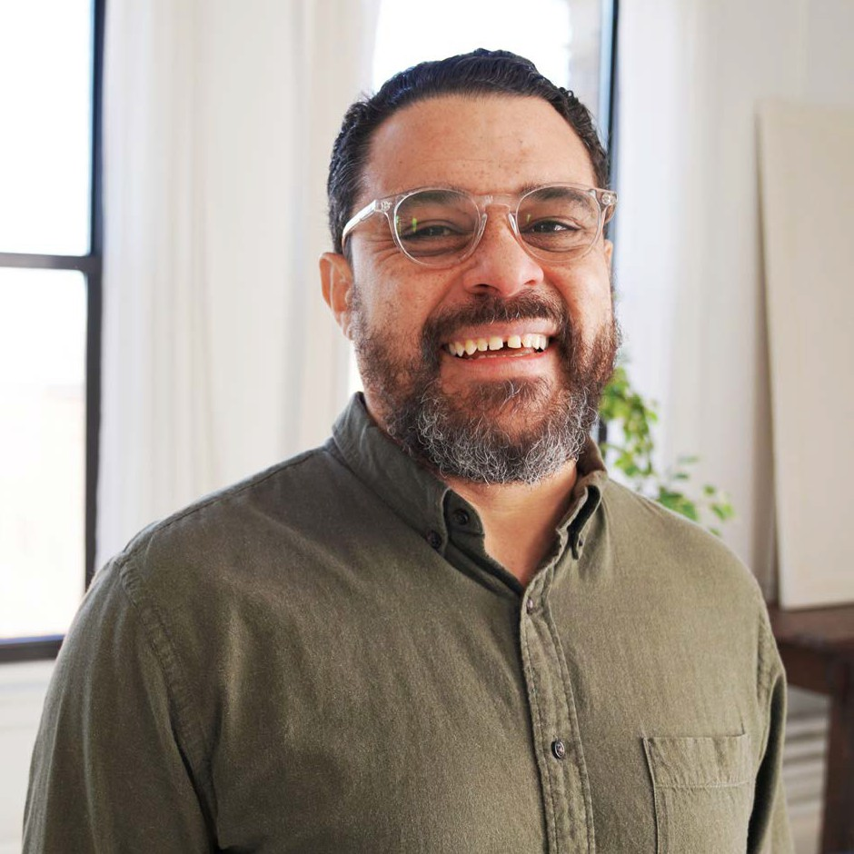
FY 23
Annual Report
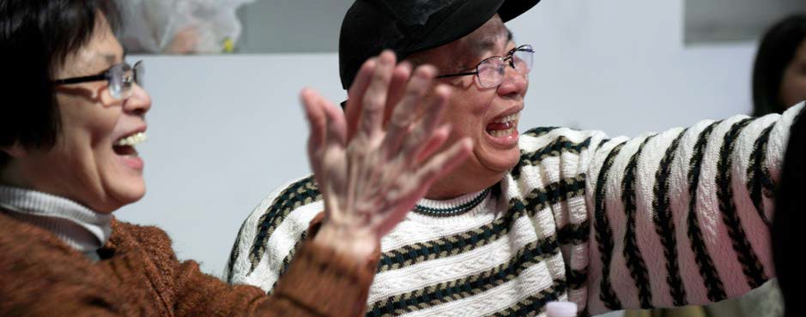
Massachusetts Department of Public Health Office of Problem Gambling Services

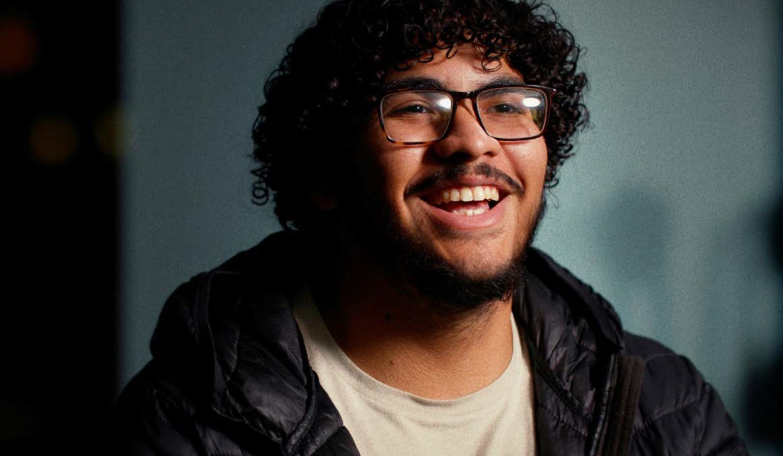

Table Of Contents
03

Message From The Department of Public Health
06

Public Health Trust Fund
08

Prevention
16

Looking Ahead to FY24

Who We Are and What We Do

OPGS by the Numbers
04
07
12

Treatment

2

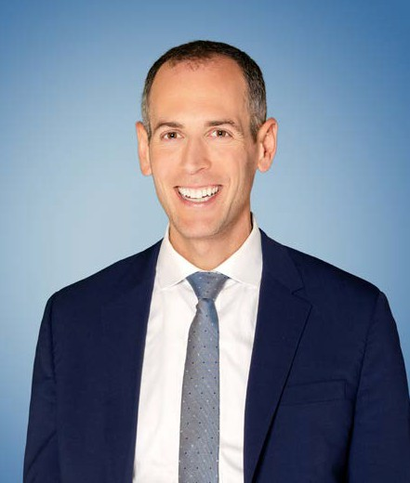
Dear Colleagues,

Message from Dr. Robert Goldstein, Commissioner, Massachusetts Department of Public Health

In 2023, gambling opportunities in the Commonwealth were expanded through the legalization of sports wagering. With this expansion came new challenges in the effort to mitigate the potential harm that gambling can cause to individuals and families. The work of the Massachusetts Department of Public Health’s Office of Problem Gambling Services (OPGS) is more important than ever. I am proud to share this FY23 Annual Report, which highlights the key accomplishments of OPGS and its partners and their positive impact on residents in Massachusetts.

OPGS is committed to strategically using its funding from various sources, including the Public Health Trust Fund, to develop programs and services centered on data and evidence, ensuring optimal impact. In FY23, the Office’s budget totaled more than $17.2 million. These funds are generated by a percentage of the tax on gross gaming and sports wagering revenues in the Commonwealth and are critical to protecting and supporting the wellbeing of our fellow residents.

The FY23 budget represents an increase of $6 million for programs, with the additional funding related to enhanced tax revenue from casinos and sports wagering in Massachusetts. OPGS prioritizes putting these resources back into the community through surveillance, prevention, intervention, and treatment and support services. In FY23, we used these funds to train and support treatment providers, expand youth programming, enhance public awareness, and sustain programs anchored in the community. With the expansion of sports wagering, we remained committed to applying these resources to aid those at risk and those affected by problem gambling.

We thank our many partners for their work and support in our shared efforts to promote wellness and health equity for all people in our state.
Dr. Robert Goldstein, Commissioner

3

Who We Are
The Office of Problem Gambling Services (OPGS) is an Office within the Massachusetts Department of Public Health, a Department under the Commonwealth’s Executive Office of Health and Human Services (EOHHS),
the largest secretariat in Massachusetts state government. Since its inception in 2016, OPGS has engaged over 2,000 community stakeholders and 40 community partners to promote equity and empowerment and minimize the harms associated with gambling.

What We Do
OPGS is committed to the optimal health and well-being of all residents of the Commonwealth and to ensuring they are provided with healthy and equitable communities to work and live in. We work with community partners in specific areas across the state to provide problem gambling prevention, intervention, and treatment services to those who need them the most. Everyone should have the opportunity to be healthy. Everyone has the right to good health. To make this a reality, we must work together to remove barriers so that everyone has the same opportunity to improve their lives and their health. This is reflected in all the work we do, which is organized into the following categories:

Surveillance and Community
Engagement

Workforce and Training
Support
Programs and Services

Public Awareness
Technical
Assistance and Evaluation

44

OPGS’ purpose, mission and vision support the MDPH mission

Purpose
Work to prevent and address problem gambling and related issues in Massachusetts.

Vision
To ensure a comprehensive and integrated public health response that will include utilization of data to inform initiatives, engage communities, and ensure cultural intelligence and humility.

Mission
The Office works every day to mitigate the harmful effects of problem gambling and related health concerns through a variety of community-level strategies that ensure a strong public health response to problem gambling.

Our guiding principles

Community Engagement
OPGS serves the community, is inspired by the community, is guided by the needs and insights of the community, and empowers the community, including individuals and groups who are passionate about addressing problem gambling and associated health concerns, at risk for problem gambling, or struggling with problem gambling and its ill effects.

Public Trust
As part of a publicly funded state agency, OPGS has a responsibility to the people of
Massachusetts to ensure that all of its operations and programs are administered with integrity and strong internal controls.

Partnership
OPGS actively seeks to connect with others who share the Office’s vision and principles while bringing complementary knowledge, skills, and resources. The Office works with an array of public and private partners on a joint, comprehensive, and integrated public health response to problem gambling and associated health concerns.

Racial Equity
OPGS adheres to the definition of racial equity put forth by the Center for Social Inclusion as “both an outcome and a process. As an outcome, we achieve racial equity when race no longer determines one’s socioeconomic outcomes; when everyone has what they need to thrive, no matter where they live.”

5
5

“The purpose of the PHTF was to allocate resources to research, prevention, intervention, treatment, and recovery support services for problem gambling and related issues.”
6

Public Health Trust Fund

In 2011, The Expanded Gaming Act (G.L. c.23k) was passed, allowing for up to three destination resort casinos across the Commonwealth. The Gaming Act also created the Public Health Trust Fund (PHTF) from a percentage of the tax on gross gaming revenues. The purpose of the PHTF was to allocate resources to research, prevention, intervention, treatment, and recovery support services for problem gambling and related issues.

In 2023, the state legislature passed An Act to Regulate Sports Wagering (Bill H.5164). The act built off the framework of the Expanded Gaming Act and further increased opportunities
for gambling within the Commonwealth. Like the Expanded Gaming Act, this legislation allocates a portion of resources to the Public Health Trust Fund. The introduction of sports wagering has changed the gambling environment, resulting in increased access that has raised concerns about related harms.

In light of this change, OPGS has built a foundation to continue leading and enhancing its work to mitigate harms. In FY23, OPGS focused on prevention and treatment, working towards helping people understand what problem gambling is and ensuring that those who need help can access resources and treatment.
Through the Public Health Trust Fund, OPGS has established the foundation for leading the public health response to problem gambling across the Commonwealth. The Office critically analyzes data, works alongside communities, and promotes equity to ensure that communities and individuals who experience the greatest inequities are at the center of its efforts to mitigate harm.

To learn more about the PHTF,
please visit our website.

OPGS by the Numbers - Spending

In FY23, the Office of Problem Gambling Services continued to serve Massachusetts residents most at risk for developing problem gambling behaviors. The final budget for FY23 was $17,295,011.

Total annual spending across these programs in FY23 was $8,166,911. The remaining balance is allocated for the planning and development of new initiatives as OPGS continues to scale its services and initiatives across the continuum of care.
Please see the table below for our FY23 spending per program.

Program / Service FY23

Photovoice Project Ambassador Project
$ 558,093
$ 415,688

AAPI Community Empowerment Initiative $ 100,000

Beat the Odds (Community Level Health Project, Springfield) Project RISE (Community Level Health Project, Everett) Suicide and Problem Gambling Training for Suicide Prevention Workforce
Public Awareness Campaigns
Massachusetts Health Promotion Clearinghouse Technical Assistance (TA) of Prevention Services Stakeholder Listening Sessions Prevention Program Evaluation MA Problem Gambling Helpline Services Project Build Up
MA Technical Assistance Center Veterans and Problem Gambling Education Staffing and Program Support
$ 325,000
$ 370,000
$ 59,423
$ 1,942,217
$ 11,978
$ 895,424
$ 123,813
$ 249,994
$ 296,822
$ 398,454
$ 904,417
$ 100,000
$ 1,415,588

7

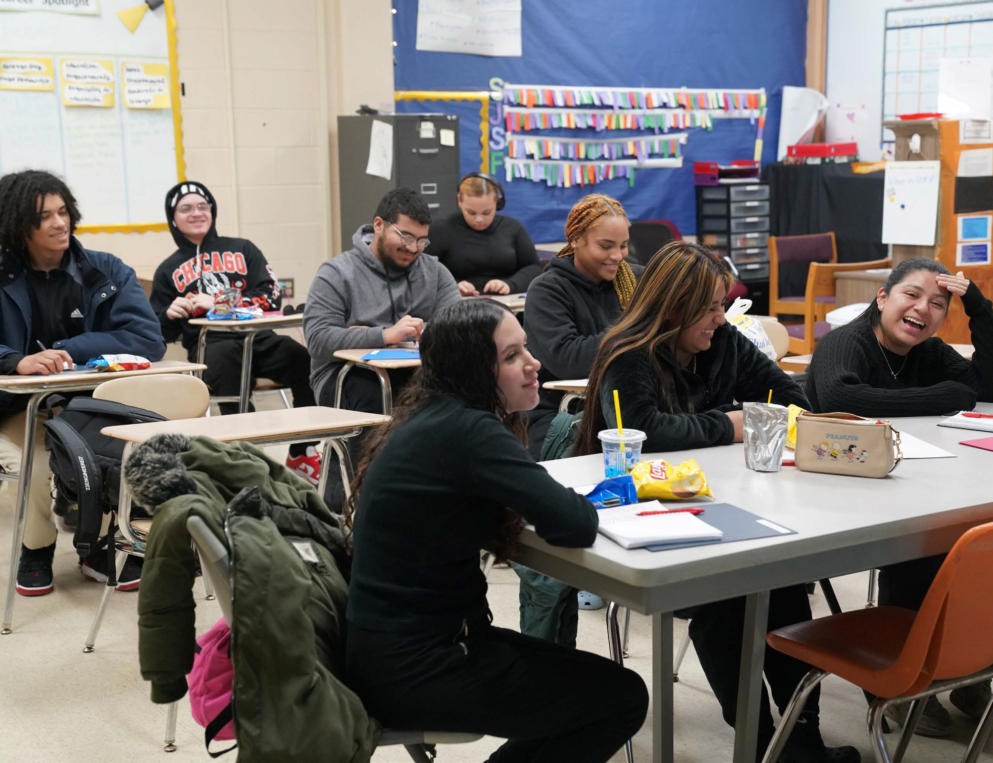
Prevention

Prevention is defined as the development of personal skills and community resources, while also working to change harmful social-environmental conditions.
Environmental conditions play a major role in health outcomes, including gambling harms. Prevention is a key strategy in the mitigation of harm associated with gambling, as informed by evidence and data. OPGS
continues its efforts to deliver comprehensive, community-centered, and culturally relevant prevention services.

Youth participate in a Beat The Odds session, discussing mental 8
health and problem gambling in their Springfield community.

Project RISE

Project RISE (Resilient Immigrants Strive for Equity) is a community engagement initiative that provides culturally and linguistically appropriate services and strengthens the fabric of immigrant communities by providing ongoing support. The project aims to promote emotional wellness and to create a sense of belonging within immigrant communities. The initiative was developed through the Community
Level Health Project, a two-phased intervention to build capacity and provide services and prevention programs for behavioral health. Through an extensive process
of research and community engagement, results from the planning year demonstrated behavioral health for immigrant communities as a priority issue within the catchment area of the casino in Everett.

Vendor: Boston Chinatown Neighborhood Center (BCNC)

FY23 KEY ACCOMPLISHMENTS:

- The Everett Haitian Community Center (EHCC) family connector created informational resources to distribute to community members and promote the initiative.
- Created summer internships for participants of the Passionate Work intervention.

- Held the annual Quincy 5K Fun Run and Quincy Family Fun Fair, which was attended by more than 700 guests.

- Participated in many other community events, including the Evergreen Breakfast, which hosted 145 families, and the End of School Bash, which hosted 130 families.
- Developed a webpage and Instagram account to showcase the mission of the project, provide background information, advertise upcoming events and activities, and share any other relevant information.
50

families reached by Project RISE
500
participants enrolled in the Children’s Wellness Activities with Emerging Bright Stars Academy

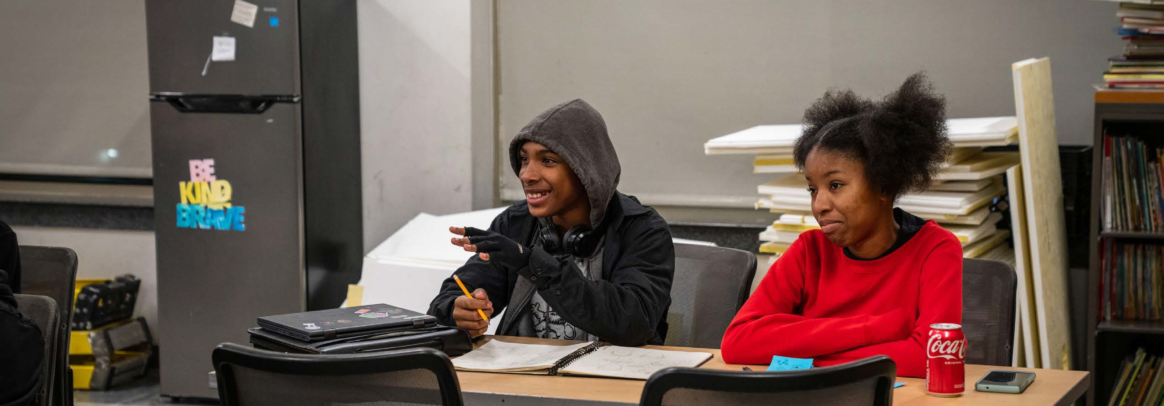
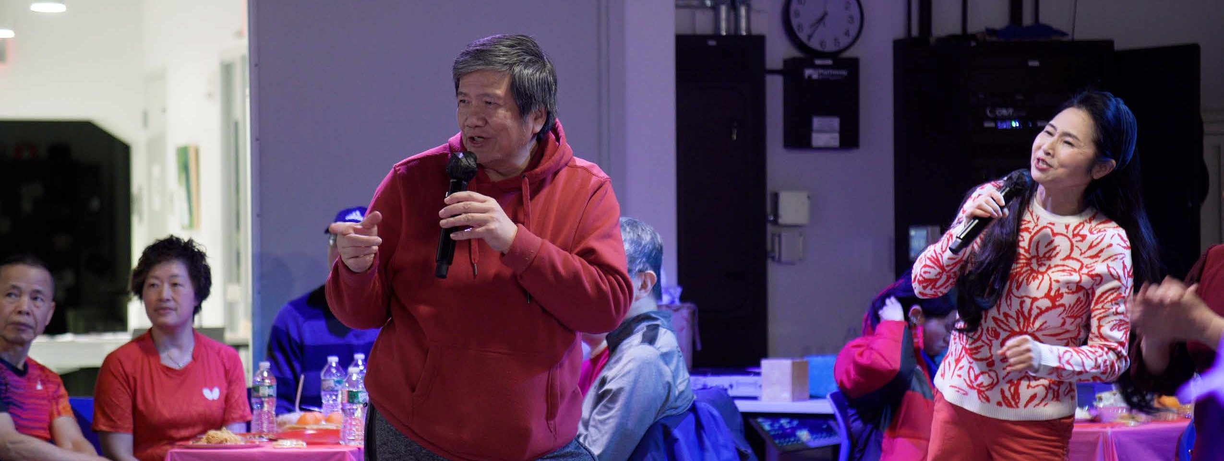
9
Participants sing karaoke as part of a weekly event hosted by BCNC in Boston’s Chinatown.
9

Ambassador Project

The Ambassador Project is a peer-based, community- centered, participatory, and culturally responsive approach to reaching a population at higher risk for problem gambling and to engaging them in prevention discussions through individual, group, and community- level interactions. The Ambassador Project is founded
upon the idea that the comorbidity between gambling, substance use, and mental health disorders indicates a need for holistic and comprehensive prevention strategies. The Project aims to address the well- established relationship between problem gambling and other health and behavioral health issues.

Vendor: Gandara Center – Hope for Holyoke, Gandara Center – PIER Recovery, Gandara Center – Stairway to Recovery

FY23 KEY ACCOMPLISHMENTS:

- In FY23, the Massachusetts Ambassador Project celebrated its 5-year milestone. Ambassadors remained committed to building lasting relationships with their communities and connecting individuals at risk of problem gambling to the supports they need.
- Ambassadors became full-time employees, enabling them to make a greater impact and contribution to those in their communities who sought education or resources about problem gambling.
- Ambassadors facilitated small group discussions with individuals and organizations, including treatment organizations, recovery organizations, social service organizations, and the faith community.

One-on-one conversations with high-risk individuals:

715
Small group educational sessions delivered:

118
Large group presentations delivered:

32

Number of people who received informational materials:

1,114
Community events attended:

31
Organizations engaged by Ambassadors:

94

4,215 Total people reached through the Ambassador Project
109
10

Public Awareness Campaigns

Public Awareness Campaigns are a key component of OPGS’ prevention framework and are part of the Let’s Get Real About Gambling Platform, aimed at promoting frank conversations about gambling as an issue of health equity. These public awareness campaigns
have used comprehensive strategies that include social media, websites, radio, streaming, billboards, and more to bring attention to problem gambling, particularly among priority populations.

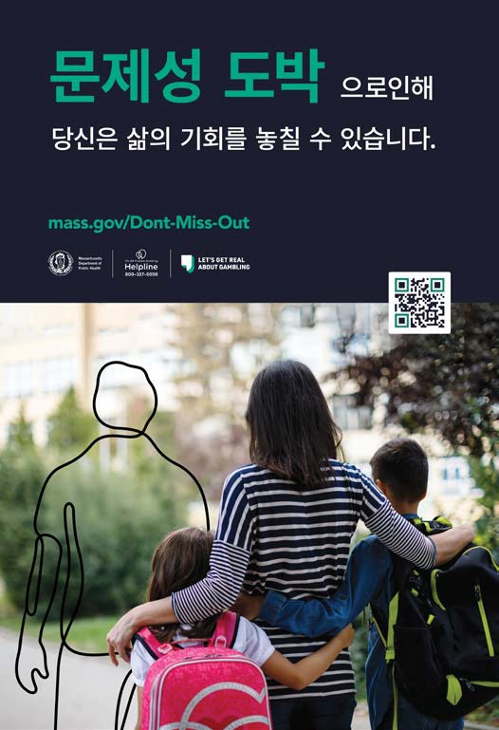
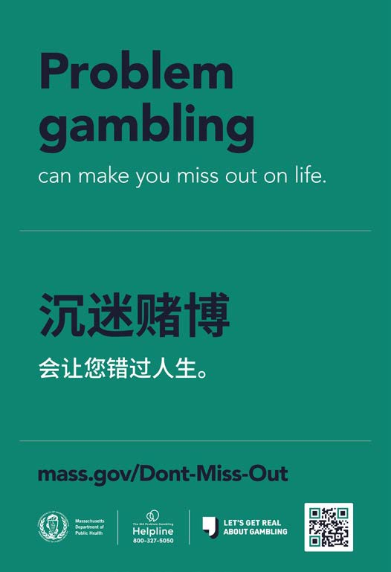
Vendor: ThinkArgus

FY23 KEY ACCOMPLISHMENTS:

- Launched the new Let’s Get Real About Gambling Campaign, aimed at raising awareness of problem gambling warning signs. The campaign served as the basis for OPGS’ redesigned public awareness platform mass.gov/ ProblemGambling.
- In partnership with the Mass State Lottery, relaunched the Holiday Lottery campaign for parents and trusted adults with children under 18. The campaign’s goal was to discourage gifting lottery tickets to minor children. The campaign had 8,137,519 total impressions.
- Developed and launched the Asian American Campaign, aimed at raising awareness about problem gambling within Chinese, Vietnamese, and Korean families and communities.
- Re-launched various campaigns, including Older Adults, Men of Color, and the MA Problem Gambling Helpline campaign

17.71 million
Impressions, General Campaign
36.15 million
Impressions, Asian American Campaign
148.09 million
Final impressions, all campaigns Posters from the Asian American campaign.

11
11

Treatment

Problem gambling treatment within outpatient services is funded by third party reimbursement.
Treatment support initiatives are enhancements to problem gambling treatment which includes the following: helpline services, professional development for treatment providers, capacity building for community-based agencies, early detection/screening access, grants to enhance treatment awareness/access, and clinical tools and resources for providers.

12

MA Technical Assistance Center on Problem Gambling Treatment

The Massachusetts Technical Assistance Center for Problem Gambling Treatment (M-TAC) provides free capacity building and technical assistance services for treatment and recovery programs and providers across the Commonwealth. M-TAC utilizes Health Resources in Action’s history of developing and implementing statewide capacity building programs and the Division on Addiction at Cambridge Health
Alliance’s research expertise on addiction and gambling disorders. M-TAC is guided by public health principles, built on data and evidence, and focused on equity. It understands the intersection of problem gambling and co-occurring substance use and mental health disorders and creates capacity building assistance in alignment with such intersections.

Vendor: Health Resources in Action (HRiA)

FY23 KEY ACCOMPLISHMENTS:

- Conducted 16 training courses for clinicians and providers regarding problem gambling.

- Hosted four Statewide Meetings for problem gambling treatment providers.

- Conducted external trainings requested directly by treatment organizations, with a total of 25 participants.

- Promoted its learning management system, resulting in 48 individuals completing online courses and receiving continuing education credits.
- Processed applications for the MA Problem Gambling Specialist Certificate (MA PGS).
86

221

individuals trained through M-TAC

people received
27
MA PGS certification

people attended M-TAC statewide meetings

“I’m so excited to host an event on Gambling Disorder Screening Day in my town, which will be in coordination with the work my nonprofit is doing to enhance awareness.”

- M-TAC training participant
13
13

Project Build Up

Project Build Up (PBU) is a capacity building and workforce development program that aims to strengthen the capacity of the workforce in outpatient substance use and gambling treatment agencies through
grants and Learning Academies focused on priority
populations. Through PBU, treatment agencies will enhance their capacity to provide or promote gambling treatment services, with an emphasis on addressing the impact of problem gambling on populations that are disproportionately affected.

Vendor: Health Resources in Action (HRiA)

FY23 KEY ACCOMPLISHMENTS:

- Provided $36,127 in grants to both clinical providers and community-based organizations.

- Launched office hours for grantees to discuss clinical topics, the promotion of problem
gambling-related services, the role of community supports, and the MA Problem Gambling Helpline.

- Hosted four Learning Academies, including:

  - Promoting and Providing Problem Gambling Services

  - Impacts of Trauma on Problem Gambling Development & Recovery

  - Promoting and Providing Problem Gambling Treatment Services to Black, African American, and African Descent Communities
  - Promoting and Providing Problem Gambling Treatment Services to People with Incarceration Experience
83

organizations received PBU grants
34
6
individuals had staff time covered to attend M-TAC trainings
individuals participated in PBU Learning Academies

“I liked [hearing] the lived experiences of the people who spoke. It makes learning more effective to hear how people with a gambling disorder struggle and cope or overcome
a gambling problem.”

- Learning Academy participant
14
14

Massachusetts Problem Gambling Helpline

In July 2020, OPGS integrated the Massachusetts Problem Gambling Helpline to better serve people experiencing problem gambling related issues in the Commonwealth of Massachusetts. The overall goal was to improve the consumer experience for those seeking treatment and support, increase reach, and
achieve greater efficiency and alignment — all while access to gambling expands in Massachusetts. The Helpline serves as the key safety net and central hub for problem gambling education, information, treatment referrals, and support for individuals, families, and the professional community

Vendor: Health Resources in Action (HRiA)

FY23 KEY ACCOMPLISHMENTS:

- Helpline specialists referred 636 callers to a variety of services to address problem gambling, including treatment services.
- Time until access to service improved from 39 seconds last year to 36 seconds this year.

- 97% of callers reported receiving the information that they needed, further demonstrating the importance of Helpline services in connecting Massachusetts residents to care.

3,112

people called for problem gambling concerns
362

callers referred to outpatient treatment services

235

callers referred to gambling self-help & recovery support

callers referred to voluntary self-exclusion
74

“I just wanted to say thank you to [calltaker]. He very calmly walked me through the options that I have for my 18 year old son. He seems to have a gambling problem so I appreciate that… I have good information now. So, thank you very much.”

- Problem Gambling Helpline caller
15
15

Looking Ahead to FY24

The Office of Problem Gambling Services and its partners celebrate all the accomplishments made together in FY23. In FY24, OPGS strives to continue leading the public health response to problem gambling by prioritizing prevention, treatment, and data to develop and launch new initiatives that directly address the harms associated with gambling.

FY24 GOALS INCLUDE:

- Launch the Data to Action Framework, a robust surveillance infrastructure to
improve understanding of the impacts of problem gambling on the Commonwealth. Data from the surveillance projects will inform future initiatives and policies to reduce harms associated with gambling.

- Initiate the Community Wellness Project (CWP) to build upon the work completed in the Community Health Workers (CHWs) and Gambling Pilot program, which saw CHWs engaging within their communities to raise awareness about problem gambling. This project will serve as a bridge to treatment and increase access for those who need help.

- Enhance our Let’s Get Real About Gambling platform to increase awareness and understanding of problem gambling throughout the Commonwealth. OPGS will launch new campaigns for priority populations, including college students and males 20-29, as well as develop new toolkits and resources for our partners, treatment centers, and community-based organizations.
- Host the 2024 MA Problem Gambling Conference to increase training opportunities for social service providers. The conference will provide a space for authentic discussion and dialogue, where individuals with lived experience and individuals with professional expertise can continue to advance the public health response to problem gambling.

- Implement the first phase of the Bridge Initiative: a comprehensive strategy for the enhancement of gambling treatment engagement, awareness, and support.

1166

Office of Problem Gambling Services
250 Washington Street
Boston, MA 02108

mass.gov/opgs

17

