INDOOR AIR QUALITY ASSESSMENT

Office of the Chief Medical Examiner
720 Albany Street
Boston, MA

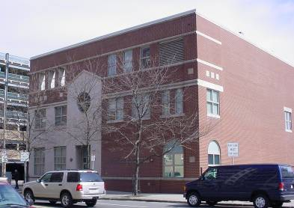

Prepared by:
Massachusetts Department of Public Health
Center for Environmental Health
Emergency Response/Indoor Air Quality Program
April 2007

Background/Introduction
At the request of the Executive Office of Public Safety (EPS) and the Office of the Chief Medical Examiner (OCME), the Massachusetts Department of Public Health (MDPH), Center for Environmental Health (CEH) conducted an indoor air quality assessment at the OCME, 720 Albany Street, Boston, Massachusetts. The request was prompted by odor complaints and concerns relative to the adequacy of fresh air ventilation in the building.
On March 27, 2007, a visit to conduct an indoor air quality assessment was made to the OCME by Michael Feeney, Director of CEH’s Emergency Response/Indoor Air Quality (ER/IAQ) Program. Mr. Feeney was accompanied by Cory Holmes, an Environmental Analyst in CEH’s ER/IAQ Program. Prior to the assessment, CEH staff met with Ms. Marsha Izzi, Chief Administrative Officer and Bill Hanson, Facilities Manager, as well as representatives from the Massachusetts Department of Labor and Workforce Development (MDLWD), Division of Occupational Safety (DOS).
The OCME is located in a two-story red brick building that was constructed in the mid- 1990s. The OCME performs case investigations and autopsies within this facility. The second floor of the building contains administrative offices, a kitchen and break room. The majority of the first floor consists of the autopsy suite, which contains autopsy rooms, offices, processing areas, supply storage areas, locker rooms and two walk-in coolers used to store case subjects. The main hallway of the autopsy suite is used as a staging area for case subjects prior to autopsy. Ms. Izzi reported that the large cooler has a capacity for remains of 75 and the small cooler has a capacity of 25, both of which have been filled beyond capacity. Due to an increase in case load, the OCME also utilizes a refrigerator truck, located behind the building, for additional storage. A waiting room, reception area and Massachusetts State Police offices are also located on the first floor at the front of the building. The first floor reception area is separated from the autopsy suite by a single set of double doors (Picture 1). Stairwells providing access to second floor offices are located at the front and back of the building. An elevator is adjacent to the stairwell at the front of the building. At the rear of the building is a three bay garage and a semi-enclosed parking lot surrounded by a ten-foot high brick wall.
Concurrent with the MDPH assessment, the OCME is conducting a feasibility study with their HVAC vendor and Division of Capital Asset Management (DCAM) to make improvements to the mechanical ventilation system/facilities. In addition, the DOS is working with OCME staff to monitor current work safety conditions and to develop and implement a worker safety training program. To this end the MDPH Radiation Control Program (RCP) has also issued a notice of violation outlining worker safety and other issues that must be addressed by the OCME.

Methods
Air testing for carbon dioxide, temperature and relative humidity were conducted with a TSI, Q-Trak, IAQ Monitor, Model 8551. Moisture content of porous building materials (e.g., carpeting, gypsum wallboard, wood) was measured with Delmhorst, BD-2000 Model, Moisture Detector with a Delmhorst Standard Probe. CEH staff also performed visual inspection of building materials for water damage and/or microbial growth. In addition to various air quality tests, CEH staff conducted a visual assessment of the building to identify potential pathways for odors from the autopsy suite to migrate into adjacent/occupied areas.

Results
The OCME has an employee population of approximately 60, with a number of members of the public visiting on a daily basis. The tests were taken during normal operations. Test results appear in Table 1. Wind speed/direction information for the day of the assessment is included in Table 2.

Discussion
Ventilation
It can be seen from Table 1 that carbon dioxide levels were below 800 parts per million (ppm) in all areas surveyed on the day of the assessment, which typically indicates adequate air exchange. However, it is important to note that despite adequate introduction of fresh air, decomposition odors from case subjects were prevalent outside the autopsy suite, indicating pathways for odor migration to occupied work areas within the building. These pathways are discussed in detail in the Odor Investigation section of this assessment.
Mechanical ventilation is supplied by air-handling units (AHUs) located in the rooftop penthouse. Fresh air is drawn into the AHUs through air intakes located on the exterior of the penthouse. Ceiling-mounted air diffusers ducted to the AHUs distribute fresh, tempered air to the spaces. Ceiling-mounted exhaust vents ducted to rooftop motors remove air from the spaces. The autopsy rooms are connected to a separate rooftop exhaust motor; exhaust is released 20+ feet from the roof surface. As reported by Mr. Hanson, exhaust air from the autopsy rooms passes through a bank of high efficiency particulate arrestance (HEPA) filters prior to release.
To maximize air exchange, the MDPH recommends that both supply and exhaust ventilation operate continuously during periods of occupancy. In order to have proper ventilation with a mechanical supply and exhaust system, the systems must be balanced to provide an adequate amount of fresh air to the interior of a room while removing stale air from the room. It is recommended that HVAC systems be re-balanced every five years to ensure adequate air systems function (SMACNA, 1994). According to Ms. Izzi, the date of the last balancing of these systems occurred over ten years ago.
The Massachusetts Building Code requires that each area have a minimum ventilation rate of 20 cubic feet per minute (cfm) per occupant of fresh outside air or openable windows (SBBRS, 1997; BOCA, 1993). The ventilation must be on at all times that the room is occupied. Providing adequate fresh air ventilation with open windows and maintaining the temperature in the comfort range during the cold weather season is impractical. Mechanical ventilation is usually required to provide adequate fresh air ventilation.
Carbon dioxide is not a problem in and of itself. It is used as an indicator of the adequacy of the fresh air ventilation. As carbon dioxide levels rise, it indicates that the ventilating system is malfunctioning or the design occupancy of the room is being exceeded. When this happens, a buildup of common indoor air pollutants can occur, leading to discomfort or health complaints. The Occupational Safety and Health Administration (OSHA) standard for carbon dioxide is 5,000 parts per million parts of air (ppm). Workers may be exposed to this level for 40 hours/week, based on a time-weighted average (OSHA, 1997).
The MDPH uses a guideline of 800 ppm for publicly occupied buildings. A guideline of 600 ppm or less is preferred in schools due to the fact that the majority of occupants are young and considered to be a more sensitive population in the evaluation of environmental health status. Inadequate ventilation and/or elevated temperatures are major causes of complaints such as respiratory, eye, nose and throat irritation, lethargy and headaches. For information concerning carbon dioxide, please see Appendix A.
Temperature readings ranged from 71º F to 75 º F, which were within the MDPH recommended comfort guidelines on the day of the assessment. The MDPH recommends that indoor air temperatures be maintained in a range of 70 º F to 78 º F in order to provide for the comfort of building occupants. In many cases concerning indoor air quality, fluctuations of temperature in occupied spaces are typically experienced, even in a building with an adequate fresh air supply.
The relative humidity measured in the building during the assessment ranged from 33 to 39 percent, which was below and/or close to the lower level of the MDPH recommended comfort range in areas surveyed. The MDPH recommends a comfort range of 40 to 60 percent for indoor air relative humidity. Relative humidity levels in the building would be expected to drop during the winter months due to heating. The sensation of dryness and irritation is common in a low relative humidity environment. Low relative humidity is a very common problem during the heating season in the northeast part of the United States.

Microbial/Moisture Concerns
The ceiling in the library composed of gypsum wallboard (GW) was water-stained. The staining appears to be from an historic roof/plumbing leak. A source of water exposure is necessary for building materials to support mold growth. CEH staff conducted testing of the stained GW in the library to determine moisture content. Materials with increased moisture content over normal concentrations may indicate the possible presence of mold growth. GW tested was found to have low (i.e., normal) moisture content and appeared to be free of visible mold colonization (Table 1).
It is important to note that moisture content of materials measured is a real-time measurement of the conditions present in the building at the time of the assessment. Repeated water damage to porous building materials can result in microbial growth. The US Environmental Protection Agency (US EPA) and the American Conference of Governmental Industrial Hygienists (ACGIH) recommend that porous materials be dried with fans and heating within 24 to 48 hours of becoming wet (US EPA, 2001; ACGIH, 1989). If not dried within this time frame, mold growth may occur. Once mold has colonized porous materials, they are difficult to clean and should be removed.

Odor Investigation
As previously mentioned, the assessment was largely prompted by odor concerns. CEH staff detected odors associated with the autopsy suite throughout the second floor offices, the waiting room/reception area on the first floor, the elevator and stairwell. The migration of these odors to areas not associated with the autopsy suite is related to the operation and design of the building.
At the rear of the building are three garage doors. The garage doors are located on the southeast-facing side of the building (Picture 3). One of the garage doors is an automatic accordion style door, which is left open for the duration of the work day to allow transport of case studies between the autopsy suite and transport vehicles. During the afternoon of the assessment, wind in Boston was steady (~4-12 mph/gusts up to 17), with a shift in wind direction from the east to south over a seven-hour period (Table 2). Given that the building faces the southeast and the wind was in an east to south direction, the open door allowed a direct flow of air from the outdoors.
With this door open, the garage becomes pressurized, forcing air into the hallway that runs through the center of the first floor autopsy suite. This pressurization then forces air/odors out from the autopsy suite through breaches and spaces in/around doors. Odor pathways include: (1) the doors to the stairwell at the rear of the building (2) the hallway doors that separate the autopsy suite from the elevator/front stairwell lobby/reception desk and (3) the door to the elevator machine room. Once beyond the autopsy suite, odors can be distributed throughout the building via the elevator and stairway.
When the elevator is operating, odors can be drawn into the elevator shaft via the elevator pressure equalization vent. This pressurization, known as the piston effect, can place the first floor (where odors accumulate) under negative pressure, which can then enhance the penetration of odors into occupied areas.
A set of swinging doors separates the autopsy suite from the elevator/front stairwell/reception area. These swinging doors are not airtight, with spaces beneath and between the doors that allows for air from the autopsy suite hallway to readily penetrate into employee/publicly occupied areas.
The autopsy suite hallway does not contain any mechanical exhaust ventilation; air from the hallway was reportedly designed to be drawn into the autopsy rooms, which are reported by OCME staff to be depressurized by the mechanical ventilation system. In the case where a steady E/SE/S wind pressurizes the autopsy suite hallway, air is then forced into the areas leading to the second floor offices via stairwells and the elevator shaft and into the front lobby through the glass of the receptionist desk.
According to Ms. Izzi, the facility has a capacity to handle 100 case subjects that would be housed within drawers of two freezer units. The capacity for storage has been grossly exceeded resulting in case studies being stored in areas that were not designed for such purposes within the building (e.g., the autopsy suite hallway). At the time of the assessment, gurneys with case subjects were stored in the main hallway of the autopsy area on the first floor, without containment or refrigeration. [Note: Even if the hallway was designed with appropriate exhaust ventilation, odors in the autopsy suite hallway would continue to be forced through doors if the hallway is pressurized by wind conditions.]
Therefore in addition to installing exhaust ventilation in the autopsy suite hallway, a number of different methods should be employed to prevent pressurization of the garage and subsequently the autopsy suite hallway.
A series of double doors installed in the autopsy suite hallway would serve to create an airlock to prevent air pressurization and serve as an odor barrier. Each set of doors should be designed to so that when the outer doors are open the inner doors remain closed until the outer doors close. Efforts should also be made to prevent pressurization of the garage to address the most significant impacts of meteorological conditions. Since the garage door must remain open, this may be achieved by installing a set of industrial strip doors (Picture 4) in two locations: over the entrance to the garage (Picture 5) and over the entrance to the autopsy suite (Picture 6) from the garage. This installation of such barriers should in theory reduce wind velocity into the garage and therefore decrease air pressurization that is forcing air from the autopsy suite hallway into occupied areas.

Conclusions/Recommendations
The indoor environmental conditions of concern at the OCME are related to storage of case subjects in the autopsy suite hallway, pressurization or the autopsy suite by outdoor wind conditions and lack of exhaust ventilation in the autopsy suite hallway. Based on these observations, the following recommendations are made:

- As soon as possible reduce the number of case studies in the OCME. Continue with plans to increase the storage capacity by the construction of a permanent freezer unit. If this cannot be accomplished in the immediate future serious consideration should be given to temporary alternatives (e.g., increasing the availability of exterior refrigeration trucks).
- Continue with plans to install automatic doors as outlined in the Odor Investigation section of this report to create air locks at either end of the autopsy suite corridor. Ensure that each door is electronically linked such that if one airlock door is open, the opposite airlock door remains closed. To provide adequate room for these doors, CEH staff agrees with relocating the door of one autopsy suite to a new location that will be within the proposed airlock system.
- Install industrial strip doors in the garage areas as recommended in this report.
- Connect the elevator shaft pressurization equalization vent in the elevator mechanical room to ductwork that draws air outdoors or a location outside the autopsy suite.
- Install weather-stripping and door sweeps on all stairwell doors and ensure that all doors fit flush within their frames to close completely.
- Install weather-stripping and door sweeps on the hallway door between the autopsy suite and the elevator/stairwell/reception area.
- Reposition the fresh air diffuser near the waiting room door in the elevator lobby so that air is directed towards the autopsy suite doors.
- Render the window in the garage airtight to prevent air penetration (Picture 7).
- Refer to resource manuals and other related indoor air quality documents for further building-wide evaluations and advice on maintaining public buildings. Copies of these materials are located on the MDPH’s website: http://mass.gov/dph/indoor_air.

References
ACGIH. 1989. Guidelines for the Assessment of Bioaerosols in the Indoor Environment. American Conference of Governmental Industrial Hygienists, Cincinnati, OH.
BOCA. 1993. The BOCA National Mechanical Code/1993. 8th ed. Building Officials and Code Administrators International, Inc., Country Club Hill, IL. Section M-308.1.1.
OSHA. 1997. Limits for Air Contaminants. Occupational Safety and Health Administration. Code of Federal Regulations. 29 C.F.R 1910.1000 Table Z-1-A.
SBBRS. 1997. Mechanical Ventilation. State Board of Building Regulations and Standards. Code of Massachusetts Regulations. 780 CMR 1209.0
SMACNA. 1994. HVAC Systems Commissioning Manual. 1st ed. Sheet Metal and Air Conditioning Contractors’ National Association, Inc., Chantilly, VA.
US EPA. 2001. Mold Remediation in Schools and Commercial Buildings. US Environmental Protection Agency, Office of Air and Radiation, Indoor Environments Division, Washington, D.C. EPA 402-K-01-001. March 2001.
Picture 1

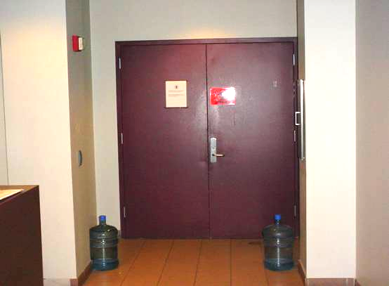

Double Door Separating Autopsy Suite from Elevator Lobby

Picture 2

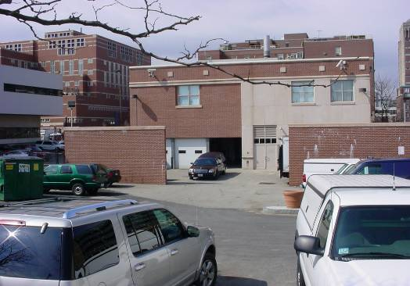

OCME garage

Picture 3

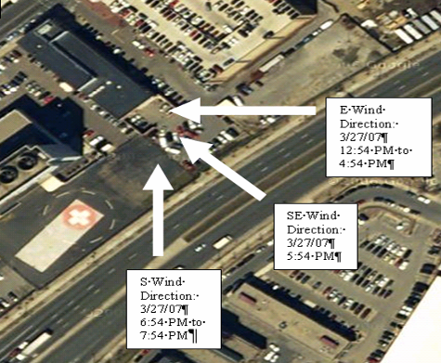

Wind Direction on March 27, 2007 around the OCME

Picture 4

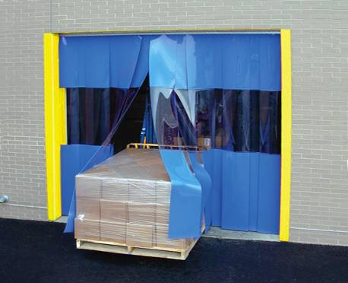

Example of Strip Door
Picture 5

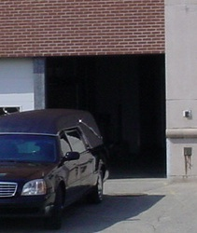

Location Where Strip Door Should Be Attached on Outside Of Building (see arrows)

Picture 6

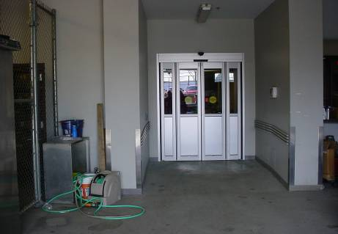

Location Where Strip Door Should Be Attached inside the Garage (see arrows)
Picture 7

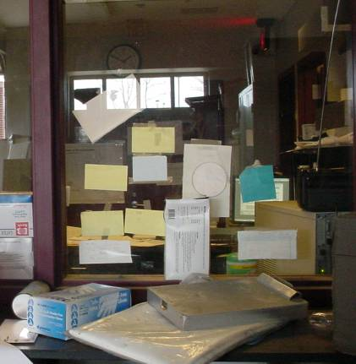

Former Check-in Window in Garage, Note Circular Opening Sealed with a Piece of Paper and Tape
Location | Carbon  Dioxide  (*ppm) | Temp  (°F) | Relative  Humidity  (%) | Occupants  in Room | Windows  Openable | Ventilation |  | Remarks
 |  |  |  |  |  | Supply | Exhaust | Remarks
Outside  (Background) | 390 | 57 | 50
Library | 634 | 72 | 39 | 3 | N | Y | Y | Water stained GW-low moisture (i.e., normal)
Stairwell (Rear) |  |  |  |  |  |  |  | Odors in stairwell, spaces beneath stairwell door, door does not shut completely
Staff Kitchen | 640 | 74 | 37 | 0 | N | Y | Y
229 | 535 | 75 | 36 | 0 | N | Y | Y
226 | 526 | 75 | 36 | 0 | Y | Y | Y
225 | 515 | 75 | 35 | 0 | N | Y | Y
Break Room | 752 | 74 | 37 | 6 | Y | Y | Y
222 | 689 | 74 | 36 | 4 | N | Y | Y
214 | 584 | 74 | 34 | 2 | Y | Y | Y
216 | 571 | 74 | 34 | 1 | Y | Y | Y
218 | 553 | 74 | 34 | 1 | Y | Y | Y
217 | 525 | 73 | 34 | 1 | Y | Y | Y
Elevator |  |  |  |  |  |  |  | Odors “trapped” in elevator, drawn from autopsy suite via elevator shaft/movement
Reception | 588 | 74 | 34 | 1 | N | Y | N | Spaces around door separating reception area from autopsy suite
Stairwell (Front) |  |  |  |  |  |  |  | Odors in stairwell, spaces beneath stairwell door
202 | 547 | 72 | 37 | 2 | N | Y | Y
Intake | 516 | 72 | 37 | 1 | N | Y | Y
201 | 522 | 73 | 35 | 0 | N | Y | Y
Chief ME Office | 535 | 72 | 37 | 1 | N | Y | Y
203 | 511 | 73 | 35 | 0 | N | N | Y
Main Office | 515 | 73 | 35 | 3 | N | Y | Y
209 | 539 | 73 | 34 | 1 | N | Y | Y
211 | 531 | 73 | 34 | 1 | N | Y | Y
Izzi Office | 503 | 72 | 34 | 0 | N | Y | Y
213 | 471 | 71 | 35 | 1 | N | Y | Y
213 Cubicles | 497 | 71 | 35 | 1 | N | Y | Y
State Police Office | 571 | 73 | 37 | 8 | N | Y | Y
Crime Scene Office | 604 | 75 | 33 | 0 | N | Y | Y

Time (EDT): | Wind Direction: | Wind Speed: | Gust Speed:
12:54 PM | East | 11.5 mph | -
1:54 PM | East | 11.5 mph | -
2:54 PM | East | 13.8 mph | -
3:54 PM | East | 10.4 mph | -
4:54 PM | East | 6.9 mph | -
5:54 PM | SE | 3.5 mph | -
6:54 PM | South | 3.5 mph | -
7:54 PM | South | 3.5 mph | -

