INDOOR AIR QUALITY ASSESSMENT
Odor Investigation

Office of the State Auditor
One Ashburton Place, 18th floor
Boston, MA

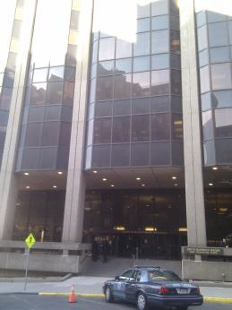

Prepared by:
Massachusetts Department of Public Health
Bureau of Environmental Health
Indoor Air Quality Program
December 2016

Background
Building: | Office of the State Auditor
Address: | One Ashburton Place, 18th floor
Assessment Requested by: | Parrish Rossi, Division of Capital Asset Management and Maintenance
Reason for Request: | Odor concerns in one office
Date of Assessment: | December 5, 2016
Massachusetts Department of Public Health/Bureau of Environmental Health (MDPH/BEH) Staff Conducting Assessment: | Ruth Alfasso, Environmental Engineer, indoor air quality (IAQ) Program
Building Description: | One Ashburton Place, also known as the McCormack Building, is a large state office building built in the 1970s.
Windows: | Not openable

Methods
Please refer to the IAQ Manual for methods, sampling procedures, and interpretation of results (MDPH, 2015).

Results/Discussion

Odor and Moisture Concerns
The reason for the requested visit was to investigate an odor that had reportedly occurred in an office on the west side of the building. It was reported that approximately one week before the visit, an employee entered the office and detected a strong moldy/musty odor, which was also noticeable from the hallway next to the office. According to office occupants, the day this occurred, there was heavy rain in Boston. The office occupant reported that the odor was lessened after a while and had not reoccurred.
At the time of the visit, neither the occupant nor the BEH/IAQ inspector noticed any odors in the office or adjacent hallway.
A few water-damaged ceiling tiles were observed in the office and adjacent areas (Pictures 1 and 2). They were not wet at the time of the visit. Above the ceiling tile system is a large open space, so ceiling tiles would likely dry very quickly and no other materials likely to become mold colonized were present. The water-damaged ceiling tiles likely result from building envelope leaks due to wind-driven rain and/or plumbing leaks, and should be replaced as soon as practical. Rapid replacement of water-damaged ceiling tiles can make detection of additional leaks faster as well. If there are areas where leaks may occur during wet and windy weather, porous items such as cardboard and paper should not be stored there.
The ventilation system in the office has induction units along the outside walls (Picture 3). These units create an updraft of air by heating, and need both the top and sides to remain free of obstructions in order to operate properly. In the office with the reported odor, some items were found on top of the unit, which can impede the flow of air. In addition, many items, such as cardboard and plastic, can give off odors when heated, and these odors can be distributed by the equipment. The induction unit in an adjacent office was observed to be stained (Picture 4) and in need of cleaning. These units also need to be cleaned on the inside, to remove dust and debris that can be aerosolized and cause odors and irritating dusts.

Conclusions/Recommendations
Based on observations at the time of assessment, the following is recommended:
- No odors or obvious sources of odors were observed during this visit. If odors reoccur, an additional visit can be made to try to identify the source.
- Water-stained ceiling tiles should be changed out to enable rapid detection of any additional leaks.
- Do not store porous items where water leaks are likely to occur to prevent damage.
- Avoid storing items on top or directly in front of induction units to allow for free flow of air and to prevent aerosolization of odors and dusts.
- Have induction units and other ventilation components cleaned both inside and out on a regular basis.
- Refer to resource manual and other related IAQ documents located on the MDPH’s website for further building-wide evaluations and advice on maintaining public buildings. These documents are available at: http://mass.gov/dph/iaq.

References
MDPH. 2015. Massachusetts Department of Public Health. Indoor Air Quality Manual: Chapters I-III. Available at: http://www.mass.gov/eohhs/gov/departments/dph/programs/environmental-health/exposure-topics/iaq/iaq-manual/.
Picture 1
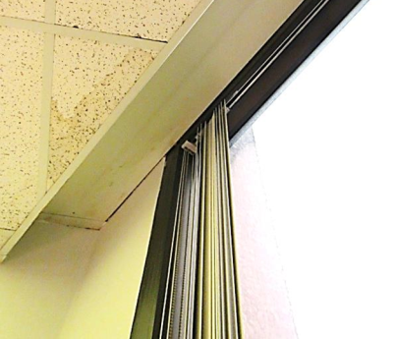
Water-damaged ceiling tile next to window in office
Picture 2
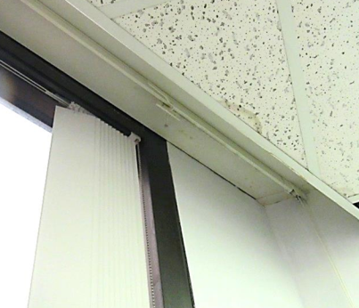
Water-damaged ceiling tile in adjacent office
Picture 3
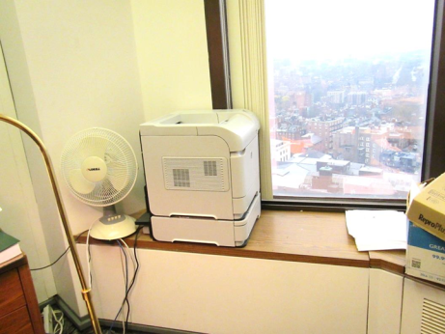
Porous items next to window and items on induction unit (note intake louvers on right)
Picture 4
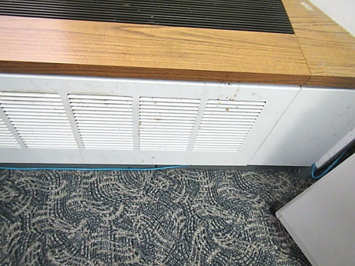
Dirty induction unit in adjacent office

