**INDOOR AIR QUALITY ASSESSMENT**

**Office of the State Auditor**

**65 Boston Post Road West**

**Suite 300**

**Marlborough, MA**

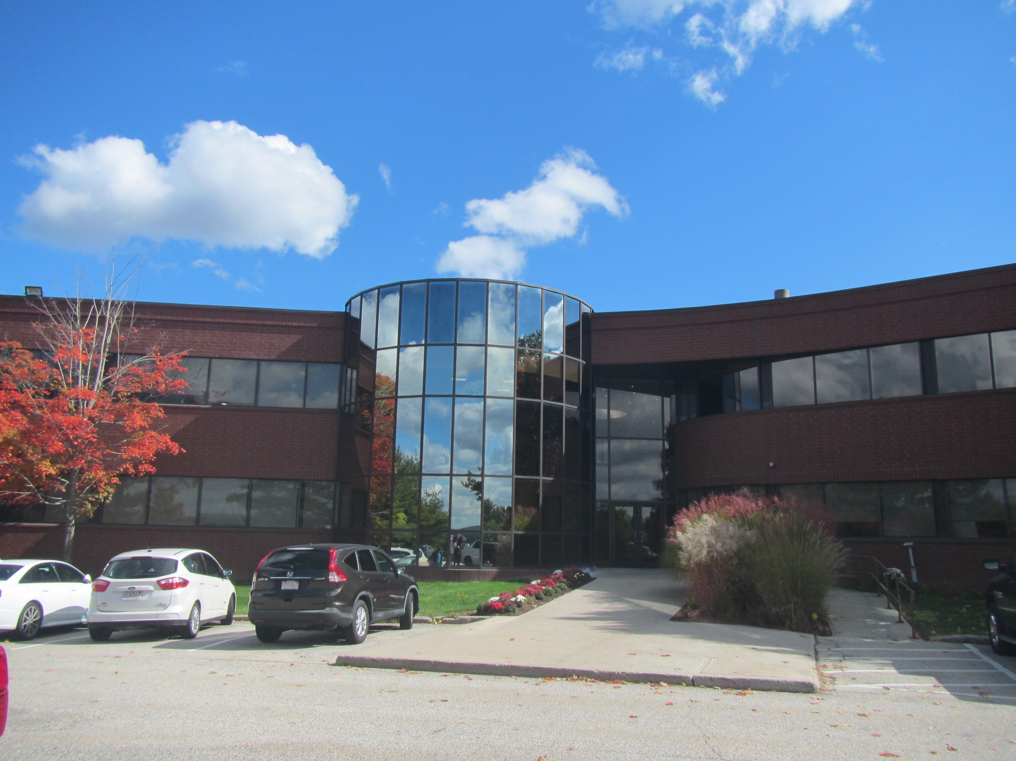

Prepared by:

Massachusetts Department of Public Health

Bureau of Climate and Environmental Health

Indoor Air Quality Program

October 2024

# BACKGROUND

|  |  |
| --- | --- |
| Building: | Office of the State Auditor (OSA) suite |
| Address: | 65 Boston Post Road West, Suite 300, Marlborough |
| Assessment Requested by: | Kendra Howes, Senior Project Manager, Division of Capital Asset Management & Maintenance (DCAMM) |
| Reason for Request: | Post-occupancy indoor air quality (IAQ) assessment. The space was recently renovated as part of the lease-renewal process. |
| Date of Assessment: | October 9, 2024 |
| Massachusetts Department of Public Health/Bureau of Climate and Environmental Health (MDPH/BCEH) Staff Conducting Assessment: | Thomas Murphy, Environmental Analyst, IAQ Program |
| Building Description: | The OSA occupies a suite of offices on the 3rd floor of a large, brick and glass building built in 1984. It is located on US Route 20 near other office buildings and a shopping plaza in Marlborough. The OSA suite includes offices, cubicles, a training room, a conference room, and a small kitchen. Interior renovations occurred, including new baseboard heater covers, painting, and carpeting. A wellness room is still in the process of being renovated and all ceiling tiles in the suite will reportedly be replaced. |
| Windows: | Windows are not openable in the suite. |

# METHODS

Please refer to the IAQ Manual for methods, sampling procedures, and interpretation of results (MDPH, 2015).

# RESULTS AND DISCUSSION

The following is a summary of indoor air testing results (Table 1).

* ***Carbon dioxide*** measurements were above the MDPH guideline of 800 parts per million (ppm) in all areas tested indicating inadequate air exchange at the time of the assessment. Occupancy of the suite was reportedly typical of operation.
* ***Temperature*** was within or close to the recommended range of 70°F to 78°F in all areas.
* ***Relative humidity*** was within the recommended range of 40% to 60% in all areas examined.
* ***Carbon monoxide*** levels were non-detectable (ND) in all indoor areas tested.
* ***Fine particulate matter (PM2.5)*** concentrations were below the National Ambient Air Quality Standard (NAAQS) level of 35 μg/m3 in all areas tested.
* ***Total Volatile Organic Compounds***were ND in all areas tested.

## Ventilation

A heating, ventilating, and air conditioning (HVAC) system has several functions. First, it provides heating and, if equipped, cooling. Second, it is a source of fresh air. Finally, an HVAC system will dilute and remove normally occurring indoor environmental pollutants by not only introducing fresh air, but also filtering the airstream and ejecting stale air to the outdoors via exhaust ventilation. Even if an HVAC system is operating as designed, point sources of respiratory irritation may exist and affect symptoms in sensitive individuals. Carbon dioxide is not a problem in and of itself. It is used as an indicator of the adequacy of the fresh air ventilation.

As carbon dioxide levels rise, it indicates that the ventilation system is malfunctioning, or the design occupancy of the room is being exceeded. When this happens, a buildup of common indoor air pollutants can occur, leading to discomfort or health complaints.

The HVAC system consists of air handling units (AHUs) which draw in outside air and heat/cool it. Conditioned air is ducted to supply vents and returned via ducted return vents (Pictures 1 and 2). Heat also appears to be provided by baseboard heating units.

The MDPH IAQ program recommends that filters be changed 2-4 times a year (or in accordance with the manufacturer’s recommendations) and be at least minimum efficiency reporting value (MERV) of 8, or higher if the equipment can handle them without a degradation in airflow, as these are adequate to filter out pollen, mold, and similar particulates (ASHRAE, 2012). The AHUs for the OSA suite were not assessed during this visit.

A portable air conditioner was observed in the server room (Picture 3). It appeared it was being used to reduce humidity in the server room and the plenum above the ceiling tiles. If the plenum is used for return air in the suite, the rate of return air needs to be sufficient to remove the extra air, heat, and potentially moisture, being introduced by the air conditioner into the ceiling plenum. If not, the plenum may become pressurized and allow the waste heat/moisture back into the OSA, along with particulates and debris from the plenum space.

To maximize air exchange, the IAQ program recommends that both supply and exhaust ventilation operate continuously during periods of occupancy. To have proper ventilation with a mechanical ventilation system, the systems must be balanced after installation to provide an adequate amount of fresh air to the interior of a room while removing stale air from the room. It is recommended that HVAC systems be re-balanced every five years to ensure adequate air systems function (SMACNA, 1994). It was not known when the last time the HVAC system was re-balanced at the time of this assessment. HVAC system renovations were not listed as improvements for the OSA.

## Microbial/Moisture Concerns

Rust was observed on at least one supply vent in the OSA (Picture 4). Rust can be a sign of condensation, which can indicate high humidity in the space or excessively cold supply air temperatures. It is important to note the rust is not mold, but any dust on the vent may become mold colonized under those conditions.

## Other IAQ Concerns

Testing was conducted for total volatile organic compounds (TVOCs). All measurements were non-detect (ND). An examination was conducted for products that may be a source of VOCs in indoor air. Products such as hand sanitizers, dry erase markers, and cleaning supplies were observed (Picture 5). VOCs from these products can build up and lead to irritation of the mucous membranes.

OSA staff reported the new wellness room was still under renovation. Materials, including a tube of caulking, were observed (Picture 6). Renovation activities that may produce odors/vapors should preferably be done when the suite is not occupied, or in areas away from staff. Use the guidance “Construction and Renovation Generated Pollutants in Occupied Buildings” (<https://www.mass.gov/info-details/construction-and-renovation-generated-pollutants-in-occupied-buildings>) to reduce the impact of renovations on staff. If mastics, glues, or paints that may have an odor will be used, this should be done when the suite is unoccupied. According to OSA staff, most of the work is being done on the weekend when the suite is closed.

Holes/openings in ceiling tiles were observed in the suite (Picture 7). According to OSA staff, all ceiling tiles are scheduled to be replaced. Installing new ceiling tiles can allow dust and debris from above the ceiling tile system into occupied areas. Cleaning with a method that does not aerosolize dust (e.g., wet wiping or using a HEPA-equipped vacuum) should be conducted following activities that disturb ceiling tiles.

Cardboard boxes were noted on the floor in several rooms (Picture 8; Table 1). Large amounts of items in offices and common areas can prevent effective cleaning and may become attractive to pests as harborage.

Personal and stand fans were also noted in the OSA (Picture 9; Table 1). If dust is accumulated on the blades, it can be aerosolized during use. Fans should be checked and cleaned periodically to remove any dust.

Finally, almost the entire OSA suite is carpeted. Carpets should be cleaned regularly in accordance with Institute of Inspection, Cleaning and Restoration Certification (IICRC) recommendations (IICRC, 2012).

# CONCLUSIONS/RECOMMENDATIONS

In view of the findings at the time of the visit, the following recommendations are made:

## Short-term Recommendations

### Ventilation recommendations

1. Operate the HVAC system (supply/exhaust) to provide for *continuous* fresh air ventilation during occupied hours.
2. Ensure the air handling unit and other HVAC system filters are at least a MERV rating of 8 and are changed at least twice a year.
3. Vent the portable air conditioner to the outside or it can pressurize the ceiling plenum, forcing dust, debris, (fiberglass insulation) into occupied areas, etc.
4. Ensure that when the portable air conditioner is operating, the plenum return has sufficient draw of air to maintain the plenum at a neutral or negative pressure to remove waste heat and moisture and prevent backdrafting.
5. It is recommended that HVAC systems be re-balanced every five years to ensure adequate air systems function (SMACNA, 1994).

### Water damage recommendations

1. All supply vents displaying rust, condensation, or dust should be cleaned, sanded, refinished/repainted or replaced if too damaged to be fixed.

### Other recommendations

1. Use VOC-containing products in areas with good ventilation and keep tightly closed when not in use. Avoid products with strong scents and avoid mixing incompatible products.
2. Follow the guidance in <https://www.mass.gov/info-details/construction-and-renovation-generated-pollutants-in-occupied-buildings> to reduce the impact of any ongoing renovations in the OSA suite.
3. After repairing and replacing holes in ceiling tiles, conduct a thorough cleaning of furniture and other items, including wet wiping of all surfaces.
4. Ensure cardboard boxes are stored in appropriate locations as soon as possible, to make thorough cleaning easier.
5. Periodically dust the blades of stand and floor fans.
6. Clean carpeting in accordance with IICRC recommendations (IICRC, 2012); annually (or semi-annually in soiled/high traffic areas).
7. Refer to resource manual and other related IAQ documents located on the MDPH’s website for further building-wide evaluations and advice on maintaining public buildings. These documents are available at: <http://mass.gov/dph/iaq>.

# REFERENCES

ASHRAE. 2012. American Society of Heating, Refrigeration and Air Conditioning Engineers (ASHRAE) Standard 52.2-2012 -- Method of Testing General Ventilation Air-Cleaning Devices for Removal Efficiency by Particle Size (ANSI Approved).

IICRC. 2012. Institute of Inspection, Cleaning and Restoration Certification. Carpet Cleaning: FAQ.

MDPH. 2015. Massachusetts Department of Public Health. Indoor Air Quality Manual: Chapters I-III. Available at: <https://www.mass.gov/lists/indoor-air-quality-manual-and-appendices>.

SMACNA. 1994. HVAC Systems Commissioning Manual. 1st ed. Sheet Metal and Air Conditioning Contractors’ National Association, Inc., Chantilly, VA.

**Picture 1**

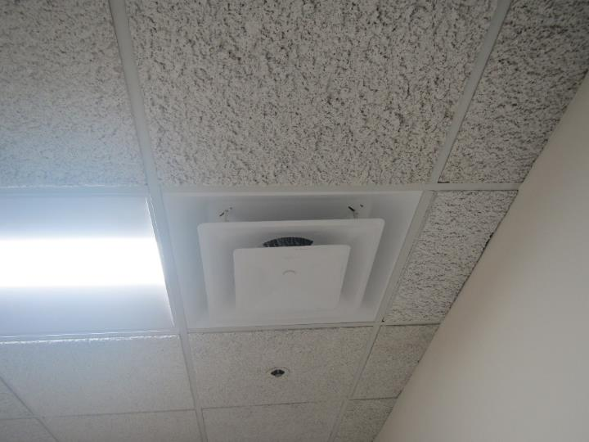

**Ceiling-mounted supply vent**

**Picture 2**

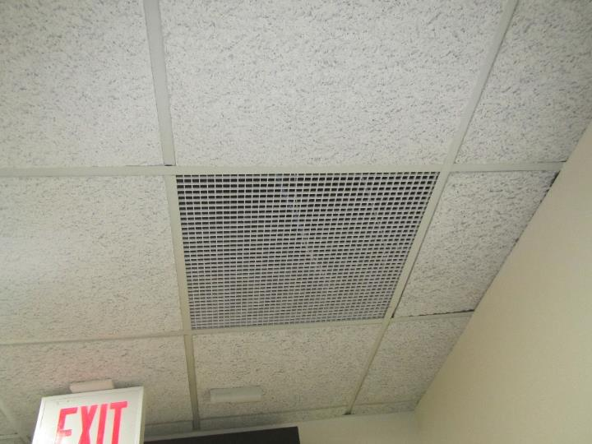

**Ceiling-mounted return vent**

**Picture 3**

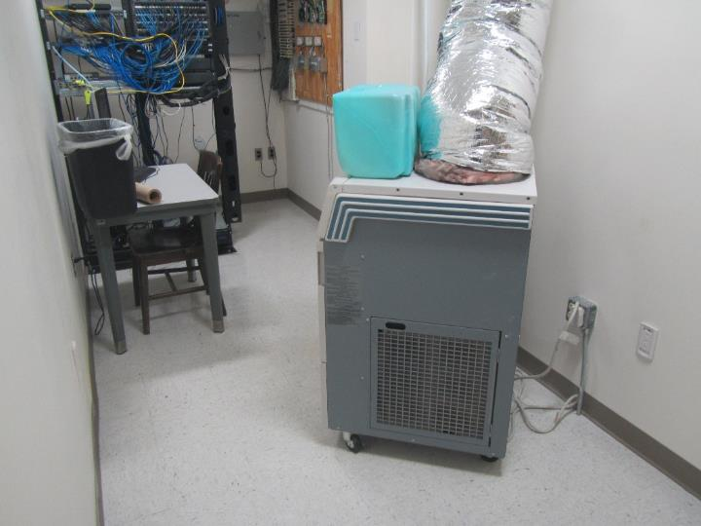

**Portable air conditioner in server room**

**Picture 4**

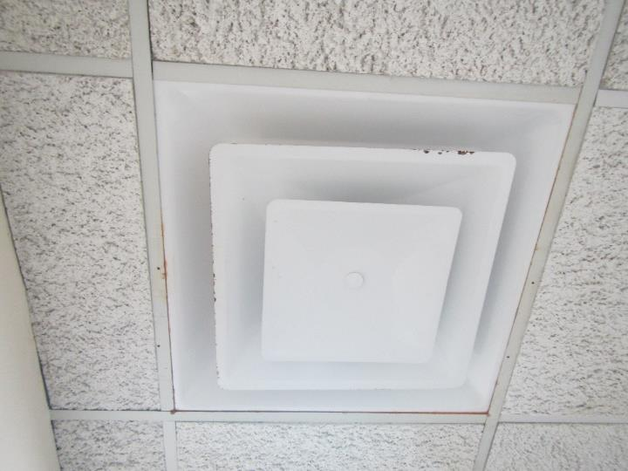

**Rust on ceiling-mounted supply vent**

**Picture 5**

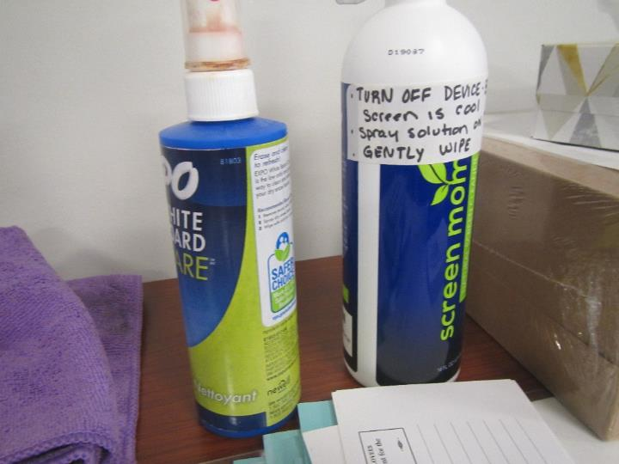

**Cleaning supplies**

**Picture 6**

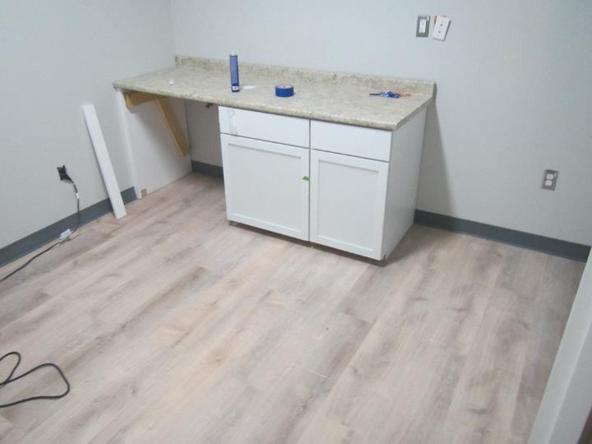

**Wellness room under renovation (note tube of caulking on counter)**

**Picture 7**

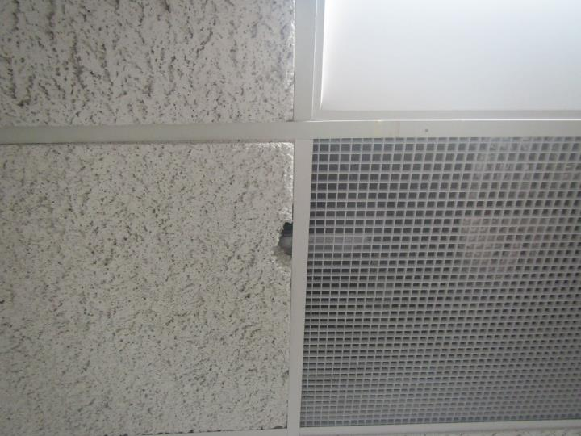

**Hole in ceiling tile**

**Picture 8**

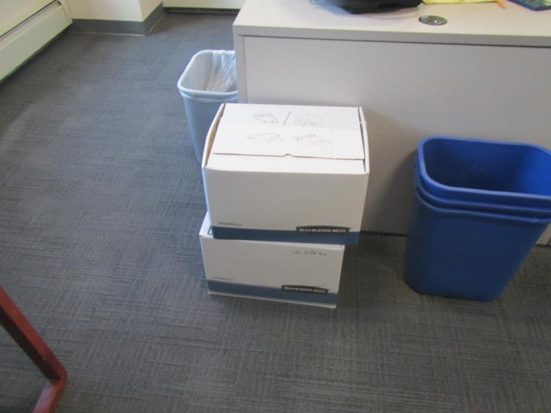

**Cardboard boxes on floor**

**Picture 9**

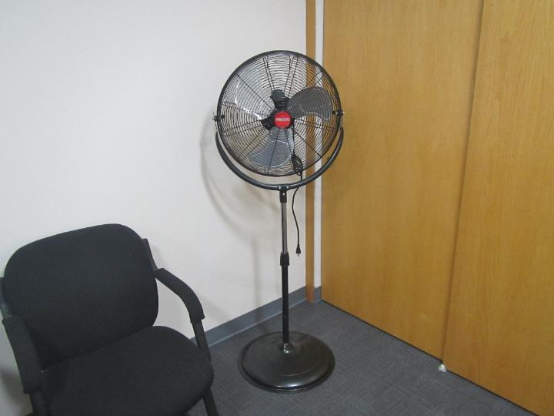

**Fan in suite**

| **Location** | **Carbon**  **Dioxide**  **(ppm)** | **Carbon Monoxide**  **(ppm)** | **Temp**  **(°F)** | **Relative**  **Humidity**  **(%)** | **PM2.5**  **(µg/m3)** | **TVOC**  **(ppm)** | **Occupants**  **in Room** | **Windows**  **Openable** | **Ventilation** | | **Remarks** |
| --- | --- | --- | --- | --- | --- | --- | --- | --- | --- | --- | --- |
| **Supply** | **Exhaust** |
| Background (outside) | 423 | ND | 64 | 44 | 1 |  |  |  |  |  | Sunny |
| Office 1 | 946 | ND | 71 | 49 | ND | ND | 1 | N | Y | Y |  |
| Office 3 | 986 | ND | 71 | 49 | ND | ND | 1 | N | Y | Y | Cardboard boxes on floor |
| Office 4 | 1042 | ND | 70 | 50 | ND | ND | 1 | N | Y | Y | Personal fan |
| Office 5 | 962 | ND | 70 | 50 | ND | ND | 0 | N | Y | Y | Cardboard boxes on floor |
| Office 6 | 937 | ND | 71 | 48 | ND | ND | 1 | N | Y | Y | Cardboard boxes on floor |
| Office 7 | 923 | ND | 71 | 48 | ND | ND | 0 | N | Y | Y |  |
| Office 8 | 933 | ND | 71 | 48 | ND | ND | 1 | N | Y | Y |  |
| Conference Room | 908 | ND | 72 | 47 | ND | ND | 0 | N | Y | Y | Personal fan, cleaning supplies |
| Cubicle Area Middle | 968 | ND | 71 | 49 | ND | ND | 0 | N | Y | Y |  |
| Cubicle Area North | 947 | ND | 71 | 49 | ND | ND | 0 | N | Y | Y |  |
| Cubicle Area Northeast | 1001 | ND | 71 | 50 | ND | ND | 0 | N | Y | Y | Cardboard boxes on floor |
| Cubicle Area South | 995 | ND | 71 | 49 | ND | ND | 2 | N | Y | Y |  |
| Entrance Area | 923 | ND | 70 | 50 | ND | ND | 2 | N | Y | Y | Stand fan |
| Server Room | 1010 | ND | 69 | 47 | ND | ND | 2 | N | Y | Y |  |
| Training Room | 962 | ND | 70 | 49 | ND | ND | 2 | N | Y | Y | Personal fan |
| Wellness Room | 906 | ND | 72 | 47 | ND | ND | 0 | N | Y | Y | Under renovation, tube of caulking, NC |