**INDOOR AIR QUALITY REASSESSMENT**

**Office of the State Auditor**

**65 Boston Post Road West**

**Suite 300**

**Marlborough, MA**

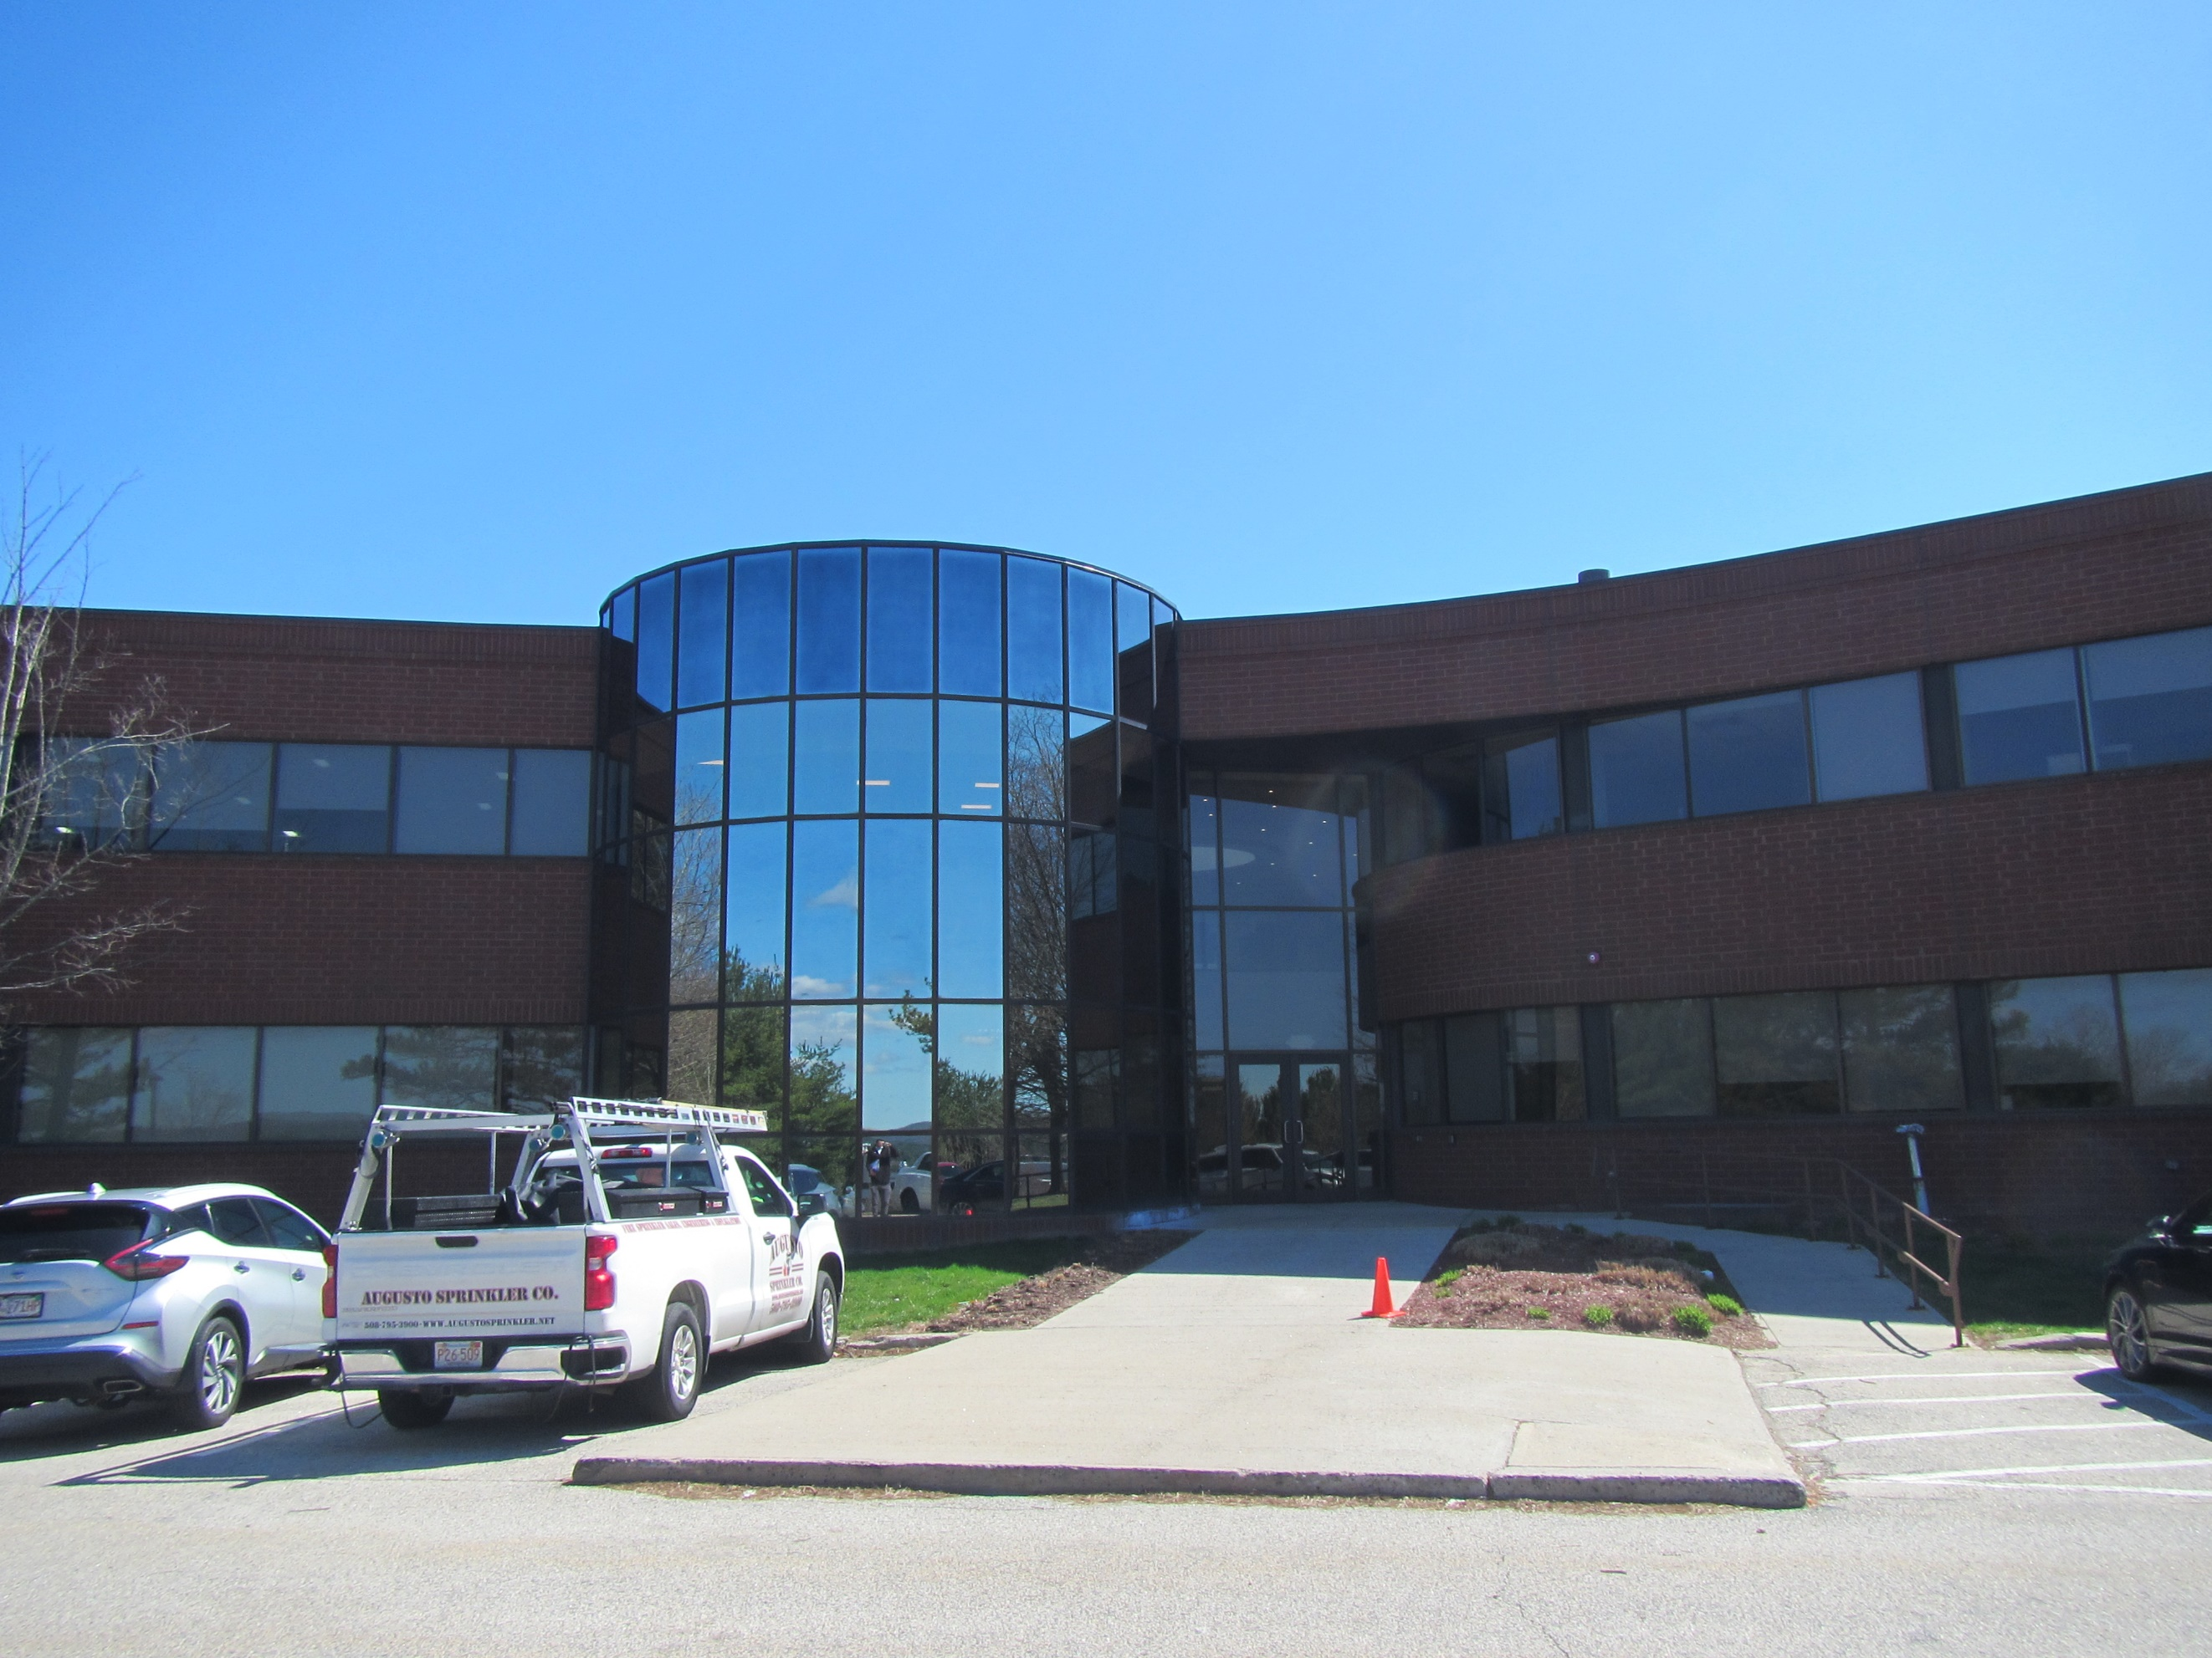

Prepared by:

Massachusetts Department of Public Health

Bureau of Climate and Environmental Health

Environmental Health Regulations and Standards

May 2025

# BACKGROUND

|  |  |
| --- | --- |
| Building: | Office of the State Auditor (OSA) suite |
| Address: | 65 Boston Post Road West, Suite 300, Marlborough |
| Assessment Requested by: | Kendra Howes, Senior Project Manager, Division of Capital Asset Management & Maintenance (DCAMM) |
| Reason for Request: | Post-occupancy indoor air quality (IAQ) reassessment. The space was recently renovated as part of the lease-renewal process and DCAMM staff requested a reassessment after renovations/upgrades to the HVAC system were completed following the initial assessment. |
| Date of Assessment: | April 17, 2025 |
| Massachusetts Department of Public Health/Bureau of Climate and Environmental Health/Division of Environmental Health Regulations and Standards (MDPH/BCEH/EHRS) Staff Conducting Assessment: | Thomas Murphy, Environmental Analyst, EHRS |
| Building Description: | The OSA occupies a suite of offices on the 3rd floor of a large, brick and glass building built in 1984. It is located on US Route 20 near other office buildings and a shopping plaza in Marlborough. The OSA suite includes offices, cubicles, a training room, a conference room, and two small kitchens. Interior renovations occurred, including HVAC upgrades/renovations, new baseboard heater covers, painting, and carpeting. A wellness room was recently renovated and all ceiling tiles in the suite will reportedly be replaced. |
| Windows: | Windows are not openable in the suite. |

# INTRODUCTION

This reassessment was requested by DCAMM staff due to carbon dioxide levels being measured above 800 parts per million (ppm) in all areas tested during the initial assessment conducted in October of 2024. During the reassessment, all areas tested had carbon dioxide levels below 800 ppm. Significant renovations/upgrades were made to the HVAC system prior to the reassessment including:

* The HVAC system was balanced.
* All new damper motors (11) were installed on every zone damper tied to wall thermostats above the ceiling.
* Every diffuser (45) was manually adjusted with a butterfly screw above the ceiling.
* The rooftop economizer had had a new damper control (1) installed for the fresh air intake damper.

The report for the first assessment can be found at [Indoor air quality reports - cities and towns: M | Mass.gov](https://www.mass.gov/info-details/indoor-air-quality-reports-cities-and-towns-m#marlborough-)

# METHODS

Please refer to the IAQ Manual for methods, sampling procedures, and interpretation of results (MDPH, 2015).

# RESULTS AND DISCUSSION

The following is a summary of indoor air testing results (Table 1).

* ***Carbon dioxide* measurements were below** the MDPH guideline of 800 parts per million (ppm) in all areas tested during this assessment indicating adequate air exchange. It is important to note that **during the first assessment all levels were above 800 ppm**. Occupancy of the suite was similar during both assessments.
* ***Temperature*** was within the recommended range of 70°F to 78°F in all areas.
* ***Relative humidity*** was below the recommended range of 40% to 60% in all areas examined, which is typical during heating season in New England.
* ***Carbon monoxide*** levels were non-detectable (ND) in all indoor areas tested.
* ***Fine particulate matter (PM2.5)*** concentrations were below the National Ambient Air Quality Standard (NAAQS) level of 35 μg/m3 in all areas tested.
* ***Total Volatile Organic Compounds***were ND in all areas tested.

## Ventilation

A heating, ventilating, and air conditioning (HVAC) system has several functions. First, it provides heating and, if equipped, cooling. Second, it is a source of fresh air. Finally, an HVAC system will dilute and remove normally occurring indoor environmental pollutants by not only introducing fresh air, but also filtering the airstream and ejecting stale air to the outdoors via exhaust ventilation. Even if an HVAC system is operating as designed, point sources of respiratory irritation may exist and affect symptoms in sensitive individuals.

The HVAC system consists of air handling units (AHUs) which draw in outside air and heat/cool it. Conditioned air is ducted to supply vents and returned via ducted return vents (Pictures 1 and 2). Heat also appears to be provided by baseboard heating units.

The MDPH/BCEH recommends that AHU filters be changed 2-4 times a year (or in accordance with the manufacturer’s recommendations) and be at least minimum efficiency reporting value (MERV) of 8, or higher if the equipment can handle them without a degradation in airflow, as these are adequate to filter out pollen, mold, and similar particulates (ASHRAE, 2012). The AHUs for the OSA suite were not assessed during this visit.

A portable air conditioner was observed in the server room (Picture 3). It appears it is used to reduce humidity in the server room and the plenum above the ceiling tiles. If the plenum is used for return air in the suite, the rate of return air needs to be sufficient to remove the extra air, heat, and potentially moisture, being introduced by the air conditioner into the ceiling plenum. If not, the plenum may become pressurized and allow the waste heat/moisture back into the OSA, along with particulates and debris from the plenum space.

Thermostats in the OSA suite were observed to be set to “fan auto” (Picture 4). In at least one office, both the supply and exhaust vents were not operating when tested during the reassessment (Table 1). The closest thermostat, which could not be manually adjusted, was set to “fan auto”. OSA staff also reported difficulty controlling the thermostat they had access to in another office where both supply and exhaust vents were found to be not operating (Table 1). MDPH/BCEH recommends that HVAC controls be set to have the fan *on* to provide *continuous* air filtration and circulation throughout the space when the building is occupied, rather than only providing fresh air when a change in temperature is required.

To have proper ventilation with a mechanical ventilation system, the systems must be balanced after installation to provide an adequate amount of fresh air to the interior of a room while removing stale air from the room. It is recommended that HVAC systems be re-balanced every five years to ensure adequate air systems function (SMACNA, 1994). According to DCAMM staff, the HVAC system was balanced in the Fall of 2024, after the first assessment.

## Microbial/Moisture Concerns

A ductless ceiling-mounted mini-split air conditioner was observed in the conference room (Picture 5). These units are equipped with tubing and sometimes a pump to drain the condensation generated through operation. Leakage of water can occur when the condensate line is blocked or damaged, or the pump malfunctions. Ductless mini-split tubing and pumps should be checked regularly to ensure proper drainage and repaired/cleaned when necessary.

Food/liquid stains were observed in one of the kitchen refrigerators (Picture 6). The interior of a microwave was also dirty (Picture 7). Food preparation equipment should be kept clean and free from spills to prevent mold growth, pests, and odors.

Rust was observed on at least one supply vent in the OSA. Rust can be a sign of condensation, which can indicate high humidity in the space or excessively cold supply air temperatures. It is important to note the rust is not mold, but any dust on the vent may become mold colonized under conditions where condensation is created on supply vents.

## Other IAQ Concerns

Testing was conducted for total volatile organic compounds (TVOCs). All measurements were non-detect (ND). An examination was conducted for products that may be a source of VOCs in indoor air. Products such as hand sanitizers, dry erase markers, and cleaning supplies were observed (Picture 8). VOCs from these products can build up and lead to irritation of the mucous membranes. Consult “[Clean Air Is Odor Free](https://www.mass.gov/doc/clean-air-is-odor-free-removing-fragrances-to-improve-indoor-air-quality-in-schools-and-offices-0/download)” for more information on fragrances in buildings.

During the October 2024 assessment, OSA staff reported that the new wellness room was still under renovation. It appeared renovations had been completed by the time of the April 17, 2025 reassessment. Renovation activities that may produce odors/vapors should preferably be done when the suite is not occupied, or in areas away from staff. Use the guidance “Construction and Renovation Generated Pollutants in Occupied Buildings” (<https://www.mass.gov/info-details/construction-and-renovation-generated-pollutants-in-occupied-buildings>) to reduce the impact of renovations on staff. According to OSA staff, most of the work was done on the weekend when the suite is closed.

Holes/openings in ceiling tiles were observed in the OSA suite (Picture 9). According to OSA staff, all ceiling tiles are scheduled to be replaced. Installing new ceiling tiles can allow dust and debris from above the ceiling tile system into occupied areas. Cleaning with a method that does not aerosolize dust (e.g., wet wiping or using a HEPA-equipped vacuum) should be conducted following activities that disturb ceiling tiles.

Cardboard boxes were noted on the floor in several rooms (Picture 10; Table 1). Large amounts of items in offices and common areas can prevent effective cleaning and may become attractive to pests as harborage.

Personal and stand fans were also noted in the OSA, including at least one which had accumulated dust (Picture 11; Table 1). If dust is accumulated on the blades, it can be aerosolized during use. Fans should be checked and cleaned periodically to remove any dust.

At least one piece of upholstered furniture was noted in the OSA suite (Table 1). Upholstered furniture should be cleaned regularly to remove dust and debris.

Finally, almost the entire OSA suite is carpeted. Carpets should be cleaned regularly in accordance with Institute of Inspection, Cleaning and Restoration Certification (IICRC) recommendations (IICRC, 2012).

# CONCLUSIONS/RECOMMENDATIONS

In view of the findings at the time of the visit, the following recommendations are made:

### Ventilation recommendations

1. Operate the HVAC system (supply/exhaust) to provide for *continuous* fresh air ventilation during occupied hours and switch all thermostats from the “fan auto” setting to “fan on”.
2. Ensure the air handling unit and other HVAC system filters are at least a MERV rating of 8 and are changed at least twice a year.
3. Ensure that when the portable air conditioner is operating, the plenum return has sufficient draw of air to maintain the plenum at a neutral or negative pressure to remove waste heat and moisture and prevent backdrafting.
4. Continue to re-balance the HVAC system every five years to ensure adequate air systems function (SMACNA, 1994).

### Water damage recommendations

1. Ensure that condensation from ceiling-mounted mini-split equipment is draining properly. Check collector pans, piping, and any associated pumps for clogs and leaks and clean periodically to prevent stagnant water build-up and remove debris that may provide a medium for microbial growth.
2. Routinely clean the kitchen including food/liquid stains from the refrigerator and food residues from microwaves and any other appliances used to prepare or heat food.
3. All supply vents displaying rust, condensation, or dust should be cleaned, sanded, refinished/repainted, or replaced if too damaged to be fixed. If condensation is noted on vents, consider methods to remove humidity or increase the temperature of the supply air.

### Other recommendations

1. Use VOC-containing products in areas with good ventilation and keep tightly closed when not in use. Avoid products with strong scents and avoid mixing incompatible products.
2. Refer to “[Clean Air Is Odor Free](https://www.mass.gov/doc/clean-air-is-odor-free-removing-fragrances-to-improve-indoor-air-quality-in-schools-and-offices-0/download)” for more information on fragrances in buildings.
3. Follow the guidance in <https://www.mass.gov/info-details/construction-and-renovation-generated-pollutants-in-occupied-buildings> to reduce the impact of any ongoing renovations in the OSA suite.
4. After repairing and replacing holes in ceiling tiles, conduct a thorough cleaning of furniture and other items, including wet wiping of all surfaces.
5. Ensure cardboard boxes are stored in appropriate locations as soon as possible, to make thorough cleaning easier.
6. Periodically dust the blades of stand and floor fans.
7. Clean upholstered furniture regularly.
8. Clean carpeting in accordance with IICRC recommendations (IICRC, 2012); annually (or semi-annually in soiled/high traffic areas).
9. Consider installing/using indoor air sensors to measure information such as carbon dioxide levels. As indoor air sensors become more sophisticated and less expensive, they can be placed in public buildings to measure and provide accurate real-time information via an application or web-based dashboard, eliminating the need for personnel to take measurements with hand-held equipment.
10. Refer to resource manual and other related IAQ documents located on the MDPH’s website for further building-wide evaluations and advice on maintaining public buildings. These documents are available at: <http://mass.gov/dph/iaq>.

# REFERENCES

ASHRAE. 2012. American Society of Heating, Refrigeration and Air Conditioning Engineers (ASHRAE) Standard 52.2-2012 -- Method of Testing General Ventilation Air-Cleaning Devices for Removal Efficiency by Particle Size (ANSI Approved).

IICRC. 2012. Institute of Inspection, Cleaning and Restoration Certification. Carpet Cleaning: FAQ.

MDPH. 2015. Massachusetts Department of Public Health. Indoor Air Quality Manual: Chapters I-III. Available at: <https://www.mass.gov/lists/indoor-air-quality-manual-and-appendices>.

SMACNA. 1994. HVAC Systems Commissioning Manual. 1st ed. Sheet Metal and Air Conditioning Contractors’ National Association, Inc., Chantilly, VA.

**Picture 1**

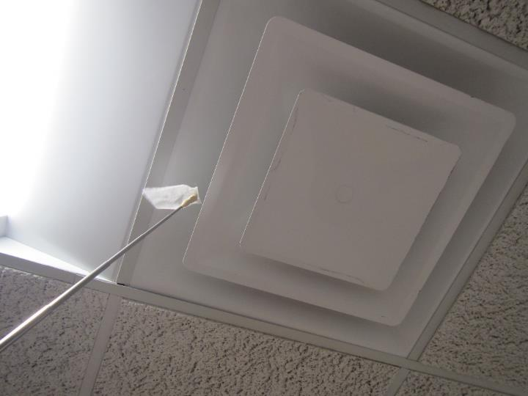

**Ceiling-mounted supply vent (note piece of tissue paper on pole was moving due to airflow)**

**Picture 2**

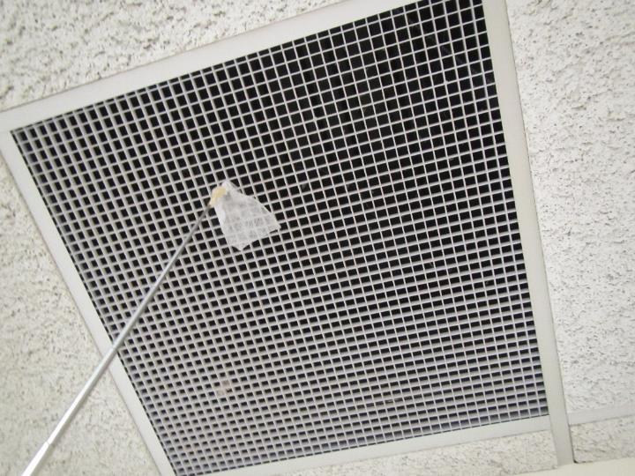

**Ceiling-mounted return vent (note piece of tissue paper being sucked in)**

**Picture 3**

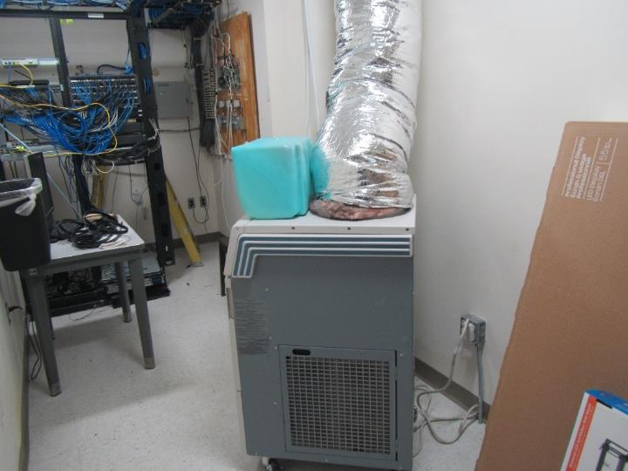

**Portable air conditioner in server room**

**Picture 4**

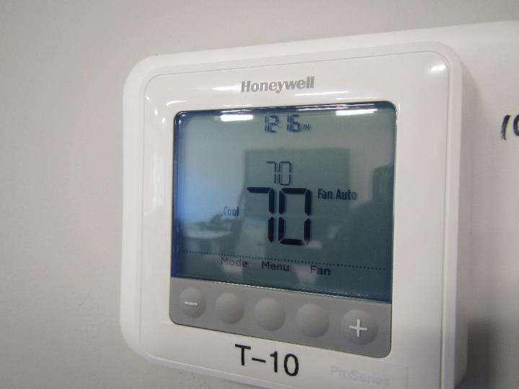

**Thermostat set to “Fan Auto”**

**Picture 5**

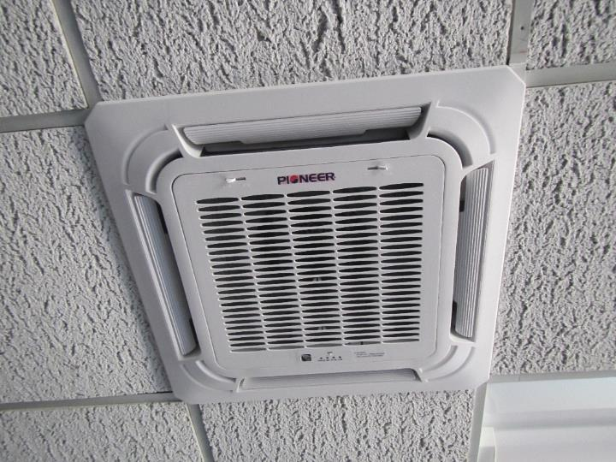

**Ceiling-mounted mini-split air conditioner in conference room**

**Picture 6**

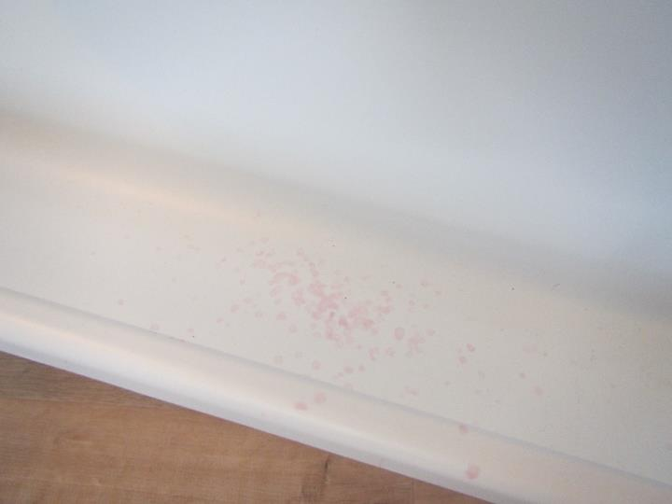

**Food/liquid stains in a refrigerator**

**Picture 7**

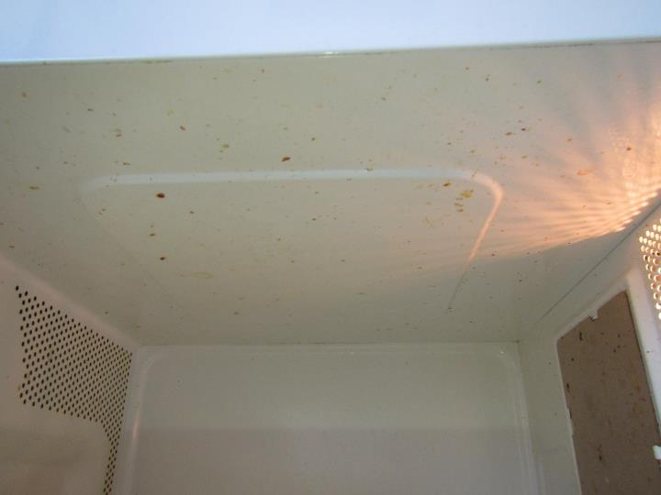

**Interior of microwave dirty**

**Picture 8**

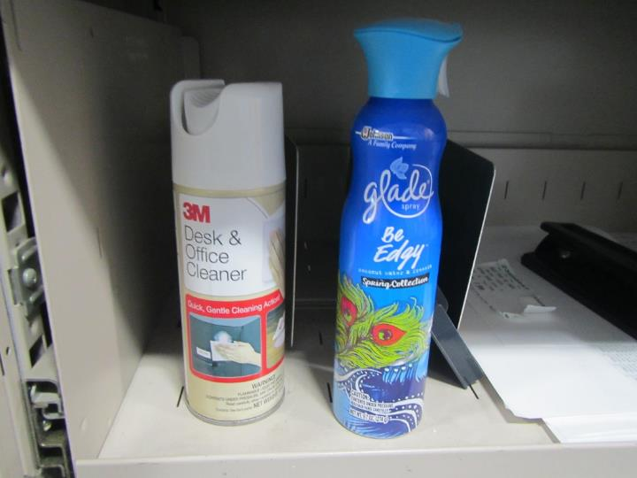

**Desk cleaner and air freshener spray**

**Picture 9**

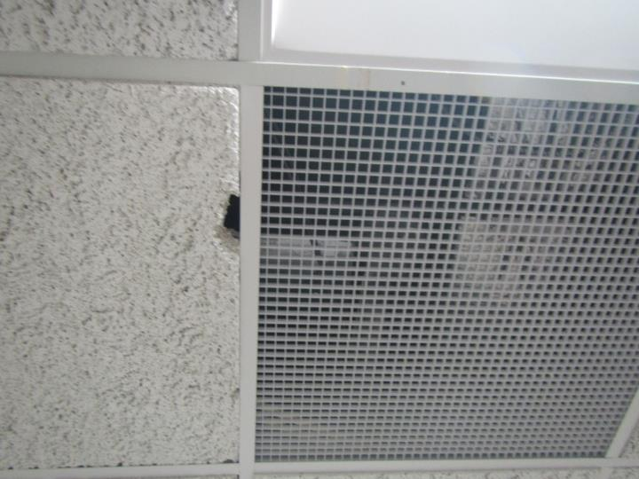

**Hole in ceiling tile**

**Picture 10**

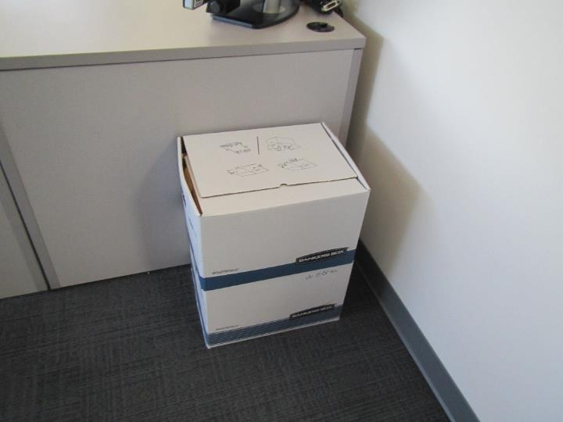

**Cardboard boxes on floor**

**Picture 11**

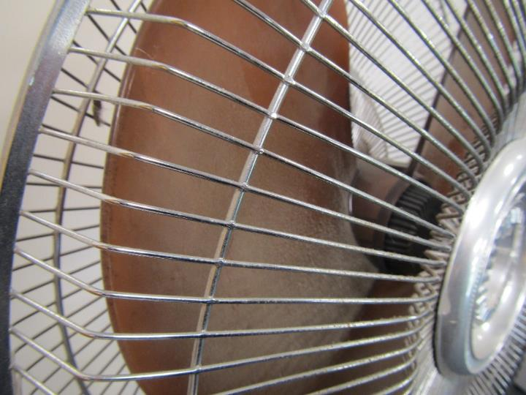

**Dust on personal fan**

| **Location** | **Carbon**  **Dioxide**  **(ppm)** | **Carbon Monoxide**  **(ppm)** | **Temp**  **(°F)** | **Relative**  **Humidity**  **(%)** | **PM2.5**  **(µg/m3)** | **TVOC**  **(ppm)** | **Occupants**  **in Room** | **Windows**  **Openable** | **Ventilation** | | **Remarks** |
| --- | --- | --- | --- | --- | --- | --- | --- | --- | --- | --- | --- |
| **Supply** | **Exhaust** |
| Background (outside) | 411 | ND | 52 | 31 | 4 |  |  |  |  |  | Sunny, breezy |
| Office 1 | 620 | ND | 72 | 22 | ND | ND | 1 | N | Y  off | Y  off | PF |
| Office 3 | 548 | ND | 71 | 21 | ND | ND | 0 | N | Y  off | Y  off | Cardboard boxes on floor, staff reported difficulty controlling thermostat |
| Office 4 | 639 | ND | 71 | 24 | ND | ND | 2 | N | Y | Y | PF |
| Office 5 | 552 | ND | 71 | 23 | ND | ND | 0 | N | Y | N | Cleaning supplies |
| Office 6 | 530 | ND | 72 | 20 | ND | ND | 0 | N | Y | N | Cleaning supplies |
| Office 8 | 532 | ND | 70 | 21 | ND | ND | 0 | N | Y | Y | Hand sanitizer |
| Conference Room | 523 | ND | 71 | 21 | ND | ND | 0 | N | Y | Y | PF, cleaning supplies, ceiling-mounted mini-split air conditioner |
| Cubicle Area Middle | 587 | ND | 72 | 23 | ND | ND | 1 | N | Y | Y | Cleaning supplies, PF |
| Cubicle Area North | 588 | ND | 72 | 22 | ND | ND | 1 | N | Y | Y |  |
| Cubicle Area Northeast | 565 | ND | 72 | 22 | ND | ND | 2 | N | Y | Y | Dusty PF, cleaning supplies |
| Cubicle Area South | 693 | ND | 70 | 25 | ND | ND | 4 | N | Y | Y | Hand sanitizer, cleaning supplies |
| Entrance Area | 651 | ND | 70 | 25 | ND | ND | 2 | N | Y | Y | Stand fan |
| Kitchen 1 (near front of entrance) | 682 | ND | 70 | 25 | ND | ND | 1 | N | Y | Y | Microwaves, refrigerator, coffee maker |
| Kitchen 2 (rear corner of office) | 538 | ND | 72 | 21 | ND | ND | 0 | N | Y | Y | Dirty microwave, food/liquid stains in refrigerator, toaster, coffee maker |
| Server Room | 644 | ND | 70 | 24 | ND | ND | 0 | N | Y | Y |  |
| Storage Room | 563 | ND | 70 | 23 | ND | ND | 0 | N | Y | Y |  |
| Training Room | 633 | ND | 71 | 24 | ND | ND | 1 | N | Y | Y | PF, cleaning supplies |
| Wellness Room | 556 | ND | 70 | 22 | ND | ND | 0 | N | Y | Y | Mini refrigerator, hole in ceiling tile, upholstered furniture |