INDOOR AIR QUALITY ASSESSMENT

Old Mill Pond Elementary School
4107 Main Street
Palmer, MA



Prepared by:
Massachusetts Department of Public Health
Bureau of Environmental Health
Indoor Air Quality Program
October 2013

Background/Introduction
At the request of Joshua Mathieu, Health Agent, Palmer Board of Health (PBOH), the Massachusetts Department of Public Health (MDPH), Bureau of Environmental Health (BEH) conducted an indoor air quality (IAQ) assessment at the Old Mill Pond Elementary School (OMPES), located at 4107 Main Street, Palmer, Massachusetts. The request was prompted by concerns related to mold. On August 21, 2013, a visit was made to the OMPES by Michael Feeney, Director of BEH’s IAQ Program. A report regarding water damage and mold growth issued as a result of that visit is attached as Appendix A. Mr. Feeney returned to the OMPES on September 6, 2013, accompanied by Ms. Kathleen Gilmore, Regional Inspector in the BEH IAQ Program, to perform additional evaluations of the building. The most recent assessment includes testing for general indoor environmental parameters to determine ventilation system capabilities during occupancy.
The OMPES is a single-level building, which had been originally constructed as a middle school in 1991. The OMPES does not have centralized air-conditioning; however a few locations do have window-mounted air conditioners. Windows are openable throughout the building.

Methods
Air tests for carbon monoxide, carbon dioxide, temperature and relative humidity were conducted with the TSI, Q-Trak, IAQ Monitor, Model 7565. Air tests for airborne particle matter with a diameter less than 2.5 micrometers were taken with the TSI, DUSTTRAK™ Aerosol Monitor Model 8520. BEH/IAQ staff also performed visual inspection of building materials for water damage and/or microbial growth.

Results
The OMPES houses approximately 600 students in grades pre-K through 4 and has a staff of approximately 50. The tests were taken during summer break with no occupants. Test results appear in Table 1.

Discussion

Ventilation
It can be seen from Table 1 that carbon dioxide levels were above 800 parts per million (ppm) in 11 of 43 areas tested, indicating less than optimal air exchange in about a quarter of the areas surveyed at the time of the assessment. Note that some rooms had windows open or had low/no occupancy; with windows closed and greater occupancy carbon dioxide levels would be expected to increase.
Fresh air in classrooms is supplied by unit ventilators (univents) (Picture 1). A univent is designed to draw air from outdoors through a fresh air intake located on the exterior wall of the building (Picture 2). Return air is drawn through an air intake located at the base of each unit where fresh and return air are mixed, filtered, heated or cooled and provided to classrooms through an air diffuser located in the top of the unit (Figure 1).
Univents were found deactivated or obstructed with classroom items in several areas (Picture 3; Table 1). In order for univents to provide fresh air as designed, intakes/returns must remain free of obstructions. Importantly, these units must remain on and be allowed to operate while rooms are occupied.
Exhaust ventilation is provided by ceiling-mounted vents inside classroom storage closets; these vents are ducted to rooftop motors (Picture 4). Air is drawn through a vent in the bottom of the closet door. If the closet is too full, materials can block airflow and reduce/prevent the draw of exhaust air from classrooms (Picture 5). Some of the exhaust vents that were examined had very low or no draw. An examination of rooftop exhaust motors revealed that seven of 21 exhaust fans were deactivated or not working (Picture 6). According to OMPES staff, a number of the exhaust vents were deactivated by timers. Exhaust ventilation is necessary for reducing the accumulation of normally-occurring indoor pollutants, including water vapor from restrooms.
To maximize air exchange, the MDPH recommends that both supply and exhaust ventilation operate continuously during periods of occupancy. In order to have proper ventilation with a mechanical supply and exhaust system, the systems must be balanced to provide an adequate amount of fresh air to the interior of a room while removing stale air from the room. It is recommended that heating, ventilating and air conditioning (HVAC) systems be re-balanced every five years to ensure adequate air systems function (SMACNA, 1994). The date of last balancing was not available at the time of the current visit.
Minimum design ventilation rates are mandated by the Massachusetts State Building Code (MSBC). Until 2011, the minimum ventilation rate in Massachusetts was higher for both occupied office spaces and general classrooms, with similar requirements for other occupied spaces (BOCA, 1993). The current version of the MSBC, promulgated in 2011 by the State Board of Building Regulations and Standards (SBBRS), adopted the 2009 International Mechanical Code (IMC) to set minimum ventilation rates. Please note that the MSBC is a minimum standard that is not health-based. At lower rates of cubic feet per minute (cfm) per occupant of fresh air, carbon dioxide levels would be expected to rise significantly. A ventilation rate of 20 cfm per occupant of fresh air provides optimal air exchange resulting in carbon dioxide levels at or below 800 ppm in the indoor environment in each area measured. MDPH recommends that carbon dioxide levels be maintained at 800 ppm or below. This is because most environmental and occupational health scientists involved with research on IAQ and health effects have documented significant increases in indoor air quality complaints and/or health effects when carbon dioxide levels rise above the MDPH guidelines of 800 ppm for schools, office buildings and other occupied spaces (Sundell et al., 2011). The ventilation must be on at all times that the room is occupied. Providing adequate fresh air ventilation with open windows and maintaining the temperature in the comfort range during the cold weather season is impractical. Mechanical ventilation is usually required to provide adequate fresh air ventilation.
Carbon dioxide is not a problem in and of itself. It is used as an indicator of the adequacy of the fresh air ventilation. As carbon dioxide levels rise, it indicates that the ventilating system is malfunctioning or the design occupancy of the room is being exceeded. When this happens, a buildup of common indoor air pollutants can occur, leading to discomfort or health complaints. The Occupational Safety and Health Administration (OSHA) standard for carbon dioxide is 5,000 parts per million parts of air (ppm). Workers may be exposed to this level for 40 hours/week, based on a time-weighted average (OSHA, 1997).
The MDPH uses a guideline of 800 ppm for publicly occupied buildings. A guideline of 600 ppm or less is preferred in schools due to the fact that the majority of occupants are young and considered to be a more sensitive population in the evaluation of environmental health status. Inadequate ventilation and/or elevated temperatures are major causes of complaints such as respiratory, eye, nose and throat irritation, lethargy and headaches. For more information concerning carbon dioxide, consult Appendix B.
Indoor temperature measurements ranged from 69F to 78F (Table 1), which were within or very close to the MDPH recommended comfort range the day of assessment. The MDPH recommends that indoor air temperatures be maintained in a range of 70F to 78F in order to provide for the comfort of building occupants. In many cases concerning indoor air quality, fluctuations of temperature in occupied spaces are typically experienced, even in a building with an adequate fresh air supply. In addition, it is difficult to control temperature and maintain comfort without operating the ventilation equipment as designed (e.g., univents/exhaust vents deactivated/obstructed).
The relative humidity measured in the building ranged from 36 to 56 percent, which was within or close to the lower end of the MDPH recommended comfort range in all areas surveyed during the assessment (Table 1). The MDPH recommends a comfort range of 40 to 60 percent for indoor relative humidity. Conditions in the building with less temperate outdoor conditions may differ from those measured during the assessment. For example, relative humidity levels in the building would be expected to drop during the winter months due to heating. The sensation of dryness and irritation is common in a low relative humidity environment. Low relative humidity is a very common problem during the heating season in the northeast part of the United States.

Microbial/Moisture Concerns
As described in the previous MDPH (2013) report, the OMPES experienced water-damaged carpeting from high relative humidity that occurred during a period of hot, humid weather over the summer. Palmer Public Schools officials reported that water damage had reoccurred in rooms B014, B015, E107 and E108 following hot, humid weather experienced during the 2013 Labor Day weekend. Recommendations in the previous report included removing the carpeting in affected classrooms if water damage reoccurs.
BEH/IAQ staff identified a number of potential water vapor sources/conditions in the OMPES that can contribute to the moistening of wall-to-wall carpeting, which can potentially result in mold colonization. Signs of water damage, as evidenced by the presence of efflorescence, were observed in areas of the exterior walls (Picture 7). Efflorescence is caused by water penetration through brick, dissolving minerals within the brick and mortar as it flows through. When the water evaporates, it leaving a dry white residue. While efflorescence is a characteristic sign of water penetration, it is not mold growth. The presence of efflorescence can indicate that rainwater is penetrating through the exterior wall system and is then seeping through exterior wall brick.
In order to explain how water penetration occurs through exterior wall systems, the following concepts concerning moisture and wall systems must be understood.
- Brick, cement, and mortar have pore spaces, which allow moisture movement through these materials;
- Wind driven rains increase water penetration through brick, cement, and mortar;
- Gravity will direct water in a building towards the ground; and
- Brick, cement, and mortar must dry in a timely manner to prevent opportunistic microbial growth.
A drainage plane is one component of an exterior wall system that is typically designed to prevent moisture penetration into the building interior. The drainage plane within the wall system should be installed in a manner that redirects water outdoors, allowing building components to remain dry. An exterior wall system should also have the following components to drain water (Figure 2):
- An exterior curtain wall forming the outer cladding of the building;
- An air space behind the curtain wall to allow water to drain downward and prevent the exterior cladding system from becoming wet;
- A drainage plane located opposite the exterior wall, across the air space. The draining plane should consist of a continuous, water-resistant material adhered to a wall (the backup wall). The purpose of the drainage plane is to prevent moisture that crosses the air space from penetrating into interior building system. Moisture that penetrates the exterior wall is directed downward to the weep holes by the water-resistant material of the drainage plane. Water-resistant materials may include tarpaper or plastic wraps.
- Flashing to direct water to weep holes is typically installed around breaks/penetrations exist in the drainage plane (e.g., window systems, door systems, and univent fresh air intakes). If the drainage plane is discontinuous, missing flashing or lacking an air space, rainwater can accumulate inside the wall cavity and penetrate the building.
- Weep holes at the base of the curtain wall that allow for water drainage. Weep holes are customarily installed at or near the foundation slab/exterior wall system junction (Figure 2). Weep holes allow for accumulated water to drain from a wall system (Dalzell, 1955). Lack of weep holes in brickwork, burial of weep holes below grade, or sealing of weep holes with cement will allow water to accumulate in the base of walls, resulting in seepage and possible moistening of building components (Figure 3).
An examination of the exterior wall system was conducted to identify the location and condition of weep holes. Weep holes were found approximately at the slab level (Picture 8). Of note is that many weep holes were blocked with cement or accumulated sediment from bricks/mortar (Picture 9). In some areas, the building slab was not visible. Weep holes in these areas may buried below the soil (Picture 10). Without appropriate drainage, moisture can build up inside the wall’s drainage plane, resulting in increased water/moisture problems.
Design features of the of the brick exterior are also contributing to moisture penetration at the OMPES. Instead of a single-plane exterior wall, the brickwork was laid to create small ledges (Pictures 11 and 12). Univent fresh air intake grills were installed into the recessed section (below the ledges) of the exterior wall. The space between the grill frame and brick was sealed using caulk. At time of assessment, BEH/IAQ staff observed caulking to be missing or eroded, creating pathways for water to readily enter and accumulate (Picture 13). Typically, univent fresh air intakes are installed on flat planes to reduce the potential for water impingement and penetration. Caulking disintegration and increased surface area exposure along the brick ledges may accelerate exterior mortar erosion.
BEH/IAQ staff noted an evergreen scent in classroom A104. The odor was traced to a large stand of evergreen bushes located near the fresh air intake of this classroom’s univent (Picture 14). During the August 21, 2013, BEH/IAQ staff observed significant sections of shrubbery abutting the exterior wall of the building in close proximity to univent fresh air intakes (Picture 15). Upon recommendations made at that time and in the MDPH (2013) report, much of this shrubbery had been removed prior to the September 6, 2013 visit (Picture 16). Shrubbery can hold damp air, which can be entrained by a univent. Plants near a building can also contribute pollen, mold spores and debris to fresh air introduced to a building.
Further, shrubs/trees in close proximity to the building hold moisture against the building exterior and prevent drying. The growth of roots against exterior walls can also bring moisture in contact with the foundation. Plant roots can eventually penetrate the wall, leading to cracks and/or fissures in the sublevel foundation. Over time, these conditions can undermine the integrity of the building envelope and provide a means of water entry into the building via capillary action through exterior walls, foundation concrete and masonry (Lstiburek & Brennan, 2001). The freezing and thawing action of water during the winter months can create cracks and fissures in the foundation that can result in additional penetration points for both water and pests. Consideration should be given to removing landscaping in close proximity to the building so as to maintain a space of 5 feet between shrubbery and the building.
An additional source of moisture impacting the exterior wall of the building include water spigots. Spigots were observed to be surrounded by corrosion stains, indicating a history of leakage (Picture 17). Water leaking from these spigots contributes to the deterioration of bricks and mortar.
Inside the building, BEH/IAQ staff identified significant cracks beneath hallway floor tiles (Picture 18). Floor slabs should be continuous. If the floor is cracked, cold air from the soil beneath the tile can lower the floor temperature. When warm, moist air passes over a surface that is colder than the air, water condensation can collect on the cold surface. Over time, water droplets can form and moisten building materials.
Several classrooms contained a number of plants. Plant soil and drip pans can serve as sources of mold. Plants should also be located away from univents and exhaust ventilation to prevent aerosolization of dirt, pollen or mold.
Water-damaged ceiling tiles were observed at the time of the assessment; these can indicate leaks from the roof or plumbing. Water-damaged ceiling tiles can be a source of mold and should be replaced once the leak has been discovered and repaired.

Other IAQ Evaluations
Indoor air quality can be negatively influenced by the presence of respiratory irritants, such as products of combustion. The process of combustion produces a number of pollutants. Common combustion emissions include carbon monoxide, carbon dioxide, water vapor and smoke (fine airborne particle material). Of these materials, exposure to carbon monoxide and particulate matter with a diameter of 2.5 micrometers (μm) or less (PM2.5) can produce immediate, acute health effects upon exposure. To determine whether combustion products were present in the indoor environment, BEH/IAQ staff obtained measurements for carbon monoxide and PM2.5.

Carbon Monoxide
Carbon monoxide is a by-product of incomplete combustion of organic matter (e.g., gasoline, wood and tobacco). Exposure to carbon monoxide can produce immediate and acute health effects. Several air quality standards have been established to address carbon monoxide and prevent symptoms from exposure to these substances. The MDPH established a corrective action level concerning carbon monoxide in ice skating rinks that use fossil-fueled ice resurfacing equipment. If an operator of an indoor ice rink measures a carbon monoxide level over 30 ppm, taken 20 minutes after resurfacing within a rink, that operator must take actions to reduce carbon monoxide levels (MDPH, 1997).
The American Society of Heating Refrigeration and Air-Conditioning Engineers (ASHRAE) has adopted the National Ambient Air Quality Standards (NAAQS) as one set of criteria for assessing indoor air quality and monitoring of fresh air introduced by HVAC systems (ASHRAE, 1989). The NAAQS are standards established by the US EPA to protect the public health from six criteria pollutants, including carbon monoxide and particulate matter (US EPA, 2006). As recommended by ASHRAE, pollutant levels of fresh air introduced to a building should not exceed the NAAQS levels (ASHRAE, 1989). The NAAQS were adopted by reference in the Building Officials & Code Administrators (BOCA) National Mechanical Code of 1993 (BOCA, 1993), which is now an HVAC standard included in the Massachusetts State Building Code (SBBRS, 2011). According to the NAAQS, carbon monoxide levels in outdoor air should not exceed 9 ppm in an eight-hour average (US EPA, 2006).
Carbon monoxide should not be present in a typical, indoor environment. If it is present, indoor carbon monoxide levels should be less than or equal to outdoor levels. On the day of assessment, outdoor carbon monoxide concentrations were non-detect (ND) (Table 1). No measurable levels of carbon monoxide were detected inside the building (Table 1).

Particulate Matter
The US EPA has established NAAQS limits for exposure to particulate matter. Particulate matter includes airborne solids that can be irritating to the eyes, nose and throat. The NAAQS originally established exposure limits to PM with a diameter of 10 μm or less (PM10). In 1997, US EPA established a more protective standard for fine airborne particulate matter with a diameter of 2.5 μm or less (PM2.5). This more stringent PM2.5 standard requires outdoor air particle levels be maintained below 35 μg/m³ over a 24-hour average (US EPA, 2006). Although both the ASHRAE standard and BOCA Code adopted the PM10 standard for evaluating air quality, MDPH uses the more protective PM2.5 standard for evaluating airborne PM concentrations in the indoor environment.
Outdoor PM2.5 concentrations were measured at 4 μg/m³ (Table 1). PM2.5 levels measured in the school ranged from ND to 6 μg/m³ (Table 1), which were below the NAAQS PM2.5 level of 35 μg/m³. Frequently, indoor air levels of particulates (including PM2.5) can be at higher levels than those measured outdoors. A number of activities that occur indoors and/or mechanical devices can generate particulate during normal operations. Sources of indoor airborne particulates may include but are not limited to particles generated during the operation of fan belts in the HVAC system, use of stoves and/or microwave ovens in kitchen areas; use of photocopiers, fax machines and computer printing devices; operation of an ordinary vacuum cleaner and heavy foot traffic indoors.

Volatile Organic Compounds
Indoor air concentrations can be greatly impacted by the use of products containing volatile organic compounds (VOCs). VOCs are carbon-containing substances that have the ability to evaporate at room temperature. Frequently, exposure to low levels of total VOCs (TVOCs) may produce eye, nose, throat and/or respiratory irritation in some sensitive individuals. For example, chemicals evaporating from a paint can stored at room temperature would most likely contain VOCs. In an effort to identify materials that can potentially increase indoor VOC concentrations, BEH/IAQ staff examined rooms for products containing these respiratory irritants.
Classrooms contained dry erase boards and related materials (Table 1). Materials such as dry erase markers and dry erase board cleaners may contain VOCs, such as methyl isobutyl ketone, n-butyl acetate and butyl-cellusolve (Sanford, 1999), which can be irritating to the eyes, nose and throat.
Hand sanitizer was also observed in several areas of the school (Table 1). Hand sanitizing products may contain ethyl alcohol and/or isopropyl alcohol which are highly volatile and may be irritating to the eyes and nose, and may also contain fragrances to which some people may be sensitive.
Other cleaning products were also found in classrooms (Table 1). Cleaning products contain chemicals that can be irritating to the eyes, nose and throat of sensitive individuals. These products should be properly labeled and stored in an area inaccessible to children. Additionally, an MSDS should be available at a central location for each product in the event of an emergency. Consideration should be given to providing teaching staff with school-issued cleaning products and supplies to ensure that MSDS information is available for all products used at the school and to prevent chemical interactions between janitorial cleaners and cleaners brought in by others.

Other Conditions
Other conditions that can affect IAQ were observed during the assessment. In many classrooms, large numbers of items were on floors, windowsills, tabletops, counters, bookcases and desks, which provide a source for dusts to accumulate (Picture 19). These items (e.g., papers, folders, boxes) make it difficult for custodial staff to clean. Items should be relocated and/or be cleaned periodically to avoid excessive dust build up. In addition, dust and debris can accumulate on flat surfaces (e.g., desktops, shelving and carpets) in occupied areas and subsequently be re-aerosolized causing further irritation.

Conclusions/Recommendations
The BEH/IAQ program recommends a two-phase approach. The first consists of short-term measures to improve air quality and the second consists of long-term measures that will require planning and resources to adequately address overall indoor air quality concerns.

Short-Term Recommendations
- Follow recommendations made in previous report (Appendix A).
- Remove wall-to-wall carpeting from rooms B103, B104, E107 and E108, and replace with floor tiles. Use of removable carpets in these classrooms is preferable if carpeting is desired.
- Monitor carpeting in other locations for moisture, and take steps to begin drying carpet within 24 hours of moistening.
- Continue with plans to remove carpeting from the entire building.
- Operate all univents during all periods of school occupancy. Remove all blockages/items from the surface of univent air diffusers and return vents (along front/bottom) to ensure adequate airflow.
- Ensure that exhaust vent fans operate during all hours of school occupancy and repair as needed. Remove items from closets containing exhaust vents to allow for exhaust airflow.
- Use openable windows to supplement fresh air in classrooms as necessary. Ensure that all windows opened are equipped with intact screens to prevent insect entry. Ensure that all windows are tightly sealed at the end of each day to prevent security issues and freezing of pipes in colder weather.
- For buildings in New England, periods of low relative humidity during the winter are often unavoidable. Therefore, scrupulous cleaning practices should be adopted to minimize common indoor air contaminants whose irritant effects can be enhanced when the relative humidity is low. To control dusts, a high efficiency particulate arrestance (HEPA) filter equipped vacuum cleaner in conjunction with wet wiping of all surfaces is recommended. Avoid the use of feather dusters. Drinking water during the day can help ease some symptoms associated with a dry environment (throat and sinus irritations).
- Remove shrubbery from the exterior walls of the building.
- Unearth buried weep holes. Open/repair all sealed/blocked weep holes to ensure moisture drainage from all exterior walls.
- Repair water spigots to prevent water leakage.
- Ensure plants, trees and shrubs are located at least five feet away from exterior walls/foundation of the building, particularly those in close proximity to univent fresh air intakes.
- Ensure roof/plumbing leaks are repaired and replace any remaining water-damaged ceiling tiles. Examine the area above these tiles for mold growth. Disinfect areas of water leaks with an appropriate antimicrobial, as needed.
- Ensure classroom are well maintained to prevent leaks, spills, mold growth, and nuisance odors.
- Store cleaning products properly and out of reach of students. All cleaning products used at the facility should be approved by the school department with MSDS’ available at a central location.
- Relocate or consider reducing the amount of materials stored in classrooms and storage areas to allow for more thorough cleaning of classrooms. Clean items regularly with a wet cloth or sponge to prevent excessive dust build-up.
- Consider adopting the US EPA (2000) document, “Tools for Schools”. This document is available at: http://www.epa.gov/iaq/schools/index.html.
- Refer to MDPH’s resource manuals and other related indoor air quality documents located on the department’s website for further building-wide evaluations and advice on maintaining public buildings. These documents are available at: http://mass.gov/dph/iaq.

Long-Term Recommendations
- Examine the feasibility of installing flashing between brick ledges and univent fresh air intakes to create a drainage plane.
- Consider the feasibility of repairing cracks beneath hallway floor tile (Picture 19).
- Consider adopting a balancing schedule of every 5 years for all mechanical ventilation systems, as recommended by ventilation industrial standards (SMACNA, 1994).

References
ASHRAE. 1989. Ventilation for Acceptable Indoor Air Quality. American Society of Heating, Refrigeration and Air Conditioning Engineers. ANSI/ASHRAE 62-1989.
BOCA. 1993. The BOCA National Mechanical Code/1993. 8th ed. Building Officials and Code Administrators International, Inc., Country Club Hill, IL.
Dalzell, J.R. 1955. Simplified Masonry Planning and Building. McGraw-Hill Book Company, Inc. New York, NY.
Lstiburek, J. & Brennan, T. 2001. Read This Before You Design, Build or Renovate. Building Science Corporation, Westford, MA. U.S. Department of Housing and Urban Development, Region I, Boston, MA.
MDPH. 1997. Requirements to Maintain Air Quality in Indoor Skating Rinks (State Sanitary Code, Chapter XI). 105 CMR 675.000. Massachusetts Department of Public Health, Boston, MA.
OSHA. 1997. Limits for Air Contaminants. Occupational Safety and Health Administration. Code of Federal Regulations. 29 C.F.R 1910.1000 Table Z-1-A.
Sanford. 1999. Material Safety Data Sheet (MSDS No: 198-17). Expo Dry Erase Markers Bullet, Chisel, and Ultra Fine Tip. Sanford Corporation. Bellwood, IL.
SBBRS. 2011. Mechanical Ventilation. State Board of Building Regulations and Standards. Code of Massachusetts Regulations, 8th edition. 780 CMR 1209.0
SMACNA. 1994. HVAC Systems Commissioning Manual. 1st ed. Sheet Metal and Air Conditioning Contractors’ National Association, Inc., Chantilly, VA.
Sundell, J., H. Levin, W. W. Nazaroff, W. S. Cain, W. J. Fisk, D. T. Grimsrud, F. Gyntelberg, Y. Li, A. K. Persily, A. C. Pickering, J. M. Samet, J. D. Spengler, S. T. Taylor, and C. J. Weschler. 2011. Ventilation rates and health: multidisciplinary review of the scientific literature. Indoor Air, Volume 21: pp 191–204.
US EPA. 2000. Tools for Schools. Office of Air and Radiation, Office of Radiation and Indoor Air, Indoor Environments Division (6609J). EPA 402-K-95-001, Second Edition. http://www.epa.gov/iaq/schools/actionkit.html
US EPA. 2006. National Ambient Air Quality Standards (NAAQS). US Environmental Protection Agency, Office of Air Quality Planning and Standards, Washington, DC. http://www.epa.gov/air/criteria.html

Figure 2

Drainage Plane Function: Weep Holes Drain Water from the Wall System to

Prevent Moisture Penetration into the Interior

Drainage Plane

Driving Rain

Water
Movement

Exterior Curtain Wall

Figure 3

Blocked Weep Hole: Water Accumulates in the Drainage Plane

Drainage Plane

Exterior Curtain Wall

Accumulate Water

Moisture Weep Hole Blocked with Wick

Picture 1

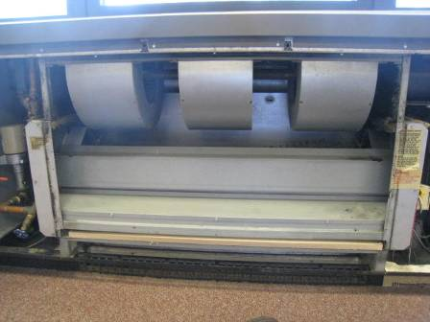

Univent, cover off

Picture 2

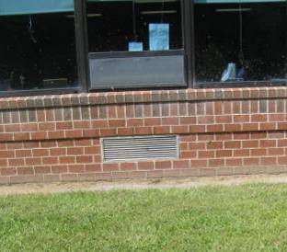

Univent fresh air intake

Picture 3

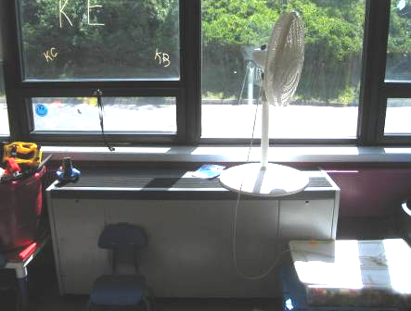

Univent blocked by materials

Picture 4

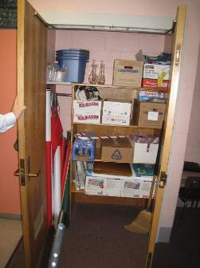

Exhaust vent in closet

Picture 5

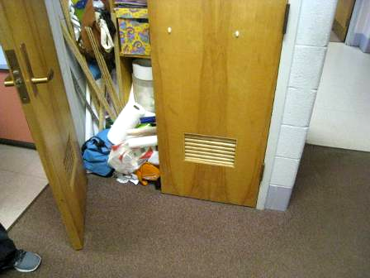

Materials on closet floor blocking exhaust airflow

Picture 6

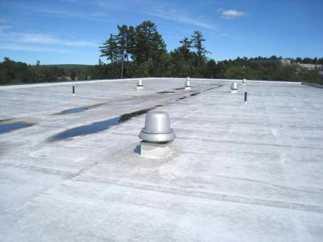

Exhaust vents on roof

Picture 7

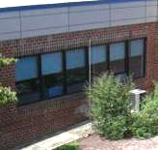

Efflorescence (white mineral deposits) below the wall fascia

Picture 8

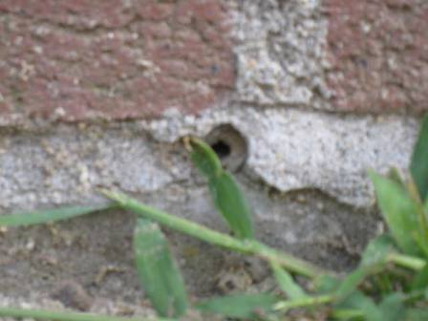

Open weep hole in exterior wall

Picture 9

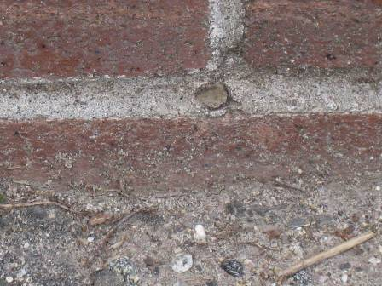

Sealed weep hole

Picture 10

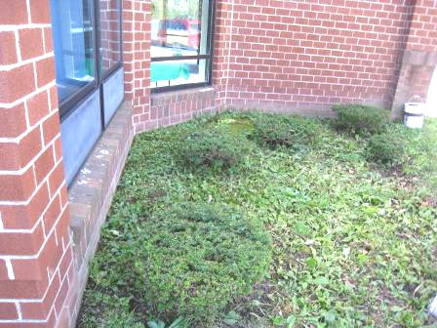

Section of wall with buried weep holes

Picture 11

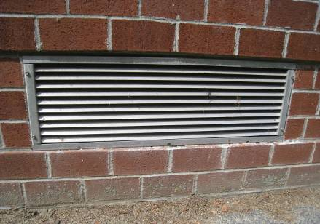

Wall has brick ledges that make the wall prone to water penetration; note flat horizontal surface below univent fresh air intake vents with damaged caulking

Picture 12

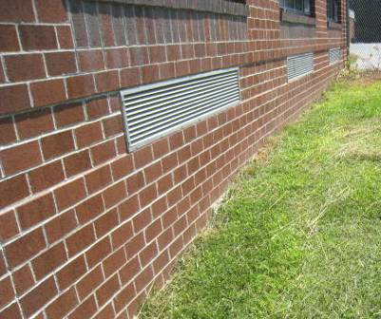

Example of fresh air intakes installed on single plane wall

Picture 13

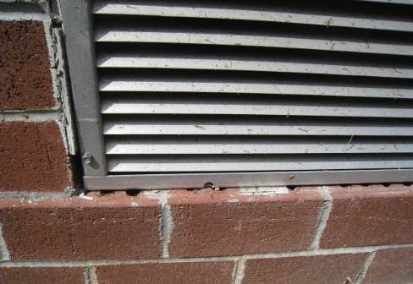

Space between the grill frame and brick was sealed using caulk (note eroded caulking exposing brick air spaces)

Picture 14



Stand of evergreen bushes located near the fresh air intake of classroom A104 univent

Picture 15

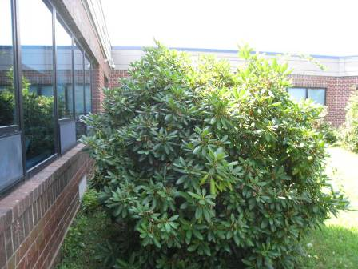

Shrubbery blocking univent fresh air intake

Picture 16

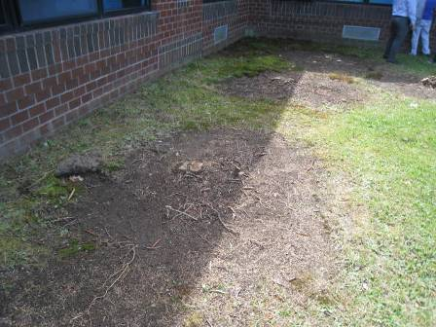

Picture 15 area after shrubbery was removed
Picture 17

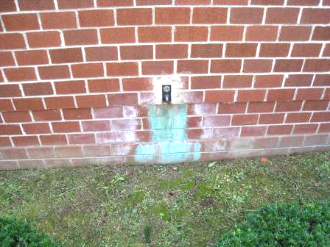

Corrosion/staining beneath exterior wall water spigots

Picture 18

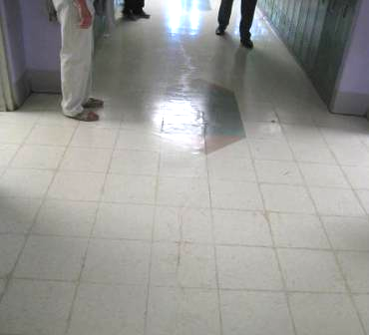

Crack in floor slab beneath hallway tile in E wing

Picture 19

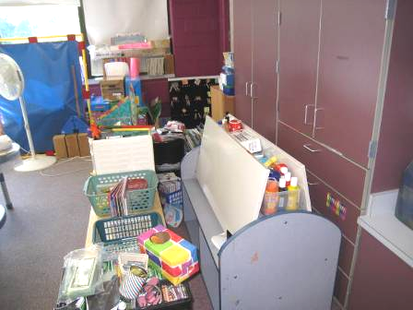

Example of cluttered classroom making custodial cleaning of flat surfaces difficult
Location/ Room | Carbon Dioxide  (ppm) | Carbon Monoxide  (ppm) | Temp  (°F) | Relative Humidity (%) | PM2.5  (µg/m³) | Occupants in Room | Windows  Openable | Ventilation |  | Remarks
 |  |  |  |  |  |  |  | Supply | Exhaust | Remarks
Background | 579 | ND | 68 | 45 | 4 |  |  |  |  | Sunny
A101 | 793 | ND | 74 | 44 | ND | 5 | Y (open) | Y | Y | DEM, clutter, carpet dirty
A102 | 692 | ND | 72 | 36 | 3 | 3 | Y | Y | Y | WD-CT, plant, clutter
A103 | 579 | ND | 70 | 41 | 3 | 0 | Y | Y | Y | PF (dirty), cleaning products on sink
A106 | 641 | ND | 71 | 41 | 2 | 2 | Y | Y | Y | DO, DEM, clutter
A107 | 735 | ND | 71 | 39 | ND | 13 | Y (open) | Y | Y | DO, CD
A109 | 811 | ND | 69 | 43 | 4 | 0 | Y | Y | Y | PF, PC, CD
Admin area | 679 | ND | 72 | 38 | 2 | 2 | Y | Y | Y | PC, laminator, scanner
B101 | 577 | ND | 72 | 38 | ND | 2 | Y | Y | Y | Cleaning products under sink, AF
B102 | 442 | ND | 71 | 41 | 1 | 5 | Y | Y | Y | DO, DEM, clutter, PF (dirty)
B103 | 599 | ND | 73 | 41 | ND | 7 | Y (open) | Y | Y | Univent blocked with window shade, Cleaning product on sink
B105 | 617 | ND | 71 | 45 | 2 | 8 | Y | Y | Y
B107 | 709 | ND | 71 | 49 | 3 | 8 | Y | Y | Y
C104 (Art Room) | 899 | ND | 72 | 45 | ND | 12 | Y | Y | Y | Boxes on floor, plants, DEM, clutter
Cafeteria | 762 | ND | 73 | 44 | 1 | 44 | Y | Y | Y
Computer room | 877 | ND | 75 | 40 | 4 | 12 | N | Y | Y
Conference room | 630 | ND | 73 | 41 | ND | 6 | N | Y | Y | DO
D101 | 824 | ND | 73 | 48 | 2 | 0 | 20 | Y | Y
D102 | 733 | ND | 78 | 39 | ND | 21 | Y | Y | Y | WD CTs (3)
D103 | 1419 | ND | 75 | 51 | ND | 20 | Y | Y | Y
D104 | 748 | ND | 72 | 49 | 2 | 0 | Y | Y | Y | DO, clutter, DEM, CD
D105 | 524 | ND | 72 | 42 | ND | 0 | Y (open) | Y | Y
D106 | 502 | ND | 70 | 44 | 2 | 1 | Y (open) | Y | Y
D107 | 837 | ND | 70 | 49 | 4 | 21 | Y | Y | Y
D108 | 764 | ND | 71 | 48 | 1 | 25 | Y | Y | Y
E101 | 599 | ND | 74 | 42 | 3 | 5 | Y (open) | Y | Y | CD, DEM, clutter
E109 | 711 | ND | 75 | 44 | 2 | 22 | Y | Y | Y | DO, DEM, carpet dirty
E110 | 701 | ND | 72 | 39 | 4 | 22 | Y | Y | Y | PF dirty, clutter
E110 Rest Room | 902 | ND | 73 | 45 | 5 | 0 | N | N | Y | Exhaust off, NC
E113 | 878 | ND | 71 | 41 | 4 | 11 | Y (open) | Y | Y | DO
E114 | 781 | ND | 73 | 44 | 4 | 0 | Y | Y | Y | DO
E117 | 636 | ND | 74 | 40 | 3 | 14 | Y | Y | Y
Guidance | 593 | ND | 72 | 37 | ND | 0 | N | Y | Y | DO, PC
Kitchen | 823 | ND | 76 | 43 | 3 | 5 | Y (open) | Y | Y | Door to outside open, large fans, exhaust hoods on
Library/  media room | 791 | ND | 73 | 50 | 2 | 28 | N | Y | Y | PC, MT, WD-CT, AF, hand sanitizer, window AC (3) on, NC
Men’s Rest Room 1 | 798 | ND | 74 | 52 | 3 | 0 | N | N | Y
Music Room | 695 | ND | 74 | 42 | ND | 2 | Y | Y | Y | DO, dirty ceiling vent
Nurses office | 674 | ND | 72 | 37 | ND | 0 | Y | Y | Y | Hand sanitizer
Public Rest Room | 890 | ND | 74 | 39 | 6 | 0 | N | Y | Y | DO, NC
Staff dining room | 779 | ND | 75 | 43 | 2 | 6 | Y | Y | Y | AD, refrigerator, microwave, NC, PF, hand sanitizer, ceiling vents dirty
Stage/storage | 686 | ND | 75 | 43 | ND | 0 | N | Y | Y | DO, clutter, boxes on floor, NC, DEM, cleaning products, wet mops
Storage | 737 | ND | 74 | 47 | 4 | 0 | N | Y | Y | DO, WD-CT, MT, clutter, cleaning products
Student Rest Room 1 | 773 | ND | 72 | 50 | 3 | 0 | N | N | Y | Exhaust dirty
Women’s Rest Room 1 | 854 | ND | 73 | 56 | 5 | 0 | N | N | Y (off) | Exhaust dirty

