# Background

**INDOOR AIR QUALITY**

**ASSESSMENT**

**Old Mill Pond Elementary School**

**4107 Main Street**

**Palmer, MA**

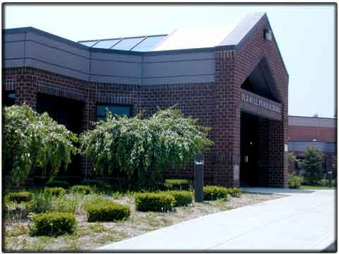

Prepared by:

Massachusetts Department of Public Health

Bureau of Environmental Health

Indoor Air Quality Program

October 2021

|  |  |
| --- | --- |
| Building: | Old Mill Pond Elementary School (OMPES) |
| Address: | 4107 Main Street  Palmer, MA |
| Assessment Requested by: | Patricia Gardner, Superintendent  Palmer Public Schools |
| Date of Assessment: | September 9, 2021 |
| Massachusetts Department of Public Health/Bureau of Environmental Health (MDPH/BEH) Staff Conducting Assessment: | Michael Feeney, Director, Indoor Air Quality (IAQ) Program |
| Date of Building Construction/Renovation | Constructed in 1991 |
| Building Description: | The OMPES is a single-level building with openable windows. The building is not equipped with central air conditioning. |

The IAQ Program conducted assessments at the OMPES for water damage issues during the summer of 2013. Reports from those visits are attached as Appendix A.

# Methods

MDPH IAQ staff conducted a series of visual assessments, temperature and relative humidity measurements to identify likely areas that could be prone to condensation in hot, humid weather. Please refer to the IAQ Manual for methods, sampling procedures, and interpretation of results (MDPH, 2015).

# Results and Discussion

The following is a summary of testing results (Table 1):

* ***Temperature*** was within the MDPH recommended range of 70°F to 78°F in all areas tested. It is important to note that although the OMPES is not an air-conditioned building, most areas are equipped with window-mounted units for comfort control.
* ***Relative Humidity*** was above the MDPH recommended range of 40 to 60% in all but one area the day of assessment due to outside weather conditions. It is important to note that outdoor relative humidity was measured at 87%.

## Ventilation

A heating, ventilating and air conditioning (HVAC) system has several functions. First it provides heating and, if equipped, cooling. Second, it is a source of fresh air. Finally, an HVAC system will dilute and remove normally-occurring indoor environmental pollutants by not only introducing fresh air, but by filtering the airstream and ejecting stale air to the outdoors via exhaust ventilation. Even if an HVAC system is operating as designed, point sources of respiratory irritation may exist and cause symptoms in sensitive individuals.

Fresh air in most classrooms is supplied by unit ventilators (univents) installed when the OMPES was constructed. Univents draw air from the outdoors through a fresh air intake located on the exterior wall of the building and return air through an air intake located at the base of the unit. Fresh and return air are mixed, filtered, heated or cooled and provided to rooms through an air diffuser located in the top of the unit (Figure 1).

Mechanical exhaust ventilation in classrooms is provided by wall-mounted exhaust vents connected to rooftop motors. The MDPH IAQ Program recommends that supply and exhaust ventilation operate continuously during occupied periods to provide air exchange and filtration. Without sufficient supply and exhaust ventilation, normally occurring environmental pollutants can build-up and lead to IAQ/comfort complaints.

It is also important to note that despite ongoing maintenance and replacement of parts/components by OMPES facilities staffs, many of the HVAC units are at the end of their life cycle. Efficient function of equipment of this age (~ 20 years old) is difficult to maintain, since compatible replacement parts are often unavailable. According to the American Society of Heating, Refrigeration, and Air-Conditioning Engineering (ASHRAE), the service life[1] of this type of unit is 15-20 years, assuming routine maintenance of the equipment (ASHRAE, 1991).

To have proper ventilation with a mechanical ventilation system, the systems must be balanced after installation to provide an adequate amount of fresh air to the interior of a room while removing stale air from the room. It is recommended that HVAC systems be re-balanced every five years to ensure adequate air systems function (SMACNA, 1994). Based on the age and condition of the univents. Re-balancing of the HVAC system may not be possible.

## Microbial/Moisture Concerns

IAQ staff did not observe mold growth or musty odors in any location in the OMPES on the day of the visit. Relative humidity indoors ranged from 59-88%. Based on these observations, weather conditions played a prominent role in raising indoor relative humidity.

As noted previously, at the time of the visit indoor relative humidity was consistently above the MDPH IAQ comfort level of 60%, and in many areas was above 70%. Elevated relative humidity reduces the ability of the human body to regulate temperature through perspiration and can lead to increased discomfort even if the temperature is in a comfortable range. Excess humidity can also be a source of water vapor to moisten building materials and stored materials.

Based on observations, the OMPES has experienced water exposure from the following sources:

* Possible condensation on classroom floors during hot, humid weather, and
* Poor drainage of ground along exterior walls

*Building Materials Prone to Condensation*

It is important to note that Massachusetts has experienced extended periods of relative humidity during the summer of 2021. This July was the wettest ever recorded in Massachusetts, and the three-month period from June through August, known as the meteorological summer, was the fourth wettest on record, according to the National Oceanic and Atmospheric Administration’s Centers for Environmental Information. The three-month period also was the third warmest ever in the state and was tied for the warmest on record across the United States. (HG, 2021, NOAA, 2021).

Based on the type of floor construction (cement on soil), the OMPES was assessed to determine if floors were subject to developing condensation during extended (> 24 hours) hot, humid weather. The key to managing condensation in hot, humid weather indoors is understanding dew point. When warm, moist air passes over a cooler surface, condensation can form. Condensation is the collection of moisture on a surface at or below the dew point. The dew point is the temperature that air must reach for saturation to occur. If a building material/component has a temperature below the dew point, condensation will accumulate on that material. Over time, condensation can collect and form water droplets. Floor tiles show signs of chronic condensation exposure.

A method to locate areas in a building prone to condensation is to measure air and building material temperatures (Table 1). If a wide temperature range exists between measurements (>5°F), the building materials at the colder end of the range may be prone to becoming moistened with condensation if exposed to hot, humid weather (70% relative humidity) for extended periods of time. According to the test results in Table 1, all floors in the building would appear to be prone to condensation if exposed to hot, humid weather for extended periods of time.

It was noted that ceiling tiles were bowed in most classrooms (Picture 1; Table 1). This condition frequently indicates that ceiling tiles have been exposed to high humidity over a long period of time. However, no water staining, or mold growth was noted on these ceiling tiles.

According to American Society of Heating, Refrigerating and Air-Conditioning Engineers (ASHRAE), if relative humidity exceeds 70%, mold growth may occur due to wetting of building materials (ASHRAE, 1989). Relative humidity measured in the building was near or exceeded 70% in all but one location during this assessment (Table 1). In this condition, porous materials such as gypsum wallboard, cardboard and other materials may become prone to developing mold colonization. It is recommended that porous material be dried with fans and heating within 24 to 48 hours of becoming wet (US EPA, 2008, ACGIH, 1989). If porous materials are not dried within this time frame, mold growth may occur. Water-damaged porous materials cannot be adequately cleaned to remove mold growth.

*Poor drainage of ground along the exterior walls*

The OMPES has a tarmac apron around the base of the exterior wall to aid water drainage. Plants growing in the apron/exterior wall junction indicate that a gap exists (Picture 2) in which water accumulates against the building slab. Without sufficient drainage, water can pool against the building slab around the exterior wall perimeter. Over time, rainwater runoff from the exterior wall can compress soil, to the building slab to cause the apron to settle, which can then result in water pooling.

The exterior windowsills as well as the apron of the building are covered in places with lichen (Picture 2), which can indicate chronic water exposure. Lichen tends to form on brickwork that retains moisture due to lack of drainage or due to being in a shaded location. Many of the wall surfaces of the OMPES do not see extended exposure to sunlight due to the topography and forests that surround the building.

# Conclusions/Recommendations

The OMPES has a number of issues related to moisture in the building in addition to HVAC system issues described in previous IAQ assessments (Appendix A). It is important to note that a number of the recommendations regarding water damage made in previous reports were implemented, including replacement of carpeting with carpet tiles, which are manufactured in a manner to resist microbial growth.

It is important to note that during the extreme relative humidity and rain of this summer, management of buildings in such weather conditions can be challenging. The following documents can provide guidance that can be used to reduce the impact of hot, humid weather in buildings.

* Preventing mold growth in Massachusetts schools during hot, humid weather: <https://www.mass.gov/service-details/preventing-mold-growth-in-massachusetts-schools-during-hot-humid-weather>
* Remediation and prevention of mold growth and water damage in public schools and buildings to maintain air quality: <https://www.mass.gov/service-details/remediation-and-prevention-of-mold-growth-and-water-damage-in-public-schools-and>
* Methods for Increasing Comfort in Non-Air-Conditioned Schools: <https://www.mass.gov/doc/methods-for-increasing-comfort-in-non-air-conditioned-schools/download>
* To remedy building problems, two sets of recommendations are made: **short-term** measures that may be implemented as soon as practicable and **long-term** measures that will require planning and resources to address overall IAQ concerns.

## Short Term Recommendations

### Implement any remaining recommendations made in previous reports (Appendix A).

1. Remove all soil and mulch that has buried the exterior wall/slab joint.
2. Remove all plants growing from the exterior wall/tarmac apron joint. Seal this joint with an appropriate water-resistant sealing material.
3. Consideration should be given to increasing sunlight exposure to exterior walls to increase drying. Consider reducing the number of trees shading the exterior walls to aid drying.
4. The U.S. Department of Education has released new guidance encouraging the use of American Rescue Plan (ARP) funds to improve ventilation systems and make other indoor air quality improvements in schools. More information can be found at this link <https://www.ed.gov/coronavirus/improving-ventilation>.
5. Consider forming an IAQ committee in each school building district-wide. Committees should have an IAQ liaison/teacher representative, a member of maintenance/facilities and administration that conduct regular walk-throughs to identify on-going and/or potential environmental issues.
6. Consider adopting the US EPA (2000) document, “Tools for Schools”. This document is available at: <http://www.epa.gov/iaq/schools/index.html>.
7. Refer to resource manual and other related IAQ documents located on the MDPH’s website for further building-wide evaluations and advice on maintaining public buildings. These documents are available at: <http://www.mass.gov/dph/iaq>.

## Long Term Recommendations

1. Contact a building engineering firm for advice regarding the following conditions noted at the OMPES.
   1. Improving water drainage from windowsills.
   2. Examine the feasibility preventing rainwater pooling along the exterior walls by regrading soil.
   3. Conduct a building-wide ventilation systems assessment. Based on historical issues with air exchange/indoor air quality complaints, age, physical deterioration, and availability of parts for ventilation components, such an evaluation is necessary to determine the operability and feasibility of replacing the equipment.

# References

ACGIH. 1989. Guidelines for the Assessment of Bioaerosols in the Indoor Environment. American Conference of Governmental Industrial Hygienists, Cincinnati, OH.

ASHRAE. 1989. Ventilation for Acceptable Indoor Air Quality. American Society of Heating, Refrigeration and Air Conditioning Engineers. ANSI/ASHRAE 62-1989.

ASHRAE. 1991. ASHRAE Applications Handbook, Chapter 33 “Owning and Operating Costs”. American Society of Heating, Refrigeration and Air Conditioning Engineers, Atlanta, GA.

HG. 2021. Mold keeps South Hadley High School shuttered. Hampshire Gazette. <https://www.gazettenet.com/South-Hadley-High-School-still-closed-amid-mold-remediation-42413519>

MDPH. 2015. Massachusetts Department of Public Health. Indoor Air Quality Manual: Chapters I-III. Available at: <https://www.mass.gov/lists/indoor-air-quality-manual-and-appendices>

NOAA. 2021. Summer 2021 neck and neck with Dust Bowl summer for hottest on record. National Oceanic and Atmospheric Administration, 1401 Constitution Avenue NW, Room 5128, Washington, DC 20230 <https://www.noaa.gov/news/summer-2021-neck-and-neck-with-dust-bowl-summer-for-hottest-on-record>

SMACNA. 1994. HVAC Systems Commissioning Manual. 1st ed. Sheet Metal and Air Conditioning Contractors’ National Association, Inc., Chantilly, VA.

US EPA. 2000. Tools for Schools. Office of Air and Radiation, Office of Radiation and Indoor Air, Indoor Environments Division (6609J). EPA 402-K-95-001, Second Edition. <https://www.epa.gov/iaq-schools/indoor-air-quality-tools-schools-action-kit>

US EPA. 2008. “Mold Remediation in Schools and Commercial Buildings”. Office of Air and Radiation, Indoor Environments Division, Washington, DC. EPA 402-K-01-001. September 2008. Available at: <http://www.epa.gov/mold/mold-remediation-schools-and-commercial-buildings-guide>

**Figure 1**

**Unit Ventilator (Univent)**

Mixed Air

Air Diffuser

**Outdoors Indoors**

Fan

Heating/Cooling Coil

Air Mixing Plenum

Filter

Outdoor Return

Air Air

Air

Flow

Control

Louvers

**Air Flow**

= Fresh Air/Return Air

= Mixed Air

**Picture 1**

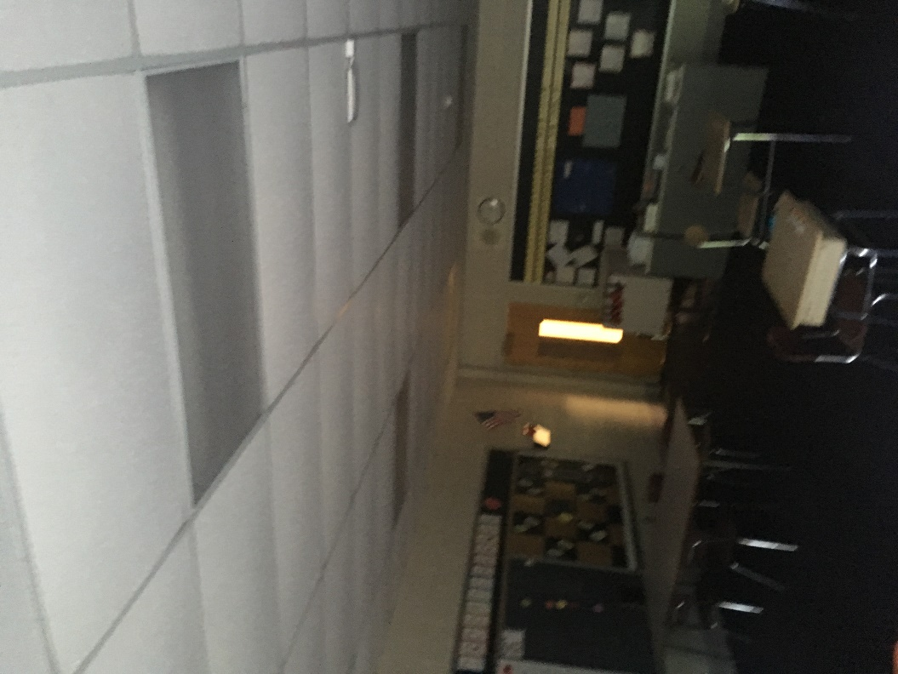

**Bowed ceiling tiles in classroom**

**Picture 2**

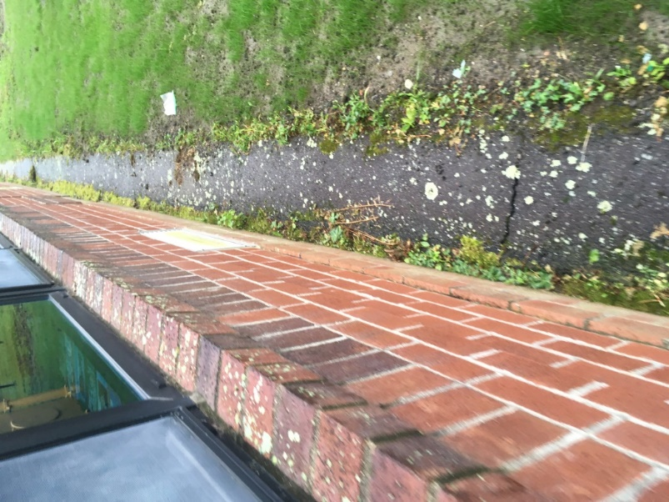

**Example of lichen growing of window sill and tarmac well as plants growing in the exterior wall/tarmac apron junction**

| **Location** | **Air Temp**  **(oF)** | **Relative Humidity**  **(%)** | **Dew Point**  **(oF)** | **Floor Temp**  **(oF)** | **Water Damaged/Missing/ Bowed Ceiling Tiles** | **Wall or Floor Temp**  **(oF)** | **Ventilation** | | | **Air to Floor Temp**  **Difference**  **(oF)** | **Comments** |
| --- | --- | --- | --- | --- | --- | --- | --- | --- | --- | --- | --- |
| **Windows openable** | **Supply** | **Exhaust** |
| Background (outdoors) | 72 | 87 | 68 |  |  |  |  |  |  |  |  |
| C101 | 75 | 85 | 70 | 68 | Y bowed | 69 | Y | Y | Y | 7 |  |
| C102 | 75 | 84 | 70 | 67 | Y bowed | 67 | Y | Y | Y | 8 |  |
| C103 | 73 | 59 | 57 | 62 | Y bowed | 62 | Y | Y | Y | 9 | Window-mounted air conditioner |
| B101 | 74 | 85 | 69 | 67 | Y bowed | 67 | Y | Y | Y | 7 | Window-mounted air conditioner |
| B102 | 75 | 87 | 70 | 67 | Y bowed | 67 | Y | Y | Y | 8 |  |
| B102 | 74 | 86 | 70 | 57 | Y bowed | 67 | Y | Y | Y | 7 |  |
| B104 | 75 | 82 | 69 | 66 | Y bowed | 65 | Y | Y | Y | 9 |  |
| B105 | 74 | 63 | 60 | 62 | Y bowed | 63 | Y | Y | Y | 12 | Window-mounted air conditioner |
| B106 | 72 | 70 | 70 | 63 | Y bowed | 63 | Y | Y | Y | 9 | Window-mounted air conditioner |
| B107 | 73 | 81 | 81 | 67 | Y bowed | 67 | Y | Y | Y | 6 |  |
| B108 | 74 | 86 | 86 | 68 | Y bowed | 68 | Y | Y | Y | 6 |  |
| B109 | 74 | 84 | 69 | 67 | Y bowed | 67 | Y | Y | Y | 7 | Window open |
| B110 | 74 | 83 | 65 | 65 | Y bowed | 64 | Y | Y | Y | 8 |  |
| B111 | 74 | 85 | 69 | 68 | Y bowed | 68 | Y | Y | Y | 6 |  |
| C104 | 75 | 84 | 70 | 68 | Y bowed | 68 | Y | Y | Y | 7 |  |
| Gym | 75 | 84 | 70 | 71 | Y bowed | 71 | Y | Y | Y | 4 |  |
| E101 | 74 | 83 | 69 | 68 | Y bowed | 69 | Y | Y | Y | 6 |  |
| E102 | 75 | 84 | 69 | 69 | Y bowed | 69 | Y | Y | Y | 5 | Window open |
| E103 | 74 | 84 | 69 | 69 | Y bowed | 69 | Y | Y | Y | 5 | Window open |
| E104 | 75 | 84 | 68 | 68 | Y bowed | 69 | Y | Y | Y | 7 | Window open |
| E105 | 75 | 85 | 68 | 68 | Y bowed | 68 | Y | Y | Y | 7 |  |
| E106 | 75 | 83 | 66 | 66 | Y bowed | 67 | Y | Y | Y | 9 | Window open |
| E107 | 74 | 84 | 70 | 66 | Y bowed | 74 | Y | Y | Y | 8 | Window open |
| E108 | 72 | 86 | 70 | 66 | Y bowed | 73 | Y | Y | Y | 6 | Window open |
| E109 | 72 | 88 | 69 | 65 | Y bowed | 73 | Y | Y | Y | 7 | Window open |
| E110 | 72 | 88 | 69 | 64 | Y bowed | 73 | Y | Y | Y | 8 | Window open |
| E111 | 72 | 88 | 69 | 66 | Y bowed | 73 | Y | Y | Y | 6 |  |
| E112 | 72 | 88 | 69 | 66 | Y bowed | 73 | Y | Y | Y | 6 | Window open |
| E113 | 74 | 88 | 70 | 67 | Y bowed | 74 | Y | Y | Y | 7 |  |
| E114 | 74 | 88 | 70 | 67 | Y bowed | 74 | Y | Y | Y | 7 |  |
| E115 | 75 | 86 | 70 | 68 | Y bowed | 75 | Y | Y | Y | 7 |  |
| E110 | 75 | 85 | 70 | 69 | Y bowed | 75 | Y | Y | Y | 6 |  |
| E117 | 75 | 85 | 70 | 68 | Y bowed | 68 | Y | Y | Y | 7 |  |
| C105 | 75 | 86 | 71 | 68 | Y bowed | 67 | Y | Y | Y | 8 |  |
| C106 | 75 | 75 | 74 | 68 | Y bowed | 67 | Y | Y | Y | 8 | Window-mounted air conditioner |
| D101 | 75 | 74 | 66 | 67 | Y bowed | 68 | Y | Y | Y | 7 | Window-mounted air conditioner |
| D102 | 74 | 57 | 63 | 65 | Y bowed | 65 | Y | Y | Y | 9 | Window-mounted air conditioner |
| D103 | 74 | 70 | 66 | 66 | Y bowed | 66 | Y | Y | Y | 8 | Window-mounted air conditioner |
| D104 | 74 | 75 | 66 | 66 | Y bowed | 67 | Y | Y | Y | 8 | Window-mounted air conditioner |
| Kid’s Corner | 74 | 71 | 65 | 67 | Y bowed | 66 | Y | Y | Y | 7 | Window-mounted air conditioner |
| D105 | 74 | 72 | 64 | 64 | Y bowed | 65 | Y | Y | Y | 10 | Window-mounted air conditioner |
| D106 | 73 | 70 | 63 | 63 | Y bowed | 64 | Y | Y | Y | 10 | Window-mounted air conditioner |
| D107 | 72 | 64 | 59 | 63 | Y bowed | 63 | Y | Y | Y | 9 | Window-mounted air conditioner |
| D108 | 73 | 80 | 60 | 65 | Y bowed | 66 | Y | Y | Y | 8 | Window-mounted air conditioner |
| A101 | 74 | 85 | 69 | 66 | Y bowed | 67 | Y | Y | Y | 8 | Window-mounted air conditioner |
| A102 | 74 | 85 | 69 | 68 | Y bowed | 69 | Y | Y | Y | 6 |  |
| A103 | 75 | 85 | 70 | 67 | Y bowed | 68 | Y | Y | Y | 8 |  |
| A104 | 75 | 85 | 70 | 68 | Y bowed | 68 | Y | Y | Y | 7 |  |
| A105 | 75 | 85 | 70 | 67 | Y bowed | 68 | Y | Y | Y | 8 |  |
| A106 | 74 | 84 | 69 | 67 | Y bowed | 66 | Y | Y | Y | 7 |  |
| A107 | 75 | 85 | 69 | 68 | Y bowed | 69 | Y | Y | Y | 7 |  |
| A108 | 75 | 85 | 69 | 68 | Y bowed | 69 | Y | Y | Y | 7 |  |
| A109 | 75 | 85 | 71 | 69 | Y bowed | 70 | Y | Y | Y | 6 |  |
| Hallway outside library | 77 | 85 | 68 | 69 | Y bowed |  | N |  |  | 8 |  |
| Library | 73 | 89 | 70 | 68 | Y bowed | 69 | Y | Y | Y | 5 |  |
| Cafeteria | 74 | 87 | 72 | 69 | Y bowed | 68 | N | Y | Y | 5 |  |
| Kitchen | 76 | 88 | 72 | 66 | Y bowed | 69 | Y | Y | Y | 7 |  |
| C109 | 75 | 84 | 70 | 67 | Y bowed | 66 | Y | Y | Y | 8 |  |
| C110 | 74 | 84 | 69 | 67 | Y bowed | 67 | N | Y | Y | 7 |  |
| Staff room | 74 | 84 | 69 | 64 | Y bowed | 67 | N | Y | Y | 10 |  |
| Guidance | 74 | 76 | 66 | 65 | Y bowed | 64 | Y | Y | Y | 9 |  |
| Guidance office | 74 | 74 | 65 | 65 | Y bowed | 65 | Y | Y | Y | 9 |  |
| Nurse | 73 | 75 | 65 | 65 | Y bowed | 65 | Y | Y | Y | 8 |  |

**MOLD Assessment**

**Old Mill Pond Elementary School**

**4107 Main Street**

**Palmer, Massachusetts**

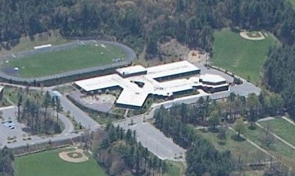

Prepared by:

Massachusetts Department of Public Health

Bureau of Environmental Health

Indoor Air Quality Program

August 2013

**Background/Introduction**

At the request of Joshua Mathieu, Health Agent, Palmer Board of Health (PBOH), the Massachusetts Department of Public Health (MDPH), Bureau of Environmental Health (BEH) conducted an indoor air quality (IAQ) assessment at the Old Mill Pond Elementary School (OMPES), located at 4107 Main Street, Palmer, Massachusetts. The request was prompted by concerns related to mold. On August 21, 2013, a visit was made to the OMPES by Michael Feeney, Director of BEH’s IAQ program. He was accompanied by Mr. Mathieu and various Palmer school officials and school board members.

BEH/IAQ staff conducted a limited assessment of the building focused on sources of water vapor/moisture and respiratory irritants. The overall function of the heating, ventilating, and air-conditioning (HVAC) system was not assessed during this visit because the building was largely unoccupied.

The OMPES is a single-level building, which had been originally constructed as a middle school in 1991 (Figure 1). The OMPES is not air-conditioned apart from a few locations with window-mounted air conditioners. Windows are openable throughout the building.

The Palmer Public Schools reportedly hired a contractor to thoroughly clean the school and carpets. This was in response to moisture damage resulting from an extended heat wave in the New England area in early July 2013. During the cleaning, doors in the building were reportedly propped open to facilitate venting of the building. Fans were also used to create airflow. In addition, classroom unit ventilators and exhaust vents were reportedly operating during the cleaning.

**Methods**

Air tests for temperature and relative humidity were conducted with the TSI, Q-Trak, IAQ Monitor, Model 7565. Surface temperatures of floors were measured with a ThermoTrace infrared thermometer. Moisture content of carpet was measured using a Tramex Moisture Encounter Plus Non-destructive Moisture Detector. BEH/IAQ staff also performed a visual inspection of building materials for water damage and/or microbial growth.

**Results**

The OMPES houses approximately 600 students in grades pre-K through 4 and has a staff of approximately 50. The tests were taken during summer break with no occupants. Test results appear in Table 1.

**Discussion**

**Microbial/Moisture Concerns**

BEH/IAQ staff conducted a visual inspection of the building and found no evidence of water damage attributable to roof or window leaks (such as stained ceiling tiles or damaged wall plaster). In addition, no visible mold growth/contamination was observed nor were musty odors attributed to mold growth detected in classrooms or other areas within the OMPES.

On the day of assessment, the outdoor relative humidity was measured at 75 percent (Table 1). Indoor relative humidity ranged from 49 to 72 percent, which was lower than the outdoor relative humidity. The MDPH recommends a comfort range of 40 to 60 percent for indoor air relative humidity. The indoor relative humidity measurements did not indicate that a significant source of water vapor existed within the OMPES on the day of assessment. However, according to the American Society of Heating Refrigeration and Air-Conditioning Engineers (ASHARE), relative humidity in excess of 70 percent for extended periods of time can provide an environment for mold and fungal growth in building materials (ASHRAE, 1989).

Of particular note was the condition of flooring in the building. The carpeting was observed to be stained and worn. As reported by school officials, the carpeting was installed in 1991. The Institute of Inspection, Cleaning and Restoration Certification (IICRC), recommends that carpeting be cleaned annually, or semi-annually in soiled high traffic areas (IICRC, 2005). Since the average service time of carpeting in a school environment is approximately eleven years (Bishop, 2002), consideration should be given to planning for the installation of new flooring as funds become available.

Temperatures in the building were measured in a range of 75°F to 81°F (Table 1). The MDPH recommends that indoor air temperatures be maintained in a range of 70ºF to 78ºF in order to provide for the comfort of building occupants. The dew point was also measured in the building. Dew point is another way of representing humidity; the dew point is the temperature at which the water vapor in the air will start to condense. If a surface in contact with the air has a temperature at or below the dew point, it will collected condensed moisture[2] and become wet. Dew points in the building ranged from 57°F to 68°F (Table 1).

BEH/IAQ staff also conducted surface temperature measurement of floors throughout the building in order to determine whether the floors would be prone to generating condensation. If the floors of the building are properly insulated, the temperature of the interior side of floors would be expected to be close to the indoor temperature. Floor temperatures were measured in a range of 66° F to 78° F (Table 1), often lower than the corresponding air temperature. All locations had floor temperatures above the corresponding dew point for each area (Table 1), indicating that no condensation would be generated under conditions observed at the time of assessment. However, it is important to note that the floor temperatures measured were often more than 5°F cooler that the corresponding air temperature (Table 1), which can indicate that the floor of the building is being cooled by contact with the ground and may be susceptible to generating condensation during hot, humid weather.

BEH/IAQ staff used a moisture meter to detect whether carpeting was moist in rooms B101 through B103 due to the room locations and low floor temperatures measured there. No detectable levels of moisture were measured in the carpet.

The US Environmental Protection Agency (US EPA) and the American Conference of Governmental Industrial Hygienists (ACGIH) recommends that porous materials be dried with fans and heating within 24 to 48 hours of becoming wet (US EPA, 2001; ACGIH, 1989). If porous materials are not dried within this time frame, mold growth may occur. Water-damaged porous materials cannot be adequately cleaned to remove mold growth. The application of a mildewcide to moldy porous materials is not recommended.

**Other Concerns**

BEH/IAQ staff examined areas in which odors had been reported by occupants. These odors were traced to shelving made from particle board. Frequently, particle board contains a binder called urea-formaldehyde resin. If this material is subjected to hot, humid conditions, the resin becomes unstable and will release formaldehyde vapor. The remaining component of the resin, urea, has a urine-like odor which was noted in a number of classrooms (Table 1). Moistened particle board will continue to emit the urea odor once the resin has broken down, particularly in hot, humid conditions.

**Conclusions/Recommendations**

As noted previously, this assessment was limited to sources of moisture/water vapor and respiratory irritants because the building was not at typical occupancy. Upon request, the BEH IAQ Program can return to the building when it is fully occupied and the heating system is activated in order to conduct a complete IAQ investigation. In view of the findings at the time of the visit, the following recommendations are provided:

1. Remove carpeting in the building as needed if hot, humid weather reoccurs this summer. Long-term plans to replace carpeting throughout the building should be made since it is likely to become moistened by condensation and is past its service life.
2. Since the building’s cement slab has a temperature that is likely below the dew point in hot, humid weather, serious consideration should be give to installing a non-porous floor covering, such as tile in place of carpeting.
3. Remove particle board furniture from areas with urea odors (Table 1).
4. Employ methods outlined in the document “Preventing Mold Growth in Massachusetts Schools During Hot, Humid Weather”) to prevent water damage from hot, humid weather.
5. Consider adopting the US EPA (2000) document, “Tools for Schools”, to maintain a good indoor air quality environment in the building. This document can be downloaded from the Internet at <http://www.epa.gov/iaq/schools/index.html>.
6. Refer to resource manuals and other related indoor air quality documents for further building-wide evaluations and advice on maintaining public buildings. Copies of these materials are located on the MDPH’s website: <http://mass.gov/dph/iaq>.

**References**

ASHRAE. 1989. ASHRAE Standard: Ventilation for Acceptable Indoor Air Quality. Sections 5.11, 5.12. American Society of Heating, Refrigerating and Air-Conditioning Engineers, Inc. Atlanta, GA.

ACGIH. 1989. Guidelines for the Assessment of Bioaerosols in the Indoor Environment. American Conference of Governmental Industrial Hygienists, Cincinnati, OH.

Bishop, J. & Institute of Inspection, Cleaning and Restoration Certification. 2002. A Life Cycle Cost Analysis for Floor Coverings in School Facilities.

IICRC. 2000. IICRC S001. Reference Guideline for Professional On-Location Cleaning of Textile Floor Covering Materials. Institute of Inspection, Cleaning and Restoration Certification. Institute of Inspection Cleaning and Restoration, Vancouver, WA.

IICRC. 2005. Carpet Cleaning FAQ 4 Institute of Inspection, Cleaning and Restoration Certification. Institute of Inspection Cleaning and Restoration, Vancouver, WA.

US EPA. 2000. Tools for Schools. Office of Air and Radiation, Office of Radiation and Indoor Air, Indoor Environments Division (6609J). EPA 402-K-95-001, Second Edition. <http://www.epa.gov/iaq/schools/index.html>.

US EPA. 2001. “Mold Remediation in Schools and Commercial Buildings”. Office of Air and Radiation, Indoor Environments Division, Washington, DC. EPA 402-K-01-001. March 2001. Available at: <http://www.epa.gov/iaq/molds/mold_remediation.html>.



**Figure 1**

**Old Mill Pond Elementary School**

|  |  |  |  |
| --- | --- | --- | --- |
| **Location: Old Mill Pond Elementary School** | | | **Indoor Air Results** |
| **Address: 4107 Main Street, Palmer, MA** | **Table 1** |  | **Date: 8/21/2013** |

| **Location/Room** | **Dew Point (°F)** | | **Temp**  **(°F)** | | **Relative**  **Humidity**  **(%)** | **Floor Temperature (°F)** | **Remarks** |
| --- | --- | --- | --- | --- | --- | --- | --- |
| Background | | 66 | | 74 | 75 | - | Partly cloudy, light breeze (9:30 am) |
| A101 | | 65 | | 78 | 64 | 75 |  |
| A102 | | 65 | | 78 | 65 | 74 |  |
| A103 | | 65 | | 78 | 64 | 71 |  |
| A104 | | 65 | | 78 | 62 | 72 |  |
| A105 | | 68 | | 79 | 68 | 75 | Urea odor from particle board |
| A106 | | 67 | | 79 | 68 | 76 |  |
| A107 | | 67 | | 79 | 68 | 77 |  |
| A108 | | 68 | | 78 | 69 | 76 |  |
| A109 | | 65 | | 76 | 69 | 76 |  |
| Art | | 64 | | 79 | 62 | 72 |  |
| B101 | | 65 | | 75 | 72 | 66 |  |
| B102 | | 65 | | 75 | 71 | 66 |  |
| B103 | | 64 | | 75 | 71 | 67 |  |
| B104 | | 65 | | 75 | 71 | 69 |  |
| B105 | | 64 | | 75 | 70 | 70 |  |
| B106 | | 67 | | 76 | 73 | 73 |  |

**Comfort Guidelines**

|  |  |  |  |
| --- | --- | --- | --- |
|  | Temperature: 70 - 78 °F | Relative Humidity: | 40 - 60% |

|  |  |  |  |
| --- | --- | --- | --- |
| **Location: Old Mill Pond Elementary School** | | | **Indoor Air Results** |
| **Address: 4107 Main Street, Palmer, MA** | **Table 1** |  | **Date: 8/21/2013** |

|  |  |  |  |  |  |
| --- | --- | --- | --- | --- | --- |
| B107 | 67 | 77 | 70 | 75 |  |
| B108 | 67 | 78 | 69 | 77 |  |
| B109 | 66 | 78 | 67 | 76 |  |
| B110 | 66 | 78 | 66 | 76 |  |
| B111 | 66 | 80 | 64 | 78 |  |
| C110 | 57 | 77 | 49 | 72 | Window-mounted air conditioner on |
| Cafeteria | 65 | 80 | 65 | 76 |  |
| D101 | 67 | 76 | 65 | 73 | Urea odor from particle board |
| D102 | 66 | 80 | 67 | 76 |  |
| D103 | 66 | 80 | 66 | 76 |  |
| D104 | 66 | 81 | 66 | 76 |  |
| D105 | 65 | 79 | 64 | 73 |  |
| D106 | 65 | 78 | 65 | 71 |  |
| D107 | 65 | 78 | 63 | 71 | Urea odor from particle board |
| D108 | 65 | 78 | 64 | 76 | Urea odor from particle board |
| E101 | 67 | 78 | 68 | 74 |  |
| E102 | 66 | 77 | 66 | 75 |  |
| E103 | 67 | 79 | 67 | 75 |  |
| E104 | 68 | 79 | 68 | 75 |  |
| E105 | 67 | 76 | 67 | 76 |  |

**Comfort Guidelines**

|  |  |  |  |
| --- | --- | --- | --- |
|  | Temperature: 70 - 78 °F | Relative Humidity: | 40 - 60% |

|  |  |  |  |
| --- | --- | --- | --- |
| **Location: Old Mill Pond Elementary School** | | | **Indoor Air Results** |
| **Address: 4107 Main Street, Palmer, MA** | **Table 1** |  | **Date: 8/21/2013** |

|  |  |  |  |  |  |
| --- | --- | --- | --- | --- | --- |
| E106 | 67 | 79 | 67 | 75 |  |
| E107 | 66 | 79 | 66 | 75 |  |
| E108 | 67 | 79 | 67 | 75 |  |
| E109 | 65 | 78 | 65 | 71 |  |
| E110 | 65 | 78 | 65 | 71 |  |
| E112 | 65 | 77 | 65 | 70 |  |
| E113 | 65 | 77 | 65 | 70 |  |
| E114 | 65 | 77 | 65 | 70 |  |
| E115 | 65 | 76 | 65 | 70 |  |
| E116 | 65 | 76 | 65 | 71 |  |
| E117 | 65 | 76 | 65 | 72 |  |
| Gym | 65 | 78 | 64 | 75 |  |
| Library | 58 | 75 | 66 | 70 | Window-mounted air conditioner on |
| Music | 66 | 81 | 66 | 76 |  |

**Comfort Guidelines**

|  |  |  |  |
| --- | --- | --- | --- |
|  | Temperature: 70 - 78 °F | Relative Humidity: | 40 - 60% |

**Background/Introduction**

**INDOOR AIR QUALITY ASSESSMENT**

**Old Mill Pond Elementary School**

**4107 Main Street**

**Palmer, MA**



Prepared by:

Massachusetts Department of Public Health

Bureau of Environmental Health

Indoor Air Quality Program

October 2013

At the request of Joshua Mathieu, Health Agent, Palmer Board of Health (PBOH), the Massachusetts Department of Public Health (MDPH), Bureau of Environmental Health (BEH) conducted an indoor air quality (IAQ) assessment at the Old Mill Pond Elementary School (OMPES), located at 4107 Main Street, Palmer, Massachusetts. The request was prompted by concerns related to mold. On August 21, 2013, a visit was made to the OMPES by Michael Feeney, Director of BEH’s IAQ Program. A report regarding water damage and mold growth issued as a result of that visit is attached as Appendix A. Mr. Feeney returned to the OMPES on September 6, 2013, accompanied by Ms. Kathleen Gilmore, Regional Inspector in the BEH IAQ Program, to perform additional evaluations of the building. The most recent assessment includes testing for general indoor environmental parameters to determine ventilation system capabilities during occupancy.

The OMPES is a single-level building, which had been originally constructed as a middle school in 1991. The OMPES does not have centralized air-conditioning; however a few locations do have window-mounted air conditioners. Windows are openable throughout the building.

**Methods**

Air tests for carbon monoxide, carbon dioxide, temperature and relative humidity were conducted with the TSI, Q-Trak, IAQ Monitor, Model 7565. Air tests for airborne particle matter with a diameter less than 2.5 micrometers were taken with the TSI, DUSTTRAK™ Aerosol Monitor Model 8520. BEH/IAQ staff also performed visual inspection of building materials for water damage and/or microbial growth.

**Results**

The OMPES houses approximately 600 students in grades pre-K through 4 and has a staff of approximately 50. The tests were taken during summer break with no occupants. Test results appear in Table 1.

**Discussion**

**Ventilation**

It can be seen from Table 1 that carbon dioxide levels were above 800 parts per million (ppm) in 11 of 43 areas tested, indicating less than optimal air exchange in about a quarter of the areas surveyed at the time of the assessment. Note that some rooms had windows open or had low/no occupancy; with windows closed and greater occupancy carbon dioxide levels would be expected to increase.

Fresh air in classrooms is supplied by unit ventilators (univents) (Picture 1). A univent is designed to draw air from outdoors through a fresh air intake located on the exterior wall of the building (Picture 2). Return air is drawn through an air intake located at the base of each unit where fresh and return air are mixed, filtered, heated or cooled and provided to classrooms through an air diffuser located in the top of the unit ([Figure 1](https://www.mass.gov/doc/unit-ventilator-univent/download)).

Univents were found deactivated or obstructed with classroom items in several areas (Picture 3; Table 1). In order for univents to provide fresh air as designed, intakes/returns must remain free of obstructions. Importantly, these units must remain on and be allowed to operate while rooms are occupied.

Exhaust ventilation is provided by ceiling-mounted vents inside classroom storage closets; these vents are ducted to rooftop motors (Picture 4). Air is drawn through a vent in the bottom of the closet door. If the closet is too full, materials can block airflow and reduce/prevent the draw of exhaust air from classrooms (Picture 5). Some of the exhaust vents that were examined had very low or no draw. An examination of rooftop exhaust motors revealed that seven of 21 exhaust fans were deactivated or not working (Picture 6). According to OMPES staff, a number of the exhaust vents were deactivated by timers. Exhaust ventilation is necessary for reducing the accumulation of normally-occurring indoor pollutants, including water vapor from restrooms.

To maximize air exchange, the MDPH recommends that both supply and exhaust ventilation operate continuously during periods of occupancy. In order to have proper ventilation with a mechanical supply and exhaust system, the systems must be balanced to provide an adequate amount of fresh air to the interior of a room while removing stale air from the room. It is recommended that heating, ventilating and air conditioning (HVAC) systems be re-balanced every five years to ensure adequate air systems function (SMACNA, 1994). The date of last balancing was not available at the time of the current visit.

Minimum design ventilation rates are mandated by the Massachusetts State Building Code (MSBC). Until 2011, the minimum ventilation rate in Massachusetts was higher for both occupied office spaces and general classrooms, with similar requirements for other occupied spaces (BOCA, 1993). The current version of the MSBC, promulgated in 2011 by the State Board of Building Regulations and Standards (SBBRS), adopted the 2009 International Mechanical Code (IMC) to set minimum ventilation rates. **Please note that the MSBC is a minimum standard that is not health-based**. At lower rates of cubic feet per minute (cfm) per occupant of fresh air, carbon dioxide levels would be expected to rise significantly. A ventilation rate of 20 cfm per occupant of fresh air provides optimal air exchange resulting in carbon dioxide levels at or below 800 ppm in the indoor environment in each area measured. MDPH recommends that carbon dioxide levels be maintained at 800 ppm or below. This is because most environmental and occupational health scientists involved with research on IAQ and health effects have documented significant increases in indoor air quality complaints and/or health effects when carbon dioxide levels rise above the MDPH guidelines of 800 ppm for schools, office buildings and other occupied spaces (Sundell et al., 2011). The ventilation must be on at all times that the room is occupied. Providing adequate fresh air ventilation with open windows and maintaining the temperature in the comfort range during the cold weather season is impractical. Mechanical ventilation is usually required to provide adequate fresh air ventilation.

Carbon dioxide is not a problem in and of itself. It is used as an indicator of the adequacy of the fresh air ventilation. As carbon dioxide levels rise, it indicates that the ventilating system is malfunctioning or the design occupancy of the room is being exceeded. When this happens, a buildup of common indoor air pollutants can occur, leading to discomfort or health complaints. The Occupational Safety and Health Administration (OSHA) standard for carbon dioxide is 5,000 parts per million parts of air (ppm). Workers may be exposed to this level for 40 hours/week, based on a time-weighted average (OSHA, 1997).

The MDPH uses a guideline of 800 ppm for publicly occupied buildings. A guideline of 600 ppm or less is preferred in schools due to the fact that the majority of occupants are young and considered to be a more sensitive population in the evaluation of environmental health status. Inadequate ventilation and/or elevated temperatures are major causes of complaints such as respiratory, eye, nose and throat irritation, lethargy and headaches. For more information concerning carbon dioxide, consult [Carbon Dioxide and its Use in Evaluating Adequacy of Ventilation](https://www.mass.gov/doc/carbon-dioxide-and-its-use-in-evaluating-adequacy-of-ventilation-in-buildings/download).

Indoor temperature measurements ranged from 69°F to 78°F (Table 1), which were within or very close to the MDPH recommended comfort range the day of assessment. The MDPH recommends that indoor air temperatures be maintained in a range of 70°F to 78°F in order to provide for the comfort of building occupants. In many cases concerning indoor air quality, fluctuations of temperature in occupied spaces are typically experienced, even in a building with an adequate fresh air supply. In addition, it is difficult to control temperature and maintain comfort without operating the ventilation equipment as designed (e.g., univents/exhaust vents deactivated/obstructed).

The relative humidity measured in the building ranged from 36 to 56 percent, which was within or close to the lower end of the MDPH recommended comfort range in all areas surveyed during the assessment (Table 1). The MDPH recommends a comfort range of 40 to 60 percent for indoor relative humidity. Conditions in the building with less temperate outdoor conditions may differ from those measured during the assessment. For example, relative humidity levels in the building would be expected to drop during the winter months due to heating. The sensation of dryness and irritation is common in a low relative humidity environment. Low relative humidity is a very common problem during the heating season in the northeast part of the United States.

**Microbial/Moisture Concerns**

As described in the previous MDPH (2013) report, the OMPES experienced water-damaged carpeting from high relative humidity that occurred during a period of hot, humid weather over the summer. Palmer Public Schools officials reported that water damage had reoccurred in rooms B014, B015, E107 and E108 following hot, humid weather experienced during the 2013 Labor Day weekend. Recommendations in the previous report included removing the carpeting in affected classrooms if water damage reoccurs.

BEH/IAQ staff identified a number of potential water vapor sources/conditions in the OMPES that can contribute to the moistening of wall-to-wall carpeting, which can potentially result in mold colonization. Signs of water damage, as evidenced by the presence of efflorescence, were observed in areas of the exterior walls (Picture 7). Efflorescence is caused by water penetration through brick, dissolving minerals within the brick and mortar as it flows through. When the water evaporates, it leaving a dry white residue. While efflorescence is a characteristic sign of water penetration, it is not mold growth. The presence of efflorescence can indicate that rainwater is penetrating through the exterior wall system and is then seeping through exterior wall brick.

In order to explain how water penetration occurs through exterior wall systems, the following concepts concerning moisture and wall systems must be understood.

1. Brick, cement, and mortar have pore spaces, which allow moisture movement through these materials;
2. Wind driven rains increase water penetration through brick, cement, and mortar;
3. Gravity will direct water in a building towards the ground; and
4. Brick, cement, and mortar must dry in a timely manner to prevent opportunistic microbial growth.

A drainage plane is one component of an exterior wall system that is typically designed to prevent moisture penetration into the building interior. The drainage plane within the wall system should be installed in a manner that redirects water outdoors, allowing building components to remain dry. An exterior wall system should also have the following components to drain water (Figure 2):

* An exterior curtain wall forming the outer cladding of the building;
* An air space behind the curtain wall to allow water to drain downward and prevent the exterior cladding system from becoming wet;
* A drainage plane located opposite the exterior wall, across the air space. The draining plane should consist of a continuous, water-resistant material adhered to a wall (the backup wall). The purpose of the drainage plane is to prevent moisture that crosses the air space from penetrating into interior building system. Moisture that penetrates the exterior wall is directed downward to the weep holes by the water-resistant material of the drainage plane. Water-resistant materials may include tarpaper or plastic wraps.
* Flashing to direct water to weep holes is typically installed around breaks/penetrations exist in the drainage plane (e.g., window systems, door systems, and univent fresh air intakes). If the drainage plane is discontinuous, missing flashing or lacking an air space, rainwater can accumulate inside the wall cavity and penetrate the building.
* Weep holes at the base of the curtain wall that allow for water drainage. Weep holes are customarily installed at or near the foundation slab/exterior wall system junction (Figure 2). Weep holes allow for accumulated water to drain from a wall system (Dalzell, 1955). Lack of weep holes in brickwork, burial of weep holes below grade, or sealing of weep holes with cement will allow water to accumulate in the base of walls, resulting in seepage and possible moistening of building components (Figure 3).

An examination of the exterior wall system was conducted to identify the location and condition of weep holes. Weep holes were found approximately at the slab level (Picture 8). Of note is that many weep holes were blocked with cement or accumulated sediment from bricks/mortar (Picture 9). In some areas, the building slab was not visible. Weep holes in these areas may buried below the soil (Picture 10). Without appropriate drainage, moisture can build up inside the wall’s drainage plane, resulting in increased water/moisture problems.

Design features of the of the brick exterior are also contributing to moisture penetration at the OMPES. Instead of a single-plane exterior wall, the brickwork was laid to create small ledges (Pictures 11 and 12). Univent fresh air intake grills were installed into the recessed section (below the ledges) of the exterior wall. The space between the grill frame and brick was sealed using caulk. At time of assessment, BEH/IAQ staff observed caulking to be missing or eroded, creating pathways for water to readily enter and accumulate (Picture 13). Typically, univent fresh air intakes are installed on flat planes to reduce the potential for water impingement and penetration. Caulking disintegration and increased surface area exposure along the brick ledges may accelerate exterior mortar erosion.

BEH/IAQ staff noted an evergreen scent in classroom A104. The odor was traced to a large stand of evergreen bushes located near the fresh air intake of this classroom’s univent (Picture 14). During the August 21, 2013, BEH/IAQ staff observed significant sections of shrubbery abutting the exterior wall of the building in close proximity to univent fresh air intakes (Picture 15). Upon recommendations made at that time and in the MDPH (2013) report, much of this shrubbery had been removed prior to the September 6, 2013 visit (Picture 16). Shrubbery can hold damp air, which can be entrained by a univent. Plants near a building can also contribute pollen, mold spores and debris to fresh air introduced to a building.

Further, shrubs/trees in close proximity to the building hold moisture against the building exterior and prevent drying. The growth of roots against exterior walls can also bring moisture in contact with the foundation. Plant roots can eventually penetrate the wall, leading to cracks and/or fissures in the sublevel foundation. Over time, these conditions can undermine the integrity of the building envelope and provide a means of water entry into the building via capillary action through exterior walls, foundation concrete and masonry (Lstiburek & Brennan, 2001). The freezing and thawing action of water during the winter months can create cracks and fissures in the foundation that can result in additional penetration points for both water and pests. Consideration should be given to removing landscaping in close proximity to the building so as to maintain a space of 5 feet between shrubbery and the building.

An additional source of moisture impacting the exterior wall of the building include water spigots. Spigots were observed to be surrounded by corrosion stains, indicating a history of leakage (Picture 17). Water leaking from these spigots contributes to the deterioration of bricks and mortar.

Inside the building, BEH/IAQ staff identified significant cracks beneath hallway floor tiles (Picture 18). Floor slabs should be continuous. If the floor is cracked, cold air from the soil beneath the tile can lower the floor temperature. When warm, moist air passes over a surface that is colder than the air, water condensation can collect on the cold surface. Over time, water droplets can form and moisten building materials.

Several classrooms contained a number of plants. Plant soil and drip pans can serve as sources of mold. Plants should also be located away from univents and exhaust ventilation to prevent aerosolization of dirt, pollen or mold.

Water-damaged ceiling tiles were observed at the time of the assessment; these can indicate leaks from the roof or plumbing. Water-damaged ceiling tiles can be a source of mold and should be replaced once the leak has been discovered and repaired.

**Other IAQ Evaluations**

Indoor air quality can be negatively influenced by the presence of respiratory irritants, such as products of combustion. The process of combustion produces a number of pollutants. Common combustion emissions include carbon monoxide, carbon dioxide, water vapor and smoke (fine airborne particle material). Of these materials, exposure to carbon monoxide and particulate matter with a diameter of 2.5 micrometers (μm) or less (PM2.5) can produce immediate, acute health effects upon exposure. To determine whether combustion products were present in the indoor environment, BEH/IAQ staff obtained measurements for carbon monoxide and PM2.5.

*Carbon Monoxide*

Carbon monoxide is a by-product of incomplete combustion of organic matter (e.g., gasoline, wood and tobacco). Exposure to carbon monoxide can produce immediate and acute health effects. Several air quality standards have been established to address carbon monoxide and prevent symptoms from exposure to these substances. The MDPH established a corrective action level concerning carbon monoxide in ice skating rinks that use fossil-fueled ice resurfacing equipment. If an operator of an indoor ice rink measures a carbon monoxide level over 30 ppm, taken 20 minutes after resurfacing within a rink, that operator must take actions to reduce carbon monoxide levels (MDPH, 1997).

The American Society of Heating Refrigeration and Air-Conditioning Engineers (ASHRAE) has adopted the National Ambient Air Quality Standards (NAAQS) as one set of criteria for assessing indoor air quality and monitoring of fresh air introduced by HVAC systems (ASHRAE, 1989). The NAAQS are standards established by the US EPA to protect the public health from six criteria pollutants, including carbon monoxide and particulate matter (US EPA, 2006). As recommended by ASHRAE, pollutant levels of fresh air introduced to a building should not exceed the NAAQS levels (ASHRAE, 1989). The NAAQS were adopted by reference in the Building Officials & Code Administrators (BOCA) National Mechanical Code of 1993 (BOCA, 1993), which is now an HVAC standard included in the Massachusetts State Building Code (SBBRS, 2011). According to the NAAQS, carbon monoxide levels in outdoor air should not exceed 9 ppm in an eight-hour average (US EPA, 2006).

*Carbon monoxide should not be present in a typical, indoor environment*. If it *is* present, indoor carbon monoxide levels should be less than or equal to outdoor levels. On the day of assessment, outdoor carbon monoxide concentrations were non-detect (ND) (Table 1). No measurable levels of carbon monoxide were detected inside the building (Table 1).

*Particulate Matter*

The US EPA has established NAAQS limits for exposure to particulate matter. Particulate matter includes airborne solids that can be irritating to the eyes, nose and throat. The NAAQS originally established exposure limits to PM with a diameter of 10 μm or less (PM10). In 1997, US EPA established a more protective standard for fine airborne particulate matter with a diameter of 2.5 μm or less (PM2.5). This more stringent PM2.5 standard requires outdoor air particle levels be maintained below 35 μg/m3 over a 24-hour average (US EPA, 2006). Although both the ASHRAE standard and BOCA Code adopted the PM10 standard for evaluating air quality, MDPH uses the more protective PM2.5 standard for evaluating airborne PM concentrations in the indoor environment.

Outdoor PM2.5 concentrations were measured at 4 μg/m3 (Table 1). PM2.5 levels measured in the school ranged from ND to 6 μg/m3 (Table 1), which were below the NAAQS PM2.5 level of 35 μg/m3. Frequently, indoor air levels of particulates (including PM2.5) can be at higher levels than those measured outdoors. A number of activities that occur indoors and/or mechanical devices can generate particulate during normal operations. Sources of indoor airborne particulates may include but are not limited to particles generated during the operation of fan belts in the HVAC system, use of stoves and/or microwave ovens in kitchen areas; use of photocopiers, fax machines and computer printing devices; operation of an ordinary vacuum cleaner and heavy foot traffic indoors.

*Volatile Organic Compounds*

Indoor air concentrations can be greatly impacted by the use of products containing volatile organic compounds (VOCs). VOCs are carbon-containing substances that have the ability to evaporate at room temperature. Frequently, exposure to low levels of total VOCs (TVOCs) may produce eye, nose, throat and/or respiratory irritation in some sensitive individuals. For example, chemicals evaporating from a paint can stored at room temperature would most likely contain VOCs. In an effort to identify materials that can potentially increase indoor VOC concentrations, BEH/IAQ staff examined rooms for products containing these respiratory irritants.

Classrooms contained dry erase boards and related materials (Table 1). Materials such as dry erase markers and dry erase board cleaners may contain VOCs, such as methyl isobutyl ketone, n-butyl acetate and butyl-cellusolve (Sanford, 1999), which can be irritating to the eyes, nose and throat.

Hand sanitizer was also observed in several areas of the school (Table 1). Hand sanitizing products may contain ethyl alcohol and/or isopropyl alcohol which are highly volatile and may be irritating to the eyes and nose, and may also contain fragrances to which some people may be sensitive.

Other cleaning products were also found in classrooms (Table 1). Cleaning products contain chemicals that can be irritating to the eyes, nose and throat of sensitive individuals. These products should be properly labeled and stored in an area inaccessible to children. Additionally, an MSDS should be available at a central location for each product in the event of an emergency. Consideration should be given to providing teaching staff with school-issued cleaning products and supplies to ensure that MSDS information is available for all products used at the school and to prevent chemical interactions between janitorial cleaners and cleaners brought in by others.

**Other Conditions**

Other conditions that can affect IAQ were observed during the assessment. In many classrooms, large numbers of items were on floors, windowsills, tabletops, counters, bookcases and desks, which provide a source for dusts to accumulate (Picture 19). These items (e.g., papers, folders, boxes) make it difficult for custodial staff to clean. Items should be relocated and/or be cleaned periodically to avoid excessive dust build up. In addition, dust and debris can accumulate on flat surfaces (e.g., desktops, shelving and carpets) in occupied areas and subsequently be re-aerosolized causing further irritation.

**Conclusions/Recommendations**

The BEH/IAQ program recommends a two-phase approach. The first consists of **short-term** measures to improve air quality and the second consists of **long-term** measures that will require planning and resources to adequately address overall indoor air quality concerns.

**Short-Term Recommendations**

1. Follow recommendations made in previous report.
2. Remove wall-to-wall carpeting from rooms B103, B104, E107 and E108, and replace with floor tiles. Use of removable carpets in these classrooms is preferable if carpeting is desired.
3. Monitor carpeting in other locations for moisture, and take steps to begin drying carpet within 24 hours of moistening.
4. Continue with plans to remove carpeting from the entire building.
5. Operate all univents during all periods of school occupancy. Remove all blockages/items from the surface of univent air diffusers and return vents (along front/bottom) to ensure adequate airflow.
6. Ensure that exhaust vent fans operate during all hours of school occupancy and repair as needed. Remove items from closets containing exhaust vents to allow for exhaust airflow.
7. Use openable windows to supplement fresh air in classrooms as necessary. Ensure that all windows opened are equipped with intact screens to prevent insect entry. Ensure that all windows are tightly sealed at the end of each day to prevent security issues and freezing of pipes in colder weather.
8. For buildings in New England, periods of low relative humidity during the winter are often unavoidable. Therefore, scrupulous cleaning practices should be adopted to minimize common indoor air contaminants whose irritant effects can be enhanced when the relative humidity is low. To control dusts, a high efficiency particulate arrestance (HEPA) filter equipped vacuum cleaner in conjunction with wet wiping of all surfaces is recommended. Avoid the use of feather dusters. Drinking water during the day can help ease some symptoms associated with a dry environment (throat and sinus irritations).
9. Remove shrubbery from the exterior walls of the building.
10. Unearth buried weep holes. Open/repair all sealed/blocked weep holes to ensure moisture drainage from all exterior walls.
11. Repair water spigots to prevent water leakage.
12. Ensure plants, trees and shrubs are located at least five feet away from exterior walls/foundation of the building, particularly those in close proximity to univent fresh air intakes.
13. Ensure roof/plumbing leaks are repaired and replace any remaining water-damaged ceiling tiles. Examine the area above these tiles for mold growth. Disinfect areas of water leaks with an appropriate antimicrobial, as needed.
14. Ensure classroom are well maintained to prevent leaks, spills, mold growth, and nuisance odors.
15. Store cleaning products properly and out of reach of students. All cleaning products used at the facility should be approved by the school department with MSDS’ available at a central location.
16. Relocate or consider reducing the amount of materials stored in classrooms and storage areas to allow for more thorough cleaning of classrooms. Clean items regularly with a wet cloth or sponge to prevent excessive dust build-up.
17. Consider adopting the US EPA (2000) document, “Tools for Schools”. This document is available at: <http://www.epa.gov/iaq/schools/index.html>.
18. Refer to MDPH’s resource manuals and other related indoor air quality documents located on the department’s website for further building-wide evaluations and advice on maintaining public buildings. These documents are available at: <http://mass.gov/dph/iaq>.

**Long-Term Recommendations**

1. Examine the feasibility of installing flashing between brick ledges and univent fresh air intakes to create a drainage plane.
2. Consider the feasibility of repairing cracks beneath hallway floor tile (Picture 19).
3. Consider adopting a balancing schedule of every 5 years for all mechanical ventilation systems, as recommended by ventilation industrial standards (SMACNA, 1994).

**References**

ASHRAE. 1989. Ventilation for Acceptable Indoor Air Quality. American Society of Heating, Refrigeration and Air Conditioning Engineers. ANSI/ASHRAE 62-1989.

BOCA. 1993. The BOCA National Mechanical Code/1993. 8th ed. Building Officials and Code Administrators International, Inc., Country Club Hill, IL.

Dalzell, J.R. 1955. *Simplified Masonry Planning and Building*. McGraw-Hill Book Company, Inc. New York, NY.

Lstiburek, J. & Brennan, T. 2001. Read This Before You Design, Build or Renovate. Building Science Corporation, Westford, MA. U.S. Department of Housing and Urban Development, Region I, Boston, MA.

MDPH. 1997. Requirements to Maintain Air Quality in Indoor Skating Rinks (State Sanitary Code, Chapter XI). 105 CMR 675.000. Massachusetts Department of Public Health, Boston, MA.

OSHA. 1997. Limits for Air Contaminants. Occupational Safety and Health Administration. Code of Federal Regulations. 29 C.F.R 1910.1000 Table Z-1-A.

Sanford. 1999. Material Safety Data Sheet (MSDS No: 198-17). Expo® Dry Erase Markers Bullet, Chisel, and Ultra Fine Tip. Sanford Corporation. Bellwood, IL.

SBBRS. 2011. Mechanical Ventilation. State Board of Building Regulations and Standards. Code of Massachusetts Regulations, 8th edition. 780 CMR 1209.0

SMACNA. 1994. HVAC Systems Commissioning Manual. 1st ed. Sheet Metal and Air Conditioning Contractors’ National Association, Inc., Chantilly, VA.

Sundell, J., H. Levin, W. W. Nazaroff, W. S. Cain, W. J. Fisk, D. T. Grimsrud, F. Gyntelberg, Y. Li, A. K. Persily, A. C. Pickering, J. M. Samet, J. D. Spengler, S. T. Taylor, and C. J. Weschler. 2011. Ventilation rates and health: multidisciplinary review of the scientific literature. *Indoor Air*, Volume 21: pp 191–204.

US EPA. 2000. Tools for Schools. Office of Air and Radiation, Office of Radiation and Indoor Air, Indoor Environments Division (6609J). EPA 402-K-95-001, Second Edition. http://www.epa.gov/iaq/schools/actionkit.html

US EPA. 2006. National Ambient Air Quality Standards (NAAQS). US Environmental Protection Agency, Office of Air Quality Planning and Standards, Washington, DC. <http://www.epa.gov/air/criteria.html>

**Figure 2**

**Drainage Plane Function: Weep Holes Drain Water from the Wall System to**

**Prevent Moisture Penetration into the Interior**

Drainage Plane

Driving Rain

Water

Movement

Exterior Curtain Wall

**Figure 3**

**Blocked Weep Hole: Water Accumulates in the Drainage Plane**

Drainage Plane

Exterior Curtain Wall

Accumulate Water

Moisture Weep Hole Blocked with Wick

**Picture 1**

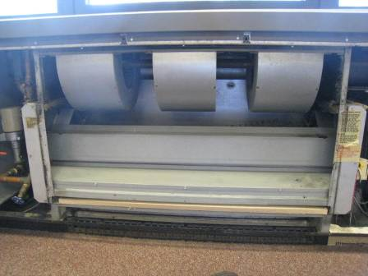

**Univent, cover off**

**Picture 2**

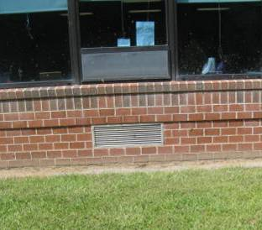

**Univent fresh air intake**

**Picture 3**

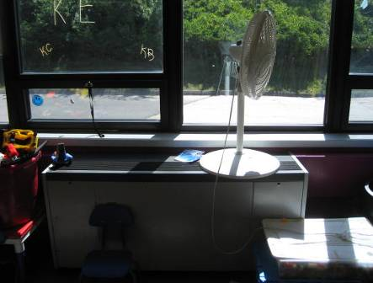

**Univent blocked by materials**

**Picture 4**

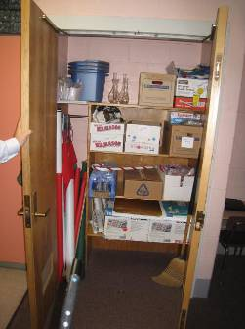

**Exhaust vent in closet**

**Picture 5**

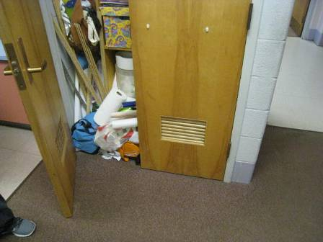

**Materials on closet floor blocking exhaust airflow**

**Picture 6**

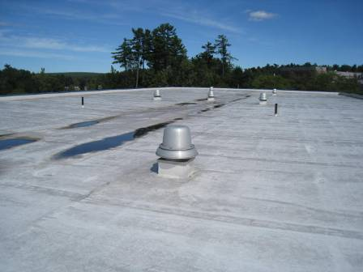

**Exhaust vents on roof**

**Picture 7**



**Efflorescence (white mineral deposits) below the wall fascia**

**Picture 8**

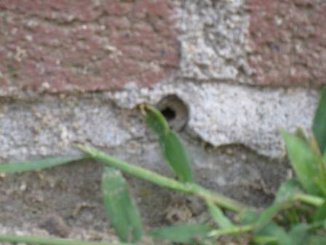

**Open weep hole in exterior wall**

**Picture 9**

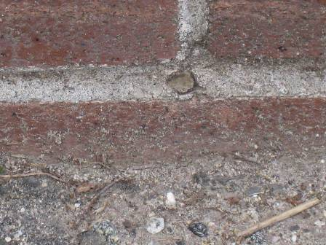

**Sealed weep hole**

**Picture 10**

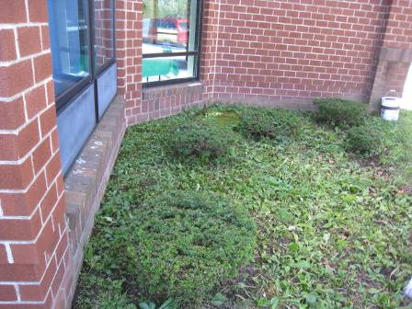

**Section of wall with buried weep holes**

**Picture 11**

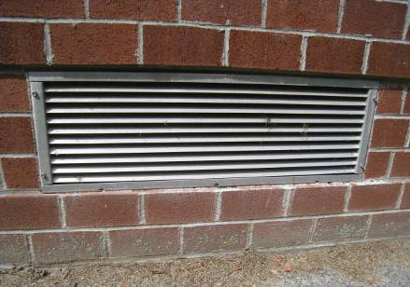

**Wall has brick ledges that make the wall prone to water penetration; note flat horizontal surface below univent fresh air intake vents with damaged caulking**

**Picture 12**

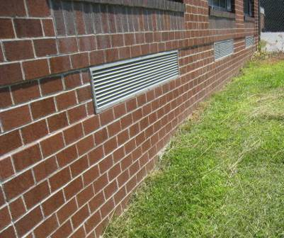

**Example of fresh air intakes installed on single plane wall**

**Picture 13**

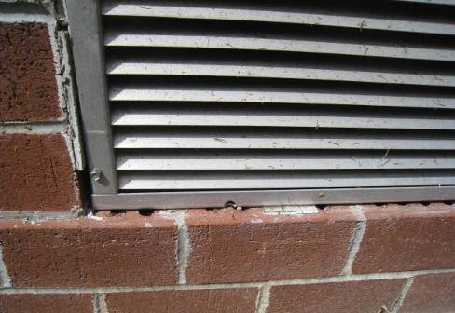

**Space between the grill frame and brick was sealed using caulk (note eroded caulking exposing brick air spaces)**

**Picture 14**

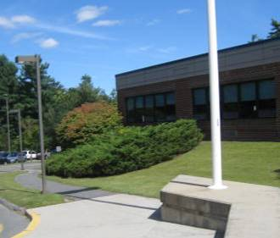

**Stand of evergreen bushes located near the fresh air intake of classroom A104 univent**

**Picture 15**

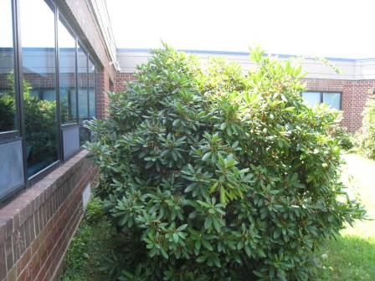

**Shrubbery blocking univent fresh air intake**

**Picture 16**

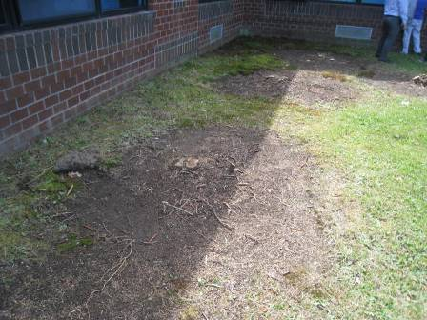

**Picture 15 area after shrubbery was removed**

**Picture 17**

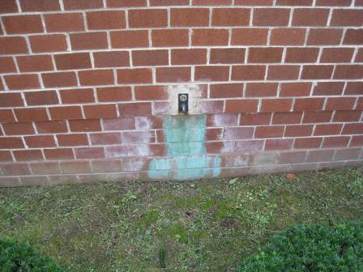

**Corrosion/staining beneath exterior wall water spigots**

**Picture 18**

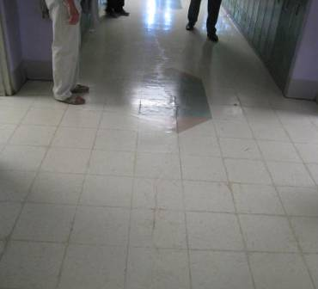

**Crack in floor slab beneath hallway tile in E wing**

**Picture 19**

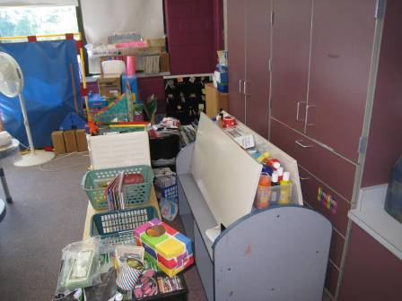

**Example of cluttered classroom making custodial cleaning of flat surfaces difficult**

|  |  |  |  |
| --- | --- | --- | --- |
| **Location: Old Mill Pond School** | | | **Indoor Air Results** |
| **Address: 4107 Main Street, Palmer, MA** | **Table 1 (continued)** |  | **Date: 9/6/2013** |

| **Location/ Room** | **Carbon Dioxide**  **(ppm)** | **Carbon Monoxide**  **(ppm)** | **Temp**  **(°F)** | **Relative Humidity (%)** | **PM2.5**  **(µg/m3)** | **Occupants in Room** | **Windows**  **Openable** | **Ventilation** | | **Remarks** |
| --- | --- | --- | --- | --- | --- | --- | --- | --- | --- | --- |
| **Supply** | **Exhaust** |
| Background | 579 | ND | 68 | 45 | 4 |  |  |  |  | Sunny |
| A101 | 793 | ND | 74 | 44 | ND | 5 | Y (open) | Y | Y | DEM, clutter, carpet dirty |
| A102 | 692 | ND | 72 | 36 | 3 | 3 | Y | Y | Y | WD-CT, plant, clutter |
| A103 | 579 | ND | 70 | 41 | 3 | 0 | Y | Y | Y | PF (dirty), cleaning products on sink |
| A106 | 641 | ND | 71 | 41 | 2 | 2 | Y | Y | Y | DO, DEM, clutter |
| A107 | 735 | ND | 71 | 39 | ND | 13 | Y (open) | Y | Y | DO, CD |
| A109 | 811 | ND | 69 | 43 | 4 | 0 | Y | Y | Y | PF, PC, CD |

|  |  |  |  |
| --- | --- | --- | --- |
| ppm = parts per million | DO = door open | MT = missing ceiling tile | PC = photocopier |
| µg/m3 = micrograms per cubic meter | CD = chalk dust | NC = non-carpeted | PF = personal fan |
| ND = non detect | CT = ceiling tile | AF = air freshener | WD = water-damaged |
| AP = air purifier | DEM = dry erase materials |  |  |

**Comfort Guidelines**

|  |  |  |  |
| --- | --- | --- | --- |
| Carbon Dioxide: | < 600 ppm = preferred | Temperature: | 70 - 78 °F |
|  | 600 - 800 ppm = acceptable | Relative Humidity: | 40 - 60% |
|  | > 800 ppm = indicative of ventilation problems | Particle matter 2.5 | < 35 ug/m3 |

|  |  |  |  |
| --- | --- | --- | --- |
| **Location: Old Mill Pond School** | | | **Indoor Air Results** |
| **Address: 4107 Main Street, Palmer, MA** | **Table 1 (continued)** |  | **Date: 9/6/2013** |

|  |  |  |  |  |  |  |  |  |  |  |
| --- | --- | --- | --- | --- | --- | --- | --- | --- | --- | --- |
| Admin area | 679 | ND | 72 | 38 | 2 | 2 | Y | Y | Y | PC, laminator, scanner |
| B101 | 577 | ND | 72 | 38 | ND | 2 | Y | Y | Y | Cleaning products under sink, AF |
| B102 | 442 | ND | 71 | 41 | 1 | 5 | Y | Y | Y | DO, DEM, clutter, PF (dirty) |
| B103 | 599 | ND | 73 | 41 | ND | 7 | Y (open) | Y | Y | Univent blocked with window shade, Cleaning product on sink |
| B105 | 617 | ND | 71 | 45 | 2 | 8 | Y | Y | Y |  |
| B107 | 709 | ND | 71 | 49 | 3 | 8 | Y | Y | Y |  |
| C104 (Art Room) | 899 | ND | 72 | 45 | ND | 12 | Y | Y | Y | Boxes on floor, plants, DEM, clutter |
| Cafeteria | 762 | ND | 73 | 44 | 1 | 44 | Y | Y | Y |  |
| Computer room | 877 | ND | 75 | 40 | 4 | 12 | N | Y | Y |  |
| Conference room | 630 | ND | 73 | 41 | ND | 6 | N | Y | Y | DO |

|  |  |  |  |
| --- | --- | --- | --- |
| ppm = parts per million | DO = door open | MT = missing ceiling tile | PC = photocopier |
| µg/m3 = micrograms per cubic meter | CD = chalk dust | NC = non-carpeted | PF = personal fan |
| ND = non detect | CT = ceiling tile | AF = air freshener | WD = water-damaged |
| AP = air purifier | DEM = dry erase materials |  |  |

**Comfort Guidelines**

|  |  |  |  |
| --- | --- | --- | --- |
| Carbon Dioxide: | < 600 ppm = preferred | Temperature: | 70 - 78 °F |
|  | 600 - 800 ppm = acceptable | Relative Humidity: | 40 - 60% |
|  | > 800 ppm = indicative of ventilation problems | Particle matter 2.5 | < 35 ug/m3 |

|  |  |  |  |
| --- | --- | --- | --- |
| **Location: Old Mill Pond School** | | | **Indoor Air Results** |
| **Address: 4107 Main Street, Palmer, MA** | **Table 1 (continued)** |  | **Date: 9/6/2013** |

|  |  |  |  |  |  |  |  |  |  |  |
| --- | --- | --- | --- | --- | --- | --- | --- | --- | --- | --- |
| D101 | 824 | ND | 73 | 48 | 2 | 0 | 20 | Y | Y |  |
| D102 | 733 | ND | 78 | 39 | ND | 21 | Y | Y | Y | WD CTs (3) |
| D103 | 1419 | ND | 75 | 51 | ND | 20 | Y | Y | Y |  |
| D104 | 748 | ND | 72 | 49 | 2 | 0 | Y | Y | Y | DO, clutter, DEM, CD |
| D105 | 524 | ND | 72 | 42 | ND | 0 | Y (open) | Y | Y |  |
| D106 | 502 | ND | 70 | 44 | 2 | 1 | Y (open) | Y | Y |  |
| D107 | 837 | ND | 70 | 49 | 4 | 21 | Y | Y | Y |  |
| D108 | 764 | ND | 71 | 48 | 1 | 25 | Y | Y | Y |  |
| E101 | 599 | ND | 74 | 42 | 3 | 5 | Y (open) | Y | Y | CD, DEM, clutter |
| E109 | 711 | ND | 75 | 44 | 2 | 22 | Y | Y | Y | DO, DEM, carpet dirty |

|  |  |  |  |
| --- | --- | --- | --- |
| ppm = parts per million | DO = door open | MT = missing ceiling tile | PC = photocopier |
| µg/m3 = micrograms per cubic meter | CD = chalk dust | NC = non-carpeted | PF = personal fan |
| ND = non detect | CT = ceiling tile | AF = air freshener | WD = water-damaged |
| AP = air purifier | DEM = dry erase materials |  |  |

**Comfort Guidelines**

|  |  |  |  |
| --- | --- | --- | --- |
| Carbon Dioxide: | < 600 ppm = preferred | Temperature: | 70 - 78 °F |
|  | 600 - 800 ppm = acceptable | Relative Humidity: | 40 - 60% |
|  | > 800 ppm = indicative of ventilation problems | Particle matter 2.5 | < 35 ug/m3 |

|  |  |  |  |
| --- | --- | --- | --- |
| **Location: Old Mill Pond School** | | | **Indoor Air Results** |
| **Address: 4107 Main Street, Palmer, MA** | **Table 1 (continued)** |  | **Date: 9/6/2013** |

|  |  |  |  |  |  |  |  |  |  |  |
| --- | --- | --- | --- | --- | --- | --- | --- | --- | --- | --- |
| E110 | 701 | ND | 72 | 39 | 4 | 22 | Y | Y | Y | PF dirty, clutter |
| E110 Rest Room | 902 | ND | 73 | 45 | 5 | 0 | N | N | Y | Exhaust off, NC |
| E113 | 878 | ND | 71 | 41 | 4 | 11 | Y (open) | Y | Y | DO |
| E114 | 781 | ND | 73 | 44 | 4 | 0 | Y | Y | Y | DO |
| E117 | 636 | ND | 74 | 40 | 3 | 14 | Y | Y | Y |  |
| Guidance | 593 | ND | 72 | 37 | ND | 0 | N | Y | Y | DO, PC |
| Kitchen | 823 | ND | 76 | 43 | 3 | 5 | Y (open) | Y | Y | Door to outside open, large fans, exhaust hoods on |
| Library/  media room | 791 | ND | 73 | 50 | 2 | 28 | N | Y | Y | PC, MT, WD-CT, AF, hand sanitizer, window AC (3) on, NC |
| Men’s Rest Room 1 | 798 | ND | 74 | 52 | 3 | 0 | N | N | Y |  | |
| Music Room | 695 | ND | 74 | 42 | ND | 2 | Y | Y | Y | DO, dirty ceiling vent | |

|  |  |  |  |
| --- | --- | --- | --- |
| ppm = parts per million | DO = door open | MT = missing ceiling tile | PC = photocopier |
| µg/m3 = micrograms per cubic meter | CD = chalk dust | NC = non-carpeted | PF = personal fan |
| ND = non detect | CT = ceiling tile | AF = air freshener | WD = water-damaged |
| AP = air purifier | DEM = dry erase materials |  |  |

**Comfort Guidelines**

|  |  |  |  |
| --- | --- | --- | --- |
| Carbon Dioxide: | < 600 ppm = preferred | Temperature: | 70 - 78 °F |
|  | 600 - 800 ppm = acceptable | Relative Humidity: | 40 - 60% |
|  | > 800 ppm = indicative of ventilation problems | Particle matter 2.5 | < 35 ug/m3 |

|  |  |  |  |
| --- | --- | --- | --- |
| **Location: Old Mill Pond School** | | | **Indoor Air Results** |
| **Address: 4107 Main Street, Palmer, MA** | **Table 1 (continued)** |  | **Date: 9/6/2013** |

|  |  |  |  |  |  |  |  |  |  |  |
| --- | --- | --- | --- | --- | --- | --- | --- | --- | --- | --- |
| Nurses office | 674 | ND | 72 | 37 | ND | 0 | Y | Y | Y | Hand sanitizer |
| Public Rest Room | 890 | ND | 74 | 39 | 6 | 0 | N | Y | Y | DO, NC |
| Staff dining room | 779 | ND | 75 | 43 | 2 | 6 | Y | Y | Y | AD, refrigerator, microwave, NC, PF, hand sanitizer, ceiling vents dirty |
| Stage/storage | 686 | ND | 75 | 43 | ND | 0 | N | Y | Y | DO, clutter, boxes on floor, NC, DEM, cleaning products, wet mops |
| Storage | 737 | ND | 74 | 47 | 4 | 0 | N | Y | Y | DO, WD-CT, MT, clutter, cleaning products |
| Student Rest Room 1 | 773 | ND | 72 | 50 | 3 | 0 | N | N | Y | Exhaust dirty |

|  |  |  |  |
| --- | --- | --- | --- |
| ppm = parts per million | DO = door open | MT = missing ceiling tile | PC = photocopier |
| µg/m3 = micrograms per cubic meter | CD = chalk dust | NC = non-carpeted | PF = personal fan |
| ND = non detect | CT = ceiling tile | AF = air freshener | WD = water-damaged |
| AP = air purifier | DEM = dry erase materials |  |  |

**Comfort Guidelines**

|  |  |  |  |
| --- | --- | --- | --- |
| Carbon Dioxide: | < 600 ppm = preferred | Temperature: | 70 - 78 °F |
|  | 600 - 800 ppm = acceptable | Relative Humidity: | 40 - 60% |
|  | > 800 ppm = indicative of ventilation problems | Particle matter 2.5 | < 35 ug/m3 |

1. The service life is the median time during which a particular system or component of …[an HVAC]… system remains in its original service application and then is replaced. Replacement may occur for any reason, including, but not limited to, failure, general obsolescence, reduced reliability, excessive maintenance cost, and changed system requirements due to such influences as building characteristics or energy prices (ASHRAE, 1991).
2. Condensation is the collection of moisture on a surface with a temperature below the dew point. The dew point is a temperature determined by air temperature and relative humidity. For example, at a temperature of 73o F and relative humidity of 57 percent indoors, the dew point for water to collect on a surface is approximately 57 o F (IICRC, 2000).