INDOOR AIR QUALITY ASSESSMENT

Old Post Road Elementary School
99 Old Post Road
Walpole, MA

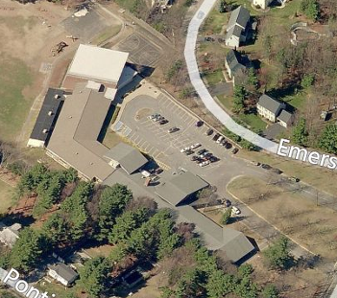

Prepared by:
The Massachusetts Department of Public Health
Bureau of Environmental Health
Indoor Air Quality Program
June 2013

Background/Introduction
At the request of Ms. Robin Chapell, Health Director, Walpole Board of Health, the Massachusetts Department of Public Health (MDPH), Bureau of Environmental Health (BEH) conducted a limited indoor air quality (IAQ) assessment at the Old Post Road Elementary School (OPRES) located at 99 Old Post Road, Walpole, Massachusetts.
The request was prompted by complaints of eye irritation during periods of indoor recess in classroom 15 during the month of February 2013. Cory Holmes, Environmental Analyst/Inspector in BEH’s IAQ Program, had previously visited the building in September of 2006 to investigate mold/water damage concerns and issued a report based on observations made at that time, with recommendations to improve air quality (MDPH, 2006). Actions taken on recommendations made in that report are listed in Appendix A. Additional recommendations from the Walpole Health Department are attached as Appendix B.
On March 4, 2013, Mr. Holmes visited the OPRES to evaluate classroom 15 as well as a similar classroom (14) which was not experiencing complaints for comparison. Mr. Holmes was accompanied by Principal Stephen Fortin and Ms. Chapell during the assessment.
Classrooms 14 and 15 are located in a wing of the school that was built in the 1980s. The rooms consist of an open floor plan with vinyl tile floors, cinderblock walls and a dropped ceiling tile system. Windows are openable and appeared to be in good condition.

Methods
Air tests for carbon monoxide, carbon dioxide, temperature and relative humidity were conducted with the TSI, Q-Trak, IAQ Monitor, Model 7565. Air tests for airborne particle matter with a diameter less than 2.5 micrometers were taken with the TSI, DUSTTRAK™ Aerosol Monitor, Model 8520. BEH/IAQ staff also performed visual inspection of building materials for water damage and/or microbial growth. Test results are listed in Table 1.

Results
This elementary school houses approximately 475 students in grades K through 5, with a staff of approximately 24. The tests were taken under normal operating conditions. Test results appear in Table 1.

Discussion

Ventilation
It can be seen from Table 1 that carbon dioxide levels were below 800 parts per million (ppm) in both classrooms 14 and 15. These results indicate adequate air exchange at the time of assessment. Fresh air in classrooms is supplied by unit ventilator (univent) systems (Picture 1). A univent draws air from the outdoors through a fresh air intake located on the exterior wall of the building (Picture 2) and returns air through an air intake located at the base of the unit. Fresh and return air are mixed, filtered, heated and provided to classrooms through an air diffuser located in the top of the unit (Figure 1). Univents have fan settings of “low” and “high” (Picture 3). At the time of assessment the univent in classroom 15 was operating on the “low” setting. Filters are reportedly changed 2-3 times over the school year and were most recently changed over February vacation.
Exhaust ventilation is provided by ceiling-mounted vents that are ducted to rooftop motors (Pictures 2 and 4). During the assessment, the exhaust vents were operating and were found to have a good draw of air. However, the exhaust grills were observed to have accumulated dust/debris (Picture 4). Exhaust vents should be periodically cleaned of accumulated dust/debris to prevent re-aerosolization of these materials under conditions where exhaust vents are deactivated or not functioning as designed and cause backdrafting. It is also important to note that exhaust vents are located near hallway doors, which are generally left open (Picture 5). With the hallway doors open however, the exhaust vent will tend to draw air from the hallway into the classroom, instead of drawing stale air from the classroom. Therefore it is recommended that classroom doors remain shut while exhaust vents are operating to function as designed.
To maximize air exchange, the MDPH recommends that both supply and exhaust ventilation operate continuously during periods of building occupancy. In order to have proper ventilation with a mechanical supply and exhaust system, the systems must be balanced to provide an adequate amount of fresh air to the interior of a room while removing stale air from the room.
Minimum design ventilation rates are mandated by the Massachusetts State Building Code (MSBC). Until 2011, the minimum ventilation rate in Massachusetts was higher for both occupied office spaces and general classrooms, with similar requirements for other occupied spaces (BOCA, 1993). The current version of the MSBC, promulgated in 2011 by the State Board of Building Regulations and Standards (SBBRS), adopted the 2009 International Mechanical Code (IMC) to set minimum ventilation rates. Please note that the MSBC is a minimum standard that is not health-based. At lower rates of cubic feet per minute (cfm) per occupant of fresh air, carbon dioxide levels would be expected to rise significantly. A ventilation rate of 20 cfm per occupant of fresh air provides optimal air exchange resulting in carbon dioxide levels at or below 800 ppm in the indoor environment in each area measured. MDPH recommends that carbon dioxide levels be maintained at 800 ppm or below. This is because most environmental and occupational health scientists involved with research on IAQ and health effects have documented significant increases in indoor air quality complaints and/or health effects when carbon dioxide levels rise above the MDPH guidelines of 800 ppm for schools, office buildings and other occupied spaces (Sundell, J. et al., 2011). The ventilation must be on at all times that the room is occupied. Providing adequate fresh air ventilation with open windows and maintaining the temperature in the comfort range during the cold weather season is impractical. Mechanical ventilation is usually required to provide adequate fresh air ventilation.
Carbon dioxide is not a problem in and of itself. It is used as an indicator of the adequacy of the fresh air ventilation. As carbon dioxide levels rise, it indicates that the ventilating system is malfunctioning or the design occupancy of the room is being exceeded. When this happens, a buildup of common indoor air pollutants can occur, leading to discomfort or health complaints. The Occupational Safety and Health Administration (OSHA) standard for carbon dioxide is 5,000 parts per million parts of air (ppm). Workers may be exposed to this level for 40 hours/week, based on a time-weighted average (OSHA, 1997).
The MDPH uses a guideline of 800 ppm for publicly occupied buildings. A guideline of 600 ppm or less is preferred in schools due to the fact that the majority of occupants are young and considered to be a more sensitive population in the evaluation of environmental health status. Inadequate ventilation and/or elevated temperatures are major causes of complaints such as respiratory, eye, nose and throat irritation, lethargy and headaches. For more information concerning carbon dioxide, consult Appendix C.
Temperatures in classrooms 14 and 15 measured during the assessment ranged from 70°F to 72°F (Table 1), which were within the MDPH recommended comfort range. The MDPH recommends that indoor air temperatures be maintained in a range of 70°F to 78°F in order to provide for the comfort of building occupants. In many cases concerning indoor air quality, fluctuations of temperature in occupied spaces are typically experienced, even in a building with an adequate fresh air supply.
The relative humidity measured in classrooms 14 and 15 ranged from 18 to 22 percent, which was below the MDPH recommended comfort range (Table 1). The MDPH recommends a comfort range of 40 to 60 percent for indoor air relative humidity. Relative humidity levels in the building would be expected to drop during the winter months due to heating. The sensation of dryness and irritation is common in a low relative humidity environment. Low relative humidity is a very common problem during the heating season in the northeast part of the United States.

Microbial/Moisture Concerns
In order for building materials to support mold growth, a source of water exposure is necessary. Identification and elimination of the source of water moistening porous materials is necessary to control mold growth. As part of the assessment, BEH/IAQ staff opened the univent in classroom 15 to observe conditions inside for possible sources of irritants. Inside the univent cabinet wet/mold-colonized paper materials were found beneath a leaking pipe (Picture 6). At the time of discovery of this material, BEH/IAQ staff recommended that the wet/moldy materials be discarded and the interior of the univent cabinet be cleaned and disinfected. No obvious leaks from the univent or sources of mold were observed in classroom 14.

Other Indoor Air Evaluations
Indoor air quality can be negatively influenced by the presence of respiratory irritants, such as products of combustion. The process of combustion produces a number of pollutants. Common combustion emissions include carbon monoxide, carbon dioxide, water vapor, and smoke (fine airborne particle material). Of these materials, exposure to carbon monoxide and particulate matter with a diameter of 2.5 micrometers (μm) or less (PM2.5) can produce immediate, acute health effects upon exposure. To determine whether combustion products were present in the indoor environment, BEH/IAQ staff obtained measurements for carbon monoxide and PM2.5.

Carbon Monoxide
Carbon monoxide is a by-product of incomplete combustion of organic matter (e.g., gasoline, wood and tobacco). Exposure to carbon monoxide can produce immediate and acute health affects. Several air quality standards have been established to address carbon monoxide and prevent symptoms from exposure to these substances. The MDPH established a corrective action level concerning carbon monoxide in ice skating rinks that use fossil-fueled ice resurfacing equipment. If an operator of an indoor ice rink measures a carbon monoxide level over 30 ppm, taken 20 minutes after resurfacing within a rink, that operator must take actions to reduce carbon monoxide levels (MDPH, 1997).
The American Society of Heating Refrigeration and Air-Conditioning Engineers (ASHRAE) has adopted the National Ambient Air Quality Standards (NAAQS) as one set of criteria for assessing indoor air quality and monitoring of fresh air introduced by HVAC systems (ASHRAE, 1989). The NAAQS are standards established by the US EPA to protect the public health from six criteria pollutants, including carbon monoxide and particulate matter (US EPA, 2006). As recommended by ASHRAE, pollutant levels of fresh air introduced to a building should not exceed the NAAQS levels (ASHRAE, 1989). The NAAQS were adopted by reference in the Building Officials & Code Administrators (BOCA) National Mechanical Code of 1993 (BOCA, 1993), which is now an HVAC standard included in the Massachusetts State Building Code (SBBRS, 2011). According to the NAAQS, carbon monoxide levels in outdoor air should not exceed 9 ppm in an eight-hour average (US EPA, 2006).
Carbon monoxide should not be present in a typical, indoor environment. If it is present, indoor carbon monoxide levels should be less than or equal to outdoor levels. Outdoor carbon monoxide concentrations were non-detect (ND) at the time of assessment (Tables 1). No measurable levels of carbon monoxide were detected in either classroom during the assessment (Tables 1).

Particulate Matter
The US EPA has established NAAQS limits for exposure to particulate matter. Particulate matter includes airborne solids that can be irritating to the eyes, nose and throat. The NAAQS originally established exposure limits to PM with a diameter of 10 μm or less (PM10). In 1997, US EPA established a more protective standard for fine airborne particulate matter with a diameter of 2.5 μm or less (PM2.5). The NAAQS has subsequently been revised, and PM2.5 levels were reduced. This more stringent PM2.5 standard requires outdoor air particle levels be maintained below 35 μg/m³ over a 24-hour average (US EPA, 2006). Although both the ASHRAE standard and BOCA Code adopted the PM10 standard for evaluating air quality, MDPH uses the more protective PM2.5 standard for evaluating airborne PM concentrations in the indoor environment.
Outdoor PM2.5 concentrations the day of the assessment were measured at 4 μg/m³. PM2.5 levels measured in both classrooms were 5 μg/m³ (Table 1). Both indoor and outdoor PM2.5 levels were below the NAAQS PM2.5 level of 35 μg/m³. Frequently, indoor air levels of particulates (including PM2.5) can be at higher levels than those measured outdoors. A number of mechanical devices and/or activities that occur indoors can generate particulate during normal operations. Sources of indoor airborne particulates may include but are not limited to particles generated during the operation of fan belts in the HVAC system, use of stoves and/or microwave ovens in kitchen areas; use of photocopiers, fax machines and computer printing devices; operation of an ordinary vacuum cleaner and heavy foot traffic indoors.

Volatile Organic Compounds
Indoor air concentrations can be greatly impacted by the use of products containing volatile organic compounds (VOCs). VOCs are carbon-containing substances that have the ability to evaporate at room temperature. Frequently, exposure to low levels of total VOCs (TVOCs) may produce eye, nose, throat and/or respiratory irritation in some sensitive individuals. For example, chemicals evaporating from a paint can stored at room temperature would most likely contain VOCs. In an effort to identify materials that can potentially increase VOC concentrations, BEH/IAQ staff examined classrooms for products that may contain these respiratory irritants.
Classrooms contained dry erase boards and dry erase board markers. Materials such as permanent markers, dry erase markers and dry erase board cleaners may contain VOCs, such as methyl isobutyl ketone, n-butyl acetate and butyl-cellusolve (Sanford, 1999), which can be irritating to the eyes, nose and throat.

Other Conditions
Other conditions that can affect indoor air quality were observed during the assessment. As previously mentioned, dust was observed accumulated on the surface of exhaust vents (Picture 4); dust/debris accumulation was also observed in the interior of univents (Picture 7). Univents and exhaust vents should be cleaned periodically (e.g., during regular filter changes) in order to prevent them from serving as a source of aerosolized particulates.
Upholstered furniture and pillows/cushions were seen in classrooms 14 and 15 (Picture 8). Upholstered furniture, pillows and cushions are covered with fabric that comes in contact with human skin. This type of contact can leave oils, perspiration, hair and skin cells. Dust mites feed upon human skin cells and excrete waste products that contain allergens. In addition, if relative humidity levels increase above 60 percent, dust mites tend to proliferate (US EPA, 1992). In order to remove dust mites and other pollutants, frequent vacuuming of upholstered furniture is recommended (Berry, M.A., 1994). It is also recommended that upholstered furniture (if present in schools), be professionally cleaned on an annual basis. If outdoor conditions or indoor activities (e.g., renovations) create an excessively dusty environment, cleaning frequency should be increased (every six months) (IICRC, 2000).
Finally, both classrooms also contained area carpets (Picture 8). The Institute of Inspection, Cleaning and Restoration Certification (IICRC), recommends that carpeting be cleaned annually (or semi-annually in soiled high traffic areas) (IICRC, 2005). Principal Fortin reported that carpets are cleaned at least once a year.

Conclusions/Recommendations
As previously mentioned, the complaints in classroom 15 were reported during indoor recess periods during the month of February. It is important to note that these conditions would create a worse-case IAQ scenario for several reasons. The main reason recess is typically held indoors is due to inclement weather conditions (e.g., heavy rain/snow, extreme cold), which was frequent during the month of February 2013. During extreme cold conditions, fresh air intake is mechanically limited to prevent univent pipes from freezing. In addition, relative humidity measurements during winter months in New England are typically low (e.g., 24% the day of the assessment) which can commonly cause dryness and irritation and make dusts more aerosolizable.
The symptoms reported in classroom 15 were likely due to a combination of the presence of several point sources of irritation (e.g., wet/moldy paper in univent, dust/debris) and a lack of air exchange due to weather conditions. In view of the findings at the time of the visit, the following recommendations are provided:
- Continue to operate ventilation systems (e.g., univents and exhaust vents) continuously during periods of occupancy.
- Close classroom doors to maximize exhaust capabilities and air exchange as designed.
- If an increase in fresh airflow/exchange is desired, consider operating univents in the fan “high” mode.
- Use openable windows where available in conjunction with classroom univents and exhaust vents to facilitate air exchange.
- Ensure exhaust vents and the interiors of univent cabinets are thoroughly cleaned of dirt, dust and loose debris on a regular basis (e.g., during regular filter changes).
- For buildings in New England, periods of low relative humidity during the winter are often unavoidable. Therefore, scrupulous cleaning practices should be adopted to minimize common indoor air contaminants whose irritant effects can be enhanced when the relative humidity is low. To control dusts, use of a vacuum cleaner equipped with a HEPA filter in conjunction with wet wiping of all surfaces is recommended. Drinking water during the day can help ease some symptoms associated with a dry environment (throat and sinus irritation).
- If not done yet, ensure pipe leak in classroom 15 is fixed. Clean interior of univent cabinet with an appropriate antimicrobial. Paper materials (e.g., equipment manuals) should not be stored within univents. Univents in other classrooms should be inspected to ensure similar conditions do not exist.
- Clean upholstered furniture, stuffed animals and pillows on a regular schedule. If not possible/practical, consider removing from classrooms.
- Continue to clean carpeting annually or semi-annually in soiled high traffic areas as per the recommendations of the Institute of Inspection, Cleaning and Restoration Certification (IICRC). Copies of the IICRC fact sheet can be downloaded at: http://www.cleancareseminars.com/carpet_cleaning_faq4.htm (IICRC, 2005).
- Consider adopting the US EPA (2000) document, “Tools for Schools”, as an instrument for maintaining a good indoor air quality environment in the building. This document is available at: http://www.epa.gov/iaq/schools/index.html.
- Refer to resource manual and other related indoor air quality documents located on the MDPH’s website for further building-wide evaluations and advice on maintaining public buildings. These documents are available at: http://mass.gov/dph/iaq.

References
ASHRAE. 1989. Ventilation for Acceptable Indoor Air Quality. American Society of Heating, Refrigeration and Air Conditioning Engineers. ANSI/ASHRAE 62-1989.
Berry, M.A. 1994. Protecting the Built Environment: Cleaning for Health. Michael A. Berry, Chapel Hill, NC.
BOCA. 1993. The BOCA National Mechanical Code/1993. 8th ed. Building Officials and Code Administrators International, Inc., Country Club Hill, IL.
IICRC. 2000. IICRC S001. Reference Guideline for Professional On-Location Cleaning of Textile Floor Covering Materials. Institute of Inspection, Cleaning and Restoration Certification. Institute of Inspection Cleaning and Restoration, Vancouver, WA.
IICRC. 2005. Carpet Cleaning FAQ 4 Institute of Inspection, Cleaning and Restoration Certification. Institute of Inspection Cleaning and Restoration, Vancouver, WA.
MDPH. 1997. Requirements to Maintain Air Quality in Indoor Skating Rinks (State Sanitary Code, Chapter XI). 105 CMR 675.000. Massachusetts Department of Public Health, Boston, MA.
MDPH. 2006. Indoor Air Quality Assessment. Mold/Water Damage Investigation. Old Post Road Elementary School, Walpole, MA. Massachusetts Department of Public Health, Center for Environmental Health, Boston, MA. October 2006.
OSHA. 1997. Limits for Air Contaminants. Occupational Safety and Health Administration. Code of Federal Regulations. 29 C.F.R 1910.1000 Table Z-1-A.
Sanford. 1999. Material Safety Data Sheet (MSDS No: 198-17). Expo® Dry Erase Markers Bullet, Chisel, and Ultra Fine Tip. Sanford Corporation. Bellwood, IL.
SBBRS. 2011. Mechanical Ventilation. State Board of Building Regulations and Standards. Code of Massachusetts Regulations, 8th edition. 780 CMR 1209.0
Sundell, J., H. Levin, W. W. Nazaroff, W. S. Cain, W. J. Fisk, D. T. Grimsrud, F. Gyntelberg, Y. Li, A. K. Persily, A. C. Pickering, J. M. Samet, J. D. Spengler, S. T. Taylor, and C. J. Weschler. 2011. Ventilation rates and health: multidisciplinary review of the scientific literature. Indoor Air, Volume 21: pp 191–204.
US EPA. 1992. Indoor Biological Pollutants. US Environmental Protection Agency, Environmental Criteria and Assessment Office, Office of Health and Environmental Assessment, research Triangle Park, NC. EPA 600/8-91/202. January 1992.
US EPA. 2000. Tools for Schools. Office of Air and Radiation, Office of Radiation and Indoor Air, Indoor Environments Division (6609J). EPA 402-K-95-001, Second Edition. http://www.epa.gov/iaq/schools/tools4s2.html
US EPA. 2006. National Ambient Air Quality Standards (NAAQS). US Environmental Protection Agency, Office of Air Quality Planning and Standards, Washington, DC. http://www.epa.gov/air/criteria.html.
Picture 1

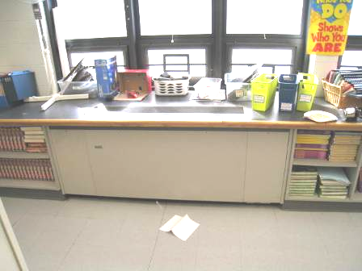

Classroom univent

Picture 2

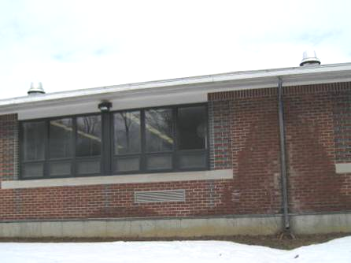

Univent fresh air intake (bottom arrow) and rooftop exhaust motors (top arrows)

Picture 3

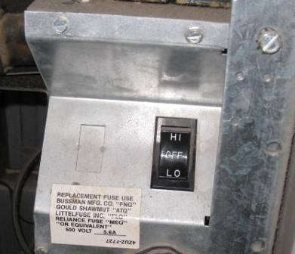

Univent fan control set to “low”

Picture 4

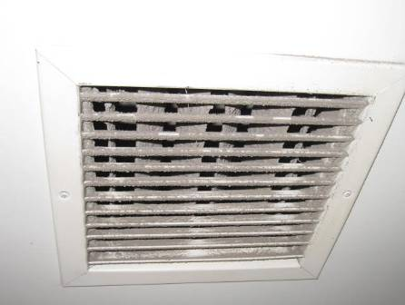

Ceiling-mounted exhaust grill, note dust/debris accumulation

Picture 5

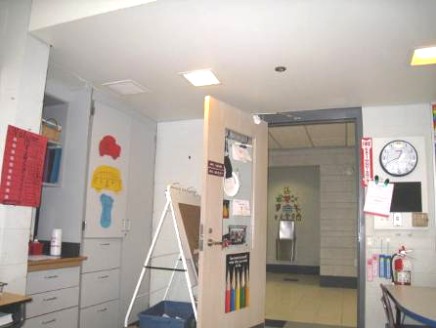

Proximity of ceiling-mounted exhaust vent to open classroom door (arrows)

Picture 6

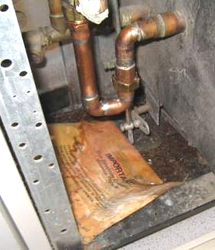

Wet/mold-colonized paper materials in univent cabinet below pipe leak

Picture 7

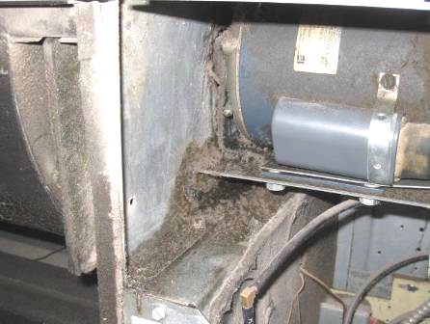

Accumulated dust and debris inside univent cabinet

Picture 8

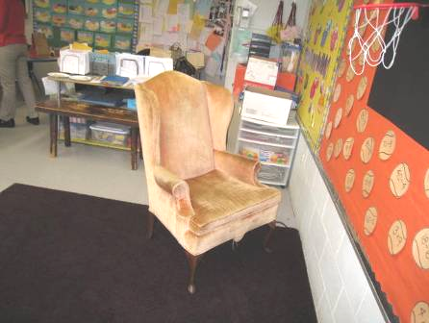

Upholstered chair and area rug in classroom 15
Location | Carbon  Dioxide  (*ppm) | Temp  (°F) | Relative  Humidity  (%) | Carbon  Monoxide  (*ppm) | PM2.5  (µg/m³) | Occupants  in Room | Windows  Openable | Ventilation
Background | 395 | 48 | 24 | ND | 4 |  |  |  |  | Cool, mostly cloudy, winds NW 12-24 mph, gusts up to 31
Classroom 14 | 534 | 70 | 18 | ND | 5 | 1 | Y | Y | Y | 20 occupants gone 2 mins., dust/debris accumulation on exhaust vent, area carpet/pillows
Classroom 15 | 678 | 72 | 22 | ND | 5 | 24 | Y | Y | Y | Dust/debris accumulation on exhaust vent and inside UV cabinet, filter clean, changed Feb, leak inside UV cabinet, wet/mold-colonized paper materials, area carpet, upholstered chair, UV set to “low” fan

Actions on MDPH Recommendations, Old Post Road Elementary School, Walpole, MA

The following is a status report of action(s) taken on MDPH recommendations made in the 2006 MDPH report (in bold) based on reports from school officials, maintenance staff, documents, photographs and MDPH staff observations. Additional actions were also implemented in response to previous recommendations from the Walpole Health Department are attached as Appendix B.

- Ensure roof/plumbing leaks are repaired and replace water-damaged ceiling tiles. Examine the area above and around these areas for mold growth (e.g., insulation). Disinfect areas of water leaks with an appropriate antimicrobial.
- Action: Leaks were repaired and water-damaged ceiling tiles were replaced.
- Remove rust deposits from metal ceiling supports by lightly sanding; prime and repaint.
- Action: Metal ceiling supports were cleaned and repainted or replaced.
- Remove all blockages from univents and exhaust vents.
- Action: Univents and exhaust vents were observed to be unblocked during the assessment.

