Mold/Water Damage Investigation

Old Rochester Regional High School
TV Studio
135 Marion Road
Mattapoisett, Massachusetts

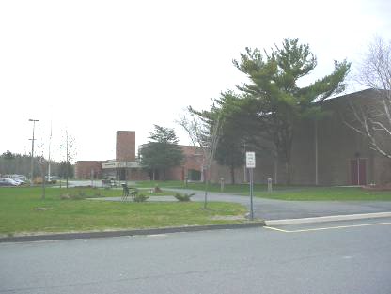

Prepared by:
Massachusetts Department of Public Health
Bureau of Environmental Health
Indoor Air Quality Program
September 2007

Background/Introduction
At the request of a Steve Shiraka, Director of Buildings and Grounds for the Old Rochester Regional School District, the Massachusetts Department of Public Health (MDPH), Bureau of Environmental (BEH) provided assistance and consultation regarding indoor air quality concerns at the Old Rochester Regional High School in Mattapoisett, Massachusetts. The request was prompted by concerns about water damage/mold growth in the basement TV studio. On April 30, 2007, a visit to conduct an indoor air quality assessment was made to this building by Cory Holmes, an Environmental Analyst in BEH’s Emergency Response/Indoor Air Quality (ER/IAQ) Program.

Methods
MDPH staff performed a visual inspection of building materials for water damage and/or microbial growth. Moisture content of porous building materials was measured with a Delmhorst, BD-2000 Model, Moisture Detector equipped with a Delmhorst Standard Probe.

Results and Discussion
As previously mentioned the assessment was prompted by concerns of mold growth in the TV studio. Mr. Shiraka reported that the source of moisture was suspected of being related to a wall-mounted air conditioning (AC) unit that had been retro-fitted into the control room (Picture 1). Condensation generated by the AC is drained by a clear plastic tube and pumped vertically above the ceiling system through an adjacent mechanical room and discharged via a drainage pipe that extends out the exterior wall (Pictures 2-5).
Prior to the BEH assessment, carpeting and sections of gypsum wallboard (GW)and vinyl base coving were removed in several areas to investigate potential sources of mold growth (Pictures 6-11). BEH staff examined building materials in the TV studio suite and found no water damage or visible mold growth.
In order for building materials to support mold growth, a source of water exposure is necessary. Identification and elimination of the source of water moistening building materials is necessary to control mold growth. Materials with increased moisture content over normal concentrations may indicate the possible presence of mold growth. All porous materials tested during the assessment were found to have low (i.e., normal) moisture content (Table 1). Moisture content of materials measured is a real-time measurement of the conditions present at the time of the assessment.
The US Environmental Protection Agency (US EPA) and the American Conference of Governmental Industrial Hygienists (ACGIH) recommends that porous materials be dried with fans and heating within 24 to 48 hours of becoming wet (US EPA, 2001; ACGIH, 1989). If porous materials are not dried within this time frame, mold growth may occur. Water-damaged porous materials cannot be adequately cleaned to remove mold growth. The application of a mildewcide to moldy porous materials is not recommended.

Conclusions/Recommendations
In view of the findings at the time of the assessment, no further remedial actions are warranted, however the following resources are provided for additional information/advice indoor air quality and mold:
- For more information on mold consult “Mold Remediation in Schools and Commercial Buildings” published by the US Environmental Protection Agency (US EPA, 2001). This document can be downloaded from the US EPA website at: http://www.epa.gov/iaq/molds/mold_remediation.html.
- Consider adopting the US EPA (2000) document, “Tools for Schools”, as an instrument for maintaining a good indoor air quality environment in the building. This document is available at: http://www.epa.gov/iaq/schools/index.html.
- Refer to resource manuals and other related indoor air quality documents for further building-wide evaluations and advice on maintaining public buildings. These materials are located on the MDPH’s website at http://mass.gov/dph/indoor_air.

References
ACGIH. 1989. Guidelines for the Assessment of Bioaerosols in the Indoor Environment. American Conference of Governmental Industrial Hygienists, Cincinnati, OH.
US EPA. 2000. Tools for Schools. Office of Air and Radiation, Office of Radiation and Indoor Air, Indoor Environments Division (6609J). EPA 402-K-95-001, Second Edition. http://www.epa.gov/iaq/schools/tools4s2.html
US EPA. 2001. “Mold Remediation in Schools and Commercial Buildings”. Office of Air and Radiation, Indoor Environments Division, Washington, DC. EPA 402-K-01-001. March 2001. Available at: http://www.epa.gov/iaq/molds/mold_remediation.html
Picture 1

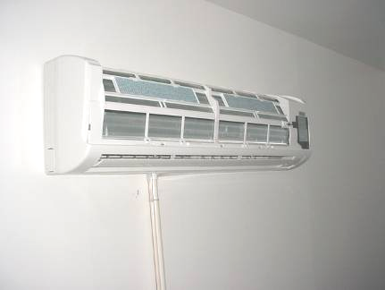

Wall-Mounted AC Unit Retro-fitted in TV Studio Control Room, Note Drainage Tube (Bottom)

Picture 2

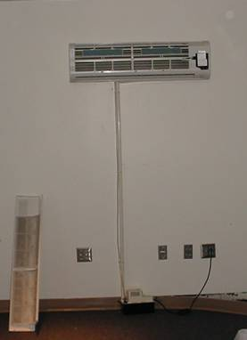

Wall-Mounted AC Unit Retro-fitted in TV Studio Control Room, Note Drainage Tube
and Mechanical Pump on Floor

Picture 3

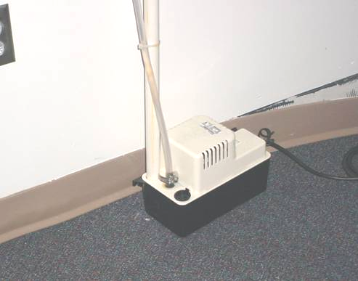

Close up of AC Condensation Drainage Pump

Picture 4

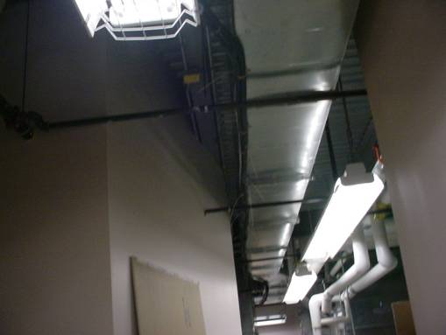

AC Condensation Drainage Hose (Parallel to Ductwork) along Ceiling of Mechanical Room
Picture 5

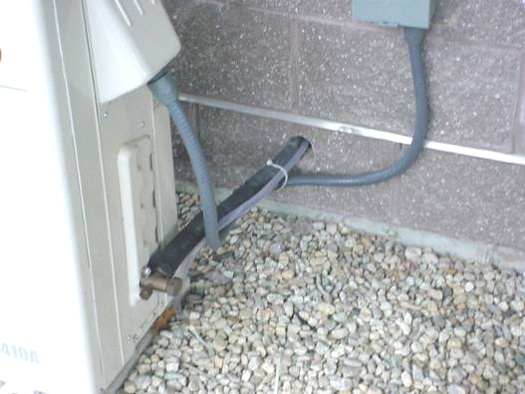

Terminus of AC Condensation Drainage Hose (Exterior of the Building)

Picture 6

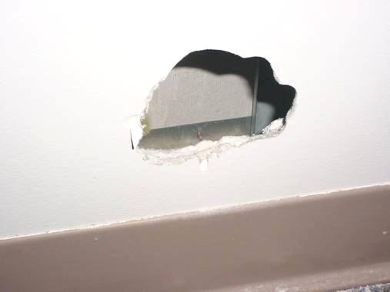

Section of GW Removed to Inspect Wall Cavity
Picture 7

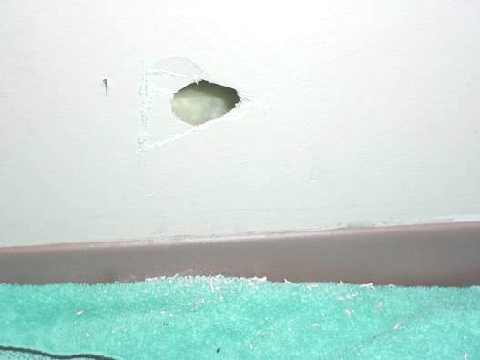

Section of GW Removed to Inspect Wall Cavity

Picture 8

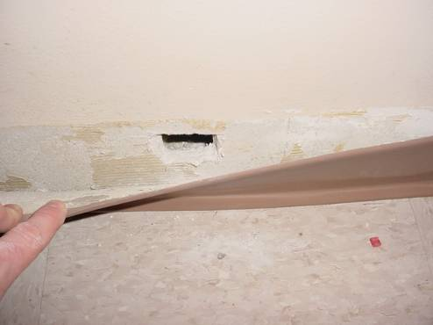

Section of GW Removed to Inspect Wall Cavity behind Vinyl Coving
Picture 9

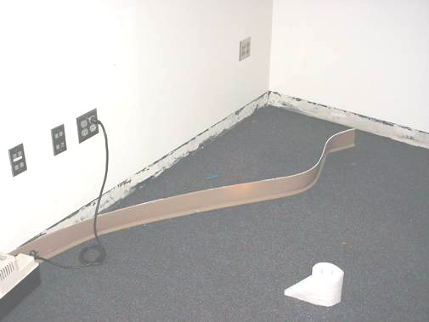

Vinyl Base Coving Removed to Examine for Mold Growth

Picture 10

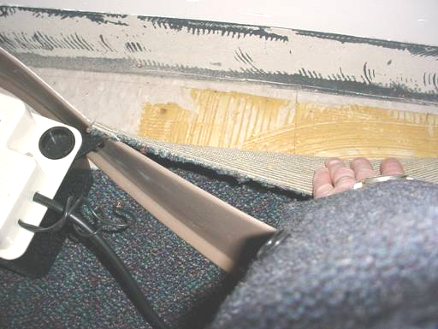

Carpeting and Vinyl Base Coving Removed to Examine for Mold Growth
Picture 11

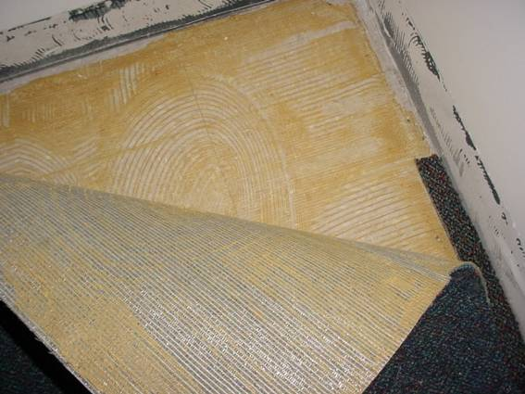

Carpeting and Vinyl Base Coving Removed to Examine for Mold Growth
Location | Moisture Measurement  (Low = Normal) | Material/Comments
TV/Video Production | No - Low  So – Low  East – Low  West – Low | No, So & East = Gypsum Wallboard  West = cloth partition
Control Room | No - Low  So – Low  East – Low  West – Low | Gypsum Wallboard, AC on west wall
Control Room | No - Low  So – Low  Center - Low  East – Low  West – Low | Carpeting
Multi-Media Room | No – Low  East – Low | Gypsum Wallboard

