Massachusetts HIV Epidemiologic Profile: Data as of 1/1/2023
Population Report: Older Individuals
Accessible MS Word Version, optimized for screen reader use
Please note that while the content of this report is the same as the pdf version, the format and pagination have been modified significantly to optimize use with screen readers to ensure access for blind or visually impaired audiences.
Suggested citation:
Massachusetts Department of Public Health, Bureau of Infectious Disease and Laboratory Sciences. Massachusetts HIV Epidemiologic Profile: Data as of 1/1/2023, Population Report: Older Individuals, https://www.mass.gov/lists/hivaids-epidemiologic-profiles Published September 2023. Accessed [date].
Bureau of Infectious Disease and Laboratory Sciences
Massachusetts Department of Public Health
Jamaica Plain Campus/State Public Health Laboratory
305 South Street
Jamaica Plain, MA 02130
Questions about this report
Tel: (617) 983-6560
To reach the Reporting and Partner Services Line
Tel: (617) 983-6999
To speak to the on-call epidemiologist
Tel: (617) 983-6800
Questions about infectious disease reporting
Tel: (617) 983-6801
Requests for additional data
https://www.mass.gov/lists/infectious-disease-data-reports-and-requests
Slide sets for HIV Epidemiologic Profile Reports
https://www.mass.gov/lists/hivaids-epidemiologic-profiles

OLDER INDIVIDUALS LIVING WITH HIV INFECTION
The number of older persons living with HIV infection in Massachusetts is increasing both because effective HIV medicines help people living with HIV lead longer, healthier lives and because HIV continues to be newly diagnosed in older individuals every year. For the purposes of this fact sheet, “older individuals” is defined as those who are aged 60+ years.
There are several distinct areas of concern regarding aging and HIV. First, older persons living with HIV may experience health challenges that tend to present later in life, such as low bone density, high cholesterol, and high blood pressure, and therefore may take substantially more medications, in addition to HIV treatments, than younger people.,. Second, HIV disease may affect the biology of aging, possibly resulting in earlier manifestations of clinical syndromes generally associated with more advanced age. Third, reduced mucosal and immunologic defenses (e.g., postmenopausal atrophic vaginitis) and changes in risk related-behaviors (e.g., decreased condom use because of lower concerns about pregnancy or more high-risk sexual activity with increased use of erectile dysfunction drugs) in older adults may lead to increased risk of acquisition and transmission of HIV. Finally, HIV screening among older adults remains low because they are generally perceived by health care providers to be at low risk of acquiring HIV. However, data indicate that older individuals are at risk for HIV acquisition, and testing and other prevention interventions are indicated for older adults.
OLDER INDIVIDUALS AT A GLANCE
N = 127, 9% of 1,419 new HIV diagnoses from 2019–2021 were among persons aged 60+ years
N = 7,414, 32% of 23,393 persons living with HIV infection in MA as of 12/31/2021 were persons aged 60+ years

FIGURE 1. Percentage distribution of persons living with HIV infection by age, Massachusetts 2012–2021
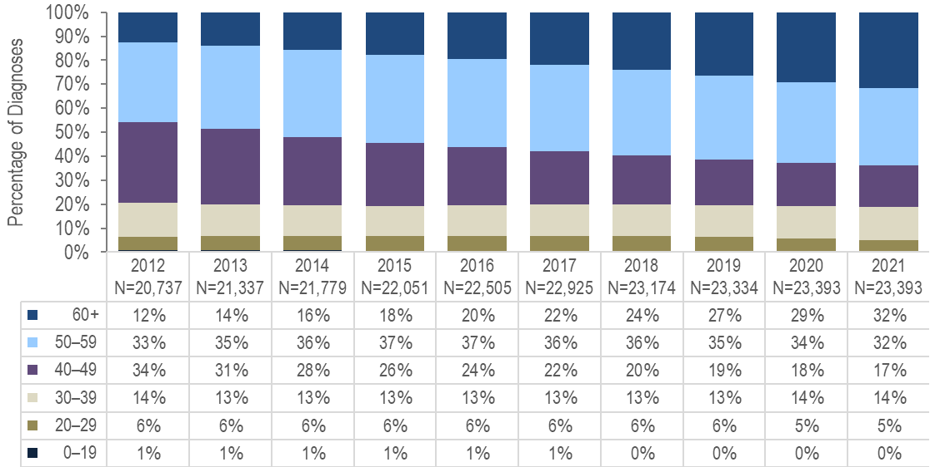
- From 2012 to 2021, the proportion of persons living with HIV infection (PLWH) who were aged 60+ years increased from 12% to 32% and who were aged 50+ years from 45% to 64%.
FIGURE 2. Persons living with HIV infection by expanded older age categories, Massachusetts 2021 (N=23,393)
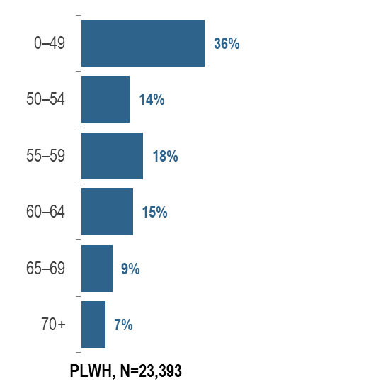
- In 2021, 17% (N=3,900) of PLWH were aged 65+ years, the age of eligibility for Medicare for individuals without a disability.
YEARS SINCE HIV INFECTION DIAGNOSIS AMONG PLWH 60+ YEARS OLD
FIGURE 3. Number of years since HIV infection diagnosis among individuals aged 60+ years living with HIV infection, Massachusetts 2021 (N=7,414)
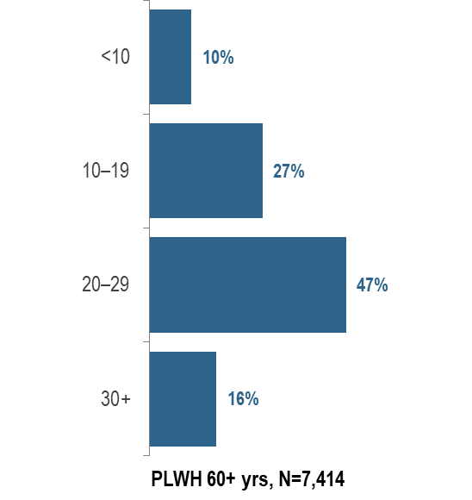
KEY FINDING
- In 2021, the majority (63%) of PLWH aged 60+ years were diagnosed with HIV infection at least 20 years ago. The average number of years since HIV infection diagnosis among PLWH aged 60+ years was 21.3 years.
FIGURE 4: People aged 60+ years and living with HIV infection compared to people aged under 60 years by selected characteristics, Massachusetts, 2021
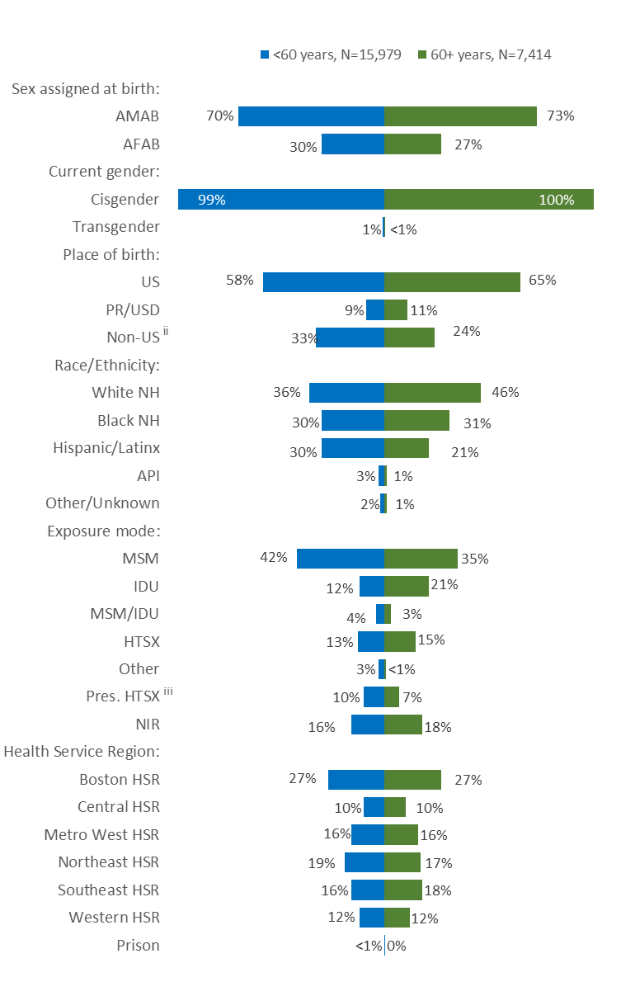
Figure 4 Notes:
^{ii} PR/USD = Puerto Rico/US Dependencies, 98% persons living with HIV infection on 12/31/2021 who were born in PR/USD were born in Puerto Rico
^{iii} Pres. HTSX=presumed heterosexual exposure, includes individuals assigned female at birth with a negative history of injection drug use who report having sex with an individual that identifies as male of unknown HIV status and risk
AMAB = assigned male at birth; AFAB = assigned female at birth; NH = non-Hispanic; API = Asian/Pacific Islander; MSM=male-to-male sex; IDU=injection drug use; HTSX=heterosexual sex; Pres. HTSX=presumed heterosexual exposure, includes individuals assigned female at birth with a negative history of injection drug use who report having sex with an individual that identifies as male of unknown HIV status and risk; NIR=no identified risk
In 2021, the distributions of people living with HIV infection by place of birth, race/ethnicity, and exposure mode varied by age:
- A larger proportion of individuals aged 60+ years (65%) than under 60 years (58%) was born in the US.
- A larger proportion of individuals aged 60+ years (46%) than under 60 years (36%) was white (non-Hispanic), and a smaller proportion was Hispanic/Latinx (21% vs. 30%).
- A larger proportion of individuals aged 60+ years (21%) than under 60 years (12%) had injection drug use exposure mode and a smaller proportion had MSM exposure mode (35% vs. 42%). However, MSM was still the most frequently reported exposure mode for both age groups.
- The distributions of people living with HIV infection by sex assigned at birth, current gender identity and health service region of current residence were similar for both age groups in 2021.
HIV CARE CONTINUUM
FIGURE 5. Viral load status among persons living with HIV infection by age (<60 years vs. 60+ years) Massachusetts, 2021
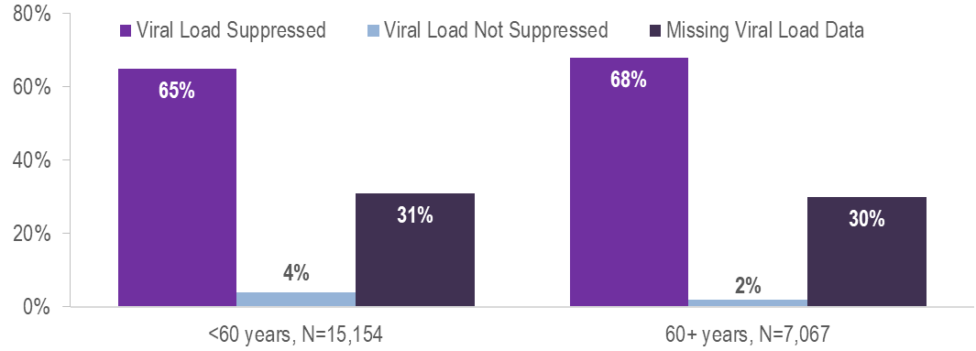
Among 7,067 persons living with HIV infection (PLWH) aged 60+ years in Massachusetts at the end of 2021 (and diagnosed through 2020), 68% were virally suppressed, 2% were not virally suppressed, and 30% did not have a viral load test in 2021. This compares to 15,154 PLWH aged under 60 years, among whom 65% were virally suppressed, 4% were not virally suppressed and 31% did not have a viral load test in 2021.
FIGURE 6. Stages of HIV care among persons living with HIV infection by age (<60 years vs. 60+ years) Massachusetts, 2021
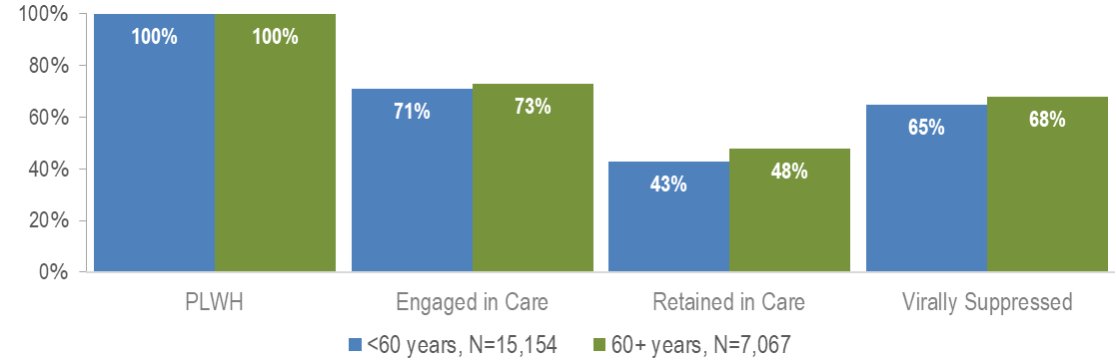
Proportions of care engagement and retention were also slightly higher among individuals aged 60+ years compared to those aged under 60 years in 2021 (73% vs. 71% and 48% vs. 43%, respectively). Overall proportions of care engagement and retention were lower in 2020 and 2021 compared to prior years likely due to the effects of the COVID-19 pandemic. However, please note that the total number of PLWH used to calculate these proportions includes all individuals who have ever been reported with HIV infection in Massachusetts with no evidence of death or having moved out of the state or country. Routine quality assurance efforts are ongoing and the number of PLWH used for this and other care continuum analyses may be updated based on these efforts.
FIGURE 7. Persons aged 60+ years living with HIV infection by exposure mode, Massachusetts 2021 (N=7,414)
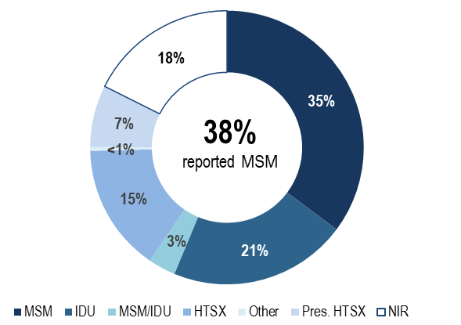
- Individuals with MSM exposure mode accounted for the largest proportion of PLWH aged 60+ years. In 2021, 35% of PLWH aged 60+ years were reported with an exposure mode of MSM and an additional 3% were reported with an exposure mode of MSM/IDU. This compares to 42% and 4% respectively for individuals aged under 60 years.
- Twenty-one percent of persons aged 60+ years were reported with an exposure mode of IDU and an additional 3% were reported with an exposure mode MSM/IDU. This compares to 12% and 4% respectively for individuals aged under 60 years.
FIGURE 8. PLWH aged 60+ years with MSM or MSM/IDU exposure mode (N=2,850) compared to PLWH aged 60+ years with other exposure modes (N=4,564) by selected demographics, Massachusetts 2021
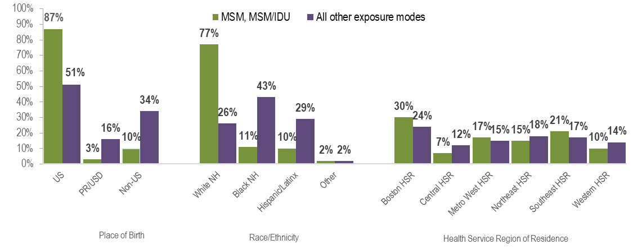
- In 2021, a larger proportion of older PLWH with MSM exposure modes:
  - was born in the United States, as compared to older PLWH with other exposure modes (87% vs. 51%);
  - was white (non-Hispanic), as compared to older PLWH with other exposure modes (77% vs. 26%); and
  - was living in the Boston or Southeast Health Service Regions, as compared to older PLWH with other exposure modes (30% and 21%, respectively vs. 24% and 17%, respectively).
FIGURE 9. Stages of HIV care among MSM (including MSM/IDU) aged 60+ years living with HIV infection, Massachusetts 2021 (N=2,756)
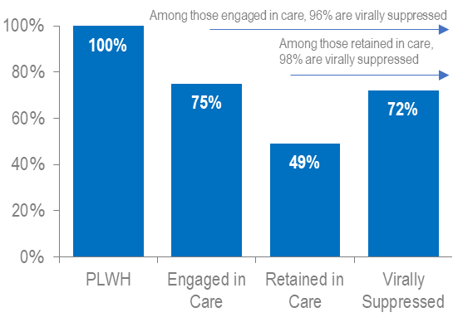
FIGURE 10. Viral load status MSM (including MSM/IDU) aged 60+ years living with HIV infection, Massachusetts 2021 (N=2,756)
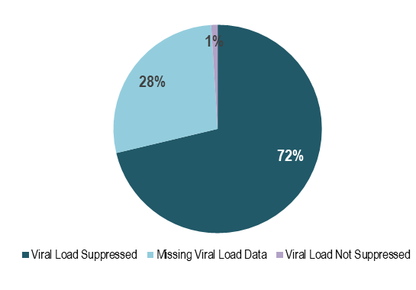
Figure 10 Note: Missing viral load data includes individuals who had not had a lab reported in the past year
In Massachusetts, among 2,756 PLWH aged 60+ years in 2021 (and diagnosed through 2020) with MSM exposure modes, 72% were virally suppressed, 1% were not virally suppressed, and 28% did not have a viral load test in 2020. Among those older PLWH with MSM exposure modes who were engaged in care (N=2,062) and retained in care (N=1,346), rates of viral suppression were higher at 96% and 98%, respectively. Engagement in care and viral suppression proportions were higher among older PLWH with MSM exposure modes (75% and 72%, respectively) as compared to older PLWH with all other exposure modes (71% and 65%, respectively, data not shown). In 2021, engagement in care and viral suppression among older PLWH with MSM exposure modes differed by place of birth, race/ethnicity, and health service region of residence. Both were lowest among MSM born outside the US and those of Hispanic/Latinx ethnicity. Engagement in care and viral suppression rates were higher in the Western HSR compared to other HSRs.
FIGURE 11. Engagement in care among MSM (including MSM/IDU) aged 60+ years living with HIV infection by place of birth, race/ethnicity, and Health Service Region of residence, Massachusetts 2021, (N=2,756)
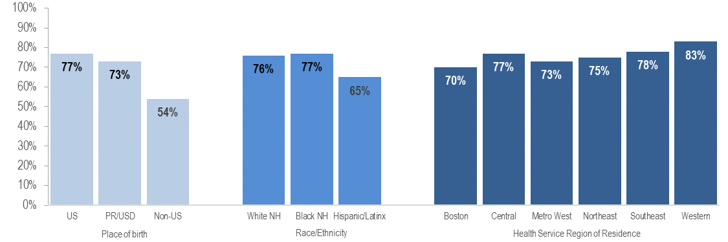
- Only 54% (N=147/271) of non-US born older MSM living with HIV infection were engaged in care, compared to 77% (N=1,856/2,404) of older US born MSM and 73% (N=59/81) of older MSM born in Puerto Rico/US Dependencies.
FIGURE 12. Viral suppression among MSM (including MSM/IDU) aged 60+ years living with HIV infection by place of birth, race/ethnicity, and Health Service Region of residence, Massachusetts 2021, (N=2,756)
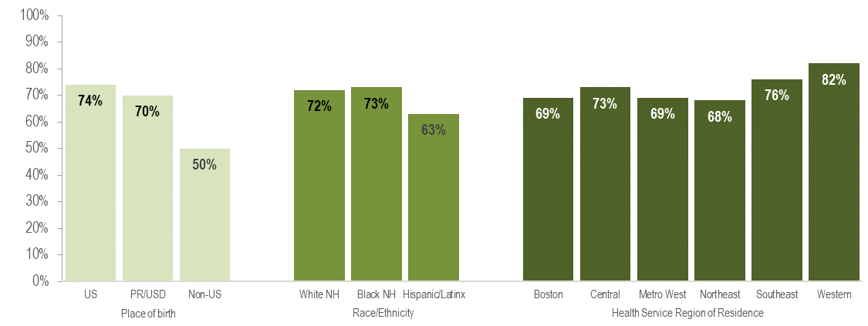
- Only 50% (N=135/271) of non-US born older MSM living with HIV infection were virally suppressed, compared to 74% (N=1,782/2,404) of older US born MSM and 70% (N=57/81) of older MSM born in Puerto Rico/US Dependencies. However, it is important to note that a much greater proportion of older non-US born MSM living with HIV infection were missing viral load information (49%) compared to those born in the US (25%) or Puerto Rico/US dependencies (28%) and that the proportion known to be not virally suppressed was actually the same for all groups (1%). This difference may highlight limited access to clinical documentation and/or less access to viral load testing in the country of origin for non-US born individuals.

OLDER INDIVIDUALS DIAGNOSED WITH HIV INFECTION
AGE AT DIAGNOSIS
FIGURE 13. Individuals diagnosed with HIV infection by age at diagnosis, Massachusetts 2012 – 2021
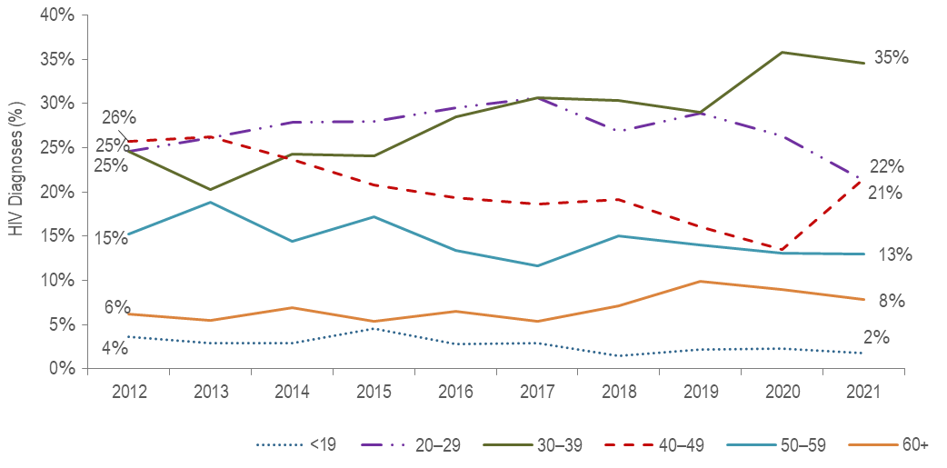
- From 2012 to 2021, the proportion of HIV infection diagnoses among 30–39 year-olds increased from 25% to 35%, while it decreased from 25% to 21% among 20–29 year-olds and from 26% to 22% among 40–49 year-olds.
- During the same time period, the percentage of HIV infection diagnoses among individuals aged 50–59 years and individuals aged 60+ years remained relatively stable.
- The average age at HIV infection diagnosis has remained relatively stable from 2012 (39.1 years) to 2021 (39.1 years). Among individuals aged 60+ years the average age at diagnosis decreased slightly from 2012 (65.7 years) to 2021 (64.4 years) (data not shown).
INDIVIDUALS DIAGNOSED WITH HIV INFECTION BY AGE (<60 VS 60+ YEARS)
SEX ASSIGNED AT BIRTH
FIGURE 14. Percentage of individuals diagnosed with HIV infection by age at diagnosis (<60 years [N=1,292] vs. 60+ years [N=127]) and sex assigned at birth, Massachusetts 2019 – 2021
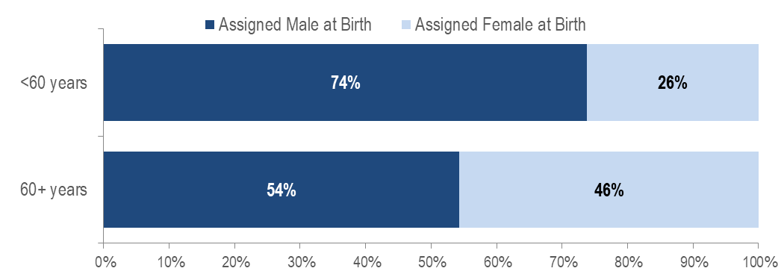
KEY FINDING
- A larger proportion of individuals recently diagnosed with HIV infection aged 60+ years (46%) than aged under 60 years (26%) was assigned female at birth.
PLACE OF BIRTH
When reviewing the following data presentations on people diagnosed with HIV infection aged 60+ years, please note that the ascertainment of accurate initial diagnosis date/age is often more difficult for individuals born outside the United States than those born in the United States or Puerto Rico. This is due to limited access to clinical documentation and/or less access to testing in the patient’s country of origin. Differences between younger (<60) and older (60+) individuals diagnosed with HIV infection displayed in this report may be an artifact of this data quality discrepancy rather than actual age at diagnosis.
FIGURE 15. Percentage of individuals diagnosed with HIV infection by age at diagnosis (<60 years [N=1,292] vs. 60+ years [N=127]) and place of birth, Massachusetts 2019 – 2021
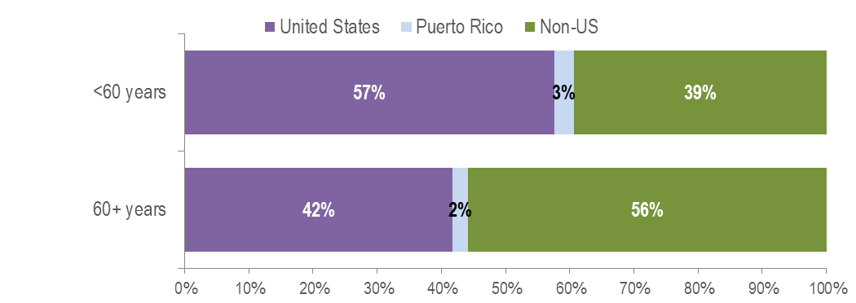
KEY FINDING
- Fifty-six percent of individuals aged 60+ years recently diagnosed with HIV infection were born outside the United States, compared to 40% of individuals aged under 60 years. Among individuals aged 60+ years recently diagnosed with HIV infection and born outside the United States, 41% were assigned male at birth (AMAB) and 59% were assigned female at birth (AFAB).
RACE/ETHNICITY
FIGURE 16. Percentage of individuals diagnosed with HIV infection by age at diagnosis (<60 years [N=1,292] vs. 60+ years [N=127]) and race/ethnicity, Massachusetts 2019 – 2021
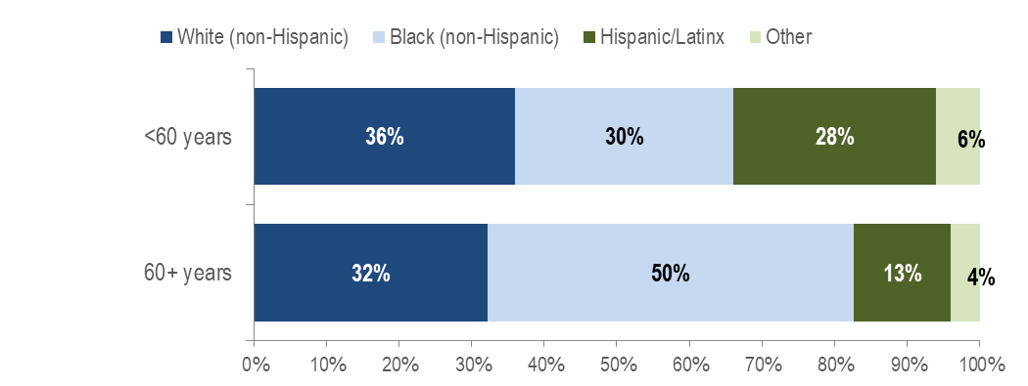
KEY FINDING
- Half of individuals aged 60+ years recently diagnosed with HIV infection were black (non-Hispanic), compared to 30% of individuals aged under 60 years.
EXPOSURE MODE
FIGURE 17. Percentage of individuals diagnosed with HIV infection by age at diagnosis (<60 years [N=1,292] vs. 60+ years [N=127]) and exposure mode, Massachusetts 2019 – 2021
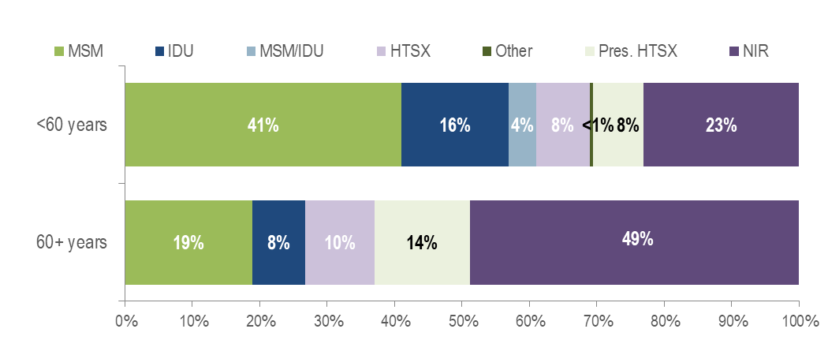
KEY FINDING
- Forty-nine percent (N=62/127) of individuals recently diagnosed with HIV infection at age 60+ years did not have exposure mode information reported that met CDC-defined categories, compared to 23% among individuals diagnosed under age 60 years. This highlights challenges in assigning primary exposure modes for the older adult population. Individuals aged 60+ years recently diagnosed without exposure mode information consisted predominantly of individuals AMAB (60%), individuals born outside the US (71%), and individuals of black (non-Hispanic) (63%) race.
EXPOSURE MODE BY SEX ASSIGNED AT BIRTH
FIGURE 18. Percentage of individuals diagnosed with HIV infection at 60+ years (N=127) by sex assigned at birth and exposure mode, Massachusetts 2019 – 2021
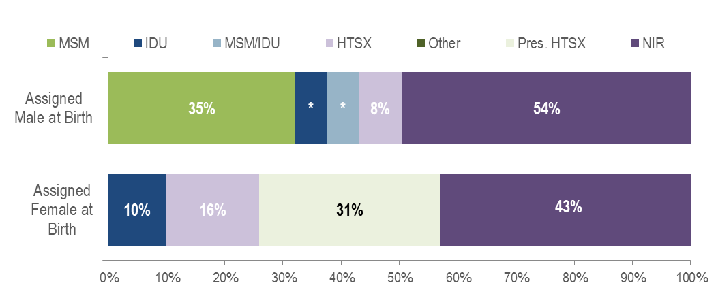Figure 18 note:
* Values less than five are suppressed for populations less than 50,000 or for populations of unknown size. Percentages do not add up to 100% due to suppressed values.
- Fifty-four percent (N=37/69) of individuals AMAB recently diagnosed with HIV infection at age 60+ years did not have exposure mode information reported that met CDC-defined categories, compared to 43% (N=25/58) among individuals AFAB diagnosed at age 60+ years. Among individuals AMAB aged 60+ years recently diagnosed with HIV infection without exposure mode information, 62% were born outside the US. Comparatively, among individuals AFAB aged 60+ years recently diagnosed with HIV infection without exposure mode information, 84% were born outside the US.
AREA OF RESIDENCE
FIGURE 19. Percentage of individuals diagnosed with HIV infection by age at diagnosis (<60 years [N=1,292] vs. 60+ years [N=127]) and by Health Service Region (HSR) of residence, Massachusetts 2019 – 2021
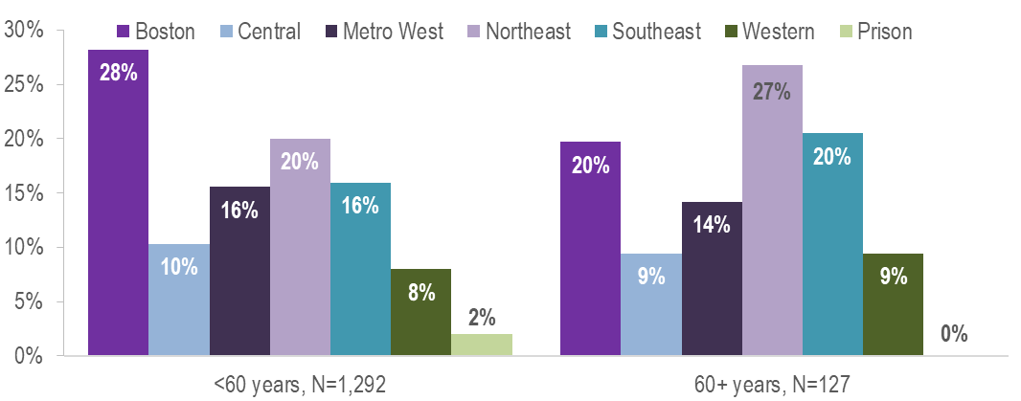
- A larger proportion of individuals recently diagnosed with HIV infection aged 60+ years (27%) than aged under 60 years (20%) were living in the Northeast HSR and a smaller proportion were living in the Boston HSR (20% vs. 28%).

Panel on Antiretroviral Guidelines for Adults and Adolescents. Guidelines for the Use of Antiretroviral Agents in Adults and Adolescents with HIV. Department of Health and Human Services. 2019. Available at https://clinicalinfo.hiv.gov/en/guidelines/hiv-clinical-guidelines-adult-and-adolescent-arv/hiv-and-older-person Accessed (2/3/2023) [HIV and the Older Person]
Please consider the impact of the COVID-19 pandemic on infectious disease screening, treatment, and surveillance in the interpretation of 2020 and 2021 data.
Please consider the impact of the COVID-19 pandemic on infectious disease screening, treatment, and surveillance in the interpretation of 2020 and 2021 data.
Please consider the impact of the COVID-19 pandemic on infectious disease screening, treatment, and surveillance in the interpretation of 2020 and 2021 data.
Please consider the impact of the COVID-19 pandemic on infectious disease screening, treatment, and surveillance in the interpretation of 2020 and 2021 data.
Please consider the impact of the COVID-19 pandemic on infectious disease screening, treatment, and surveillance in the interpretation of 2020 and 2021 data.
HIV care continuum among persons living with HIV infection (PLWH) in Massachusetts: “PLWH” refers to individuals diagnosed through 2020, alive through 12/31/2021, and living in Massachusetts based on last known address. “Engaged in Care” is defined as having ≥1 VL or CD4 test result in 2020. “Retained in Care” is defined as having ≥2 VL or CD4 test results at least 3 months apart in 2021. “Virally Suppressed” is defined as having a VL <200 copies/mL for the most recent VL test drawn in 2021.
Please consider the impact of the COVID-19 pandemic on infectious disease screening, treatment, and surveillance in the interpretation of 2020 and 2021 data.
Routine quality assurance and follow up are conducted to update mortality status and the current residence of PLWH.
Please consider the impact of the COVID-19 pandemic on infectious disease screening, treatment, and surveillance in the interpretation of 2020 and 2021 data.
Includes MSM and MSM/IDU exposure modes
Please consider the impact of the COVID-19 pandemic on infectious disease screening, treatment, and surveillance in the interpretation of 2020 and 2021 data.
Includes MSM and MSM/IDU exposure modes
Please consider the impact of the COVID-19 pandemic on infectious disease screening, treatment, and surveillance in the interpretation of 2020 and 2021 data.
Please consider the impact of the COVID-19 pandemic on infectious disease screening, treatment, and surveillance in the interpretation of 2020 and 2021 data.
Please consider the impact of the COVID-19 pandemic on infectious disease screening, treatment, and surveillance in the interpretation of 2020 and 2021 data.
Please consider the impact of the COVID-19 pandemic on infectious disease screening, treatment, and surveillance in the interpretation of 2020 and 2021 data.
Please consider the impact of the COVID-19 pandemic on infectious disease screening, treatment, and surveillance in the interpretation of 2020 and 2021 data.

